**(PHP)Day 3 lab**

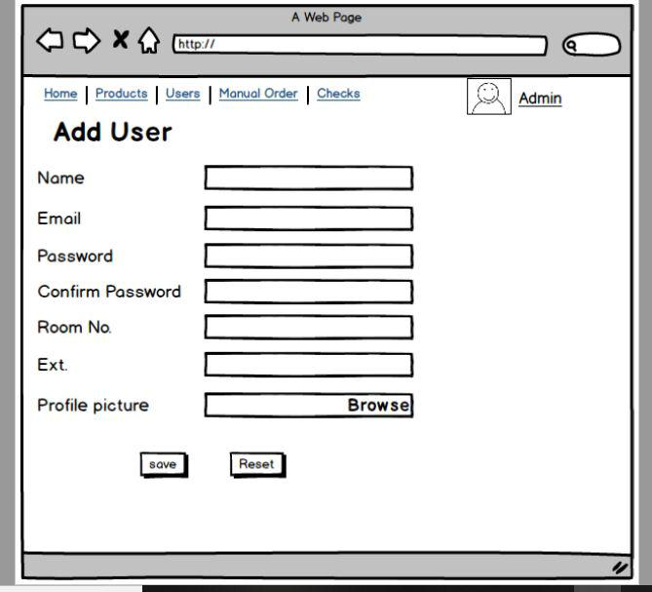

**Requirements:**

**1-Implement the above form in php**

**2-Apply the validation on the email field on the php side.**

**3- Room number should be a drop down that contains ‘Application1, Application2 and cloud)**

**4-Upload a profile picture and ensure that is a photo [not allowed to upload another types]**

**5-Show output in [profile.php] page**

**Bonus**

**1-Add validation on the password field to be only a. Only 8 chars**

**b. Doesn’t allow special chars -only underscore allowed-**

**c. Doesn’t accept Capital characters**

**2-When you found an error in the email or password redirect to a new page that displays the error you had and Don’t submit the data into file**

**3-Well-formed code is bonus.**

**Good luck ^^**

**Noha Shehab**

***Teaching Assistant OpenSource -iti***