Bachelor of Software Engineering

Centre for IT Education (CITES)

Department of Electrical and Computer Engineering The Open University of Sri Lanka

EEI4366 – Data Modelling and Database Systems

Academic Year – 2022/2023

Lab Test - 02

Name : **A. M. Asky**

Reg-Number : **621426603**

1. Create a view named ‘SalesRepresentative’ to display details of all the employees who have a job title of a ‘SalesRep’.

1. Create a view named ‘EmpCity’ to display the name (firstname and lastname combined), email, the job title and the city taken from ‘offices’ table.

1. From the view created in question 2, obtain details of all the employees working as ‘SalesRep’ at the city of ‘San Francisco’.

1. Create a view named ‘Customer_Products’ with all the products ordered by the customers displaying the customer name, country, product name and the quantity ordered.

1. From the view created in question 4,
2. Obtain the details of customers who ordered the product ‘1911 Ford Town Car’.

1. Obtain the number of customers who ordered the product ‘1911 Ford Town Car’.

1. Create a table named ‘Product_Text’ with the given schema and use a trigger, ‘insert_product’ to load data to it using ‘products’ table after a new record is entered into ‘products’ table. Product_Text (productCode, productName, productVendor, quantityInStock)

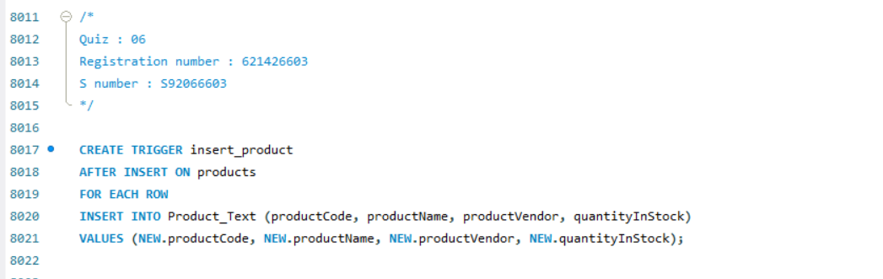



1. Insert new values to the ‘products’ tables and show the values getting inserted automatically to ‘Product_Text’ table due to the execution of the trigger created in question 6.

1. Create a trigger, ‘delete_product’ to delete the values in ‘Product_Text’ table when the inserted values in ‘products’ table get deleted.

1. Delete the inserted values from the ‘products’ tables and show the values getting deleted automatically from the ‘Product_Text’ table as well due to the execution of the trigger created in question 8.

