Installation & User Guide

TestManager_Migration

**Table of Contents:**

1. Publish the Library ……………………………………………………………………………………………... 1
2. Install the Library …………………………………………………………………………………………………4
3. Using the Library ………………………………………………………………………………………………….4
4. Activities……………………………………………………………………………………………………………..5
   1. Migrate_All_Entities……………………………………………………………………………………5
   2. Create_Project ………………………………………………………………………………………….6
   3. Create_Requirements_workflow ………………………………………………………………....8
   4. Create_TestCases …………………………………………………………………………………....9
   5. Create_TestSet ………………………………………………………………………………………...10
   6. Link_TestCase_Requirement ……………………………………………………………………...12
   7. Link_TestCase_TestSet ……………………………………………………………………………...13
   8. Token ................................................................................................................14
5. Support .........………………………………………………………………………………………………........15

**Publish the Library**

**Steps:**

1. Open the Project ‘TestLibrary_Migration’ in the studio.
2. Connect the studio to the Tenant.
3. Check the permissions required to publish the library.
4. Click on Design>Publish.
5. Enter the package name ‘TestManager_Migration’ in the ‘Package Name’ field.

1. Publish the Library.
2. The library will be published under Tenant, Package>Libraries>Tenant.

**NOTE: This Topic will be Removed from the final version**

**Install the Library**

**Steps:**

1. Open the UiPath Studio.
2. Create a Process/Test Automation.
3. Check if Studio is connected to the same tenant the library was published. (This point will be removed in the final version).
4. Click on Design>Manage Packages.

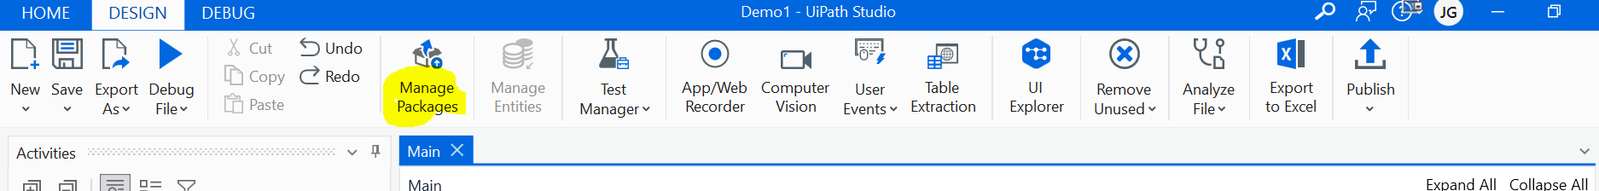

1. Click on ‘All Packages’.
2. Search the published TestManager_Migration.

1. Install the library and save the Changes.

**Using the Library**

**Steps:**

1. After installing the library go to the ‘Activities’ tab.
2. Search for the TestManagerLibrary activities.

1. Drag these activities according to the migratory needs.

**Note**

* Before execution of the activities, an External Application with proper scope must be created. (Refer to Pre-requisites.docx)
* Users must have access to Test Manager. (Refer to Pre-requisites.docx).
* Data must be filled in ‘Template.xlsx’ or must be in same format with identical sheets and column name.

**4.0 Activities**

**4.1 Migrate_All_Entities**

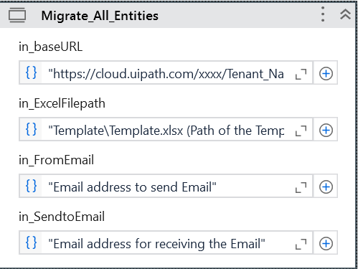

1. This activity migrates Project, Requirements, Test Cases, Test Steps, Test Sets and links them in TestManager.
2. Fill the fields of the library and execute.
3. ‘Template.xlsx’ is the file that has data about the entities that are supposed to be migrated (Template.xlsx file can be stored within the project).
4. To download Template.xlsx visit <https://github.com/AM-accelirate/TestMigration_Library>
5. Fields -

in_baseURL - "https://cloud.uipath.com/xxx/<Tenant_Name>/testmanager_/ (Base_url of the tenant)".

in_ExcelFilePath - "Template\Template.xlsx (Path of the Template.xlsx)".

in_FromEmail - “Email address to send Email”.

in_SendtoEmail - “Email address for receiving the Email”.

**4.2 Create_Project**

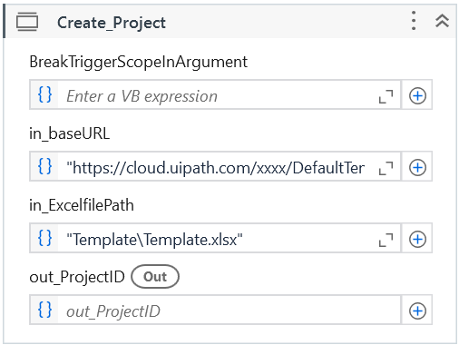

1. This library creates a project in Test Manager.’
2. It also gives out project ID after creating the project or if project is already created
3. It can be to obtain projectID required for requirements, test cases, test sets etc.
4. Fields -

BreakTriggerScopeInArgument – It is automatically created during the publication of library, leaves the field empty, does not affect the execution of the activity.

in_baseURL - "https://cloud.uipath.com/xxx/<Tenant_Name>/testmanager_/ (Base_url of the tenant)".

in_ExcelFilePath - "Template\Template.xlsx (Path of the Template.xlsx)". Or user can create his own Excel File using ‘Template.xlsx’, update with all data required and give the file path here.

out_ProjectID – Gives out Project ID after activity is executed, variable must be created to store the variable value.

**4.3 Create_Requirements_workflow**

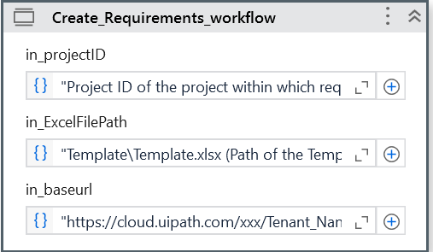

Fields –

in_projectID – Project ID of the project within which requirements will be created

in_ExcelFilePath – Template\Template.xlsx (Path of the Template.xlsx).

in_baseurl – "https://cloud.uipath.com/xxx/<Tenant_Name>/testmanager_/ (Base_url of the tenant)".

in_ExcelFilePath - "Template\Template.xlsx (Path of the Template.xlsx) ".

This activity creates the requirement according to the data provided in ‘Template.xlsx’

**4.4 Create_TestCases**

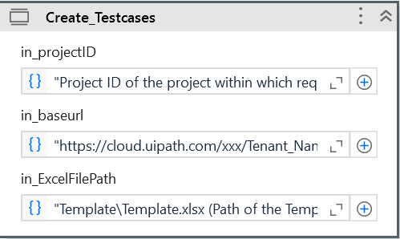

Fields –

in_ExcelFilePath – Template\Template.xlsx (Path of the Template.xlsx)

in_baseurl – https://cloud.uipath.com/xxx/<Tenant_Name>/testmanager_/ (Base_url of the tenant).

in_ExcelFilePath - Template\Template.xlsx (Path of the Template.xlsx).

in_projectID – Project ID of the project within which requirements will be created.

This activity creates the Test cases according to the data provided in ‘Template.xlsx’ file within the project.

**4.5 Create_TestSet**

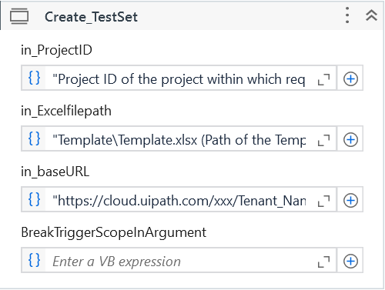

Fields-

in_ExcelFilePath – Template\Template.xlsx (Path of the Template.xlsx).

in_baseurl – https://cloud.uipath.com/xxx/<Tenant_Name>/testmanager_/ (Base_url of the tenant).

in_ExcelFilePath - Template\Template.xlsx (Path of the Template.xlsx).

in_projectID – Project ID of the project within which requirements will be created.

BreakTriggerScopeInArgument – It is automatically created during the publication of library, leaves the field empty, does not affect the execution of the activity.

This activity creates the Test Set according to the ‘Template.xlsx’ that must be created within the project

**4.6** **Link_TestCase_Requirement**

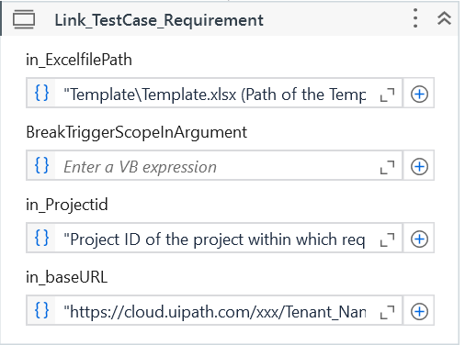

Fields –

in_ExcelFilePath – Template\Template.xlsx (Path of the Template.xlsx).

BreakTriggerScopeInArgument – It is automatically created during the publication of library, leaves the field empty, does not affect the execution of the activity.

in_baseurl – https://cloud.uipath.com/xxx/<Tenant_Name>/testmanager_/ (Base_url of the tenant).

in_ExcelFilePath - Template\Template.xlsx (Path of the Template.xlsx).

in_Projectid – Project ID of the project within which requirements will be created.

This activity links the Test_Cases with Requirements, Test cases that has to be linked must be added in ‘TestCase_name’ column within ‘Requirement’ sheet.

**4.7 Link_TestCase_TestSet**

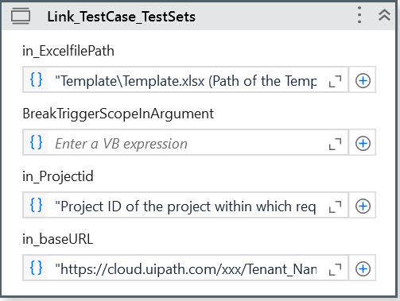

Fields –

in_ExcelFilePath – Template\Template.xlsx (Path of the Template.xlsx)

BreakTriggerScopeInArgument – It is automatically created during the publication of library, leaves the field empty, does not affect the execution of the activity.

in_baseurl – https://cloud.uipath.com/xxx/<Tenant_Name>/testmanager_/ (Base_url of the tenant).

in_ExcelFilePath - Template\Template.xlsx (Path of the Template.xlsx).

in_Projectid – Project ID of the project within which requirements will be created.

This activity links the Test Case with Test Sets. Test cases that must be added in Test Set must be added in ‘Test_cases’ column.

**4.8 Token**

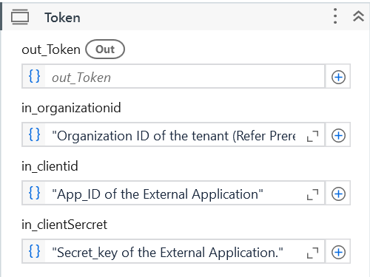

1. This activity generates the access token required for API requests within the activities
2. Fields –

in_organizationid – ID of the automation cloud.

in_clientid – App_ID of the External Application.

in_clientSecret – Secret_key of the External Application.

out_Token – Gives the access token, variable must be defined to store the token.

**Note-**

* The format of ‘Template.xlsx’ file must not be changed, any change in the name of the columns or sheet may cause failure.

**5.0 Support**

* For Any Queries reach out to our support team [TAC_testmanagersupport@accelirate.com](mailto:TAC_testmanagersupport@accelirate.com) [Need to confirm with Namrata and Hossien]