**Prerequisite Document for TestManager_Migration**

**Table of Contents**

1.0 Test Manager ....................................................................................... 3

2.0 External Application .............................................................................5

3.0 Organization ID .....................................................................................8

4.0 Input File ..............................................................................................11

(Template.xlsx)

6.0 Browser ................................................................................................12

5.0 Support ................................................................................................12

**1.0**  **Test Manager**

* Test Manager must be enabled for the Tenant within which you are migrating all entities.

**Steps:**

* 1. Open the UiPath Automation Cloud.
  2. Click on ‘Admin’.
  3. Click on your Tenant, under the ‘Tenants’.

* 1. Click on ‘Services’.
  2. If ‘Test Manager’ is visible check if it is enabled.

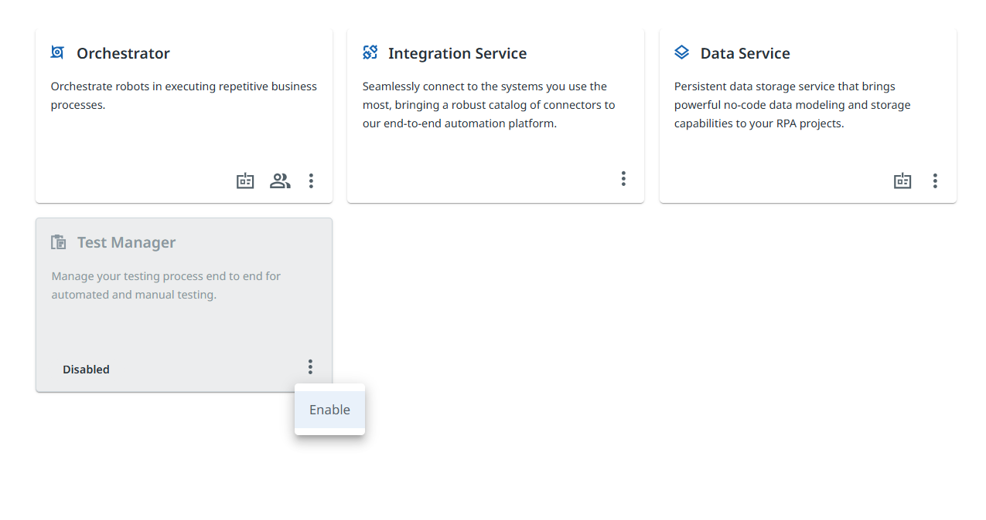

* 1. If ‘Test Manager’ is not visible click on ‘Add services’, search for Test Manager and add it to the Tenant.
  2. The Test Manager will be visible, enable it if not yet enabled.

**2.0** **External Application (OAuth)**

* External Application is required for the access token which is needed for library to function.
* Scope mentioned in the External Application limits the access of the API which is using the token generated with the use of respective Application.

**Steps:**

1. Open the Automation Cloud. ( <https://www.uipath.com/product/automation-cloud>, Sign In using your UiPath credentials).
2. Click on Admin (Refer the image below), click on cloud above ‘Tenant’.

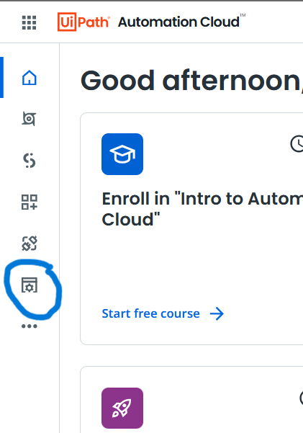

1. Click on External Application. (Refer to the image above).
2. Click on ‘Add Applications’. (Refer to the image below).

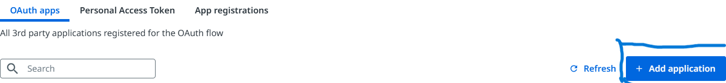

1. Fill out the name of the application.
2. Keep Application Type as ‘Confidential Application’.
3. Put ‘http://localhost:8081/callback’ as redirect URL.
4. Add User Scope, by clicking on ‘+ Add scopes.

1. Search Test Manager in Resource.
2. Click on ‘Select All’. Refer to the above image.
3. Click on ‘Save’.
4. Click on ‘Add’ button the right bottom of the page.

**3.0 OrganizationID**

OrganiationID is needed for the functioning of library, one of the methods is illustrated below for your reference.

* This method uses Inspect Window to extract ID from network traffic.
* OrganizationID is needed for access token, it must be included in ‘Template.xlsx’ file within ‘Prerequisite’ sheet.

**Steps:**

1. Open the UiPath Automation Cloud.
2. Go to Cloud within Admin Panel.
3. Open Settings.

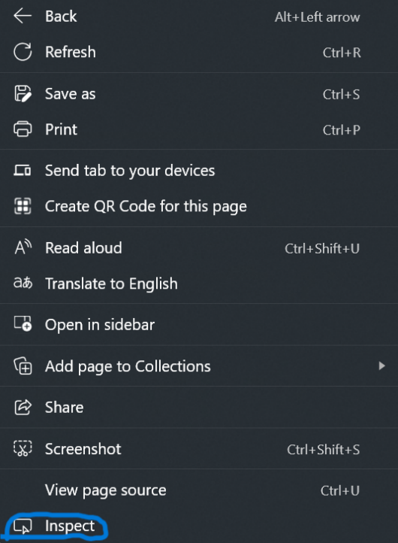

1. Now open the Inspect window (Right click on the screen and select ‘Inspect’ option, refer to the Image above), go to Network Tab. (Refer to the Image below).

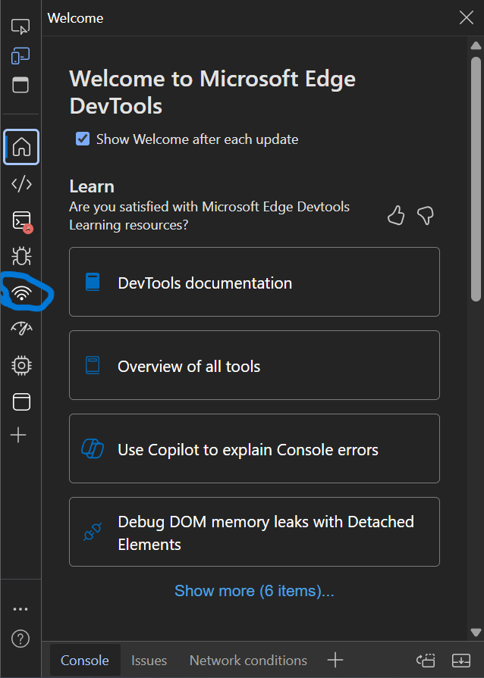

1. Open ‘Fetch/XHR’. (Refer to the Image below).

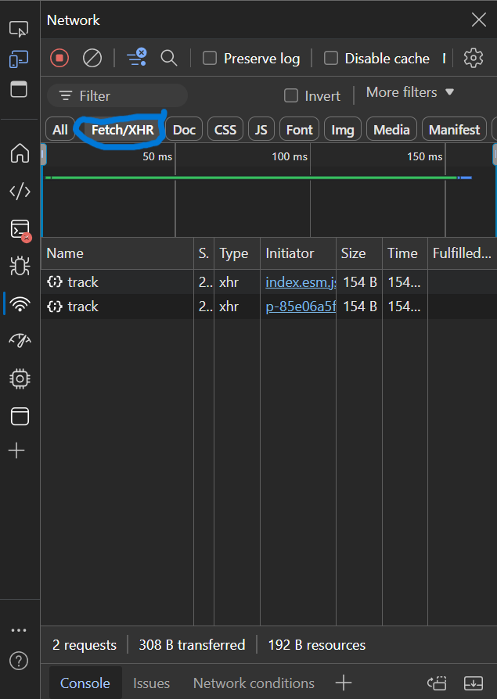

1. Now click ‘Advanced’ option on the web page next to ‘General’.
2. Within ‘Fetch/XHR’, there will be ‘tenant?organizationGUID=_____’, click on it. (Refer to the image below).

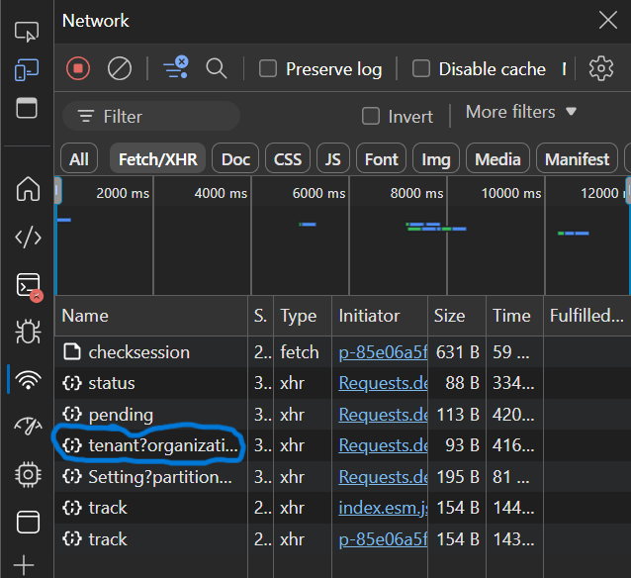

1. This organizationGUID is the organizationID which must be mentioned under OrganizarionID column within ‘Prerequisite’ sheet in the ‘Template.xlsx’ file.

**4.0 Input File (Template.xlsx)**

* Data needed for migration is added to the Input file, it must be in the required format.
* Input file is the Excel File named Template.xlsx, it is advisable to continue with the same name as in most of the documentation ‘Template.xlsx’ is used to refer Input file.
* Template.xlsx file can be added in to the project in which TestManager_Migration library is implemented so the path addition to the activities becomes simple.
* Link to download Template.xlsx file - <https://github.com/AM-accelirate/TestMigration_Library>

***Note -***

* *Path of the file must be recorded correctly; library activities need to access the file hence incorrect path will lead to error.*
* *The names of the columns and sheets must not be changed, it may lead to failure.*
* *Template.xlsx must be closed before executing the library activities (Save and close the file after editing the file and before executing the library activities).*
* *Within ‘Prerequisite’ sheet add ‘Client_id’ (App ID of the External Application), Client_Secret(Secret ID found under the App secrets within External Application), OrganizationID (Refer 3.0 Organization ID section of this document).*

**5.0 Browser**

* For the working of TestManager_Migration library ‘Chrome’ browser must be installed on the machine
* Also ‘UiPath Browser Automation’ extension must be enabled for Chrome browser.
* Refer [Studio - Extension for Chrome](https://docs.uipath.com/studio/standalone/2023.10/user-guide/extension-for-chrome#uninstalling) documentation for managing the extension.

**6.0 Support**

* For Any Queries reach out to our support team [TAC_testmanagersupport@accelirate.com](mailto:TAC_testmanagersupport@accelirate.com) [Need to confirm with Namrata and Hossien]