AM2PM SUPPORT PVT. LTD.
Call Center CRM
System Architecture & MongoDB Data Design

Stack: Vercel (Next.js) · MongoDB Atlas · Upstash QStash + Redis · Vercel Blob / R2
Scope: multi-client BPO CRM with lead auto-import, dedupe, auto-assignment, telephony, outbound webhooks, per-client backup and reporting
Version 1.1 · 1 October 2026 (adds per-client backup and restore) · Prepared for Ankit Kapoor
Sources compared: crmv7.gs (Sheet CRM v4.9), "Call Center CRM: Architecture & MongoDB Design" (v1), "AM2PM Call Center CRM — Low-Cost System Design" (PDF)

Contents

1. Summary
Build the new AM2PM Call Center CRM on Vercel (Next.js) + MongoDB Atlas + Upstash (QStash queue, Redis), with call recordings in Vercel Blob or Cloudflare R2. It costs about $28/month in pilot, ~$105/month at 200 agents and ~$550/month at 2,000 agents, with no servers, Kubernetes or ops staff.
The design keeps the proven business logic of the Google Apps Script CRM (crmv7.gs v4.9: dedupe, weighted auto-assignment, callback reminders, CallerDesk / Interakt / Brevo / Resend integrations) and the data shape of the MongoDB design document (tenantId everywhere, webhook_events inbox, one interactions timeline, workflow engine). It replaces what makes each one expensive or fragile.
Three things run on their own from day one:
- Auto-import: every lead source pushes (webhook) or is pulled (15-minute cron). Nobody clicks "Sync".
- Auto-assignment: each lead is deduped and handed to an eligible agent within seconds of landing.
- Outbound webhooks: lead.converted, lead.assigned, disposition.set and 5 more events are HMAC-signed, retried for 24 hours and logged.
Honest trade-off: MongoDB costs roughly 1.5× the Neon Postgres option at growth and scale, and has no database-level row security. It wins on flexible per-client custom fields, one document per lead, and the schema work already done in the MongoDB design document.

2. Comparing the three sources
The Apps Script CRM has the right features but hits Google limits; the MongoDB document has the right structure but is sized for 2,000 agents on day one; the low-cost PDF has the cheapest serverless runtime. This design keeps crmv7 logic, the MongoDB collections and the PDF runtime.
Area | crmv7.gs (Sheets, v4.9) | MongoDB design doc (v1) | Low-cost PDF (Neon) | This design keeps
Runtime | Apps Script; 6-min runs; 25 s lock on doPost | NestJS monolith + BullMQ on Kubernetes | Next.js on Vercel + QStash | Next.js on Vercel + QStash
Database | Sheet tabs: CRM_Calling, Marketing_Leads, WebhookLog, MissedCalls | MongoDB replica set, then sharded cluster | Neon Postgres + JSONB | MongoDB Atlas: Flex → M10 → M30; no sharding until needed
Lead import | Manual "Sync Marketing → Calling" | source field; unique dedupeKey | Auto-import, 7 sources | Auto-import, 7 sources
Dedupe | Last 10 digits of phone or chosen column | Unique partial index | Unique partial index | Same rule, unique partial index on isActive leads
Assignment | Equal / % / Ratio / Number; contiguous blocks | Round-robin / skill / load; atomic update | All of both | All of both, interleaved, in a transaction
Outbound webhooks | None | Workflow action only | First-class, signed, retried | First-class, signed, retried, via outbox
Telephony / messaging | CallerDesk, Interakt, Brevo, Resend, WhatsApp Web | Adapter layer, 10 providers | Adapter layer | Adapter layer; port crmv7 four first
Reports | 30+ report builders into a sheet | Pre-aggregated daily_stats | SQL views + rollup | daily_stats via nightly $merge
Tenant isolation | One spreadsheet per client | tenantId injected by data layer | Postgres Row-Level Security | tenantId injected by one repository layer + tests
Cost at 200 agents | ~$0 but breaks at scale | ~$400+ plus ops staff | ~$70 | ~$105

Dropped: Kubernetes, always-on NestJS servers, BullMQ workers, sharding plans, Sheets as the database. Deferred to phase 4: LMS, attendance and shifts, reimbursements, invoicing (the schema is reserved).

3. Stack and cost
Every component is serverless and billed per use, so cost follows agent count rather than peak capacity.
Layer | Choice | Replaces | Why
App + API | Next.js (App Router) on Vercel, Fluid compute | Sheets UI; NestJS | One codebase for agent screen, admin, client portal, public API, webhooks
Database | MongoDB Atlas via Vercel Marketplace, Mumbai region | Sheets; self-run replica set | Flexible custom fields, one bill, env vars injected
DB driver | Official mongodb driver; one cached client; attachDatabasePool (@vercel/functions) | Mongoose on long-lived servers | Avoids connection storms from many function instances
Queue + retries | Upstash QStash (Vercel Queues as alternative) | Apps Script triggers; BullMQ | Webhook processing, assignment, outbound webhooks, DLQ
Live state | Upstash Redis | Script cache | Agent presence, round-robin cursors, rate limits
Scheduled jobs | Vercel Cron → QStash fan-out | ScriptApp.newTrigger | Reminders, sweeper, recycle, rollups, retention
Files | Vercel Blob or Cloudflare R2 | Recording links in cells | Recordings and CSV uploads; signed URLs
Auth | Auth.js: Google + email OTP; optional TOTP | Sheet protection by email | Roles, sessions, 2FA
Providers | CallerDesk, Interakt, Brevo, Resend | Same | Already integrated in crmv7

3.1 Monthly cost by stage (USD, approximate)
Item | Pilot: 1 client, ≤20 agents | Growth: ~200 agents | Scale: ~2,000 agents
Vercel Pro (Hobby is non-commercial) | $20 | ~$30 | ~$60–100
MongoDB Atlas | $8 (Flex, 5 GB) | ~$57 (M10) | ~$388 (M30)
Upstash QStash ($1 per 100K messages) | $0 (1,000/day free) | ~$10 | ~$30
Upstash Redis | $0 | ~$5 | ~$20
Recording storage | ~$0 | ~$3 | ~$30
Total | ~$28 | ~$105 | ~$530–570

For comparison: Neon Postgres ~$20 / ~$70 / ~$350; the original MongoDB design ~$400+ at scale before servers, Redis and Kubernetes. Provider charges (CallerDesk minutes, WhatsApp template fees, email volume) are the same in every option and excluded. Prices checked 30 Sep 2026 on mongodb.com/pricing, upstash.com/pricing/qstash and vercel.com/pricing.

3.2 Cost rules
- Recordings never go in MongoDB, only the storage key; this keeps the database under Flex’s 5 GB through the pilot.
- TTL indexes delete raw webhook payloads after 60 days and workflow runs / deliveries after 90 days.
- Dashboards read daily_stats, never raw interactions.
- Move to M10 before go-live with a paying client: Flex has shared resources and a 500 ops/sec ceiling; M10 adds continuous backups and private endpoints.
- Per-client backups add roughly $1–5/month at growth and ~$20/month at scale (compressed snapshots in R2, no egress fees); Atlas Cloud Backup on M10+ is billed by snapshot storage (approximate).

4. Architecture
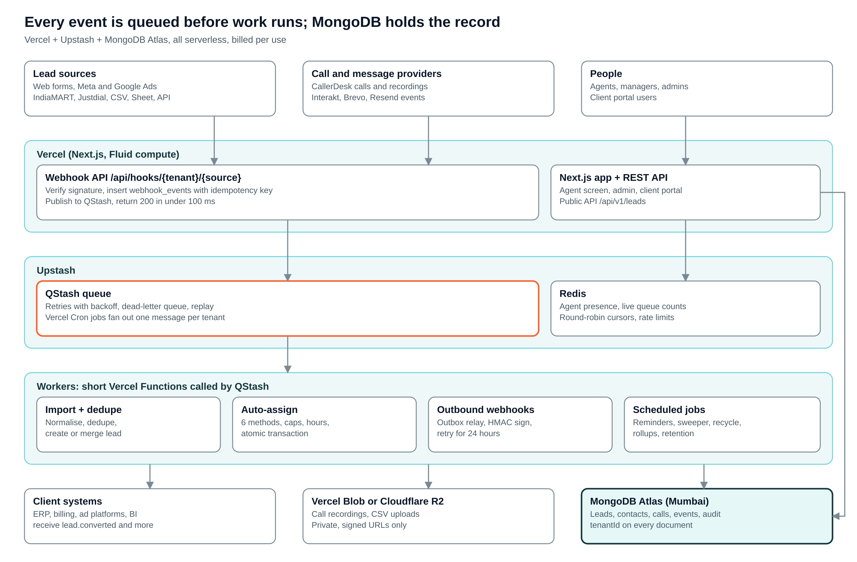
Figure 1. System architecture
Lead sources and providers only ever touch the webhook API, which saves and queues. All real work runs in short QStash-triggered functions. The agent app reads and writes MongoDB directly (right-hand line), and Redis holds only fast-changing state that can be rebuilt.

4.1 Component responsibilities
Component | Responsibility | Must never
Webhook API | Verify, persist to webhook_events, publish to QStash, return 200 | Run business logic inline
Next.js app + API | Agent screen, admin, client portal, public REST API, SSE stream | Query without the tenant repository
QStash | Deliver jobs with retry/backoff; dead-letter queue; delayed messages for reminders | Hold state beyond the message
Redis | Presence, live counts, eligible-agent cache (30 s), rate limits | Be the only copy of any record
Workers | Import, dedupe, assign, outbound webhooks, workflows, reminders, rollups | Run longer than ~60 s; fan out instead
MongoDB Atlas | System of record for all business data | Store recordings or files
Blob / R2 | Recordings and uploaded files; private | Serve public URLs

4.2 Why this shape
- Webhooks from telephony, WhatsApp and email are never processed inline. They are validated, stored with an idempotency key, queued, and processed by workers. This protects the API during call spikes and removes crmv7’s 25-second script lock.
- Vercel functions are short-lived, so long-running listeners (MongoDB change streams, BullMQ workers, WebSocket servers) are replaced by the outbox pattern, QStash and Server-Sent Events.
- Start as one Next.js codebase (modular monolith). Split a module out only when it needs independent scaling, usually telephony ingestion or analytics.

5. Multi-tenancy strategy
Option | Pros | Cons | Verdict
Shared collections + tenantId | Simplest ops, cheapest, easy cross-tenant admin reporting | Risk of a missed filter; noisy neighbour | Default
Database per tenant | Strong isolation; per-client backup, delete, region | Many databases; harder global reporting | Only for large or regulated clients
Cluster per tenant | Maximum isolation | Very expensive | Avoid

Recommended hybrid: shared database with tenantId for all standard clients. A tenant flagged isolation: "dedicated" is routed to its own database by a connection resolver; application code is identical.

5.1 Rules that enforce safety
- Every tenant-scoped document has tenantId: ObjectId as a required field, enforced by $jsonSchema validation.
- Every tenant-scoped index starts with tenantId.
- A repository layer db(ctx) injects { tenantId } from the authenticated session into every find, update, aggregate ($match as the first stage) and insert.
- Raw collection access is blocked by a lint rule outside the platform-admin module.
- An automated test calls every API route as tenant A and asserts zero tenant-B documents come back.
- Super Admin cross-tenant queries use an explicitly named platformScope path and are audit-logged.

6. Modelling principles (embed vs reference)
Situation | Choice | Example
Child data always read with the parent, bounded size | Embed | contacts.phones[], processes.stages[], workflows.actions[]
Child grows unbounded or is queried on its own | Reference | interactions, lead_events, callbacks, audit_logs
Need a snapshot at a point in time | Embed a copy | interactions.agent = {id, name}; leads.lastDisposition = {code, label}
Many-to-many | Array of ObjectIds on the smaller side | users.processIds[], users.teamIds[]
Hot, high-churn counters | Redis, flushed or rebuilt | Live queue length, agent talk time today

Bucketing rule: never embed unbounded arrays (calls in a lead, messages in a chat). Keep them as separate documents in interactions. No document should grow past ~1 MB.

7. Database relationships
Twenty-one core collections, two supporting ones (teams, integrations) and three for per-client backup (backup_policies, backup_snapshots, restore_jobs; section 17). Every tenant-scoped document carries tenantId, createdAt and updatedAt; references are ObjectIds stored on the child side.
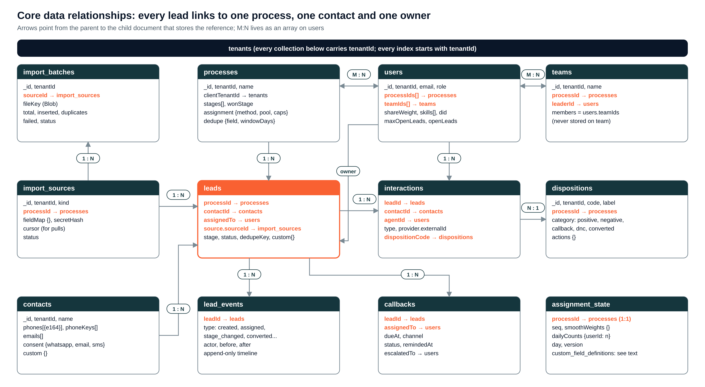
Figure 2. Core data relationships (orange fields are references)
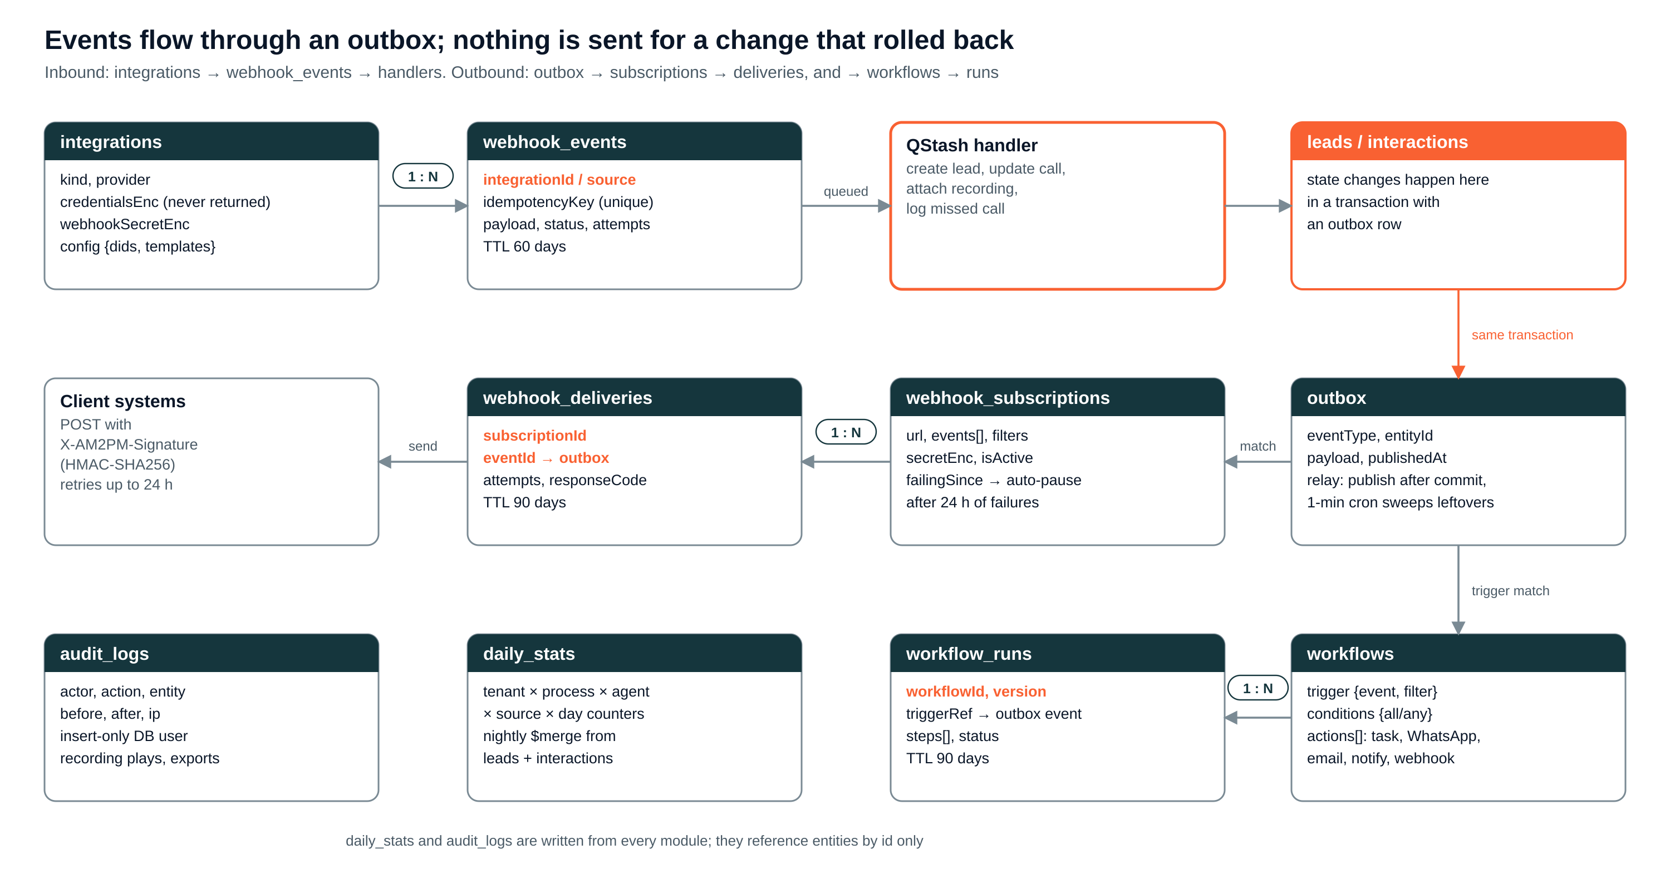
Figure 3. Event, webhook and automation relationships

7.1 Relationship reference
Parent | Child | Cardinality | Stored as | Query / index
tenants | every collection | 1 : N | tenantId on child | Prefix of every index; injected filter
tenants (client) | processes | 1 : N | processes.clientTenantId | {tenantId, clientTenantId}
processes | leads | 1 : N | leads.processId | {tenantId, processId, stage, assignedTo}
processes | dispositions | 1 : N | dispositions.processId (null = tenant-wide) | {tenantId, processId, code} unique
processes | import_sources | 1 : N | import_sources.processId | {tenantId, kind}
processes | assignment_state | 1 : 1 | assignment_state.processId | {tenantId, processId} unique
processes | teams | 1 : N | teams.processId | {tenantId, processId}
users ↔ processes | — | M : N | users.processIds[] | {tenantId, processIds, isAvailable}
users ↔ teams | — | M : N | users.teamIds[] (members never stored on team) | {tenantId, teamIds}
users | leads (owner) | 1 : N | leads.assignedTo | {tenantId, assignedTo, nextCallbackAt}
users | interactions | 1 : N | interactions.agentId + agent snapshot | {tenantId, agentId, startedAt:-1}
users | callbacks | 1 : N | callbacks.assignedTo | {tenantId, assignedTo, status, dueAt}
contacts | leads | 1 : N | leads.contactId | {tenantId, contactId}
contacts | interactions | 1 : N | interactions.contactId | {tenantId, contactId, startedAt:-1}
leads | interactions | 1 : N | interactions.leadId | {tenantId, leadId, startedAt:-1}
leads | lead_events | 1 : N | lead_events.leadId | {tenantId, leadId, createdAt:-1}
leads | callbacks | 1 : N | callbacks.leadId | {tenantId, leadId}
dispositions | interactions / leads | 1 : N | dispositionCode + label snapshot | UI reads cached dispositions
import_sources | import_batches | 1 : N | import_batches.sourceId | {tenantId, createdAt:-1}
import_sources | leads | 1 : N | leads.source.sourceId | daily_stats by source
integrations | webhook_events | 1 : N | webhook_events.integrationId | {tenantId, source, idempotencyKey} unique
outbox | webhook_deliveries | 1 : N | webhook_deliveries.eventId | {tenantId, subscriptionId, createdAt:-1}
webhook_subscriptions | webhook_deliveries | 1 : N | webhook_deliveries.subscriptionId | same
workflows | workflow_runs | 1 : N | workflow_runs.workflowId + version | {tenantId, workflowId, createdAt:-1}
custom_field_definitions | leads / contacts | defines | values in custom {} keyed by definition key | Only indexed:true fields get an index

7.2 Denormalisation and consistency
- Copy small, slow-changing values into the child (agent name, disposition label, client name). The authoritative value stays in one place; a background job updates copies when it changes (rare).
- Use multi-document transactions only where state must be atomic: lead assignment + agent counter + outbox; conversion + outbox; merge of duplicates. Everything else uses single-document atomic updates and idempotent workers.
- Never do "find then insert" for dedupe: insertOne and catch duplicate-key error 11000.

8. Collection reference
Notation: every tenant-scoped collection also has _id (ObjectId), tenantId, createdAt, updatedAt, createdBy unless marked global.

8.1 Platform and tenancy

tenants (global)
One document per AM2PM client organisation (and one for AM2PM itself).
Field | Type | Notes
name, slug | string | slug unique; used in webhook URLs
status | enum | active, trial, suspended, closed
isolation / dbName | enum / string | shared or dedicated; dbName only if dedicated
settings | embedded | { timezone, currency, workingHours, retentionDays, recordingRetentionDays }
featureFlags | embedded | { whatsapp, brevo, resend, clientPortal, workflows }
branding | embedded | { logoKey, primaryColor } for the client portal

Indexes: {slug:1} unique; {status:1}

users
AM2PM staff and client-portal users. Roles are a field; permissions come from the role matrix in section 15.
Field | Type | Notes
email, name, phone | string | email unique per tenant
role | enum | super_admin, admin, project_supervisor, manager, process_coordinator, trainer, client, agent
processIds[] | ObjectId[] → processes | Process mapping; grants access to a client’s leads
teamIds[] | ObjectId[] → teams | Team membership
did | string | CallerDesk DID used for click-to-call (crmv7 roster DID column)
shareWeight | number | Share for Percentage / Ratio assignment (crmv7 roster Share)
skills[] | string[] | Language, city, product tags for skill routing
maxOpenLeads / openLeads | number | Capacity cap and live counter (conditional $inc)
isAvailable | boolean | Logged in and not on break; mirrored in Redis
auth | embedded | { googleId, totpSecretEnc, ipAllowlist[], lastLoginAt }
status | enum | active, inactive, locked

Indexes: {tenantId, email} unique; {tenantId, processIds, isAvailable}; {tenantId, teamIds}

teams
Groups of agents under a leader, per process.
Field | Type | Notes
name | string
processId | ObjectId → processes
leaderId | ObjectId → users | Team lead

Indexes: {tenantId, processId}
Members are not stored on the team; query users.teamIds to avoid two-way sync.

processes
A campaign or line of business for one client (e.g. "Flo Mattress – Sales").
Field | Type | Notes
name, type | string | sales, support, data_ops
clientTenantId | ObjectId → tenants | Which client this process serves
stages[] / wonStage | string[] / string | Pipeline stages (crmv7 Lead Stage dropdown); reaching wonStage = converted
assignment | embedded | { method, pool[userIds], weights{}, dailyQuota{}, workingHours, slaMinutes, recycleHours, sticky }
dedupe | embedded | { field: "phoneKey" | "email" | custom key, reEnquiryDays }
integrationIds[] | ObjectId[] → integrations | Telephony / WhatsApp / email used
status | enum | active, paused, closed

Indexes: {tenantId, clientTenantId}; {tenantId, status}

integrations
Provider accounts per tenant. Secrets are encrypted and never returned by the API.
Field | Type | Notes
kind / provider | enum | telephony: callerdesk, myoperator, exotel · whatsapp: interakt · email: brevo, resend
credentialsEnc | binary | AES-256-GCM with a key in Vercel env vars
webhookSecretEnc | binary | Used to verify inbound signatures
config | embedded | { dids[], senderIds, templateMap, rateLimitPerMin }
fallbackIntegrationId | ObjectId | Failover provider (phase 2)

Indexes: {tenantId, kind, status}

8.2 Customer and lead data

contacts
Person-level master record, deduplicated by phone and email across processes.
Field | Type | Notes
name | string
phones[] | embedded[] | [{ e164, label, isPrimary }]
phoneKeys[] | string[] | Last 10 digits of each phone (crmv7 phoneKey rule), for lookup
emails[] | embedded[] | [{ address (lowercase), isPrimary, bounced }]
consent | embedded | { whatsapp, email, sms: { optedIn, at, source } } (crmv7 opt-in gate)
dnc | boolean | Set by a DNC disposition; blocks all outreach
custom | object | Custom field values (section 9)

Indexes: {tenantId, phoneKeys}; {tenantId, "emails.address"}

leads
One enquiry for one process. The unit that is assigned, called and converted.
Field | Type | Notes
processId / contactId | ObjectId | → processes / → contacts
source | embedded | { kind, sourceId → import_sources, batchId, campaign, adId, formId }
stage / status | string / enum | stage from process list; status open, won, lost, dnc
assignedTo / assignedAt | ObjectId / date | → users; current owner
score / attempts | number | Lead score; call attempts
lastDisposition | embedded | { code, label, category, at } snapshot for list views
lastInteractionAt / nextCallbackAt / lastEnquiryAt | date | Denormalised for queues and SLAs
convertedAt | date | Set with status won
dedupeKey / isActive | string / boolean | processId + phoneKey by default; isActive false frees the key
custom | object | Custom field values

Indexes: {tenantId, processId, dedupeKey} unique partial {isActive:true}; {tenantId, assignedTo, nextCallbackAt}; {tenantId, processId, stage, assignedTo}; {tenantId, contactId}; {tenantId, status, assignedTo} partial for unassigned sweeper
Why isActive: MongoDB partial indexes cannot use $ne, so archiving sets isActive:false instead of status != archived.

lead_events
Append-only history of a lead. Replaces crmv7’s "Timeline History" cell.
Field | Type | Notes
leadId | ObjectId → leads
type | enum | created, merged, assigned, reassigned, stage_changed, disposition_set, callback_set, converted, lost
actor | embedded | { kind: user | system | source, id, name }
before / after | object | Changed fields only

Indexes: {tenantId, leadId, createdAt:-1}

import_sources
Configured lead source per process (web form, ad platform, portal, CSV, sheet, API).
Field | Type | Notes
kind | enum | web_form, meta_ads, google_ads, indiamart, justdial, csv, sheet, api
processId | ObjectId → processes | Leads land in this process
fieldMap | object | { full_name: "name", phone_number: "phone", city: "custom.city" }
secretHash | string | SHA-256 of the source key; key shown once
cursor | embedded | Last pulled id / row / timestamp for cron pulls
status / lastLeadAt | enum / date | active, paused, error; health check

Indexes: {tenantId, kind}; {tenantId, processId}

import_batches
One CSV upload or scheduled pull.
Field | Type | Notes
sourceId | ObjectId → import_sources
fileKey | string | Blob/R2 key of the upload
total / inserted / duplicates / failed | number | Per-batch reconciliation
errorsKey | string | Row-level error report file
status | enum | queued, running, done, failed

Indexes: {tenantId, createdAt:-1}

8.3 Interactions, dispositions, callbacks

interactions
One collection for calls, WhatsApp, SMS, email and notes: a single customer timeline with one index. The largest collection.
Field | Type | Notes
type / direction | enum | call, whatsapp, email, sms, note / inbound, outbound
leadId, contactId, processId | ObjectId | Timeline keys
agentId / agent | ObjectId / embedded | { id, name } snapshot
provider | embedded | { name, externalId } e.g. CallerDesk call id (idempotency)
status | string | call: ringing, answered, missed, failed · message: queued, sent, delivered, read, failed
startedAt / endedAt / durationSec / talkSec | date / number
recordingKey | string | Blob/R2 key; played only via signed URL
disposition | embedded | { code, label, category, subKey } set at wrap-up
message | embedded | { templateId, body, deliveredAt, readAt, errorCode } for WhatsApp/SMS/email
notes | string | Agent remark (crmv7 Remark)

Indexes: {tenantId, "provider.name", "provider.externalId"} unique sparse; {tenantId, leadId, startedAt:-1}; {tenantId, contactId, startedAt:-1}; {tenantId, agentId, startedAt:-1}; {tenantId, processId, startedAt:-1}

dispositions
Call outcomes per process (crmv7 Lead Disposition dropdown). The category drives automation.
Field | Type | Notes
processId | ObjectId | null | null = tenant-wide
code / label | string | code immutable
category | enum | positive, negative, neutral, callback, dnc, converted
subDispositions[] | embedded[] | [{ key, label, requiresNote }]
actions | embedded | { createCallback, moveToStage, closeLead, requireCallbackTime }
order / isActive | number / boolean

Indexes: {tenantId, processId, code} unique

callbacks
Scheduled follow-ups (crmv7 Callback Date-Time).
Field | Type | Notes
leadId / assignedTo | ObjectId | → leads / → users
dueAt | date | In UTC; shown in tenant timezone
channel | enum | call, whatsapp, email
status | enum | pending, done, missed, escalated, cancelled
remindedAt / escalatedTo | date / ObjectId | Reminder 15 min before; escalate after 30 min

Indexes: {tenantId, status, dueAt}; {tenantId, assignedTo, status, dueAt}

assignment_state
Per-process state for fair, atomic assignment.
Field | Type | Notes
processId | ObjectId → processes | 1 : 1
seq | number | Equal round-robin pointer
smoothWeights | object | { userId: currentWeight } for smooth weighted round-robin
day / dailyCounts | string / object | Tenant-local date; { userId: n } for the Number quota
version | number | Optimistic concurrency check

Indexes: {tenantId, processId} unique

custom_field_definitions
Per-tenant (optionally per-process) field definitions.
Field | Type | Notes
entity | enum | lead, contact, interaction
processId | ObjectId | null
key / label | string | key immutable, stored inside custom {}
type | enum | text, number, dropdown, multiselect, date, boolean, phone, email
options / validation | array / embedded | { required, min, max, regex }
indexed | boolean | Creates a partial index via background job

Indexes: {tenantId, entity, processId, key} unique

8.4 Events, webhooks, automation

webhook_events (inbound)
Raw inbound provider payloads for idempotency, debugging and replay.
Field | Type | Notes
source / integrationId | string / ObjectId | callerdesk, interakt, meta_ads, web_form...
idempotencyKey | string | Provider event id, else SHA-256 of body
payload | object | Raw JSON
status / attempts / error | enum / number / string | received, processing, done, failed, dead

Indexes: {tenantId, source, idempotencyKey} unique; {status, createdAt}; TTL 60 days on createdAt

outbox
Business events written in the same transaction as the change that caused them.
Field | Type | Notes
eventType | string | lead.created, lead.assigned, lead.converted...
entityId | ObjectId | Lead, callback or interaction
payload | object | Event data as sent
publishedAt | date | null | null until QStash accepted it

Indexes: {publishedAt:1, createdAt:1}; TTL 30 days after publish

webhook_subscriptions (outbound)
Client endpoints that receive events.
Field | Type | Notes
url | string | HTTPS only
events[] | string[] | Subscribed event types
filters | embedded | { processIds[], stages[] }
secretEnc | binary | HMAC secret, shown once
isActive / failingSince | boolean / date | Auto-pause after 24 h of failures

Indexes: {tenantId, isActive}

webhook_deliveries
One document per event per subscription; attempts appended.
Field | Type | Notes
subscriptionId / eventId | ObjectId | → webhook_subscriptions / → outbox
eventType | string
status | enum | pending, delivered, failed, dead
attempts[] | embedded[] | [{ at, responseCode, ms, error }] (max 6)

Indexes: {tenantId, subscriptionId, createdAt:-1}; TTL 90 days

workflows / workflow_runs
Trigger → conditions → actions automation, and its execution log.
Field | Type | Notes
trigger | embedded | { event, filter }
conditions | embedded | { all: [{ field, op, value }] }
actions[] | embedded[] | create_task, send_whatsapp_template, send_email, notify_user, update_lead, webhook
workflow_runs | collection | workflowId, version, triggerRef, steps[], status; TTL 90 days

Indexes: {tenantId, "trigger.event", isActive}; runs {tenantId, workflowId, createdAt:-1}

daily_stats / audit_logs
Reporting rollup and append-only audit trail.
Field | Type | Notes
daily_stats | collection | tenant × process × agent × source × day: leads, dupes, calls, talkSec, connects, dispositions{}, conversions
audit_logs | collection | actorId, action (recording.played, lead.exported, role.changed), entity, entityId, before, after, ip, userAgent

Indexes: daily_stats {tenantId, date, processId, agentId} unique; audit_logs {tenantId, createdAt:-1}, {tenantId, entity, entityId}; insert-only DB user

9. Custom fields
Definitions live in custom_field_definitions; values live inside the parent document as a plain object, so one read returns everything.
{
"_id": "6700a0...",
"tenantId": "64f1...",
"processId": "64f3...",
"stage": "Interested",
"custom": {
"mattress_size": "Queen",
"budget": 25000,
"preferred_time": "2026-10-05T11:00:00Z",
"has_old_mattress": true
}
}
- The write path validates against definitions (type, required, regex). Field keys are immutable; only labels change.
- Deleting a definition soft-deletes it; data stays. Changing a dropdown option does not rewrite old data.
- Default: custom fields are not indexed. Fields flagged indexed get {tenantId, processId, "custom.<key>"} via a background job. Cap ~50 custom fields per entity.

10. Lead pipeline: auto-import and dedupe
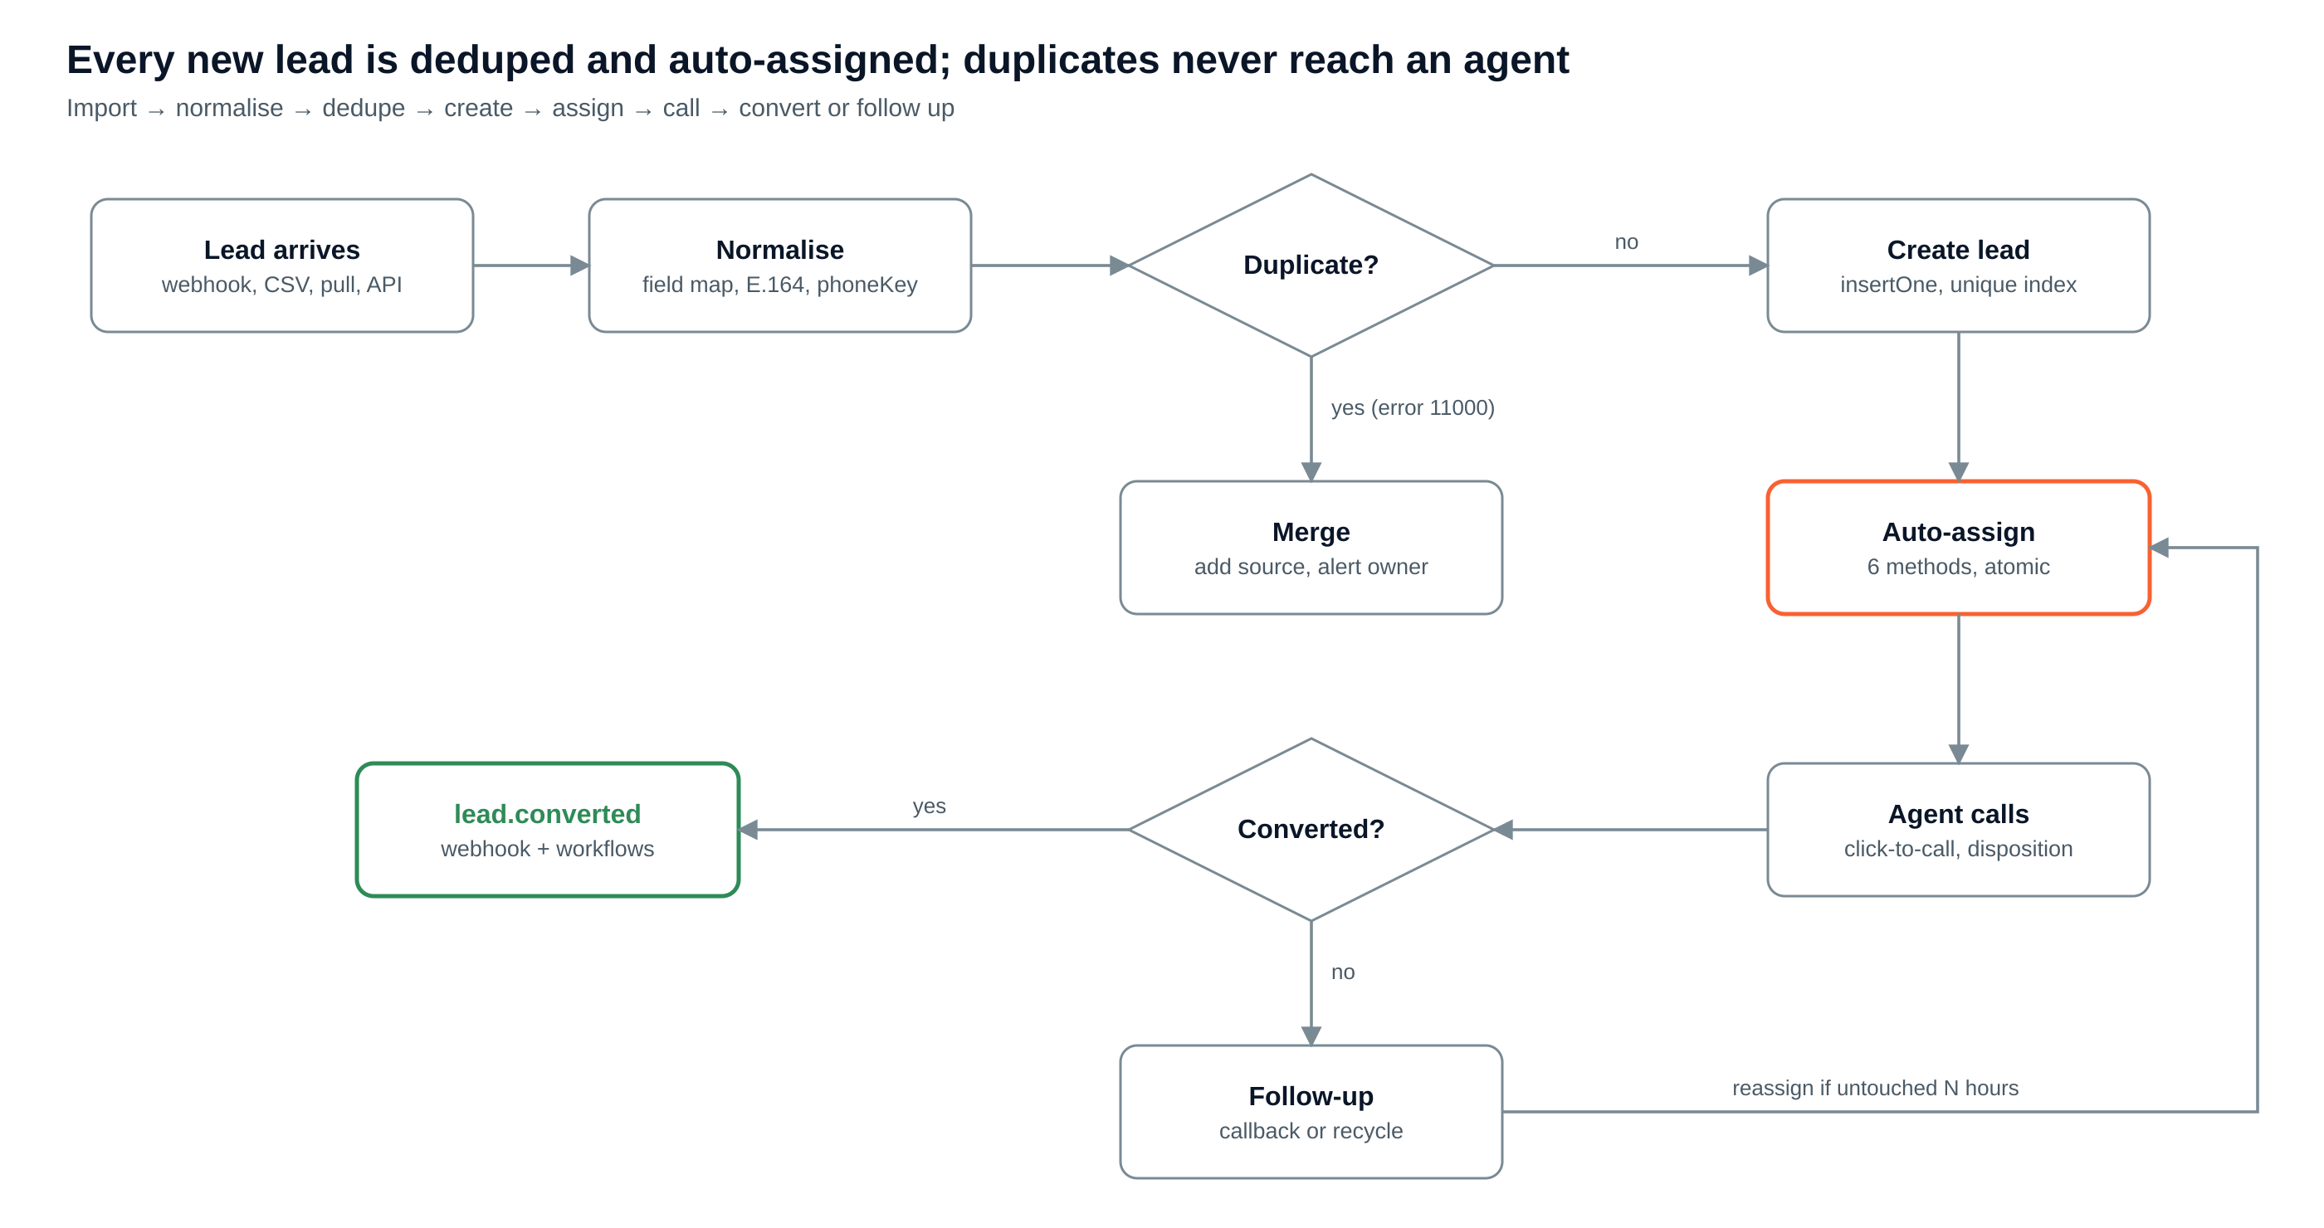
Figure 4. Lead pipeline from import to conversion

10.1 Auto-import sources
Source | How it arrives | Notes
Website / landing-page forms | POST /api/hooks/{tenant}/{sourceId} with a source key | Field map per source, set in admin UI
Meta Lead Ads | Page leadgen webhook, then Graph API fetch of the lead by id | One Meta app for AM2PM; each client connects its page
Google Ads lead forms | Lead-form webhook with a shared key | Key stored hashed
IndiaMART, Justdial, other portals | Push webhook where offered, else 15-min cron pull with a saved cursor | Cursor avoids re-reading
CSV / Excel upload | File to Blob; batch job via QStash, 500 rows per message | Per-row report: inserted, duplicate, failed
Google Sheet (today’s Marketing_Leads) | 15-min cron pull of rows after the last synced row | Clients keep their sheet during migration
Public API | POST /api/v1/leads with a tenant API key | Returns lead id + assignee

10.2 Normalise
- Apply the source fieldMap; unmapped fields go to custom.
- Phone to E.164 plus a 10-digit phoneKey (crmv7 toTenDigits / isValidMobile10 rules).
- Reject rows with no valid phone and no email; log them in the batch report.
- Stamp source { kind, sourceId, campaign, adId } for source-performance reports.

10.3 Dedupe
- dedupeKey = processId + phoneKey by default; per process, admins can switch to email or any field (crmv7 "Duplicate Check Column").
- Unique partial index {tenantId, processId, dedupeKey} where isActive:true: two imports racing each other still create one lead; the loser gets error 11000 and becomes a merge.
- Merge appends the new source to lead_events, bumps lastEnquiryAt and alerts the owner ("re-enquired from Meta Ads").
- Re-enquiry window: after N days a closed lead is archived (isActive:false) and a repeat creates a fresh lead.
try {
await leads.insertOne({ tenantId, processId, contactId, dedupeKey, isActive: true, status: "open", ... }, { session });
await outbox.insertOne({ tenantId, eventType: "lead.created", entityId: lead._id, payload }, { session });
} catch (e) {
if (e.code !== 11000) throw e;
await mergeDuplicate(ctx, { processId, dedupeKey, source }); // lead_events + owner alert
}

11. Auto-assignment engine
A new lead gets an owner within seconds, without anyone pressing "Auto-Assign", and two workers can never give the same lead twice.
Eligibility filter (in order): user active → mapped to the process → isAvailable → inside working hours (tenant timezone) → openLeads < maxOpenLeads → under today’s quota (Number method) → tags match (Skill method).
Method | How it picks | Source
Equal | Next eligible agent in turn (seq pointer) | crmv7
Percentage / Ratio | Smooth weighted round-robin on shareWeight; interleaves A,B,A,C,A instead of crmv7’s contiguous blocks | crmv7, improved
Number | Fixed daily quota per agent, then skip | crmv7
Load-based | Fewest openLeads right now | MongoDB doc
Skill / language / city | Only agents whose tags match the lead fields | MongoDB doc
Sticky owner | Returning contact goes to the previous owner if eligible | New

11.1 Smooth weighted round-robin
// weights: { A: 50, B: 30, C: 20 } -> sequence A B A C A B A ...
for (const u of eligible) state.smoothWeights[u] = (state.smoothWeights[u] || 0) + weight[u];
const pick = argmax(eligible, u => state.smoothWeights[u]);
state.smoothWeights[pick] -= sum(eligible.map(u => weight[u]));

11.2 Atomic pick in MongoDB
- Read eligible agents (cached 30 s in Redis per process).
- Compute the choice from assignment_state (weights, today’s counts).
- In one transaction: findOneAndUpdate the chosen user with filter {_id, openLeads: {$lt: maxOpenLeads}} and $inc {openLeads: 1}; update assignment_state with a version check; set leads.assignedTo only if still unassigned; insert lead_events and an outbox row for lead.assigned.
- If the agent filled up meanwhile (no match) or the version changed, retry with the next agent, up to 3 times.

11.3 Edge cases
- No eligible agent: the lead waits unassigned; the 5-minute sweeper retries (e.g. night leads are assigned when the shift starts). After the process SLA (e.g. 15 min in working hours) the supervisor is alerted.
- Recycle: an open lead untouched for N hours (per process) is reassigned and logged.
- Agent leaves: their open leads return to the pool in one admin action.
- openLeads decrements on won, lost, DNC or reassignment; a nightly job recounts to correct drift.

12. Webhooks and events

12.1 Inbound (providers → CRM)
One endpoint per source: /api/hooks/{tenant}/{sourceId} for lead sources, /api/hooks/{tenant}/callerdesk for call events; likewise Interakt, Brevo, Resend.
- Verify the signature or shared secret; return 401 if it fails.
- insertOne into webhook_events with an idempotency key; duplicate-key error returns 200 and stops.
- Publish the event id to QStash and return 200. No business logic inline.
- The QStash consumer runs the handler: create lead, update call, attach recording, log missed call. crmv7’s CallerDesk caller-leg recovery (resolveCustomerPhone_) is ported as-is.
- 5 retries with backoff, then the dead-letter queue and an admin "Failed events" screen with Replay.

12.2 Outbound event catalogue
Event | Fires when | Typical receiver
lead.created | Any import or manual create | Slack, ad-platform offline conversions
lead.assigned | Auto or manual assignment | Agent WhatsApp/SMS alert
disposition.set | Agent saves a call outcome | Client dashboard, BI
lead.stage_changed | Stage moves (e.g. Warm → Hot) | Nurture email tool
lead.converted | Disposition category converted, or stage = process wonStage | Client ERP/billing, Meta/Google conversion API, invoice trigger
lead.lost | Negative or DNC disposition closes the lead | Retargeting audience removal
callback.missed | Callback due + 15 min with no call | Supervisor escalation
call.completed | CallerDesk call report received | QA / call-audit tool
backup.completed / backup.failed | Nightly or on-demand tenant backup finishes | Client IT, AM2PM ops alert
restore.completed | A restore job finishes (any mode) | Client admin, audit

12.3 Payload and signature
POST https://client.example.com/crm-hook
X-AM2PM-Signature: t=1790812345,v1=5f2c...e91
Content-Type: application/json

{
"id": "evt_6701c2...",
"type": "lead.converted",
"tenant": "flo-mattress",
"occurredAt": "2026-10-01T09:14:05Z",
"data": {
"leadId": "6700a0...", "process": "Flo Mattress - Sales",
"contact": { "name": "Rahul S", "phone": "+9198XXXX4321" },
"disposition": { "code": "SALE", "label": "Order placed" },
"agent": { "id": "64aa...", "name": "Rohit Kumar" },
"source": { "kind": "meta_ads", "campaign": "Diwali-26" },
"custom": { "mattress_size": "Queen", "budget": 25000 }
}
}
// Receiver verification (Node)
const [t, v1] = header.split(",").map(p => p.split("=")[1]);
if (Math.abs(Date.now() / 1000 - Number(t)) > 300) reject();
const expected = crypto.createHmac("sha256", secret).update(t + "." + rawBody).digest("hex");
if (!crypto.timingSafeEqual(Buffer.from(expected), Buffer.from(v1))) reject();

12.4 Delivery rules
- id is stable so receivers can dedupe.
- Outbox relay: the API publishes the outbox row right after commit; a 1-minute cron sweeps anything unpublished. No event is lost and none is sent for a rolled-back change.
- QStash retries at about 1 min, 5 min, 30 min, 2 h, 12 h; any 2xx = delivered; every attempt logged in webhook_deliveries.
- A subscription failing for 24 hours straight is auto-paused and the tenant admin is emailed.
- MongoDB change streams need a long-running listener, which Vercel functions are not; Atlas Triggers can be added later if near-instant fan-out is needed.

13. Key flows

13.1 Inbound call → lead → disposition → callback
# | From → To | Action
1 | CallerDesk → Webhook API | call.start (caller number, DID)
2 | Webhook API → MongoDB | insert webhook_events (idempotency key)
3 | Webhook API → QStash | publish processCallEvent; return 200 to CallerDesk
4 | Worker → MongoDB | find contact by phoneKeys or create; find or create lead (dedupeKey)
5 | Worker → MongoDB | insert interactions (type call, status ringing)
6 | Worker → Redis → Agent UI | screen-pop via SSE to the owner (sticky) or the queue
7 | CallerDesk → Webhook API → Worker | call_report: duration, recording URL; copy recording to Blob; store key
8 | Agent UI → API → MongoDB | set disposition Interested + callback +2 days (transaction with outbox)
9 | Outbox → QStash → Workflows | disposition.set: create callback, send WhatsApp template via Interakt

13.2 Conversion
# | Step
1 | Agent saves a disposition with category converted (or moves stage to wonStage).
2 | One transaction: leads.status = won, convertedAt = now, users.openLeads − 1, lead_events converted, outbox lead.converted.
3 | Relay publishes the outbox row to QStash; each matching subscription gets a signed POST.
4 | Workflows on lead.converted run (e.g. notify supervisor, send thank-you WhatsApp, create billing task).
5 | Nightly rollup counts the conversion in daily_stats for funnel, source and agent reports.

14. Agent workflow and background jobs
- Queue: callbacks due now, then fresh leads, then recycled ones. New leads appear via Server-Sent Events or a 5-second poll of a Redis counter.
- Click-to-call: the API calls CallerDesk with the agent’s DID (crmv7 handleClickToCall) and creates an interactions row.
- Disposition is required before the next call; its category drives callback, convert, DNC or close.
- Messaging: Interakt templates, Brevo campaigns, Resend email — blocked unless contacts.consent for that channel is true.
Job | Schedule (tenant TZ) | Replaces in crmv7 | What it does
Callback reminders | Every 5 min | processCallbackReminders (hourly) | Notify 15 min before due; mark missed; escalate after 30 min
Assignment sweeper | Every 5 min | runControlAutoAssign | Assign leads left unassigned
Outbox relay | Every 1 min | — | Publish any unpublished events
Stale-lead recycle | Hourly | rptStaleLeads | Reassign leads untouched for N hours
Scheduled imports | Every 15 min | syncMarketingToCalling | Pull Sheet / IndiaMART / Justdial
Daily rollup | 00:30 | Report builders | $merge into daily_stats
Manager digest | 09:00 | runNotifications | Hot leads, follow-ups due, disposition counts
Agent weekly report | Mon 08:00 | sendAllUserReports | Per-agent summary email
Retention | 02:00 | — | Cold-store old recordings; run erasure requests
Tenant backup | 01:30 | — | Encrypted per-client snapshot to R2 (section 17)
Backup prune + verify | Sun 03:00 | — | Expire old snapshots; restore-test one random tenant

15. Access control
Scope | Filter injected into queries
own | assignedTo = user._id (or agentId)
team | assignedTo ∈ users sharing a teamId (cached list)
process | processId ∈ user.processIds
tenant | tenantId = user.tenantId
global | Super Admin only; audit-logged

Legend: V view, C create, E edit, D delete, A approve, X export.
Module | Super Admin | Admin | Supervisor | Manager | Coordinator | Client | Agent
Tenants / config | VCEDAX | VCE | V | V | - | - | -
Users | VCEDAX | VCEDX | VE | VE | V | - | own
Leads | VCEDAX | VCEDX | VCEAX | VCEAX | VCE | V (process) | VE (own)
Interactions | VX | VX | VX | VX | V | V (masked) | VC (own)
Callbacks | VCEDX | VCEDX | VCEA | VCEA | VCE | - | VCE (own)
Import sources | VCED | VCED | V | V | - | - | -
Webhooks / workflows | VCEDX | VCED | VE | V | - | - | -
Reports | VX | VX | VX | VX | V | V (assigned) | own
Integrations | VCED | VCE | - | - | - | - | -
Backups | VCEDAX (restore any) | VCX + request restore | V | V | - | V + download (if allowed) | -
Audit logs | V | V | - | - | - | - | -

16. Security and compliance
- Transport and rest: TLS everywhere; Atlas encryption at rest; Atlas region Mumbai (ap-south-1).
- Network: Atlas access limited to Vercel egress, or Atlas private endpoint on M10+.
- DB users: app (read/write), reporting (read-only), audit (insert-only).
- Secrets: provider keys encrypted with AES-256-GCM using a key in Vercel env vars; never returned by the API (in crmv7 they sit in plain Config cells).
- Auth: Google sign-in + email OTP, optional TOTP 2FA, optional IP allowlist for agents, 12-hour sessions; sessions stored hashed with TTL.
- PII: phone masking by role; recordings only via short-lived signed URLs; every play and export written to audit_logs.
- Consent and DNC: consent per channel; bulk sends skip non-opted-in contacts; DNC blocks all outreach.
- DPDP Act (India): per-tenant retention, an erasure job that anonymises a contact and its interactions, a data-processing agreement per client.
- Edge: Vercel Firewall rate limits on /api/hooks/* (e.g. 300 requests/min per source) and on login.

16.1 Retention defaults (configurable per tenant)
Data | Hot | Archive / cold | Delete
Interactions | 12 months in Atlas | Atlas Online Archive or export to R2 (Parquet) | Per contract
Call recordings | 30 days standard storage | Infrequent-access tier | Per contract (30 days to 2 years)
Audit logs | 1 year | Export to R2 | 5+ years per policy
webhook_events | 60 days | None | TTL
workflow_runs, webhook_deliveries | 90 days | None | TTL

17. Backup and restore (per client)
Every client (tenant) gets its own encrypted nightly backup that its admin can see, download and ask to restore, without touching any other client. Atlas snapshots alone are not enough: they restore the whole cluster, which rolls back every client at once.
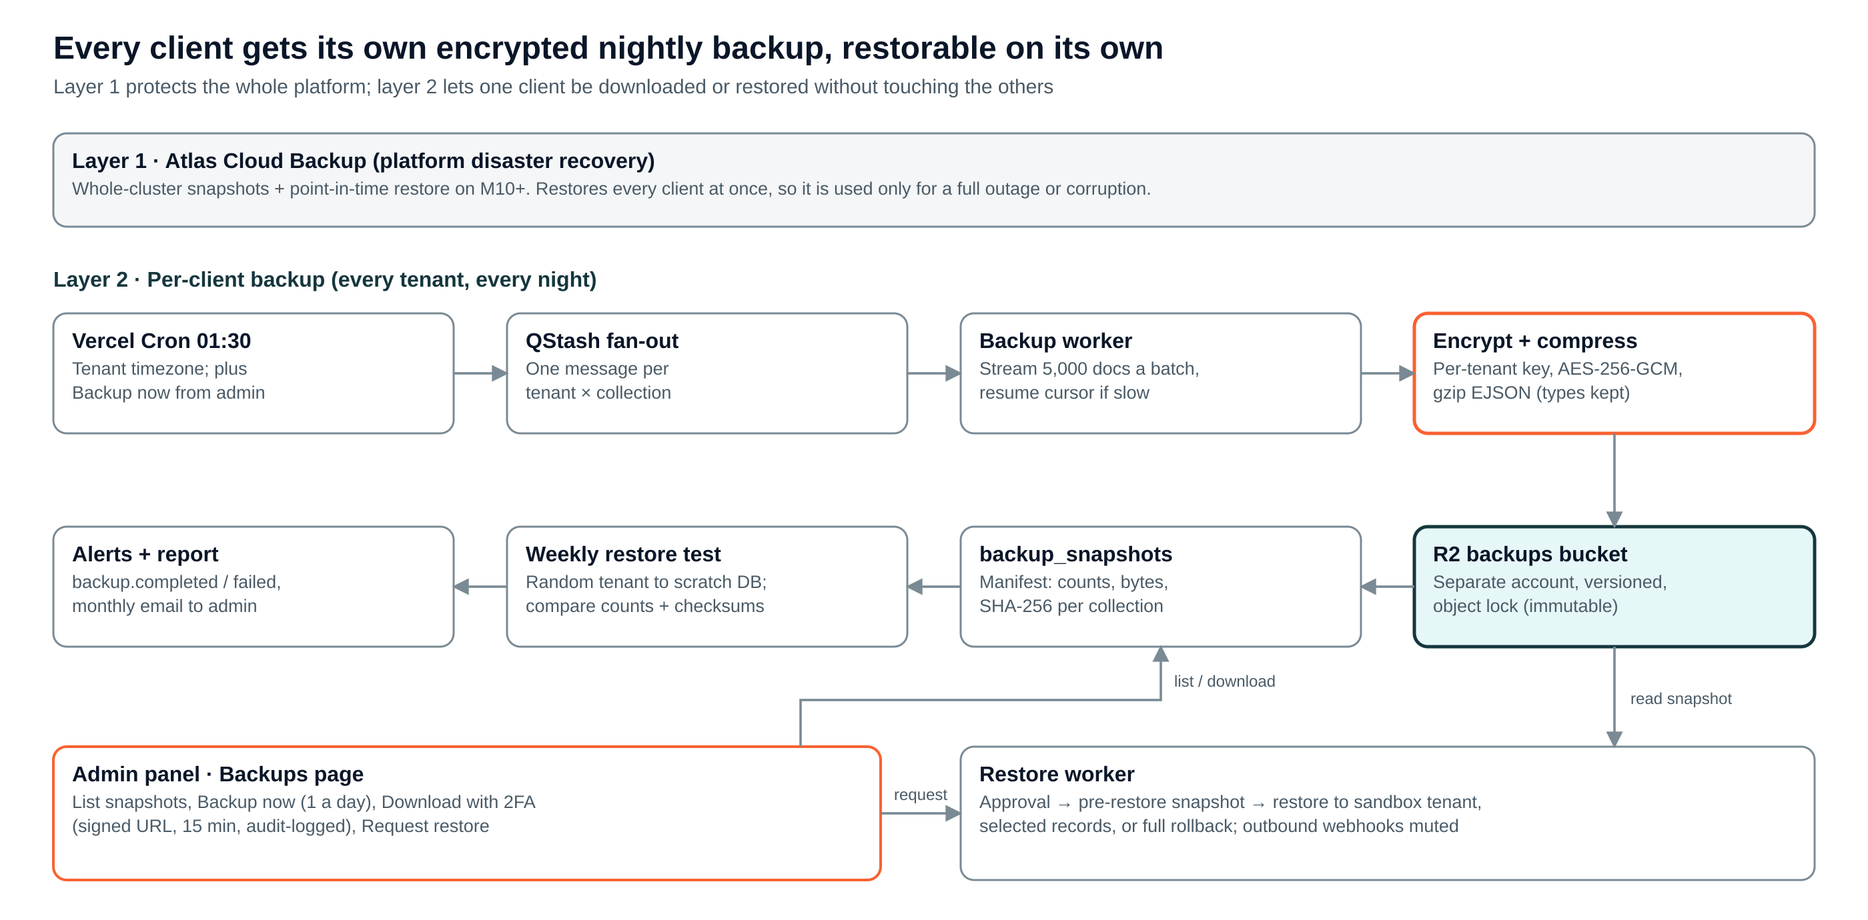
Figure 5. Two-layer backup: platform snapshots plus per-client backups

17.1 Two layers
Layer | What it protects | How | RPO / RTO target
1 · Platform (Atlas Cloud Backup) | Whole cluster: outage, corruption, bad migration | Flex: automatic snapshots. M10+: scheduled snapshots + continuous backup (point-in-time restore), snapshot copy to a second region | RPO minutes (PITR); RTO ~1–2 h for the cluster
2 · Per client (this design) | One client: accidental bulk delete, bad import, wrong reassignment, contract exit, client asks for their data | Nightly logical export of every tenant-scoped collection filtered by tenantId, encrypted, to R2 | RPO 24 h (6 h on premium plans); RTO < 1 h for a typical client

17.2 What each client backup contains
- All tenant-scoped collections: contacts, leads, lead_events, interactions, callbacks, dispositions, processes, users (password and 2FA secrets removed), import_sources (secrets removed), webhook_subscriptions (secrets removed), workflows, custom_field_definitions, daily_stats, audit_logs.
- Excluded: webhook_events (raw payloads, 60-day TTL), outbox, sessions, and integration credentials. Credentials are never exported; they are re-entered after a restore.
- Recordings: not copied again (already in R2). The backup holds a recordings manifest (key, size, SHA-256); the recordings bucket is versioned with a 30-day delete protection.
- Format: one gzip file per collection in MongoDB Extended JSON, so ObjectIds and dates keep their types; plus manifest.json with counts, bytes and SHA-256 per file.

17.3 How a backup runs on serverless
- Vercel Cron at 01:30 (tenant timezone) publishes one QStash message per tenant × collection; an admin can also press Backup now (max once a day).
- The worker streams documents in batches of 5,000 with a multipart upload to R2. If it nears the function time limit it saves the last _id in backup_snapshots and re-queues itself; the next message resumes from that cursor.
- Each file is gzip-compressed and encrypted with AES-256-GCM using a per-tenant data key; the data key is itself encrypted by a master key held in Vercel env vars (envelope encryption). Deleting a tenant’s key makes its old backups unreadable (crypto-erasure for DPDP).
- Storage path: backups/{tenantSlug}/{YYYY-MM-DD}/{collection}.ejson.gz.enc in a separate R2 account and bucket with versioning and object lock, so an app bug or leaked app key cannot delete backups.
- When all collections finish, the manifest is written, backup_snapshots.status = completed, and backup.completed is emitted (webhook + email). Any failure retries 3 times, then emits backup.failed and alerts AM2PM ops.
- Weekly full backup plus daily incrementals (documents with updatedAt after the last snapshot, and a tombstone list of deleted ids) keeps storage low for large clients.

17.4 Retention (configurable per client plan)
Plan | Daily | Weekly | Monthly | Extra
Standard | 7 | 4 | 3 | —
Premium | 14 | 8 | 12 | 6-hourly incrementals; copy to second region
Contract exit | — | — | — | Final full backup handed to the client, then deletion certificate after 30 days

17.5 Admin Backups page
Action | Who | Guard rails
View snapshots (date, type, size, record counts, status, verified) | Super Admin, client Admin, Manager | Tenant scope only
Backup now | Super Admin, client Admin | Max 1 a day per tenant; queued like the nightly job
Download full backup | Super Admin; client Admin if the contract allows | Fresh TOTP 2FA; signed URL valid 15 min; decrypted zip streamed; audit-logged; email to all admins
Export CSV (leads, contacts, interactions) | Client Admin, Manager | Excel-friendly; phone masking follows role
Request restore | Client Admin | Choose snapshot, mode and scope; reason required
Approve and run restore | Super Admin (AM2PM) | Two-person rule: requester and approver must differ

17.6 Restore modes
Mode | Use it when | What happens
Sandbox restore | Check old data before deciding | Snapshot loaded into a new read-only tenant (e.g. flo-mattress-restore-0930) that admins can browse; deleted after 7 days
Selective restore | Some leads or contacts were deleted or overwritten | Chosen collections or ids are upserted by _id; newer live documents are kept unless "overwrite" is ticked; lead_events records the restore
Full tenant rollback | A bad import or bulk update damaged a whole client | Pre-restore snapshot taken first; tenant set read-only; collections replaced from the snapshot; openLeads recounted; tenant reopened

- Every restore re-checks tenantId on every document and refuses a snapshot from another tenant.
- Outbound webhooks and workflows are muted during a restore, so clients are not flooded with old lead.created events; a single restore.completed event is sent at the end.
- restore_jobs keeps requester, approver, mode, scope, counts restored and the pre-restore snapshot id, so a restore can itself be undone.

17.7 New collections
Collection | Key fields | Indexes
backup_policies | tenantId, schedule, timezone, retention {daily, weekly, monthly}, allowClientDownload, dataKeyEnc, premium | {tenantId} unique
backup_snapshots | tenantId, type (full / incremental), baseSnapshotId, trigger (cron / manual / pre_restore / exit), status, cursor {collection, lastId}, collections {name: {count, bytes, sha256, key}}, sizeBytes, startedAt, finishedAt, verifiedAt, expiresAt | {tenantId, startedAt:-1}; {status, startedAt}; {expiresAt}
restore_jobs | tenantId, snapshotId, mode (sandbox / selective / full), scope {collections[], ids[]}, overwrite, reason, requestedBy, approvedBy, preRestoreSnapshotId, status, counts {} | {tenantId, createdAt:-1}; {status}

17.8 Verification
- Every file’s SHA-256 is checked against the manifest before download or restore.
- Every Sunday the prune job restores one random tenant’s latest snapshot into a scratch database, compares counts and checksums, then drops it; a mismatch pages AM2PM ops.
- Each client admin gets a monthly email: last successful backup, snapshots held, last verified date.
- Quarterly: AM2PM runs a full platform restore drill from Atlas into a staging cluster and records the time taken.

18. API surface
Method + path | Purpose | Auth
POST /api/hooks/{tenant}/{sourceId} | Lead source webhook | Source key / signature
POST /api/hooks/{tenant}/callerdesk | Call events, recordings | Shared secret
POST /api/hooks/{tenant}/interakt | brevo | resend | Message status events | Provider signature
POST /api/v1/leads | Create lead from client CRM or partner | Tenant API key
GET /api/v1/leads?stage=&assignedTo=&cursor= | List leads, cursor pagination | Session / API key
PATCH /api/v1/leads/{id} | Update stage, custom fields | Session
POST /api/v1/leads/{id}/disposition | Save call outcome (+ callback) | Session (agent)
POST /api/v1/leads/{id}/call | Click-to-call via CallerDesk | Session (agent)
POST /api/v1/imports | Upload CSV, returns batch id | Session (admin)
CRUD /api/v1/webhook-subscriptions | Manage outbound webhooks; test-send | Session (admin)
GET /api/v1/backups | List the tenant’s snapshots | Session (admin)
POST /api/v1/backups | Backup now (max 1 a day per tenant) | Session (admin)
POST /api/v1/backups/{id}/download | Signed URL, 15 min; needs fresh 2FA | Session (admin) + TOTP
POST /api/v1/restores | Request restore (mode, scope) | Session (admin)
POST /api/v1/restores/{id}/approve | Second approver starts the job | Session (super admin)
GET /api/v1/stream | Server-Sent Events: new leads, screen-pop | Session
POST /api/jobs/* | QStash consumers (verified by QStash signature) | QStash signing key
GET /api/cron/* | Vercel Cron entry points | CRON_SECRET

19. Indexing and performance rules
- Every query has a supporting compound index starting with tenantId; check with explain("executionStats"), target keysExamined ≈ docsReturned.
- Cursor pagination (_id or startedAt + _id), never skip/limit, for queues and timelines.
- Project only needed fields in list APIs; keep documents small.
- $match on tenantId first in every aggregation; heavy reports read daily_stats.
- One MongoClient per function instance, maxPoolSize 10, attachDatabasePool; never open a client per request.
- Schema validation ($jsonSchema, moderate) on core collections; schemaVersion field for migrations.

20. Build roadmap and migration
Run the new CRM beside the sheet for one process first; move each client only after 14 days of matching lead counts. The plan assumes 2 full-stack developers and 14 weeks.
Phase | Weeks | Scope | Gate
1 — Core | 1–6 | Tenants, users, roles, processes, contacts, leads, dispositions, callbacks; agent screen; CSV + web-form + Sheet import; dedupe; Equal/%/Ratio/Number assignment; CallerDesk click-to-call, webhook, recordings; manager digest; nightly per-client backup | One pilot process fully on the new CRM; counts match the sheet daily for 14 days
2 — Automation | 7–10 | Meta/Google Ads, IndiaMART, Justdial; load, skill, sticky assignment; hours and caps; recycle; outbound webhooks (lead.converted first); workflows; Interakt, Brevo, Resend | A signed lead.converted reaches a client system and is verified
3 — Reporting & portal | 11–14 | Rollups, dashboards, client portal with masked data, audit viewer; admin Backups page (download, restore); move Atlas to M10 with PITR | All clients off Sheets; Apps Script read-only
4 — Later | 15+ | LMS / training gate, attendance and shifts, reimbursements, invoicing, predictive dialer, AI call QA | —

Data migration per spreadsheet: a one-off script exports CRM_Calling, Marketing_Leads, CRM_WebhookLog and MissedCalls; maps Assigned To → assignedTo by roster name, Lead Disposition, Lead Stage, Remark, Callback Date-Time; splits Timeline History into lead_events; loads Config dropdowns as dispositions and stages; loads the roster with Share and DID; prints a count reconciliation per sheet.

21. Risks and open decisions
Risk | Impact | Mitigation
Missed tenantId filter leaks a client’s data | High | Single repository layer, lint rule, cross-tenant test on every route
Connection storms from many function instances | Medium | Cached MongoClient, maxPoolSize 10, attachDatabasePool, Fluid compute
Flex tier throttles above 500 ops/sec | Medium | Move to M10 before the first paying client
openLeads counter drift | Low | Nightly recount
QStash retries billed as extra messages | Low | Idempotent handlers; alert on DLQ growth
Vendor lock-in (Vercel/Upstash) | Low | Plain Next.js + HTTP queue; portable to any Node host

21.1 Open decisions
- MongoDB Atlas or Neon Postgres (~$35/month more at 200 agents for Mongo’s flexible custom fields).
- Agents and leads per day at launch and in 12 months (picks the Growth or Scale cost row).
- Which lead sources are live today.
- Which systems receive lead.converted, and what counts as converted per client: a disposition, a stage or a payment.
- CallerDesk only, or MyOperator / Exotel as fallback in v1.
- Recording retention per client contract.
- Backup retention and whether client admins may download full backups themselves.
- Build in-house or with a contractor.

