

**AXI XGS Deserializer core**

**User Guide**

|  |  |
| --- | --- |
| Authors | Gert Rijckbosch |
| Issue 1 | February 20 2019; Origination |

Contents

1 Disclaimer 3

2 Description 4

3 Main Blocks 5

3.1 Register interface 5

3.2 Deserializer 5

3.3 Gearbox 5

3.4 FIFO 6

4 Parameters 7

5 Port Description 8

6 Register map 9

6.1 Overview 9

6.2 Detailed register description 10

6.2.1 COMMAND: 0x0000 10

6.2.2 TRAINING: 0x0004 10

6.2.3 ENABLE_TRAINING: 0x0008 10

6.2.4 MANUAL_TAP: 0x000C 11

6.2.5 ENABLE: 0x0010 11

7 Programming Sequence 12

# Disclaimer

***********************************************************************************************

Copyright (c) 2019, ON Semiconductor Inc.

This intellectual property and/or documentation is provided by ON Semiconductor under limited terms and conditions.

The terms and conditions pertaining to the intellectual property and/or documentation are available at [www.onsemi.com](http://www.onsemi.com) ("ON Semiconductor Standard Terms and Conditions of Sale").

Do not use this intellectual property and/or documentation unless you have carefully read and you agree to the limited terms and conditions.

By using this intellectual property and/or documentation, you agree to the limited terms and conditions.

DEVELOPMENT PRODUCT(S), PROTOTYPE OR OTHER NON-PRODUCTION PRODUCT(S),SAMPLES OF PRODUCTION PRODUCT(S) SOFTWARE AND INTELLECTUAL PROPERTY ARE NOT WARRANTED AND ARE PROVIDED ON AN "AS IS" BASIS ONLY. IN NO EVENT SHALL ON SEMICONDUCTOR BE LIABLE FOR ANY SPECIAL, INCIDENTAL OR CONSEQUENTIAL DAMAGES ARISING FROM INFRINGEMENT OR ALLEGED INFRINGEMENT OF PATENTS, COPYRIGHTS, OR OTHER INTELLECTUAL PROPERTY RIGHTS.

THE INTELLECTUAL PROPERTY PROVIDED IS PROVIDED "AS IS".

ON SEMICONDUCTOR EXPRESSLY DISCLAIMS ALL WARRANTIES WITH RESPECT TO THE INTELLECTUAL PROPERTY PROVIDED, WHETHER EXPRESS OR IMPLIED, INCLUDING WITHOUT LIMITATION, WARRANTIES OF NONINFRINGMENT, MERCHANTABILITY AND FITNESS FOR A PARTICULAR PURPOSE, AND ANY WARRANTY OF CONTINUED OR UNINTERRUPTED OPERATION OF THE INTELLECTUAL PROPERTY PROVIDED HEREUNDER.

IN NO EVENT SHALL ON SEMICONDUCTOR BE LIABLE FOR SPECIAL, INCIDENTAL OR CONSEQUENTIAL DAMAGES OF ANY NATURE WHATSOEVER (INCLUDING, BUT NOT LIMITED TO, LOSS OF PROFITS, LOSS OF USE AND LOSS OF GOODWILL), REGARDLESS OF WHETHER ON SEMICONDUCTOR HAS BEEN GIVEN NOTICE OF ANY SUCH ALLEGED DAMAGES, AND REGARDLESS OF WHETHER SUCH ALLEGED DAMAGES ARE SOUGHT UNDER CONTRACT, TORT OR OTHER THEORIES OF LAW.

***********************************************************************************************

# Description

The axi_xgs_hispi_deser is an IP block that takes data of the xgs family HiSpi lanes and converts it into an AXI streaming interface. This streaming interface can be connected to a decoder block to obtain the raw data content.

The IP performs bit and word alignment for Xilinx FPGA’s.

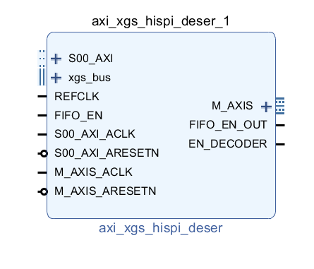

# Main Blocks

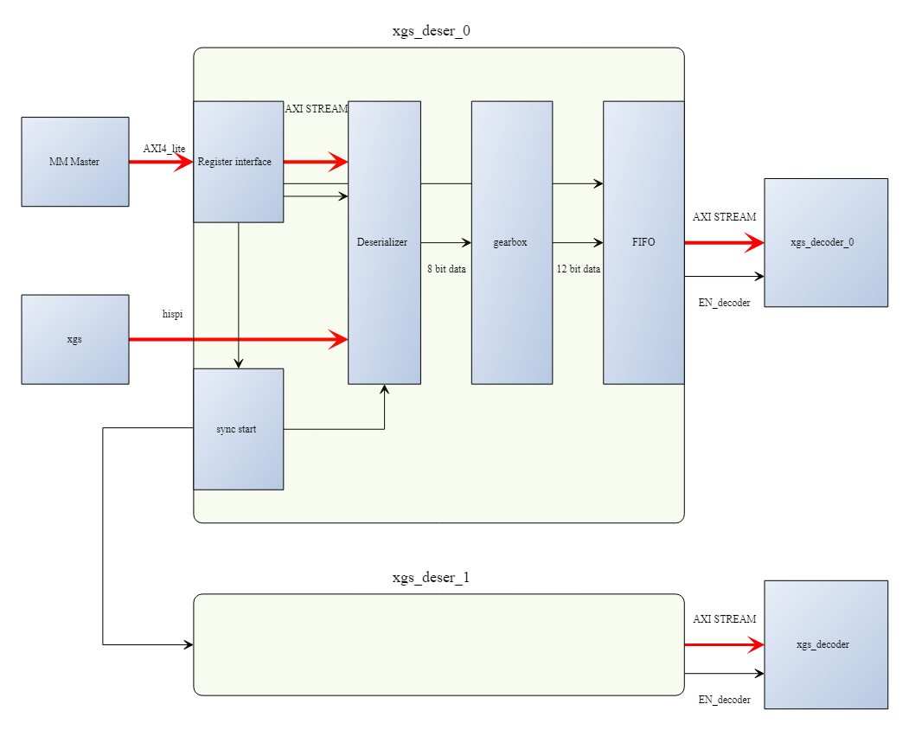

## Register interface

The register interface connects trough an AXI4_LITE interface to the XGS deserializer IP.

Specific registers and their function are described in the section register map.

## Deserializer

Converts the serial incoming data stream to a parallel word of the native width of the FPGA.

## Gearbox

Converts the words in the FPGA’s native width into the DUT’s parallel word size.

## FIFO

FIFO used to convert the data stream into an AXI stream protocol.

# Parameters

Following custom parameters control this block

|  |  |  |  |
| --- | --- | --- | --- |
| Parameter | Default value | Description | Editable |
| C_SIM | 0 | Use simulation model | N |
| C_NROF_DATACONN | 12 | Number of HiSpi data input channels | Y |
| C_INPUT_DATAWIDTH | 12 | Number of bits per pixel of incoming data | N |
| C_M_AXIS_TDATA_WIDTH | 12*12 | Master axi streaming bus data width | N |
| C_M_AXIS_TUSER_WIDTH | 1 | Master axi streaming number of Tuser bits | N |
| C_S00_AXI_DATA_WIDTH | 32 | Axi4 lite data width | N |
| C_S00_AXI_ADDR_WIDTH | 12 | Axi4 lite address width | N |
| C_SERDES_FAMILY | ULTRASCALE | FPGA family (only Xilinx Ultrascale supported) | N |
| C_REFCLK_F | 200 | Reference clock speed (MHz) | N |
| C_SERDES_DATAWIDTH | 8 | Depth of the FPGA device specific SERDES primitive | N |

# Port Description

Signals grouped as per clock domain.

|  |  |  |  |
| --- | --- | --- | --- |
| **Signal Name** | **Interface** | **Signal Type** | **Description** |
| **Clock Domain:** REF_CLOCK | | | |
| REFCLK | clock | input | Reference clock for serdes delay taps |
| **Clock Domain:** XGS_CLOCK | | | |
| DATA_P | xgs_bus | input | HiSpi differential data_p input channels from the xgs device |
| DATA_N | xgs_bus | input | HiSpi differential data_n input channels from the xgs device |
| D_CLK_P | xgs_bus | clock | HiSpi differential clock_p input channels from the xgs device |
| D_CLK_N | xgs_bus | clock | HiSpi differential clock_n input channels from the xgs device |
| **Clock Domain:** AXI_MM_CLOCK | | | |
| S00_AXI_ACLK | clock | input | Axi clock |
| S00_AXI_ARESETN | reset | input | Active low reset |
| S00_AXI | AXI LITE | Slave | Axi MM bus interface with 32-bit register interface and 16 registers. |
| FIFO_EN | synchro | input | synchronization signal input in order to start multiple axi_xgs_hispi_deser IP blocks at the same time |
| FIFO_EN_OUT | synchro | output | synchronization signal output in order to start multiple axi_xgs_hispi_deser IP blocks at the same time |
| EN_DECODER | synchro | output | synchronization signal output in order to start multiple decoder blocks at the same time (legacy) |
| **Clock Domain:** AXI_STREAM_CLK | | | |
| M_AXIS_ACLK | clock | input | Axi Master ST clock |
| M_AXIS_ARESETN | reset | input | Active low reset |
| M_AXIS | AXI STREAM | Source | Axi Master ST bus interface |

# Register map

## Overview

The following registers are accessible through the AXI4 Lite Slave (S00_AXI) interface.

|  |  |  |  |
| --- | --- | --- | --- |
| **Address Offset** | **Register Name** | **R/W** | **Description** |
| 0x0000 | COMMAND | RW | Every bit can be used to send a command, the busy can be polled on the same bit |
| 0x0004 | TRAINING | W | Lowest bits represent the training/ idle word needed to do word alignment must be set to the same value as the DUT’s idle (blanking) word |
| 0x0008 | ENABLE_TRAINING | W | One hot encoding to enable training per attached channel. Set to one for every active channel. |
| 0x000C | MANUAL_TAP | W | Setting to change the delay tap on the data in order to get good bit to clock alignment |
| 0x0010 | ENABLE | W | Register used to enable and reset FIFO and DECODER  See detailed descripting for more details |
| 0x0014 | SERDES_CLK_STATUS | R | STATUS of the serdes clocks |
| 0x0018 | SERDES_WORD_ALIGN | R | STATUS of the word alignment |
| 0x001C | RFU |  |  |
| 0x0020 | SERDES_SLIP_COUNT_0 | R |  |
| 0x0024 | SERDES_SLIP_COUNT_1 | R |  |
| 0x0028 | SERDES_SLIP_COUNT_2 | R |  |
| 0x002C | SERDES_SHIFT_STATUS_0 | R | 6 bit per HiSpi lane: |
| 0x0030 | SERDES_SHIFT_STATUS_1 | R |  |
| 0x0034 | SERDES_SHIFT_STATUS_2 | R |  |
| 0x0038 | SERDES_ERROR | R | Serdes error flag |
| 0x003C | RFU |  |  |

## Detailed register description

### COMMAND: 0x0000

|  |  |  |
| --- | --- | --- |
| **Bit Offset** | **Field Name** | **Description** |
| [31:1] | RESERVED | Not used |
| 0 | (W) START_TRAINING  (R) BUSY_TRAINING | Bit used to start the training algorithm and read back if the training is finished.  Once training is finished the software should check if all succeeded ( see other registers) |

### TRAINING: 0x0004

|  |  |  |
| --- | --- | --- |
| **Bit Offset** | **Field Name** | **Description** |
| [31:12] | RESERVED | Not used |
| [11:0] | TRAINING_WORD | Configuration of serdes training word |

### ENABLE_TRAINING: 0x0008

|  |  |  |
| --- | --- | --- |
| **Bit Offset** | **Field Name** | **Description** |
| [31:12] | RESERVED | Not used |
| [11:0] | ENABLE_TRAINING | Set to one for every active HiSpi channel. |

### MANUAL_TAP: 0x000C

|  |  |  |
| --- | --- | --- |
| **Bit Offset** | **Field Name** | **Description** |
| [31:16] | RESERVED | Not used |
| [15:0] | MANUAL_TAP | Delay tap setting for serdes, range 0 to 1023. |

### ENABLE: 0x0010

|  |  |  |
| --- | --- | --- |
| **Bit Offset** | **Field Name** | **Description** |
| [31:2] | RESERVED | Not used |
| 3 | FILTER_MODE | If set to 1, enable serdes filter mode |
| 2 | EN_DECODER | Attached to en_decoder output pin (not used anymore) |
| 1 | FIFO_RESET | If set to 1, the axi stream fifo is in reset. |
| 0 | FIFO_EN | If set to 1, the axi stream fifo gets filled. |

# Programming Sequence

* Enable FIFO reset ENABLE(0x10) bit 1 set to 1
* Disable FIFO reset ENABLE(0x10) bit 1 set to 0
* Set MANUAL_TAP(0xC) to a desired value, default 0x0000
* Enable the used channels in the ENABLE_TRAINING(0x08) default 0xFFF (12 channels enabled)
* Configure registers to enable word alignment: set TRAINING(0x04) to the same value as the idle word of the DUT.
* Configure the DUT to send out idle words
* Start the word alignment. Set bit 0 of the COMMAND register to 1. Poll bit 0 of the COMMAND register until it’s 0.
* ENABLE FIFO_EN and EN_DECODER by putting ENABLE(0x10) to 0x05
* Configure the DUT to capture images.