MATROX Image Processing Group

FDK DMA Write Transfer Unit (DMAWR)
(FID:0xC011)

Hardware
Specification

Document #: 513-DEIP-C011-0.0.4

PRELIMINARY

Matrox Confidential information. Do not circulate outside Matrox without the prior consent of the Matrox Engineering department. Advance Information. Contains information on product in the design phase of development.

24/11/2005

Table of contents

1- Features 5
2- DMAWR overview 5
2.1- Stream Input port (Avalon Slave Port) 5
2.2- Memory Interface 7
2.3- DMA address generator 7
2.4- Register File (Avalon Slave Port) 8
3- Streaming addressing 8
4- Memory registers 10
Stream to DMA write module 11
APPENDIX B: RELATED DOCUMENTS 30

Table of figures

Stream Packing Format 6
Stream to DMA Write registers table 10

Revision history

11/24/2005  0.0.1 | - Initial revision
0.0.2
0.0.3 | - Update document’s title to “FDK DMA Write Transfer Unit”  - Updated feature list  - Describe the supported packing format in a stream on page 6  - Updated the memory interface section on page 8  - DSTFSTARTresized to 32 bits  - DSTLNPITCH resized to 20 bits  - DSTLNSIZE resized to 20 bits  - Added DSTFSTART1, DSTFSTART2, DSTFSTART3, DSTCTRL registers  - FVERSION updated to 2.1.0
0.0.4 | - DSTLNPITCH resized to 21 bits

Features
- Optional Transfer unit IP core.
- 128/256/512-bit data path Avalon Master Write Memory port.
- Support of Stratix, Stratix II, Stratix III, Stratix IV technology
- Byte Alignment DMA write resolution.
- Bloc transfer type on image resolution
- 64-bit data path Avalon Slave Stream Input port (up to 100 MHz).
- 32-bit data path Avalon Slave Register File Port (up to 100 MHz).

DMAWR overview
The “DMA Write” transfer unit or DMAWR is used to convert “Stream transactions” into “Direct Memory Addressing” transactions. A destination address, horizontal and vertical parameters are used in order to write the Stream transactions properly into the defined memory locations. This unit can be used when a Stream buffer needs to be written in either the SDRAM memory or the SRAM memory. This unit can be instantiated in several copies into the Processing Interface FPGA, in order to achieve concurrent Stream transactions in the device

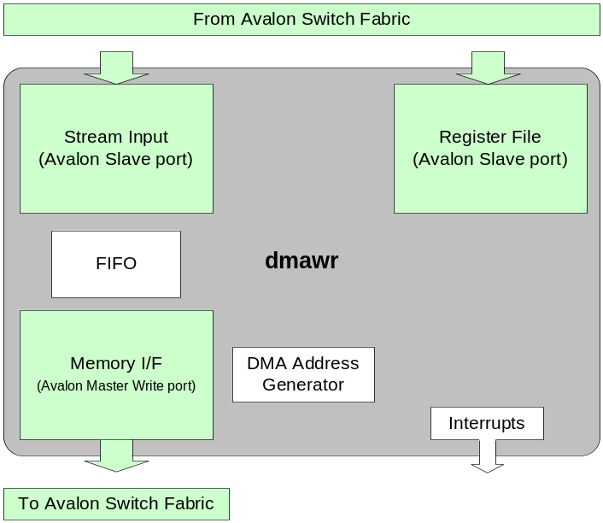

Stream Input port (Avalon Slave Port)
The Stream Input Port of is a 64-bit data path Avalon Slave Port that support Stream Transactions. The input data flow is control by synchronization op-codes encoded in the input address. For more information on stream transfer please refer to section 3-Streaming addressing.

In the case of the DMAWR flavors that support four contexts, data is packed according to the following table in the input stream:

Stream Packing Format
Bit depth | Number of contexts | Packing format
8 bits buffers  (BITWDTH = 0b) | 1 Context  (NBCONTX = 00b) | 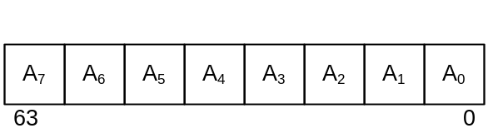
8 bits buffers  (BITWDTH = 0b) | 2 Contexts  (NBCONTX = 01b) | 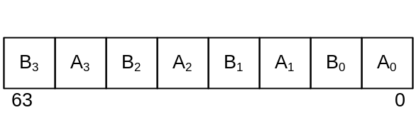
8 bits buffers  (BITWDTH = 0b) | 3 Contexts  (NBCONTX = 10b) | 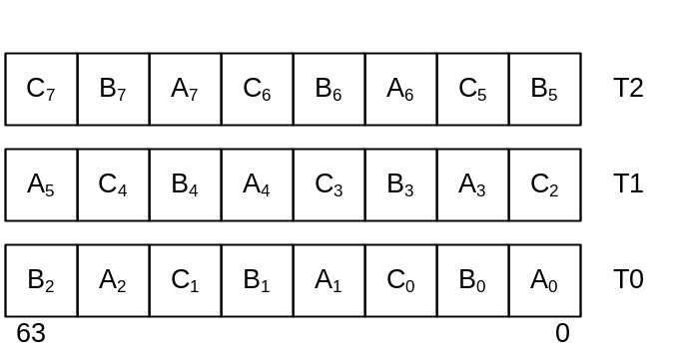
8 bits buffers  (BITWDTH = 0b) | 4 Contexts  (NBCONTX = 11b) | 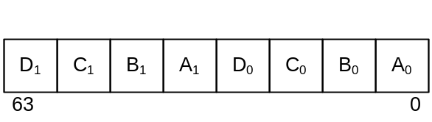
16 bits buffers  (BITWDTH = 1b) | 1 Context  (NBCONTX = 00b) | 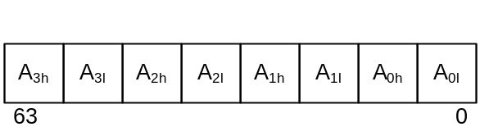
16 bits buffers  (BITWDTH = 1b) | 2 Contexts  (NBCONTX = 01b) | 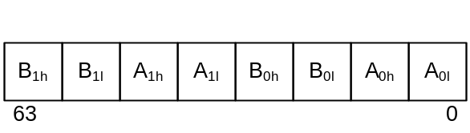
16 bits buffers  (BITWDTH = 1b) | 3 Contexts  (NBCONTX = 10b) | 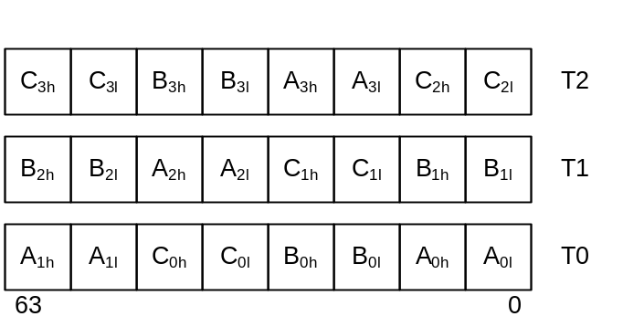
16 bits buffers  (BITWDTH = 1b) | 4 Contexts  (NBCONTX = 11b) | 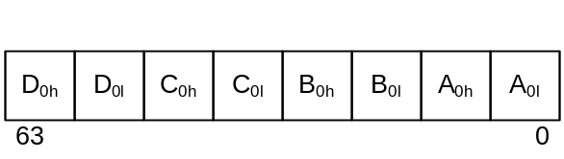

In SOPC builder this port should only be connected to Stream Input type ports.

Memory Interface
Depending on the sub function ID, the DMAWR transfer unit can implement 1 to 4 memory interface port. Each the memory interface implement an Avalon MM Write Master interface protocol.

Transfer unit name | subFID | Number  of mem. I/F | Data bus  width | Interface
dmawr_sub0 | 0x0000 | 1 | 128 | SDRAM
dmawr _sub1 | 0x0001 | 2 | 32 | QDR2-SRAM
dmawr _sub2 | 0x0002 | 4 | 32 | QDR2-SRAM
dmawr _sub3 | 0x0003 | 1 | 256 | SDRAM
dmawr _sub4 | 0x0004 | 1 | 512 | SDRAM
dmawr _sub5 | 0x0005 | 1 | 512 | SDRAM (4 contexts)

DMA address generator
The “Direct Memory Addressing” portion of this unit calculates all address required to transfer a full image buffer. It uses typical image buffer parameters to write data in memory. These parameters are:
- Frame start address
- Line Pitch (Byte)

In opposition of the DMA Read Module, the DMA Write section does not need the line size and the number of line fields. The Address and line counters are incremented and reset under the control of the stream input sync.

Register File (Avalon Slave Port)
The Register File port is 32 bits wide Avalon slave port. This port support read write transactions. It is used to program the register file of the DMAWR core instantiate in an Avalon system. In SOPC builder this port should only connect to the Register File type port.

Streaming addressing
Most of the time, the data that a processing unit has to compute is an image, or any kind of buffer that can be represented by a fixed amount of lines and a fixed amount of bytes for each line. The streaming addressing is a way of transferring such a data buffer using a simplified addressing. The data is sent to the appropriate target using markers that indicate the beginning of a frame, the end of each line, and the end of the frame. Contrarily to “Direct Memory Addressing” that requires an address for each data, the “Streaming Addressing” just requires indications when a new “boundary” is reached.

Synchronization markers table

Marker | Signification
00 | Start Of Frame (indicates the beginning of a frame)
01 | End Of Line (indicates the end of the previous line)
10 | Continue (continuation of previous data)
11 | End Of Frame (indicates the end of a frame)

The streaming addressing is device specific and is used only for internal transfers into the Processing Interface FPGA.

A slave port that supports streaming addressing uses address bits (13:12) as markers to identify the data that follow.

Address bits (11:0) are meaningless and are ignored by the target.

Some of the upper address bits (31:14) are used by the switch fabric to decode a stream transaction and to forward it toward the addressed target.

Most of the time, address bits (31:14) are meaningless for a target. But some of these bits could be used for decoding purposes, if this unit is designed to support the reception of several distinct streams.

A stream transaction cannot involve any of the Processing Interface FPGA external interfaces. It means that data that need to be sent to an external interface using the streaming addressing requires the use of a specific transfer unit that is specifically designed to receive a stream transaction that will be converted into “Direct Memory Addressing” transactions involving the related interface.

Note that the “High-Speed Serial Interface” and the “PCI-X to Avalon” units implements engines that allows the handling of “Stream transactions”.

* For more details on “Stream Transactions”, please refer to the Odyssey OASIS specification.

Memory registers

Stream to DMA Write registers table
Section | Register Name | Address offset | Page
HEADER | FSTRUC | 0x0 | 12
HEADER | FID | 0x8 | 13
HEADER | FSIZE | 0x10 | 14
HEADER | FCTRL | 0x18 | 15
HEADER | FOFFSET | 0x20 | 17
HEADER | FINT | 0x28 | 18
HEADER | FVERSION | 0x30 | 19
HEADER | FRSVD3 | 0x38 | 21
DMA Write | DSTFSTART | 0x40 | 22
DMA Write | DSTLNPITCH | 0x48 | 23
DMA Write | DSTLNSIZE | 0x50 | 24
DMA Write | DSTNBLINE | 0x58 | 25
DMA Write | DSTFSTART1 | 0x60 | 26
DMA Write | DSTFSTART2 | 0x68 | 27
DMA Write | DSTFSTART3 | 0x70 | 28
DMA Write | DSTCTRL | 0x78 | 29

Stream to DMA write module

FSTRUC | Function STRUCture

Address: | DMAWR Base Address +0x0
Attribute: | Read only, Static

31 30 29 28 27 26 25 24
TAG(31:24)
23 22 21 20 19 18 17 16
TAG(23:16)
15 14 13 12 11 10 9 8
TAG(15:8)
7 6 5 4 3 2 1 0
MJVER(3:0) | MNVER(3:0)

TAG | structure valid TAG
RO (23:0)  (Static) | This field is a tag identifying the beginning of a register section associated with every IP block.
Values: | 0x4D5458 (“byte” read as “XTM”)

MJVER | Standard header structure MaJor VERsion
RO (3:0)  (Static) | This field reflects any major changes in the register structure associated with the standard 32 byte function header. Zero value is reserved for field overflow.  (Not software backward compatible)
Reset:
Values: | Any 4 bits value.  Current Major revision: 0x1

MNVER | Standard header structure MiNor VERsion
RO (3:0)  (Static) | This field reflects any minor changes in the register structure associated with the standard 32 bytes function header. (Software backward compatible)
Values: | Any 4 bits value.  Current Minor revision: 0x4

FID | Function IDentification

Address: | DMAWR Base Address + 0x8
Attribute: | Read only, Static

31 30 29 28 27 26 25 24
FID(15:8)
23 22 21 20 19 18 17 16
FID(7:0)
15 14 13 12 11 10 9 8
CAPABILITY(15:8)
7 6 5 4 3 2 1 0
CAPABILITY(7:0)

FID | Function IDentification
RO (15:0)  (Static) | This field indicates the IP’s unique ID
Values: | 0XC010  (See FID distribution in document puiddistribution.doc.)

CAPABILITY | CAPABILITY list
RO (15:0)  (Static) | This 16 bit value reflects the functionality and features that can be present or not depending on the configuration chosen for the function IP block.
Values: | 0x0000 | No specific capability field

FSIZE | Function register SIZE

Address: | DMAWR Base Address + 0x10
Attribute: | Read only, Static

31 30 29 28 27 26 25 24
FULLSIZE(15:8)
23 22 21 20 19 18 17 16
FULLSIZE(7:0)
15 14 13 12 11 10 9 8
USERSIZE(15:8)
7 6 5 4 3 2 1 0
USERSIZE(7:0)

FULLSIZE | FULL register SIZE
RO (15:0)  (Static) | This field indicates the amount of QWORD ( = 8bytes = int64 = long long) that is mapped on the register address space by the entire register structure associated with this function. Maximum size is 256MB. Granularity of 512 bytes.
Values: | 0x200 | 4KByte of memory space reserved (to big…!!!)

USERSIZE | User SPECific register SIZE
RO (15:0)  (Static) | This field indicates the amount of QWORD ( = 8bytes = int64 = long long) that is mapped on the register address space by the user specific register section (“user” registers) that is associated with the control and functionality of the IP block.
Values: | 0x0004.

FCTRL | Function ConTRoL

Address: | DMAWR Base Address + 0x18
Attribute: | Read/Write, Static

31 30 29 28 27 26 25 24
Reserved | SNPPDG | ACTIVE | Reserved | SNPSHT | ABORT
23 22 21 20 19 18 17 16
IPFERR(7:0)
15 14 13 12 11 10 9 8
Reserved(15:8)
7 6 5 4 3 2 1 0
Reserved(7:0)

SNPPDG | SNapSHot PenDinG
RO | This field is asserted whenever the SNPSHT bit is being set if the ABORT signal is not asserted. This bit stays asserted to a logic 1 until the arrival of the event to which the snapshot was referring to (usually a stream start-of-frame event).
Values: | 0b0 | Do nothing
 | 0b1 | A snapshot command is pending

ACTIVE | ACTIVE
RO | This field indicates that a transfer is currently active. This means the PU is currently processing data. Note that on the occurrence of an ABORT event, this bit must stay active until the PU has reached an idle state.
Values: | 0b0 | Do nothing
 | 0b1 | A transfer is active

SNPSHT | SNaPSHoT
WO | This bit field sets the processing unit in a state in which it can process a forthcoming stream, usually a frame. This bit sets the snapshot pending signal allowing acceptation of the next input stream of data. Writing zero has no effect. Should be read as zero.
Values: | 0b0 | Do nothing
 | 0b1 | Snapshot

ABORT | ABORT process
RW | Asynchronously or synchronously resets all the logic related to a pending or active transaction.
Values: | 0b0 | Do nothing
 | 0b1 | Reset logic.

IPFERR(7:0) | IP Function ERRor
RO (7:0) | This bit field is used to report error code. Specific error codes have not been defined yet.
Values: | 0b0000 | Do nothing

FOFFSET | Function OFFSET

Address: | DMAWR Base Address + 0x20
Attribute: | Read only, Static

31 30 29 28 27 26 25 24
IOCTLOFF(15:8)
23 22 21 20 19 18 17 16
IOCTLOFF(7:0)
15 14 13 12 11 10 9 8
USEROFF (15:8)
7 6 5 4 3 2 1 0
USEROFF(7:0)

IOCTLOFF | IO ConTroL register OFFset
RO(15:0)  (Static) | This field indicates the distance in QWORD (( = 8bytes = int64 = long long) from the function header base address to the beginning of the [stream] IO control register section. If no I/O section is declared in the HDF the value of this field is 0x0..
Values: | 0x0040.

USEROFF | SPECific register offset
RO(15:0)  (Static) | This field indicates distance in QWORD (( = 8bytes = int64 = long long) from the function header base address to the beginning of the user specific register section. If no specific register section is defined the value of this field is 0x0.
Values: | 0x0060

FINT | Function Interrupt

Address: | DMAWR Base Address + 0x28
Attribute: | Read only, Static

31 30 29 28 27 26 25 24
Reserved (31:24)
23 22 21 20 19 18 17 16
Reserved (23:16)
15 14 13 12 11 10 9 8
Reserved | LSBOF (6:0)
7 6 5 4 3 2 1 0
Reserved | IPEVENT (2:0)

LSBOF | LSB OFFSET
RO(6:0) | This field indicates the position mapping of the first interrupt event in the interrupt forwarding vector.
Values | 0x1 to 0x7D | LSB Offset assigned by the top level generator.
 | 0x7E | Reserved
 | 0x7F | Interrupt not mapped.

IPEVENT | IP (number of) EVENT
RO(2:0)  (Static) | This field indicates the amount of distinct event(s) (start-of-frame, end-of-frame, etc…) this IP would reported to the interrupt manager module.
Values | 0x1 | One Interrupt implemented

FVERSION | Function VERSION

Address: | DMAWR Base Address + 0x30
Attribute: | Read only, Static

31 30 29 28 27 26 25 24
Reserved(31:24)
23 22 21 20 19 18 17 16
SUBFID (23:16)
15 14 13 12 11 10 9 8
IPMJVER(3:0) | IPMNVER(3:0)
7 6 5 4 3 2 1 0
IPHWVER(4:0) | Reserved

SUBFID | SUB Function ID
RO(7:0)
(Static)
Value | 0x00 | DMA write (1 x 128-bit SDRAM bank)
Value | 0x01 | DMA write (2 x 32-bit SRAM banks)
Value | 0x02 | DMA write (4 x 32-bit SRAM banks)
Value | 0x03 | DMA write (1 x 256-bit SDRAM bank)
Value | 0x04 | DMA write (1 x 512-bit SDRAM bank)
Value | 0x05 | DMA write 4 contexts (1 x 512-bit SDRAM bank)
Value | 0x06 to 0xFF | Reserved

IPMJVER | IP register structure MaJor VERsion
RO(3:0)  (Static) | This field reflects any major changes in the register structure associated with the IP’s specific registers. Zero value is reserved for field overflow
Value | 0x2

IPMNVER | IP register structure MiNor VERsion
RO(3:0)  (Static) | This field reflects any minor changes in the register structure associated with the IP’s specific registers
Value | 0x1

IPHWVER | IP HardWare VERsion
RO(4:0)  (Static) | This field indicates the functional hardware revision associated with the current IP build. The hardware version is incremented for any new build that includes a functional change (bug fixes, performance issue, functionality, etc…). This field is reset to zero whenever the register structure minor or major field is incremented. Note that a “snapshot” of the RTL files used in the current build can be retrieved from the three fields IPMJVER.IPMNVER.IPHWVER.
Values: | 0x00

FRSVD3 | Function ReSerVed 3

Address: | DMAWR Base Address + 0x38
Attribute: | Read only, Static

31 30 29 28 27 26 25 24
FRSVD3(31:24)
23 22 21 20 19 18 17 16
FRSVD3(23:16)
15 14 13 12 11 10 9 8
FRSVD3(15:8)
7 6 5 4 3 2 1 0
FRSVD3(7:0)

FRSVD3 | Function Reserved 3
RO(31:0) | Function header reserved expansion register.
Values: | 0x00000000

DSTFSTART | DeSTination Frame START register

Address: | DMAWR Base Address + 0x40
Attribute: | Read/Write

31 30 29 28 27 26 25 24
FSTART(31:24)
23 22 21 20 19 18 17 16
FSTART(23:16)
15 14 13 12 11 10 9 8
FSTART(15:8)
7 6 5 4 3 2 1 0
FSTART(7:0)

FSTART  (31:0) | Frame START address
FSTART  (31:0) | This field indicates the byte position in memory where the received image will be written (first byte of the first image’s line). The frame start can map to everywhere in the 4GB range. This field is always available in every flavor of the DMARD TU
Attribute: | Read/Write
Reset: | 0x00000000
Value: | Any 32-bit value

DSTLNPITCH | DMAWR: DeSTination Line PITCH register

Address: | DMAWR Base Address + 0x48
Attribute: | Read/Write

31 30 29 28 27 26 25 24
Reserved
23 22 21 20 19 18 17 16
Reserved | LNPITCH(20:16)
15 14 13 12 11 10 9 8
LNPITCH(15:8)
7 6 5 4 3 2 1 0
LNPITCH(7:0) | *See definition below

LNPITCH(20:0) | LiNe PITCH
LNPITCH(20:0) | This field indicates the number of bytes between the beginning of a line and the beginning of the next line of an image to write to memory. Minimum resolutions are:
LNPITCH(20:0) | SubFid | Minimum Resolution  (Bytes) | *LSB values
LNPITCH(20:0) | 0x00 | 16 | LNPITCH(3:0) = 0b0000
LNPITCH(20:0) | 0x01 | 8 | LNPITCH(2:0) = 0b000
LNPITCH(20:0) | 0x02 | 16 | LNPITCH(3:0) = 0b0000
LNPITCH(20:0) | 0x03 | 32 | LNPITCH(4:0) = 0b00000
LNPITCH(20:0) | 0x04 | 64 | LNPITCH(5:0) = 0b000000
LNPITCH(20:0) | 0x05 | 64 | LNPITCH(5:0) = 0b000000
LNPITCH(20:0) | 0x06 | 16 | LNPITCH(3:0) = 0b0000
Attribute: | Read/Write
Reset: | 0x000000
Value: | Any 21-bit value
LPITCH  (20:0) RW | Line PITCH
LPITCH  (20:0) RW | This field indicates the number of bytes between the beginning of a line and the beginning of the next line of an image written in memory. This value has a one byte resolution”.
Attribute: | Read/Write
Reset: | 0x000000
Value: | Any 21-bit value

DSTLNSIZE | DMAWR: DeSTination LiNe SIZE register

Address: | DMAWR Base Address + 0x50
Attribute: | Read/Write

31 30 29 28 27 26 25 24
Reserved
23 22 21 20 19 18 17 16
Reserved
15 14 13 12 11 10 9 8
LNSIZE(15:8)
7 6 5 4 3 2 1 0
LNSIZE(7:0)

LNSIZE  (15:0) | LiNe SIZE
LNSIZE  (15:0) | This field indicates the number of bytes to transfer for each line of the image.
Attribute: | Read/Write
Reset: | 0x0000
Value: | Any 16-bit value. If set to 0, no transfer will occur (FCTRL.SNPSHT bit is ignored).

DSTNBLINE | DMAWR: DeSTination NumBer of LINE register

Address: | DMAWR Base Address + 0x58
Attribute: | Read/Write

31 30 29 28 27 26 25 24
Reserved
23 22 21 20 19 18 17 16
Reserved | NBLINE(19:16)
15 14 13 12 11 10 9 8
NBLINE(15:8)
7 6 5 4 3 2 1 0
NBLINE(7:0)

NBLINE  (19:0) | NumBer of LINEs
NBLINE  (19:0) | This field indicates the amount of line to transfer.
Attribute: | Read/Write
Reset: | 0x00000
Value: | Any 19-bit value. If set to 0, no transfer will occur (FCTRL.SNPSHT bit is ignored).

DSTFSTART1 | DeSTination Frame START register context 1

Address: | DMAWR Base Address + 0x60
Attribute: | Read/Write

31 30 29 28 27 26 25 24
FSTART(31:24)
23 22 21 20 19 18 17 16
FSTART(23:16)
15 14 13 12 11 10 9 8
FSTART(15:8)
7 6 5 4 3 2 1 0
FSTART(7:0)

FSTART  (31:0) | Frame START address of the context number 1
FSTART  (31:0) | This field indicates the byte position in memory where the received image will be written (first byte of the first image’s line). The frame start can map to everywhere in the 4GB range. This field is always available in every flavor of the DMARD TU
Attribute: | Read/Write
Reset: | 0x00000000
Value: | Any 32-bit value

DSTFSTART2 | DeSTination Frame START register context 2

Address: | DMAWR Base Address + 0x68
Attribute: | Read/Write

31 30 29 28 27 26 25 24
FSTART(31:24)
23 22 21 20 19 18 17 16
FSTART(23:16)
15 14 13 12 11 10 9 8
FSTART(15:8)
7 6 5 4 3 2 1 0
FSTART(7:0)

FSTART  (31:0) | Frame START address of the context number 2
FSTART  (31:0) | This field indicates the byte position in memory where the received image will be written (first byte of the first image’s line). The frame start can map to everywhere in the 4GB range. This field is always available in every flavor of the DMARD TU
Attribute: | Read/Write
Reset: | 0x00000000
Value: | Any 32-bit value

DSTFSTART3 | DeSTination Frame START register context 3

Address: | DMAWR Base Address + 0x70
Attribute: | Read/Write

31 30 29 28 27 26 25 24
FSTART(31:24)
23 22 21 20 19 18 17 16
FSTART(23:16)
15 14 13 12 11 10 9 8
FSTART(15:8)
7 6 5 4 3 2 1 0
FSTART(7:0)

FSTART  (31:0) | Frame START address of the context number 3
FSTART  (31:0) | This field indicates the byte position in memory where the received image will be written (first byte of the first image’s line). The frame start can map to everywhere in the 4GB range. This field is always available in every flavor of the DMARD TU
Attribute: | Read/Write
Reset: | 0x00000000
Value: | Any 32-bit value

DSTCTRL | DeSTination ConTRoL

Address: | DMAWR Base Address + 0x78
Attribute: | Read/Write

31 30 29 28 27 26 25 24
Reserved (31:24)
23 22 21 20 19 18 17 16
Reserved (23:16)
15 14 13 12 11 10 9 8
Reserved(15:8)
7 6 5 4 3 2 1 0
Reserved | DTE3 | DTE2 | DTE1 | DTE0 | BITWDTH | NBCONTX(1:0)

NBCONTX  (1:0) | NumBer of CONTeXt
NBCONTX  (1:0) | This field indicates the number of context to enable. A maximum of four contexts is supported. Unused contexts are disabled. This field is only available in DMAWR TU that support multi context.
Attribute: | Read/Write
Reset: | 00b
Value: | 00b | One context
Value: | 01b | Two contexts
Value: | 10b | Tree contexts
Value: | 11b | Four contexts

BITWDTH | BIT WiDTH
BITWDTH | This field indicates the bit width of each buffer to write..
Attribute: | Read/Write
Reset: | 0b
Value: | 0b | 8 bits per component
Value: | 1b | 16 bits per component

DTEx | Data Transfer Enable x
DTEx | This bit is used to enable the transfer of the component x during a multi context transfer.
Attribute: | Read/Write
Reset: | 1b
Value: | 0b | Component transfer disabled. The constant value 0x0 is sent instead of the pixel values for each pixel of the component x.
Value: | 1b | Component transfer is enabled.

APPENDIX B: RELATED DOCUMENTS

Matrox Imaging, Camera Link and Analog Interface Fpgas. Document 469-DEAS-001-0.70, April 9, 2004

PCI Special Interest Group, PCI-X Addendum to the PCI Local Bus Specification. Revision 1.0b, July 29, 2002

Altera, Avalon Interface Specification, MNL-AVABUSREF-3.1, Revision-3.1, April, 2005.

