

AXI test pattern generator

Documentation
Authors | Bert Dewil
Issue 1 | July 23 2019; Origination

Contents
1 Disclaimer 3
2 Description 4
3 RTL parameters/generics 5
4 Register map 6
4.1 Overview 6
4.2 EnableReg/BusyReadback – 0x0 7
4.2.1 Write 7
4.2.2 Read 7
4.3 Linelength – 0x4 7
4.4 NrofLines – 0x8 8
4.5 Xinc – 0xC 8
4.6 Yinc_Finc – 0x10 8
5 Operation 9

Disclaimer
***********************************************************************************************
Copyright (c) 2019, ON Semiconductor Inc.
This intellectual property and/or documentation is provided by ON Semiconductor under limited terms and conditions.
The terms and conditions pertaining to the intellectual property and/or documentation are available at www.onsemi.com ("ON Semiconductor Standard Terms and Conditions of Sale").
Do not use this intellectual property and/or documentation unless you have carefully read and you agree to the limited terms and conditions.
By using this intellectual property and/or documentation, you agree to the limited terms and conditions.

DEVELOPMENT PRODUCT(S), PROTOTYPE OR OTHER NON-PRODUCTION PRODUCT(S),SAMPLES OF PRODUCTION PRODUCT(S) SOFTWARE AND INTELLECTUAL PROPERTY ARE NOT WARRANTED AND ARE PROVIDED ON AN "AS IS" BASIS ONLY. IN NO EVENT SHALL ON SEMICONDUCTOR BE LIABLE FOR ANY SPECIAL, INCIDENTAL OR CONSEQUENTIAL DAMAGES ARISING FROM INFRINGEMENT OR ALLEGED INFRINGEMENT OF PATENTS, COPYRIGHTS, OR OTHER INTELLECTUAL PROPERTY RIGHTS.
THE INTELLECTUAL PROPERTY PROVIDED IS PROVIDED "AS IS".
ON SEMICONDUCTOR EXPRESSLY DISCLAIMS ALL WARRANTIES WITH RESPECT TO THE INTELLECTUAL PROPERTY PROVIDED, WHETHER EXPRESS OR IMPLIED, INCLUDING WITHOUT LIMITATION, WARRANTIES OF NONINFRINGMENT, MERCHANTABILITY AND FITNESS FOR A PARTICULAR PURPOSE, AND ANY WARRANTY OF CONTINUED OR UNINTERRUPTED OPERATION OF THE INTELLECTUAL PROPERTY PROVIDED HEREUNDER.
IN NO EVENT SHALL ON SEMICONDUCTOR BE LIABLE FOR SPECIAL, INCIDENTAL OR CONSEQUENTIAL DAMAGES OF ANY NATURE WHATSOEVER (INCLUDING, BUT NOT LIMITED TO, LOSS OF PROFITS, LOSS OF USE AND LOSS OF GOODWILL), REGARDLESS OF WHETHER ON SEMICONDUCTOR HAS BEEN GIVEN NOTICE OF ANY SUCH ALLEGED DAMAGES, AND REGARDLESS OF WHETHER SUCH ALLEGED DAMAGES ARE SOUGHT UNDER CONTRACT, TORT OR OTHER THEORIES OF LAW.
***********************************************************************************************

Description
This block generates test pattern images according to the streaming AXI video format. It can be used to debug image pipelines and sdram readout.
It is based on a legacy Fillfactory test pattern IP that had been in use since early 2000.
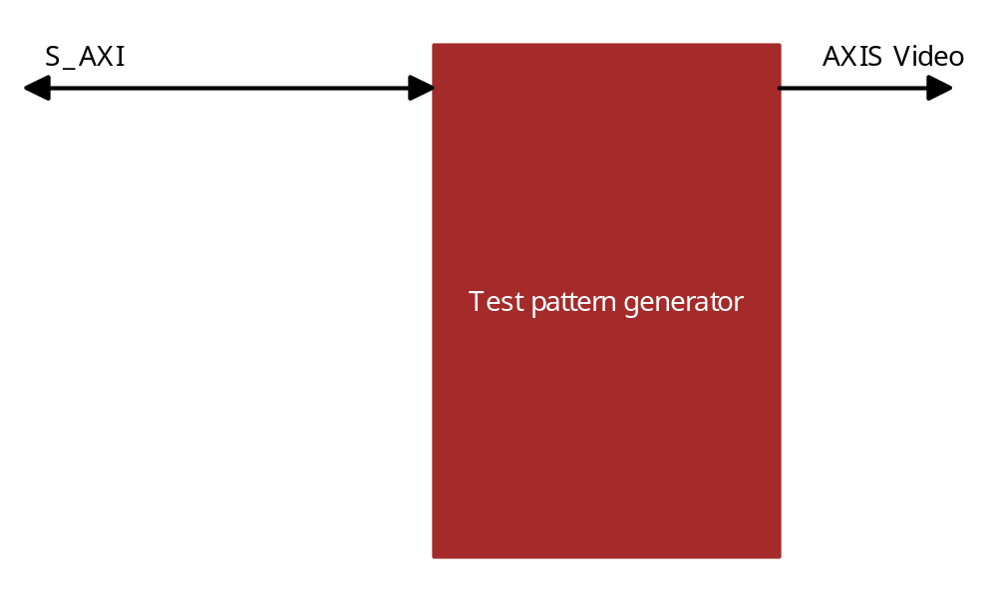

RTL parameters/generics
Following custom parameters control this block
Parameter | Default value | Description
C_FAMILY | kintexu | Family generic, hidden in customization interface. Not editable.
C_S00_AXI_DATA_WIDTH | 32 | Only 32 is supported. Not editable.
C_S00_AXI_ADDR_WIDTH |  | Not editable
C_M00_AXIS_TDATA_WIDTH | 128 | Datawidth of the pixel bus. Must be a 2**n multiple of 16, pixels are 16bit wide.
C_M00_AXIS_TUSER_WIDTH | 16 | Only the LSB is used to indicate ‘SOF’.

Register map

Overview
The following registers are accessible through the S_AXI interface.
Address | Name | R/W | Default value | Description
0x0 | EnableReg | W | 0x00000000 | Enable bits
0x0 | BusyReadback | R | NA | Readback of enable config through axi
0x4 | LineLength | R/W | 0x00000000 | Number of words/beats in a line. Word width is defined with a parameter.
0x8 | NrofLines | R/W | 0x00000000 | Number of lines to output.
0xC | Xinc | R/W | 0x00000000 | Increment per beat. To have a nicely incrementing pattern, the xinc value depends on the word width.
0x10 | Yinc[15:0]/Finc[31:16] | R/W | 0x00000000 | Yinc: Increment per line.Depending on the image size and the word width the yinc value needs to be changed to get a nice gradient.  Finc: Increment per frame, can be used to generate different frames

EnableReg/BusyReadback – 0x0

Write
31 | 1 | 0
RFU |  | Enable patterngen

Set bit 0 to ‘1’ to enable the pattern generator.

Read
31 | 2 | 1 | 0
RFU |  | Patterngen busy | Patterngen enabled

Reading bit0 reads back the ‘enable patterngen’ bit. Reading bit1 returns whether the patterngen is busy.

Linelength – 0x4

31 | 16 | 15 | 0
RFU (All zeros) |  | Linelength

Number of words/beats in a line. Word width is defined with a parameter.

NrofLines – 0x8

31 | 16 | 15 | 0
RFU |  | Nroflines

Number of lines to output.

Xinc – 0xC

31 | 16 | 15 | 0
RFU (All zeros) |  | Xinc
Increment per beat. To have a nicely incrementing pattern, the xinc value depends on the word width.

Yinc_Finc – 0x10

31 | 16 | 15 | 0
Finc |  | Yinc

Yinc: Increment per line.Depending on the image size and the word width the yinc value needs to be changed to get a nice gradient.
Finc: Increment per frame, can be used to generate different frames.

Operation
To use the patterngenerator you have to first configure all the required registers (linelength, nroflines, xinc, yinc, finc) and then enable it. The bandwidth it requires in hardware depends on the selected data interface width. It is almost capable of 100% dutycycle data generation, there is only one clock of overhead per line, when the data is not throttled by the AXIS interface. Keep this in mind as most sdram interfaces cannot handle this bandwidth.
For best results it is recommended to use a square image resolution, with equal size in X and Y dimensions, eg 1024x1024. This results in a 2MB test image.
Here is an example of how a typical test image from the pattern generator should look like.
