Chapter 1. Declarative Resource Management
1. Real World Problem
Imagine managing an enterprise application ecosystem with dozens of microservices. You have three distinct environments: Development, Staging, and Production. If you rely on imperative commands like oc new-app or oc set env directly in the terminal, you introduce massive risk. Someone will inevitably forget a step, a configuration will drift, and suddenly a deployment works perfectly in Staging but crashes the moment it hits Production. Declarative Resource Management solves this "snowflake environment" problem by treating infrastructure as code, ensuring every environment is reproducible, auditable, and identical aside from specific, version-controlled overlays.
2. Theory
Declarative management relies on defining the desired state of your application using manifest files, rather than scripting the step-by-step actions to get there. You tell OpenShift what you want (e.g., "I want 3 replicas of Nginx"), and the cluster's control loops work continuously to make the actual state match your desired state.
Kustomize is a configuration management tool built natively into the Kubernetes and OpenShift CLI. Instead of using complex templating languages with endless variables, Kustomize uses a base-and-overlay architecture. You define your standard application components in a "base" directory. Then, you create "overlays" for your specific environments (Dev, Prod) that patch or add to the base without altering the original files.
OpenShift Context: Because Kustomize is upstream in Kubernetes, it works identically in OpenShift. The key difference is that your base and overlays might include OpenShift-specific Custom Resource Definitions (CRDs) like DeploymentConfig, Route, or ImageStream, which vanilla Kubernetes does not natively understand without extensions.
3. Key Terminologies
- Declarative Management: The practice of declaring the desired state of resources in files, allowing the cluster to handle the deployment logic.
- Manifest: A YAML or JSON file describing a Kubernetes/OpenShift object (e.g., a Deployment or Service).
- Base: A directory containing the core, unmodified manifests and a kustomization.yaml file that binds them together.
- Overlay: A directory that references a base and contains specific patches or additions for a target environment.
- kustomization.yaml: The configuration file read by the oc kustomize tool to determine how to assemble the final manifests.
4. Architecture Diagram
Plaintext
=============================================================
KUSTOMIZE ARCHITECTURE
=============================================================

[ BASE DIRECTORY ]
├── deployment.yaml (Default replicas: 1)
├── service.yaml (Port: 8080)
└── kustomization.yaml

│
├── [ DEV OVERLAY ]
│ ├── kustomization.yaml (References Base)
│ └── patch.yaml (Adds 'env: DEV')
│
└── [ PROD OVERLAY ]
├── kustomization.yaml (References Base)
└── patch.yaml (Sets replicas: 3)

[ oc apply -k overlays/prod ] ---> [ OPENSHIFT CLUSTER ]
=============================================================
5. YAML Breakdown
Below is an explanation of the core fields found in a kustomization.yaml file.
Field | Description | Required/Optional
apiVersion | Specifies the Kustomize API version (kustomize.config.k8s.io/v1beta1). | Required
kind | Always set to Kustomization. | Required
resources | A list of manifest files or base directories to include. | Required
namePrefix | Prepends a string to the names of all resources (e.g., dev-). | Optional
commonLabels | Injects key-value labels into all resources and selectors. | Optional
patches | Lists files or inline configurations used to modify the base resources. | Optional
6. CLI Commands
Command | Purpose
oc apply -f <file> | Applies a standard declarative YAML manifest to the cluster.
oc kustomize <dir> | Renders the manifests to the standard output without applying them (Dry Run).
oc diff -k <dir> | Compares the current cluster state against the proposed Kustomize directory.
oc apply -k <dir> | Renders and directly applies the Kustomize directory to the cluster.
oc delete -k <dir> | Deletes all resources defined in the Kustomize directory from the cluster.
7. Hands-on Lab
Objective: Deploy a base application and then use a Kustomize overlay to deploy a development variant to OpenShift Local.
Step 1: Create the directory structure
Bash
1. mkdir -p app-deploy/{base,overlays/dev}
2. cd app-deploy
Step 2: Create the Base Manifests
Create base/deployment.yaml:
Bash
cat <<EOF > base/deployment.yaml
apiVersion: apps/v1
kind: Deployment
metadata:
name: my-app
spec:
replicas: 1
selector:
matchLabels:
app: my-app
template:
metadata:
labels:
app: my-app
spec:
containers:
- name: nginx
image: docker.io/amitfreeze/oc:v2
ports:
- containerPort: 8080
EOF

Create base/kustomization.yaml:
Bash
cat <<EOF > base/kustomization.yaml
apiVersion: kustomize.config.k8s.io/v1beta1
kind: Kustomization
resources:
- deployment.yaml
EOF

Step 3: Create the Dev Overlay
Create overlays/dev/kustomization.yaml:
Bash
cat <<EOF > overlays/dev/kustomization.yaml
apiVersion: kustomize.config.k8s.io/v1beta1
kind: Kustomization
resources:
- ../../base
namePrefix: dev-
commonLabels:
env: development
patches:
- target:
kind: Deployment
name: my-app
patch: |-
- op: replace
path: /spec/replicas
value: 2
EOF

Step 4: Preview and Deploy
View the rendered output before applying:
Bash
oc kustomize overlays/dev

Apply the configuration to the cluster:
Bash
oc apply -k overlays/dev

Step 5: Verify
Ensure the deployment was created with the dev- prefix and has 2 replicas:
Bash
oc get deployments
oc get pods -l env=development

Step 3: Create the Prod Overlay
Create overlays/prod/kustomization.yaml:
Bash
cat <<EOF > overlays/dev/kustomization.yaml
apiVersion: kustomize.config.k8s.io/v1beta1
kind: Kustomization
resources:
- ../base
namePrefix: prod-
commonLabels:
env: production
patches:
- target:
kind: Deployment
name: my-app
patch: |-
- op: replace
path: /spec/replicas
value: 2
EOF

Step 4: Preview and Deploy
View the rendered output before applying:
Bash
oc kustomize overlays/prod

Apply the configuration to the cluster:
Bash
oc apply -k overlays/prod

Step 5: Verify
Ensure the deployment was created with the dev- prefix and has 2 replicas:
Bash
oc get deployments
oc get pods -l env=production

8. Troubleshooting Lab
Scenario: A student attempts to deploy the production overlay, but OpenShift returns an error stating error: accumulating resources: path '...' must resolve to a file.
The Mistake: The student incorrectly referenced the base directory path in the overlay's kustomization.yaml file. They used resources: ['../base'] instead of resources: ['../../base'] from within a nested overlays/prod folder.
The Fix:
- Navigate to the overlay directory:
Bash
cd overlays/prod

- Inspect the kustomization.yaml file:
Bash
cat kustomization.yaml

- Edit the file to fix the relative path using vi or nano, ensuring it points exactly to the directory containing the base kustomization.yaml.
YAML
resources:
- ../../base

- Verify the syntax is correct by running a dry render:
Bash
oc kustomize .

- Apply the fixed overlay:
Bash
oc apply -k .

9. Interview Questions
- Basic: What is the primary advantage of using declarative resource management over imperative commands in OpenShift?
  - Answer: Declarative management allows for version control, repeatability, and auditing of infrastructure. It prevents configuration drift and reduces the human error associated with typing sequential terminal commands.
- Intermediate: How does Kustomize differ from Helm when deploying applications?
  - Answer: Helm is a package manager that uses a templating engine (Go templates) to inject variables into manifests. Kustomize is a configuration management tool built directly into oc and kubectl that uses a patch-and-overlay approach, keeping the base YAML files pure and completely free of template variables.
- Scenario: You have a base deployment requiring 1 GB of memory. Your staging environment needs 2 GB, and production needs 4 GB. You must not duplicate the deployment YAML. How do you structure this?
  - Answer: I would create a single base directory containing the deployment.yaml with the 1 GB default. I would then create two overlay directories (staging and production), both referencing the base. Each overlay's kustomization.yaml would include a JSON6902 patch or a Strategic Merge Patch to specifically replace the memory resource limits in the container spec.
10. Assignment
Task: Build upon the Hands-on Lab by creating a Production overlay.
- Create a new directory at overlays/prod.
- Create a kustomization.yaml that references the base.
- Configure the Kustomization to add a prod- prefix to all resources.
- Apply a patch to scale the Production deployment to 3 replicas.
- Add a completely new resource specifically for production: Create an oc route YAML manifest (expose port 8080) and include it in the resources section of the overlays/prod/kustomization.yaml.
- Run oc diff -k overlays/prod to view the changes before executing oc apply -k overlays/prod.

Chapter 2. Deploying Packaged Applications

1. Real World Problem
Imagine you need to deploy a complete three-tier web application (Frontend, Backend API, and a PostgreSQL database) across multiple OpenShift clusters. The database needs specific environment variables, persistent volume claims, and secret credentials. If you hand a folder of 15 separate YAML files to another team or a customer, they will have to manually edit passwords, change storage sizes, and apply them in a specific sequence. A single typo or missed file breaks the entire stack. You need a way to bundle these resources into a single, parameterizable package that anyone can deploy with a single click or command, ensuring consistency and reusability.
2. Theory
OpenShift provides two primary ways to package and distribute multi-resource applications: OpenShift Templates and Helm Charts.
OpenShift Templates
Templates are native OpenShift resources (kind: Template). They allow you to define a list of objects (Deployments, Services, Routes, etc.) that can be parameterized. When a user processes a template, the cluster substitutes placeholders (like ${DB_PASSWORD}) with actual values provided by the user or auto-generated by the cluster, and then creates the objects.
Helm Charts
Helm is the de facto standard package manager for the broader Kubernetes ecosystem, fully integrated into OpenShift. A Helm Chart is a collection of files inside a directory structured with templates and a default configuration file (values.yaml).
Key Differences
- Templates are cluster-native custom resources stored directly inside an OpenShift namespace or globally in the openshift namespace. They are quick to create but lack advanced lifecycle features like release history or rollback mechanisms.
- Helm Charts are managed client-side via the helm binary (or natively in the OpenShift Web Console). Helm tracks deployments as "Releases," allowing you to easily upgrade, roll back to a specific version (helm rollback), and manage dependencies between charts.
3. Key Terminologies
- Template: An OpenShift-specific resource that describes a set of objects that can be parameterized and processed to produce a configuration.
- Chart: A Helm package containing all the resource definitions necessary to run an application inside a Kubernetes/OpenShift cluster.
- values.yaml: The file containing the default configuration values for a Helm chart, which can be overridden during deployment.
- Release: An instance of a Helm chart running in an OpenShift cluster.
- Helm Repository: A HTTP server that houses packaged Helm charts and an index.yaml file listing available charts.
4. Architecture Diagram
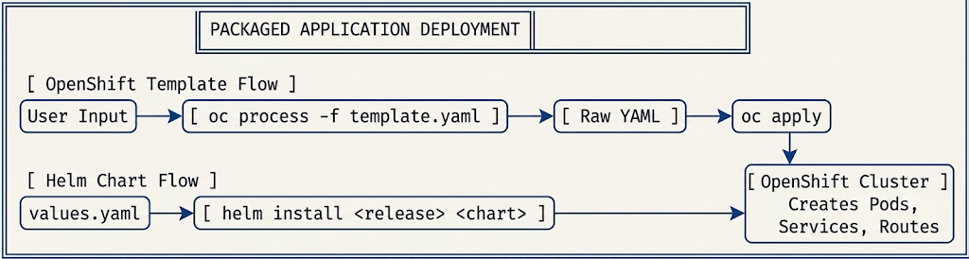
5. YAML Breakdown
OpenShift Template Structure
Below is an anatomy of the parameter and object substitution fields in an OpenShift Template manifest.
YAML
apiVersion: template.openshift.io/v1
kind: Template
metadata:
name: mariadb-template
objects:
- apiVersion: apps/v1
kind: Deployment
metadata:
name: ${APP_NAME} # Placeholder matching parameter name
spec:
template:
spec:
containers:
- name: mariadb
image: ${IMAGE_NAME}:${IMAGE_TAG}
parameters:
- name: APP_NAME # Required: The variable name referenced in objects
description: Application name
value: backend-db # Optional: Default value if not specified
required: true
- name: IMAGE_NAME
value: registry.redhat.io/rhel8/mariadb-105
- name: IMAGE_TAG
value: "latest"

Helm values.yaml Structure
Below is the standard layout for parameterizing values in a Helm chart configuration file.
YAML
# Default values for my-custom-app.
replicaCount: 2

image:
repository: registry.access.redhat.com/ubi8/nginx-120
tag: "1.20"
pullPolicy: IfNotPresent

service:
type: ClusterIP
port: 8080

6. CLI Commands
Command | Purpose
oc process -f <template>.yaml -p PARAM=value | Parses a template file, substitutes parameters, and outputs raw YAML.
oc create -f <template>.yaml | Stores the template resource into the active OpenShift namespace.
oc new-app --template=<template-name> -p PARAM=value | Instantiates an application from a cluster-stored template.
helm repo add <name> <url> | Adds a remote Helm chart repository to your local client config.
helm install <release-name> <chart-name> -f values.yaml | Deploys a Helm chart to the cluster using custom values.
helm list | Lists all active Helm releases in the current namespace.
helm upgrade <release-name> <chart-name> | Upgrades an existing release to a new version or new configuration.
7. Hands-on Lab
Part A: Deploy via OpenShift Template (CLI)
Step 1: Create a parameterizable OpenShift template file
Create a template named simple-template.yaml that bundles a deployment and a service:
Bash
cat <<EOF > simple-template.yaml
apiVersion: template.openshift.io/v1
kind: Template
metadata:
name: simple-web-template
objects:
- apiVersion: apps/v1
kind: Deployment
metadata:
name: ${APP_NAME}
spec:
replicas: 1
selector:
matchLabels:
app: ${APP_NAME}
template:
metadata:
labels:
app: ${APP_NAME}
spec:
containers:
- name: web
image: docker.io/amitfreeze/oc:v2
ports:
- containerPort: 8080
- apiVersion: v1
kind: Service
metadata:
name: ${APP_NAME}-svc
spec:
ports:
- port: 8080
targetPort: 8080
selector:
app: ${APP_NAME}
parameters:
- name: APP_NAME
description: "The name of the application resources"
value: "default-web"
required: true
EOF

Step 2: Instantiate the template instantly using the CLI
Process the template on-the-fly and pipe it straight to the cluster to create resources:
Bash
oc process -f simple-template.yaml -p APP_NAME=prod-frontend | oc apply -f -

Step 3: Verify the resources
Bash
oc get deployment prod-frontend
oc get svc prod-frontend-svc

Part B: Deploy via Helm Chart (CLI)
Step 1: Create new project and install helm
Bash
oc new-project helm-nginx-lab
winget install Helm.Helm

Step 2: Add a Red Hat Helm repository and Search for an available chart
Bash
helm repo add redhat-charts https://charts.openshift.io/
helm repo update

helm search repo nginx

Step 3: Install the chart with a custom release name
Bash
helm install my-web-server redhat-charts/redhat-nginx-template

Step 4: Import the Missing Builder Image
Because CRC is a lightweight, single-node environment, it does not always come pre-loaded with the global builder images found in enterprise OpenShift clusters. The Helm chart you just installed created a BuildConfig that is waiting for an nginx:1.24-ubi8 builder image.
Import the required image directly from Red Hat's public registry into your local namespace:
Bash
oc import-image nginx:1.24-ubi8 --from=registry.access.redhat.com/ubi8/nginx-124 --confirm
Step 5: Trigger the Build Pipeline
oc start-build nginx-example --follow

Step 6: Verify the Deployment
oc get route nginx-example
oc delete project helm-nginx-lab

10. Assignment
Task: Create an automated application deployment package that sets up an environment platform using templates.
- Design a custom OpenShift template manifest that bundles together a single web instance deployment alongside a cluster network Route resource object.
- Expose a parameter named ENVIRONMENT_LABEL that defaults to the value sandbox.
- Use that parameter placeholder to auto-inject labels into your workload metadata sections.
- Test your package creation by instantiating the resource under two distinct environment tracking configurations via the CLI:
  - Run one iteration generating resources with -p ENVIRONMENT_LABEL=dev
  - Run a secondary iteration generating resources with -p ENVIRONMENT_LABEL=qa
- Execute oc get route to verify both routes were created successfully.

Chapter 3. Authentication and Authorization
1. Real World Problem
Imagine you have just deployed a new OpenShift cluster for your organization. By default, the only user who can access anything is the kubeadmin account, which holds god-mode privileges over the entire system. If you share this password with your development team, someone might accidentally delete a critical production namespace or change cluster-wide ingress settings. You need a way to let developers log in with their own unique credentials, but restrict their access so they can only view or edit resources within their specific project boundaries.
2. Theory
Unlike vanilla Kubernetes, which relies heavily on external certificates or generic OIDC for user management, OpenShift has a built-in, highly integrated OAuth server. When a user attempts to log in via the web console or the CLI (oc login), their request goes to the OpenShift OAuth server.
OpenShift does not maintain its own internal database of user passwords. Instead, it delegates identity verification to external Identity Providers (IdP). One of the simplest IdPs to configure—especially for local development, OpenShift Local, or smaller deployments—is HTPasswd. This method uses a flat file containing usernames and hashed passwords. Once a user successfully authenticates against the IdP, OpenShift generates an OAuth access token for them.
After authentication (verifying who you are), OpenShift uses Role-Based Access Control (RBAC) for authorization (verifying what you can do). RBAC is driven by Roles (a set of permissions like "create pods") and RoleBindings (attaching those permissions to a specific user or group).
3. Key Terminologies
- Identity Provider (IdP): An external system or mechanism (like HTPasswd, LDAP, Active Directory, or GitHub) that validates a user's credentials.
- OAuth Server: The OpenShift component that interfaces with the IdP and issues access tokens to users upon successful login.
- RBAC: Role-Based Access Control. The system used to grant or deny access to cluster resources.
- Role / ClusterRole: A collection of permissions (e.g., get, list, create, delete) mapped to specific resources (e.g., pods, services). Roles are confined to a single namespace; ClusterRoles apply globally.
- RoleBinding / ClusterRoleBinding: The "glue" that attaches a Role or ClusterRole to a specific User, Group, or ServiceAccount.
4. Architecture Diagram
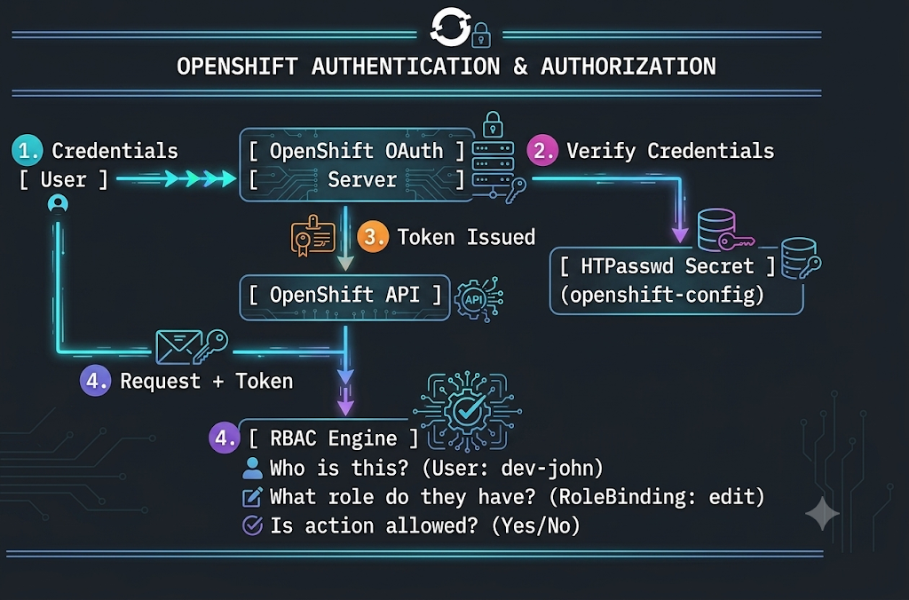

5. YAML Breakdown
Below is the structure of the OAuth custom resource used to configure the HTPasswd identity provider in OpenShift.
Field | Description | Required/Optional
apiVersion | config.openshift.io/v1 | Required
kind | OAuth | Required
metadata.name | Must always be exactly cluster. | Required
spec.identityProviders | A list of configured IdPs for the cluster. | Required
name | A recognizable name for the provider (e.g., my_htpasswd). | Required
mappingMethod | How to map external identities to OpenShift users (usually claim). | Required
type | Identifies the IdP type. Must be HTPasswd (Case Sensitive). | Required
htpasswd.fileData.name | The exact name of the Secret in the openshift-config namespace holding the htpasswd file. | Required
6. CLI Commands
Command | Purpose
htpasswd -c -B -b <file> <user> <pass> | Creates a new htpasswd file (-c), uses bcrypt encryption (-B), and accepts password via CLI (-b).
oc create secret generic <name> --from-file=htpasswd=<file> -n openshift-config | Packages the flat file into an OpenShift Secret so the cluster can read it.
oc edit oauth cluster | Opens the cluster's global OAuth configuration in the default terminal text editor.
oc adm policy add-role-to-user <role> <user> -n <project> | Grants a specific role (like edit or view) to a user within a specific project namespace.
oc adm policy add-cluster-role-to-user <role> <user> | Grants a cluster-wide role (like cluster-admin) to a user across all namespaces.
7. Hands-on Lab
Objective: Create an HTPasswd file, configure OpenShift Local to use it, create a developer user, and grant them namespace-level access.
Step 1: Create the HTPasswd file locally
Use the htpasswd utility (requires the httpd-tools or apache2-utils package installed on your local machine) to create a user named developer1 with the password redhat.
Bash
htpasswd -c -B -b users.htpasswd developer1 redhat

Step 2: Create the OpenShift Secret
Log into your OpenShift Local cluster as kubeadmin and upload the file as a Secret to the openshift-config namespace:
Bash
oc create secret generic htpass-secret --from-file=htpasswd=users.htpasswd -n openshift-config

Step 3: Apply the OAuth Configuration
Create a YAML file named oauth-update.yaml to define the IdP:
Bash
cat <<EOF > oauth-update.yaml
apiVersion: config.openshift.io/v1
kind: OAuth
metadata:
name: cluster
spec:
identityProviders:
- name: local_htpasswd
mappingMethod: claim
type: HTPasswd
htpasswd:
fileData:
name: htpass-secret
EOF

Apply the configuration:
Bash
oc apply -f oauth-update.yaml

Step 4: Wait for the Authentication Operator to roll out
The cluster will immediately spin up new authentication pods. Wait for this to complete (this may take 1-2 minutes):
Bash
oc get pods -n openshift-authentication -w

Step 5: Test the Login
Log in as the new user:
Bash
oc login -u developer1 -p redhat

(Notice that if you run oc get projects, you will see very little, as no RBAC permissions have been assigned yet).

Step 6: Assign RBAC Permissions
Log back in as the cluster administrator (kubeadmin) and create a project for the developer:
Bash
oc login -u kubeadmin -p <your-kubeadmin-password>
oc new-project dev-sandbox

Grant the edit role to developer1 inside the dev-sandbox project:
Bash
oc adm policy add-role-to-user edit developer1 -n dev-sandbox

8. Troubleshooting Lab
Scenario: A student creates a new user qa-user using htpasswd and successfully logs into the cluster. However, when the student tries to view the pods in the frontend-app project, the CLI returns:
Error from server (Forbidden): pods is forbidden: User "qa-user" cannot list resource "pods" in API group "" in the namespace "frontend-app".
The Mistake: The student assumed that successfully authenticating (logging in) automatically grants authorization (permission to view resources). In OpenShift, authentication and authorization are distinct. A new user has exactly zero permissions by default.
The Fix:
- Log into the cluster using an account with cluster-admin privileges (like kubeadmin).
Bash
oc login -u kubeadmin

- Identify the namespace the user needs to access:
Bash
oc get projects | grep frontend-app

- Create a RoleBinding granting the view (or edit) role to qa-user specifically for that namespace:
Bash
oc adm policy add-role-to-user view qa-user -n frontend-app

- Verify the binding was created successfully:
Bash
oc describe rolebinding -n frontend-app | grep qa-user

9. Interview Questions
- Basic: What is the difference between Authentication and Authorization in OpenShift?
  - Answer: Authentication is the process of verifying a user's identity (proving who you are, typically via a username/password or token). Authorization is the process of checking RBAC rules to determine if that authenticated user has the necessary permissions to perform a specific action (determining what you can do).
- Intermediate: Why is the htpasswd Secret specifically required to be placed in the openshift-config namespace?
  - Answer: The openshift-config namespace is the dedicated, highly privileged namespace where the OpenShift cluster's global configuration operators (like the Authentication operator) look for user-provided configurations, certificates, and secrets. If you put it in a standard user namespace, the cluster's control plane will not be able to read it securely.
- Scenario: A developer leaves the company, and you need to revoke their access. You are using the HTPasswd identity provider. Walk me through the exact steps to remove them from OpenShift.
  - Answer: First, I would delete the user's entry from my local users.htpasswd file using the command htpasswd -D users.htpasswd <username>. Second, I would update the OpenShift Secret with the new file by running oc create secret generic htpass-secret --from-file=htpasswd=users.htpasswd -n openshift-config --dry-run=client -o yaml | oc replace -f -. Finally, I would delete their internal OpenShift User and Identity objects by running oc delete user <username> and oc delete identity local_htpasswd:<username> to ensure all their active tokens are immediately invalidated.
10. Assignment
Task: Configure a secondary user and apply cluster-wide permissions.
- Append a new user named cluster-auditor to your existing users.htpasswd file locally (remember to drop the -c flag so you do not overwrite the existing developer1 user).
- Update the htpass-secret in the openshift-config namespace with the newly modified file.
- Verify you can log in as cluster-auditor.
- As kubeadmin, use the oc adm policy command to grant the cluster-auditor user the cluster-reader role. (This gives them global read-only access to all namespaces).
- Log back in as cluster-auditor and verify you can successfully run oc get nodes and oc get pods -A.

Chapter 4. Network Security
1. Real World Problem
Imagine your company runs a multi-tenant OpenShift cluster. The marketing team deploys a vulnerable WordPress blog in Project A, while the finance team runs a highly sensitive payroll database in Project B. By default, Kubernetes networks are "flat"—meaning a compromised pod in the marketing project can freely scan and attack the finance database. Furthermore, if the payroll web interface is exposed to the internet without encryption, employee salaries and passwords are transmitted in plaintext. You need a way to build invisible firewalls around your applications and ensure all traffic, both entering the cluster and moving within it, is heavily encrypted.
2. Theory
Network security in OpenShift is addressed at three critical boundaries:
1. External Traffic (Routes & Ingress):
OpenShift uses an Ingress Controller (HAProxy by default) to route external HTTP/HTTPS traffic to internal services. To secure this, OpenShift supports three types of TLS termination:
- Edge: TLS is terminated at the router. Traffic from the router to the internal pod is unencrypted.
- Passthrough: The router sends the encrypted traffic straight to the pod without decrypting it. The pod itself must have the TLS certificates.
- Re-encrypt: TLS is terminated at the router with a public certificate, and then the router creates a new TLS connection to the pod using an internal certificate.
2. Internal Traffic (Network Policies):
OpenShift uses a Software Defined Network (SDN), typically OVN-Kubernetes. By default, all pods can talk to all other pods across all namespaces. Network Policies are Kubernetes resources that act as internal firewalls. They operate at Layer 3/4 (IP and Port) and use label selectors to define exactly which pods can communicate. The moment you apply a Network Policy to a pod, it defaults to denying all traffic not explicitly allowed by the policy.
3. Internal Certificates (Service CA):
To support Re-encrypt routes or secure pod-to-pod communication, OpenShift has a built-in internal Certificate Authority (CA). By simply adding an annotation to a Service, OpenShift will automatically generate a TLS certificate and mount it as a Secret into your pod.
3. Key Terminologies
- Edge Termination: Decrypting external traffic at the OpenShift router perimeter.
- Passthrough Termination: Forwarding encrypted external traffic directly to the destination pod.
- Re-encrypt Termination: Decrypting traffic at the router and re-encrypting it before sending it to the pod.
- NetworkPolicy: A specification of how groups of pods are allowed to communicate with each other and other network endpoints.
- Service Certificate: An automatically generated TLS certificate provided by OpenShift's internal CA for securing pod-to-pod traffic.
4. Architecture Diagram
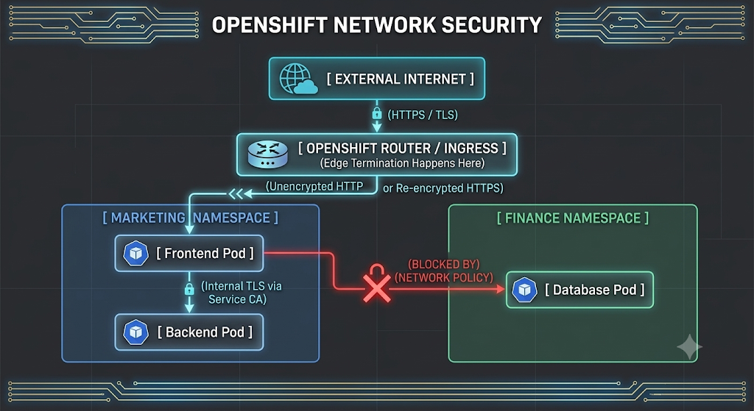

5. YAML Breakdown
Below is the breakdown of a NetworkPolicy manifest designed to allow ingress traffic only from specific pods.
Field | Description | Required/Optional
apiVersion | networking.k8s.io/v1 | Required
kind | NetworkPolicy | Required
spec.podSelector | Defines the "target" pods this policy applies to (e.g., matchLabels: app=database). Empty {} selects all pods. | Required
spec.policyTypes | Specifies whether the policy applies to Ingress, Egress, or both. | Required
spec.ingress.from.podSelector | Allows traffic from specific pods within the same namespace. | Optional
spec.ingress.from.namespaceSelector | Allows traffic from any pod within a specific external namespace. | Optional
spec.ingress.ports | The specific ports/protocols allowed (e.g., TCP port 3306). | Optional
6. CLI Commands
Command | Purpose
oc create route edge <name> --service=<svc> --insecure-policy=Redirect | Exposes a service securely with Edge termination and forces HTTP to HTTPS.
oc annotate service <svc> service.beta.openshift.io/serving-cert-secret-name=<secret-name> | Triggers OpenShift to auto-generate an internal TLS certificate for the service.
oc create -f <policy.yaml> | Applies a NetworkPolicy to the current namespace.
oc get networkpolicy | Lists all active network policies in the namespace.
oc describe networkpolicy <name> | Shows the detailed rules and target pods of a specific network policy.
7. Hands-on Lab
Objective: Secure an application by forcing HTTPS for external traffic, enabling an internal TLS certificate, and isolating it with a Network Policy.
Step 1: Deploy a basic application
Bash
oc new-project secure-net-lab
oc new-app registry.access.redhat.com/ubi8/nginx-120~https://github.com/sclorg/nginx-ex.git --name=secure-web

Step 2: Protect External Traffic (Edge Route)
Create an Edge route that redirects all plaintext HTTP traffic to encrypted HTTPS:
Bash
oc create route edge secure-web-route --service=secure-web --insecure-policy=Redirect

Test the route (it should use a default OpenShift certificate):
Bash
oc get route secure-web-route
Step 3: Protect Internal Traffic (Service Certificates)
Request an internal TLS certificate for the secure-web service:
Bash
oc annotate service secure-web service.beta.openshift.io/serving-cert-secret-name=internal-tls-secret

Verify the cluster generated the Secret containing the tls.crt and tls.key:
Bash
oc get secret internal-tls-secret

Step 4: Configure Network Policies (Default Deny)
Create a default-deny.yaml file to block ALL traffic in the project:
Bash
cat <<EOF > default-deny.yaml
kind: NetworkPolicy
apiVersion: networking.k8s.io/v1
metadata:
name: deny-by-default
spec:
podSelector: {}
ingress: []
EOF

Apply it and test access (the route will now return a 503 or timeout because the router is blocked from reaching the pod):
Bash
oc apply -f default-deny.yaml
oc get route secure-web-route

Step 5: Allow OpenShift Router Traffic
Create an allow-from-router.yaml file to let the Ingress controller reach your pod:
Bash
cat <<EOF > allow-from-router.yaml
kind: NetworkPolicy
apiVersion: networking.k8s.io/v1
metadata:
name: allow-from-openshift-ingress
spec:
podSelector:
matchLabels:
app: secure-web
ingress:
- from:
- namespaceSelector:
matchLabels:
network.openshift.io/policy-group: ingress
EOF

Apply the policy and verify the web application is accessible from the outside again:
Bash
oc apply -f allow-from-router.yaml
curl -I https://$(oc get route secure-web-route -o jsonpath='{.spec.host}')

8. Troubleshooting Lab
Scenario: A developer applied a Network Policy to secure a database pod (app=db). They wrote a rule allowing ingress from the frontend pod (app=frontend) using a podSelector. However, the frontend pod keeps throwing "Connection Refused" and "Timeout" errors when trying to reach the database.
The Mistake: The frontend pod is in the web-project namespace, and the database is in the data-project namespace. A podSelector by itself only looks for pods within the exact same namespace where the Network Policy is deployed.
The Fix:
- Inspect the current broken Network Policy:
Bash
oc describe networkpolicy allow-frontend -n data-project

- Edit the Network Policy YAML to include a namespaceSelector combined with the podSelector.
- First, label the frontend namespace so the policy can find it:
Bash
oc label namespace web-project tier=frontend

- Apply the corrected Network Policy YAML to the data-project:
YAML
ingress:
- from:
- namespaceSelector:
matchLabels:
tier: frontend
podSelector:
matchLabels:
app: frontend

- Verify the connection using oc rsh from the frontend pod:
Bash
oc rsh <frontend-pod-name> curl -v http://database:3306

9. Interview Questions
- Basic: What is the difference between an Edge Route and a Passthrough Route in OpenShift?
  - Answer: An Edge route terminates the TLS encryption at the OpenShift Router (HAProxy), meaning the traffic between the router and the pod is unencrypted. A Passthrough route does not decrypt the traffic at the router; it sends the encrypted traffic directly to the pod, requiring the pod to hold the TLS certificate and handle the decryption itself.
- Intermediate: If you apply a Network Policy with an empty podSelector: {} and no ingress rules, what happens to the pods in that namespace?
  - Answer: It creates a "Default Deny" posture. Because the podSelector is empty, it targets every single pod in that namespace. Because there are no ingress rules defined, it explicitly denies all incoming traffic to all pods in that project, isolating them completely.
- Scenario: You have a backend service that must comply with strict security standards requiring end-to-end encryption. The external client must connect via HTTPS, and the traffic must remain encrypted on the OpenShift internal network until it hits the pod. Which Route type do you use, and how do you configure the internal certificates without buying new ones?
  - Answer: I would use a Re-encrypt route. I would annotate the backend Service with service.beta.openshift.io/serving-cert-secret-name=<name> to leverage the OpenShift Service CA to automatically generate an internal certificate. I would then mount that generated Secret into my backend pod, and configure the Re-encrypt route to trust that internal destination CA.
10. Assignment
Task: Build a secure, two-tier isolated application.
- Create a new project named net-assignment.
- Deploy two applications: backend-api (using a standard nginx image) and frontend-ui (using a standard nginx image).
- Expose the frontend-ui to the internet using an Edge route that redirects HTTP to HTTPS.
- Do not expose the backend-api to the internet (no route).
- Implement a Network Policy named deny-all that blocks all traffic in the net-assignment namespace.
- Implement a Network Policy named allow-ui-ingress that allows external internet traffic (via the OpenShift ingress controller) to hit only the frontend-ui pods.
- Implement a Network Policy named allow-api-internal that allows traffic to hit the backend-api pods, but only if that traffic originates from the frontend-ui pods.
- Test your setup: You should be able to curl the frontend-ui route successfully, and if you oc rsh into the frontend-ui pod, you should be able to curl the backend-api service. No other pod in the cluster should be able to reach the backend-api.

Chapter 5. Exposing non-HTTP/SNI Applications

1. Real World Problem
Imagine you are leading automation for a large industrial account, and your team has just containerized a legacy telemetry collector that receives machine data via a custom, raw TCP protocol on port 9000. You deploy it to OpenShift, but quickly realize a major issue: the OpenShift Ingress Controller (HAProxy) routes traffic by reading the HTTP host headers or the SNI (Server Name Indication) in a TLS handshake. Because your legacy manufacturing protocol is purely raw TCP and lacks these headers, the OpenShift Router drops the traffic. You need a way to punch a hole straight through the cluster perimeter directly to your application, completely bypassing the Layer 7 OpenShift Router.
2. Theory
By default, OpenShift routes external traffic using Route objects, which operate at Layer 7 (Application Layer). When you have an application that uses non-HTTP/SNI protocols (like SSH, SFTP, raw TCP/UDP databases, or custom automation protocols), you must drop down to Layer 4 (Transport Layer) or Layer 2 (Data Link Layer). OpenShift provides two primary methods for this:
1. LoadBalancer Services (Layer 4)
A Kubernetes Service of type: LoadBalancer provisions a dedicated external IP address that routes directly to your pods, bypassing the OpenShift Ingress Controller entirely. In a public cloud (AWS, Azure, GCP), OpenShift API calls the cloud provider to provision a native cloud load balancer. On bare-metal or on-premises clusters, you typically install an operator like MetalLB to announce the IP addresses to the local network using ARP or BGP.
2. Multus Secondary Networks (Layer 2 / Layer 3)
Sometimes, even a LoadBalancer isn't enough. Telecom, high-performance computing, or strict enterprise security environments often require pods to sit directly on a specific physical VLAN. Multus is a "meta-plugin" for the Container Network Interface (CNI). While the default OpenShift SDN (OVN-Kubernetes) provides the primary eth0 interface for pod-to-pod communication, Multus allows you to attach secondary network interfaces (e.g., net1) directly to a pod. This allows the pod to bridge directly onto the host's physical network (using Macvlan or IPVlan), effectively giving the pod an IP address from the external network router.
3. Key Terminologies
- SNI (Server Name Indication): An extension to the TLS protocol that indicates which hostname the client is attempting to connect to. Required by the OpenShift Router for HTTPS passthrough.
- Service (type: LoadBalancer): A Kubernetes object that exposes an application to the outside world using a dedicated external IP address.
- MetalLB: A bare-metal load-balancer implementation for Kubernetes that provides network load-balancing for clusters not running on a public cloud.
- Multus CNI: A container network interface plugin that enables attaching multiple network interfaces to a single pod.
- NetworkAttachmentDefinition (NAD): A Custom Resource (CR) in OpenShift that defines how a secondary network should be configured (e.g., specifying the bridge or macvlan details).
4. Architecture Diagram
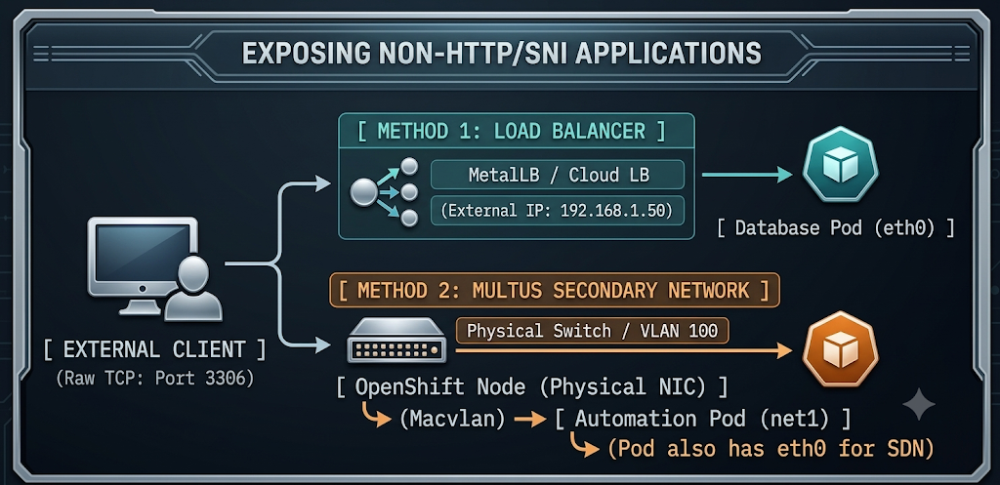

5. YAML Breakdown
LoadBalancer Service
Field | Description | Required/Optional
spec.type | Must be set to LoadBalancer. | Required
spec.ports.port | The port exposed on the external LoadBalancer IP. | Required
spec.ports.targetPort | The actual port the container is listening on. | Required
spec.allocateLoadBalancerNodePorts | Can be set to false to disable automatic NodePort allocation, saving port space. | Optional
NetworkAttachmentDefinition (Multus)
Field | Description | Required/Optional
apiVersion | k8s.cni.cncf.io/v1 | Required
kind | NetworkAttachmentDefinition | Required
spec.config | A JSON string defining the CNI plugin to use (e.g., macvlan), the master interface, and the IP Address Management (IPAM) strategy. | Required
6. CLI Commands
Command | Purpose
oc expose deployment <name> --type=LoadBalancer --name=<svc-name> | Imperatively creates a LoadBalancer service for an existing deployment.
oc get svc <svc-name> | Retrieves the Service details. Check the EXTERNAL-IP column.
oc get network-attachment-definitions | Lists available secondary network definitions in the current namespace.
oc annotate pod <pod-name> k8s.v1.cni.cncf.io/networks=<nad-name> | Attaches a secondary network interface to a pod (typically done in the Deployment template).
oc exec -it <pod-name> -- ip a | Views the network interfaces inside a running pod to verify net1 is attached.
7. Hands-on Lab
Objective: Deploy a non-HTTP application (MariaDB) and expose it via a LoadBalancer Service. Then, define a Multus secondary network.
Part 1: Expose via LoadBalancer
(Note: In OpenShift Local, a LoadBalancer will stay in "Pending" unless MetalLB is configured, but the creation mechanism is identical to production).
Step 1: Deploy a raw TCP application
Bash
oc new-project non-http-lab
oc new-app registry.redhat.io/rhel8/mariadb-105 --name=tcp-db -e MYSQL_ROOT_PASSWORD=redhat
Step 2: Expose the deployment as a LoadBalancer
Instead of using oc expose service (which creates a Route), we expose the Deployment directly to create a Service:
Bash
oc expose deployment tcp-db --port=3306 --target-port=3306 --type=LoadBalancer --name=db-external-lb

Step 3: Verify the Service
Bash
oc get svc db-external-lb

Look under the EXTERNAL-IP column. In a cloud environment, this will eventually populate with a public IP. In a bare-metal cluster without MetalLB, it will say <pending>.
Part 2: Configure a Multus Secondary Network
Step 1: Create the NetworkAttachmentDefinition
Create a macvlan-net.yaml file. This tells Multus how to attach pods directly to a host interface.
Bash
cat <<EOF > macvlan-net.yaml
apiVersion: "k8s.cni.cncf.io/v1"
kind: NetworkAttachmentDefinition
metadata:
name: macvlan-conf
spec:
config: '{
"cniVersion": "0.4.0",
"type": "macvlan",
"master": "eth10",
"mode": "bridge",
"ipam": {
"type": "host-local",
"subnet": "192.168.1.0/24",
"rangeStart": "192.168.1.200",
"rangeEnd": "192.168.1.216",
"routes": [
{ "dst": "0.0.0.0/0" }
],
"gateway": "192.168.1.1"
}
}'
EOF

Apply it to the cluster:
Bash
oc apply -f macvlan-net.yaml

Step 2: Deploy a Pod using the secondary network
Create a multus-pod.yaml file. Notice the specific annotation requesting the secondary network.
Bash
cat <<EOF > multus-pod.yaml
apiVersion: v1
kind: Pod
metadata:
name: multus-tester
annotations:
k8s.v1.cni.cncf.io/networks: macvlan-conf
spec:
securityContext:
runAsNonRoot: true
seccompProfile:
type: RuntimeDefault
containers:
- name: toolbox
image: registry.access.redhat.com/ubi8/toolbox:latest
command: ["sleep", "3600"]
securityContext:
allowPrivilegeEscalation: false
capabilities:
drop: ["ALL"]
EOF

Apply the pod:
Bash
oc apply -f multus-pod.yaml

Step 3: Verify the interfaces inside the Pod
Once the pod is running, check its internal network configuration. You should see an eth0 (OpenShift SDN) and a net1 (Macvlan interface).
Bash
oc exec -it multus-tester -- ip a
8. Troubleshooting Lab
Scenario: A developer created a LoadBalancer service for their custom SFTP pod, but after 30 minutes, the application is still unreachable from the outside. When they run oc get svc sftp-lb, the EXTERNAL-IP column shows <pending>.
The Mistake: The cluster is running on bare-metal (or VMWare/OpenShift Local), and the developer assumed that setting type: LoadBalancer automatically magically creates an IP address. LoadBalancer services require an external provider (like AWS ELB) or an internal IP Address Management operator (like MetalLB) to assign the IP. If MetalLB is not installed, or if the MetalLB IP Address Pool is exhausted, the service will remain stuck in Pending.
The Fix:
- Check the events on the Service to confirm why it is pending:
Bash
oc describe svc sftp-lb

- If MetalLB is installed, verify that the IP address pools have available addresses:
Bash
oc get ipaddresspool -n metallb-system

- If MetalLB is NOT installed or cannot be used, instruct the developer to fall back to a NodePort service. Edit the service:
Bash
oc patch svc sftp-lb -p '{"spec": {"type": "NodePort"}}'

- Verify the new NodePort assignment (a port between 30000-32767):
Bash
oc get svc sftp-lb

- Access the application using the IP address of any OpenShift worker node and the newly assigned NodePort.
9. Interview Questions
- Basic: Why can't you use a standard OpenShift Route to expose a database like PostgreSQL to an external client?
  - Answer: OpenShift Routes rely on the Ingress Controller (HAProxy), which natively handles Layer 7 HTTP, HTTPS, and TLS SNI traffic. PostgreSQL uses a custom, raw TCP protocol that does not contain HTTP headers or SNI information, meaning the router doesn't know where to send the traffic.
- Intermediate: When using a Multus secondary network, does the pod lose its connection to the default OpenShift Software Defined Network (SDN)?
  - Answer: No. Multus is a multiplexer. The default OpenShift SDN (OVN-Kubernetes) still provides the primary eth0 interface so the pod can communicate with other pods and services inside the cluster. Multus simply adds secondary interfaces (like net1, net2) for direct external access.
- Scenario: You have a strict requirement from the security team that a specific pod must receive traffic directly from a legacy physical switch on VLAN 45 without going through any NAT or load balancing. How do you architect this in OpenShift?
  - Answer: I would use Multus CNI. First, I would ensure the physical OpenShift worker nodes have their NICs trunked to VLAN 45. Then, I would create a NetworkAttachmentDefinition using the macvlan or ipvlan CNI plugin, referencing the host's physical interface. Finally, I would add the k8s.v1.cni.cncf.io/networks annotation to my pod's deployment manifest, which instructs OpenShift to attach a secondary NIC directly to that VLAN inside the pod.
10. Assignment
Task: Expose a non-HTTP application using NodePort (as a fallback for environments without MetalLB).
- Create a new deployment running a Redis instance (registry.access.redhat.com/rhscl/redis-5-rhel7).
- Create a Kubernetes Service for the Redis deployment.
- Edit the Service so its type is set to NodePort.
- Use the oc get svc command to identify the high-range port (30000-32767) that OpenShift automatically assigned to your service.
- Identify the IP address of one of your OpenShift worker nodes by running oc get nodes -o wide.
- Formulate the exact command string you would use to connect a theoretical external Redis client to your database using the Node IP and the NodePort.

Chapter 6. Enabling Developer Self-service
1. Real World Problem
Imagine you give 50 developers access to a shared OpenShift cluster. A junior developer runs a load-testing script and deploys a pod without specifying any memory limits. That single pod consumes 90% of the worker node's RAM, causing the node to panic and evict critical production applications. Alternatively, imagine Ops is a bottleneck: every time a developer needs a sandbox environment, they must submit an IT ticket and wait 3 days. You need a way to allow developers to instantly provision their own projects, but with strict, automated guardrails so they cannot accidentally or maliciously consume all the cluster's resources.
2. Theory
OpenShift uses a multi-layered approach to handle resource constraints and self-service provisioning:
1. Resource Quotas (The Neighborhood Boundary)
A ResourceQuota defines the maximum aggregate amount of resources (CPU, memory, number of pods, number of Persistent Volume Claims) that all objects in a single namespace can consume combined.
OpenShift Specific: OpenShift also offers ClusterResourceQuota, which applies an aggregate quota across multiple namespaces owned by a specific user or matching a specific label.
2. Limit Ranges (The House Boundary)
While Quotas govern the whole project, a LimitRange governs individual pods and containers. It sets the minimum and maximum CPU/memory a single pod can request. Crucially, if a developer forgets to define resource requests/limits in their Deployment YAML, the LimitRange automatically injects default values to ensure the pod doesn't run unbounded. (Note: If a Quota exists for CPU/Memory, OpenShift forces you to specify limits on your pods; a LimitRange solves this by auto-injecting them).
3. Project Templates and Self-Provisioning
By default, anyone who logs into OpenShift has the self-provisioner role, allowing them to run oc new-project. When they do, OpenShift doesn't just create an empty namespace; it runs a hidden Project Template. Administrators can extract this template, modify it (e.g., automatically inject a default LimitRange and ResourceQuota into every new project), and configure the cluster to use the customized template. If strict Ops-only provisioning is required, administrators can simply revoke the self-provisioner role from developers.
3. Key Terminologies
- ResourceQuota: An object that limits total resource consumption per namespace.
- ClusterResourceQuota: An OpenShift-specific object that limits total resource consumption across multiple namespaces.
- LimitRange: An object that sets minimum, maximum, and default resource limits for individual containers/pods within a namespace.
- Project Request Template: A customizable OpenShift Template that defines the default objects (Quotas, RoleBindings, LimitRanges) created automatically when oc new-project is executed.
- Self-Provisioner: A default ClusterRole in OpenShift that allows authenticated users to create their own projects.

4. Architecture Diagram
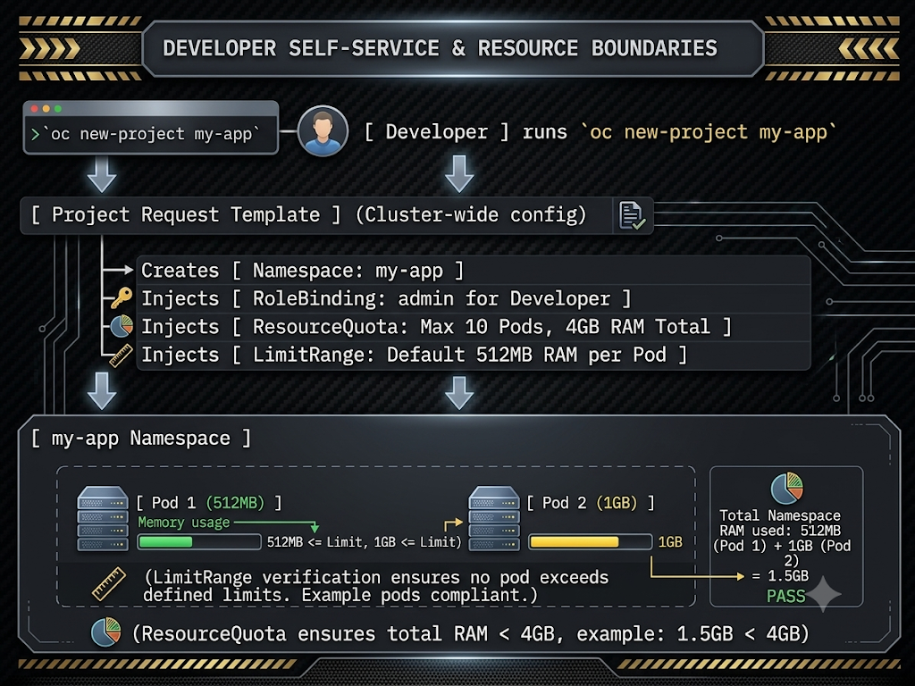

5. YAML Breakdown
Below is the structure of a LimitRange used to constrain and inject default values into pods.
Field | Description | Required/Optional
apiVersion | v1 | Required
kind | LimitRange | Required
spec.limits.type | Defines what is being limited (Container or Pod). | Required
spec.limits.default | The default limit (hard cap) injected if the developer omits it. | Optional
spec.limits.defaultRequest | The default request (guarantee) injected if the developer omits it. | Optional
spec.limits.max | The absolute maximum a developer is allowed to explicitly request. | Optional
spec.limits.min | The absolute minimum a developer is allowed to explicitly request. | Optional
6. CLI Commands
Command | Purpose
oc create quota <name> --hard=pods=10,limits.cpu=4,limits.memory=8Gi | Creates a namespace-level ResourceQuota.
oc describe quota | Views the current usage vs. limits of the quota in the active namespace.
oc adm create-bootstrap-project-template -o yaml | Generates the default OpenShift project template so you can edit it.
oc edit project.config.cluster/cluster | Edits the global cluster configuration to point to a custom project template.
oc adm policy remove-cluster-role-from-group self-provisioner system:authenticated:oauth | Revokes the ability for standard users to create their own projects.
7. Hands-on Lab
Objective: Customize the cluster's Project Request Template to automatically inject a LimitRange into every new project, and then restrict self-provisioning to a specific group.
Step 1: Extract and modify the default Project Template
Log in as kubeadmin. Extract the default template and save it:
Bash
oc login -u kubeadmin -p <password>
oc adm create-bootstrap-project-template -o yaml | Out-File -Encoding utf8 custom-project-template.yaml
Step 2: Add a LimitRange to the template
Open custom-project-template.yaml in a text editor. Find the objects: array and append a LimitRange to it. (Ensure correct YAML indentation matching the other objects):
YAML
apiVersion: template.openshift.io/v1
kind: Template
metadata:
name: project-request
objects:
- apiVersion: project.openshift.io/v1
kind: Project
metadata:
annotations:
openshift.io/description: ${PROJECT_DESCRIPTION}
openshift.io/display-name: ${PROJECT_DISPLAYNAME}
openshift.io/requester: ${PROJECT_REQUESTING_USER}
name: ${PROJECT_NAME}
spec: {}
status: {}
- apiVersion: rbac.authorization.k8s.io/v1
kind: RoleBinding
metadata:
name: admin
namespace: ${PROJECT_NAME}
roleRef:
apiGroup: rbac.authorization.k8s.io
kind: ClusterRole
name: admin
subjects:
- apiGroup: rbac.authorization.k8s.io
kind: User
name: ${PROJECT_ADMIN_USER}
# --- NEW LIMITRANGE ADDED HERE ---
- apiVersion: v1
kind: LimitRange
metadata:
name: default-limits
spec:
limits:
- type: Container
default:
memory: 512Mi
cpu: "1"
defaultRequest:
memory: 256Mi
cpu: "100m"
# ---------------------------------
parameters:
- name: PROJECT_NAME
- name: PROJECT_DISPLAYNAME
- name: PROJECT_DESCRIPTION
- name: PROJECT_ADMIN_USER
- name: PROJECT_REQUESTING_USER

Step 3: Apply the Template to the cluster
Create the template in the global openshift-config namespace:
Bash
oc apply -f custom-project-template.yaml -n openshift-config

Tell the cluster to use this new template for all future projects:
Bash
oc edit project.config.openshift.io/cluster
Modify the spec section to reference the new template: WAIT FOR 3 MINS
YAML
spec:
projectRequestTemplate:
name: project-request
Step 4: Test the customized self-service
Verify and Create a new user and login.
Bash
oc get co openshift-apiserver -w
oc login -u developer
oc new-project dev-sandbox

Verify the LimitRange was automatically injected:
Bash
oc get limitrange
oc describe limitrange default-limits

Cleanup

### Step 1: Restore Self-Provisioning
Give standard users the ability to create their own projects again by adding the role back to the default group:
oc login -u kubeadmin -p <password>

### Step 2: Unlink the Custom Template
oc edit project.config.openshift.io/cluster
spec: {}

### Step 3: Delete the Custom Template Object
oc delete template project-request -n openshift-config

8. Troubleshooting Lab
Scenario: An Operations engineer creates a ResourceQuota limiting a namespace to limits.memory: 4Gi. A developer then attempts to run oc new-app registry.access.redhat.com/ubi8/nginx-120. The deployment is created, but the pod never starts. Running oc get pods shows nothing, but oc get replicasets shows the replica set is stuck.
The Mistake: When a ResourceQuota defines compute resources (CPU/Memory limits), Kubernetes strictly enforces that every new pod must declare its resource limits so the quota can accurately track consumption. Because the developer used oc new-app without specifying limits, and because there was no LimitRange configured to inject default limits, the cluster blocked the pod creation entirely.
The Fix:
- Check the events on the ReplicaSet to see the exact error:
Bash
oc describe replicaset <nginx-replicaset-name>

Output will say: Error creating: pods "nginx..." is forbidden: failed quota... must specify limits.memory
- Solution A (The Developer Fix): Edit the deployment to explicitly define resource limits.
Bash
oc set resources deployment/nginx-120 --limits=memory=512Mi,cpu=500m

- Solution B (The Admin Fix): Apply a LimitRange to the namespace to handle this automatically for developers.
Bash
cat <<EOF | oc apply -f -
apiVersion: v1
kind: LimitRange
metadata:
name: auto-limits
spec:
limits:
- type: Container
default:
memory: 256Mi
EOF

- Verify the pods now spin up successfully:
Bash
oc get pods

9. Interview Questions
- Basic: What is the difference between a ResourceQuota and a LimitRange?
  - Answer: A ResourceQuota dictates the maximum total resources that an entire namespace can consume collectively (e.g., "This project can use a maximum of 10GB of RAM across all pods"). A LimitRange dictates the resource constraints for individual pods or containers within that namespace (e.g., "No single pod in this project can request more than 2GB of RAM, and if they don't specify a request, give them 512MB by default").
- Intermediate: Why might an administrator choose to use a ClusterResourceQuota instead of a standard ResourceQuota?
  - Answer: A standard ResourceQuota is bound to a single namespace. If a developer owns five different projects (e.g., frontend, backend, database, cache, monitoring), an admin would have to manage five separate quotas. A ClusterResourceQuota allows the admin to apply a single, overarching quota based on a user annotation or a label, summing up the resource usage across all five of that developer's projects collectively.
- Scenario: You have removed the self-provisioner role from the system:authenticated:oauth group to stop developers from making random projects. However, a senior developer named alice genuinely needs the ability to spin up test projects on the fly. How do you grant just her the ability to self-provision without opening it up to everyone?
  - Answer: I would grant the self-provisioner cluster role directly to Alice's user account using the command: oc adm policy add-cluster-role-to-user self-provisioner alice.
10. Assignment
Task: Configure and test a ClusterResourceQuota.
- Log in as kubeadmin.
- Create two separate projects: tenant-a-dev and tenant-a-prod.
- Annotate both projects to indicate they belong to the same billing department:
oc annotate project tenant-a-dev openshift.io/requester=tenant-a
oc annotate project tenant-a-prod openshift.io/requester=tenant-a
- Create a ClusterResourceQuota named tenant-a-global-quota that applies to any project with the annotation openshift.io/requester=tenant-a. Set a hard limit of pods=5.
- Deploy 3 replica pods in tenant-a-dev.
- Attempt to deploy 3 replica pods in tenant-a-prod.
- Run the command oc describe clusterresourcequota tenant-a-global-quota and analyze the output to prove that the 6th pod was blocked across the namespace boundary.

Chapter 7. Managing Kubernetes Operators
1. Real World Problem
Imagine you are managing a massive, stateful database cluster for an enterprise manufacturing client. Deploying the initial pods and services is straightforward. But what happens at 3:00 AM when the primary database node suddenly fails? Or when the database requires a complex, multi-step minor version upgrade without incurring any downtime? While external automation tools like Ansible are exceptional for initial provisioning and broad infrastructure management, they aren't constantly running inside the cluster watching for split-second state changes. You need a "robot administrator" that lives natively inside OpenShift, understands the specific operational rules of that exact database, and automatically handles backups, scaling, failovers, and upgrades 24/7.
2. Theory
The Operator Pattern is a method of packaging, deploying, and managing a Kubernetes-native application. An Operator encodes human operational knowledge into software. It does this by extending the native Kubernetes API using Custom Resource Definitions (CRDs) to introduce new object types (like a Database or KafkaCluster object) and employing a Custom Controller to manage them. The controller runs as a continuous reconciliation loop, constantly comparing the cluster's actual state to the desired state defined by the user in the CRD, and taking action to align them.
OpenShift Context: OpenShift takes Operators to the extreme; the cluster itself is built from and managed by them (via the Cluster Version Operator or CVO). To manage the lifecycle of third-party and optional Red Hat operators, OpenShift uses the Operator Lifecycle Manager (OLM). OLM acts as a package manager and app store. It handles the installation, dependency resolution, RBAC configuration, and automated over-the-air updates for Operators.
3. Key Terminologies
- Operator: Software that encodes operational domain knowledge to manage a complex application automatically.
- CRD (Custom Resource Definition): An extension of the Kubernetes API that allows you to create custom objects beyond standard Pods and Deployments.
- OLM (Operator Lifecycle Manager): The OpenShift component responsible for installing, managing, and upgrading Operators securely.
- CatalogSource: A repository of metadata, CRDs, and CSVs that OLM queries to discover available Operators.
- CSV (ClusterServiceVersion): A YAML manifest created by OLM that represents a specific, deployed version of an Operator. It contains the metadata, required RBAC rules, and deployment specs needed to run it.
- Subscription: A request by a cluster administrator to track an Operator package from a specific CatalogSource and channel, keeping the Operator updated.
4. Architecture Diagram
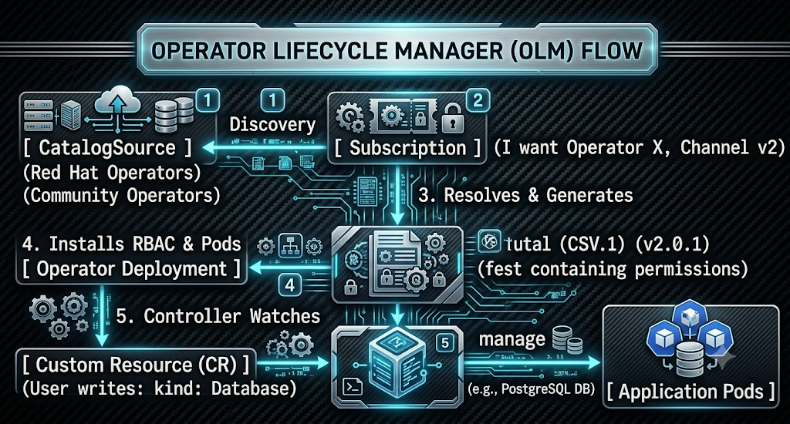

5. YAML Breakdown
Below is the breakdown of a Subscription manifest, which is the primary object used to install an Operator via the CLI.
Field | Description | Required/Optional
apiVersion | operators.coreos.com/v1alpha1 | Required
kind | Subscription | Required
spec.channel | The update stream to track (e.g., stable, fast, v4.12). | Required
spec.name | The exact package name of the Operator. | Required
spec.source | The CatalogSource to pull from (e.g., redhat-operators). | Required
spec.sourceNamespace | The namespace where the catalog lives (usually openshift-marketplace). | Required
spec.installPlanApproval | Dictates how upgrades happen: Automatic or Manual. | Optional (Defaults to Automatic)
6. CLI Commands
Command | Purpose
oc get packagemanifests -n openshift-marketplace | Lists all available Operators from all active CatalogSources.
oc describe packagemanifest <name> -n openshift-marketplace | Views details about a specific Operator, including available channels and provided CRDs.
oc get operatorgroups | Lists the OperatorGroups in the current namespace, determining which namespaces the operator will watch.
oc get subscriptions | Lists the active Operator tracking subscriptions in the namespace.
oc get csv | Verifies the status of the installed Operator version (look for Phase: Succeeded).
7. Hands-on Lab
Objective: Install the OpenShift Cert Manager Operator using the CLI by querying the catalog, setting up the required objects, and verifying the installation.
Step 1: Discover the Operator
Search the package manifests to find the exact name of the Cert Manager operator:
Powershell
oc get packagemanifests -n openshift-marketplace | Select-String cert-manager
Inspect the manifest to determine the default channel (e.g., stable-v1):
Powershell
oc describe packagemanifest openshift-cert-manager-operator -n openshift-marketplace | Select-String "Default Channel"

Step 2: Prepare the Namespace
Operators usually require their own namespace (or a target namespace).
Bash
oc new-project cert-manager-operator

Step 3: Create the OperatorGroup
OLM requires an OperatorGroup in the namespace before it will process a Subscription. This tells the Operator which namespaces it is allowed to manage.
Bash
cat <<EOF > operatorgroup.yaml
apiVersion: operators.coreos.com/v1
kind: OperatorGroup
metadata:
name: cert-manager-og
namespace: cert-manager-operator
spec: {}

EOF
oc apply -f operatorgroup.yaml

Step 4: Create the Subscription
Define and apply the Subscription to trigger OLM to install the Operator:
Bash
cat <<EOF > subscription.yaml
apiVersion: operators.coreos.com/v1alpha1
kind: Subscription
metadata:
name: openshift-cert-manager-operator
namespace: cert-manager-operator
spec:
channel: stable-v1
installPlanApproval: Automatic
name: openshift-cert-manager-operator
source: redhat-operators
sourceNamespace: openshift-marketplace
EOF
oc apply -f subscription.yaml

Step 5: Verify the Installation
Wait a few moments, then check if OLM successfully generated the CSV and deployed the pods:
Bash
oc get pods -n openshift-marketplace -w
oc get csv -n cert-manager-operator
oc get pods -n cert-manager-operator

Cleanup
oc delete subscription openshift-cert-manager-operator -n cert-manager-operator
oc delete csv --all -n cert-manager-operator
oc delete project cert-manager-operator
Remove-Item operatorgroup.yaml, subscription.yaml -ErrorAction SilentlyContinue

8. Troubleshooting Lab
Scenario: A student attempts to install the Advanced Cluster Management (ACM) Operator via the CLI. They successfully write and apply the Subscription.yaml manifest. The command returns subscription.operators.coreos.com/acm-operator created. However, 10 minutes pass, and running oc get csv returns No resources found. The Operator pod never spins up.
The Mistake: The student created the Subscription in a newly minted namespace, but they completely forgot to create an OperatorGroup first. Without an OperatorGroup, OLM's resolution engine pauses. It does not know the intended scope of the Operator (whether it should watch all namespaces or just specific ones), so it refuses to generate the InstallPlan or the CSV.
The Fix:
- Check the status of the Subscription to identify the bottleneck:
Bash
oc describe subscription acm-operator

(Look at the events at the bottom. You will likely see an error stating "No OperatorGroup found".)
- Verify that no OperatorGroup exists in the current namespace:
Bash
oc get operatorgroup

- Create a default OperatorGroup that targets the current namespace:
Bash
cat <<EOF | oc apply -f -
apiVersion: operators.coreos.com/v1
kind: OperatorGroup
metadata:
name: acm-og
EOF

- Check the CSV again. Within seconds of the OperatorGroup being applied, OLM will unpause and generate the CSV:
Bash
oc get csv -w

9. Interview Questions
- Basic: What is the fundamental difference between using Helm and using an Operator to deploy an application?
  - Answer: Helm is primarily a "Day 1" packaging tool; it templates YAML files and applies them to the cluster, but once deployed, Helm has no active process monitoring the application's health. An Operator is a "Day 2" lifecycle management tool; it includes a continuously running software controller inside the cluster that actively watches the application, handles self-healing, manages complex backups, and performs seamless version upgrades.
- Intermediate: Explain the relationship between a Subscription and a ClusterServiceVersion (CSV).
  - Answer: A Subscription is the request made by the user to track and install an Operator from a catalog (like a subscription to a magazine). The CSV is the actual, tangible output generated by OLM in response to that subscription. The CSV contains all the metadata, container images, and strict RBAC definitions required to actually spin up the Operator pods on the cluster (the magazine issue itself).
- Scenario: You are managing an OpenShift cluster for an enterprise bank. Security policy dictates that no software upgrades can occur outside of approved weekend maintenance windows. However, you need to use an Operator. How do you configure OLM to ensure it doesn't automatically pull down and apply a major Operator update on a Tuesday morning?
  - Answer: When creating the Subscription for the Operator, I would set the spec.installPlanApproval field to Manual. This tells OLM to track the catalog for updates and generate a new InstallPlan when a new version is detected, but it will freeze and wait for a cluster administrator to explicitly review and approve that InstallPlan before executing the upgrade and changing the CSV.
10. Assignment
Task: Install an Operator using the OpenShift Web Console graphical interface.
- Log into the OpenShift Web Console as a cluster administrator (kubeadmin).
- Navigate to Operators -> OperatorHub in the left-hand menu.
- Search for the Web Terminal Operator (provided by Red Hat).
- Click Install.
- During the installation configuration, observe the UI options: Ensure the update channel is set appropriately, leave the Installation Mode to its default (All namespaces), and set the Update Approval to Automatic.
- Click Install and wait for the status to change to Installed.
- Verify the installation worked: Open a terminal locally and run oc get csv -n openshift-operators. You should see the Web Terminal CSV listed with a Succeeded phase.
- Bonus: Test the Operator by clicking the new terminal icon >_ that should have appeared in the top right header of the OpenShift Web Console.

Chapter 8 – Application Security

1. Real World Problem
Imagine your development team writes a custom node-level logging agent. This agent must run on every worker node, read the physical host's /var/log directory, and run as the root user to access those files. In vanilla Kubernetes, a developer might just set privileged: true in the deployment YAML and deploy it. But when they try this in OpenShift, the cluster outright rejects the pod or forces it to run under a randomized, unprivileged user ID, causing the app to crash with "Permission Denied" errors. You need a way to selectively bypass OpenShift's ironclad default security to allow specific applications elevated host access, without granting the developers global admin rights.
2. Theory
OpenShift enforces a two-tiered security model for applications:
- RBAC (Role-Based Access Control): Controls what a pod can do to the Kubernetes API (e.g., can it delete other pods? Can it read secrets?).
- SCC (Security Context Constraints): Controls what a pod can do to the Host Linux Operating System (e.g., can it run as root? Can it mount host directories? Can it use host networking?).
OpenShift Specific: By default, OpenShift applies the restricted-v2 SCC to all pods. This forces the pod to run as a randomly assigned, high-number user ID (e.g., UID 1000650000) and completely blocks root access.
To grant a pod elevated privileges (either API access or Host OS access), you must use a ServiceAccount. A ServiceAccount is a special type of user identity that belongs to an application, not a human. You create a ServiceAccount, attach the necessary RBAC roles or SCCs to it, and then instruct your deployment to run as that ServiceAccount instead of the default one.
Once applications have the right ServiceAccounts, you can automate them using CronJobs, which are native Kubernetes objects that run pods on a time-based schedule (like Linux cron), perfect for database backups or cluster cleanup tasks.
3. Key Terminologies
- ServiceAccount (SA): An identity used by processes running inside a pod to interact with the OpenShift cluster or authenticate against SCCs.
- Security Context Constraints (SCC): OpenShift-specific policies that dictate the OS-level permissions of a pod (e.g., root access, host mounts).
- anyuid SCC: A built-in SCC that allows a pod to run as the User ID defined in the container image (including root/UID 0) rather than a randomized ID.
- privileged SCC: The most dangerous SCC; allows the pod to do almost anything the host kernel allows, bypassing almost all container isolation.
- CronJob: A Kubernetes resource that creates Jobs on a repeating schedule defined by a standard cron expression format (e.g., * * * * *).
4. Architecture Diagram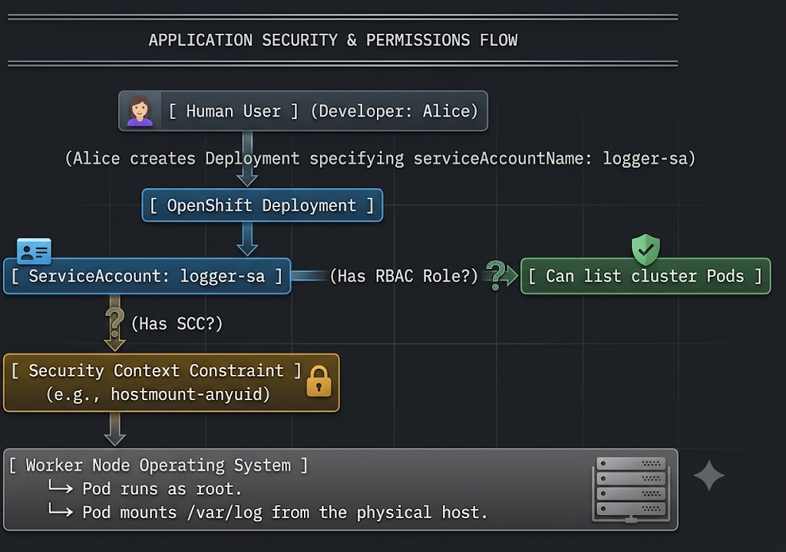
5. YAML Breakdown
Below is the breakdown of a CronJob manifest that specifically references a custom ServiceAccount.
Field | Description | Required/Optional
apiVersion | batch/v1 | Required
kind | CronJob | Required
spec.schedule | The cron expression dictating when the job runs (e.g., */5 * * * * for every 5 minutes). | Required
spec.jobTemplate | The template describing the Job to be created. | Required
spec.jobTemplate.spec.template | The Pod template for the actual work. | Required
...spec.serviceAccountName | The identity the Pod assumes. If omitted, defaults to default. | Optional
...spec.restartPolicy | Must be set to OnFailure or Never for Jobs (cannot be Always). | Required
6. CLI Commands
Command | Purpose
oc create sa <sa-name> | Creates a new ServiceAccount in the current project.
oc get scc | Lists all Security Context Constraints available in the cluster.
oc adm policy add-scc-to-user <scc-name> -z <sa-name> | Grants an SCC to a ServiceAccount (-z stands for service account).
oc adm policy add-role-to-user <role> -z <sa-name> | Grants an RBAC role to a ServiceAccount.
oc set serviceaccount deployment/<name> <sa-name> | Updates an existing deployment to run as a specific ServiceAccount.
7. Hands-on Lab -A
Objective: Deploy an application that requires root privileges by creating a ServiceAccount and assigning it the anyuid SCC.
Step 1: Create a project and attempt to run a root pod
Bash
oc new-project app-sec-lab
# We use a standard centos image which attempts to run as root by default
oc create deployment root-test --image=quay.io/centos/centos:stream8 -- command "sleep" "3600"

Step 2: Observe the default restriction
Check the UID the pod is actually running as. Notice it is NOT root (UID 0), because the default restricted-v2 SCC overrode it with a random high number:
Bash
oc exec deployment/root-test -- id

Step 3: Create a custom ServiceAccount
Bash
oc create sa root-runner

Step 4: Grant the SCC to the ServiceAccount
You must be a cluster administrator (kubeadmin) to grant SCCs.
Bash
oc login -u kubeadmin -p <password>
oc project app-sec-lab
oc adm policy add-scc-to-user anyuid -z root-runner

Step 5: Attach the ServiceAccount to the Deployment
Instruct the deployment to use our new root-runner ServiceAccount instead of the default one.
Bash
oc set serviceaccount deployment/root-test root-runner

Step 6: Verify the application now runs as root
The deployment will automatically spin up a new pod. Check its ID:
Bash
oc exec deployment/root-test -- id
#Output should now show: uid=0(root) gid=0(root)

7 Hand on Lab – B
Lab Objectives
- Automate Cluster Maintenance: Deploy and configure a Kubernetes CronJob resource to execute administrative tasks on a recurring, automated schedule.
- Inject Executable Scripts: Utilize a ConfigMap to store and mount a bash script into a Pod without baking it directly into the container image.
- Manage Execution Identities: Create a dedicated ServiceAccount to separate the automated workload's identity from the default namespace identity.
- Elevate Application Security Contexts: Safely bypass OpenShift's default container isolation by binding the privileged Security Context Constraint (SCC) to a specific ServiceAccount, allowing it root-level access to the host.
- Configure Global RBAC: Grant cluster-wide API access to an automated process by assigning the cluster-admin ClusterRole.
- Execute Host-Level Commands: Use the oc debug mechanism and chroot /host to access the underlying OpenShift node's operating system and directly interact with the CRI-O container runtime (crictl).

Step 1: Create the ConfigMap
This ConfigMap holds the bash script that will loop through your node(s) and execute the crictl prune command via oc debug.
Run the following command to create the file and apply it:
Bash
oc login -u kubeadmin -p <your-crc-password> https://api.crc.testing:6443
oc new-project appsec-prune

cat << 'EOF' > configmap-prune.yaml
apiVersion: v1
kind: ConfigMap
metadata:
name: maintenance
labels:
ge: appsec-prune
app: crictl
data:
maintenance.sh: |
#!/bin/bash -eu
NODES=$(oc get nodes -o=name)
for NODE in ${NODES}
do
echo ${NODE}
oc debug ${NODE} -- chroot /host /bin/bash -euxc 'crictl images ; crictl rmi --prune'
done
EOF

oc apply -f configmap-prune.yaml

Step 3: Configure Security Permissions
The script requires deep node-level access. You need a dedicated ServiceAccount with elevated privileges to run it.
Bash
# 1. Create the ServiceAccount
oc create sa image-pruner

# 2. Grant the required Security Context Constraint (SCC)
oc adm policy add-scc-to-user privileged -z image-pruner

# 3. Grant Cluster Admin permissions so it can query nodes
oc adm policy add-cluster-role-to-user cluster-admin -z image-pruner

Step 4: Create the CronJob
This CronJob is scheduled to run every 4 minutes. Notice it uses the public quay.io image and already references the image-pruner ServiceAccount.
Run the following command to create and apply the file:
Bash
cat << 'EOF' > cronjob-prune.yaml
apiVersion: batch/v1
kind: CronJob
metadata:
name: image-pruner
labels:
ge: appsec-prune
app: crictl
spec:
schedule: '*/4 * * * *'
jobTemplate:
spec:
template:
spec:
serviceAccountName: image-pruner
dnsPolicy: ClusterFirst
restartPolicy: Never
containers:
- name: crictl
image: quay.io/openshift/origin-cli:4.18
resources: {}
command:
- /opt/maintenance.sh
volumeMounts:
- name: scripts
mountPath: /opt
volumes:
- name: scripts
configMap:
name: maintenance
defaultMode: 0555
EOF

oc apply -f cronjob-prune.yaml

Step 5: Test the Pruner Job
Because the cron schedule is set to */4 (every 4 minutes), you can either wait, or instantly trigger a manual job from the CronJob to test it right away:
Bash
# Manually trigger the job immediately
oc create job --from=cronjob/image-pruner manual-prune-test

# Watch for the pod to spin up and complete
watch oc get jobs,pods
Once the pod shows Completed, check the logs to verify it successfully ran the prune command on your CRC node:
Bash
# Replace the pod name with your actual pod name
oc logs pod/manual-prune-test-xxxxx

(Note: As the lab mentions, you can safely ignore any errors stating an image is currently in use by a container. crictl will only prune unused images).
Step 6: Clean Up
When you are finished testing, clean up your CRC environment so the job doesn't run forever in the background.
Bash
oc delete cronjob/image-pruner configmap/maintenance
oc adm policy remove-scc-from-user privileged -z image-pruner
oc adm policy remove-cluster-role-from-user cluster-admin -z image-pruner
oc delete project appsec-prune

8. Troubleshooting Lab
Scenario: A student creates a CronJob to automatically back up OpenShift objects (like ConfigMaps) to an external server. The CronJob triggers on time, but the pod immediately fails. Checking the logs of the pod reveals: Error from server (Forbidden): configmaps is forbidden: User "system:serviceaccount:backup-project:default" cannot list resource "configmaps" in API group "" in the namespace "backup-project".
The Mistake: The student successfully scheduled the pod using a CronJob, but they assumed the pod would inherently have administrative rights to the OpenShift API. By default, pods run as the default ServiceAccount, which has zero RBAC permissions to read or write Kubernetes API objects.
The Fix:
- Create a dedicated ServiceAccount for the backup task:
Bash
oc create sa backup-bot

- Grant the necessary RBAC role (view or edit) to the new ServiceAccount in the current project:
Bash
oc adm policy add-role-to-user view -z backup-bot

- Edit the CronJob to explicitly use this new identity:
Bash
oc edit cronjob <cronjob-name>

- Find the Pod spec section (under jobTemplate.spec.template.spec) and add the serviceAccountName:
YAML
spec:
serviceAccountName: backup-bot
containers:
- name: backup-container

- Test the job immediately without waiting for the cron schedule:
Bash
oc create job --from=cronjob/<cronjob-name> manual-backup-test

9. Interview Questions
- Basic: What is the difference between a User and a ServiceAccount in OpenShift?
  - Answer: A User represents a human (like a developer or administrator) who interacts with the cluster via the CLI or Web Console. A ServiceAccount represents an application/pod running inside the cluster that needs to interact with the OpenShift API or the host operating system.
- Intermediate: Explain the difference between RBAC and SCC.
  - Answer: RBAC (Role-Based Access Control) governs access to the OpenShift API (e.g., creating pods, deleting services, reading secrets). SCC (Security Context Constraints) governs access to the worker node's Host Linux Kernel (e.g., running as the root user, mounting host directories, dropping Linux capabilities).
- Scenario: You have a third-party security scanner container that must be deployed as a DaemonSet. It requires access to the host's /var/run/docker.sock or crio socket to scan running containers. How do you deploy this securely?
  - Answer: I would never assign an SCC directly to a human user. Instead, I would create a dedicated ServiceAccount specifically for the scanner. I would log in as cluster-admin and run oc adm policy add-scc-to-user privileged -z <scanner-sa>. Finally, I would configure the DaemonSet YAML to include serviceAccountName: <scanner-sa> so that only the scanner pods run with those highly elevated host privileges.
10. Assignment
Task: Automate cluster cleanup using a CronJob and an elevated ServiceAccount.
- Create a new project called cron-cleanup.
- Create three dummy pods using the standard nginx image and label them all status=stale.
- Create a ServiceAccount named janitor.
- Grant the janitor ServiceAccount the edit role in the cron-cleanup project so it has permission to delete pods.
- Create a CronJob YAML manifest named stale-pod-remover.
- Configure the schedule to run every 2 minutes (*/2 * * * *).
- The container image should be registry.redhat.io/openshift4/ose-cli:latest (which contains the oc binary).
- The command the container runs should be: ["/bin/sh", "-c", "oc delete pods -l status=stale"].
- Ensure the CronJob specification sets serviceAccountName: janitor.
- Apply the CronJob, wait 2 minutes, and verify the nginx pods have been successfully deleted by the automated task.

Chapter 9. OpenShift Updates
1. Real World Problem
Imagine an urgent, critical security vulnerability (CVE) is discovered in the core Kubernetes API server. In a traditional IT environment, patching the cluster infrastructure means scheduling an 8-hour weekend maintenance window, notifying all customers of downtime, manually upgrading components one by one, and crossing your fingers that the state store doesn't corrupt. If it fails, rolling back could take days. You need a mechanism that delivers secure, over-the-air updates to both the cluster control plane and the underlying host operating systems automatically, ensuring that production applications continue running without a single dropped packet during the process.
2. Theory
OpenShift completely revolutionizes the cluster upgrade process. Instead of treating the cluster as a collection of disjointed Linux packages, OpenShift is fundamentally "self-updating." The cluster is managed by the Cluster Version Operator (CVO).
When an update is initiated, the CVO fetches a cryptographic payload from the OpenShift Update Service (OSUS). It then begins updating the cluster's core services (the Cluster Operators) in a highly specific, dependency-aware order.
Once the control plane operators are updated, the Machine Config Operator (MCO) takes over to update the worker nodes. It performs a rolling update: it cordons a node (stops new pods from scheduling), drains it (safely evicts existing pods to other nodes), applies the new Red Hat Enterprise Linux CoreOS (RHCOS) image, reboots the node, and uncordons it.
The Danger of Deprecated APIs: Before upgrading, cluster administrators must verify that no applications are using deprecated Kubernetes APIs (e.g., relying on a v1beta1 manifest when the new cluster version completely removes it in favor of v1). If a cluster upgrades and removes an API that a core application relies on, that application will break or be unmanageable.
3. Key Terminologies
- Cluster Version Operator (CVO): The master operator that orchestrates the update process for the entire OpenShift cluster payload.
- Machine Config Operator (MCO): The operator responsible for managing and updating the base operating system (RHCOS) of the cluster nodes.
- Update Channel: A release stream (e.g., stable-4.12, fast-4.12) that dictates which update versions the cluster is allowed to see and pull from the Red Hat Update Service.
- Upgrade Graph: The web of verified, safe upgrade paths. You cannot always jump directly from version A to version Z; you must follow the graph (e.g., A → B → C).
- APIRequestCount: A native OpenShift custom resource that tracks how many times a specific API endpoint has been called, used to hunt down deprecated API usage.
4. Architecture Diagram
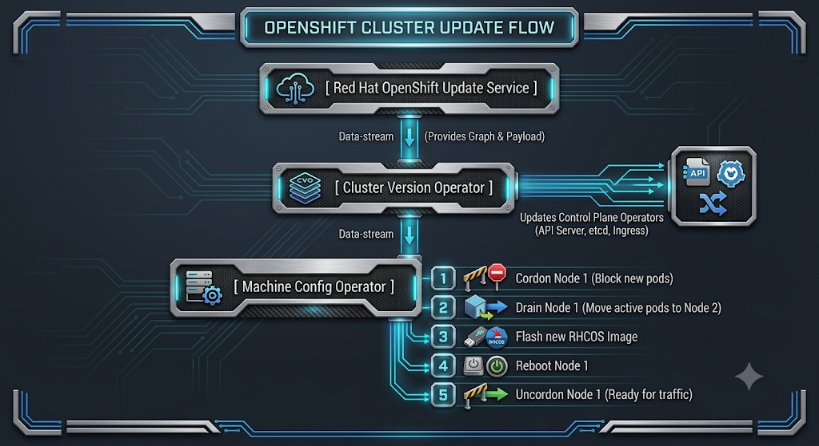
5. YAML Breakdown
Below is a breakdown of the ClusterVersion global configuration resource, which dictates how the cluster receives updates.
Field | Description | Required/Optional
apiVersion | config.openshift.io/v1 | Required
kind | ClusterVersion | Required
metadata.name | Must always be exactly version. | Required
spec.channel | The release channel to track (e.g., stable-4.12). | Required
spec.upstream | The URL of the update server (defaults to Red Hat's public OSUS server). | Optional
status.availableUpdates | A list of valid target versions the cluster can safely upgrade to right now based on the graph. | Read-Only (System)
status.history | A log of all previous updates applied to the cluster and their completion status. | Read-Only (System)
6. CLI Commands
Command | Purpose
oc get clusterversion | Displays the current cluster version and whether an update is available.
oc adm upgrade | Lists the available updates and the current update channel.
oc adm upgrade --to=<version> | Triggers the cluster upgrade to a specific, available version.
oc get clusteroperators | Monitors the health and upgrade status of all core cluster operators.
oc get apirequestcounts | Lists metrics on API usage to help identify deprecated API calls before an upgrade.
7. Hands-on Lab
Objective: Evaluate the cluster's upgrade path, check for deprecated APIs, and initiate an update command.
Step 1: Check current version and available updates
Log in as kubeadmin and check the overarching cluster version status:
Bash
oc get clusterversion
oc adm upgrade

Note the available versions listed in the output.
Remove the Override
Run these two commands exactly as written:
$patch = '{"spec":{"overrides":[]}}'
oc patch clusterversion version --type=merge -p $patch
OR
oc edit clusterversion version
#make changes to YAML

Step 2: Detect Deprecated API Usage
Before updating, verify if anyone is using an API that is slated for removal. Ask OpenShift to show you the API request counts:
Bash
oc get apirequestcounts -o custom-columns=NAME:.metadata.name,REMOVED_IN:.status.removedInRelease,REQUESTS_LAST_HOUR:.status.requestCount --sort-by=.status.removedInRelease

If a resource shows it will be removed in the next release AND has requests in the last hour, you must investigate which namespace/user is calling it.
Step 3: Trigger the Update
If an update is available (e.g., 4.12.15), initiate it:
Bash
oc adm upgrade --to=4.21.15

Step 4: Monitor the Control Plane Update
Watch the ClusterVersion object to see the percentage complete:
Bash
oc watch clusterversion

Simultaneously, you can watch the individual cluster operators transition their versions:
Bash
oc get clusteroperators

Step 5: Monitor the Node Update
Once the CVO finishes the operators, the MCO begins rolling the worker nodes. Watch the nodes transition into SchedulingDisabled and NotReady states as they reboot:
Bash
oc get nodes -w

8. Troubleshooting Lab
Scenario: A cluster administrator initiates a minor version update. The control plane operators update successfully, but the cluster upgrade process halts at 85%. The administrator runs oc get nodes and sees worker-node-1 has been stuck in the SchedulingDisabled state for 45 minutes, but never reboots.
The Mistake: A developer deployed an application with a highly restrictive PodDisruptionBudget (PDB) requiring 100% of the replicas to be available at all times. When the Machine Config Operator attempts to "drain" worker-node-1, it tries to gracefully evict the pod. The PDB blocks the eviction because terminating the pod would violate the availability rule. The node drain hangs infinitely, freezing the entire cluster upgrade.
The Fix:
- Identify the node that is stuck:
Bash
oc get nodes

- Manually check the drain logs or events on that specific node to see which pod is refusing to be evicted:
Bash
oc adm drain <node-name> --dry-run=true

(The output will explicitly state "Cannot evict pod due to PodDisruptionBudget")
- Locate the restrictive PDB in the developer's namespace:
Bash
oc get pdb -A

- Temporarily edit or delete the PDB to allow the eviction to proceed:
Bash
oc delete pdb <pdb-name> -n <namespace>

- Return to watching the nodes. The MCO will immediately resume the drain process, and the node will reboot, unblocking the cluster upgrade.
9. Interview Questions
- Basic: What is the difference between the Cluster Version Operator (CVO) and the Machine Config Operator (MCO) during an update?
  - Answer: The CVO is responsible for updating the software components running inside the cluster (the OpenShift API, Ingress controller, DNS, networking plugins). The MCO is responsible for updating the physical or virtual host machines themselves (updating the CoreOS kernel, applying kubelet configurations, and coordinating the node reboots).
- Intermediate: You want to upgrade your cluster from OpenShift 4.10 directly to OpenShift 4.12. However, when you run oc adm upgrade, version 4.12 is not listed as an option. Why, and how do you resolve this?
  - Answer: OpenShift upgrades must follow verified upgrade graphs to ensure data structures (like etcd) migrate correctly. You cannot skip minor versions. To get from 4.10 to 4.12, you must first run oc adm upgrade --to=<latest-4.11-version>. Once the cluster stabilizes on 4.11, the upgrade graph will automatically present 4.12 as the next available target.
- Scenario: You are tasked with upgrading an OLM-managed Operator (like OpenShift Serverless) via the Web Console. The Operator's subscription is set to Manual approval. Walk me through exactly what happens when a new version hits the Red Hat catalog, and how you apply it.
  - Answer: Because the subscription is set to Manual, the Operator Lifecycle Manager (OLM) will detect the new version in the catalog but will not install it. Instead, OLM generates an InstallPlan object and places it in an "Upgrade Pending" state. As the administrator, I must log into the Web Console, navigate to the Installed Operators page, click on the pending upgrade, review the proposed changes (like new RBAC rules or CRDs), and explicitly click "Approve". Only then will OLM generate the new ClusterServiceVersion (CSV) and roll out the new operator pods.
10. Assignment
Task: Investigate deprecated API usage using the CLI.
- Log into your OpenShift cluster as kubeadmin.
- Run the command to list all APIRequestCount resources.
- Identify an API resource that is heavily used (e.g., pods or routes.route.openshift.io).
- Output the exact YAML structure of that specific API's APIRequestCount using oc get apirequestcount <name> -o yaml.
- Analyze the status.currentHour block in the YAML. Write a short explanation detailing how many total requests were made to that API in the current hour, and identify which username or serviceaccount is generating the highest volume of those requests.

Chapter 10. OpenShift Capstone Project

1. Real World Problem
Imagine you are the lead architect for a production OpenShift cluster. A development team needs to deploy a complex, stateful application stack (like a managed database and API backend) provided by a vendor as a Helm chart. This third-party chart requires specific compute resources, unique internal TLS certificates, and a container that historically runs as root. If you grant the developers full cluster admin rights, you compromise the entire environment. If you do nothing, their Helm deployment will fail immediately due to OpenShift's default security constraints. You must seamlessly combine Developer Self-Service (Quotas/RBAC), Application Security (SCCs/Network Policies), and Package Management (Helm) to allow them to deploy successfully, autonomously, and securely.
2. Theory
This comprehensive review brings together three foundational pillars of OpenShift Administration:
- Cluster Self-Service: In a multi-tenant environment, you cannot afford to have Operations manually provision every pod. You enable self-service by defining strict boundaries using ResourceQuotas (to cap total consumption) and LimitRanges (to catch unbounded pods).
- Application Security: OpenShift's default posture is zero-trust. Pods are isolated via NetworkPolicies (default deny), and host-level access is heavily restricted by the restricted-v2 Security Context Constraint (SCC). When an application genuinely needs elevated privileges (like running as a specific UID), you do not give the developer an SCC; instead, you bind the SCC to a specific ServiceAccount and force the application to use it.
- Packaged Applications: Modern applications are rarely deployed via dozens of manual YAML files. They are parameterizable and version-controlled. By utilizing OpenShift Templates and Helm Charts, administrators can provide standardized, repeatable deployment patterns that respect the quotas and security boundaries established in the cluster.
3. Key Terminologies
- Comprehensive Multi-Tenancy: The architectural practice of safely hosting multiple independent teams or applications on a single OpenShift cluster without resource starvation or security cross-contamination.
- Resource Boundary: The combination of ResourceQuotas and LimitRanges that constrain a project.
- Execution Boundary: The combination of ServiceAccounts and SCCs that dictate what a running container is allowed to do on the host operating system.
- Network Boundary: Layer 3/4 NetworkPolicies that prevent unauthorized pod-to-pod communication.

4. Architecture Diagram
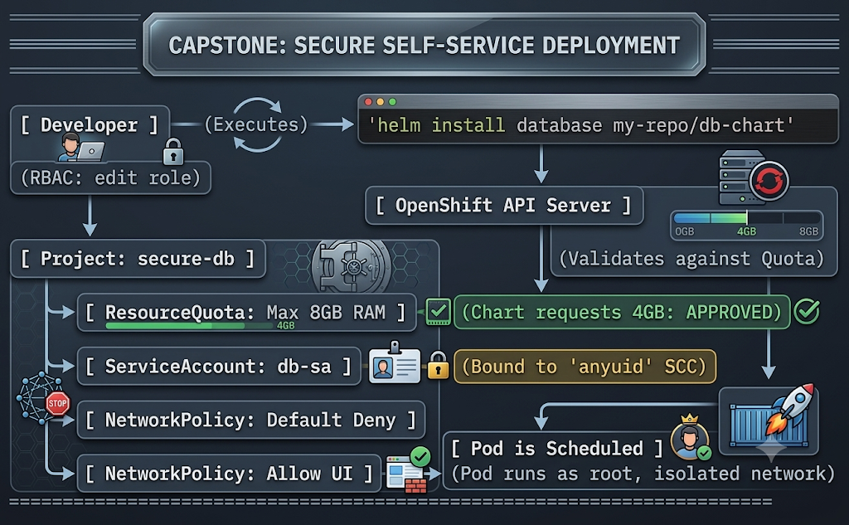

5. YAML Breakdown
In a comprehensive review, it is critical to understand how a packaged application explicitly requests a security identity. Below is the YAML breakdown of a standard Deployment (often generated by Helm or a Template) specifically invoking a custom ServiceAccount.
Field | Description | Required/Optional
apiVersion | apps/v1 | Required
kind | Deployment | Required
spec.template.spec.serviceAccountName | CRITICAL: Binds the pods to a specific ServiceAccount (e.g., db-runner) instead of the default account, allowing it to inherit custom SCCs. | Optional (Defaults to default)
spec.template.spec.securityContext | Defines pod-level security settings (e.g., runAsUser: 0). This will be rejected by OpenShift unless the ServiceAccount holds the correct SCC. | Optional
spec.template.spec.containers[].resources | Defines requests and limits. Must comply with the namespace's ResourceQuota and LimitRange. | Optional (Highly Recommended)
6. CLI Commands
A master cheat sheet of the core commands required for configuring a production environment.
Command | Purpose
oc create quota <name> --hard=pods=10,limits.memory=8Gi | Establishes the resource boundary for the project.
oc adm policy add-role-to-user edit <user> | Grants a developer self-service rights within a boundary.
oc create sa <sa-name> | Creates an execution identity for an application.
oc adm policy add-scc-to-user anyuid -z <sa-name> | Elevates the execution identity (Admin only).
oc process -f <template> -p PARAM=value | oc apply -f - | Deploys a packaged OpenShift template.
helm install <release> <chart> -f values.yaml | Deploys a packaged Helm chart.
7. Hands-on Lab
Objective: Synthesize the course. Create a locked-down project, configure a ServiceAccount with an elevated SCC, and deploy an application via an OpenShift template that utilizes that ServiceAccount.
Step 1: Set up Cluster Self-Service Boundaries
Log in as the cluster administrator and create a strictly bounded project for a developer.
Bash
oc login -u kubeadmin
oc new-project capstone-lab
oc create quota capstone-quota --hard=pods=5,requests.cpu=1,requests.memory=2Gi,limits.cpu=2,limits.memory=4Gi
oc adm policy add-role-to-user edit dev-user -n capstone-lab

Step 2: Secure Applications (Execution Boundary)
Create a ServiceAccount designed to run a legacy application that requires root access. Grant the SCC as the administrator.
Bash
oc create sa legacy-app-sa
oc adm policy add-scc-to-user anyuid -z legacy-app-sa

Step 3: Secure Applications (Network Boundary)
Apply a default-deny NetworkPolicy to ensure the application is completely isolated from other tenants.
Bash
cat <<EOF | oc apply -f -
kind: NetworkPolicy
apiVersion: networking.k8s.io/v1
metadata:
name: default-deny
spec:
podSelector: {}
ingress: []
EOF

Step 4: Deploy Packaged Applications
Log in as the developer and deploy an application using an OpenShift template. We will pass a parameter to force the template to use the new ServiceAccount.
(Note: Assume legacy-template.yaml exists and accepts a SA_NAME parameter).
Bash
oc login -u dev-user
oc project capstone-lab
oc process -f legacy-template.yaml -p SA_NAME=legacy-app-sa | oc apply -f -

Step 5: Verify the Deployment
Check that the pod successfully started (proving the quota was not violated and the SCC was accepted) and verify its network isolation.
Bash
oc get pods
oc describe quota capstone-quota

8. Troubleshooting Lab
Scenario: A developer uses Helm to upgrade a currently running application: helm upgrade backend-db my-repo/database --set limits.memory=8Gi. The Helm command reports STATUS: deployed, but the developer notices the old pods are terminating, and the new pods are stuck in Pending. The application goes down.
The Mistake: The developer attempted a standard deployment process, but their new values.yaml override (limits.memory=8Gi) exceeded the hard limits defined by the namespace's ResourceQuota (which was capped at 4Gi). Helm tracks the deployment object success, not necessarily the pod scheduling success.
The Fix:
- Diagnose the issue by checking the ReplicaSet (which manages the pods) rather than just the Deployment or Helm status:
Bash
oc get replicaset
oc describe replicaset <name-of-new-replicaset>

(Look at the events: Error creating: pods is forbidden: exceeded quota: limits.memory)
- Check the current quota consumption to understand the limit:
Bash
oc describe quota

- Use Helm's rollback feature to immediately restore the application to its previous, functioning state while the developer fixes their resource requests:
Bash
helm history backend-db
helm rollback backend-db 1

- Verify the original pods spin back up:
Bash
oc get pods -w

9. Interview Questions
- Basic: If a developer complains that they cannot create a new OpenShift project because they get a "Forbidden" error, what cluster configuration is likely responsible?
  - Answer: An administrator has likely removed the self-provisioner cluster role from the system:authenticated:oauth group, disabling global developer self-service to enforce strict operations-led provisioning.
- Intermediate: You apply a NetworkPolicy to a namespace that allows ingress on port 8080 from pods labeled role=frontend. However, external users hitting the OpenShift Route still get a 503 error. Why?
  - Answer: OpenShift Routes utilize the OpenShift Ingress Controller (HAProxy). If you implement a restrictive NetworkPolicy, you must explicitly write a rule that allows ingress traffic from the namespace containing the OpenShift router (using a namespaceSelector matching network.openshift.io/policy-group: ingress), otherwise the router itself is blocked from reaching your pod.
- Scenario: You are handed a Helm chart for a monitoring agent. The documentation states it must run with privileged: true in its security context. Walk me through the exact, secure administrative workflow to allow a developer to deploy this Helm chart without making the developer a cluster admin.
  - Answer: First, I create a dedicated target namespace. Second, I create a ServiceAccount in that namespace (e.g., monitor-sa). Third, logged in as kubeadmin, I run oc adm policy add-scc-to-user privileged -z monitor-sa. Finally, I instruct the developer to run their helm install command, passing a custom value (e.g., --set serviceAccount.name=monitor-sa) so the deployed pods assume the identity of the ServiceAccount with the elevated SCC.
10. Assignment
Task: Execute the Ultimate Capstone Challenge in your OpenShift Local environment.
- Log in as a cluster administrator.
- Create a project named final-exam.
- Create a ResourceQuota restricting the namespace to exactly 2 pods and 1Gi of memory limits.
- Create a ServiceAccount named web-runner.
- Create a NetworkPolicy that allows ingress traffic only from the OpenShift Ingress Controller.
- Create a custom OpenShift Template (final-template.yaml) that defines a standard Nginx Deployment and a Service. Parameterize the serviceAccountName field in the template.
- Process and apply the template, explicitly passing the web-runner ServiceAccount as a parameter.
- Expose the Service using an Edge-terminated Route.
- Attempt to scale your deployment to 3 replicas using oc scale.
- Document the error message you receive (proving your ResourceQuota successfully blocked the scaling attempt), and verify you can successfully curl your Edge Route (proving your Network Policy allowed the router traffic).

EXAM LABS
Lab Question: Deploy Packaged Applications
Log in to the local CRC cluster as the developer user with developer as the password. Create the packaged-review and packaged-review-prod projects.
1. Add a public Helm repository to your environment using the URL https://charts.bitnami.com/bitnami and examine its contents.
2. Install the nginx chart from your new repository into the packaged-review namespace, with the release name test. Use the quay.io/redhattraining/hello-world-nginx:v1.0 image from the provided public list.
Create a values-test.yaml file with the specific image registry, repository, and tag parameters required to override the default chart image:
- image.registry: quay.io
- image.repository: redhattraining/hello-world-nginx
- image.tag: v1.0
3. Upgrade the application in the packaged-review namespace. Set the image tag for the deployment in the values-test.yaml file to use the latest version available in your image list:
- image.tag: latest
4. Create a second deployment of the chart in the packaged-review-prod namespace, using the prod release name and the original v1.0 image. Copy the values-test.yaml file to a new values-prod.yaml file. Enable the route (ingress) and set the host to map to your CRC environment:
- ingress.enabled: true
- ingress.hostname: hello.apps-crc.testing
Access the application via the route URL to verify that it is working correctly: http://hello.apps-crc.testing

5. Add resource limits to the prod instance in the packaged-review-prod namespace. Set limits and requests for the deployment in the values-prod.yaml file. Upgrade the release to apply the changes.
- resources.limits.memory: 256Mi
- resources.requests.memory: 128Mi
Lab Solution
Prerequisites & Login
Log in to your local CRC cluster and create the required projects.
Bash
oc login -u developer -p developer https://api.crc.testing:6443
oc new-project packaged-review
oc new-project packaged-review-prod

Step 1: Add and search the Helm repository
Bash
helm repo add do280-repo https://charts.bitnami.com/bitnami
helm repo update
helm search repo do280-repo/nginx

Step 2: Create values file and install the test release
Create the values-test.yaml file:
YAML
image:
registry: quay.io
repository: redhattraining/hello-world-nginx
tag: "v1.0"

Install the Helm chart in the packaged-review project:
Bash
helm install test do280-repo/nginx -n packaged-review -f values-test.yaml

Step 3: Upgrade the test release
Update the values-test.yaml file to change the image tag to latest:
YAML
image:
registry: quay.io
repository: redhattraining/hello-world-nginx
tag: "latest"

Apply the upgrade:
Bash
helm upgrade test do280-repo/nginx -n packaged-review -f values-test.yaml

Step 4: Create the production release and configure the route
Copy the values file:
Bash
cp values-test.yaml values-prod.yaml

Modify values-prod.yaml to revert to v1.0 and configure the CRC route (ingress):
YAML
image:
registry: quay.io
repository: redhattraining/hello-world-nginx
tag: "v1.0"
ingress:
enabled: true
hostname: hello.apps-crc.testing

Install the production deployment in the packaged-review-prod project:
Bash
helm install prod do280-repo/nginx -n packaged-review-prod -f values-prod.yaml

Verify the deployment is accessible:
Bash
curl http://hello.apps-crc.testing

Step 5: Apply resource limits to the production release
Modify values-prod.yaml to include the resource constraints:
YAML
image:
registry: quay.io
repository: redhattraining/hello-world-nginx
tag: "v1.0"
ingress:
enabled: true
hostname: hello.apps-crc.testing
resources:
limits:
memory: 256Mi
requests:
memory: 128Mi

Upgrade the production deployment to apply the limits:
Bash
helm upgrade prod do280-repo/nginx -n packaged-review-prod -f values-prod.yaml

OC Command cheat sheet
1. Project & Access Management
- Create Project: oc new-project <name>
- Delete Project: oc delete project <name>
- Grant Role to User: oc adm policy add-role-to-user <role> <user> -n <project>
- Grant Cluster Role: oc adm policy add-cluster-role-to-user <role> <user>
- Service Account (SA) Management:
  - Create SA: oc create sa <name>
  - Bind SCC to SA: oc adm policy add-scc-to-user <scc> -z <sa-name>
  - Bind Role to SA: oc adm policy add-role-to-user <role> -z <sa-name>
  - Assign SA to Deployment: oc set serviceaccount deployment/<name> <sa-name>
2. Workload & Deployment
- Deploy Template: oc process -f <file> -p PARAM=val | oc apply -f -
- Create from Image: oc new-app <image>~<git-url> --name=<name>
- Expose Service (Route): oc create route edge <name> --service=<svc>
- Edit Resources: oc set resources deployment/<name> --limits=memory=512Mi,cpu=500m
- Start Build: oc start-build <name> --follow
- Import Image: oc import-image <tag> --from=<registry-url> --confirm
3. Networking & Storage
- Network Policies:
  - Apply Policy: oc apply -f <policy.yaml>
  - List/Describe: oc get networkpolicy, oc describe networkpolicy <name>
- Secondary Networks (Multus):
  - List NADs: oc get network-attachment-definitions
  - Attach to Pod: oc annotate pod <pod> k8s.v1.cni.cncf.io/networks=<nad-name>
- Service & LoadBalancer:
  - Expose: oc expose deployment <name> --type=LoadBalancer --name=<svc-name>
  - Patch Service: oc patch svc <svc-name> -p '{"spec": {"type": "NodePort"}}'
4. Cluster Lifecycle & Operators (OLM)
- Upgrade/Version:
  - Check Status: oc get clusterversion, oc adm upgrade
  - Trigger Upgrade: oc adm upgrade --to=<version>
  - Monitor Components: oc get clusteroperators -w, oc get nodes -w
- Operator Management:
  - Search Operators: oc get packagemanifests -n openshift-marketplace | Select-String <name>
  - Get CSV Status: oc get csv -n <namespace>
  - Apply Operator: oc apply -f <operatorgroup.yaml>, oc apply -f <subscription.yaml>
5. Troubleshooting & Observability
- Resources & Quotas:
  - Get All Resources: oc get all
  - Create Quota: oc create quota <name> --hard=<limits>
  - Describe Quota: oc describe quota <name>
- Debugging:
  - Remote Shell into Pod: oc exec -it <pod-name> -- <command>
  - Check API Deprecation: oc get apirequestcounts -o custom-columns=NAME:.metadata.name,REMOVED_IN:.status.removedInRelease,REQUESTS_LAST_HOUR:.status.requestCount --sort-by=.status.removedInRelease
  - Describe Object: oc describe <resource-type> <name>
  - Watch Pods: oc get pods -w
6. Security & Configuration
- Secrets: oc create secret generic <name> --from-file=<key>=<file>
- OAuth Configuration: oc edit oauth cluster
- Security Contexts: oc get scc
- Project Templates:
  - Generate Template: oc adm create-bootstrap-project-template -o yaml
  - Apply Custom Template: oc apply -f <template.yaml> -n openshift-config

Public Source Repository
quay.io/​jkube/​jkube-java-binary-s2i:0.0.9
quay.io/​openshift/​origin-cli:4.12
quay.io/​redhattraining/​books:v1.4
quay.io/​redhattraining/​builds-for-managers
quay.io/​redhattraining/​do280-beeper-api:1.0
quay.io/​redhattraining/​do280-payroll-api:1.0
quay.io/​redhattraining/​do280-product:1.0
quay.io/​redhattraining/​do280-product-stock:1.0
quay.io/​redhattraining/​do280-project-cleaner:v1.0
quay.io/​redhattraining/​do280-project-cleaner:v1.1
quay.io/​redhattraining/​do280-show-config-app:1.0
quay.io/​redhattraining/​do280-stakater-reloader:v0.0.125
quay.io/​redhattraining/​exoplanets:v1.0
quay.io/​redhattraining/​famous-quotes:2.1
quay.io/​redhattraining/​famous-quotes:latest
quay.io/​redhattraining/​gitlab-ce:8.4.3-ce.0
quay.io/​redhattraining/​hello-world-nginx:latest
quay.io/​redhattraining/​hello-world-nginx:v1.0
quay.io/​redhattraining/​loadtest:v1.0
quay.io/​redhattraining/​php-hello-dockerfile
quay.io/​redhattraining/​php-ssl:v1.0
quay.io/​redhattraining/​php-ssl:v1.1
quay.io/​redhattraining/​scaling:v1.0
quay.io/​redhattraining/​todo-angular:v1.1
quay.io/​redhattraining/​todo-angular:v1.2
quay.io/​redhattraining/​todo-backend:release-46
quay.io/redhattraining/do280-roster:v1
quay.io/redhattraining/do280-roster:v2
quay.io/​redhattraining/​wordpress:5.7-php7.4-apache
registry.access.redhat.com/​rhscl/​httpd-24-rhel7:latest
registry.access.redhat.com/​rhscl/​mysql-57-rhel7:latest
registry.access.redhat.com/​rhscl/​nginx-18-rhel7:latest
registry.access.redhat.com/​rhscl/​nodejs-6-rhel7:latest
registry.access.redhat.com/​rhscl/​php-72-rhel7:latest
registry.access.redhat.com/​ubi7/​nginx-118:latest
registry.access.redhat.com/​ubi8/​httpd-24:latest
registry.access.redhat.com/​ubi8:latest/​
registry.access.redhat.com/​ubi8/​nginx-118:latest
registry.access.redhat.com/​ubi8/​nodejs-10:latest
registry.access.redhat.com/​ubi8/​nodejs-16:latest
registry.access.redhat.com/​ubi8/​php-72:latest
registry.access.redhat.com/​ubi8/​php-73:latest
registry.access.redhat.com/​ubi8/​ubi:8.0
registry.access.redhat.com/​ubi8/​ubi:8.4
registry.access.redhat.com/​ubi8/​ubi:latest
registry.access.redhat.com/​ubi9/​httpd-24:latest
registry.access.redhat.com/​ubi9/​nginx-120:latest
registry.access.redhat.com/​ubi9/​ubi:latest
registry.redhat.io/​redhat-openjdk-18/​openjdk18-openshift:1.8
registry.redhat.io/​redhat-openjdk-18/​openjdk18-openshift:latest
registry.redhat.io/​rhel8/​mysql-80:1-211.1664898586
registry.redhat.io/​rhel8/​mysql-80:latest
registry.redhat.io/​rhel8/​postgresql-13:1-7
registry.redhat.io/​rhel8/​postgresql-13:latest
registry.redhat.io/​ubi8/​ubi:8.6-943

