India CPI Inflation Chartbook
  - Fixed Income Macro Analysis
2026-01-12
Table of contents

✓ Loaded 178 rows, 341 columns
✓ Sanitized HTML entities in column names and weight keys
✓ Preprocessing complete
✓ Weight coverage: 99.7%
✓ Leaf components: 298
✓ Data range: 2011-01 to 2025-10

1. Headline vs Core Trend
Policy anchor: tracking headline and core inflation against RBI target band.
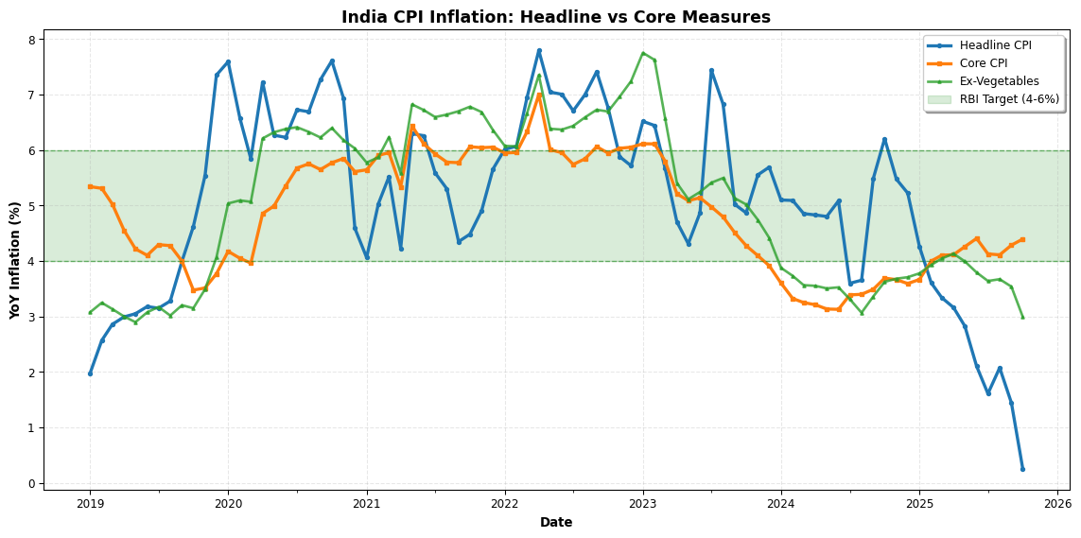
Figure 1: Headline and Core Inflation (YoY) - 7 Year Trend
Note: Chart shows available measures. Core = {CORE_COL if CORE_COL else ‘N/A’}.

2. Momentum & Turning Points
Short-term momentum signals for rate traders: 3-month and 6-month SAAR.
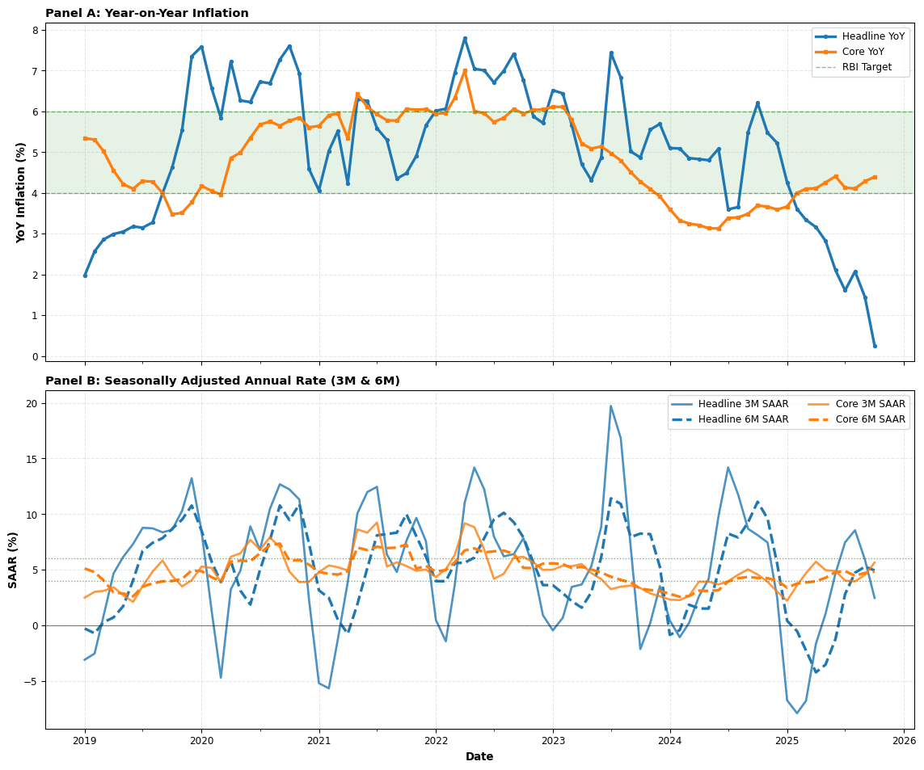
Figure 2: Inflation Momentum: YoY and SAAR Measures
SAAR formula: ((I_t / I_{t-w})^(12/w) - 1) × 100. Captures recent momentum better than YoY during turning points.

3. Inflation Drivers
TRUE contributions in percentage points (not stacked YoY rates). Shows which sectors drive headline inflation.
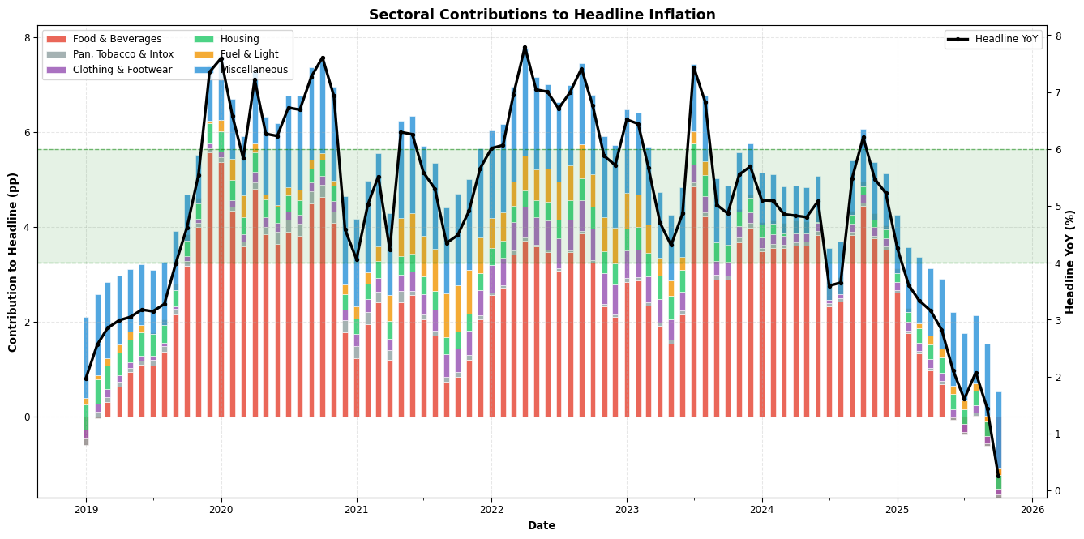
Figure 3: Inflation Drivers: Sectoral Contributions (pp) to Headline YoY
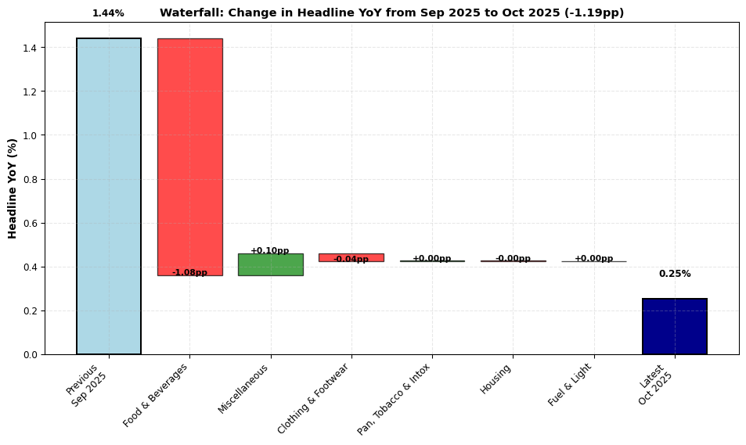
Figure 4: Latest Month: Change in Headline YoY Decomposition
Contributions computed as (group_weight / 100) × group_YoY. Shows true pp impact on headline.

4. Inflation Breadth & Diffusion
Weighted diffusion using leaf components: measures broad-based vs concentrated inflation.
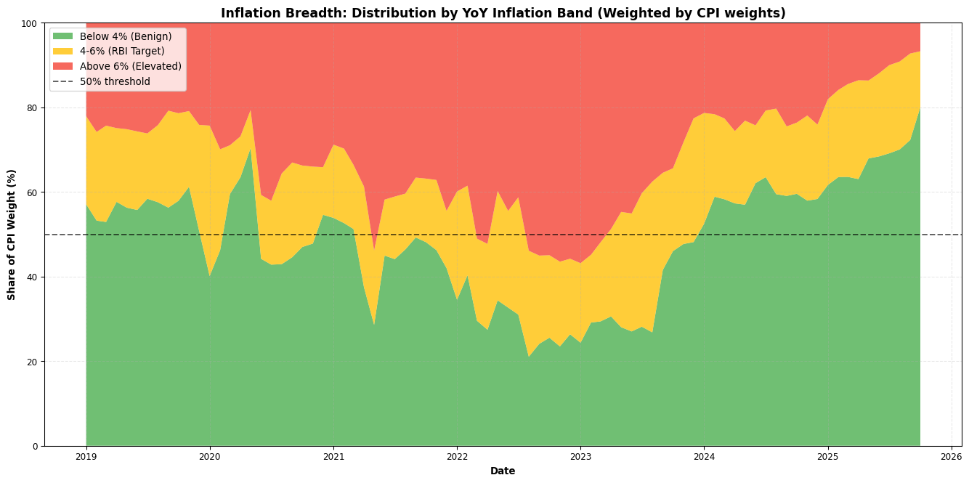
Figure 5: Inflation Breadth: Distribution of CPI Components
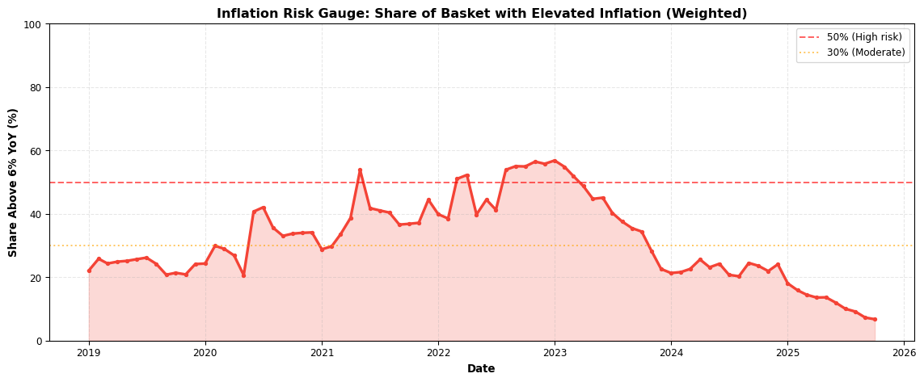
Figure 6: Risk Gauge: Share of Basket Above 6% YoY
Diffusion method: {‘Weighted by CPI weights’ if USE_WEIGHTED else ‘Unweighted (fallback due to <70% weight coverage)’}. Weight coverage: {weight_coverage:.1f}%.

5. Distribution Snapshot
Cross-sectional distribution of inflation across components (latest month).
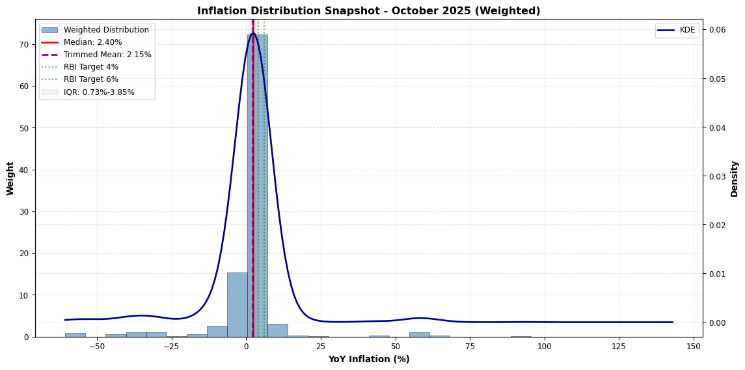
Figure 7: Current Inflation Distribution Across CPI Components

6. Underlying Inflation
Weighted median and trimmed mean: robust measures less affected by outliers.
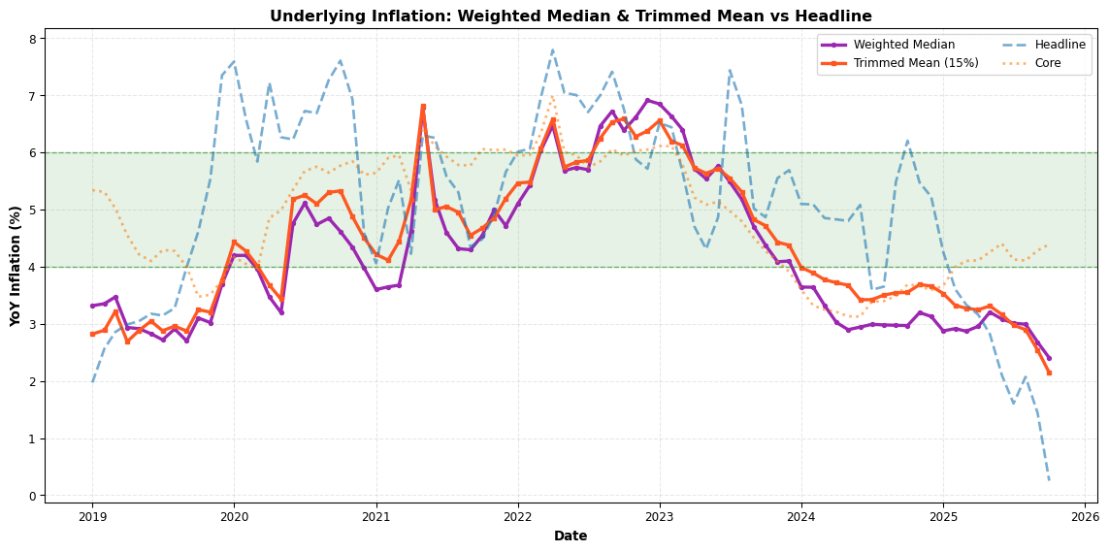
Figure 8: Underlying Inflation Measures
Trimmed mean excludes top/bottom 15% by weight. More stable than headline during supply shocks.

7. Seasonality Patterns
MoM inflation heatmaps reveal seasonal patterns in key categories.
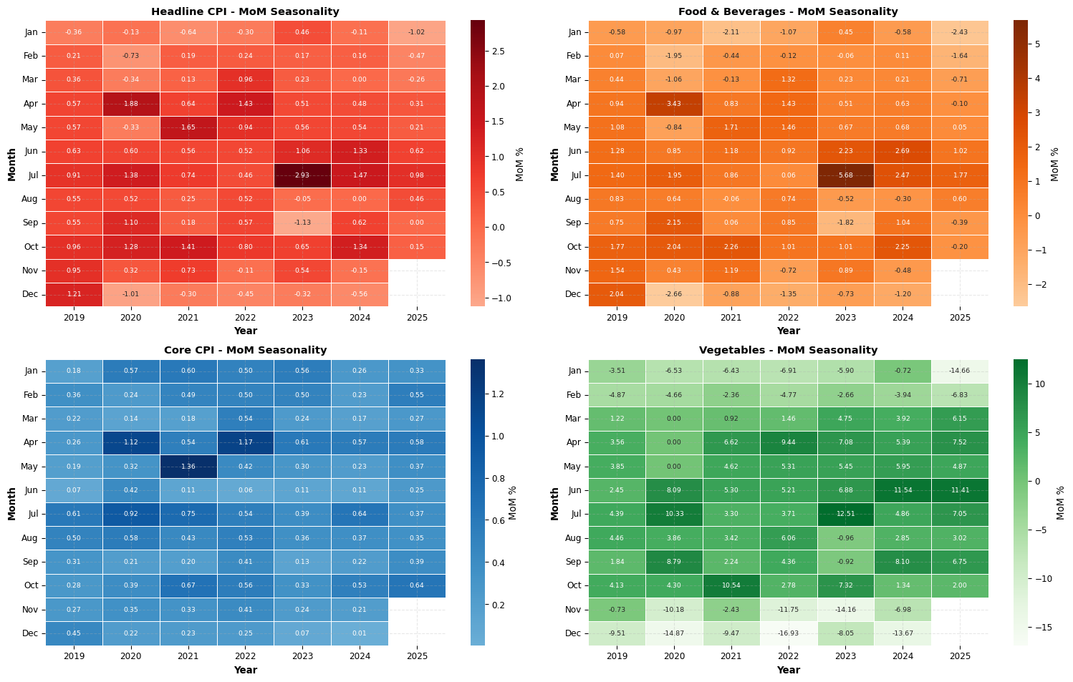
Figure 9: Seasonality Heatmap: MoM Inflation Patterns
Color intensity shows MoM % change. Patterns reveal recurring seasonal effects (e.g., harvest cycles, festival demand).

8. Shock Trackers
Volatile components and stress indicators for fixed-income positioning.
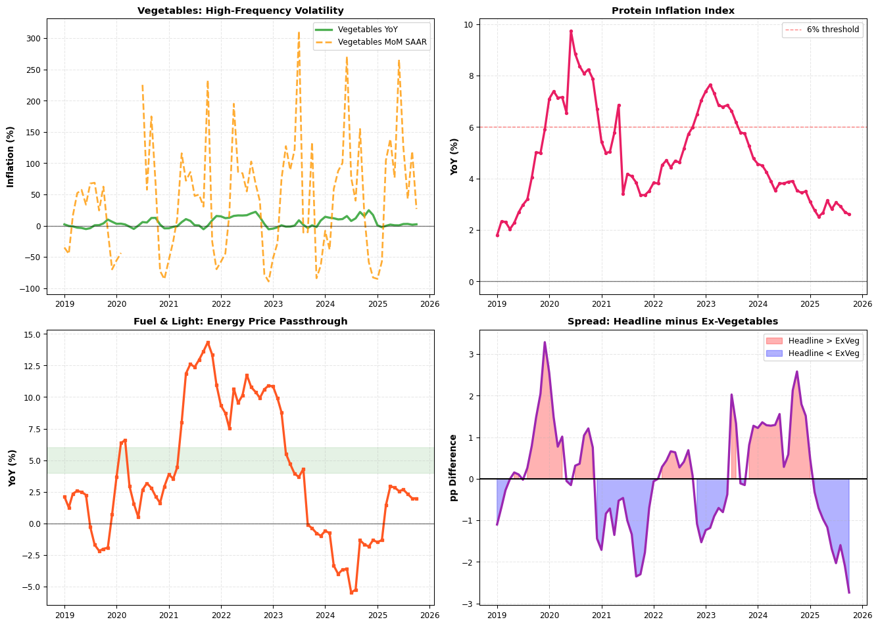
Figure 10: Volatility & Shock Indicators
Shock trackers highlight volatile components driving near-term inflation surprises.

9. Top Movers
Components with largest contribution to recent inflation changes (leaf-level only).
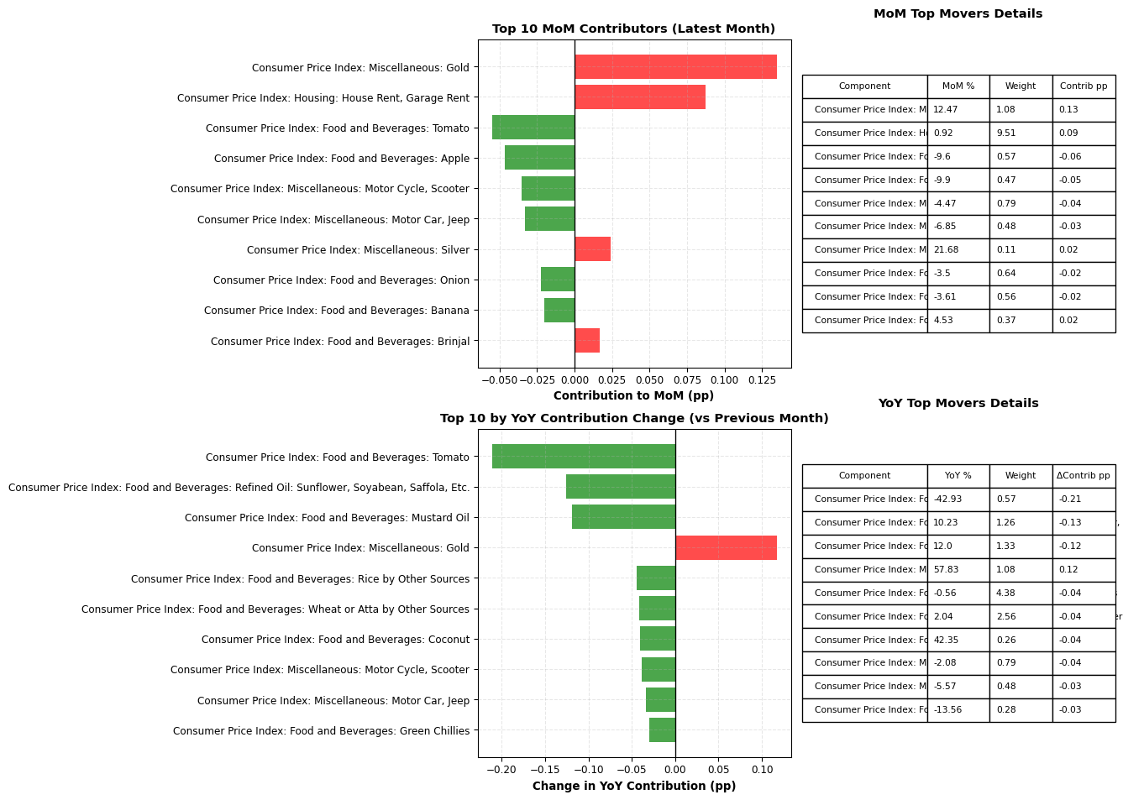
Figure 11: Top Contributors to Recent Inflation
Contribution-aware analysis: identifies which components materially moved headline inflation.

Appendix: Methodology & Data Diagnostics

Key Definitions
YoY (Year-over-Year): 12-month percentage change in index level: ${\text{YoY}}_{t}=\frac{I_{t}−I_{t−12}}{I_{t−12}}×100$
MoM (Month-over-Month): 1-month percentage change: ${\text{MoM}}_{t}=\frac{I_{t}−I_{t−1}}{I_{t−1}}×100$
SAAR (Seasonally Adjusted Annual Rate): Annualized growth rate over $w$ months: ${\text{SAAR}}_{t}=\left[{\left(\frac{I_{t}}{I_{t−w}}\right)}^{12/w}−1\right]×100$
TRUE Contribution (pp): Exact percentage point impact: ${\text{Contrib}}_{i}=\frac{w_{i}}{100}×{\text{YoY}}_{i}$ where $w_{i}$ is CPI weight.
Weighted Median: Middle value after sorting components by YoY with cumulative weight reaching 50%.
Trimmed Mean: Weighted average excluding top/bottom 15% of components by weight.
Diffusion: Share of CPI weight (or count) with YoY in specified range (e.g., >6%, 4-6%, <4%).

Data Processing Notes
print("=" * 70)
print("DATA DIAGNOSTICS SUMMARY")
print("=" * 70)
print(f"\n1. RESOLVED COLUMN NAMES:")
print(f" Headline: {HEADLINE_COL}")
print(f" Core: {CORE_COL if CORE_COL else 'NOT FOUND'}")
print(f" Ex-Vegetables: {EXVEG_COL if EXVEG_COL else 'NOT FOUND'}")
print(f" Ex-Gold: {EXGOLD_COL if EXGOLD_COL else 'NOT FOUND'}")
print(f" Food & Beverages: {list(MAJOR_GROUPS.keys())[0] if len(MAJOR_GROUPS) > 0 else 'NOT FOUND'}")
print(f"\n2. WEIGHT COVERAGE:")
print(f" Total leaf components: {len(leaf_cols)}")
print(f" Total weight covered: {weight_coverage:.2f}%")
print(f" Weighted analysis enabled: {USE_WEIGHTED} (threshold: 70%)")
print(f"\n3. TIME COVERAGE:")
print(f" Full dataset: {df['time'].min().strftime('%Y-%m-%d')} to {df['time'].max().strftime('%Y-%m-%d')}")
print(f" 7-year window: {df_7y['time'].min().strftime('%Y-%m-%d')} to {df_7y['time'].max().strftime('%Y-%m-%d')}")
print(f" Total months (full): {len(df)}")
print(f" Total months (7y): {len(df_7y)}")
print(f"\n4. INTERPOLATION POLICY:")
print(f" Method: Linear interpolation for gaps ≤3 months")
print(f" Imputed months: {len(DIAGNOSTICS.get('imputed_months', [])) if 'imputed_months' in DIAGNOSTICS else 'Not tracked'}")
print(f"\n5. MAJOR GROUPS (weights):")
for group, info in MAJOR_GROUPS.items():
print(f" {group}: {info['weight']:.2f}%")
print(f"\n6. AGGREGATE SERIES EXCLUDED:")
print(f" Count: {len(AGGREGATE_SERIES)}")
print(f" Examples: {list(AGGREGATE_SERIES)[:5]}")
print(f"\n7. MISSING DATA HANDLING:")
missing_components = []
for col in leaf_cols:
yoy_col = f'{col}_YoY'
if yoy_col in df.columns:
missing_pct = df[yoy_col].isna().sum() / len(df) * 100
if missing_pct > 10:
missing_components.append((col, missing_pct))
if missing_components:
print(f" Components with >10% missing YoY data:")
for comp, pct in sorted(missing_components, key=lambda x: x[1], reverse=True)[:10]:
print(f" {comp}: {pct:.1f}% missing")
else:
print(f" No components with >10% missing data")
print("\n" + "=" * 70)
======================================================================
DATA DIAGNOSTICS SUMMARY
======================================================================
1. RESOLVED COLUMN NAMES:
Headline: Consumer Price Index
Core: Core Index
Ex-Vegetables: CPI (ExVeggies)
Ex-Gold: NOT FOUND
Food & Beverages: Food & Beverages
2. WEIGHT COVERAGE:
Total leaf components: 298
Total weight covered: 99.67%
Weighted analysis enabled: True (threshold: 70%)
3. TIME COVERAGE:
Full dataset: 2011-01-01 to 2025-10-01
7-year window: 2019-01-01 to 2025-10-01
Total months (full): 178
Total months (7y): 82
4. INTERPOLATION POLICY:
Method: Linear interpolation for gaps ≤3 months
Imputed months: Not tracked
5. MAJOR GROUPS (weights):
Food & Beverages: 45.86%
Pan, Tobacco & Intox: 2.38%
Clothing & Footwear: 6.53%
Housing: 10.07%
Fuel & Light: 6.84%
Miscellaneous: 28.32%
6. AGGREGATE SERIES EXCLUDED:
Count: 21
Examples: ['Exclusion Index', 'Consumer Price Index: Pan, Tobacco and Intoxicants', 'CPI (ExVeggies)', 'Consumer Price Index: Food and Beverages', 'Protein Index']
7. MISSING DATA HANDLING:
Components with >10% missing YoY data:
Consumer Price Index: Food and Beverages: Leechi: 29.2% missing
Consumer Price Index: Food and Beverages: Rice by Public Distribution System: 27.0% missing
Consumer Price Index: Food and Beverages: Rice by Other Sources: 27.0% missing
Consumer Price Index: Food and Beverages: Chira: 27.0% missing
Consumer Price Index: Food and Beverages: Muri: 27.0% missing
Consumer Price Index: Food and Beverages: Other Rice Products: 27.0% missing
Consumer Price Index: Food and Beverages: Wheat or Atta by Public Distribution System: 27.0% missing
Consumer Price Index: Food and Beverages: Wheat or Atta by Other Sources: 27.0% missing
Consumer Price Index: Food and Beverages: Maida: 27.0% missing
Consumer Price Index: Food and Beverages: Suji, Rawa: 27.0% missing
======================================================================

Limitations & Caveats
- Index Construction: CPI indices provided as-is; no rebasing or chaining performed.
- Weight Accuracy: Weights from detailed_weights.json; may not sum exactly to 100 due to rounding.
- Seasonal Adjustment: Raw data used; no seasonal adjustment applied.
- Component Classification: Leaf vs aggregate status inferred from AGGREGATE_SERIES set.
- Missing Data: Linear interpolation used for gaps ≤3 months; longer gaps left as NaN.
- Weighted Analysis: Falls back to unweighted if weight coverage <70%.

Suggested Use Cases
- Rates Traders: Focus on Sections 1-3 (trend, momentum, drivers) and Section 8 (shocks).
- Policy Analysis: Sections 4-6 (breadth, distribution, underlying) for broad-based vs concentrated inflation.
- Nowcasting: Section 9 (top movers) for latest month attribution.
- Seasonality Research: Section 7 heatmaps for harvest/festival effects.

Chartbook Generated: {pd.Timestamp.now().strftime(‘%Y-%m-%d %H:%M:%S’)}
Data Through: {df[‘time’].max().strftime(‘%B %Y’)}

