Inflation Analysis Report
2026-01-12
Table of contents

1. Overall Consumer Price Index Heatmap

1.1 Year-on-Year Change
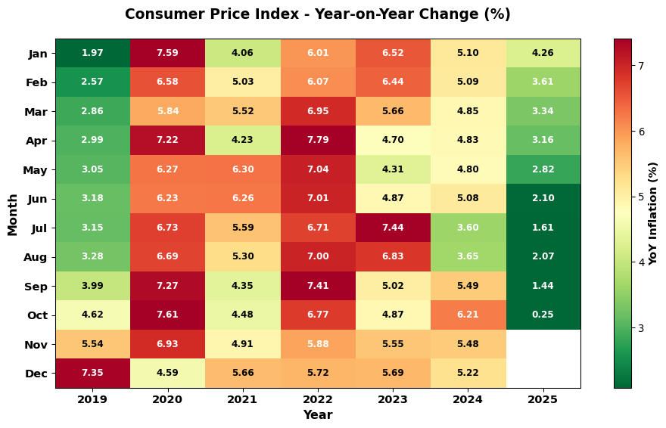
Figure 1: Consumer Price Index - Year-on-Year Change Heatmap

1.2 Month-on-Month Change
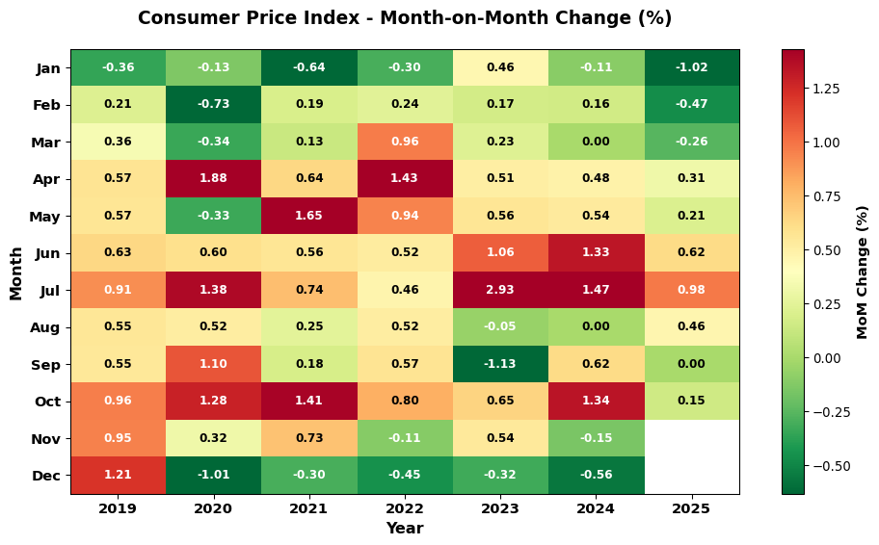
Figure 2: Consumer Price Index - Month-on-Month Change Heatmap

2. Top 5 Changes
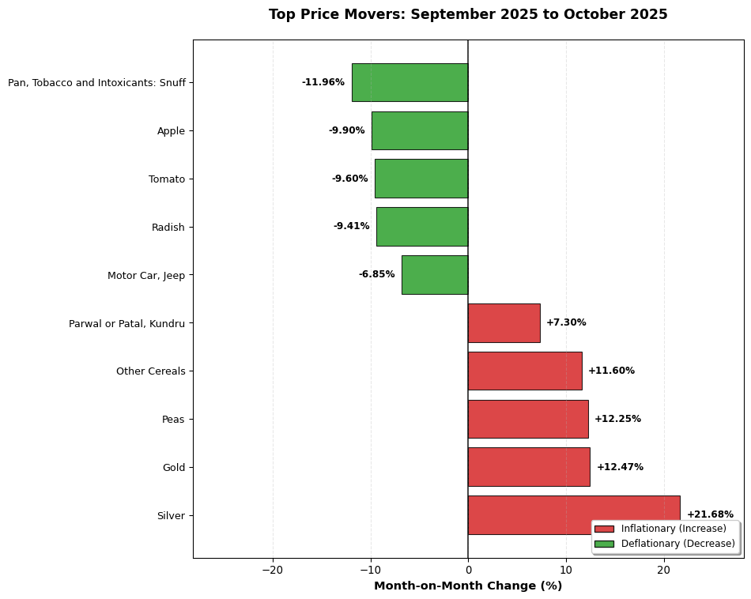
Figure 3: Top Inflationary and Deflationary Categories (Month-on-Month)

2.1 Key Observations
- Silver experienced the highest inflationary pressure with a 21.68% increase.
- Motor Car, Jeep showed the largest deflationary trend with a -6.85% decrease.

2.2 Year-on-Year Top Movers
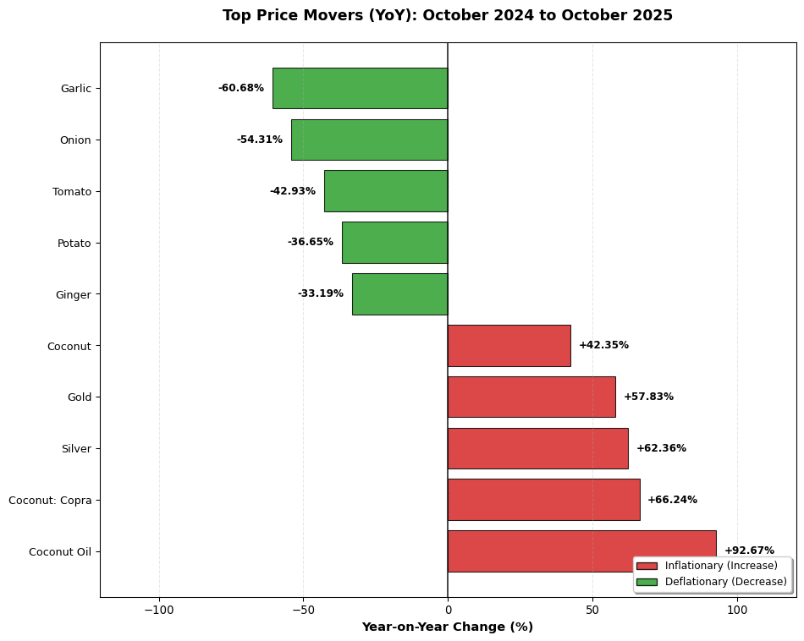
Figure 4: Top Inflationary and Deflationary Categories (Year-on-Year)

2.2.1 Key Observations (YoY)
- Coconut Oil experienced the highest year-on-year inflationary pressure with a 92.67% increase.
- Ginger showed the largest year-on-year deflationary trend with a -33.19% decrease.

3. Inflation Dispersion Analysis
This section analyzes how inflation is distributed across different CPI components, showing whether price changes are broad-based or concentrated in specific items.

3.1 Distribution Over Time (Normalized)
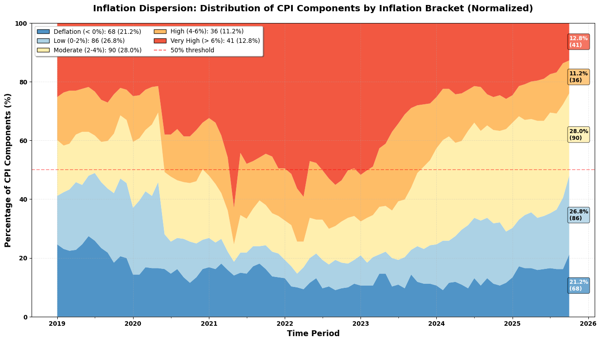
Figure 5: Inflation Dispersion - Percentage of CPI Components by Bracket

3.2 Recent Trends (Last 3 Years)
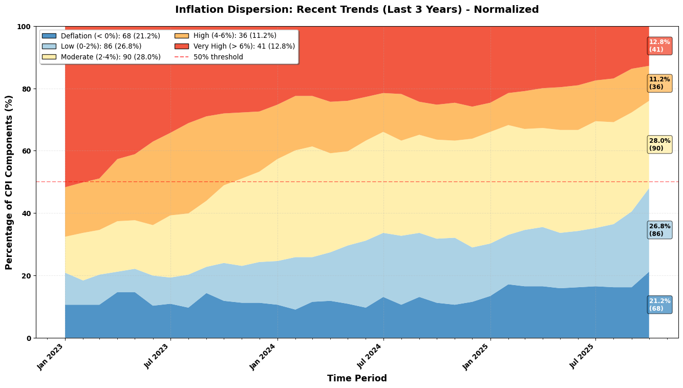
Figure 6: Inflation Dispersion - Last 3 Years (Normalized)

3.3 Distribution Over Time (Absolute Counts)
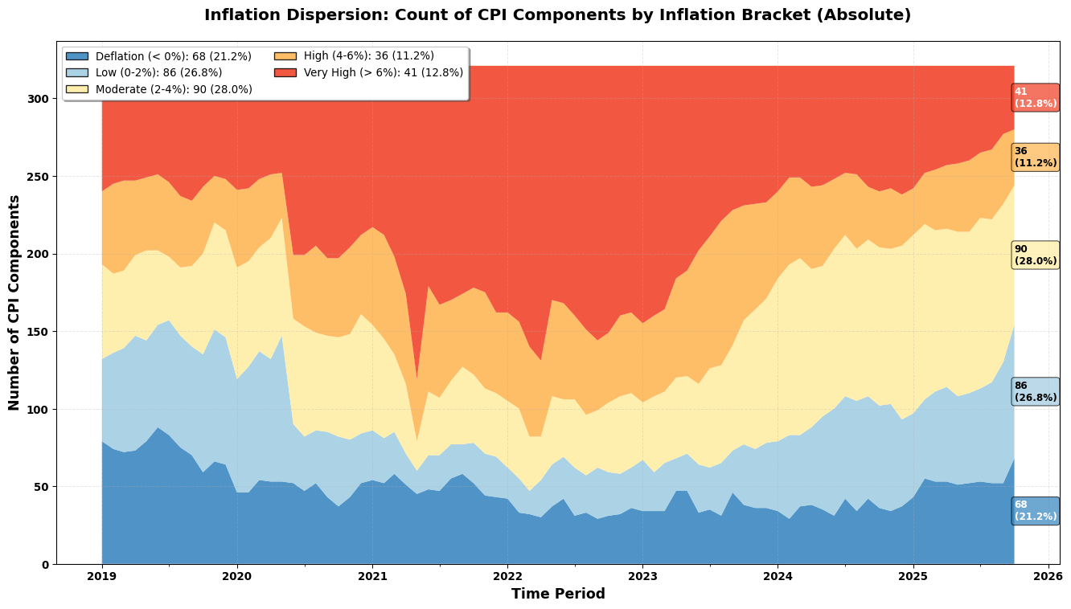
Figure 7: Inflation Dispersion - Absolute Count of CPI Components by Bracket

3.4 Recent Trends (Last 3 Years - Absolute)
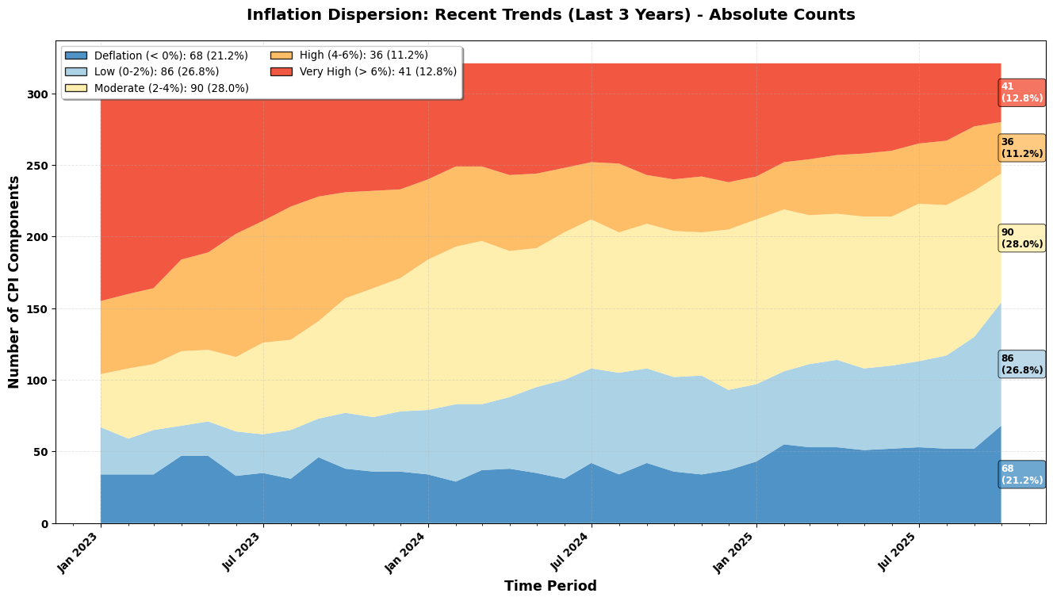
Figure 8: Inflation Dispersion - Last 3 Years (Absolute Counts)

3.5 Annualized MoM Threshold Analysis

3.5.1 6% Annualized Threshold (0.5% MoM)
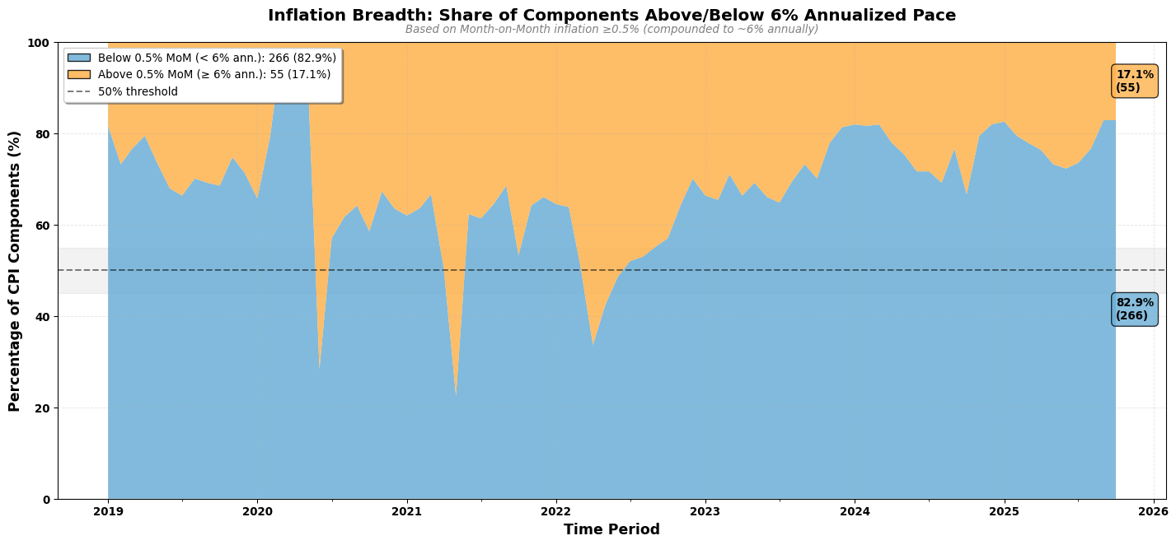
Figure 9: Inflation Breadth: Share of Components Above/Below 6% Annualized Pace

3.5.2 4% Annualized Threshold (0.33% MoM)
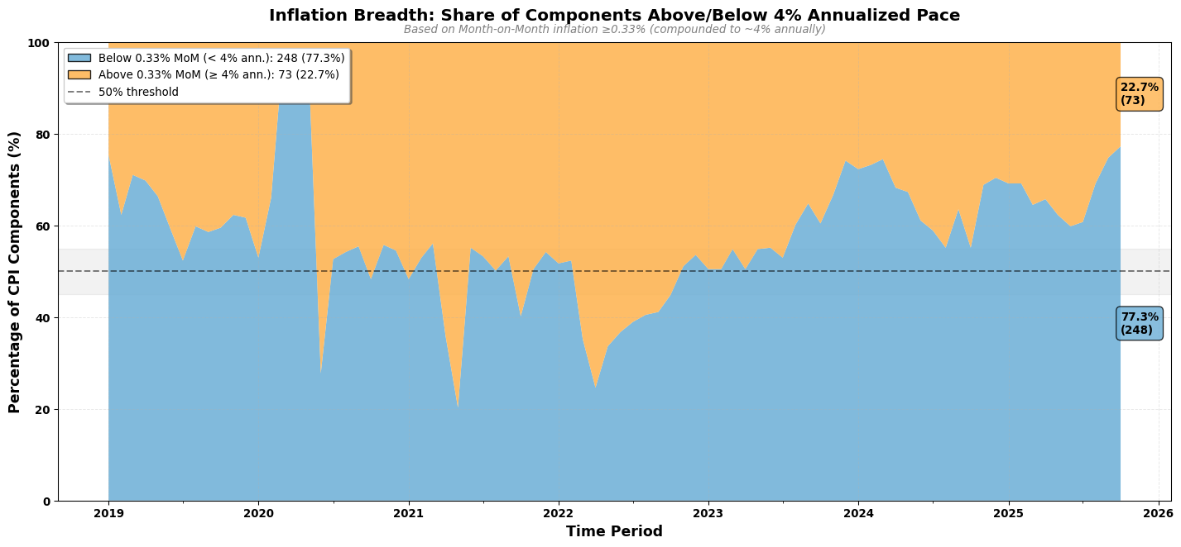
Figure 10: Inflation Breadth: Share of Components Above/Below 4% Annualized Pace

3.5.3 MoM Threshold Insights

3.5.4 Current Month (October 2025)

3.5.4.1 6% Annualized Threshold
- 17.1% (55 components) are currently inflating above the 6% annualized pace (>0.5% MoM)
- Inflation pressure is concentrated in select items, suggesting contained inflation with most components cooling

3.5.4.2 4% Annualized Threshold
- 22.7% (73 components) are inflating above the 4% annualized pace (>0.33% MoM)
- The majority of components are below the 4% lower bound, potentially signaling room for policy easing

3.5.4.3 Change from Year Ago (October 2024)
- The share of components above 6% annualized pace has decreased by 16.2 percentage points
- The share of components above 4% annualized pace has decreased by 22.1 percentage points

3.5.4.4 12-Month Trend
- Components above 6% threshold show no clear trend over the past year
- Components above 4% threshold show no clear trend over the past year

3.6 Key Insights

3.6.1 Current Month (October 2025)
- 11.2% of CPI components are within the RBI target band (4-6%)
- 12.8% of components are experiencing above-target inflation (>6%)
- 76.0% of components are below the 4% threshold
- The dominant category is Moderate (2-4%) with 28.0% of all components

3.6.2 Change from Year Ago (October 2024)
- Inflation distribution remains relatively stable

4. Seasonality Analysis

4.1 CPI Ex Vegetables
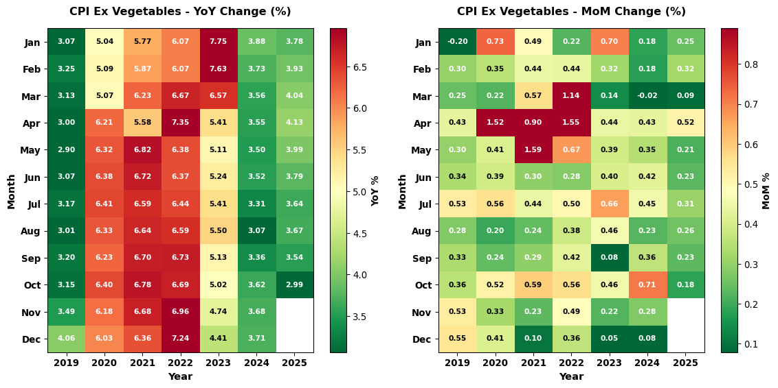
Figure 11: CPI Excluding Vegetables - Seasonality Patterns (YoY and MoM)

4.2 Core CPI (Ex Food, Beverages & Fuel)
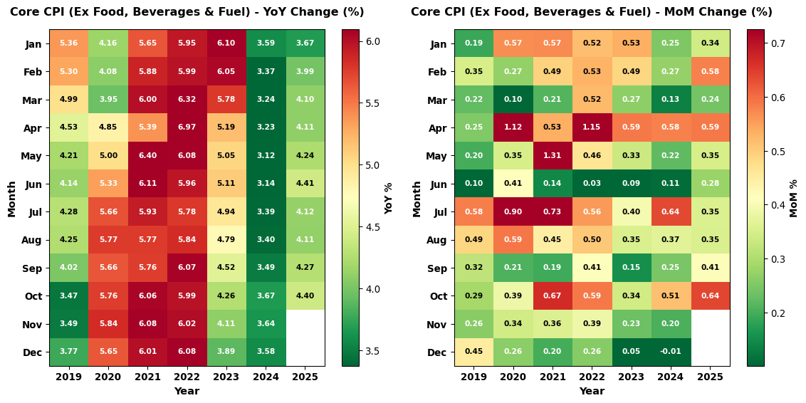
Figure 12: Core CPI (Excluding Food, Beverages & Fuel & Light) - Seasonality Patterns (YoY and MoM)

4.3 Personal Care & Effects
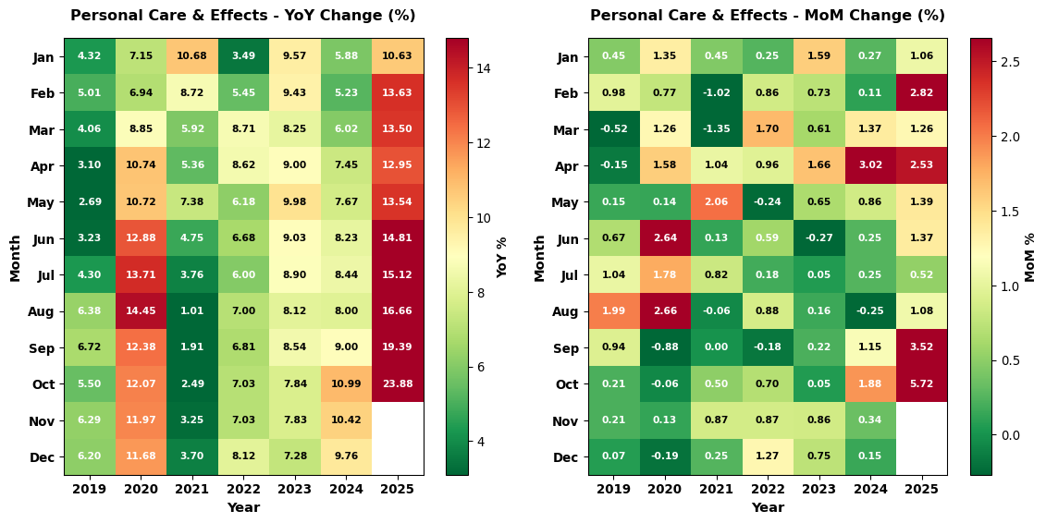
Figure 13: CPI Miscellaneous (Personal Care & Effects) - Seasonality Patterns (YoY and MoM)

4.4 Food Price Index
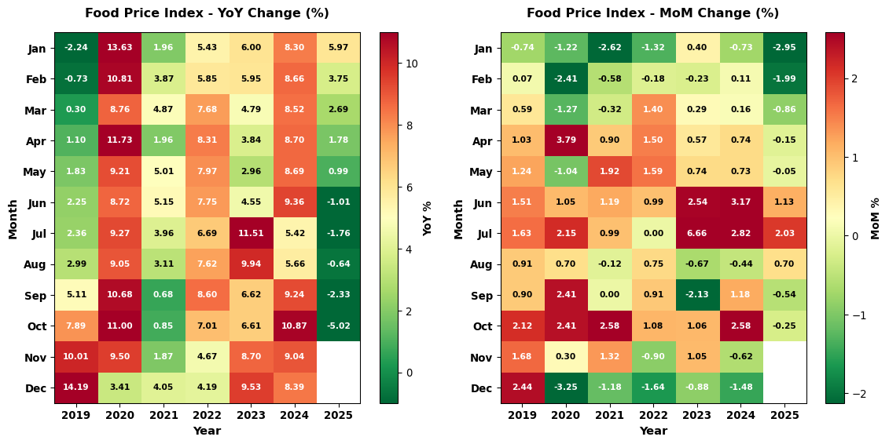
Figure 14: Consumer Food Price Index - Seasonality Patterns (YoY and MoM)

4.5 CPI (Excluding Gold)
![Consumer Food Price Index (Excluding Gold)](inflation_analysis_files/figure-docx/fig-seasonality-cpi-(ex-gold-output-1.png){#fig-seasonality-cpi-(ex-gold}

4.6 CPI (Excluding Gold and Silver)
![Consumer Food Price Index (Excluding Gol and Silver)](inflation_analysis_files/figure-docx/fig-seasonality-cpi-(ex-gold-and-silver-output-1.png){#fig-seasonality-cpi-(ex-gold-and-silver}

5. Inflation Trends Over Time

5.1 Recent Trends (Last 7 Years)
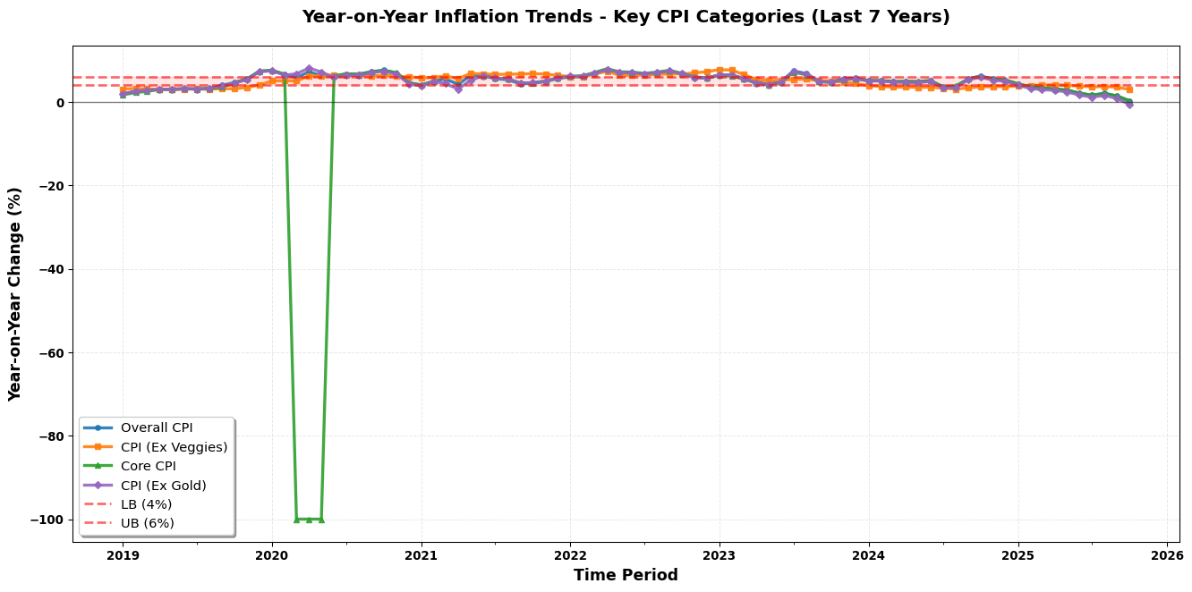
Figure 15: Year-on-Year Inflation Trends - CPI Categories Comparison

5.2 Month on Month Trend
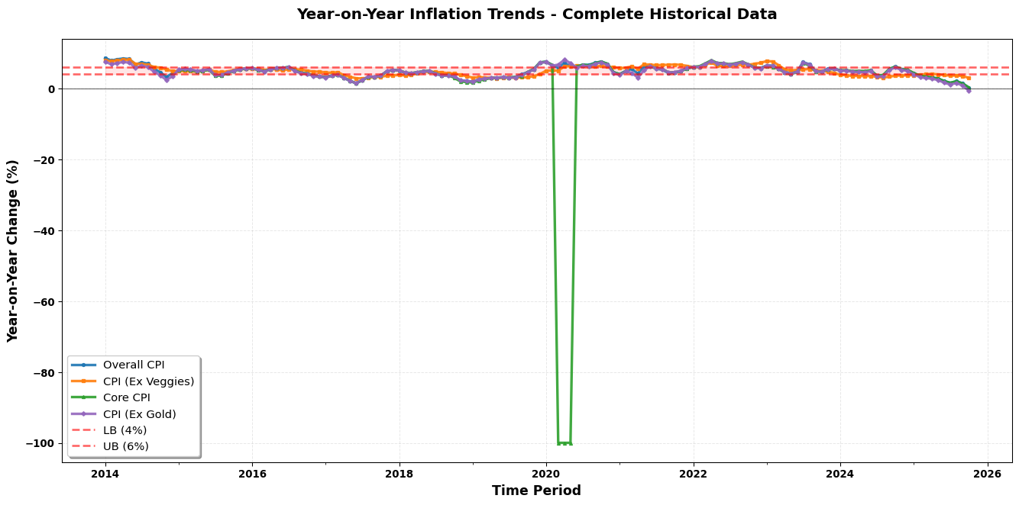
Figure 16: Month-on-Month Inflation Trends - CPI Categories Comparison

5.3 Historical Overview

Figure 17: Year-on-Year Inflation Trends - Complete Historical Data

