Granular CPI Analysis Report - Sub-Component Level
2025-12-12
Table of contents

Total granular CPI components: 298

1. Top Movers

1.1 Month-on-Month Top Movers
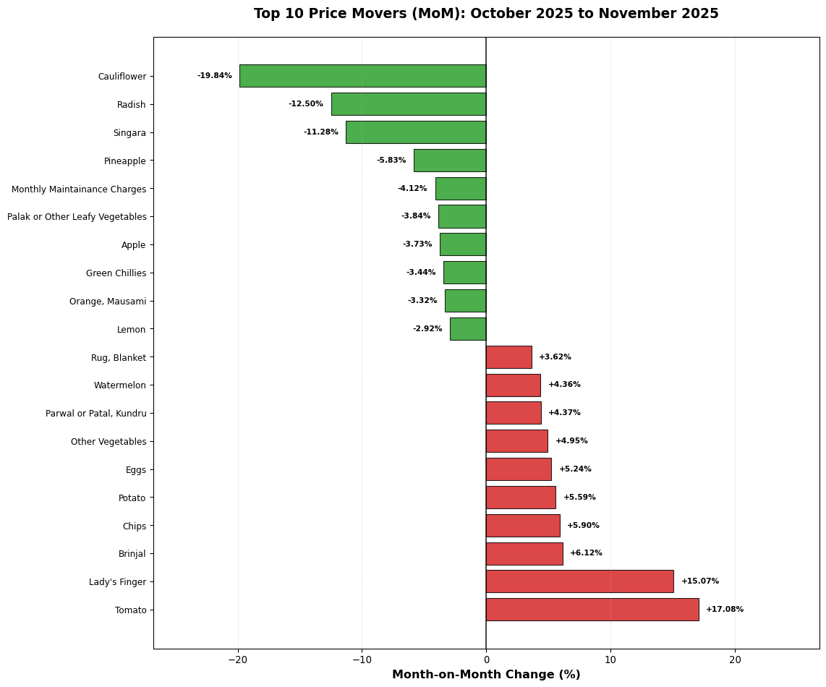
Figure 1: Top 10 Inflationary and Deflationary Items (Month-on-Month)

1.2 Year-on-Year Top Movers
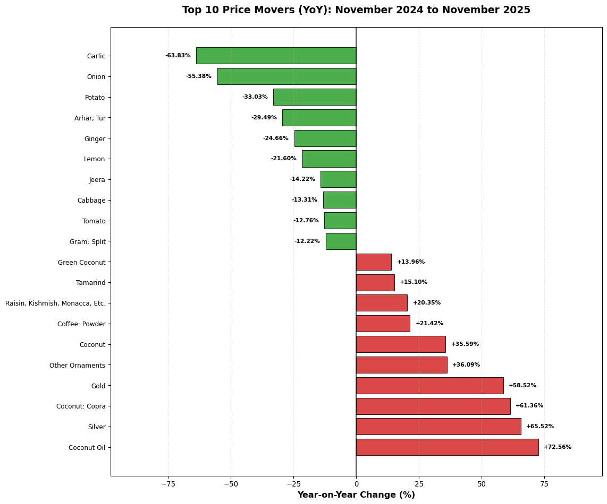
Figure 2: Top 10 Inflationary and Deflationary Items (Year-on-Year)

2. Inflation Distribution

2.1 Count-Based Dispersion (Number of Items)

2.1.1 7-Year View (Normalized)
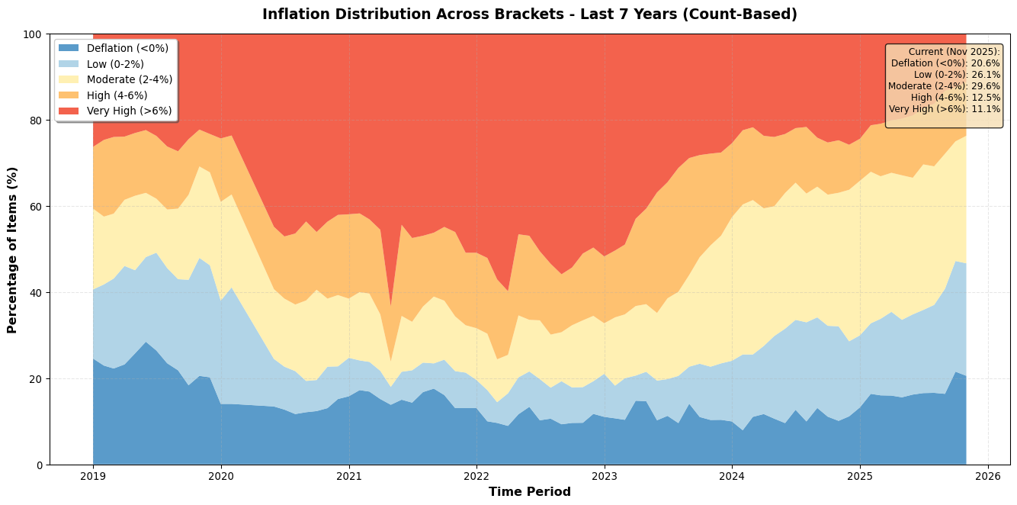
Figure 3: Inflation Distribution by Bracket - Last 7 Years (Normalized, Count-Based)

2.1.2 3-Year View (Normalized)
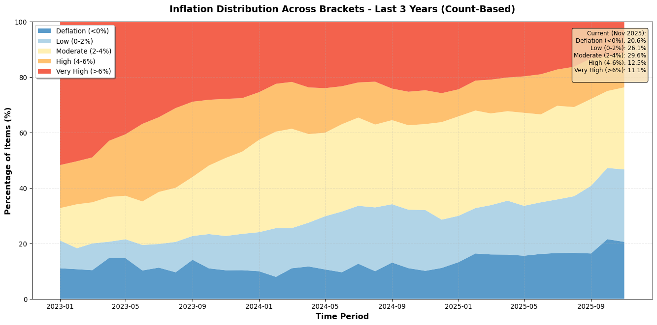
Figure 4: Inflation Distribution by Bracket - Last 3 Years (Normalized, Count-Based)

2.2 Weight-Based Dispersion (% of CPI Weight)

2.2.1 7-Year View (Normalized, Weight-Based)
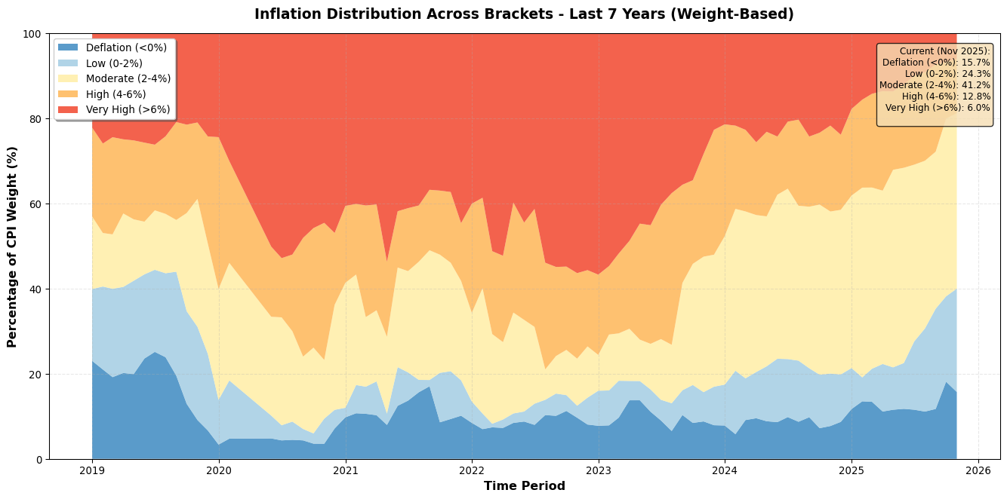
Figure 5: Inflation Distribution by Bracket - Last 7 Years (Weight-Based)

2.2.2 3-Year View (Normalized, Weight-Based)
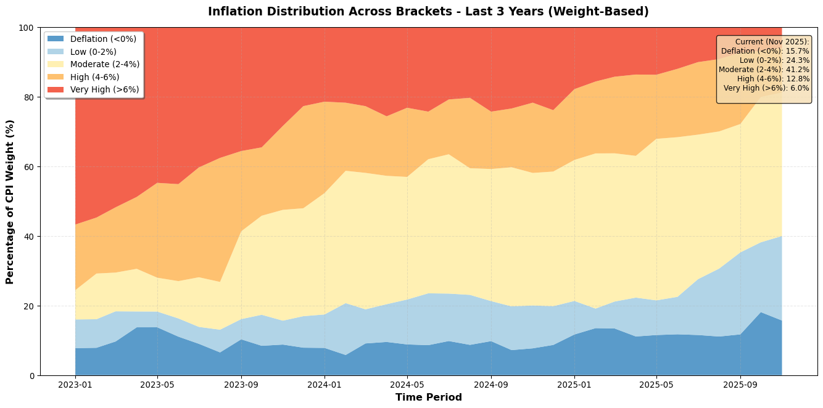
Figure 6: Inflation Distribution by Bracket - Last 3 Years (Weight-Based)

3. Annualized MoM Threshold Analysis

3.1 6% Annualized (0.5% MoM Threshold)
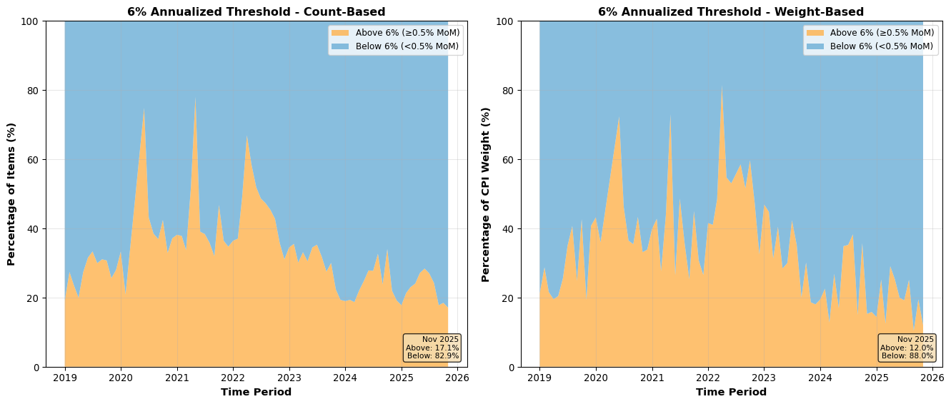
Figure 7: Items Above/Below 6% Annualized Inflation (0.5% MoM) - Count and Weight

3.2 4% Annualized (0.33% MoM Threshold)
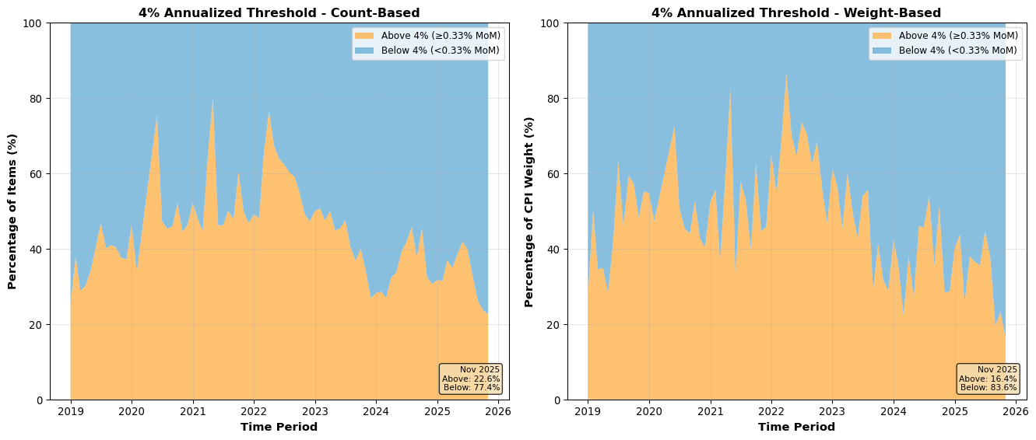
Figure 8: Items Above/Below 4% Annualized Inflation (0.33% MoM) - Count and Weight

