Assignment 4: Testing Evidence

1. Automated Test Results

Test 1: Initialization

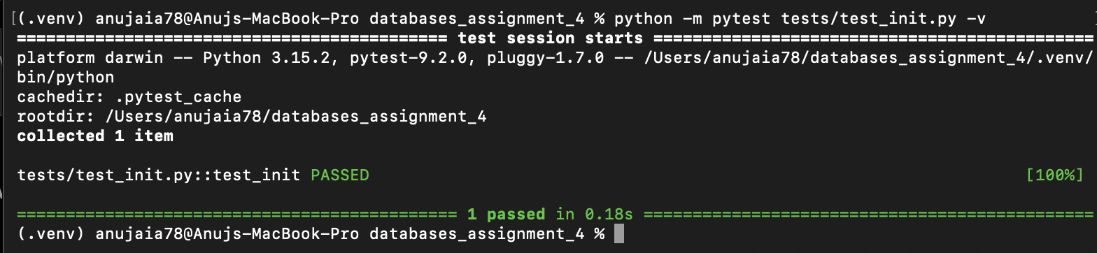

Test 2: Full Load

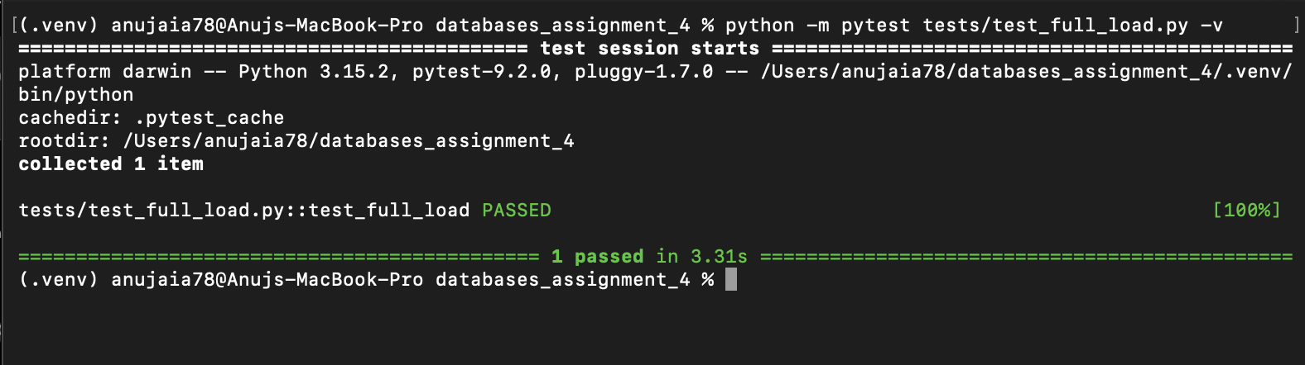

Test 3: Incremental Inserts

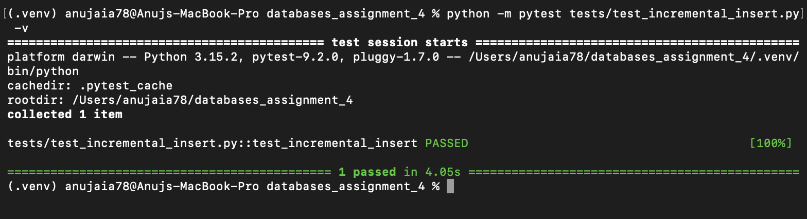

Test 4: Incremental Updates

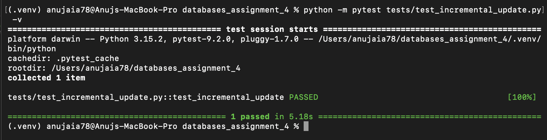

Test 5: Validation

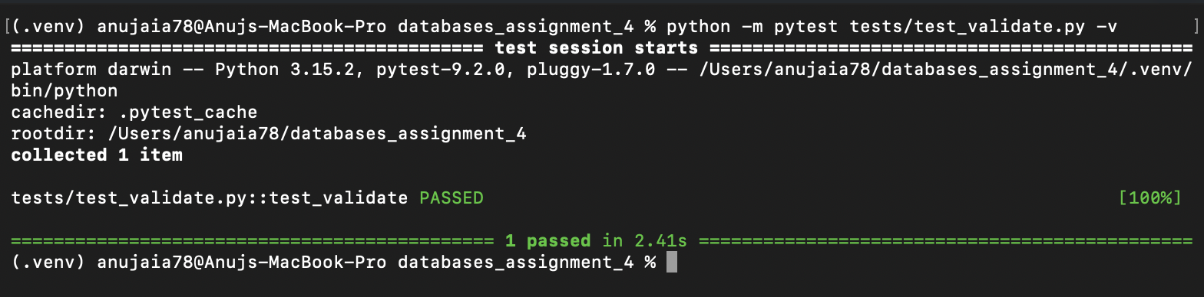

2. Command-Line Outputs

Init

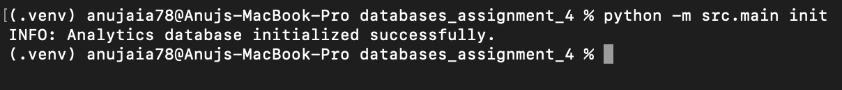

full-load

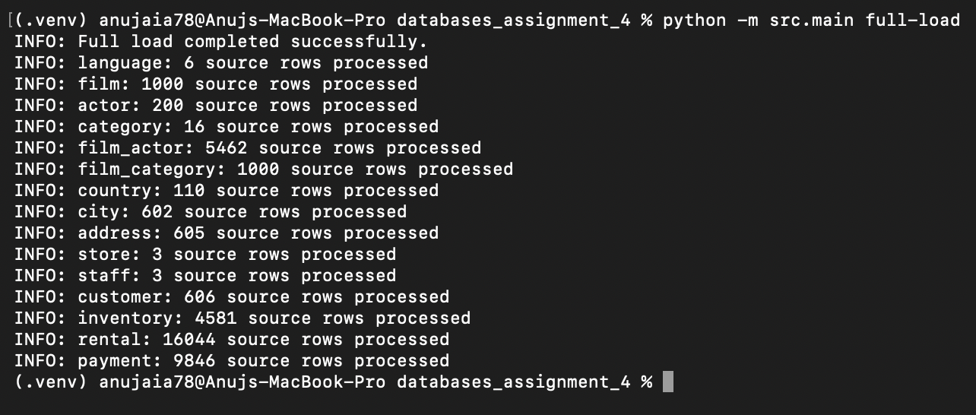

incremental

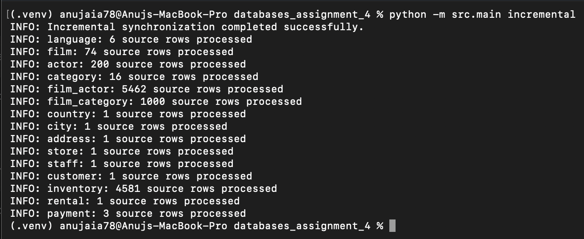

validate
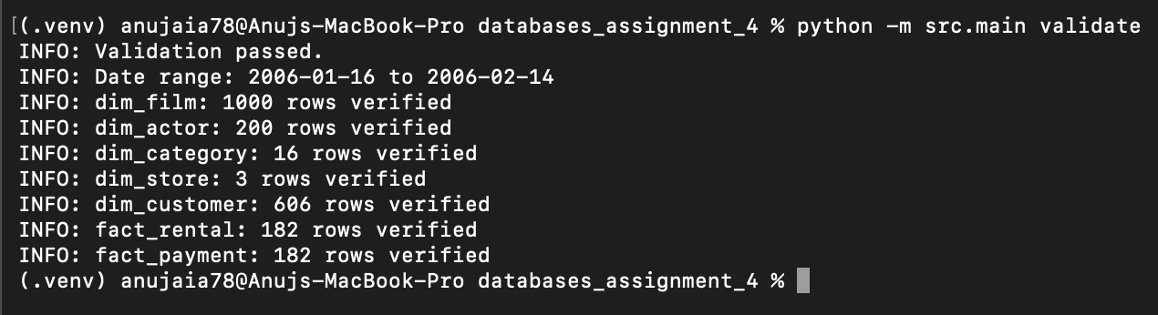

validate date range


