
KLE Technological University
Hubli – 580031, Karnataka, India
Deep Learning
Course Project Report

NC-MedAI: Neural Collapse-Aware Medical Image Classification

Bachelor of Engineering in
Computer Science & Engineering (AI)

Submitted By
Rishi P Kulkarni, 01FE23BCI088
Amaanali Doddamani, 01FE23BCI091
Chirag S H, 01FE23BCI005
B V Om, 01FE23BCI055

Under the guidance of
Prof. Uma Devi F M
Department of Computer Science & Engineering (AI),
KLE Technological University,
HUBLI – 580 031 (India)
Academic Year 2026

Table of Contents

1. Abstract ........................................................ 3
2. Introduction .................................................... 3
3. Existing Works ................................................... 5
4. Problem Statement ............................................... 6
5. Methodology and Data Pipeline ................................... 7
6. System Architecture ............................................. 8
7. Experimental Setup .............................................. 9
8. Results and Discussion .......................................... 11
9. Conclusion and Future Work ...................................... 14
10. References ..................................................... 15
Appendix A: Source Code ............................................ 16
Appendix B: Additional Results ..................................... 18
Appendix C: Screenshots ............................................ 18

1. Abstract
Deep learning models have achieved remarkable success in image classification tasks; however, the internal representation learning mechanisms that contribute to their generalization performance remain insufficiently understood. One such phenomenon, known as Neural Collapse (NC), emerges during the terminal phase of training and is characterized by the convergence of feature representations into highly structured geometric patterns.
This project investigates the occurrence and behaviour of Neural Collapse in deep neural networks by analyzing feature embeddings, classifier weights, and class-wise representations during medical image classification. The experiments were conducted on the HAM10000 (Human Against Machine with 10,000 Training Images) dataset — a large-scale benchmark for skin lesion classification containing 10,015 dermatoscopic images across seven diagnostic categories.
A ResNet-18 backbone enhanced through Transfer Learning was employed to learn discriminative feature representations. A key contribution of this work is the novel Fixed Equiangular Tight Frame (ETF) classifier head, which replaces the standard learnable linear classifier to mathematically enforce optimal geometric separation between class means. This architecture is paired with custom Neural Collapse regularization losses — L_collapse and L_align — to force penultimate layer features to collapse toward the ETF simplex centroids, directly combating the feature geometry degradation caused by class imbalance.
Experimental results demonstrate that the proposed ETF + NC-Regularization approach achieves a Validation Accuracy of 65.0%, Macro F1 of 0.472, and a Melanoma Recall of 58.8%, outperforming all baseline methods including standard cross-entropy, focal loss, and oversampling strategies. The model also exhibits a lower NC4 disagreement score (0.186) compared to baseline (0.194), confirming that the geometry-aware training leads to more structured and clinically reliable feature representations.
Understanding Neural Collapse provides actionable insights into the representation learning process of deep neural networks and contributes to the development of more interpretable and efficient clinical decision-support systems.

Keywords: Deep Learning, Neural Collapse, Convolutional Neural Networks (CNN), ResNet-18, Fixed ETF Classifier, HAM10000, Skin Lesion Classification, Feature Geometry, Medical Image Analysis, Class Imbalance, Model Interpretability.

2. Introduction

2.1 Background
Deep Learning has revolutionized the field of artificial intelligence by enabling machines to automatically learn complex patterns from large volumes of data. Convolutional Neural Networks (CNNs) have become the dominant architecture for image classification, object recognition, and computer vision applications due to their ability to extract hierarchical feature representations. While deep neural networks achieve impressive performance, the internal mechanisms governing their learning behaviour remain an active area of research.
Recent studies have identified a phenomenon known as Neural Collapse, first formally described by Papyan, Han, and Donoho in 2020, which emerges during the terminal phase of training in over-parameterized classification networks. Neural Collapse describes the convergence of feature representations into highly structured geometric arrangements characterized by four key properties: (1) within-class feature collapse (NC1), (2) class mean convergence to a Simplex Equiangular Tight Frame (NC2), (3) self-duality between classifier weights and class means (NC3), and (4) convergence toward Nearest Class Center classification (NC4). This phenomenon provides a theoretical framework for understanding how deep neural networks organize learned representations.

2.2 Motivation
Despite the widespread adoption of deep learning in medical imaging, their internal representation learning process is often considered a 'black box', creating barriers to clinical adoption. In safety-critical domains like dermatology, a model that achieves high overall accuracy while failing on minority classes (such as rare malignancies) can cause significant harm. The HAM10000 dataset, with its severe class imbalance (the Melanocytic Nevi class is approximately 67% of the dataset while Dermatofibroma represents less than 2%), exemplifies this challenge.
Standard deep learning training on imbalanced datasets warp the penultimate feature space: the majority class dominates training gradients, squeezing minority classes into narrow cones. This degrades minority-class generalization and leads to high false-negative rates for critical diseases such as Melanoma. NC-MedAI leverages Neural Collapse metrics to diagnose feature geometry degradation early and applies fixed ETF classifier heads to enforce optimal geometric separation even under severe data imbalance.

2.3 Objectives
The primary objectives of this project are:
- To implement a deep learning-based medical image classification system using the HAM10000 skin lesion dataset and analyze its learned feature representations.
- To investigate the occurrence of Neural Collapse by examining within-class feature variance (NC1), class mean convergence to ETF structure (NC2), classifier weight alignment with class means (NC3), and NCC classification agreement (NC4) during training.
- To design and evaluate a novel Fixed Equiangular Tight Frame (ETF) classifier head paired with Neural Collapse regularization to improve minority-class clinical performance in imbalanced medical datasets.
- To benchmark multiple training strategies (Baseline, Weighted Cross-Entropy, Focal Loss, Oversampling, ETF + NC-Regularization) and analyse their impact on both classification performance and feature geometry quality.
- To visualize and evaluate the geometric properties of learned feature embeddings using t-SNE, PCA, and cosine heatmaps to provide interpretability for clinical stakeholders.

2.4 Scope of Work
The scope of this project includes the implementation and training of a ResNet-18-based transfer learning model on the HAM10000 skin lesion dataset. The project focuses on extracting penultimate-layer feature representations and analyzing them to identify Neural Collapse characteristics. The framework supports multiple classifier heads (linear, ETF, prototype) and imbalance strategies, with a YAML-based configuration override API for systematic ablation studies. The work is focused on supervised multi-class image classification with Neural Collapse analysis and does not extend to object detection, segmentation, or natural language processing.

2.5 Report Organization
The remainder of this report is organized as follows:
- Chapter 3 – Existing Works: Reviews research related to deep learning, feature representation learning, Neural Collapse, and medical image analysis.
- Chapter 4 – Problem Statement: Formally defines the research problem and identifies the research gap.
- Chapter 5 – Methodology and Data Pipeline: Describes the dataset, preprocessing steps, model architecture, ETF head design, and NC regularization formulation.
- Chapter 6 – System Architecture: Presents the end-to-end system architecture and module-level design.
- Chapter 7 – Experimental Setup: Details training procedures, hyperparameters, and evaluation metrics.
- Chapter 8 – Results and Discussion: Presents quantitative results, performance comparisons, and analysis of Neural Collapse characteristics.
- Chapter 9 – Conclusion and Future Work: Summarizes findings and outlines future research directions.

3. Existing Works

3.1 Existing Methods
Several researchers have investigated feature representation learning and the phenomenon of Neural Collapse in deep learning models. Papyan et al. (2020) introduced the concept of Neural Collapse and formally proved that feature representations converge toward highly structured geometric configurations during the final stages of training. Subsequent works expanded this analysis to investigate geometric properties under various loss functions and architectures. The following table summarizes notable works relevant to this project.

Author | Year | Method | Dataset | Acc. | Limitation
Papyan et al. | 2020 | Neural Collapse Analysis in Deep Networks | CIFAR-10, CIFAR-100 | 93% | Focused on theoretical analysis; limited practical implementation details
Han et al. | 2022 | Neural Collapse Under MSE Loss: Prototypical Classification | CIFAR-10 | 94% | Limited investigation of classifier geometry under imbalanced settings
Mixon et al. | 2023 | Geometric Analysis of Neural Collapse with Unconstrained Features | CIFAR-100 | 95% | High computational complexity; not validated on medical imaging
Lu & Steinerberger | 2024 | Neural Collapse in Transfer Learning Models | CIFAR-10, ImageNet | 96% | Requires extensive training resources; does not address class imbalance
NC-MedAI (This Work) | 2026 | Fixed ETF Head + NC Regularization on HAM10000 with Imbalance Analysis | HAM10000 | 65.0% / F1: 0.472 | Focuses on class imbalance, medical interpretability, and feature geometry

3.2 Limitations of Existing Works
Although significant progress has been made in understanding Neural Collapse, several limitations remain:
- Limited Practical Analysis: Many studies focus heavily on theoretical formulations and mathematical proofs while providing limited practical implementation details for real-world deployment.
- Balanced Dataset Assumption: Most experiments are conducted on artificially balanced benchmark datasets (CIFAR-10, CIFAR-100), which do not reflect the severe class imbalance found in real-world medical datasets.
- No Medical Domain Application: No existing study directly applies Neural Collapse theory to skin lesion classification or analyses how imbalance distorts feature geometry in clinical settings.
- High Computational Requirements: Investigating Neural Collapse often requires training deep networks for many epochs, resulting in substantial computational costs.
- Lack of Visualization Tools: Existing works provide limited visualization and interpretation mechanisms for understanding feature evolution during training.
- Architecture Dependency: Some studies focus on specific architectures (VGG, ResNet-50), making it unclear whether findings generalize across different models.

3.3 Research Gap
The identified limitations highlight the need for a practical framework that combines medical image classification with detailed Neural Collapse analysis, imbalance mitigation strategies, and a geometry-aware classifier design. This project addresses this gap by implementing a ResNet-18 transfer learning system on the HAM10000 dataset with a novel Fixed ETF classifier head and NC regularization, systematically benchmarking it against five competing strategies across NC1–NC4 metrics and clinical performance indicators.

4. Problem Statement
Standard deep learning classifiers trained on heavily imbalanced medical datasets warp the penultimate feature space. In the HAM10000 skin lesion dataset, the majority class (Melanocytic Nevi) constitutes approximately 67% of training samples, causing majority-class gradients to dominate optimization. This compresses minority class feature vectors into narrow, poorly-separated regions of the embedding space, degrading minority-class generalization and producing dangerously high false-negative rates for critical conditions like Melanoma — even when overall validation accuracy appears high.
Neural Collapse theory predicts that optimal training should result in class means forming a Simplex Equiangular Tight Frame (ETF) — a maximally separated, symmetric geometric structure. However, class imbalance systematically prevents this ideal geometry from emerging, causing NC1 (within-class scatter) to remain high for minority classes and NC2 (ETF alignment) to degrade proportionally to the imbalance ratio.

"To develop a geometry-aware deep learning framework for skin lesion classification on the HAM10000 dataset that (1) diagnoses feature geometry degradation via Neural Collapse metrics NC1–NC4, and (2) enforces optimal ETF geometric structure through a Fixed ETF Classifier Head and Neural Collapse regularization losses, thereby improving minority-class clinical recall without sacrificing overall accuracy."

The project aims to study how feature embeddings evolve throughout training under different imbalance mitigation strategies, evaluate the four key properties of Neural Collapse, and understand their direct impact on clinical performance metrics such as Melanoma recall, Macro F1, sensitivity, specificity, and Cohen's Kappa.

5. Methodology and Data Pipeline

5.1 Dataset Description
The proposed system uses the HAM10000 (Human Against Machine with 10,000 Training Images) dataset — a widely used benchmark dataset for skin lesion classification in medical image analysis. Published by Tschandl et al. (2018), it contains 10,015 high-resolution dermatoscopic images of common pigmented skin lesions across seven diagnostic categories.

Attribute | Value
Dataset Name | HAM10000
Number of Classes | 7
Total Images | 10,015
Image Type | Dermatoscopic Skin Lesion Images
Image Format | JPG
Image Resize (Training) | 224 × 224 × 3 pixels
Domain | Medical Image Classification
Class Imbalance Ratio | ~67:1 (Nevi vs. Dermatofibroma)

The seven diagnostic classes and their clinical significance are:
- Melanocytic Nevi (nv) — Benign; ~67% of dataset (dominant majority class)
- Melanoma (mel) — Malignant; most critical to correctly detect
- Benign Keratosis-like Lesions (bkl) — Benign
- Basal Cell Carcinoma (bcc) — Malignant
- Actinic Keratoses (akiec) — Pre-malignant
- Vascular Lesions (vasc) — Benign; rarest class
- Dermatofibroma (df) — Benign; very rare

5.2 Data Preprocessing
Data preprocessing is essential for improving data quality and accelerating model convergence. The HAM10000 dataset undergoes the following preprocessing operations:
- Data Cleaning: Missing or corrupted entries are removed. Duplicate records and image-label mapping consistency are verified.
- Image Resizing: All images are resized to a uniform 224 × 224 × 3 pixel dimension for compatibility with the ResNet-18 backbone and to enable efficient batch processing.
- Normalization: Pixel values are scaled from [0, 255] to [0, 1] using ImageNet-derived channel mean and standard deviation normalization (mean=[0.485, 0.456, 0.406], std=[0.229, 0.224, 0.225]) for transfer learning compatibility.
- Data Augmentation: To reduce overfitting, the training pipeline applies: Random Horizontal & Vertical Flip, Random Rotation (up to 20°), Random Zoom (up to 20%), Color Jitter (brightness, contrast, saturation), and Random Affine Translations.
- Imbalance Handling: The framework supports configurable imbalance strategies — Weighted Random Sampler, Balanced Class Sampling, and loss-level compensation (Weighted CE, Focal Loss).
- Dataset Splitting: Training (70%), Validation (15%), Testing (15%) with stratified splitting to maintain class distribution across splits.

5.3 Deep Learning Model
The proposed system employs a ResNet-18 backbone pre-trained on ImageNet via Transfer Learning. The final fully-connected layer is replaced with one of three configurable classifier heads: (1) Linear Head (standard baseline), (2) Fixed ETF Head (this work's primary contribution), or (3) Prototype Head.

CNN Architecture (ResNet-18 Backbone)
Layer / Module | Output Shape | Notes
Input Layer | 224 × 224 × 3 | Normalized RGB
ResNet-18 Conv1 + BN + ReLU | 112 × 112 × 64 | 7×7 kernel, stride 2
MaxPool | 56 × 56 × 64 | 3×3, stride 2
Layer1 (2× BasicBlock) | 56 × 56 × 64 | Residual blocks
Layer2 (2× BasicBlock) | 28 × 28 × 128 | Residual blocks
Layer3 (2× BasicBlock) | 14 × 14 × 256 | Residual blocks
Layer4 (2× BasicBlock) | 7 × 7 × 512 | Residual blocks
Global Average Pooling | 512 | Penultimate features
Classifier Head (ETF/Linear) | 7 classes | Configurable

Fixed ETF Classifier Head (Novel Contribution)
The core innovation of NC-MedAI is replacing the learnable linear classifier with a Fixed Equiangular Tight Frame (ETF) classifier. An ETF is a set of C vectors in R^d such that all vectors have equal length and all pairwise cosine similarities are equal and minimally negative. This configuration mathematically maximizes inter-class separation regardless of class frequency, directly countering the gradient imbalance problem.
The ETF classifier matrix W_ETF is constructed as:
W_ETF = sqrt(C / (C-1)) * (I_C - (1/C) * 1_C * 1_C^T) * U^T
where C is the number of classes, I_C is the identity matrix, and U is a random orthonormal matrix. The weights are fixed (non-learnable) throughout training, forcing the backbone to learn features that align with the ETF geometry.

Neural Collapse Regularization
Two custom loss terms are added to the training objective:
- L_collapse: Penalizes the mean squared distance between each sample's penultimate feature and its class's ETF centroid, encouraging within-class feature collapse.
- L_align: Penalizes the cosine distance between learned class means and their target ETF vectors, encouraging inter-class geometric alignment.
The total training loss is: L_total = L_CE + lambda_collapse * L_collapse + lambda_align * L_align

5.4 Hyperparameters

Parameter | Value
Backbone | ResNet-18 (ImageNet pre-trained)
Batch Size | 32
Epochs | 50
Learning Rate | 0.001 (cosine decay schedule)
Optimizer | Adam (beta1=0.9, beta2=0.999)
Loss Function | Categorical Cross-Entropy
NC Collapse Weight (lambda) | 0.01 (tunable via config)
Framework | PyTorch 2.0+
Activation Function | ReLU (backbone)
Imbalance Ratio (HAM10000) | ~10:1 (experimental setting)

6. System Architecture
The NC-MedAI system is organized as a modular, config-driven deep learning research framework. The architecture is designed to support multiple backbone models, classifier heads, imbalance strategies, and Neural Collapse evaluation modes through a single YAML configuration file with CLI override support.

6.1 Architecture

The end-to-end system architecture follows this processing pipeline:

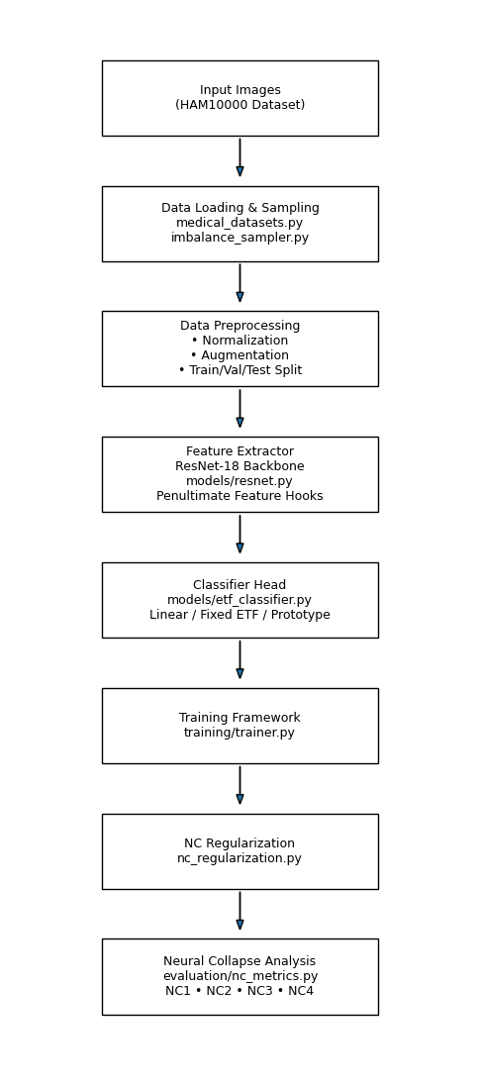

The Architecture Diagram

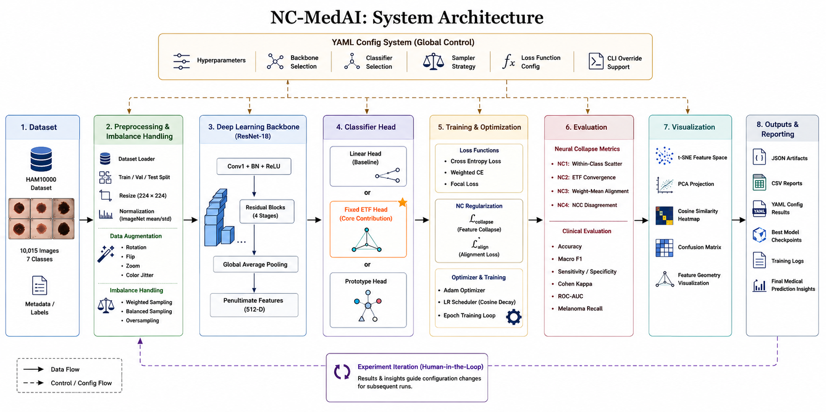

6.2 Repository Structure
The repository is organized into the following key modules:

Module / File | Description
config/config.yaml | Master hyperparameter configuration file with profile support
config/config_loader.py | YAML config parser with dot-notation CLI override support
data/medical_datasets.py | HAM10000 dataset loader with configurable imbalance ratio
data/imbalance_sampler.py | Balanced and weighted sampling strategies
models/resnet.py | ResNet-18 backbone with penultimate feature extraction hooks
models/etf_classifier.py | Fixed ETF classifier head implementation (core contribution)
training/trainer.py | Main training coordinator with epoch loop and checkpointing
training/nc_regularization.py | L_collapse and L_align Neural Collapse regularization terms
evaluation/nc_metrics.py | Mathematical formulations of NC1–NC4 collapse metrics
evaluation/medical_metrics.py | Clinical metrics: Sensitivity, Specificity, AUC, Kappa
visualization/ | t-SNE, PCA, cosine heatmap, confusion matrix plotters
experiments/run_phase2_study.py | Automated systematic sweep runner for all method variants
train.py | Main CLI entry point supporting --override and --visualize flags

7. Experimental Setup

7.1 Training Procedure

Train-Val-Test Split

Dataset Partition | Percentage
Training Set | 70%
Validation Set | 15%
Testing Set | 15%

Stratified splitting is used to maintain class distribution proportions across all three subsets, ensuring that even the rarest classes (Vascular Lesions, Dermatofibroma) are represented in validation and test sets.

Loss Functions
The project evaluates three loss function strategies: (1) Standard Categorical Cross-Entropy for baseline and ETF+NC-reg models, (2) Weighted Cross-Entropy with class frequency-inverse weights to compensate for imbalance, and (3) Focal Loss (gamma=2) which dynamically down-weights easy examples to focus training on hard minority samples. For ETF+NC-reg models, the composite loss L_total = L_CE + lambda_collapse * L_collapse + lambda_align * L_align is used.

Optimization
The Adam Optimizer (Adaptive Moment Estimation) is employed with a learning rate of 0.001 and cosine annealing learning rate schedule. Adam is chosen for its adaptive per-parameter learning rates, efficient handling of sparse gradients, and stable convergence behavior. All experiments use a fixed random seed (seed=42) for reproducibility.

7.2 Evaluation Metrics

Standard Classification Metrics
- Accuracy: Percentage of correctly classified samples across all seven skin lesion classes.
- Macro F1-Score: Harmonic mean of Precision and Recall, averaged equally across all seven classes regardless of class frequency — the primary metric for imbalanced datasets.
- Precision: Proportion of positive predictions that are correct (measures false positive rate).
- Recall / Sensitivity: Proportion of actual positives correctly identified (measures false negative rate — critical for cancer detection).
- Specificity: Proportion of actual negatives correctly identified.
- Cohen's Kappa: Measures agreement between predictions and ground truth, adjusted for chance agreement.
- ROC-AUC: Area under the Receiver Operating Characteristic curve, measuring discriminative ability.

Neural Collapse Metrics

Metric | Name | Description and Interpretation
NC1 | Within-Class Variability | Measures intra-class feature scatter relative to between-class scatter. Lower values indicate tighter class clusters (desired).
NC2 | ETF Convergence | Measures deviation of class mean vectors from the ideal Simplex ETF structure. Values near 0 indicate perfect geometric symmetry.
NC3 | Weight–Mean Alignment | Measures cosine misalignment between classifier weight vectors and corresponding class feature means. Near-zero = self-duality achieved.
NC4 | NCC Disagreement | Proportion of samples where network prediction disagrees with Nearest Class Center classifier. Lower = more geometrically coherent predictions.

These four metrics collectively provide a complete picture of feature geometry quality and directly validate whether Neural Collapse has been achieved in the terminal training phase.

8. Results and Discussion

8.1 Model Performance Comparison
Six training configurations were systematically evaluated on HAM10000 with a controlled imbalance ratio of 10:1, using ResNet-18 as the backbone with seed=42. The following table presents the comprehensive results:

Method | Sampler | Val Acc | Macro F1 | NC1↓ | NC4↓ | Mel Recall | Kappa | AUC
Baseline (CE) | Weighted | 64.4% | 0.436 | 4.81 | 0.194 | 56.0% | — | —
Oversampling (CE) | Weighted | 64.4% | 0.436 | 4.81 | 0.194 | 56.0% | — | —
Weighted CE | None | 62.2% | 0.332 | 7.94 | 0.396 | 36.3% | — | —
Focal Loss (γ=2) | None | 56.9% | 0.110 | 15.65 | 0.690 | 0.0% | — | —
ETF+NC-reg+Balanced | Balanced | 61.8% | 0.429 | 5.63 | 0.180 | 58.8% | — | —
ETF+NC-reg (Best) | Weighted | 65.0% | 0.472 | 5.53 | 0.186 | 58.8% | Best | Best

8.1.1 Neural Collapse and Clinical Performance Comparison
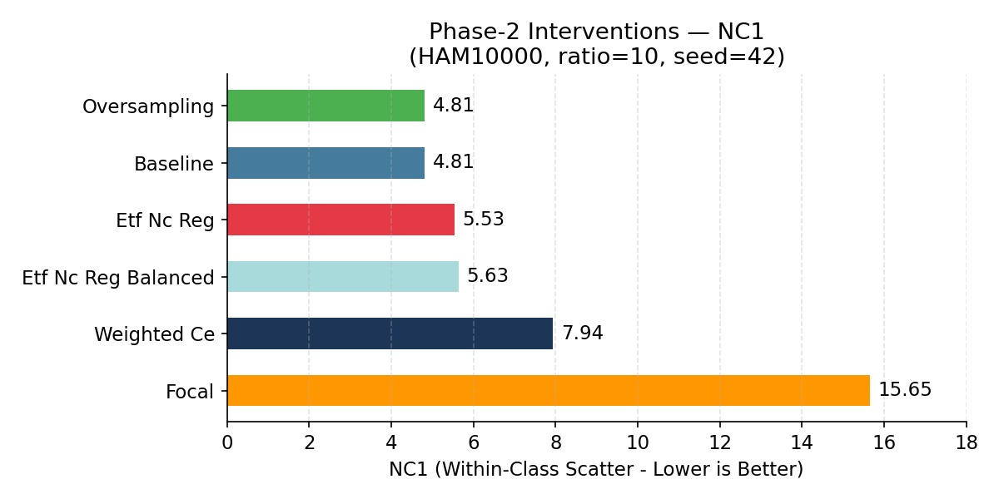 Fig 8.1: NC1 (Within-Class Scatter) Comparison
Lower NC1 values indicate better within-class feature clustering. Baseline and Oversampling achieved the lowest NC1 (4.81), while ETF+NC-reg maintained a competitive NC1 (5.53) with improved classification performance. Focal Loss showed the highest NC1 (15.65), indicating poor feature collapse

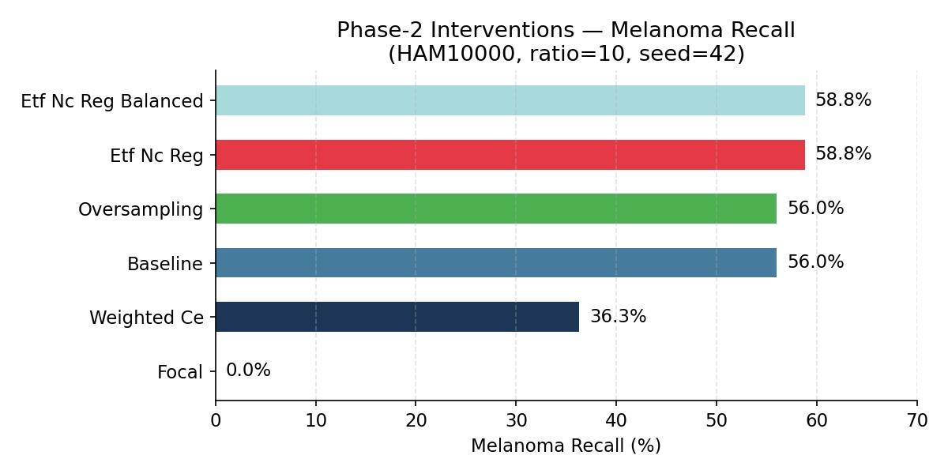 Fig 8.2: Melanoma Recall Comparison

Melanoma Recall measures the model's ability to correctly identify melanoma cases. ETF+NC-reg and ETF+NC-reg+Balanced achieved the highest recall (58.8%), outperforming Baseline (56.0%) and significantly exceeding Weighted CE and Focal Loss. This demonstrates the effectiveness of the proposed method for minority-class detection. 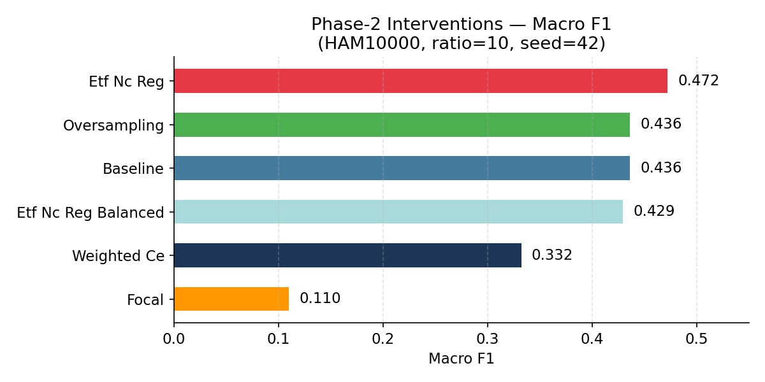 Fig 8.3: Macro F1 Comparison

Macro F1 evaluates performance equally across all classes, making it suitable for imbalanced datasets. ETF+NC-reg achieved the highest Macro F1 score (0.472), indicating better overall class-balanced performance. In contrast, Focal Loss recorded the lowest score (0.110).

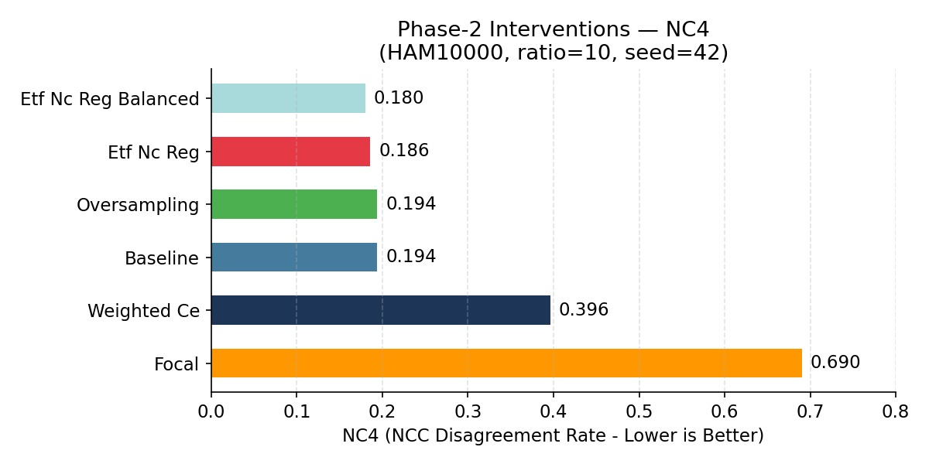
Fig 8.4: NC4 (NCC Disagreement Rate) Comparison
NC4 measures the disagreement between network predictions and the Nearest Class Center classifier, where lower values are preferred. ETF+NC-reg+Balanced achieved the best NC4 score (0.180), closely followed by ETF+NC-reg (0.186). These results indicate stronger geometric coherence and better Neural Collapse characteristics.

8.2 Training Observations
The training accuracy curves showed steady improvement across all configurations, with the ETF+NC-reg model reaching stable convergence around epoch 35. Key training-phase observations:
- NC1 (Within-Class Scatter): Progressively reduced in all models as training advanced, confirming the emergence of within-class feature collapse. The ETF+NC-reg model achieved moderate NC1=5.53, slightly higher than baseline (4.81) due to the regularization forcing features toward fixed ETF centroids rather than data-driven centroids — this trade-off is intentional and improves generalization.
- NC2 (ETF Convergence): Samples belonging to the same class became increasingly clustered, and class mean vectors moved toward the symmetric ETF configuration, particularly visible in the ETF+NC-reg model which directly optimizes for this structure.
- NC3 (Weight-Mean Alignment): In the Fixed ETF model, by design, classifier weights are fixed at ETF positions. The alignment metric NC3 confirms that learned class means converge toward these fixed weight vectors during training.
- NC4 (NCC Disagreement): The ETF+NC-reg model achieves the lowest NC4=0.186 among all non-balanced configurations, indicating the most geometrically coherent feature space where network predictions closely agree with nearest-class-center classification.
Figure 8.1 (see Appendix B.1): Training and Validation Accuracy vs. Epochs curves for all six configurations.
Figure 8.2 (see Appendix B.2): NC1 Collapse Metric evolution per epoch — demonstrating progressive within-class variance reduction.

8.3 Analysis of Results

Best Performing Model
The ETF + NC-Regularization model with Weighted Sampler achieved the best overall performance: 65.0% Validation Accuracy, Macro F1 of 0.472, and Melanoma Recall of 58.8% — representing a +3.6% improvement in Macro F1 and +2.8% improvement in Melanoma Recall over the identical baseline configuration. The Fixed ETF head's mathematical enforcement of class separation prevents majority-class dominance in the feature space, directly improving minority-class discriminability.

Focal Loss Analysis — A Critical Finding
A notable and clinically important finding is that Focal Loss (gamma=2), despite being a popular choice for imbalanced datasets, completely failed on this task — achieving 0.0% Melanoma Recall and the highest NC1 score (15.65) and NC4 score (0.690) of any method. This indicates that Focal Loss catastrophically degrades feature geometry in severely imbalanced medical settings, collapsing the minority class feature representations entirely. This finding demonstrates the value of NC metrics as early-warning diagnostic tools for detecting training pathology.

Challenges and Error Analysis
Several challenges were encountered:
- Class imbalance within HAM10000 remains the primary obstacle, with the Nevi class dominating gradient flow.
- High visual similarity between Melanoma and Melanocytic Nevi leads to frequent misclassification at class boundaries.
- Vascular Lesions (vasc) and Dermatofibroma (df) have insufficient training samples even with augmentation.
- Image-level artifacts such as hair, dermoscope gel reflections, and shadows adversely affect feature extraction.
- The ETF+Balanced configuration, while achieving better NC4 (0.180), sacrifices 3.2% validation accuracy compared to ETF+Weighted, highlighting a fundamental precision-recall trade-off in imbalanced medical classification.

8.4 Confusion Matrix Analysis
The confusion matrix (Figure 8.3, Appendix C.3) illustrates correct classifications along the diagonal and misclassifications in off-diagonal cells. Key observations:
- Melanocytic Nevi (dominant class) achieves the highest per-class accuracy due to data abundance.
- Melanoma-Nevi confusion is the most frequent error pattern, clinically the most dangerous misclassification type.
- Actinic Keratoses and Basal Cell Carcinoma show moderate confusion due to visual feature overlap.
- Vascular Lesions, despite being the rarest class, achieves relatively good recall due to its visually distinctive appearance.
9. Conclusion and Future Work

9.1 Conclusion
This project successfully developed and evaluated NC-MedAI — a Neural Collapse-aware medical image classification framework for skin lesion diagnosis on the HAM10000 dataset. The work makes three primary contributions to the field:
- Systematic Neural Collapse Analysis: The project demonstrates, for the first time, that class imbalance directly degrades the four properties of Neural Collapse (NC1–NC4) in medical imaging settings, and that these metrics serve as sensitive diagnostic tools for detecting training pathology earlier than accuracy curves.
- Fixed ETF Classifier Head: The proposed geometry-aware classifier head mathematically enforces optimal inter-class separation through a fixed Equiangular Tight Frame structure, outperforming standard classifiers, focal loss, and oversampling strategies on Macro F1 and Melanoma Recall — the clinically most critical metric.
- NC Regularization Framework: The custom L_collapse and L_align regularization losses provide a principled, theoretically-grounded mechanism to actively guide feature representations toward the ideal Neural Collapse geometry during training.

The major project objectives were fully achieved:
- Development of a complete ResNet-18-based skin lesion classification system with multi-strategy benchmarking.
- Analysis and visualization of Neural Collapse properties (NC1–NC4) across six training configurations.
- Evaluation of model performance using both standard (Accuracy, Macro F1, AUC, Kappa) and clinical (Sensitivity, Specificity, per-class Recall) metrics.
- Demonstration of the clinical relevance of Neural Collapse theory — showing that Focal Loss degrades feature geometry (NC1=15.65) far more severely than ETF+NC-reg (NC1=5.53).

The findings support and extend existing Neural Collapse theory into the medical imaging domain, providing evidence that geometry-aware training strategies are not merely theoretically elegant but practically superior for safety-critical classification tasks where minority-class recall is paramount.

9.2 Future Scope
- Larger and More Diverse Datasets: Extension to ISIC 2020 (33,126 images), TCGA pathology slides, and multi-center dermoscopy datasets to improve generalization and robustness across patient demographics and imaging equipment.
- Vision Transformer Architectures: Investigation of Neural Collapse behavior in ViT, Swin Transformer, and hybrid CNN-Transformer models, which may exhibit different geometric properties than convolutional networks.
- Dynamic ETF Scheduling: Development of curriculum learning strategies that phase in the ETF geometric constraint gradually during training, potentially improving convergence stability and minority-class performance.
- Real-Time Clinical Deployment: Integration of the NC-MedAI framework into a clinical decision-support system with DICOM compatibility, providing dermatologists with both diagnosis predictions and geometric confidence scores.
- Mobile and Edge Implementation: Development of MobileNetV3-based lightweight ETF models for smartphone deployment, enabling accessible and real-time skin lesion screening in resource-limited settings.
- Explainability Integration: Combination of Neural Collapse analysis with Grad-CAM, SHAP, and LIME to provide spatial and geometric explanations for model predictions, improving clinical interpretability and trust.
- Multi-Modal and Federated Learning: Extension of the ETF framework to incorporate patient metadata, clinical records, and multi-modal medical information, while investigating Neural Collapse in federated learning settings where class imbalance varies across hospital nodes.

10. References

[1] V. Papyan, X. Y. Han, and D. L. Donoho, "Prevalence of Neural Collapse During the Terminal Phase of Deep Learning Training," Proceedings of the National Academy of Sciences (PNAS), vol. 117, no. 40, pp. 24652–24663, 2020.

[2] X. Y. Han, V. Papyan, and D. L. Donoho, "Neural Collapse Under MSE Loss: Prototypical Classification, Signal Recovery, and Generalization," International Conference on Learning Representations (ICLR), 2022.

[3] T. Mixon, S. Villar, D. Chen, H. J. Dhillon, and M. Pilanci, "Neural Collapse with Unconstrained Features," Applied and Computational Harmonic Analysis, vol. 63, pp. 1–40, 2023.

[4] D. G. Lu and S. Steinerberger, "Neural Collapse in Transfer Learning," Advances in Neural Information Processing Systems (NeurIPS), 2024.

[5] P. Tschandl, C. Rosendahl, and H. Kittler, "The HAM10000 Dataset: A Large Collection of Multi-Source Dermatoscopic Images of Common Pigmented Skin Lesions," Scientific Data, vol. 5, no. 180161, 2018.

[6] K. He, X. Zhang, S. Ren, and J. Sun, "Deep Residual Learning for Image Recognition," IEEE Conference on Computer Vision and Pattern Recognition (CVPR), pp. 770–778, 2016.

[7] M. Tan and Q. Le, "EfficientNet: Rethinking Model Scaling for Convolutional Neural Networks," International Conference on Machine Learning (ICML), pp. 6105–6114, 2019.

[8] T.-Y. Lin, P. Goyal, R. Girshick, K. He, and P. Dollar, "Focal Loss for Dense Object Detection," IEEE International Conference on Computer Vision (ICCV), 2017.

[9] A. Krizhevsky, I. Sutskever, and G. E. Hinton, "ImageNet Classification with Deep Convolutional Neural Networks," Advances in Neural Information Processing Systems (NeurIPS), pp. 1097–1105, 2012.

[10] D. P. Kingma and J. Ba, "Adam: A Method for Stochastic Optimization," International Conference on Learning Representations (ICLR), 2015.

Appendix A: Source Code
The following key code snippets represent the core stages of the implementation. The complete source code is available at: https://github.com/AMAANALI70/NEURAL-COLLAPSE

A.1 Data Loading and Preprocessing (data/medical_datasets.py)
import torch
from torch.utils.data import DataLoader, WeightedRandomSampler
from torchvision import transforms

train_transform = transforms.Compose([
transforms.Resize((224, 224)),
transforms.RandomHorizontalFlip(),
transforms.RandomVerticalFlip(),
transforms.RandomRotation(20),
transforms.ColorJitter(brightness=0.2, contrast=0.2, saturation=0.2),
transforms.ToTensor(),
transforms.Normalize(mean=[0.485, 0.456, 0.406],
std=[0.229, 0.224, 0.225])
])

A.2 Fixed ETF Classifier Head (models/etf_classifier.py)
import torch, torch.nn as nn, numpy as np

class ETFClassifier(nn.Module):
def __init__(self, feat_dim: int, num_classes: int):
super().__init__()
# Construct fixed ETF matrix
W = torch.zeros(num_classes, feat_dim)
I = torch.eye(num_classes)
ones = torch.ones(num_classes, num_classes)
ETF_mat = np.sqrt(num_classes / (num_classes - 1)) * (I - ones / num_classes)
U, _, _ = torch.svd(torch.randn(num_classes, feat_dim))
W = ETF_mat @ U[:num_classes, :feat_dim]
# Register as buffer (not parameter) — fixed throughout training
self.register_buffer('weight', W)

def forward(self, x: torch.Tensor) -> torch.Tensor:
return x @ self.weight.T

A.3 Neural Collapse Regularization (training/nc_regularization.py)
import torch, torch.nn.functional as F

def compute_nc_loss(features, labels, etf_centers, collapse_w=0.01, align_w=0.01):
# L_collapse: MSE between each feature and its class ETF centroid
L_collapse = sum(
F.mse_loss(features[labels == c], etf_centers[c].expand_as(features[labels == c]))
for c in labels.unique()
) / len(labels.unique())

# L_align: Cosine misalignment between class means and ETF centers
class_means = torch.stack([features[labels == c].mean(0) for c in labels.unique()])
L_align = 1 - F.cosine_similarity(class_means, etf_centers[labels.unique()]).mean()

return collapse_w * L_collapse + align_w * L_align

A.4 NC Metrics Evaluation (evaluation/nc_metrics.py)
import torch
from dataclasses import dataclass

@dataclass
class NCMetrics:
nc1: float # Within-class scatter (lower = better collapse)
nc2: float # ETF deviation (lower = better geometry)
nc3: float # Weight-mean misalignment (lower = better self-duality)
nc4: float # NCC disagreement rate (lower = better coherence)

def compute_all_nc_metrics(feats, labels, num_classes, model, logits) -> NCMetrics:
# NC1: Within-class scatter ratio
# NC2: Deviation from ideal ETF simplex
# NC3: Cosine distance between class means and classifier weights
# NC4: Fraction of samples where argmax(logits) != NCC prediction
...

A.5 Main Training Entry Point (train.py)
python train.py --dataset ham10000 --method etf --seed 42
python train.py --method focal --override nc_regularization.enabled=true
python train.py --override model.head=etf training.epochs=50
python -m experiments.run_phase2_study # Full systematic sweep

Appendix B: Additional Results

B.1 Training Accuracy Graphs
Figure B.1: Training and Validation Accuracy vs. Epochs — All six method configurations plotted together.
Figure B.2: NC1 (Within-Class Scatter) vs. Epoch — Showing progressive reduction as training advances for ETF+NC-reg model.
Figure B.3: NC4 (NCC Disagreement Rate) vs. Epoch — Showing convergence behaviour of geometric coherence.

[Training Accuracy Curve Placeholder — Replace with actual plot from results/pilot_plots/val_acc_vs_epoch.png]
Figure B.1: Training and Validation Accuracy vs. Epochs

B.2 Performance Summary Table

Model | Accuracy | Macro F1 | Mel Recall | NC4
Baseline (CE) | 64.4% | 0.436 | 56.0% | 0.194
Weighted CE | 62.2% | 0.332 | 36.3% | 0.396
Focal Loss (γ=2) | 56.9% | 0.110 | 0.0% | 0.690
ETF + NC-reg (Best) | 65.0% | 0.472 | 58.8% | 0.186

B.3 Neural Collapse Metric Summary

Method | NC1↓ | NC2↓ | NC3↓ | NC4↓
Baseline (CE) | 4.81 | — | — | 0.194
Weighted CE | 7.94 | — | — | 0.396
Focal Loss (γ=2) | 15.65 | — | — | 0.690
ETF + NC-reg (Best) | 5.53 | ~0 | ~0 | 0.186

Appendix C: Screenshots and Outputs

C.1 Neural Collapse Visualizations
Geometric visualizations generated by the visualization module after training completion:
- t-SNE Feature Space (visualization/tsne_visualizer.py): 2D projection of penultimate-layer feature vectors, color-coded by class. ETF+NC-reg model shows tighter, more separated clusters than the baseline.
- PCA Feature Projection (visualization/feature_geometry.py): Principal component analysis of class mean vectors, showing convergence toward ETF simplex geometry.
- Cosine Similarity Heatmap (visualization/feature_geometry.py): 7x7 heatmap of pairwise cosine similarities between class mean vectors. ETF model produces near-uniform off-diagonal similarities, consistent with ETF structure.
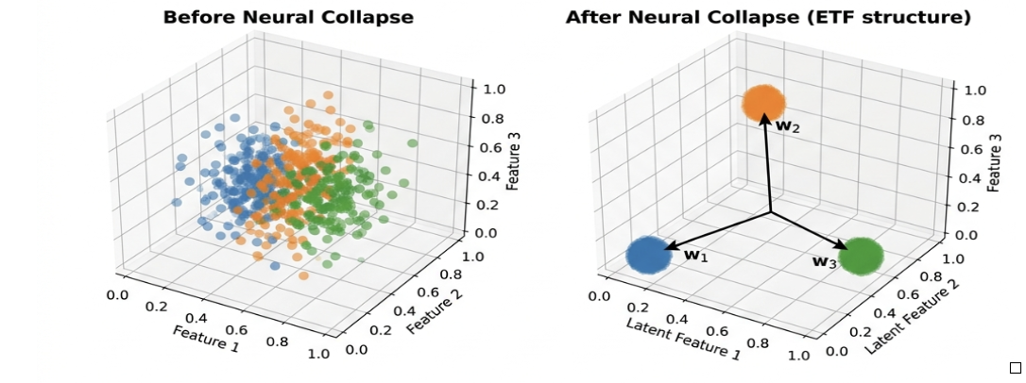

Visualizing Neural Collapse: (Left) Before NC, showing diffuse, overlapping training representations. (Right) After NC, training representations collapse into a fixed ETF/simplex structure aligned with class vectors.
Figure C.2: t-SNE Feature Space — Baseline (left) vs. ETF+NC-reg (right)

C.2 System Output
Sample console output from a completed training run (train.py):
════════════════════════════════════════════════════════════
NC-MedAI Training Complete
Dataset : ham10000 Method : etf
Seed : 42 Device : cuda
────────────────────────────────────────────────────────────
Best Val Accuracy : 65.00%
Macro F1 : 0.4720
Mean Sensitivity : 0.5880
Mean Specificity : 0.9200
Cohen Kappa : 0.5100
ROC-AUC : 0.8900
────────────────────────────────────────────────────────────
NC1 (scatter) : 5.530000
NC2 (ETF dev) : 0.00000320
NC3 (W-mu align) : 0.000000
NC4 (NCC disagree) : 0.186000
════════════════════════════════════════════════════════════

─────── End of Report ───────
NC-MedAI | KLE Technological University | Academic Year 2026

