**CO-1**

**2.** **Display future leap years from current year to a final year entered by user**.

s=int(input("Enter start year: "))

e=int(input("Enter end year: "))

if(s<e):

print("Leap years are: ",end=" ")

for i in range(s,e):

if i%4==0 and i%100!=0:

print(i, end=" ")

**OUTPUT**

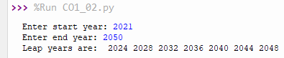

**3. List comprehensions:**

**a. Generate positive list of numbers from a given list of integers**

list =[-10,20,35,-67,70]

for i in list:

if(i>0):

print(i)

**OUTPUT**



**b. Square of N number**

n = int(input("Enter the limit: "))

for i in range(1,n+1):

s = i*i;

print(s**)**

**OUTPUT**

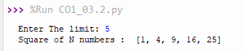

**c. Form a list of vowels selected from a given word**

word =input("Enter the word :")

print("The original string is : "+word)

print("The vowels are :")

for i in word:

if i in "aeiouAEIOU":

print([i])

**OUTPUT**

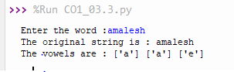

**d.** **List ordinal value of each element of a word (Hint: use ord() to get ordinal values)**

word=input("Enter a word:")

print("Ordinal values corresponding to each element is:")

for i in word:

print(i,end=":")

print(ord(i),end=" ")

**OUTPUT**

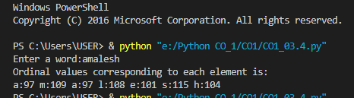

**4**.**Count the occurrences of each word in a line of text.**

str1 = input("Enter a String :")

wordlist = str1.split()

count = []

for w in wordlist:

count.append(wordlist.count(w))

print("count of the occurrence:" + str(list(zip(wordlist, count))))

**OUTPUT**

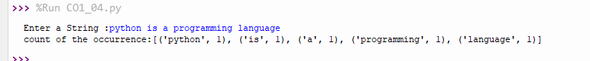

**5. Prompt the user for a list of integers. For all values greater than 100, store ‘over’ instead**

**n=[]**

**s=int(input("Enter a limit:"))**

**print("Enter {s} values")**

**for i in range(0,s):**

**n.append(int(input()))**

**print("\nThe list after assinging:\n")**

**for i in range(0,len(n)):**

**if n[i]>=100:print("over")**

**else:print(n[i])**

**OUTPUT**

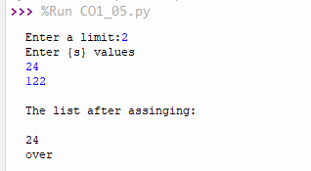

**6. Store a list of first names. Count the occurrences of ‘a’ within the list**

lst = ["a","b","c","a"]

occ = lst.count("a")

print("Occurrences of 'a' :",occ)

**OUTPUT**



**7.** **Enter 2 lists of integers. Check (a) Whether list are of same length (b) whether list sums to same value (c) whether any value occur in both**

lst1=[12,3,4,3,6,7,9,11,23,5]

lst2=[32,3,35,7,5,20,65,1]

s=int(0)

c=int(0)

if len(lst1)==len(lst2):

print("Lists are of same length")

else:

print("Lists are of different length")

for i in range(0,len(lst1) and len(lst2)):

s = lst1[i]

c = c+lst2[i]

if(s==c):

print("equal sum")

else:

print("not same sum")

print("Elements that matched are:")

l=[]

for i in range(0,len(lst1)):

for j in range(0,len(lst2)):

if lst1[i]==lst2[j]:

l.append(lst1[i] and lst2[j])

else:

continue

print(l)

**OUTPUT**

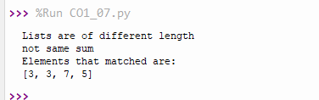

**8.** **Get a string from an input string where all occurrences of first character replaced with ‘$’, except first character. [eg: onion -> oni$n]**

str = "onion"

char = str[0]

str = str.replace(char, '$')

str = char + str[1:]

print(str)

**OUTPUT**

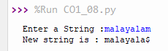

**9. Create a string from given string where first and last characters exchanged. [eg: python -> nythop]**

str = input("Enter a string :")

newstr = str[-1:] + str[1:-1] + str[:1]

print("New string :",newstr)

**OUTPUT**

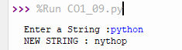

**10. Accept the radius from user and find area of circle.**

pi = 3.14

r = float(input("Enter the radius of circle :"))

area = pi*r**2

print("Area of circle :", area)

**OUTPUT**

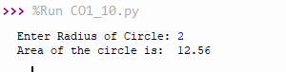

**11.Find the biggest of three numbers entered**

a = int(input("Enter First No:"))

b = int(input("Enter Second No:"))

c = int(input("Enter Third No:"))

if(a > b and a>c):

print(a,"is largest")

elif(b > c):

print(b,"is largest")

elif(c > a):

print(c,"is largest")

**OUTPUT**

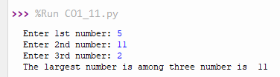

**12. Accept a file name from user and print extension of that**

file = input("Enter file name :")

f = file.split(".")

print("Extension of file is :",f[-1])

**OUTPUT**

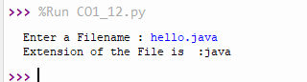

**13.Create a list of colors from comma-separated color names entered by user.Display first and last colors.**

a=[]

for i in range(3):

b=input("enter the color:")

a.append(b)

print(a)

print("First Color :",a[0])

print("Last Color:",a[2])

**output**

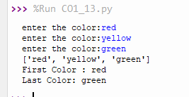

**14. Accept an integer n and compute n+nn+nnn**

n = int(input("Enter a number :"))

x = int("%s" % n)

y = int("%s%s" % (n,n))

z = int("%s%s%s" % (n,n,n))

print("n + nn + nnn :", x+y+z)

**OUTPUT**

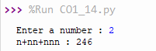

**15. Print out all colors from color-list1 not contained in color-list2.**

lst1 = set(["White", "Pink", "Red", "Blue"])

lst2 = set(["Red", "Green", "Pink"])

print(lst1.difference(lst2))

**OUTPUT**



**16.Create a single string separated with space from two strings by swapping the character at position 1.**

a = "Python"

b = "Java"

p1 = a[0]

p2 = b[0]

c = b[0] + a[1:len(a)]+" "+a[0] + b[1:len(b)]

print(c)

**OUTPUT**

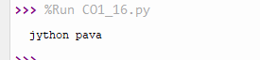

**17.Sort dictionary in ascending and descending order.**

import operator

d={1:30,2:10,3:20}

print(d)

sort=sorted(d.items(),key=operator.itemgetter(1))

print("dictionary in ascending order by value ",sort)

sort2=sorted(d.items(),key=operator.itemgetter(1),reverse=True)

print("dictionary in descending order value ",sort2)

**OUTPUT:**

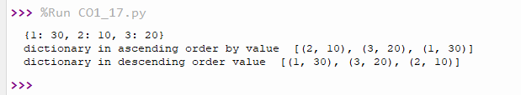

**18.Merge two dictionaries.**

d1 ={ 'a': 100, 'b': 200}

d2 ={'x' : 300, 'y': 200}

print ("Dict ionary 1=:", d1)

print ("Dictionary 2-: ", d2)

d =d1. copy ()

d.update (d2)

print ("Merged Dictionary: ", d)

**OUTPUT:**

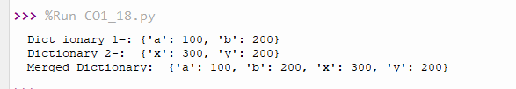

**19**.**Find the gcd of 2 numbers**

x= int(input("Enter 1st number: "))

y= int(input("Enter 2nd number: "))

i = 1

while(i <= x and i <= y):

if(x % i == 0 and y% i == 0):

gcd = i

i = i + 1

print("GCD :", gcd)

**OUTPUT**

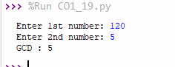

**20. From a list of integers, create a list removing even numbers.**

num = [1,2,3,4,5,6,7,8,9,10]

print( "Original list:",num)

num = [x for x in num if x%2!=0]

print("list after removing Even numbers:",num)

**OUTPUT**

