**CO3 PROGRAMS**

**1.Work with built-in packages**

**MATH MODULE**

import calendar

mm=int(input("Enter Month: "))

yy=int(input("Enter Year: "))

print(calendar.month(yy,mm)) #printing the calendar of the specified month & year

print(calendar.calendar(yy)) #printing calendar of the specified year

**OUTPUT**

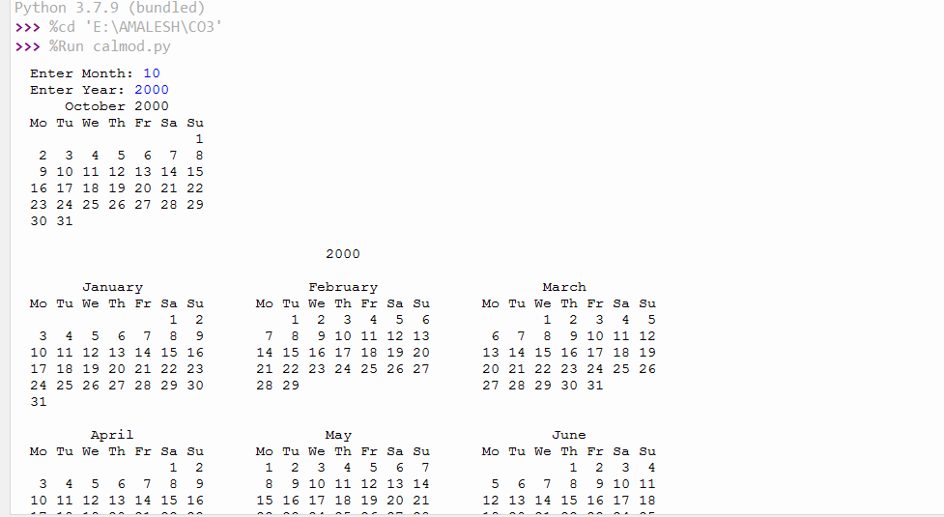

**DATE TIME MODULE**

import datetime

t=datetime.time(22,56,44,17) #hour mint sec microsec

print(t)

print("Hour is ",t.hour)

print("Minute is ",t.minute)

print("Second is ",t.second)

print("Micro Second is",t.microsecond)

d=datetime.date.today()

print(d)

print("Year is ",d.year)

print("Month is ",d.month)

d1=datetime.date.today()

print(d1)

td=datetime.timedelta(days=2) #timedelta class

print(td)

d2=d1+td #adding 2 days

print(d2)

dt=datetime.datetime.combine(d,t)

print(dt)

**OUTPUT**

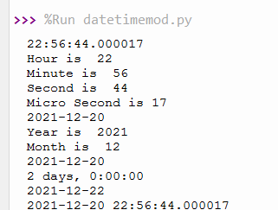

**MATH MODULE**

# import math as m #importing math module as m

# print(m.pi) #prints the value of pi

import math as m

from math import pi,sqrt

print("The value of pi is",m.pi)

print("Square root of 5 is",sqrt(5))

print("cos of 90 =",m.cos(90))

print("tan of 45 is =",m.tan(45))

print("sin of 45 is =",m.sin(90))

**OUTPUT**

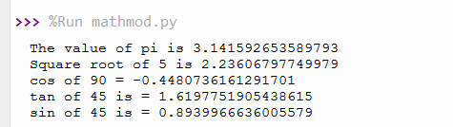

**RANDOM Module**

import random

random.seed(10)

print(random.random())

print(random.getstate())

print(random.randrange(3, 9))

**OUTPUT**

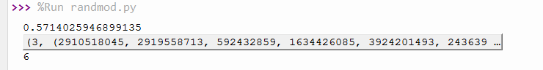

**STATISTICS Module**

# Import statistics Library

import statistics

a=[1, 3, 5, 7, 9, 11, 13]

# Calculate harmonic mean

print(statistics.harmonic_mean(a))

# Calculate average values

print(statistics.mean([1, 3, 5, 7, 9, 11, 13]))

# Calculate middle values

print(statistics.median([1, 3, 5, 7, 9, 11, 13]))

# Calculate the mode

print(statistics.mode(['red', 'green', 'blue', 'red']))

print(statistics.mode([1,2,3,1]))

print(statistics.mode([1, 3, 3, 3, 5, 7, 7, 9, 11]))

# Calculate the variance of an entire population

print(statistics.pvariance([1, 3, 5, 7, 9, 11]))

# Calculate the variance of an entire population

print(statistics.pvariance(a))

**OUTPUT**

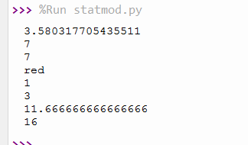

**TIME Module**

import time

print("Current Time in Sec",time.time())

print("Current Time is ",time.ctime()) #printing the current time

print("Time after 30 sec",time.ctime(time.time()+30)) #time after 30 sec

t=time.localtime()

print("Current Time",t)

print("Current Year",t.tm_year)

print("Current Month",t.tm_mon)

print("Current Day",t.tm_mday)

print("Current Hour",t.tm_hour)

print("Current Minute",t.tm_min)

#print("Current Week",t.tm_week)

**OUTPUT**

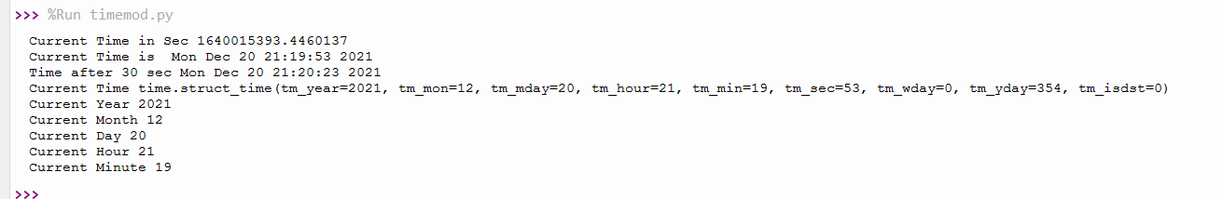

**2. Create a package graphics with modules rectangle, circle and sub-package 3D-graphics with modules cuboid and sphere. Include methods to find area and perimeter of respective figures in each module. Write programs that finds area and perimeter of figures by different importing statements. (Include selective import of modules and import * statements)**

**Graphics**

1. circle.py

def area(r):

print("Area of Circle is:",3.14*r*r)

def perimeter(r):

print("Perimeter of Circle is:",2*3.14*r)

1. rectangle.py

def area(l,b):

print("Area of Rectangle is:",l*b)

def perimeter(l,b):

print("Perimeter of Rectangle is:", 2*(l+b))

1. **__init__.py**

**graphicspack.py**

from graphics import rectangle

from graphics import circle

l=int(input("Enter Length of Rectangle:"))

b=int(input("Enter Breadth of Rectangle:"))

rectangle.area(l,b)

rectangle.perimeter(l,b)

r=int(input("Enter radius of the circle:"))

circle.area(r)

circle.perimeter(r)

**OUTPUT**

