ARCHITECTURE DOCUMENT
AI-Powered Health Insurance Claims Processing System

——————————————————————

Project | Multi-Agent Claims Pipeline — Health Insurance Claims Processing System
Status | All 9 pipeline stages implemented and working — 12/12 official test cases passing
Stack | React + TypeScript + Vite · FastAPI (Python, async) · SQLAlchemy + SQLite · Anthropic Claude Sonnet 4.5 (Gemini also supported, config-only switch)

Table of Contents
(Right-click below and choose “Update Field” — or press F9 — if the entries below do not appear automatically when this document is opened.)
1. Overview 4
What it can do 4
2. System Architecture 5
3. How a Claim Flows Through the System 7
4. The Pipeline Stages 8
5. AI Integration 9
Getting structured answers back 9
What actually uses AI, and what doesn't 9
6. Document Handling 10
Getting document types right 10
7. Policy, Financial & Fraud Logic 11
Policy checks 11
Money math 11
Fraud checks 11
8. Decision & Explanation 12
9. Data & Storage 13
10. API 14
11. Frontend 15
12. Observability & Error Handling 16
13. Security 17
14. Design Decisions 18
AI for reading, code for deciding 18
One interface for AI, not a direct SDK call from every agent 18
Separate stages instead of one big function 18
Financial calculation kept separate from the decision 18
SQLite for now, not Postgres 18
One process, not microservices 18
The official evaluation doesn't call live AI 19
15. Limitations & Scaling Notes 20
What I know is missing today 20
If this needed to handle 10x the traffic 20
16. Closing Thoughts 22

1. Overview
I built this to automate the first pass of health insurance claims processing. Someone submits a claim — their member ID, what kind of treatment, how much they paid, and photos or PDFs of their prescription and bill — and the system has to work out whether it should be paid, and how much.
The hard part is that real claim documents are messy: handwritten prescriptions, phone photos of bills, lab reports with all sorts of layouts. That's a job for AI, not regex. But I did not want AI anywhere near the actual coverage decision — nobody should get their claim rejected because a language model guessed wrong about a policy rule. So the whole system is built around one split:
- AI reads the documents — figures out what type each one is, and pulls out the useful fields (diagnosis, medicines, line items, amounts).
- Plain Python code makes every decision that matters — is this covered, how much is payable, does a fraud rule trip, what's the final outcome. All of that reads straight from the policy file, no model involved.
Everything else in this document follows from that one decision.

What it can do
- Reads real uploaded documents (not just filenames) and classifies them correctly by structure — an itemized dental bill is a bill, not a dental report, regardless of the specialty that issued it.
- Checks a claim against the actual policy contract — limits, waiting periods, exclusions, pre-authorization, network hospitals — deterministically.
- Produces one of four outcomes: approved, partially approved, rejected, or sent for manual review, each with a reason and a confidence score.
- Logs every step it took, so any claim's outcome can be reconstructed and explained after the fact.
- Keeps running if one part fails — a bad AI call or a broken component degrades the result instead of crashing the request.

2. System Architecture
Four layers. A React frontend, a FastAPI backend, a nine-stage processing pipeline sitting inside that backend, and a persistence layer underneath it. The pipeline is really the heart of the system — everything else exists to get a claim into it and get the result back out.
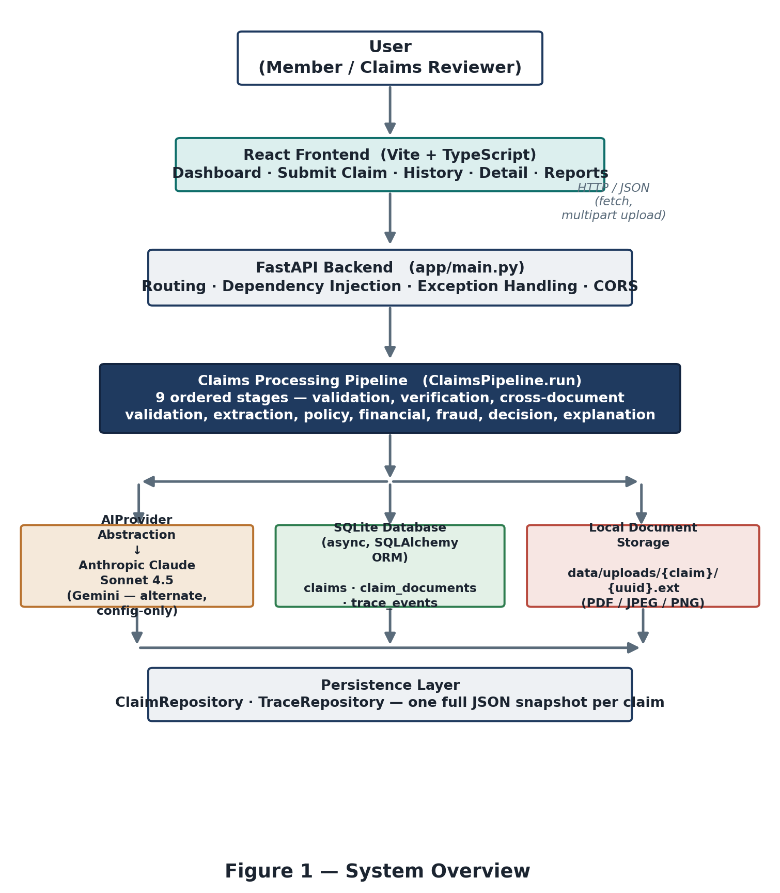
System overview
Layer | What it's built with | What it does
Frontend | React + TypeScript + Vite | Submit a claim, browse history, view a claim in detail, check the evaluation report.
API | FastAPI, Pydantic | Routing, request validation, dependency wiring, one place all errors get handled.
Pipeline | app/pipeline/pipeline.py | Runs the 9 stages in order, decides when to stop early and when to keep going after a failure.
Domain logic | 7 agents + the policy engine + the financial service | Validation, document reading, policy rules, money math, fraud checks, the final decision, the explanation.
Storage | SQLite (via SQLAlchemy) + local disk for files | Everything about a claim, plus the raw uploaded files.

3. How a Claim Flows Through the System
Someone fills in member ID, policy ID, claim category, treatment date, claimed amount, and attaches their documents. Here's what happens after they hit submit:
- 1. The form posts to POST /api/v1/claims as multipart form data.
- 2. Claim Validation checks the member exists, the policy matches, the category is valid, and the amount clears the minimum. If any of that's wrong, it stops right here.
- 3. Document Verification reads each uploaded file with AI and works out what it is. If a required document is missing or unreadable, it stops here too.
- 4. Cross-Document Validation makes sure every document names the same patient, and that patient matches the member on the claim.
- 5. Document Extraction pulls structured data out of each document — diagnosis, medications, line items, whatever's relevant to that document type.
- 6. The Policy Engine checks the claim against the actual policy — coverage, waiting periods, exclusions, pre-authorization, and so on.
- 7. Financial Calculation works out what would be payable — discount, limits, copay.
- 8. Fraud Analysis checks a few deterministic thresholds against the member's claim history.
- 9. Decision Generation puts all of that together and picks the final outcome.
- 10. Explanation writes up a plain-language summary of that decision.
- 11. The whole result gets saved, and the API responds with everything — the frontend then takes the member straight to that claim's detail page.
Steps 2 through 4 can stop the whole thing early — there's no point extracting data or running policy checks on a claim that's missing a required document. Steps 5 through 8 don't stop anything; if one of them fails, the pipeline just carries on with a lower confidence score.

4. The Pipeline Stages
This is the exact order things run in, straight from ClaimsPipeline.run(). I've marked which stages call AI and which ones can actually stop a claim.
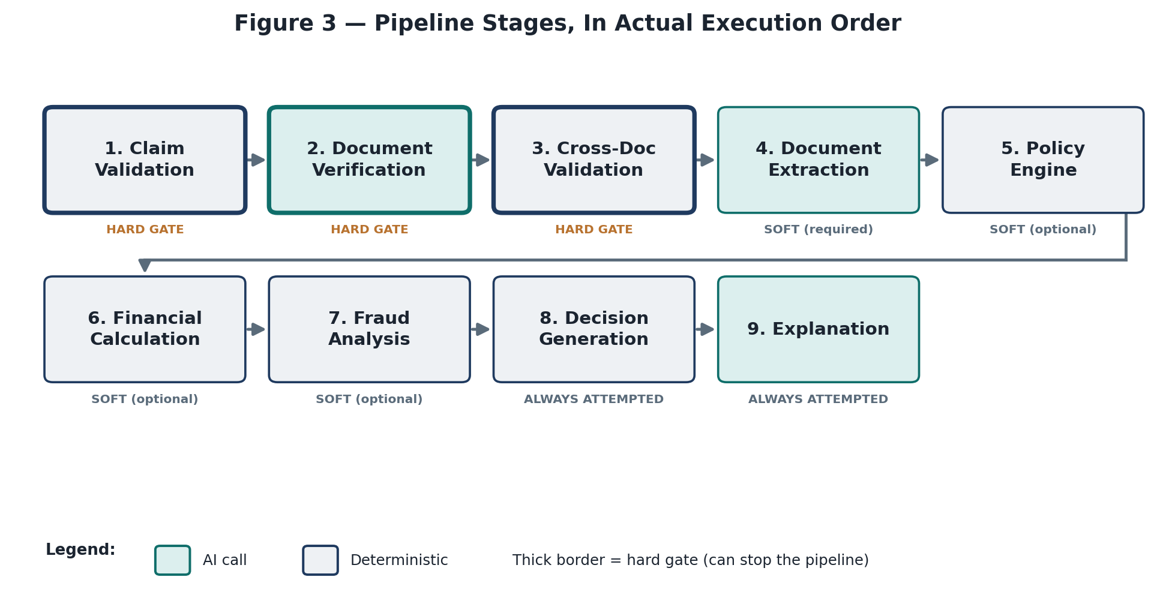
The 9 stages, in order
# | Stage | AI? | Can it stop the claim?
1 | Claim Validation | No | Yes
2 | Document Verification | Yes | Yes
3 | Cross-Document Validation | No | Yes
4 | Document Extraction | Yes | No — failures are per-document
5 | Policy Engine | No | No — degrades confidence instead
6 | Financial Calculation | No | No
7 | Fraud Analysis | No | No
8 | Decision Generation | No | Always runs, falls back to manual review if it errors
9 | Explanation | Yes | Never — a failure just skips the AI write-up

A quick note on the vocabulary I use for outcomes: PASS/BLOCKED are what the verification stages report; APPROVED/PARTIAL/REJECTED/MANUAL_REVIEW are the four possible final decisions; SKIPPED shows up in the trace for any stage that never ran because an earlier stage already stopped the claim. When that happens, I make sure every remaining stage gets an explicit SKIPPED entry in the trace rather than just silently not appearing — a claim's trace should always account for all 9 stages, even the ones it never reached.

5. AI Integration
I didn't want any agent talking to the Anthropic or Gemini SDK directly, so there's one interface — AIProvider — that every agent depends on, and exactly two files that import a vendor SDK at all: the Anthropic adapter and the Gemini adapter. Everything else just calls generate_text(), generate_structured(), or analyze_document() and doesn't know or care which provider is actually behind it.
This paid off in practice — I switched the default provider from Gemini to Anthropic partway through building this, and didn't have to touch a single agent to do it. It's just a couple of environment variables (AI_PROVIDER, AI_MODEL).

Getting structured answers back
Both providers are used in a mode that forces a proper JSON response back, matching a schema I define — never free text I then have to regex apart. Anthropic does this with a forced tool call; Gemini does it with its own response_schema option. Either way, the agent gets a parsed dictionary back, not a wall of text to parse.

What actually uses AI, and what doesn't
Only three of the nine stages ever call an AI provider: Document Verification (classifying documents), Document Extraction (pulling structured fields out of them), and Explanation (writing up the decision in plain language). The other six — validation, cross-document checks, policy, financial, fraud, and the final decision itself — are plain Python with no AI call anywhere in them. I mean that literally: you can grep those files for anything AI-related and find nothing but a docstring mentioning it.
That last point matters most for Decision Generation. It runs before Explanation, and it's the only thing that ever sets the final decision and the approved amount. By the time Explanation runs, those are already locked in — the explanation step can only write text, never touch the decision itself.

6. Document Handling
A document goes through a few steps: it gets validated and stored, then classified, then checked against the other documents, then extracted.
- Validation — size, MIME type, and an actual check of the file's first few bytes (so someone can't just rename a .exe to .pdf and get past the MIME check).
- Storage — saved to disk under a generated filename, not the one the user uploaded, to avoid any path-traversal shenanigans.
- Classification — AI looks at the actual file content and decides what type of document it is.
- Verification — compares what came in against what the policy requires for that claim category.
- Extraction — pulls out the fields that matter, differently depending on the document type.

Getting document types right
This is the part I had to fix a couple of times during development. The mistake to avoid is classifying a document by the medical specialty or the specific test it mentions, instead of by its actual structure. A few examples that tripped this up:
Document | Correct type | Why
A lab's own report of an MRI — accredited lab letterhead, a sample ID, a results table, a pathologist's sign-off | LAB_REPORT | It has the structure of a lab report. The fact the test happens to be an MRI doesn't matter.
A diagnostics center's itemized bill for that same MRI | HOSPITAL_BILL | It's a bill — line items, a total, payment details — regardless of what specialty issued it.
A specialist's own written interpretation of the scan, with no lab sign-off structure | DIAGNOSTIC_REPORT | Narrative content, no billing, no lab-tracking structure.

The fix, both times, was in the prompt — making the rule about structure explicit and generic, never hardcoding a specific test case or document ID to work around a one-off failure.

7. Policy, Financial & Fraud Logic
This is the deterministic core of the system — no AI touches any of it. Everything here reads straight from policy_terms.json, so a rule can always be traced back to an actual line in that file.

Policy checks
The policy engine runs about twenty individual checks — is the category covered, has the waiting period passed, does an exclusion apply, is pre-authorization required and was it provided, is the hospital in-network, and so on. Each one comes back as a named finding (passed, failed, warning, or not applicable) with the evidence behind it, so nothing is a black box.
One bug worth mentioning: the waiting-period check used to match “hernia” as a plain substring, which meant it matched inside “Herniation” too — a completely unrelated spinal condition. Fixed with a proper word-boundary check, and I added a test to make sure it doesn't come back.

Money math
Financial calculation is a separate step from policy — it takes the claimed amount and works out what would be payable: apply a network discount if the hospital qualifies, cap it against the remaining annual allowance, deduct the copay. This is just arithmetic (using Decimal, not floats, so nothing rounds strangely) and it doesn't know or care whether the claim will actually be approved.
That last part is worth sitting with for a second, because it explains something that looks odd at first glance: a claim can show a claimed amount of ₹7,500, a computed payable amount of ₹6,750, and still end up with an approved amount of ₹0. That happens when the decision step separately finds a reason to reject the claim — a waiting period, a missing pre-authorization, whatever — after the financial math already ran. Payable amount answers “how much would this be worth,” approved amount answers “was it actually approved.” They're not the same question.

Fraud checks
Four simple threshold checks — too many claims the same day, too many in the same month, a high-value claim, or a claim way above the auto-review threshold. Nothing adaptive, nothing AI-driven, just counting against the member's real claim history. If any of the review-triggering thresholds hit, the claim gets flagged for manual review rather than auto-rejected.

8. Decision & Explanation
One agent, DecisionGenerationAgent, is responsible for the final call. It works through a fixed order of checks — exclusion, waiting period, missing pre-auth, over the per-claim limit, fraud flag, zero payable amount — and the first one that matches decides the outcome. If nothing matches, it's either approved in full or partially approved, depending on whether a line-item exclusion knocked the eligible amount below what was claimed. And if the overall confidence across every stage ends up too low, the whole thing gets downgraded to manual review regardless of what it would otherwise have decided.
Explanation runs last, and only after the decision above is already final. It takes a compact summary of the decision — never the raw documents — and asks the AI to write it up in plain language, with a fairly long list of things it's explicitly not allowed to do: recalculate an amount, invent a policy rule, contradict the decision, or claim something about a document that isn't in the evidence it was given. If that AI call fails for any reason, there's a plain deterministic fallback built straight from the decision's own fields, so the member never sees a blank explanation.

9. Data & Storage
SQLite for now, through SQLAlchemy's async ORM — three tables: claims, claim_documents, and trace_events. I kept every query going through the ORM, no raw SQL anywhere, specifically so moving to Postgres later is a one-line connection-string change instead of a rewrite.
Each claim's full result — validation, policy findings, financial breakdown, fraud result, decision — gets stored as JSON alongside the regular columns, so nothing gets lost when it's saved, and it can be read back exactly as it was.
Uploaded files themselves don't go in the database at all — they sit on local disk under a generated filename, and only a reference string is stored. Keeps the database small, and means swapping to something like S3 later is just a new implementation of the same storage interface, not a rewrite of anything that calls it.

10. API
Six endpoints, all under /api/v1:
Endpoint | What it does
GET /health | Basic status check — is the backend up, which AI provider is configured.
POST /claims | Submit a claim with real documents. Runs the full pipeline and returns the result.
GET /claims | List claims, newest first.
GET /claims/{id} | Full detail for one claim.
GET /claims/{id}/trace | Every trace event for that claim, in order.
GET /evaluation | Re-runs the 12 official test cases live and reports pass/fail.

Errors go through two handlers that wrap every route: anything the system itself raises comes back as a proper error code and message; anything unexpected comes back as a generic 500 with no internal detail leaked.

11. Frontend
React, TypeScript, five pages, one place all the API calls live (services/api.ts). Nothing fancy on state management — each page fetches what it needs on mount.
- Dashboard — system health and a list of the pipeline stages, mostly for orientation.
- Submit Claim — the form. Fill it in, attach files, submit.
- Claim History — a table of past claims.
- Claim Detail — the full picture for one claim — decision, documents, policy/financial/fraud results, and the trace.
- Evaluation Report — runs the 12 official test cases against the real backend and shows what passed.
Every number and status shown on these pages comes straight from the backend response — the frontend doesn't recompute or guess at anything.

12. Observability & Error Handling
Every stage of every claim writes a trace event — started, completed, failed, skipped, or a warning — and those get saved independently of the claim record itself. For the stages that call AI, I also record which provider and model handled it, how long it took, and token usage. Given a claim ID, I can pull up its trace and see exactly what happened, in order, without guessing.
I split failures into two kinds. A hard failure — an unknown member, a missing document, a patient mismatch — stops the claim immediately with a specific message explaining what's wrong. A soft failure — the policy engine throwing an unexpected error, say — doesn't stop anything; it gets logged, confidence takes a hit, and the pipeline keeps going. That second behavior is also what the assignment's simulated-failure test checks: the system should degrade, not crash, when something breaks internally.
If Decision Generation itself somehow errors out, I don't leave the claim without a decision — it falls back to manual review at zero confidence rather than just failing the request.

13. Security
- API keys live in a git-ignored .env file, never hardcoded, never returned by any endpoint.
- Uploads are checked against both an allowed MIME type list and the actual file signature — not just trusting the Content-Type header.
- Uploaded files are always saved under a server-generated name, never the client's original filename, to avoid path traversal.
- Every database query goes through the ORM — no raw SQL string-building anywhere.
- CORS is locked to a specific list of allowed origins, not a wildcard.
- Unhandled errors always return a generic message — nothing internal ever leaks into an error response.

14. Design Decisions
A few calls I made along the way, and why.

AI for reading, code for deciding
This is the decision everything else follow. The alternative — letting an LLM decide the claim directly — would have been faster to build, but I wouldn't trust it, and neither should an auditor. A policy rule should be applied exactly as written, not approximated by a model.

One interface for AI, not a direct SDK call from every agent
Could have just called the Anthropic SDK from wherever I needed AI. Went with an abstraction instead so a provider swap is a config change, not a rewrite — which turned out to matter, since I actually did switch providers partway through.

Separate stages instead of one big function
Nine small stages instead of one large claim-processing function. More plumbing up front, but each piece is independently testable, and a bug in one stage can't quietly corrupt another's output.

Financial calculation kept separate from the decision
Could have folded the money math into decision generation. Kept it separate on purpose, so “how much would this be worth” and “should it be approved” stay two different questions — which is exactly what lets a rejected claim still show a sensible payable amount instead of forcing everything to zero the moment a rejection fires.

SQLite for now, not Postgres
Zero setup, which mattered for building this quickly. Not a production choice long term — see the next section — but since nothing in the repository layer uses raw SQLite-specific SQL, moving to Postgres later is genuinely just a connection string change.

One process, not microservices
Everything runs in a single backend process today. At this scale, splitting it into separate services would add network hops and deployment complexity for no real benefit — I'd rather earn that complexity when the traffic actually needs it. More on this in the next section.

The official evaluation doesn't call live AI
The 12 official test cases run against the real decision logic using pre-classified documents, not a live model call. That's on purpose — it means a real regression in the decision logic and an off day for the AI provider look completely different, instead of getting confused with each other. I verify real document classification separately, against the actual live API.

15. Limitations & Scaling Notes

What I know is missing today
- The submission-deadline check runs and reports a result, but the final decision doesn't actually act on it yet — a late claim can still get approved. On my list to fix.
- AI calls for a claim's documents run one after another, not in parallel — fine at low volume, but it adds up with multiple documents.
- Everything runs as one process talking to one SQLite file — no horizontal scaling yet.
- Uploaded files live on local disk, which doesn't work once you have more than one backend instance.
- No retry logic on a transient AI failure — a timeout just fails that one document's classification rather than trying again.

If this needed to handle 10x the traffic
The AI calls would be the first thing to hit a wall, not the database and not the decision logic — those are just fast, deterministic Python. So the real changes would be:
- Queue the work — submitting a claim would enqueue it and return immediately, instead of blocking on the full pipeline. A pool of workers would process claims off that queue, running the exact same pipeline stages unchanged.
- Parallelize document calls — a claim's documents don't depend on each other, so their AI calls could run concurrently instead of one after another.
- Move to Postgres — already just a config change, plus connection pooling and an index on member ID and treatment date for the fraud checks.
- Move file storage off local disk — onto something like S3, so it doesn't matter which backend instance or worker handles a given claim.
- Add retries and rate limiting around the AI calls — so a transient failure or a burst of traffic doesn't just fail claims outright.
- Better observability across the board — centralized logs and metrics, since a single claim's processing would now span multiple processes instead of one.
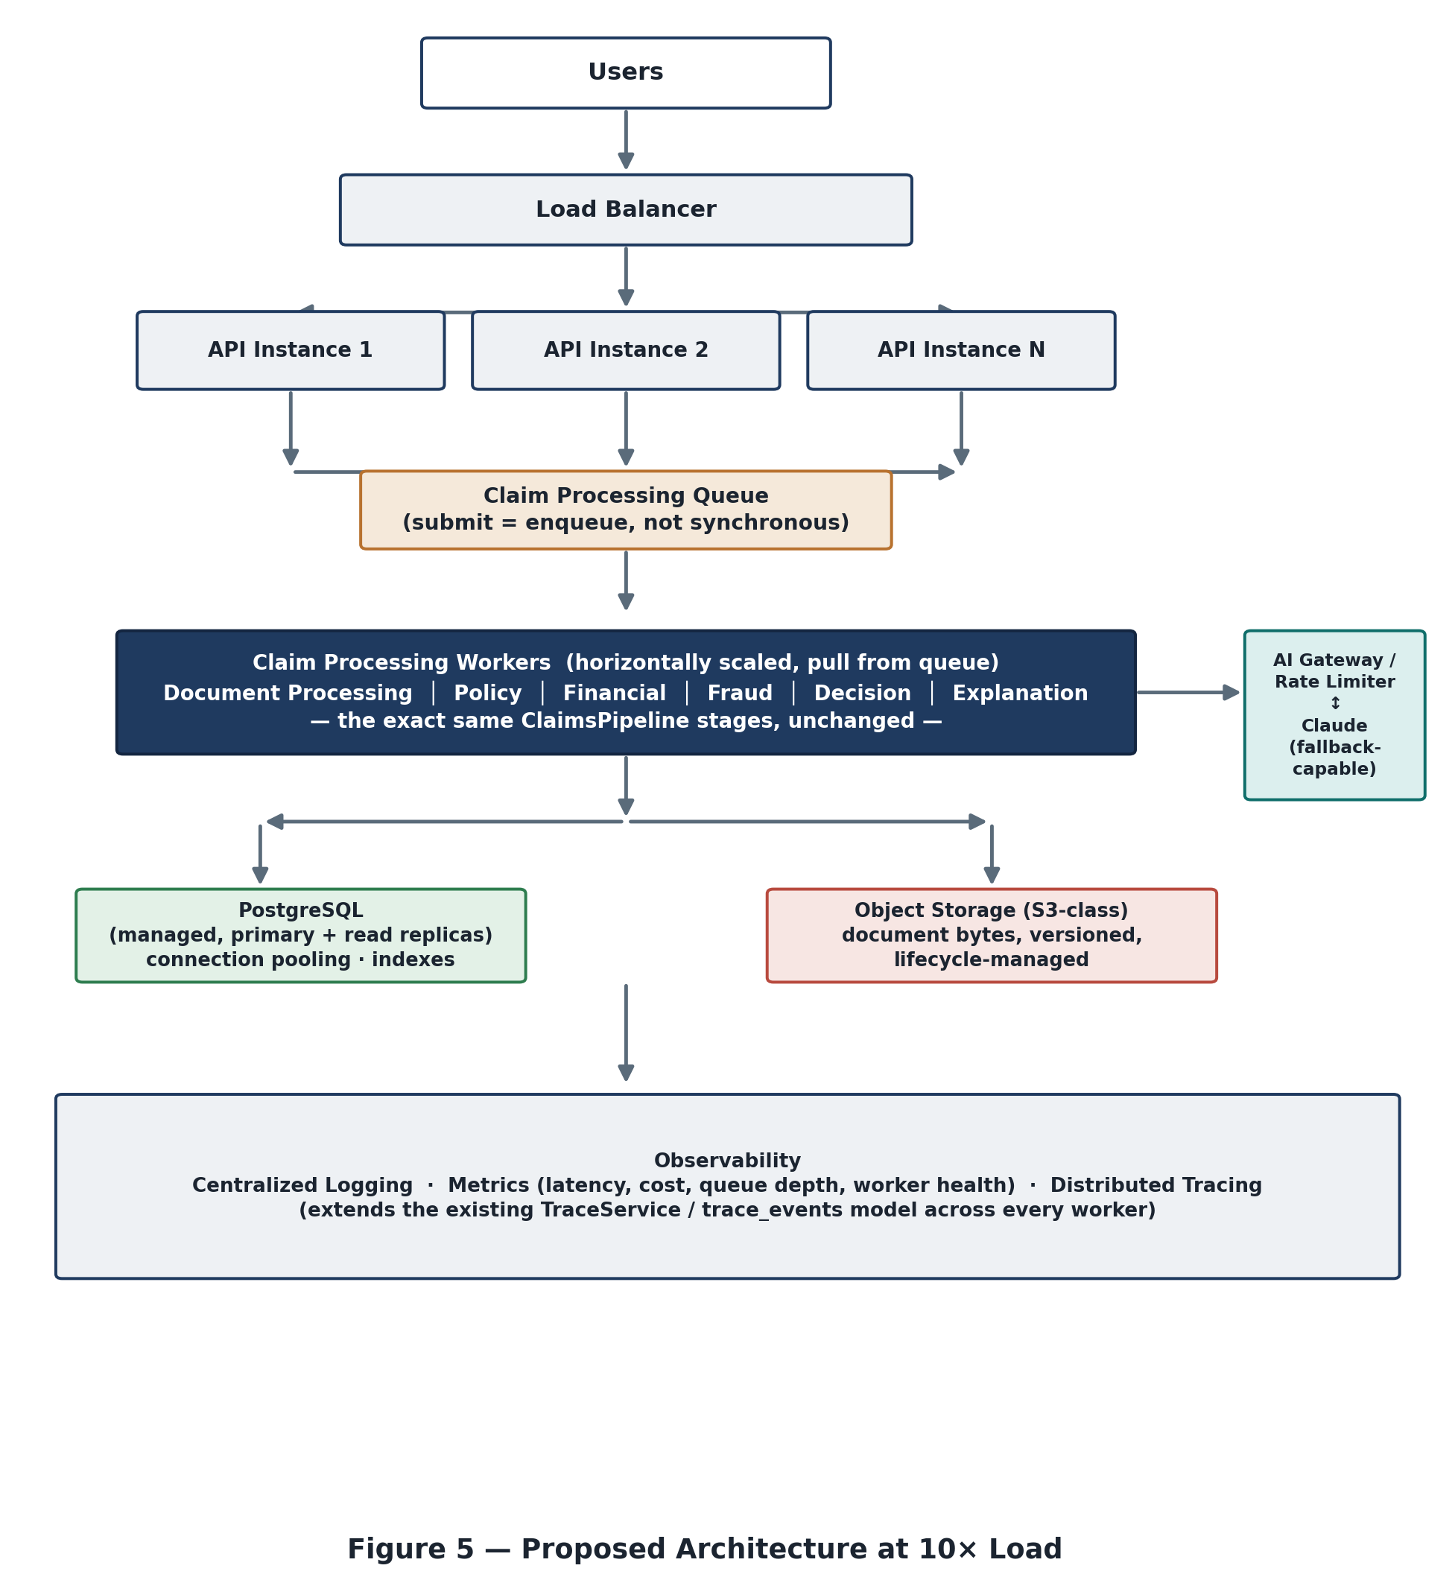
What that looks like at 10x scale
None of this touches the actual business logic — the pipeline stages, the policy rules, the decision precedence all stay exactly as they are. It's purely about how the work gets distributed and where things are stored.

16. Closing Thoughts
The whole system comes down to one line I keep coming back to: let AI read things, and let code decide things. Everything else — the nine stages, the separate policy and financial and fraud logic, the trace on every claim — exists to make that split actually hold up under real use, not just as a nice idea in a diagram.
It's a single backend process today, and that's the right call at this scale — it's simple to run, simple to debug, and fast to change. If it ever needs to handle real production volume, the plan in the previous section gets it there without touching any of the actual decision logic described in this document.

— end —

