Component Contracts
Health Insurance Claims Processing System
This document describes the interface of every important component in the claims pipeline — what it takes in, what it gives back, what it depends on, and what happens when it fails. It's meant so another developer can understand how a piece fits into the system without reading its implementation.
For the bigger picture — why the system is put together this way, the overall architecture, and the trade-offs — see ARCHITECTURE.docx. This document sticks to interfaces.

1. Domain Models
These are the Pydantic models that get passed between components. Everything in this document refers back to these.
Model | Important fields | Purpose
ClaimSubmission | member_id, policy_id, claim_category, treatment_date, claimed_amount, documents, hospital_name, ytd_claims_amount | What the member actually submitted. Built from the upload, before anything has run.
Claim | claim_id, submission, status, documents, member, decision, and one result field per stage (validation_result, document_verification_result, ...) | The whole claim as it moves through the pipeline. Each stage fills in its own result field on this object.
Member | member_id, name, date_of_birth, relationship, join_date, dependents | One row from the member list in policy_terms.json.
DocumentClassification | file_id, document_type, quality, patient_name, confidence, source | What Document Verification decided one document is. source is either “ai” or “fixture” (fixture = pre-supplied, used by the evaluation runner).
DocumentVerificationResult | status, required_documents, received_documents, missing_documents, wrong_documents, quality_issues, classifications, user_message, confidence | The output of Document Verification for the whole claim, not just one document.
CrossDocumentValidationResult | status, patient_names, user_message, confidence | Whether every document (and the member) agree on who the patient is.
PolicyEvaluationResult | covered, findings, passed_rules, failed_rules, requires_pre_authorization, pre_authorization_provided, waiting_period_applies, exclusion_applies, is_network_hospital, line_item_findings, confidence | Every policy rule checked, plus the flags Decision Generation actually reads.
FinancialBreakdown | claimed_amount, eligible_amount, network_discount_amount, payable_amount, calculation_steps, warnings, confidence | The money math. payable_amount is what Decision Generation copies into approved_amount when the claim isn't rejected.
FraudAnalysisResult | risk_level, flags, same_day_claim_count, monthly_claim_count, is_high_value, requires_manual_review, confidence | Deterministic fraud signal, not a decision.
ClaimDecision | decision, approved_amount, rejection_reasons, line_item_decisions, reason_code, confidence_score, explanation, member_facing_message, degraded_components | The final answer. Everything downstream (the API response, the frontend) reads from this.
ExplanationResult | member_summary, operations_summary, key_reasons, deductions, policy_findings, warnings, source, degraded, confidence | The write-up. source is “AI” or “FALLBACK” depending on whether the AI call worked.

2. Claims Pipeline
ClaimsPipeline.run() takes a ClaimSubmission wrapped in a Claim object and a TraceService, and runs each stage in a fixed order. It always returns a Claim — it never raises. If something goes wrong partway through, the Claim it returns just has status=BLOCKED and a message explaining why, instead of an exception coming out.
In / Out | Type
Input | Claim (wrapping a ClaimSubmission) + a TraceService
Output | The same Claim, with every stage's result filled in (or stopped early with status set)

Stage order
This is the order things actually run in, straight from the code:

1. Claim Validation
Input | ClaimSubmission
Output | ValidationResult
Does AI call | No
Can stop pipeline | Yes
Main failure | Unknown member, wrong policy, unsupported category, amount below minimum

2. Document Verification
Input | Uploaded documents
Output | DocumentVerificationResult
Does AI call | Yes
Can stop pipeline | Yes
Main failure | Missing required document, unreadable document

3. Cross-Document Validation
Input | Classified documents + member
Output | CrossDocumentValidationResult
Does AI call | No
Can stop pipeline | Yes
Main failure | Documents belong to different patients, or don't match the claim's member

4. Document Extraction
Input | Verified documents
Output | ClaimExtractionResult
Does AI call | Yes
Can stop pipeline | No
Main failure | A single document's extraction fails — handled per document, doesn't stop the claim

5. Policy Engine
Input | Claim + extracted data
Output | PolicyEvaluationResult
Does AI call | No
Can stop pipeline | No
Main failure | Internal error — result becomes None, confidence drops, claim keeps going

6. Financial Calculation
Input | Claim + PolicyEvaluationResult
Output | FinancialBreakdown
Does AI call | No
Can stop pipeline | No
Main failure | Same as above

7. Fraud Analysis
Input | Claim + claim history
Output | FraudAnalysisResult
Does AI call | No
Can stop pipeline | No
Main failure | Same as above — also where the simulated component-failure test hooks in

8. Decision Generation
Input | Policy + Financial + Fraud results
Output | ClaimDecision
Does AI call | No
Can stop pipeline | Always attempted
Main failure | Falls back to MANUAL_REVIEW rather than leaving the claim without a decision

9. Explanation
Input | The final ClaimDecision
Output | ExplanationResult
Does AI call | Yes
Can stop pipeline | Never blocks
Main failure | Falls back to deterministic text built from the decision itself

Stages 1 through 3 are gates — if one of them fails, the pipeline stops right there and every stage after it gets marked SKIPPED in the trace instead of just not running silently.

3. Claim Validation
ClaimValidationAgent.run(submission) — first thing that runs, and the cheapest to fail fast on.
Input | ClaimSubmission
Output | ValidationResult (valid, errors, warnings, member)
Checks | Member exists · policy_id matches · category is a real category · claimed amount ≥ minimum
Depends on | PolicyRepository — reads members and category list from policy_terms.json
Errors | MEMBER_NOT_FOUND, POLICY_NOT_FOUND, UNSUPPORTED_CATEGORY, BELOW_MINIMUM_AMOUNT

Note: there's no submission-deadline check in this agent. PolicyEngine reports a deadline finding later , but nothing currently rejects a claim for being late.

4. Document Verification
DocumentVerificationAgent.run() — reads each uploaded file and works out what it is. This is the one place that reads real document bytes.
Input | claim_category + the list of uploaded documents
Output | DocumentVerificationResult
AI call | Yes — AIProvider.analyze_document(), once per document, sends the actual PDF/image bytes
Checks | Every document gets a type, a quality rating, and a confidence score; then compared against what's required for that category
Status values | PASS, BLOCKED (missing a required document), NEEDS_RESUBMISSION (a document was unreadable)

Document types that matter
Type | What it is
PRESCRIPTION | Doctor's Rx — diagnosis, medications.
HOSPITAL_BILL | Any itemized bill — general, dental, or a diagnostics center. Classified by billing structure (line items, a total, payment details), not by specialty.
LAB_REPORT | A lab's own report — accredited lab identity, a sample ID, a results table, a pathologist sign-off.
DIAGNOSTIC_REPORT | A narrative clinical report without that lab-issued structure.
DENTAL_REPORT | Dental clinical narrative — not a bill.
PHARMACY_BILL, DISCHARGE_SUMMARY, PRE_AUTH_LETTER, UNKNOWN | The rest of the DocumentType enum. UNKNOWN is a real, valid outcome — the model is told to prefer it over guessing.

The classification prompt is in app/ai/prompts/document_verification.py if you need the exact wording — not reproduced here.

5. Cross-Document Validation
CrossDocumentValidationAgent.run() — no AI, just string comparison.
Input | The document classifications from stage 2, plus the claim's member (optional)
Output | CrossDocumentValidationResult (status, patient_names, user_message, confidence)
Logic | Normalize every document's patient_name (lowercase, whitespace collapsed) and compare. If more than one distinct name shows up → BLOCKED. If they agree but don't match the claim's member → also BLOCKED.
Note | Matching is exact after normalization, not fuzzy — “Rajesh Kumar” and “Raj Kumar” won't match.

6. Document Extraction
DocumentExtractionAgent.run() — pulls structured fields out of each document, one AI call per document, using a schema specific to that document's type.
Input | The list of documents, already classified
Output | ClaimExtractionResult (extractions, failures, skipped, confidence, has_failures)
AI call | Yes — AIProvider.analyze_document(), same mechanism as classification, different schema
Skipped vs. failed | DIAGNOSTIC_REPORT, PRE_AUTH_LETTER and UNKNOWN aren't extracted at all (skipped, not a failure). Anything else that errors out is recorded as a per-document failure and doesn't stop the claim.

What gets extracted, by type
Document type | Fields
Prescription | doctor, diagnosis, medications (name/dosage/frequency/duration), investigations
Hospital Bill | hospital_name, bill_number, line_items (description/amount), total
Lab Report | laboratory_name, tests (test_name/result/unit/reference_range), report_date
Pharmacy Bill | pharmacy_name, items (medicine_name/batch/expiry/amount), total

7. Policy Engine
PolicyEngine.evaluate(claim) no AI. Every rule reads from policy_terms. json through PolicyRepository, nothing is hardcoded.
Input | The claim, plus whatever Document Extraction produced
Output | PolicyEvaluationResult
AI call | No

What it checks
- Category coverage and policy active dates
- Submission deadline (reported, not enforced — see §3)
- Per-claim limit, annual limit, sub-limit (reported here; the per-claim limit is actually enforced in Decision Generation, §10)
- Copay and network discount
- Network hospital match
- Waiting periods, including a specific-condition check against the extracted diagnosis text
- Exclusions (general, dental, vision)
- Pre-authorization requirement and whether it was provided
- Document requirements specific to a category (e.g. a dental report for DENTAL)
Each check comes back as a named finding — PASSED, FAILED, WARNING, or NOT_APPLICABLE — with a short evidence string. It's deterministic on purpose: a policy rule needs to come out the same way every time, and needs to be traceable back to the actual JSON field, not a model's guess.

8. Financial Calculation
FinancialCalculationService.calculate(claim, policy) — also no AI, just money math.
Input | Claimed amount + the PolicyEvaluationResult
Output | FinancialBreakdown
Order | claimed amount → eligible amount (reduced only by a genuine line-item exclusion) → network discount → annual-limit cap → copay → payable amount
Arithmetic | Python Decimal throughout, rounded with ROUND_HALF_UP to 2 places
Warnings | If a bill's line items don't add up to its own stated total, a warning gets recorded — neither number is silently corrected

Claimed vs. payable vs. approved
Three different numbers, three different answers. Claimed amount is what the member asked for. Payable amount is what this service computes — what the claim would be worth if it's approved. Approved amount is what Decision Generation actually authorizes, and it can be forced to zero even when payable amount is a real, positive number — that happens whenever the claim gets rejected for a reason that has nothing to do with the money math, like a waiting period or a missing pre-authorization.

9. Fraud Analysis
FraudAnalysisAgent.run(claim) — deterministic threshold checks, no AI.
Input | The claim + the member's claim history (from a fixture list, or a real ClaimRepository query)
Output | FraudAnalysisResult
Checks | Same-day claim count, monthly claim count, high-value threshold, auto-manual-review threshold — all read from policy_terms.json's fraud_thresholds
risk_level | HIGH if any review-triggering rule fired, MEDIUM if just high-value, else LOW

There's an ai_risk_score field on the result, reserved for a future AI-assisted signal. It's always None right now — not used.

10. Decision Generation
DecisionGenerationAgent.run(claim) — the only component allowed to set the final decision. No AI.
Input | PolicyEvaluationResult + FinancialBreakdown + FraudAnalysisResult
Output | ClaimDecision
AI call | No

How it picks an outcome
It checks things in a fixed order, and the first match wins:
- Policy or Financial result missing → MANUAL_REVIEW
- A whole-claim exclusion applies → REJECTED
- A waiting period applies → REJECTED
- Pre-authorization required but missing → REJECTED
- Nothing above fired, and claimed amount is over the per-claim limit → REJECTED
- Fraud flags requires_manual_review → MANUAL_REVIEW
- Payable amount is zero → REJECTED
- Eligible amount is less than claimed (a line-item exclusion) → PARTIAL, otherwise → APPROVED
- If overall confidence ends up below 0.5 after all that → downgraded to MANUAL_REVIEW
Confidence is the minimum of every stage's own confidence, minus a penalty for each stage that didn't produce a result at all.

11. Explanation
ExplanationAgent.run(claim, decision) — writes up the decision in plain language. Runs last, after the decision is already final.
Input | The final ClaimDecision + a compact summary of the claim (never the raw documents)
Output | ExplanationResult (member_summary, operations_summary, key_reasons, deductions, ...)
AI call | Yes — AIProvider.generate_structured(), text only, no document bytes
Fallback | If the AI call isn't configured or fails, a plain explanation gets built directly from the decision's own fields instead. source is set to FALLBACK so it's visible which one happened.

This can't change the decision. By the time this stage runs, decision and approved_amount are already set — the pipeline only ever copies explanation, explanation_detail and member_facing_message back onto the claim.

12. AI Provider
Every AI call in the system goes through one interface, AIProvider (app/ai/providers/base.py). Agents never talk to the Anthropic or Gemini SDK directly.
Agent | ↓ calls generate_text() / generate_structured() / analyze_document()
AIProvider | ↓ abstract interface
AnthropicProvider / GeminiProvider | ↓ the only two files that import a vendor SDK
Claude / Gemini API | the actual model

Currently configured provider: Anthropic, model claude-sonnet-4-5 (set in .env — switching to Gemini is just changing AI_PROVIDER and AI_MODEL, no code change).

Why the abstraction
Wanted a provider swap to be a config change, not a rewrite. Proved out in practice — this project's default provider actually moved from Gemini to Anthropic and no agent code needed to change.

What it returns
- Structured calls always return a parsed dictionary matching the schema the caller asked for — never raw text to regex apart.
- Every response carries the provider name, model name, latency in ms, and token usage where the provider reports it.
- Errors get mapped to a small set of typed exceptions: AITimeoutError, AIAuthenticationError, AIRateLimitError, AIResponseParseError.

13. Repositories / Database
SQLite through SQLAlchemy's async ORM. Repositories are the only files that touch a database session — nothing else issues a query.
 | Input | Output | Purpose
ClaimRepository | a Claim object (save), or a claim_id (get) | the saved Claim, or None if not found | Reads and writes the claims and claim_documents tables. Also used by Fraud Analysis to pull a member's claim history.
PolicyRepository | nothing at runtime — loads policy_terms.json once at startup | members, category terms, document requirements, thresholds, etc. | The only place policy_terms.json gets read. Cached in memory, reused for the process lifetime.
TraceRepository | a TraceEvent | nothing (write), or a list of events (read by claim_id/trace_id) | Persists trace events — see §14.

14. Trace Service
TraceService — every stage of every claim writes an event here as it runs.
Input | component (which stage), event type, an optional message/metadata/confidence
Output | A TraceEvent, appended in memory and (if a sink is attached) saved to the trace_events table right away
Event types | STARTED, COMPLETED, FAILED, SKIPPED, WARNING

Reason this exists: given just a claim ID, I want to see exactly what happened to it — which stage ran, how long it took, which AI model handled it, and why it stopped or degraded if it did — without guessing. Any sensitive-looking metadata key (api_key, token, secret, etc.) gets redacted before it's ever written.

15. File Storage
DocumentStorage (app/storage/document_storage.py) — the uploaded PDF/JPEG/PNG bytes never go in the database, only on disk.
- Validation — size limit (10 MB), MIME type allow-list, and an actual check of the file's first bytes against the real file signature — not just trusting the Content-Type header.
- Storage — saved under data/uploads/{claim_id}/{generated_uuid}.{ext}. The client's original filename is never used as the actual path — only a whitelisted extension survives.
- Reference — only the storage path string gets saved in the database; that string is deliberately left out of the API response.

16. API Contracts
Method | Endpoint | Purpose
GET | /api/v1/health | Is the backend up, which AI provider is configured
POST | /api/v1/claims | Submit a claim with real documents, runs the full pipeline
GET | /api/v1/claims | List claims, newest first
GET | /api/v1/claims/{claim_id} | Full state of one claim
GET | /api/v1/claims/{claim_id}/trace | Every trace event for that claim
GET | /api/v1/evaluation | Runs the 12 official test cases live, returns pass/fail

POST /api/v1/claims, in a bit more detail
Request | multipart/form-data: member_id, policy_id, claim_category, treatment_date, claimed_amount, optional hospital_name / ytd_claims_amount / simulate_component_failure, documents[]
Response | 201 with the full Claim — status, documents, every stage's result, and decision if one was reached
Errors | 422 for a bad category/amount or a document that fails validation, with a specific error code and message

17. Frontend Contracts
Page | Gets data from | Main purpose | Key user action
Dashboard | GET /health | System status at a glance | none — read only
Submit Claim | POST /claims | Create a claim | Fill the form, attach files, submit
Claim History | GET /claims | Browse past claims | Click a row to open it
Claim Detail | GET /claims/{id}, GET /claims/{id}/trace | Full picture of one claim | Expand sections (documents, policy, financial, trace)
Reports | GET /evaluation | Run the 12 official test cases against the real backend | Re-run evaluation

18. Error / Failure Behavior
Component | Failure | What happens
Claim Validation | Invalid member/policy/category/amount | Pipeline stops, status BLOCKED, specific message
Document Verification | Missing required document | Pipeline stops, status BLOCKED
Document Verification | Unreadable document | Pipeline stops, status DOCUMENTS_PENDING (asks for re-upload)
Cross-Document Validation | Patient mismatch | Pipeline stops, status BLOCKED
Document Verification / Extraction | AI call fails | Verification: stops the whole claim (it's a gate). Extraction: only that one document fails, claim continues.
Policy / Financial / Fraud | Internal error | Result becomes None, confidence drops, pipeline keeps going
Decision Generation | Internal error | Falls back to MANUAL_REVIEW at zero confidence instead of no decision at all
Explanation | AI call fails | Falls back to deterministic text, decision itself untouched
Fraud Analysis | simulate_component_failure=true | Same as any internal error — logged, degraded, claim continues (this is the assignment's resilience test)

19. Component Dependency Flow
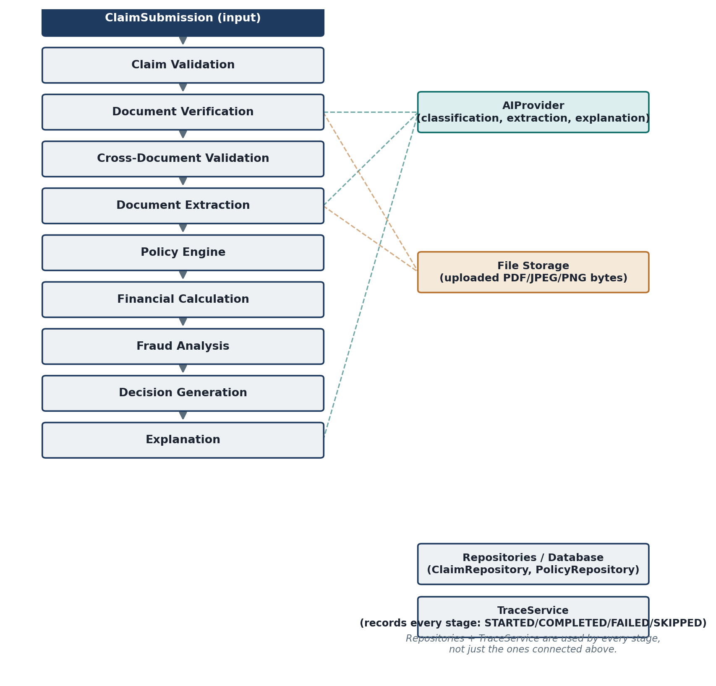
Pipeline stages and what they depend on

20. Reimplementation Notes
If someone rebuilt this system from scratch, these are the contracts worth keeping — not the code, the behavior.
- Policy evaluation is deterministic. No AI call anywhere in PolicyEngine.
- Financial calculations use Decimal, not float, and round with ROUND_HALF_UP.
- Document verification produces a structured classification (type, quality, confidence) — never a free-text guess.
- A blocked claim stops downstream processing. Everything after the point it stopped gets an explicit SKIPPED trace entry, not silence.
- Decision Generation works off structured results from Policy/Financial/Fraud. It never asks the AI to make the call.
- Explanation can only add text. It cannot touch decision or approved_amount — that's enforced by stage order, not a check.
- Every stage of every claim gets a trace event, saved independently of whether the claim itself finishes saving.
- Claimed amount, payable amount, and approved amount are three different numbers and stay that way — don't collapse them into one.

— end —

