**Class no 1 ->Modulation**

# **Introduction to Modulation**

### **Definition:**

Modulation is the process of varying a **carrier signal** (high-frequency sine wave) according to the **message signal** (low-frequency information signal) so that it can be transmitted efficiently over long distances.

### **Basic Concept:**

* **Tx:** Transmitter (sends the signal)
* **Rx:** Receiver (receives and demodulates)

Two main types of modulation:

1. **Analog Modulation**
2. **Digital Modulation**

# **🧭 2. Analog Modulation (as in 1st image)**

Analog modulation uses a continuous-time carrier wave whose **amplitude**, **frequency**, or **phase** is varied according to the input message signal *m(t)*.

You drew three analog modulation types:

### **a) AM – Amplitude Modulation**

**Concept:** The amplitude (height) of the carrier wave changes according to the message signal, but frequency and phase remain constant.

**Diagram meaning:** The envelope (outer shape) of the high-frequency wave follows the message signal.

**Equation:** s(t) = [Aₐ + m(t)] cos(2πfₐt)

**Used in:** AM radio broadcasting.

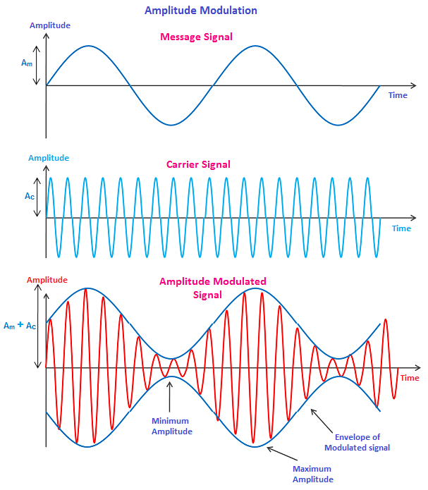

### **b) FM – Frequency Modulation**

**Concept:** The frequency of the carrier changes with the message signal amplitude, while amplitude remains constant.

**Diagram meaning:** When *m(t)* increases, the carrier frequency increases (waves are close together).  
 When *m(t)* decreases, the frequency reduces (waves spread out).

**Equation:** s(t) = Aₐ cos[2πfₐt + 2πk_f ∫m(t)dt]

**Used in:** FM radio, TV sound, etc.

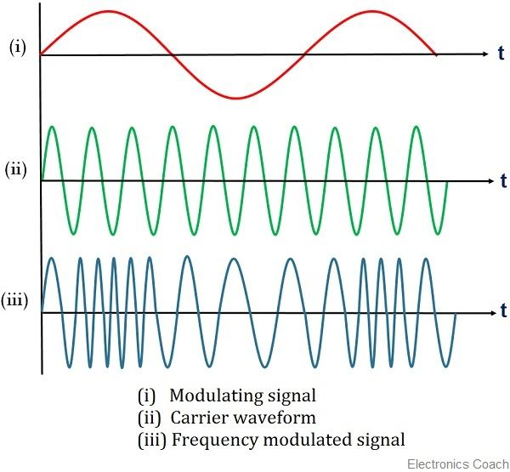

### **c) PM – Phase Modulation**

**Concept:** The phase of the carrier wave changes according to the instantaneous value of the message signal.

**Diagram meaning:** You can see sudden shifts in the carrier wave’s phase (starting point of the cycle) when message signal changes.

**Equation:** s(t) = Aₐ cos[2πfₐt + k_p m(t)]

**Used in:** Digital communication, modern wireless systems.

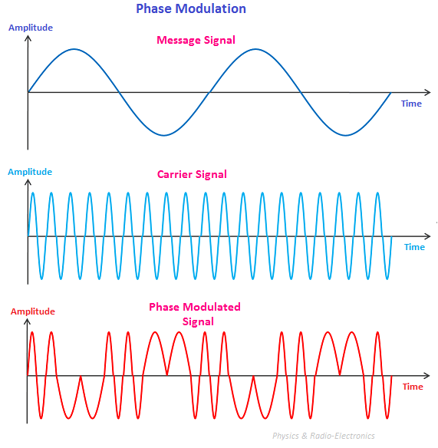

# **💻 3. Digital Modulation (as in 2nd image)**

Digital modulation converts a **digital message (0s and 1s)** into a waveform that can be transmitted.  
 The basic digital modulation schemes are:

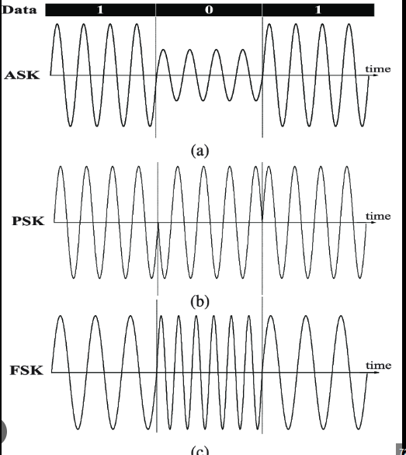

### **a) ASK – Amplitude Shift Keying**

**Concept:** Amplitude of the carrier changes according to the bit (1 or 0).

* Bit 1 → high amplitude
* Bit 0 → low (or zero) amplitude

**Diagram meaning:** The signal disappears or becomes weak when bit = 0 and becomes stronger when bit = 1.

**Used in:** Optical fiber communication, RFID.

### **b) FSK – Frequency Shift Keying**

**Concept:** Frequency of the carrier is changed depending on whether the bit is 1 or 0.

* Bit 1 → higher frequency
* Bit 0 → lower frequency

**Diagram meaning:** Two frequencies appear alternately as the bits change.

**Used in:** Modems, Bluetooth, pager systems.

### **c) PSK – Phase Shift Keying**

**Concept:** Phase of the carrier changes when bit value changes.

* Bit 1 → phase shifted by 180° (π radians)
* Bit 0 → normal phase

**Diagram meaning:** The wave starts at a different point in the cycle when bit = 1.

**Used in:** Wi-Fi, 3G, 4G, satellite systems.

# **⚙️ Summary Table**

|  |  |  |  |
| --- | --- | --- | --- |
| **Modulation Type** | **Varies** | **Constant** | **Typical Use** |
| **AM** | Amplitude | Frequency & Phase | AM radio |
| **FM** | Frequency | Amplitude & Phase | FM radio |
| **PM** | Phase | Amplitude & Frequency | Digital systems |
| **ASK** | Amplitude | Frequency & Phase | Optical, RFID |
| **FSK** | Frequency | Amplitude & Phase | Modem, Bluetooth |
| **PSK** | Phase | Amplitude & Frequency | Wi-Fi, 4G, Satellite |

## **🔹 Multiple Access Techniques – Overview**

### **Definition:**

Multiple Access is the use of **multiplexing techniques** to provide communication service to **multiple users over a single channel**.

* **Goal**: Allow multiple users to **share a limited spectrum** efficiently.
* **How**: By dividing access through **frequency**, **time**, or **code**.

## **🔹 Communication Modes:**

### **1. Simplex**

* **One-way communication only**.
* Data flows in a **single direction**.
* Example: **Broadcast TV**.

### **2. Half-Duplex**

* **Two-way communication**, but **one direction at a time**.
* Only **one user can transmit** at a time.
* Example: **Walkie-talkies**.

### **3. Full-Duplex**

* **Simultaneous two-way communication**.
* Both users can **send and receive** data at the same time.
* Example: **Phone calls**.

|  |  |  |  |
| --- | --- | --- | --- |
| **Feature** | **Simplex** | **Half-Duplex** | **Full-Duplex** |
| **Direction of Data** | One-way only | Two-way (but one direction at a time) | Two-way simultaneously |
| **Communication Type** | Unidirectional | Bidirectional (but not at the same time) | Bidirectional (at the same time) |
| **Sender/Receiver Role** | One is always sender, the other always receiver | Both take turns as sender/receiver | Both can send and receive at once |
| **Efficiency** | Least efficient | Moderate efficiency | Most efficient |
| **Examples** | - Keyboard to CPU- Radio broadcast | - Walkie-talkie- CB radio | - Telephone- Internet chat |

## **🔹 Multiple Access Options**

Mentioned:

* **FDMA**
* **TDMA**
* **CDMA**

These stand for:

* **FDMA** – Frequency Division Multiple Access
* **TDMA** – Time Division Multiple Access
* **CDMA** – Code Division Multiple Access

## **🔸 FDMA – Frequency Division Multiple Access**

### **📌 Description:**

* The **available bandwidth** is divided into multiple **narrow frequency bands**.
* **Each user** is assigned a **unique frequency band**.
* **Transmissions are simultaneous** but **on different frequencies**.

### **🟡 Optical Variant:**

* In fiber optics, a similar method is used called **WDMA (Wavelength Division Multiple Access)**.
* Uses **different light wavelengths** instead of radio frequencies.

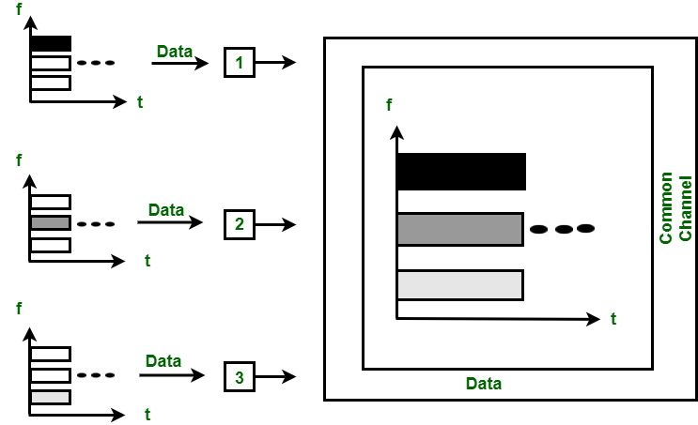

## **🔸 TDMA – Time Division Multiple Access**

### **📌 Description:**

* Each user gets a **time slot** on the same frequency.
* **Time is divided** into frames, and each frame into **slots**.
* A **single user per time slot**.
* Users take turns to transmit data in **repeating time cycles**.

### **🔄 Synchronization:**

* TDMA requires **tight synchronization** so that each device knows exactly **when its time slot occurs**.

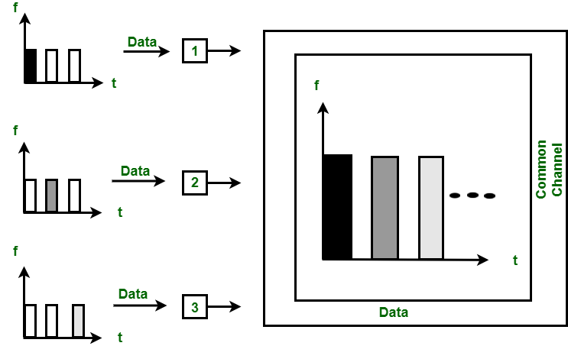

## **🔸 CDMA – Code Division Multiple Access**

### **📌 Description (as per your notes):**

Transmitted Signal = **Data Signal × Pseudo-random Code**

* All users **transmit at the same time** and **on the same frequency**.
* Each user is assigned a **unique pseudo-random code (spreading code)**.
* These codes allow the receiver to **differentiate** between users, even though they share time and frequency.

### **📊 Visual Explanation (from your image):**

* A **data signal** is encoded using a unique **code(y)**.
* After encoding, the resulting **spread signal f(x)** is transmitted.
* The receiver uses the same **code** to decode the correct signal.

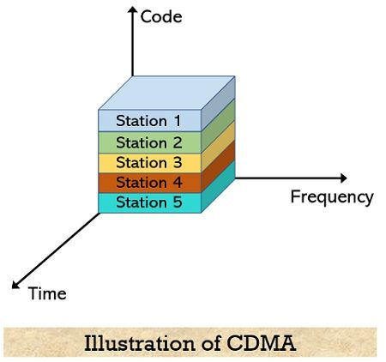

Time (Z)

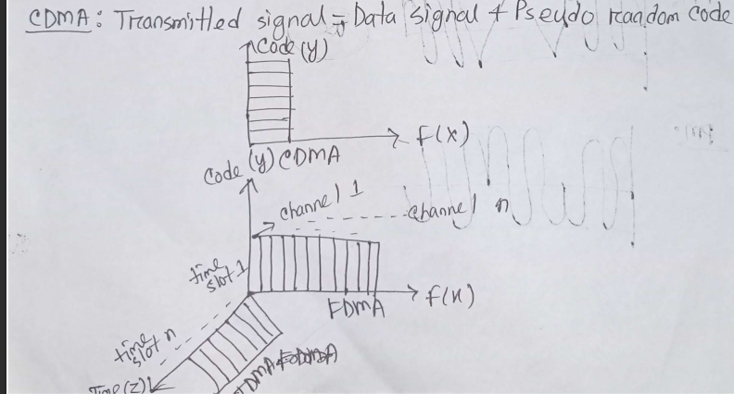

GSM

## **🔸 GSM – Global System for Mobile Communications**

### **📌 Uses a hybrid of FDMA + TDMA**

* FDMA divides the total bandwidth (**25 MHz**) into **124 frequency channels**, each **200 kHz wide**.
* TDMA further divides each frequency channel into **8 time slots**.
* **8 users per frequency channel** → **124 × 8 = 992 users**

### **📶 Uplink & Downlink:**

* **Uplink (Mobile → Tower):** 890 – 915 MHz
* **Downlink (Tower → Mobile):** 935 – 960 MHz

## **🔚 Summary Table (Based on Your Lecture)**

|  |  |  |  |
| --- | --- | --- | --- |
| **Technique** | **Division By** | **Users Share Channel By** | **Notes** |
| FDMA | Frequency | Unique frequency bands | Fixed bands per user |
| TDMA | Time | Unique time slots | One at a time, synchronized |
| CDMA | Code | Unique spreading codes | All use same freq/time |
| GSM | Frequency + Time | FDMA + TDMA | 124 freqs × 8 slots = 992 users |

**Class no 2**

# **Analog to Digital: PCM (Pulse Code Modulation)**

### **Introduction**

Pulse Code Modulation (PCM) is a technique used to **convert an analog signal into a digital signal** so that it can be transmitted, processed, or stored by digital systems.  
 In PCM, the analog signal is represented by a series of **binary codes (0s and 1s)** that correspond to the amplitude of the signal at specific time intervals.

It is the **most common form of analog-to-digital conversion** used in modern communication systems, telephony, and digital audio.

## **🧩 Step-by-Step Process of PCM**

The PCM process involves **three main stages**:

### **1. Sampling**

* The **continuous-time analog signal** is measured (sampled) at uniform time intervals.
* This converts the signal from a **continuous-time** to a **discrete-time** form.
* The rate at which the signal is sampled is called the **sampling frequency (fₛ)**.
* According to the **Nyquist Theorem**,
* The sampling rate must be at least **twice the highest frequency** present in the signal.  
  fs≥2fmaxfₛ ≥ 2f_{max}fs​≥2fmax​

**Example:** If the maximum frequency in a voice signal is 4 kHz, it should be sampled at least at 8 kHz.

### **2. Quantization**

* Each sampled value is **approximated to the nearest discrete level** (quantization level).
* This introduces a small error called **quantization error** (difference between actual and approximated value).
* Quantization can be of two types:
* **Uniform Quantization:** Levels are equally spaced.
* **Non-uniform Quantization:** Levels are unequally spaced, used for voice signals (as in µ-law or A-law companding).

**Purpose:** To limit the infinite possible amplitude values of the analog signal to a finite number suitable for digital encoding.

### **3. Encoding**

* The quantized values are then **encoded into binary numbers**.
* Each quantized level is assigned a unique binary code.
* For example, if there are 8 quantization levels, each level can be represented by **3 bits (since 2³ = 8)**.

**Result:** The output is a digital bitstream of 0s and 1s that represents the original analog waveform.

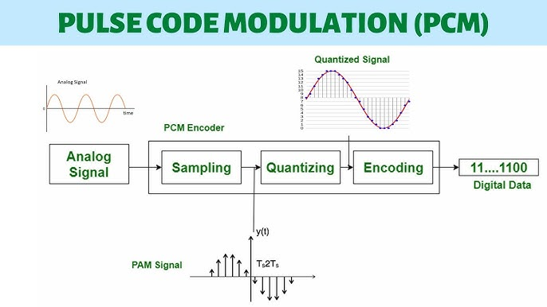

## **💡 Overall PCM Signal Representation**

The PCM signal consists of **a series of binary pulses**, each representing the amplitude of the signal sample at that moment in time.

**Final Output:** Analog Signal → Sampling → Quantization → Encoding → **Digital Signal (Binary Code)**

## **🛰️ Advantages of PCM**

1. High noise immunity — less affected by external interference.
2. Easy to store, compress, and encrypt.
3. Compatible with digital transmission systems.
4. Can be regenerated perfectly at the receiver.
5. Suitable for long-distance communication (e.g., satellite, fiber optic).

## **⚠️ Disadvantages of PCM**

1. Requires higher bandwidth compared to analog transmission.
2. Quantization error may cause slight distortion.
3. More complex circuitry for encoding and decoding.

## **📘 Applications of PCM**

* Digital telephony (voice transmission in PSTN, VoIP)
* Compact Discs (CDs) and Digital Audio
* Satellite and optical fiber communication
* Computer sound cards
* Speech recognition and processing systems

## **🧠 Example**

Let’s say the analog signal is sampled 8 times, and each sample is encoded into a 3-bit binary number.

|  |  |  |  |
| --- | --- | --- | --- |
| **Sample Number** | **Sample Value** | **Quantized Level** | **Binary Code** |
| 1 | 0.1 | 1 | 001 |
| 2 | 0.4 | 3 | 011 |
| 3 | 0.7 | 5 | 101 |
| 4 | 0.9 | 7 | 111 |

**Final PCM Output:** 001 011 101 111 → Transmitted as a digital bitstream.

## **📊 Summary of PCM Process**

|  |  |  |
| --- | --- | --- |
| **Step** | **Function** | **Output** |
| **Sampling** | Converts continuous-time to discrete-time | Sampled signal |
| **Quantization** | Approximates amplitude to fixed levels | Quantized signal |
| **Encoding** | Converts quantized levels to binary | Digital PCM code |

### **In short:**

PCM is a digital representation of an analog signal obtained by sampling, quantizing, and encoding the signal.

## **\*Evolution of Mobile (Wireless) Radio Communication**

This topic shows **how wireless communication evolved step by step**, from simple radio broadcasting to modern mobile (cellular) communication.

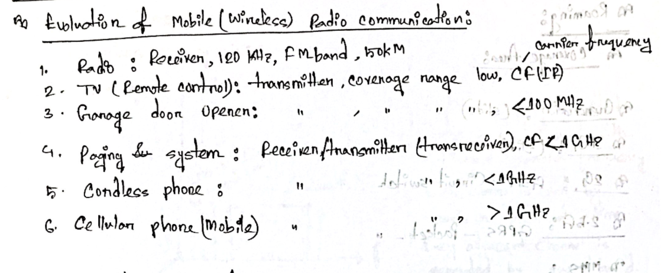

### **1. Radio**

* **Type:** Receiver only (no transmission from user side)
* **Frequency:** Around **120 kHz – FM band (~50 km range)**
* **Description:**
* The earliest form of wireless communication.
* A **radio receiver** picks up broadcast signals transmitted by radio stations.
* The information (audio) is modulated on a **carrier frequency (CF)** using AM or FM.
* **No two-way communication**, only one-directional (broadcasting).

**Example:** FM/AM radio broadcasting stations.

### **2. TV / Remote Control**

* **Type:** Transmitter (remote) → Receiver (TV)
* **Coverage Range:** Low (few meters)
* **Carrier Frequency (CF):** Infrared (IR) or sometimes Radio Frequency (RF)
* **Description:**
* Wireless signal used to **control TV** from a short distance.
* Uses **Infrared (IR)** light or **low RF** to transmit control signals.
* Still **one-way communication** (remote → TV).

**Example:** IR TV remote, RF remote for set-top boxes.

### **3. Garage Door Opener**

* **Type:** Transmitter → Receiver
* **Carrier Frequency:** Less than **100 MHz**
* **Description:**
* A short-range wireless control system.
* The remote control sends a coded signal to open/close the garage door.
* Uses **radio frequency**, usually **below 100 MHz**.
* Again, **one-way communication**.

**Example:** Car remote or home garage door opener.

### **4. Paging System**

* **Type:** Transmitter and Receiver (Transceiver)
* **Carrier Frequency:** Less than **1 GHz**
* **Description:**
* Used before mobile phones for **one-way or limited two-way messaging**.
* The paging system sends numeric or text messages to a pager device.
* **Communication is partly two-way**, since it can acknowledge messages.
* Operates in **UHF bands (300 MHz – 900 MHz)** range.

**Example:** Beepers used by doctors, police, or emergency services.

### **5. Cordless Phone**

* **Type:** Transceiver (can both transmit and receive)
* **Carrier Frequency:** Less than **1 GHz** (around 800–900 MHz)
* **Description:**
* A home phone with a base station connected to the landline and a wireless handset.
* Short-range wireless communication (tens of meters).
* **Two-way communication**, but **limited range**.
* Operates below 1 GHz, typically **around 900 MHz**.

**Example:** Home cordless phones before mobile became common.

### **6. Cellular Phone (Mobile)**

* **Type:** Transceiver (Full-duplex communication)
* **Carrier Frequency:** Greater than **1 GHz**
* **Description:**
* Fully mobile, wireless two-way communication device.
* Works through a **cellular network** of base stations.
* Uses **frequency reuse** and **handover** to maintain connection while moving.
* Operates in **microwave frequency bands**, e.g., **1–2 GHz or higher** (now up to several GHz in 5G).

**Example:** GSM, 3G, 4G, 5G mobile phones.

## **📊 Summary Table**

|  |  |  |  |  |  |  |
| --- | --- | --- | --- | --- | --- | --- |
| **Stage** | **Device/Technology** | **Type** | **Carrier Frequency** | **Communication Type** | **Range** | **Remarks** |
| 1 | Radio | Receiver | ~120 kHz – FM Band | One-way | ~50 km | Audio broadcasting |
| 2 | TV Remote | Transmitter | IR / Low RF | One-way | Few meters | Infrared control |
| 3 | Garage Door Opener | Transmitter | < 100 MHz | One-way | Few meters | RF control |
| 4 | Paging System | Transmitter & Receiver | < 1 GHz | One-way or limited two-way | City-wide | Early messaging |
| 5 | Cordless Phone | Transceiver | < 1 GHz | Two-way | 10–100 m | Home wireless phone |
| 6 | Cellular Phone | Transceiver | > 1 GHz | Two-way (Full duplex) | Many km (with base stations) | Mobile communication |

## **\*Mobile Communication**

Mobile communication is a system that allows **wireless voice and data transfer** between a **mobile device** and a **base station** using **radio waves**.  
 It enables communication **without physical connections**, allowing users to move freely while staying connected.

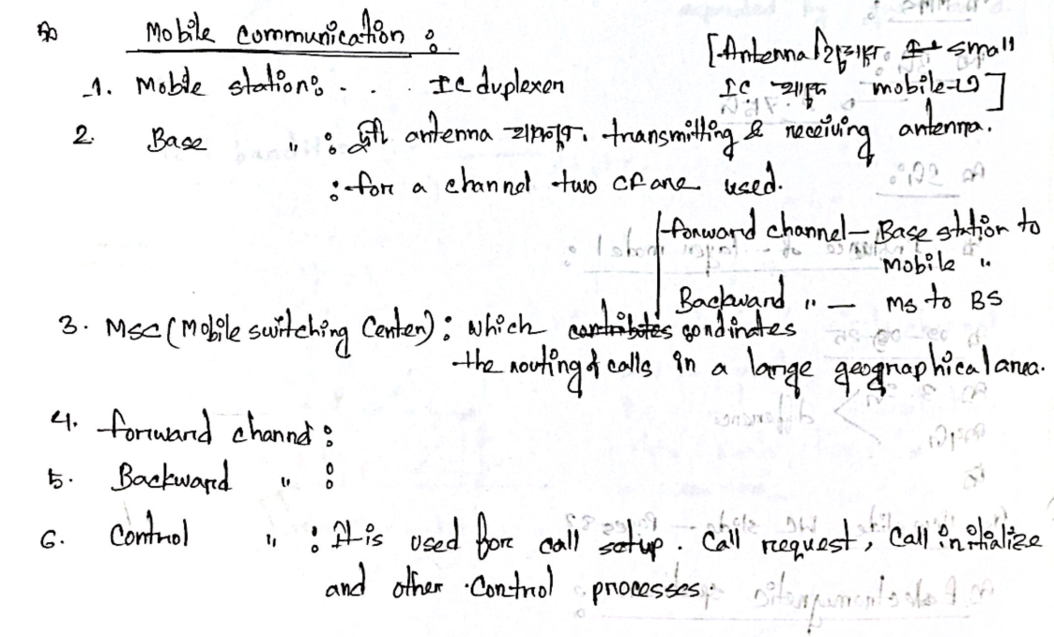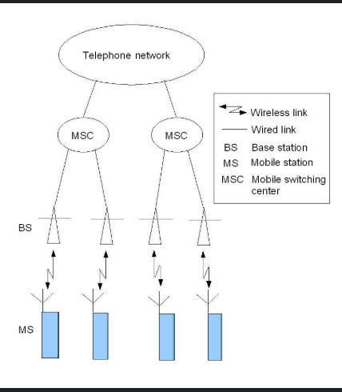

### **🔹 1. Mobile Station (MS)**

* The **mobile station** is the **user’s device** — your **mobile phone**.
* It includes:
* **Transmitter** (to send signals)
* **Receiver** (to receive signals)
* **Antenna** (to radiate and receive electromagnetic waves)
* It works in **duplex mode**, meaning:
* It can **transmit and receive simultaneously** on two different frequencies.
* Duplex communication enables **two-way conversation** in real time (like in a phone call).

📘 *Example:* While you speak, your voice is transmitted to the network, and at the same time, you hear the other person — this is full-duplex communication.

### **🔹 2. Base Station (BS)**

* A **base station** is a fixed station that communicates with mobile devices in its **coverage area (cell)**.
* It consists of:
* **Two antennas**:

1. **Transmitting antenna** – sends signals from the base to mobile users.
2. **Receiving antenna** – receives signals from mobile users.

* For a single communication channel, **two carrier frequencies (CFs)** are used:
* One for the **forward link** (base to mobile)
* One for the **reverse link** (mobile to base)

🛰️ The base station handles **radio communication** and **connects to the Mobile Switching Center (MSC)** for routing calls.

### **🔹 3. MSC (Mobile Switching Center)**

* MSC is the **central control unit** of the mobile communication system.
* Its main functions:
* **Coordinates** all base stations in a large geographical area.
* **Routes calls** between mobile users, or between mobile and landline users.
* **Handles mobility management**, such as handoff (when you move from one cell to another).
* It acts like the **“brain”** of the cellular network.

📘 *Think of it like a telephone exchange but for mobile networks.*

### **🔹 4. Forward Channel**

* The **forward channel** is the communication link from:
* **Base Station → Mobile Station (BS → MS)**
* It carries:
* Voice/data from the network to the user
* Control signals (e.g., paging, call setup info)

📶 Example: When someone calls you, the base station sends a “ring” signal to your phone via the forward channel.

### **🔹 5. Backward Channel**

* The **backward channel** is the communication link from:
* **Mobile Station → Base Station (MS → BS)**
* It carries:
* Voice/data from the user to the network
* Control signals (e.g., call request, responses)

📶 Example: When you press “Call,” your phone sends a call request to the base station via the backward channel.

### **🔹 6. Control Channel**

* The **control channel** is used for **managing and setting up calls**, not for voice or data transfer.
* It handles:
* **Call setup** (initiating a call)
* **Call request**
* **Call initialization**
* **Other control processes** (like handover, authentication, etc.)
* It ensures smooth and organized communication between the mobile station and base station.

📘 *Think of it as the “traffic controller” that organizes who can talk and when.*

## **🧩 Summary Table**

|  |  |  |
| --- | --- | --- |
| **Component** | **Description** | **Direction / Function** |
| **Mobile Station (MS)** | User device with transmitter, receiver, and antenna | Communicates with BS |
| **Base Station (BS)** | Fixed radio equipment with two antennas (Tx & Rx) | Connects mobiles to MSC |
| **MSC (Mobile Switching Center)** | Coordinates routing of calls and manages network | Central control unit |
| **Forward Channel** | From BS → MS | Sends info to mobile |
| **Backward Channel** | From MS → BS | Sends info to base |
| **Control Channel** | Used for call setup, control, and management | Organizes communication |

### **🧠 In Simple Words:**

When you make or receive a call:

1. Your **mobile station** sends a request via the **backward channel**.
2. The **base station** receives it and forwards it to the **MSC**.
3. The **MSC** finds the receiver’s location and sets up the connection.
4. The **forward channel** sends voice/data from the network to your phone.
5. **Control channels** handle all signaling and coordination during this process.

## **1. Handoff (or Handover)**

### **📘 Definition:**

**Handoff** is the process of **transferring an ongoing call or data session** from one **base station** (cell tower) to another **without breaking the connection** when the user moves from one cell area to another.

### **🔹 Purpose:**

* To **maintain call continuity** when the mobile user moves.
* To **keep signal strength stable** (avoid signal drop or Doppler effect).
* Without handoff, the **communication would break** as the mobile leaves the coverage area of one base station.

### **🔹 How It Works:**

1. When you move away from the current base station, its **signal strength decreases**.
2. At the same time, the **signal strength from a nearby base station increases**.
3. The system automatically **switches (hands off)** your connection to the new base station.
4. This happens **without interrupting the ongoing call or data**.

### **🔹 Example:**

When you are on a phone call and traveling in a car — your call continues smoothly even though you move from one cell tower’s area to another.  
 👉 That’s because of **handoff**.

### **🔹 Key Points:**

* Prevents **call drop** or **communication break**.
* Controlled by the **Mobile Switching Center (MSC)**.
* Every mobile device supports handoff.
* Helps in maintaining **network balance and quality**.

## **🌍 2. Roaming**

### **📘 Definition:**

**Roaming** allows a **mobile user** to **access the mobile network even when outside their home network’s coverage area**, using another operator’s network.

### **🔹 Explanation:**

* Each network has a **coverage area**, divided into **cells**.
* When you move to a **different city, region, or country**, you may enter another operator’s coverage zone.
* **Roaming** ensures that your mobile still connects and works (for calls, SMS, or data) by using **partner networks**.

### **🔹 Types of Roaming:**

1. **National Roaming:** When you move from one area to another within the same country but use another operator’s network.
2. **International Roaming:** When you travel to another country and your mobile connects to a foreign network.

### **🔹 Example:**

If your SIM is from **Grameenphone (Bangladesh)** and you visit **India**, your mobile might use **Airtel India’s** network to stay connected — this is **international roaming**.

### **🔹 Key Points:**

* Expands your **coverage area** beyond your home network.
* May involve **extra charges**.
* Ensures **network availability everywhere**.

## **🧩 Summary Table**

|  |  |  |  |
| --- | --- | --- | --- |
| **Concept** | **Meaning** | **Purpose** | **Example** |
| **Handoff** | Transfer of ongoing call between base stations | Maintain continuous communication while moving | Moving in a car during a call |
| **Roaming** | Using another network when outside home coverage | Enable communication outside home area | Using your SIM abroad |

### **🧠 In Simple Words:**

* **Handoff** → Keeps your call active when you move from one tower to another.
* **Roaming** → Keeps your mobile connected when you move outside your network’s region.

## **Mobile Communication Generations (1G → 4G and Beyond)**

### **🛰️ 1st Generation (1G) – Analog Voice Era**

**Keywords from your notes:** *Vodafone, 900MHz, FDMA*

|  |  |
| --- | --- |
| **Feature** | **Description** |
| **Technology** | **Vodafone**, **TACS** (based on **AMPS**) |
| **Frequency** | **900 MHz** |
| **Access Method** | **FDMA** (Frequency Division Multiple Access) |
| **Nature** | **Analog**, voice-only |
| **Channel Bandwidth** | 30 kHz per call |
| **Key Details** | Each call used a dedicated channel; no data support |
| **Example** | Motorola DynaTAC |
| **Limitation** | Poor security, low capacity, analog interference |

🟩 **Summary:** First analog system, focused only on **voice** communication using **FDMA** at **900MHz**.

### **📡 2nd Generation (2G) – Digital Voice Era**

**Keywords from your notes:** *GSM, 800–900MHz, BW = 25MHz, Circuit-switched, SMS*

|  |  |
| --- | --- |
| **Feature** | **Description** |
| **Technology** | **GSM** (Global System for Mobile Communication) |
| **Frequency Range** | **800–900 MHz** |
| **Bandwidth** | **25 MHz** |
| **Switching** | **Circuit-switched** |
| **Access Method** | **TDMA / CDMA** |
| **Key Features** | Digital encryption, clear voice, roaming |
| **Services** | **SMS (Short Message Service)** |
| **Improvement Over 1G** | Digital channels, secure communication, efficient use of spectrum |

🟩 **Summary:** **Digital** communication introduced with **SMS** and **circuit-switched** voice calls.  
 First global standard — **GSM** dominated worldwide.

### **🌐 2.5 Generation (2.5G) – Data Introduction**

**Keywords from your notes:** *GPRS, Packet-switched, MMS*

|  |  |
| --- | --- |
| **Feature** | **Description** |
| **Technology** | **GPRS** (General Packet Radio Services) |
| **Switching** | **Packet-switched** for data + circuit-switched for voice |
| **Data Rate** | ~170 kbps (theoretical) |
| **Protocols** | TCP/IP, X.25 |
| **New Services** | **MMS** (Multimedia Messaging Service), Email, Web browsing |
| **Advantage** | Uses bandwidth only when data is sent |
| **Purpose** | Bridge between **2G (voice)** and **3G (data)** |

🟩 **Summary:** Introduced **packet-switching**, enabling **Internet**, **Email**, and **MMS** over GSM.

### **⚡ 2.75 Generation (2.75G) – EDGE**

**Keywords from your notes:** *EDGE (2.75G)*

|  |  |
| --- | --- |
| **Feature** | **Description** |
| **Technology** | **EDGE** (Enhanced Data Rates for GSM Evolution) |
| **Modulation** | **8PSK** (3 bits/symbol) |
| **Data Rate** | Up to **384 kbps** (3× faster than GPRS) |
| **Access Method** | TDMA / GSM compatible |
| **Enhancement** | **Incremental Redundancy** – improves packet recovery |
| **Purpose** | Transition to 3G speeds on existing GSM infrastructure |

🟩 **Summary:** **EDGE** enhanced **GPRS** with **8PSK** modulation for faster data and better reliability.

### **💻 3rd Generation (3G) – Multimedia Era**

**Keywords from your notes:** *WCDMA, UTRAN, UMTS (144kbps)*

|  |  |
| --- | --- |
| **Feature** | **Description** |
| **Technology** | **WCDMA**, **UTRAN**, **UMTS** |
| **Data Rate** | 144 kbps → 384 kbps (mobile), 2 Mbps (stationary) |
| **Frequency** | 1900–2025 MHz & 2110–2200 MHz |
| **Switching** | Circuit + Packet |
| **Applications** | Video calls, streaming, mobile TV, online games |
| **Protocols** | CDMA2000, WCDMA |
| **Advantage** | High-speed multimedia and broadband Internet |

🟩 **Summary:** **3G** brought **video**, **music**, and **Internet** to phones — real multimedia communication.

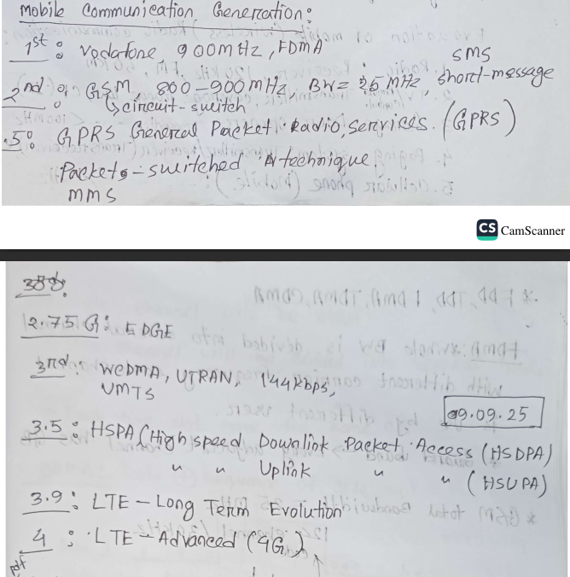

Class No 2

### **🚀 3.5 Generation (3.5G) – HSPA (High-Speed Packet Access)**

**Keywords from your notes:** *HSDPA, HSUPA*

|  |  |
| --- | --- |
| **Feature** | **Description** |
| **Technology** | **HSDPA (Downlink)** + **HSUPA (Uplink)** |
| **Data Rate** | 10–30 Mbps |
| **Improvement** | Adaptive Modulation (**QPSK & 16QAM**), **Fast Scheduling**, **Hybrid ARQ** |
| **Delay (TTI)** | Reduced from 10 ms → **2 ms** |
| **Compatibility** | Backward compatible with **3G (UMTS)** |
| **Purpose** | Faster data rates and better efficiency |

🟩 **Summary:** **3.5G (HSPA)** upgraded **3G** to broadband-like speeds for smoother streaming and faster uploads.

### **🌍 3.9 Generation (3.9G) – LTE**

**Keywords from your notes:** *LTE, Long Term Evolution*

|  |  |
| --- | --- |
| **Feature** | **Description** |
| **Technology** | **LTE (Long-Term Evolution)** |
| **Nature** | All-IP network |
| **Switching** | Fully **Packet-switched** |
| **Improvement** | Lower latency, higher data rates (~50 Mbps) |
| **Purpose** | Bridge between 3.5G and 4G |
| **Advantage** | Prepared network for true 4G deployment |

🟩 **Summary:** **LTE** — the **foundation of 4G**, with high-speed Internet and all-IP core network.

### **🛰️ 4th Generation (4G) – LTE Advanced**

**Keywords from your notes:** *LTE-Advanced (4G)*

|  |  |
| --- | --- |
| **Feature** | **Description** |
| **Technology** | **LTE-Advanced** |
| **Concept** | “Mobile Broadband Everywhere” |
| **Access Method** | **OFDM (Orthogonal Frequency Division Multiplexing)** |
| **Radio Tech** | **MIMO-OFDM** |
| **Data Rate** | Up to **70 Mbps** |
| **Performance** | 10× faster than 3G, 2000× faster than 1G |
| **Applications** | HD video streaming, large file downloads, mobile hotspot |
| **Advantage** | Low latency, high speed, global connectivity |

🟩 **Summary:** **4G** gives true **mobile broadband** — high-speed Internet, streaming, and cloud services.

### **💡 Beyond 4G – LiFi (Light Fidelity)**

|  |  |
| --- | --- |
| **Feature** | **Description** |
| **Technology** | **LiFi (Visible Light Communication)** using LEDs |
| **Medium** | Light waves instead of radio waves |
| **Speed** | >100 Mbps (faster than Wi-Fi) |
| **Advantages** | Energy efficient, secure, uses existing lights |
| **Applications** | Hospitals, traffic lights, street lamps, indoor data transfer |

🟩 **Summary:** **LiFi** — the **future** of wireless data using **light** instead of radio.

### **📊 Quick Comparison Summary\*\*\*\*\*\*\***

|  |  |  |  |  |
| --- | --- | --- | --- | --- |
| **Generation** | **Technology** | **Data Rate** | **Switching** | **Key Feature** |
| **1G** | FDMA (Analog) | 2.4 Kbps | Circuit | Voice only |
| **2G** | GSM | 64 Kbps | Circuit | Digital voice, SMS |
| **2.5G** | GPRS | 170 Kbps | Packet | MMS, Internet |
| **2.75G** | EDGE | 384 Kbps | Packet | Enhanced data |
| **3G** | WCDMA / UMTS | 2 Mbps | Packet + Circuit | Multimedia, video |
| **3.5G** | HSPA | 30 Mbps | Packet | High-speed data |
| **3.9G** | LTE | ~50 Mbps | Packet | Pre-4G architecture |
| **4G** | LTE-Advanced | 70 Mbps | Packet | True mobile broadband |
| **Beyond 4G** | LiFi | >100 Mbps | Light-based | Optical communication |

|  |  |  |  |  |  |
| --- | --- | --- | --- | --- | --- |
| **Term** | **Full Form** | **Generation** | **Main Function / Purpose** | **Key Features & Improvements** | **Typical Data Speed** |
| **GSM** | Global System for Mobile Communications | 2G | Provides digital **voice calling**, **SMS**, and basic data. | - Uses **TDMA** (Time Division Multiple Access). - Introduced **SIM cards** for user identity. - International roaming support. | ~9.6–14.4 kbps |
| **SMS** | Short Message Service | 2G | Allows sending **short text messages** over GSM. | - Up to **160 characters per message**. - Works without internet. - Basis for OTPs and alerts. | N/A (text only) |
| **GPRS** | General Packet Radio Service | 2.5G | Introduced **mobile internet** using packet-switched data. | - Always-on connection. - Enables email, web, and basic apps. - Works over existing GSM infrastructure. | ~56–114 kbps |
| **MMS** | Multimedia Messaging Service | 2.5G | Sends **images, audio, or video** via mobile network. | - Extension of SMS. - Requires GPRS/EDGE data. - Used before WhatsApp & social media. | Depends on GPRS speed |
| **EDGE** | Enhanced Data Rates for GSM Evolution | 2.75G | Improves GPRS data rates using better modulation. | - Uses **8PSK** modulation (vs GMSK in GSM). - Better internet experience. - Bridge between 2G and 3G. | Up to ~384 kbps |
| **WCDMA** | Wideband Code Division Multiple Access | 3G | Main **radio access technology** for UMTS networks. | - Users share same frequency via unique codes. - Supports **voice + data simultaneously**. - Foundation for 3G mobile broadband. | Up to ~2 Mbps |
| **UTRAN** | UMTS Terrestrial Radio Access Network | 3G | Radio access part of 3G network (connects user to core). | - Consists of **Node B (base stations)** and **RNC (Radio Network Controller)**. - Uses WCDMA for transmission. | Same as UMTS (~2 Mbps) |
| **UMTS** | Universal Mobile Telecommunications System | 3G | Successor of GSM; combines WCDMA and UTRAN. | - Provides **voice, video, and internet**. - Circuit + packet switching. - Global roaming support. | ~384 kbps to 2 Mbps |
| **HSPA** | High Speed Packet Access | 3.5G | Improves UMTS data transfer (combines HSDPA + HSUPA). | - Enhanced modulation and coding. - Higher capacity and speed. - Lower latency than UMTS. | Up to ~14 Mbps |
| **HSDPA** | High Speed Downlink Packet Access | 3.5G | Increases **download** speed for 3G users. | - Part of HSPA family. - Ideal for **video streaming, browsing**. - Adaptive modulation for better performance. | Up to ~14.4 Mbps |
| **HSUPA** | High Speed Uplink Packet Access | 3.5G | Improves **upload** speed in 3G networks. | - Enhances data upload (for photos, videos). - Part of HSPA. - Reduces delay during uploads. | Up to ~5.8 Mbps |
| **LTE** | Long Term Evolution | 4G | Next-generation high-speed **all-IP network**. | - Uses **OFDMA** and **MIMO** technology. - Very low latency (good for real-time apps). - Supports **VoLTE** (Voice over LTE). | Up to ~100 Mbps (mobile), ~300 Mbps (stationary) |
| **LTE-Advanced** | Long Term Evolution Advanced | 4G+ | Upgraded LTE with faster and more stable performance. | - **Carrier aggregation** (combines multiple frequency bands). - Supports higher MIMO (up to 8x8). - Improved throughput and coverage. | Up to ~1 Gbps |

|  |  |  |  |
| --- | --- | --- | --- |
| **Technology** | **Frequency** | **Wavelength** | **Simple Explanation** |
| **GSM Phones** | ≈ 900 MHz | ≈ 33 cm | GSM (Global System for Mobile Communication) is used for 2G mobile networks. It operates around 900 MHz. The longer wavelength (33 cm) helps signals travel farther, which is why GSM networks have wide coverage. |
| **PCS Phones** | ≈ 1.8 GHz | ≈ 17.5 cm | PCS (Personal Communication Service) is another mobile system, used mainly in 3G/early 4G networks. Its higher frequency (1.8 GHz) means shorter wavelength, giving faster data speed but slightly less coverage area. |
| **Bluetooth** | ≈ 2.4 GHz | ≈ 12.5 cm | Bluetooth is used for short-range wireless communication (like connecting headphones or keyboards). The higher frequency allows quick data exchange, but it works best over short distances. |

### **🟩 1. Simplex Communication**

* **Definition:** Communication that happens **only in one direction**.
* **Example:** A keyboard sending signals to a computer.
* **Key Point:**
* Only one side transmits; the other side only receives.
* No reply or feedback goes back.
* **Use Case:** Simple control systems, sensors, or broadcasting (like TV or radio).

### **🟦 2. Duplex Communication**

It means **two-way communication** — both sides can send and receive signals.

There are two types:

#### **🔹 (a) FDD — Frequency Division Duplex**

* **Full form:** Frequency Division Duplex.
* **Working Principle:**
* Two **separate frequency bands** are used —
* One for sending (uplink / forward channel)
* One for receiving (downlink / reverse channel).
* **Example:** GSM mobile systems.
* **Advantage:** Sending and receiving happen **at the same time** (simultaneous).
* **Disadvantage:** Needs **more bandwidth** because two frequencies are used.

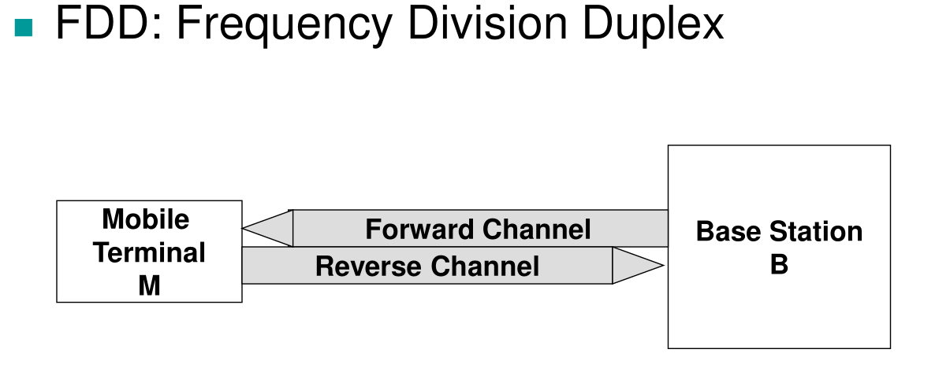

#### **🔹 (b) TDD — Time Division Duplex**

* **Full form:** Time Division Duplex.
* **Working Principle:**
* A **single frequency** is used.
* The channel is **divided into time slots** —
* One time slot for transmitting
* The next for receiving.
* **Example:** Wi-Fi, 4G LTE, some 5G systems.
* **Advantage:** Saves frequency space (only one channel used)

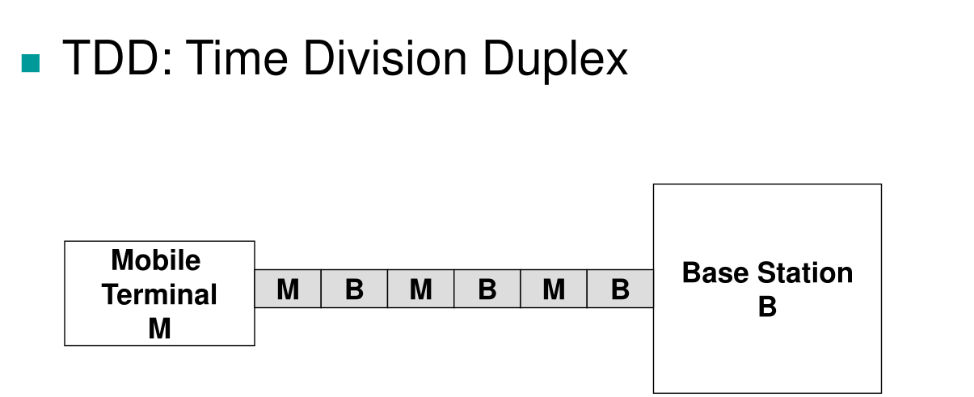

* **Disadvantage:** Sending and receiving **cannot happen at the same instant** — they take turns.

### **🧠 Simple Comparison Table\*\*\*\*\*\***

|  |  |  |  |  |  |
| --- | --- | --- | --- | --- | --- |
| **Type** | **Direction** | **Frequency Use** | **Timing** | **Example** | **Notes** |
| **Simplex** | One-way only | One channel | One direction only | TV, keyboard | No response path |
| **FDD** | Two-way | Two frequencies | Simultaneous | GSM | Faster, needs more bandwidth |
| **TDD** | Two-way | One frequency | Alternating in time | Wi-Fi, LTE | Efficient, but slightly slower |

**FDD vs FDM**

|  |  |  |
| --- | --- | --- |
| **Feature** | **FDM (Frequency Division Multiplexing)** | **FDD (Frequency Division Duplex)** |
| **Type** | Multiplexing (sharing bandwidth) | Duplexing (two-way communication) |
| **Purpose** | Combine multiple signals | Allow transmit & receive at same time |
| **Number of Channels** | Many users share one channel | Two channels: uplink & downlink |
| **Example** | Radio or cable TV | GSM mobile communication |
| **Relation** | FDD actually **uses** FDM — to separate uplink and downlink frequencies |

# **Comprehensive Explanation of FDMA, TDMA, and CDMA**

Based on your lecture notes and the provided documents, let me explain these multiple access techniques comprehensively.

## **Overview**

**FDMA, TDMA, and CDMA** are multiple access techniques that allow multiple users to share a communication channel. They differ fundamentally in how they divide resources:

* **FDMA**: Divides **frequency**
* **TDMA**: Divides **time**
* **CDMA**: Uses **unique codes**

## **1. FDMA (Frequency Division Multiple Access)**

### **How It Works**

The entire available bandwidth is divided into multiple smaller frequency channels. Each user gets a dedicated frequency band for transmission.

### **Key Characteristics from Your Notes**

**From Image 1 (Your Handwritten Notes):**

* Whole bandwidth is divided into several channels with different carrier frequencies
* Each channel is used by different users
* **Guard bands** exist between every adjacent channel to prevent interference
* **Example**: GSM total bandwidth = 25 MHz
* 124 channels / 30 kHz per channel

### **Resource Division**

FDMA divides frequency into separate channels, with guard bands between adjacent channels. Each user transmits continuously on their assigned frequency.

### **Advantages**

1. Simple to implement

2 .Reduces inter-symbol interference (ISI)**(one data symbol interferes with the next symbol during transmission, causing them to overlap and making it hard to distinguish between them at the receiver.)**

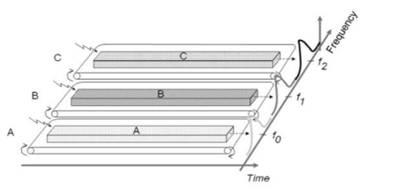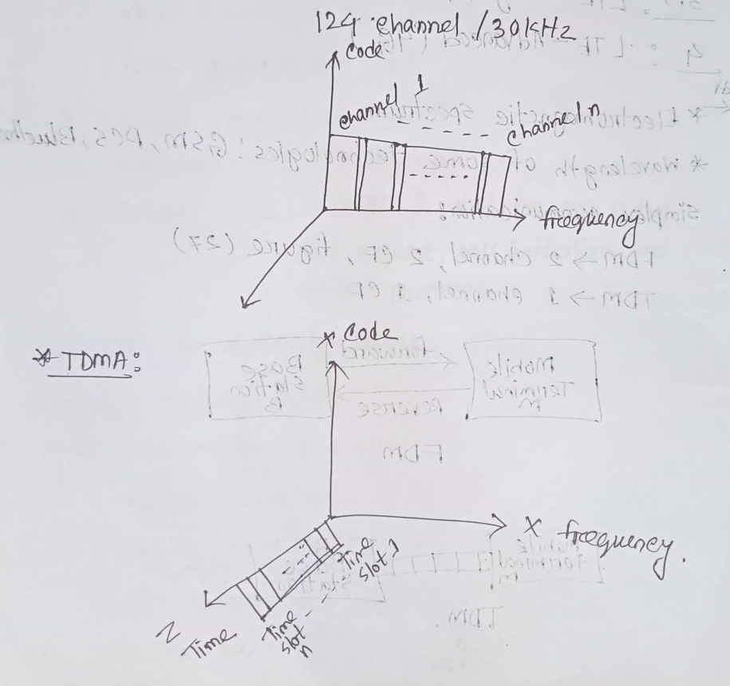

1. No equalization necessary**(a filtering technique used to remove or reduce ISI by compensating for the channel distortion and restoring the original signal shape.)**
2. Continuous transmission requires fewer bits for synchronization
3. Low bit rates with large symbol time

### **Disadvantages**

1. Inefficient bandwidth usage due to guard bands
2. Fixed and small maximum data rate per channel
3. Doesn't differ significantly from analog systems
4. Requires narrowband filters (cannot be realized in VLSI, increasing cost)
5. Potential for co-channel interference

## **2. TDMA (Time Division Multiple Access)**

### **How It Works**

The transmission time is divided into sequential time slots. Each user gets a specific time slot to transmit over the entire frequency band.

### **Key Characteristics from Your Notes**

**From Image 1 & 2 (Your Handwritten Notes):**

* Single channel divided into several time slots
* Each time slot has the same carrier frequency (CF)
* Users transmit in turns during their assigned slots

**From Image 2:**

* CDMA uses **Data ⊕ sequence of code** (XOR operation)
* Shows waveform diagram with Data 1, Data 0, and Code sequences

### **Multi-carrier TDMA System (from documents)**

* 25 MHz frequency range holds 124 carrier frequencies
* Each carrier = 200 kHz bandwidth
* Each frequency channel contains **8 TDMA conversation channels**
* Mobile station transmits a data packet in each timeslot

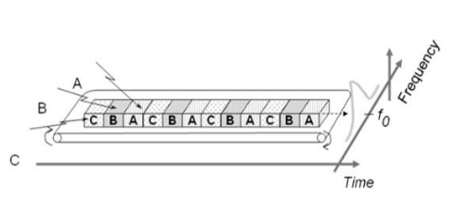

### **Resource Division**

TDMA divides time into slots. All users share the same frequency but transmit during different time slots in a repeating frame structure.

### **Advantages**

1. More flexible and efficient than FDMA
2. Permits flexible data rates (multiple slots can be assigned)
3. Can handle variable bit rate traffic
4. No guard band required for wideband systems
5. No narrowband filter required

### **Disadvantages**

1. Requires precise synchronization between users
2. High data rates require complex equalization
3. Burst mode requires additional bits for synchronization
4. Guard time needed in each slot for clock inaccuracies
5. High bit rates increase energy consumption
6. Performance affected by interference between adjacent time slots

## **3. CDMA (Code Division Multiple Access)**

### **How It Works**

All users transmit simultaneously over the same wide frequency band. Each user is assigned a unique spreading code that differentiates their signal.

### **Key Characteristics from Your Notes**

**From Image 2 (Your Handwritten Notes):** You asked: **"Why CDMA differs from FDMA and TDMA?"******(class)**

**Answer:**

* **CDMA is FAST, TDMA is SLOW, FDMA is at a time**
* CDMA: Fast transmission, 1 channel at a time
* TDMA: Slow transmission, 1 channel with time division
* FDMA: 2 channels at a time with guard bands (code-based separation)

**From Image 3 (Your Handwritten Notes):** CDMA encoding rules (from page 7):

* **+1 → represents 1** (data bit 1)
* **-1 → represents 0** (data bit 0)
* **Silent → 0**

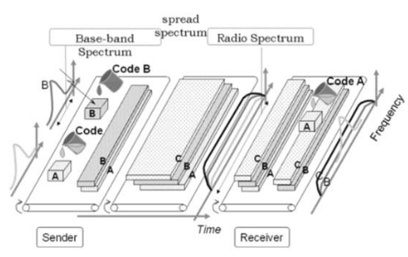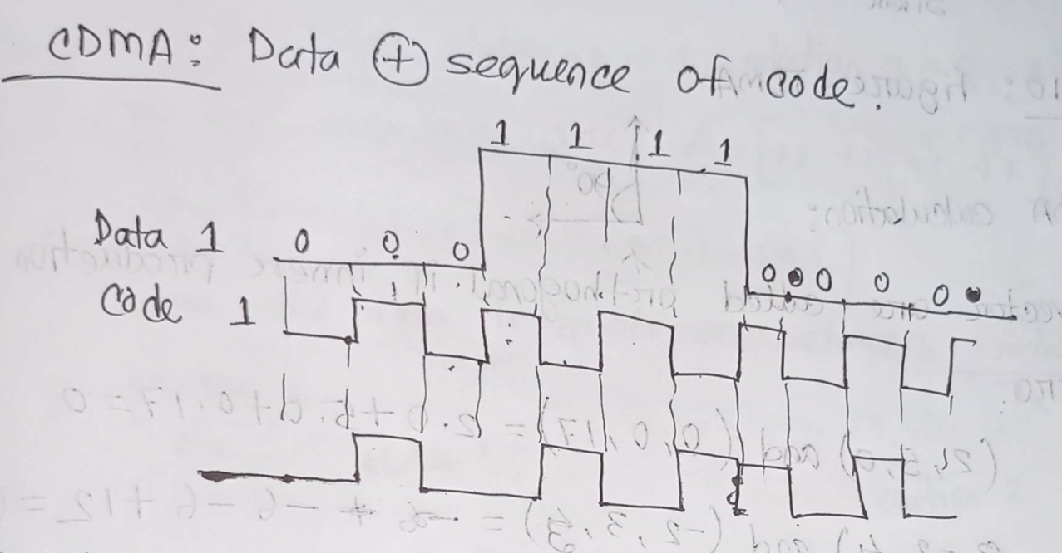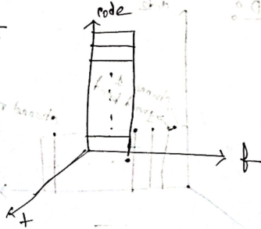

### **Station Codes Example (from documents)**

Four stations with assigned codes:

* Station A: (+1, +1, +1, +1)
* Station B: (+1, -1, +1, -1)
* Station C: (+1, +1, -1, -1)
* Station D: (+1, -1, -1, +1)

### **CDMA Specifications**

* **Frequency band**: 824 MHz to 894 MHz (50 MHz + 20 MHz separation)
* **1.25 MHz FDMA channel** divided into **64 code channels**
* Allows up to **61 concurrent users** in a 1.2288 MHz channel

### **Processing Gain Calculation**

P(gain) = 10 log(W/R)

Where:

* W = Spread Rate = 1,228,800
* R = Data Rate = 9,600

P(gain) = 10 log(1,228,800/9,600) = 21 dB

**Actual Processing Gain:**

* Required SNR for adequate voice quality = 7 dB
* Actual gain = 21 - 7 = **14 dB**

### **CDMA Capacity Factors**

1. **Processing Gain**: 21 dB
2. **Signal to Noise Ratio**: 7 dB required
3. **Voice Activity Factor**: 0.4 = -4 dB
4. **Frequency Reuse Efficiency**: 0.67 (70%) = -1.73 dB

### **Resource Division**

CDMA allows all users to transmit simultaneously on the same frequency band. Each user is assigned a unique spreading code. The receiver uses the corresponding code to extract the desired signal from the combined transmission.

### **Advantages**

1. Higher capacity than FDMA/TDMA
2. Better security (unique codes)
3. Soft capacity (more codes = more users)
4. 100% frequency reuse
5. Rake receivers can improve signal reception
6. Flexible handover (soft handoff)
7. Reduced interference through burst transmission

### **Disadvantages**

1. Complex to implement
2. Higher infrastructure and equipment costs
3. Code length must be carefully selected
4. Requires tight power control (near-far effect problem)
5. Time synchronization required
6. System performance degrades as users increase
7. Gradual transfer may reduce capacity

## **Comparison Summary**\*\*\*\*\*\*

|  |  |  |  |
| --- | --- | --- | --- |
| **Feature** | **FDMA** | **TDMA** | **CDMA** |
| **Division Method** | Frequency | Time | Code |
| **Bandwidth Usage** | Dedicated band | Entire band in turns | Entire band always |
| **Time Usage** | Continuous | Time slots | Continuous |
| **Complexity** | Simple | Moderate | Complex |
| **Capacity** | Low | Medium | High |
| **Synchronization** | Not critical | Critical | Critical |
| **Interference** | Co-channel | Adjacent slots | Near-far effect |
| **Cost** | Low | Medium | High |
| **Security** | Low | Medium | High |

## **Key Differences (Answering Your Question from Image 2)**

**Why CDMA differs from FDMA and TDMA:\*\*\*\*\*\*\***

1. **CDMA vs FDMA**:

* CDMA: Only one channel occupies entire bandwidth
* FDMA: Multiple separate frequency channels with guard bands

1. **CDMA vs TDMA**:

* CDMA: All stations send data simultaneously (fast/parallel)
* TDMA: Stations take turns in time slots (slow/sequential)

1. **CDMA Unique Feature**:

* Uses coding theory with chip sequences
* Encoding: Data bit 0 → -1, Data bit 1 → +1, Silent → 0
* Signals separated by orthogonal codes at receiver

## **Practical Applications**

* **FDMA**: First generation analog mobile phones (1G)
* **TDMA**: GSM (2G) - Digital mobile systems
* **CDMA**: IS-95, CDMA2000, 3G systems - UHF cellular (800 MHz - 1.9 GHz)

**All class qus answer**

# **How CDMA Differs from FDMA & TDMA + Similarities**\*\*\*\*\*\*\*\*

## **Key Differences**

### **1. Resource Division Method**

**FDMA:**

* Divides **frequency** into separate channels
* Each user gets a dedicated frequency band
* Like different radio stations (FM 88.0, FM 89.0, FM 90.0)

**TDMA:**

* Divides **time** into slots
* Users take turns using the same frequency
* Like people taking turns to speak in a meeting

**CDMA:**

* Uses **unique codes** to separate users
* All users transmit at the same time on the same frequency
* Like people speaking different languages in the same room - you understand only your language

### **2. How Users Share the Channel**

|  |  |  |  |
| --- | --- | --- | --- |
| **Aspect** | **FDMA** | **TDMA** | **CDMA** |
| **Frequency** | Different for each user | Same (shared) | Same (shared) |
| **Time** | Continuous (always on) | Different slots | Continuous (always on) |
| **Code** | Not used | Not used | Unique for each user |

### **3. Similarities Between Them**

All three techniques:

* ✓ Allow **multiple users** to share the same communication channel
* ✓ Are **multiple access methods** for wireless communication
* ✓ Aim to **maximize channel utilization**
* ✓ Used in **cellular mobile systems**
* ✓ Require **resource management** to avoid conflicts

## **Why CDMA is More Efficient Than Others\*\*\*\*\*\*\***

### **1. Higher Capacity**

**CDMA can support more users simultaneously:**

* FDMA: Limited by number of frequency channels (e.g., 124 channels)
* TDMA: Limited by number of time slots (e.g., 8 slots per frequency)
* **CDMA: Can support 61+ users on same frequency** using different codes

**Why?**

* Uses entire bandwidth all the time
* Soft capacity - can add more codes as needed
* No wasted guard bands (FDMA) or guard times (TDMA)

### **2. 100% Frequency Reuse**

**CDMA:**

* Same frequency used in all cells
* No frequency planning needed
* Different codes distinguish users

**FDMA/TDMA:**

* Must use different frequencies in adjacent cells
* Frequency reuse factor < 100%
* Reduces overall capacity

### **3. Better Signal Quality**

**Processing Gain:**

* Spreads signal over wide bandwidth
* Provides 21 dB processing gain
* Improves signal-to-noise ratio
* Better performance in noisy environments

**Rake Receiver:**

* Combines multipath signals constructively
* Turns multipath (problem in FDMA/TDMA) into advantage
* Improves signal reception

### **4. Soft Handoff**

**CDMA:**

* Mobile connects to multiple base stations simultaneously
* Seamless handover
* "Make before break"

**FDMA/TDMA:**

* Hard handoff
* "Break before make"
* May cause call drops

### **5. Better Security**

**CDMA:**

* Each user has unique spreading code
* Very difficult to intercept
* Built-in encryption

**FDMA/TDMA:**

* Easier to intercept (just tune to frequency or time slot)
* Lower security

### **6. Variable Data Rates**

**CDMA:**

* Can allocate different spreading codes for different data rates
* Voice Activity Factor (0.4) - only transmits when speaking
* Saves power and reduces interference

**FDMA:**

* Fixed bandwidth per channel
* Less flexible

### **7. Graceful Degradation**

**CDMA:**

* As users increase, quality gradually decreases
* Soft capacity limit
* Can still add users with slightly reduced quality

**FDMA/TDMA:**

* Hard capacity limit
* Once all channels/slots full, no more users can be added
* Sudden blocking

## **Efficiency Comparison**

### **Capacity Example:**

**Same 25 MHz bandwidth:**

|  |  |
| --- | --- |
| **System** | **Users Supported** |
| FDMA | ~124 users (1 per channel) |
| TDMA | ~992 users (124 channels × 8 slots) |
| **CDMA** | **~7,500+ users** (124 carriers × 61 users) |

## **Why CDMA is Complex but Worth It**\*\*\*\*\*\*

### **Trade-offs:**

**Advantages (Efficiency):**

* ✓ Higher capacity
* ✓ Better security
* ✓ Improved signal quality
* ✓ Frequency reuse = 100%
* ✓ Soft handoff
* ✓ Multipath resistance

**Disadvantages (Complexity):**

* ✗ Requires tight power control
* ✗ Near-far effect problem
* ✗ Complex signal processing
* ✗ Higher cost
* ✗ Time synchronization needed

**🧩 Comparison between FDMA, TDMA, and CDMA**

|  |  |  |  |
| --- | --- | --- | --- |
| **Feature** | **FDMA (Frequency Division Multiple Access)** | **TDMA (Time Division Multiple Access)** | **CDMA (Code Division Multiple Access)** |
| **Full Form** | Frequency Division Multiple Access | Time Division Multiple Access | Code Division Multiple Access |
| **Basic Principle** | Each user is given a separate **frequency band** | Each user is given a separate **time slot** on the same frequency | All users share the **same frequency and time**, but each uses a unique **code** |
| **Channel Separation** | By **frequency** | By **time** | By **code** |
| **Bandwidth Usage** | Fixed frequency for each user → not very efficient | More efficient than FDMA | Most efficient use of bandwidth |
| **Synchronization** | Not required | Precise time synchronization needed | Complex code synchronization required |
| **Interference** | Less interference between frequency bands | Interference possible if time slots overlap | Low interference due to code separation |
| **Data Transfer** | Continuous | In bursts (during assigned time slots) | Continuous (spread spectrum) |
| **Used In** | Analog systems (like 1G) | 2G GSM systems | 3G and some 4G systems |
| **Example** | AMPS (Advanced Mobile Phone System) | GSM (Global System for Mobile Communication) | CDMA2000, WCDMA |

## **Simple Answer to Your Question:**

**"How is CDMA different and more efficient?"**

CDMA lets everyone talk at the same time on the same frequency using different codes (like different languages). This means:

* More users can fit in the same space
* Better quality through processing gain
* Same frequency everywhere (no planning needed)
* More secure

It's like a stadium where everyone speaks different languages vs. a meeting room where people take turns (TDMA) or different rooms for each person (FDMA).

**CDMA diagram (class)**

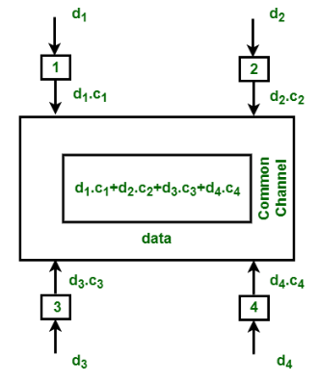

### **How It Works (Step-by-Step):**

1. **Each user has data and a unique code:**

* User 1 → data = d₁, code = c₁
* User 2 → data = d₂, code = c₂
* User 3 → data = d₃, code = c₃
* User 4 → data = d₄, code = c₄

1. **Encoding:**

* Each user multiplies their data bit by their unique code:  
   → d₁·c₁, d₂·c₂, d₃·c₃, d₄·c₄

1. **Transmission:**

* All these encoded signals are **added together** and sent **through the same common channel**.
* So, the total transmitted signal =  
  **d₁·c₁ + d₂·c₂ + d₃·c₃ + d₄·c₄**

1. **Reception:**

* The receiver who knows a particular code (say c₁) can **extract** user 1’s data by using that same code (since codes are orthogonal).
* This is done by **correlation** — multiplying the combined signal by c₁ and summing, which retrieves d₁.

### **🧭 Explanation of the Diagram:**

User 1 → d₁·c₁

User 2 → d₂·c₂

User 3 → d₃·c₃

User 4 → d₄·c₄

⬇️  
 All signals are **combined** in a **common channel** as:  
**d₁·c₁ + d₂·c₂ + d₃·c₃ + d₄·c₄** ⬇️  
 At the receiver, each user’s signal is **separated** using their unique code (c₁, c₂, c₃, or c₄).

### **🧠 Key Points to Remember (for exam):**

* All users share **the same frequency** and **time**.
* Each user has a **unique code sequence**.
* **No interference** because codes are orthogonal.
* **Efficient** and **secure**, but **complex** to implement.
* Used in **3G (WCDMA)** and **some 4G systems**.

### **📝 In Short:**

CDMA allows multiple users to send data simultaneously using the same frequency band by assigning each a unique code. Signals are separated at the receiver using these codes.

**Class no 4 or 5**

## **What is a Mobile Phone?**

A mobile phone (also called a cell phone or cellular phone) is a portable wireless communication device that allows users to make and receive calls, send messages, and access data services over a cellular network. Modern smartphones also function as powerful handheld computers with internet connectivity, cameras, GPS, and countless applications.

## **How Mobile Phones Work**

Based on your presentation, here's how the mobile communication process works:

### **The Communication Flow:**

1. **Signal Generation**: When you make a call or send data, your **Mobile Station (MS)** - your phone - generates a radio frequency signal containing your voice or data.
2. **Base Station Reception**: The signal is picked up by the nearest **Base Station (BS)**, which contains a **Base Transceiver Station (BTS)**. The BTS is responsible for:

* Receiving radio signals from mobile phones
* Transmitting signals back to mobile phones
* Managing the radio communications within its coverage area (cell)

**3. Mobile Switching Center Processing**: The signal is then routed to the **Mobile Switching Center (MSC)**, which is essentially the brain of the cellular network. The MSC handles:

* Call routing (finding where to send your call)
* Call setup (establishing the connection)
* Basic switching functions
* Managing handoffs between different base stations as you move

**4 .Reaching the Destination**: The MSC routes the signal to the appropriate Base Station that covers the recipient's location, and finally the BTS transmits the signal to the receiving Mobile Station.

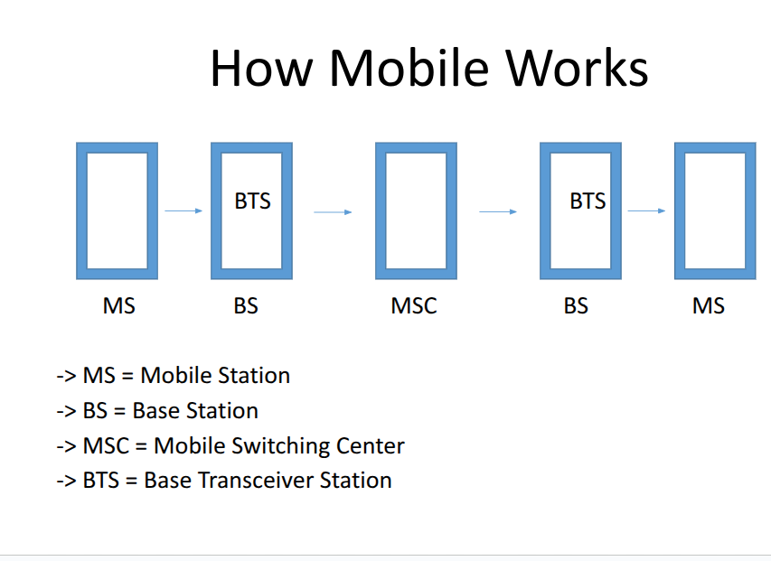

### **Key Components Inside a Mobile Phone:**

* **PCB (Printed Circuit Board)**: The main board that connects all components
* **Microphone**: Captures your voice
* **Speaker**: Produces audio output
* **Antenna**: Sends and receives radio signals
* **Battery**: Provides power to the device
* **Flash Memory**: Stores data, apps, and the operating system
* **DSP (Digital Signal Processor)**: Processes signals (40 MIPS refers to processing speed)
* **RF Amplifier**: Boosts the radio frequency signals for transmission

**Transmit Power**

* Transmit Power of Base Station Antenna is 10 – 100 watt.
* Transmit Power of Mobile Station is 0.5 watt.

# **Adaptive Power Control**

Adaptive power control is a unique feature of a mobile phone that provides a facility to control the transmit power of a mobile phone according to the signal radiation intensity or the distance from the base station antenna.

**How it works:**

* If a phone is far from a mobile tower, the phone will transmit maximum signal to be in range of the tower.
* The closer it gets to the mobile tower, it lessens the transmit power.

This process is called Adaptive Power Control.

# **Special Codes of Mobile**

There are three special codes of mobile:

1. **Electronic Serial Number (ESN)**: A unique 32-bit number programmed into the phone when it is manufactured.
2. **Mobile Identification Number (MIN)**: A 10-digit number derived from the user's phone number.
3. **System Identification Code (SID)**: A unique 5-digit number that is assigned to each carrier by the Federal Communications Commission (FCC).

# **SIM Card**

A **Subscriber Identity Module (SIM)** is an integrated circuit chip.

## **What a SIM Card Contains:**

* Unique serial number (ICCID)
* International Mobile Subscriber Identity (IMSI) number
* Security authentication and ciphering information
* Temporary information related to the local network

## **IMSI Number Structure:**

* **First three digits**: Mobile Country Code (MCC)
* **Next two or three digits**: Mobile Network Code (MNC)
* **Remaining digits**: Mobile Subscriber Identification Number (MSIN) - normally 10 digits

# **Handover (Handoff)**

In cellular telecommunications, **handover** or **handoff** refers to the process of transferring an ongoing call or data session from one channel connected to the core network to another channel.

## **Types of Handover:**

**1. Hard Handover**: The channel in the source cell is released and only then the channel in the target cell is engaged.

**2. Soft Handover**: The channel in the source cell is retained and used for a while in parallel with the channel in the target cell.

# **GSM Frequencies**

There are mainly 4 types of GSM frequencies:

1. **GSM-900, EGSM/EGSM-900 and GSM-1800**
2. **GSM-850 and GSM-1900**
3. **GSM 900/1800 and GSM 850/1900**
4. **GSM-450**

## **Most Commonly Used:**

GSM-900 and GSM-1800 are used in most parts of the world.

## **GSM-900 Specifications:**

* **Uplink** (Mobile Station to Base Transceiver Station): 890 - 915 MHz
* **Downlink** (Base Transceiver Station to Mobile Station): 935 - 960 MHz
* **RF Channels**: 124 channels (channel numbers 1 to 124) spaced at 200 kHz
* **Duplex Spacing**: 45 MHz is used for avoiding the interference of signals

# **Why Uplink is Smaller than Downlink in GSM**

The main reason for selecting a lower frequency for the uplink channel in GSM is because of **free space path loss**. The higher the frequency, the greater the loss.

## **Explanation:**

* **Mobile phones** are battery-driven devices with **limited power**. Therefore, they need lower path loss to transmit signals efficiently.
* **BTS (Base Transceiver Station) antennas** can transmit signals with **comparatively high power**, which compensates for the path loss in the downlink channel.
* Since lower frequencies experience less signal loss, the uplink uses lower frequencies (890-915 MHz) so that the mobile phone's weak signal can reach the tower.
* The downlink uses higher frequencies (935-960 MHz) because the BTS has sufficient power to overcome the higher path loss.

**In summary**: Lower frequency for uplink = less power needed from your phone's battery. Higher frequency for downlink = BTS can handle it with its stronger power source.

# **FDMA and TDMA in GSM**

## **FDMA in GSM (Frequency Division Multiple Access)**

The FDMA part involves the division by frequency of the (maximum) 25 MHz bandwidth into 124 carrier frequencies spaced 200 kHz apart. 25 MHz is divided by 200 KHz.

**Calculation:**

* Total Frequency = 25MHz/200KHz = 125

**Guard Band:**

* Each 200 kHz channel has 100 KHz guard bands on both sides (100 KHz + 100 KHz) to prevent interference between adjacent channels
* From total 125 KHz, 1 KHz is used for guard band
* Remaining usable frequency = 125 - 1 = 124 channels

**Distribution Among Operators:** If the remaining 124 frequencies are divided into 3 operators, then each will get:

* 124/3 = 41.3 frequencies (approximately 41 frequencies per operator)

**The overall process is done by FDMA** - meaning different operators use different frequency bands.

## **TDMA in GSM (Time Division Multiple Access)**

In GSM, TDMA is used in combination with FDMA to overcome capacity issues due to the problem of limited frequency spectrum.

**How TDMA Works:**

* In GSM networks, on one carrier frequency that all users in the same cell are using, TDMA allocates **8 timeslots** (numbered 0 to 7)
* Each slot contains uplink (UL) and downlink (DL)

**Timing:**

* 1 slot works for **577 microseconds**
* Total slots work for **4.615 milliseconds** (8 × 577 µs)

This means 8 different users can share the same frequency by using different time slots.

## **Example: TDMA Time Slot Allocation**

If there are 41 frequencies, then the time slot allocation using TDMA will be like below:

* Total frequencies available: 41
* 1 frequency is used as **guard band**
* **Remaining frequency = 41 - 1 = 40F**

**Summary:**

* FDMA divides the spectrum into different frequencies for different operators
* TDMA further divides each frequency into 8 time slots so multiple users can share the same frequency
* Together, FDMA + TDMA allow GSM networks to serve many users efficiently with limited spectrum

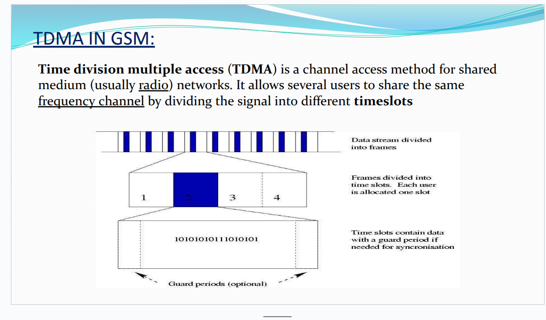

# **What is Hyperframe?**

A **Hyperframe** is the **largest time structure** in the GSM (Global System for Mobile Communications) time hierarchy. It represents the complete timing cycle in GSM networks.

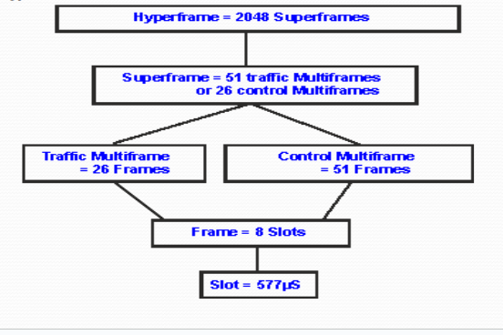

## **Basic Information:**

* **1 user can use 1 slot**
* **1 slot = 577 microseconds**

## **GSM Frame Hierarchy:**

### **1. Hyperframe (Top Level)**

* 1 Hyperframe = **2048 Superframes**

### **2. Superframe**

* 1 Superframe = **51 traffic Multiframes** OR **26 control Multiframes**

### **3. Multiframe (Two Types)**

* **Traffic Multiframe** = 26 Frames
* **Control Multiframe** = 51 Frames

### **4. Frame**

* 1 Frame = **8 Slots**

### **5. Slot (Smallest Unit)**

* 1 Slot = **577 microseconds (577 µs)**

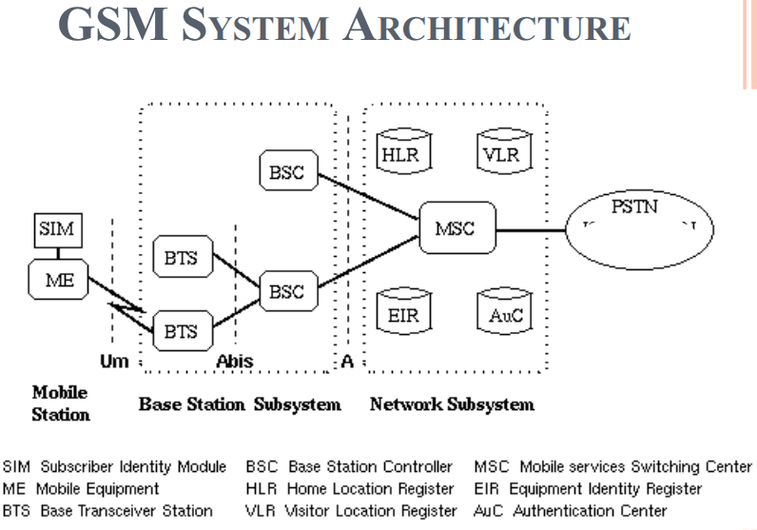

# **GSM System Architecture(ct 15)**

GSM architecture consists of three main subsystems:

## **1. Mobile Station (MS)**

**Mobile Equipment (ME)**:

* Your mobile phone device
* Uniquely identified by IMEI (International Mobile Equipment Identity)
* Handles voice and data transmission
* Power level: 0.8W – 20W
* Can send 160 character SMS

**Subscriber Identity Module (SIM)**:

* Smart card containing IMSI (International Mobile Subscriber Identity)
* Protected by PIN
* Can be moved from phone to phone
* Contains key information to activate the phone

## **2. Base Station Subsystem (BSS)**

**Base Transceiver Station (BTS)**:

* Communicates with mobile phones
* Encodes, encrypts, and transmits RF signals through antenna
* Connects mobile phones to the network

**Base Station Controller (BSC)**:

* Manages radio resources for multiple BTS
* Assigns frequency and time slots
* Handles call setup and handover
* Connects BTS to MSC

## **3. Network Switching Subsystem (NSS)**

**Mobile Switching Center (MSC)**:

* Heart of the GSM network
* Manages communication between GSM and other networks
* Handles billing and mobility management
* Controls registration, location updating, and handoffs

**Home Location Register (HLR)**:

* Permanent database storing subscriber information
* Contains IMSI, phone number, prepaid/postpaid status, roaming restrictions

**Visitor Location Register (VLR)**:

* Temporary database for roaming subscribers
* Assigns TMSI (Temporary Mobile Subscriber Identity)
* Updates when a mobile enters its area

**Authentication Center (AUC)**:

* Contains authentication algorithms and encryption keys
* Protects network from fraud
* Part of HLR

**Equipment Identity Register (EIR)**:

* Database tracking all registered devices using IMEI
* Prevents calls from stolen or unauthorized devices

## **Key Features of GSM:**

* Fully digital system using 900/1800 MHz frequency bands
* International roaming capability
* User authentication for security
* Data services up to 9.6 Kbps
* SMS support (160 characters)
* Encryption for privacy and security
* Better battery life due to reduced transmission power

## **GSM Generations:**

* **2G (GSM)**: 9.6 Kbps
* **2.5G**:
* HSCSD: 76.8 Kbps
* GPRS: 14.4 - 115.2 Kbps
* EDGE: Up to 547.2 Kbps
* **3G (WCDMA)**: 0.348 – 2.0 Mbps

# **Spread Spectrum Techniques**

## **1. What is Spread Spectrum?**

Spread Spectrum is a wireless communication technique where the transmitted signal is spread over a wider frequency bandwidth than the minimum bandwidth required to transmit the information. This makes the signal more resistant to interference, noise, and interception.

## **2. Types of Spread Spectrum Techniques**

### **i) FHSS (Frequency Hopping Spread Spectrum)**

**Frequency Hopping Spread Spectrum** is a technique where the carrier frequency rapidly switches (hops) among many different frequency channels in a predetermined pattern.

### **How FHSS Works:**\*\*\*\*

**Step by step:**

1. Your data needs to be transmitted
2. Instead of using ONE fixed frequency, the system uses MANY different frequencies
3. The transmitter **"hops"** (jumps) from one frequency to another very quickly
4. The pattern of hopping is **predetermined** (like a secret code)
5. The receiver knows this same pattern and hops along with the transmitter
6. They stay synchronized - both on the same frequency at the same time

**How it works:**

* The total bandwidth is divided into multiple channels (e.g., 79 channels of 1 MHz each)
* The transmitter and receiver hop together through these channels in a synchronized pattern
* Each channel is used for a very short time before hopping to the next frequency
* The hopping pattern is known only to the transmitter and receiver

**Example from the diagram:**

* Shows 79 channels divided into 1 MHz bandwidth
* Three channels (Channel 1, Channel 2, Channel 78) are shown hopping between frequencies 2.401 GHz to 2.479 GHz
* Time is shown in milliseconds (200ms to 1600ms)

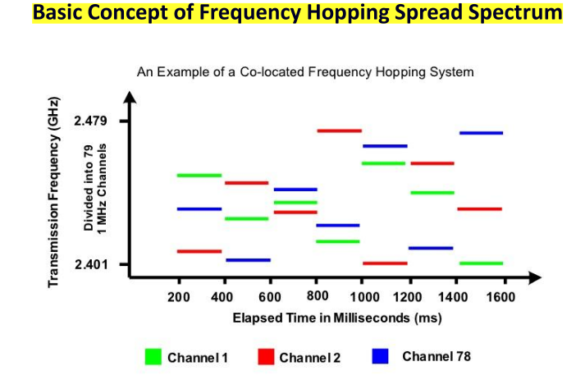

### **ii) DSSS (Direct Sequence Spread Spectrum)**

**Direct Sequence Spread Spectrum** is a technique where the original data signal is multiplied with a high-speed pseudo-random noise (PN) code, spreading the signal over a wider bandwidth.

### **How DSSS Works:**

**Step by step:**

1. Your original data signal is taken (e.g., 1 bit: "1")
2. This 1 bit is multiplied by a **pseudo-noise (PN) code** - a long sequence of random-looking bits (e.g., "1 0 1 1 0 1 0 1")
3. Your single bit "1" becomes "1 0 1 1 0 1 0 1" - much longer!
4. This spreads your signal across a **wider frequency range**
5. The receiver has the same PN code and can extract your original data
6. Without the PN code, the signal looks like random noise

## **3. EMI and SNR Relationship (proportional)to Performance**

**EMI (Electromagnetic Interference):**

* Spread spectrum techniques reduce the impact of EMI
* By spreading the signal across multiple frequencies, interference on one frequency doesn't destroy the entire signal

**SNR (Signal-to-Noise Ratio):**

* SNR is **proportional to performance**
* Higher SNR = Better signal quality and performance
* Spread spectrum improves SNR by:
* Spreading energy across wider bandwidth
* Making signal less susceptible to narrowband interference
* Processing gain helps recover signal even in noisy environments

## **4. FHSS - Fast Hopping vs Slow Hopping**

### **Fast Hopping:**

* Multiple frequency hops occur during transmission of **one data symbol**
* Hopping rate is **faster** than the data rate
* Better resistance to interference
* More complex to implement

### **Slow Hopping:**

* Multiple data symbols are transmitted on **one frequency** before hopping
* Hopping rate is **slower** than the data rate
* Simpler to implement
* Less overhead

**Key difference:** Fast hopping changes frequency multiple times per symbol, while slow hopping transmits multiple symbols on one frequency before changing.

## **5. FHSS Transmitter and Receiver**

### **FHSS FSK Transmitter Components:**

1. **FSK Modulator**: Modulates the input data
2. **Frequency Up Converter**: Converts signal to transmission frequency
3. **Pseudo-Noise Generator**: Generates random hopping sequence
4. **Frequency Synthesizer**: Creates the hopping frequencies based on PN code
5. **Output**: Transmitted signal φ_FSK(t) through RF channel

### **FHSS FSK Receiver Components:**

1. **Frequency Down Converter**: Receives signal from RF channel and converts to lower frequency
2. **FSK Detector**: Demodulates the FSK signal to recover data
3. **Pseudo-Noise Generator**: Generates same hopping sequence as transmitter
4. **Frequency Synthesizer**: Synchronized with transmitter to track frequency hops
5. **Output**: Recovered data

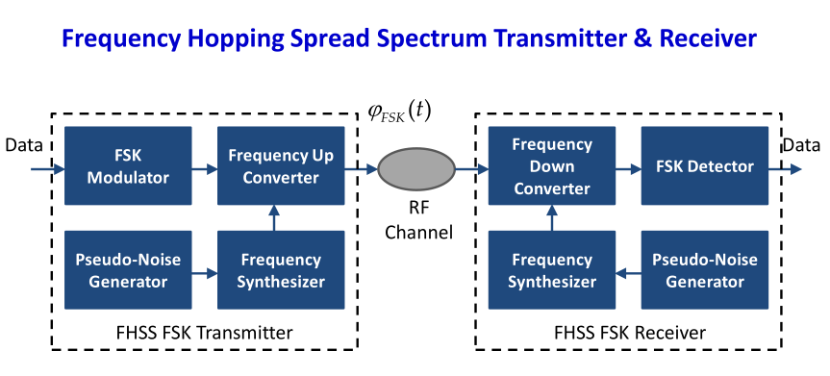

**Important Note:** Most FHSS communication systems adopt binary or M-ary FSK modulation. This makes systems that do not need coherent detection.

**Synchronization:** Both transmitter and receiver must use the same pseudo-noise sequence and be perfectly synchronized to hop to the same frequencies at the same time.

## **FHSS vs DSSS Comparison**

|  |  |  |
| --- | --- | --- |
| **Feature** | **FHSS** | **DSSS** |
| **Basic Method** | Hops between different frequencies | Spreads signal using PN code on same frequency |
| **Time Domain** | Uses one frequency at a time, changes over time | Uses all bandwidth continuously |
| **Frequency Domain** | Narrow signal that moves around | Wide signal that stays in place |
| **Analogy** | Changing radio stations rapidly | Whispering in a noisy room |
| **Bandwidth Usage** | Uses small bandwidth, changes location | Uses wide bandwidth, stays in one place |
| **Interference Resistance** | Good - if one frequency is jammed, you hop away | Good - interference affects only part of spread signal |
| **Implementation** | Simpler, less complex | More complex, requires fast PN code |
| **Synchronization** | Must sync hopping pattern | Must sync PN code |
| **Power Consumption** | Generally lower | Generally higher |
| **Examples** | Bluetooth (uses FHSS) | Wi-Fi 802.11b, GPS, CDMA (use DSSS) |