**S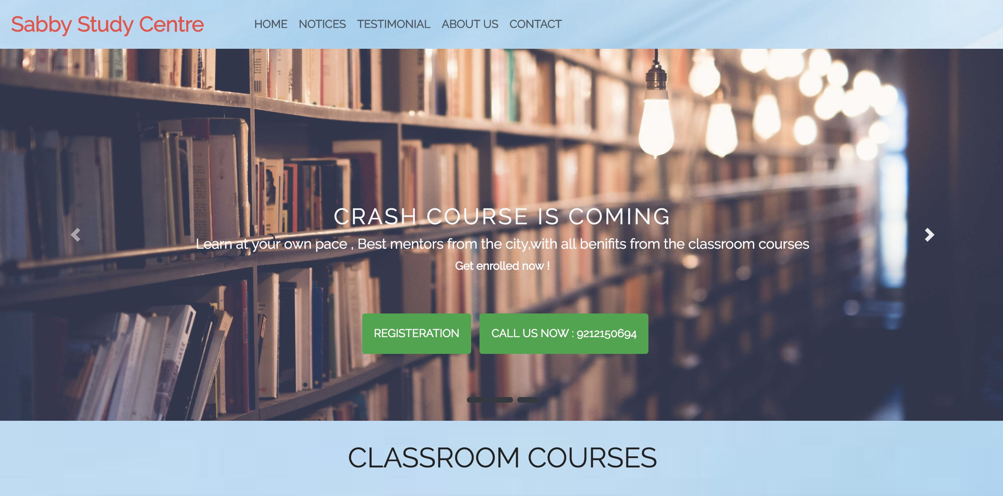ABBY APP**

**INTRODUCTION**

## 

## SABBY APP

I **AMAN SINGH** a second year Computer Science students from the **NETAJI SUBHAS INSTITUTE OF TECHNOLOGY**. As part of our course,I have been working on a App Development project . This project aims to introduce App development concepts and development to students by matching them with companies who act as clients and assign projects to the student teams. I , chose to work with an Coaching Institute as we all agreed that the project offered was achievable yet challenging and would benefit our skill set. The summary of the brief was quite open ended and gave us an opportunity to brainstorm a range of different project ideas.

**Project Brief**

“Design and produce a mobile Android application which allow users to get basic register and get basic notifications of the Institute which enables the users to get updated by the activities of the Institute.”

**Problem**

We then began to analyse the problem domain in order to come up with a useful solution. Previously students in order to register or taking assignments he/she had to reach the Organization in order to full fill its need along with this if a Organisation wants to communicate or convey some information it has to contact to each and every individual personally and there is great involvement of effort and resources .

**Solution**

To solve the problems identified above, the application will consist of dynamic notice registration panel from which a individual can register in the specified course from any remote location .An Organisation can provide any information such like Notices, Assignments ,Circular etc, through the means of the dynamic panel from which it can make available its content in the notice panel from which user can download that content from any remote corner without being available in the Organization.By registering in a particular course the student can get the welcome mail by the Organization and the Organization can get the details filled by the student in their respective database .

**ACKNOWLEDGEMENT**

I would like to express my special thanks of gratitude to my teacher. (Deepicka mam) who gave me the golden opportunity to do this wonderful project on the topic (App Development), which also helped me in doing a lot of Research and i came to know about so many new things I am really thankful to them. I am highly indebted to (Deepika mam) for their guidance and constant supervision as well as for providing necessary information regarding the project & also for their support in completing the project.

Secondly i would also like to thank my parents and friends who helped me a lot in finalizing this project within the limited time frame.I would like to express my gratitude towards my parents for their kind co-operation and encouragement which help me in completion of this project.

I would like to express my special gratitude and thanks to industry persons for giving me such attention and time.

My thanks and appreciations also go to my colleague in developing the project and people who have willingly helped me out with their abilities.

**INDEX**

1) Project Profile

* + Project Definition
  + System Requirement

2) Analysis

3)Design

4)Implementation

5)Tools and Technology

6)Bibliography

**Project Profile**

**Title:** Sabby App

**Definition:**

Sabby App define as to interact with the coaching centre named ‘ SABBY STUDY CENTRE ’.

**Description:**

This app is used to register and get updates of the Institute.

It facilitates to register and get updates to the registered users.

It displays a registration form which students can register

for the specified course and the registered students can rec- ceive all the notifications and can download the assignments along with it they can view their result.

In this application,Admin can send and edit its notifica- tions, Assignments etc. By registering in the course Institute can get the form filled by the student and simultaneously student can get the welcome mail by the Institute.

**Project Profile**

* + - * **Project Hardware Requirement**
        + Android /IOS Device. (cell/tablet ….)
        + Computer/Laptop
  + **Project Software Requirement** 
    - Front End
      * + Android
        + nodejs
        + Nodemailer
        + IDE(Visual Studio Code 1.28 or above )
        + Javascript
    - Back End
      * + Sqlite Database
        + Nodemailer
  + **Project Network Requirement** 
    - Internet connection

Analysis

* + **Application Requirements**

Sequelize

Nodemailer

JSON parser

Bootstrap

* + **Limitation ofApplication**

Must required Android 2.2 and above version.

Internet connection must require

**Analysis**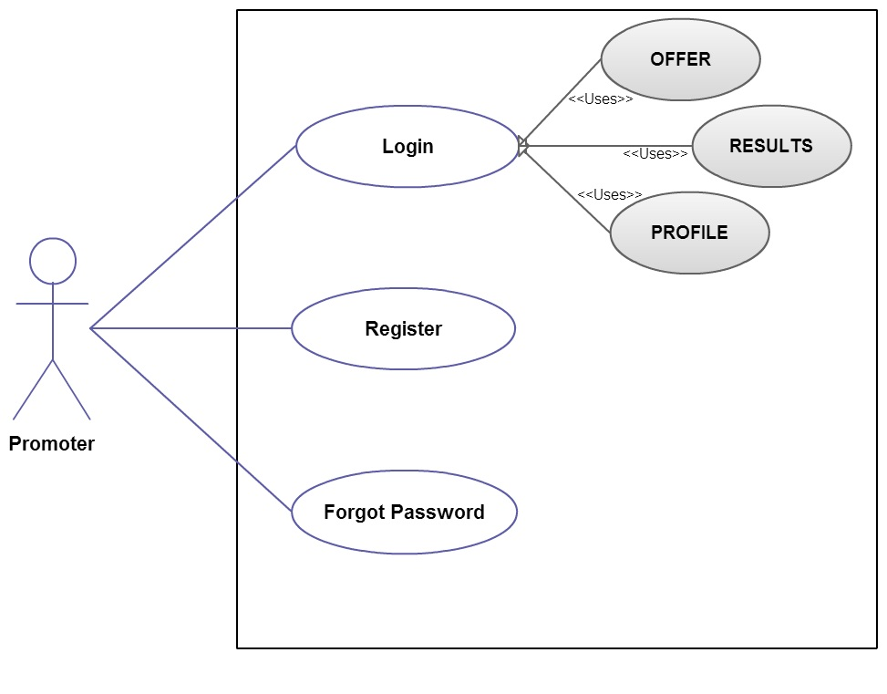

**Use Case Diagram for Home Screen:**

**ANALYSIS**

**ADMINISTRATOR**

ADMIN PANNEL

**USER**

**DESIGN**

**Component Diagram**

SABBY APP

USERS

SERVER

REGISTER

TESTIMONIAL

FORM DATA

NOTIFICATIONS/ASSIGNMENTS

**IMPLEMENTATION**

* **USER INTERFACE**

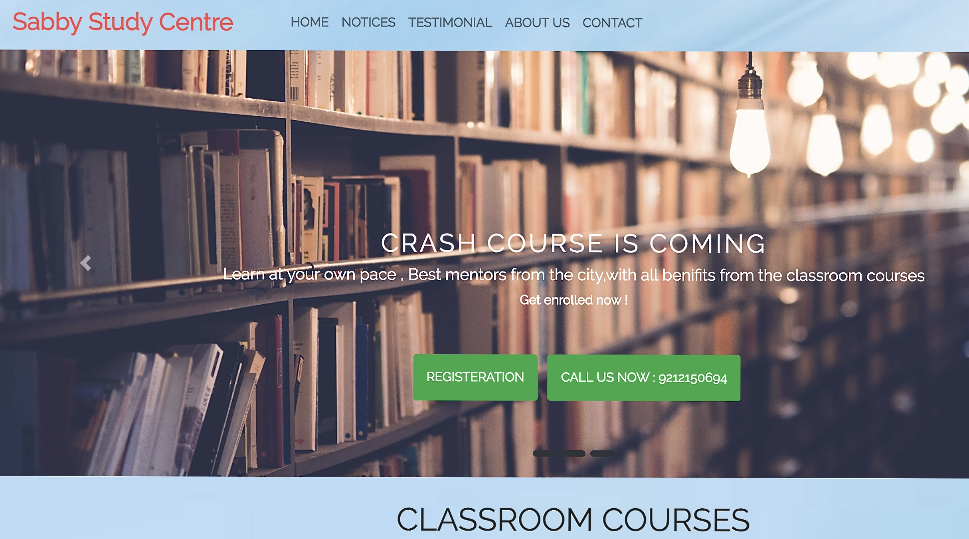

* + - It allows user to interact with the ui of the app.
    - It provides the directions of the app which led user to full fill its need .
* **REGISTRATION FORM**

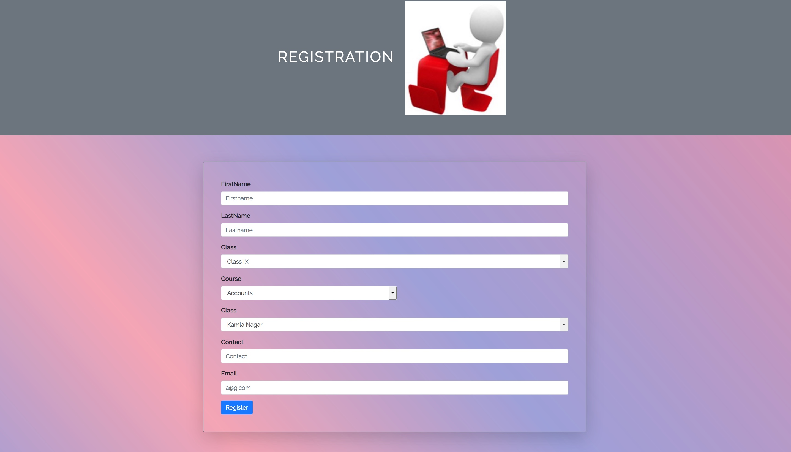

* It allows user to register for a particular course.
* Form consist of the basic requirements such as class, course, branch, contact, email.
* By registering a welcome is received by the user from the Institute.
* By registering Institute will get the details filled by the user in the form ,so it is easy for the Institute to keep the users data.
* **NOTICES**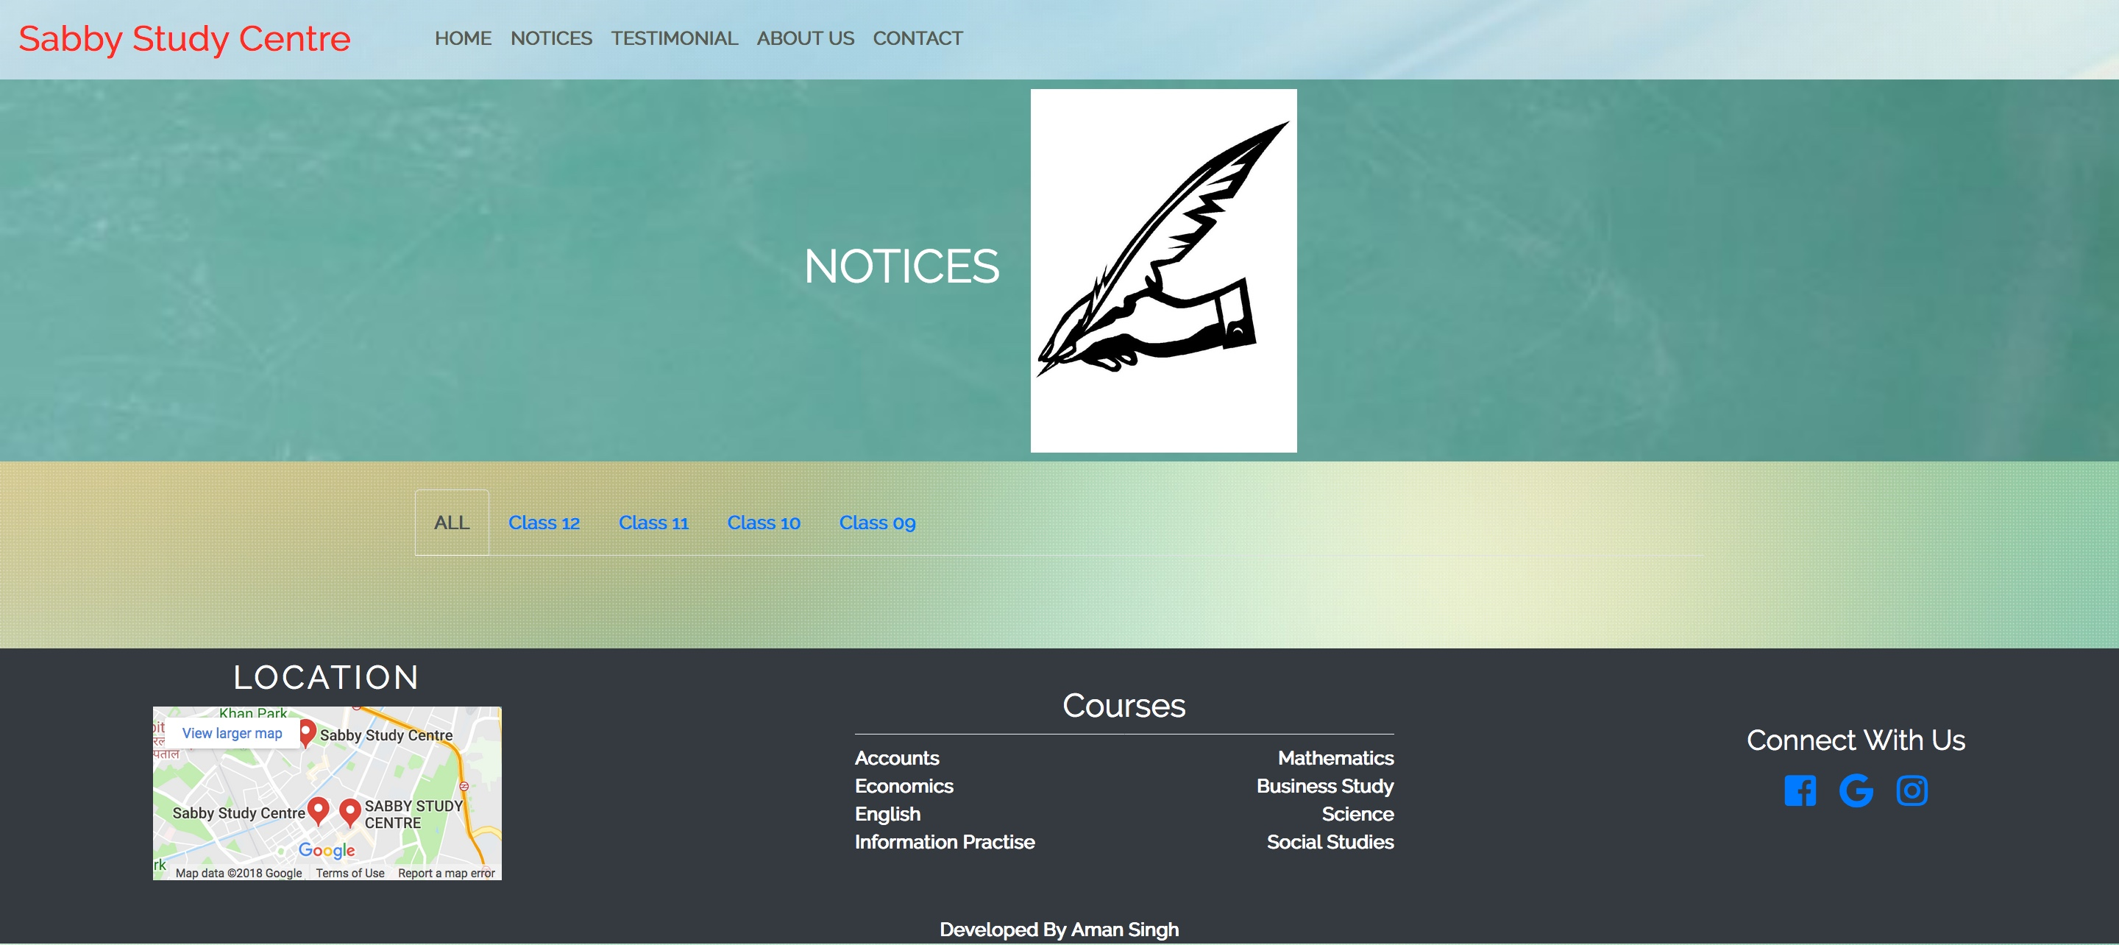
* It allows user to get notifications from the Institute.
* Notifications can be in any form like results, assignments, notices etc.
* Notices can be in any format like word file ,pdf format ,image etc.
* By clicking user can download the specified content.
* **ADMIN PANEL**

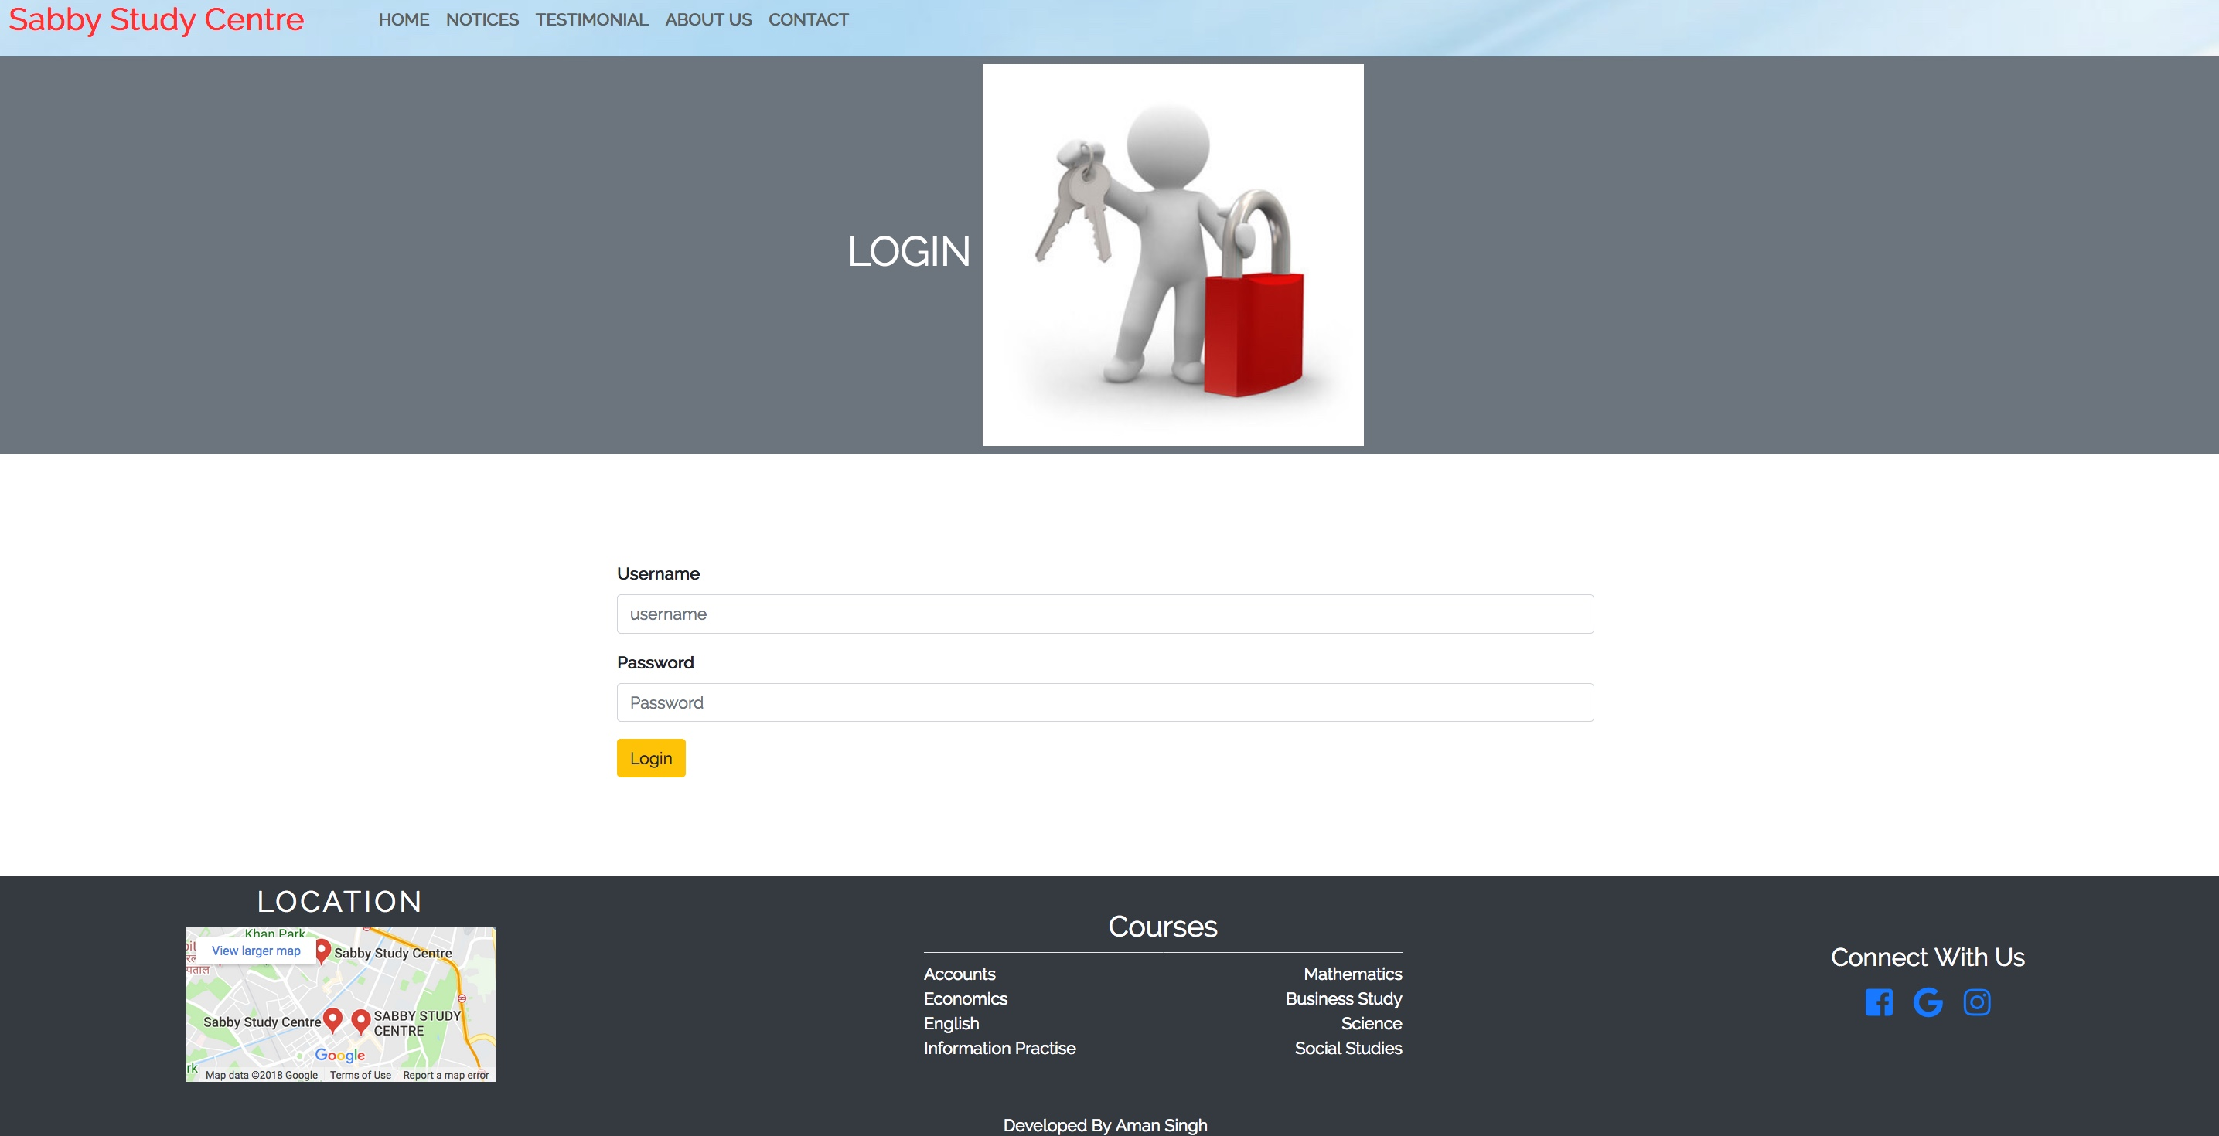

* Admin panel used to operate and control all the website.
* It allows Administrator to add notices ,remove notices ,edit notices.
* It takes the necessary content from the desktop or any other directory.
* It hides all the admin details from the user.
* **TESTIMONIAL**

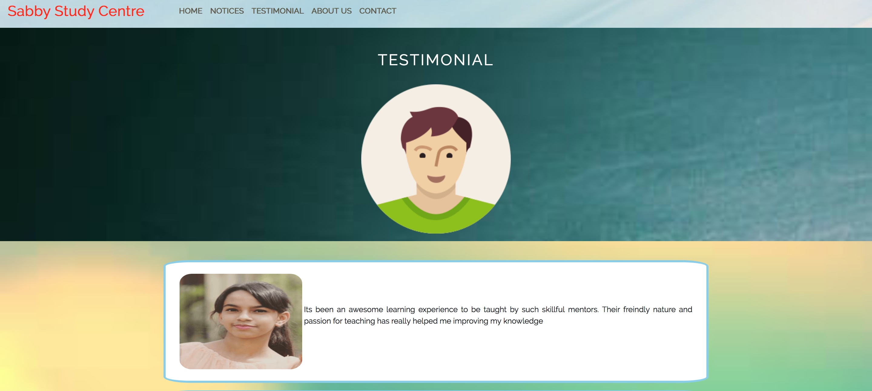

* It basically give the basic experience of the shinning students passed from the Institute.
* User can get the necessary feedback from these testimonials.
* If user was alumni of the Institute user can send his testimonial to the Institute and his/her testimonial is added to the testimonial page .
* Basically it reflects the status of the Institute.

**TOOLS and TECHNOLOGY**

* **TOOLS**
  + - * + Visual Studio Code
        + Photoshop
        + Android
        + Internet
* **TECHNOLOGY**
  + - * + Html
        + Css
        + nodejs
        + Javascript
        + Sql
        + npm

**BIBLIOGRAPHY**

**WEBSITES VISITED**

**https://stackoverflow.com/**

**https://developer.mozilla.org/en-US/**

**https://www.w3schools.com**

**https://getbootstrap.com/**

**https://www.npmjs.com/get-npm**

[https://www.github.com](https://www.github.com/)

**BOOKS REFERRED**

Mastering JavaScript Single Page Application Development

by **Philip Klauzinski,** John Moore

THANK YOU !!!