**S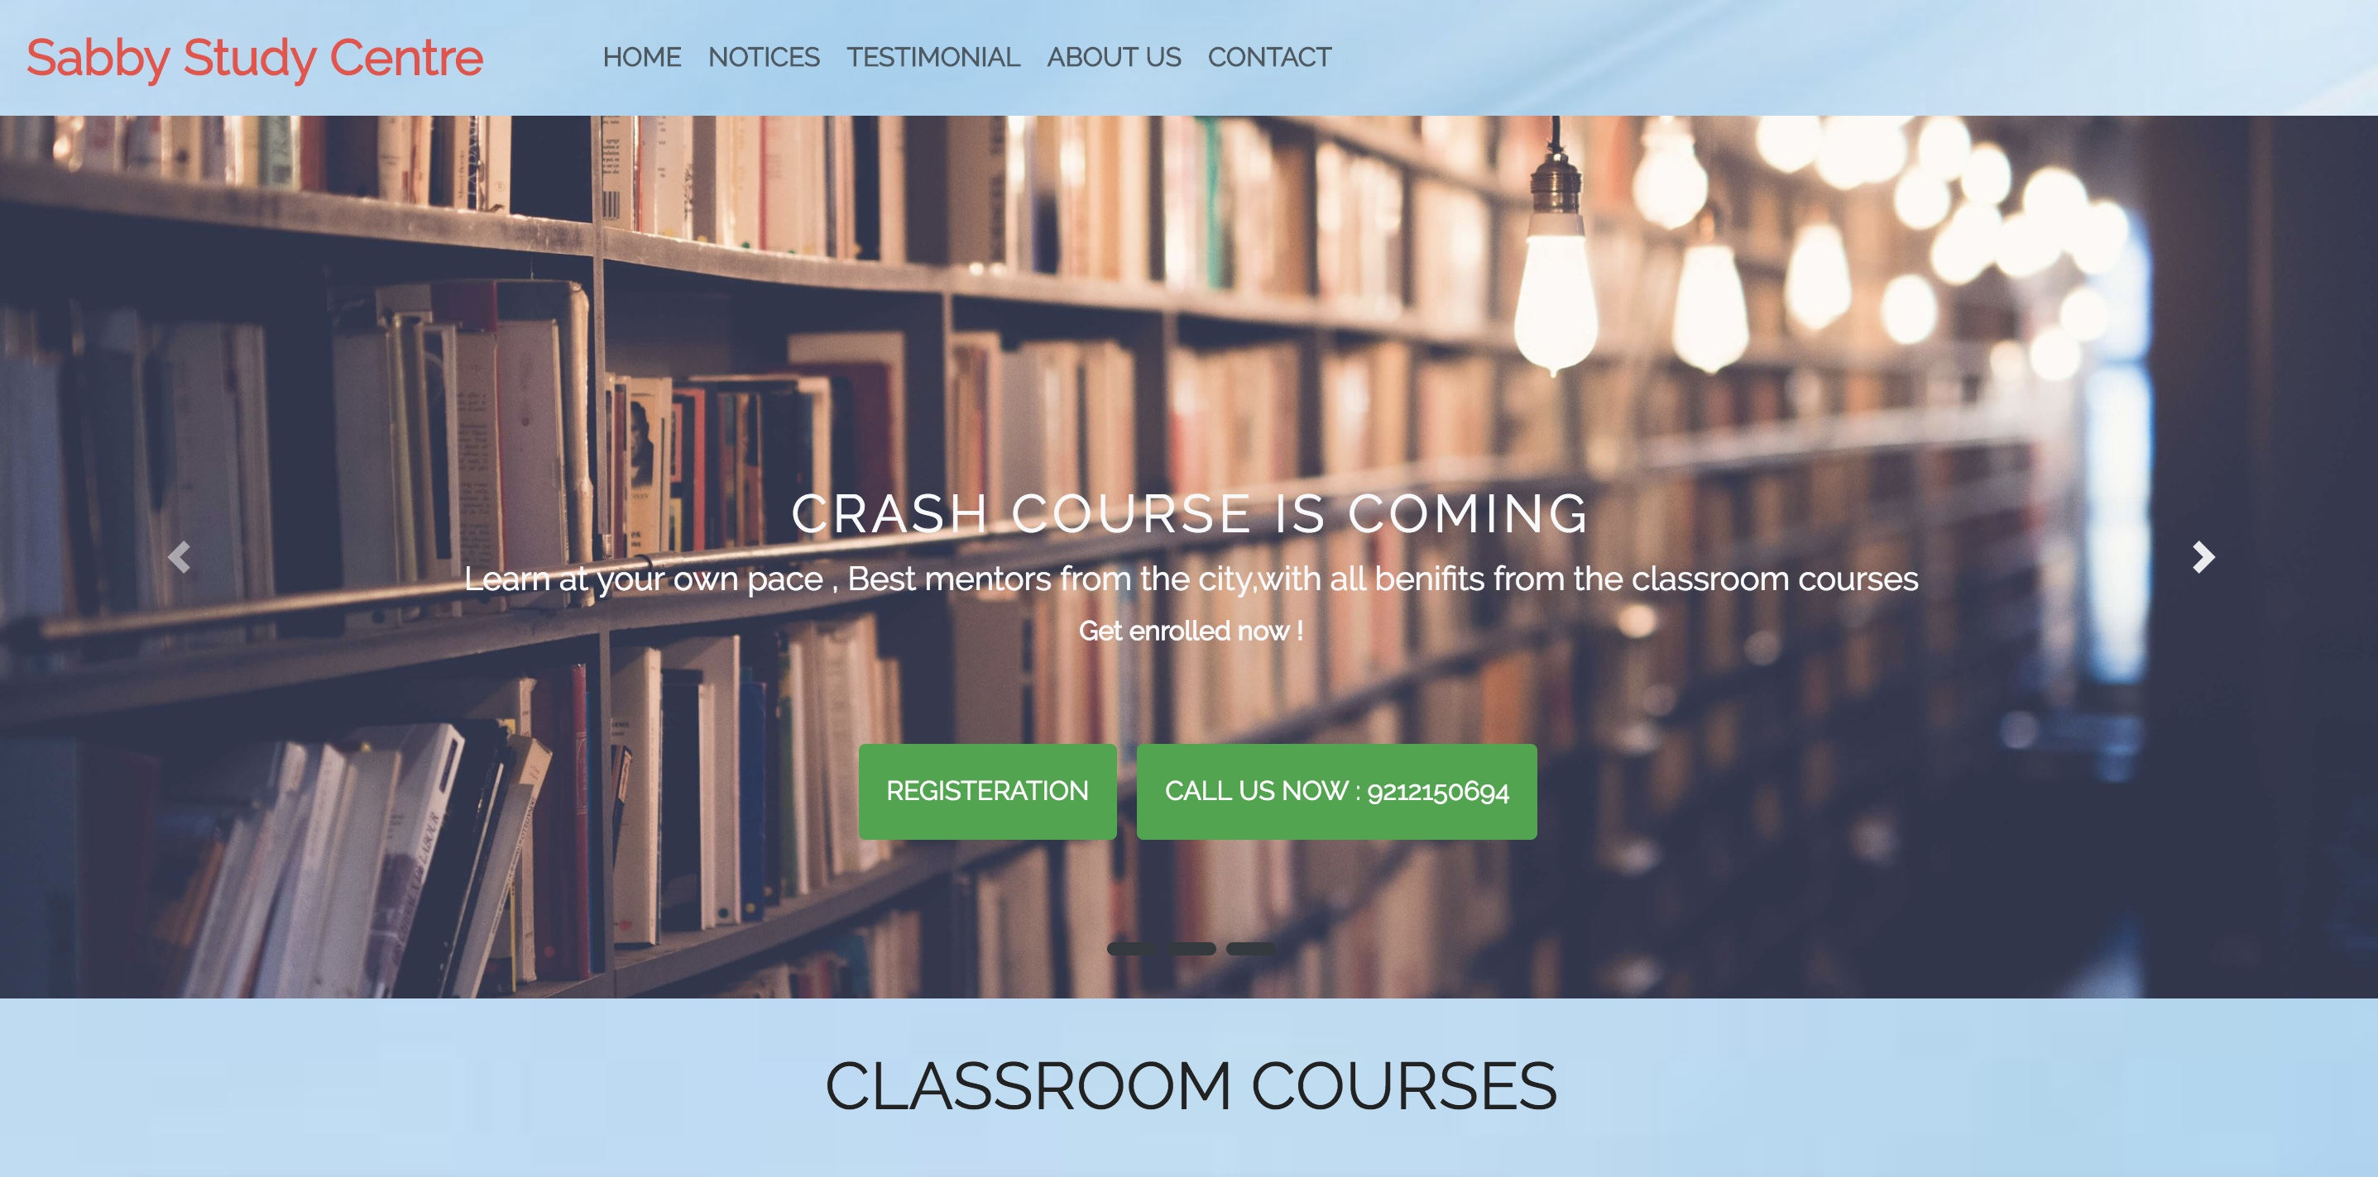ABBY APP**

# Introduction

## 

## Curabitur vulputate viverra pede

Consectetuer arcu ipsum ornare pellentesque vehicula, in vehicula diam, ornare magna erat felis wisi a risus. Justo fermentum id. Malesuada eleifend, tortor molestie, a a vel et. Mauris at suspendisse, neque aliquam faucibus adipiscing, vivamus in. Wisi mattis leo suscipit nec amet, nisl fermentum tempor ac a, augue in eleifend in venenatis, cras sit id in vestibulum felis in, sed ligula. In sodales suspendisse mauris quam etiam erat, quia tellus convallis eros rhoncus diam orci, porta lectus esse adipiscing posuere et, nisl arcu vitae laoreet. Congue porta scelerisque praesent at, lacus vestibulum et at dignissim cras urna, ante convallis turpis duis lectus sed aliquet, at et ultricies.

Morbi integer molestie, amet suspendisse morbi, amet maecenas, a maecenas mauris neque proin nisl mollis. Suscipit nec ligula ipsum orci nulla, in posuere ut quis ultrices, lectus primis vehicula velit hasellus lectus, vestibulum orci laoreet inceptos vitae, at consectetuer amet et consectetuer. Praesent integer leo orci aliquam, nibh a. Diam nobis, erat natoque integer fringilla viverra. Fermentum pede fringilla urna semper, pede quam scelerisque et enim in commodo, dictum a consequatur arcu adipiscing volutpat.

**Analysis** 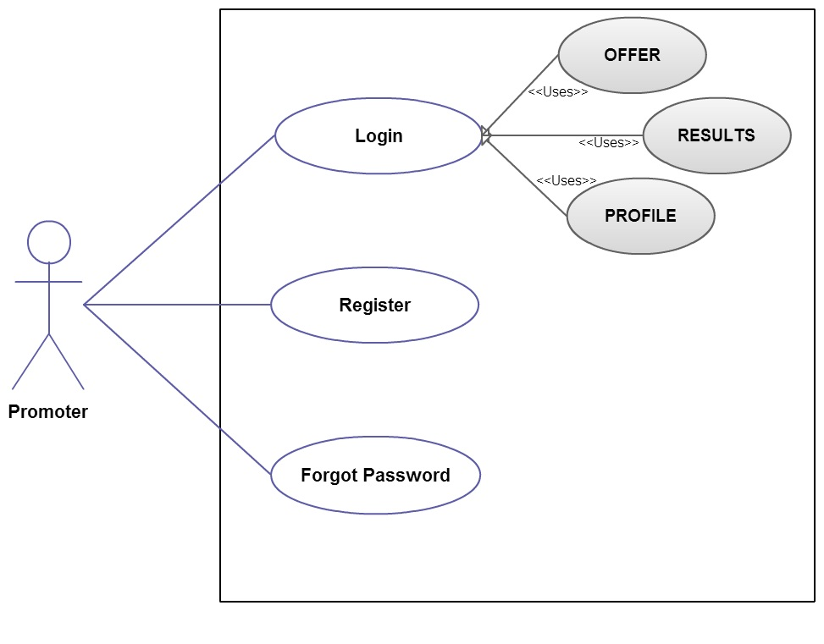

**Use Case Diagram for Home Screen:**

**INDEX**

1) Project Profile

2) Project Definition

3) System Requirement

2) Analysis

3)Design

4)Implementation

5)Tools and Technology

6)Biblography

**Project Profile**

**Title:** Sabby App

**Definition:**

Sabby App define as to interact with the coaching centre named ‘ SABBY STUDY CENTRE ’.

**Description:**

This app is used to register and get updates of the Institute.

It facilitates to register and get updates to the registers users.

It displays a registration form which students can register

for the specified course and the registered students can receive all the notifications and can download the assignments along with it they can view their result.

In this applicantion you Admin send and edit its notifications,

Assignments etc. By registering in the course Institute can get the form filled by the student and simultaneously student can get the welcome mail by the Institute.

**Project Profile**

* + - * **Project Hardware Requirement**
        + Android /IOS Device. (cell/tablet ….)
        + Computer/Laptop
  + **Project Software Requirement** 
    - Front End
      * + Android
        + nodejs
        + Nodemailer
        + IDE(Visual Studio Code 1.28 or above )
        + Javascript
    - Back End
      * + Sqlite Database
        + Nodemailer

* + **Project Network Requirement** 
    - Internet connection

Analysis

* + **Application Requirements**

Sequelize

Nodemailer

JSON parser

Bootstrap

* + **Limitation ofApplication**

Must required Android 2.2 and above version.

Internet connection must require

**ANALYSIS**

ADMIN PANNEL

**DESIGN**

**Component Diagram**

SABBY APP

USERS

SERVER

REGISTER

TESTIMONIAL

FORM DATA

NOTIFICATIONS/ASSIGNMENTS

**IMPLEMENTATION**

* **USER INTERFACE**

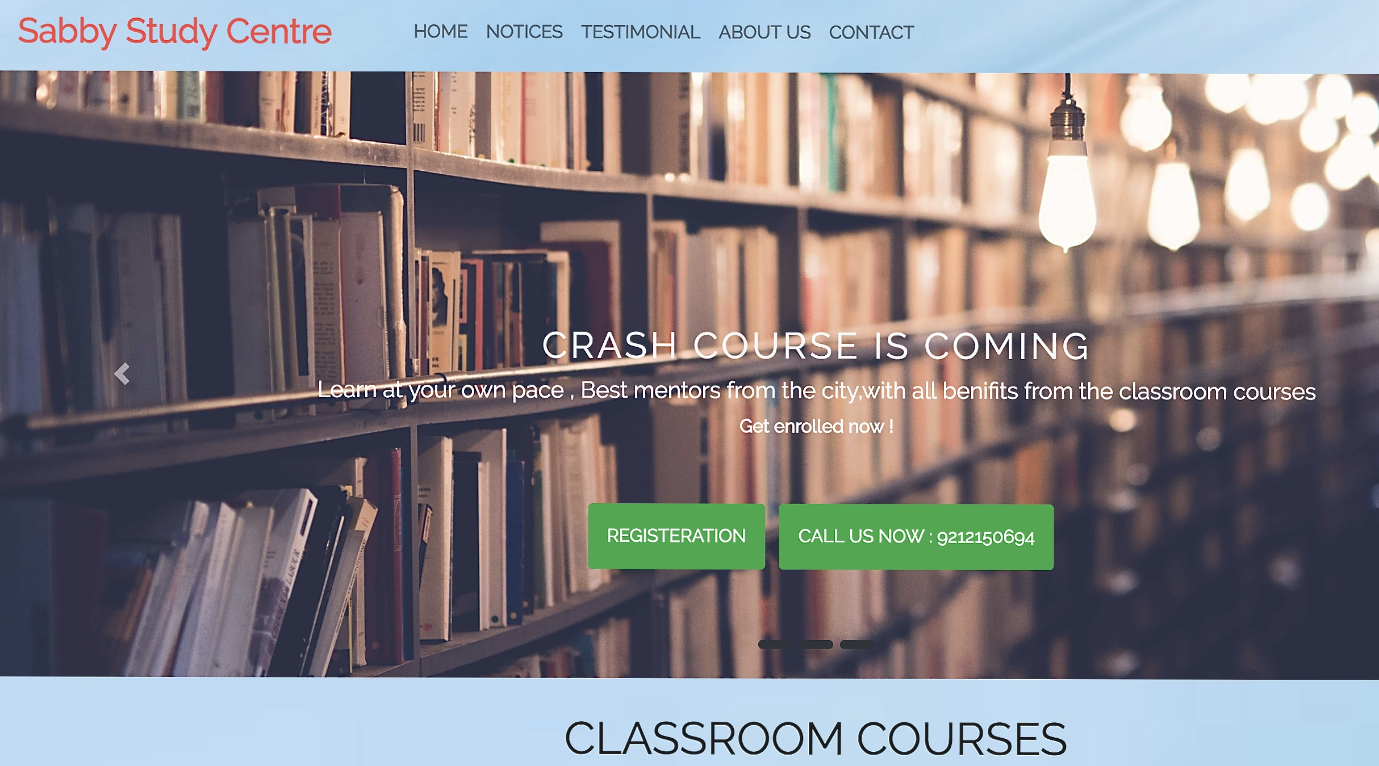

* + - **It allows user to interact with the ui of the app.**
    - **It provides the directions of the app which led user to fullfill its need .**
* **REGISTRATION FORM**

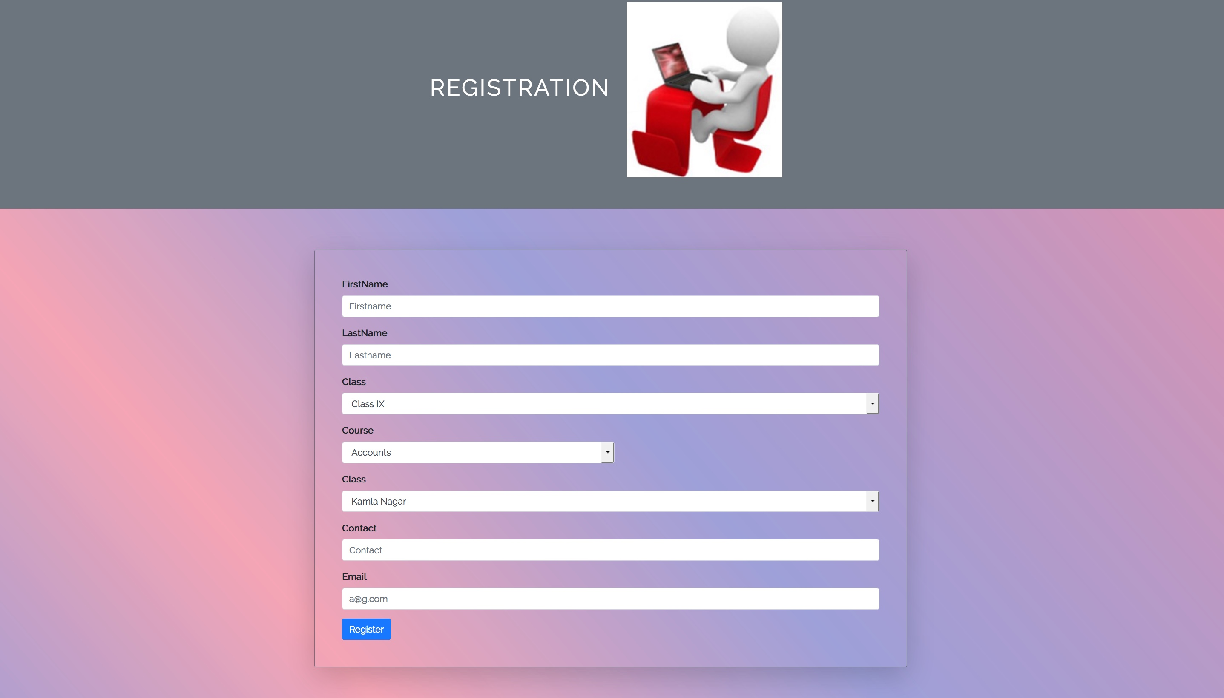

* **It allows user to register for a particular course.**
* **Form consist of the basic requirements such as class, course, branch, contact,email.**
* **By registering a welcome is received by the user from the Institute.**
* **By registering Institute will get the details filled by the user in the form ,so it is easy for the Institute to keep the users data.**
* **NOTICES**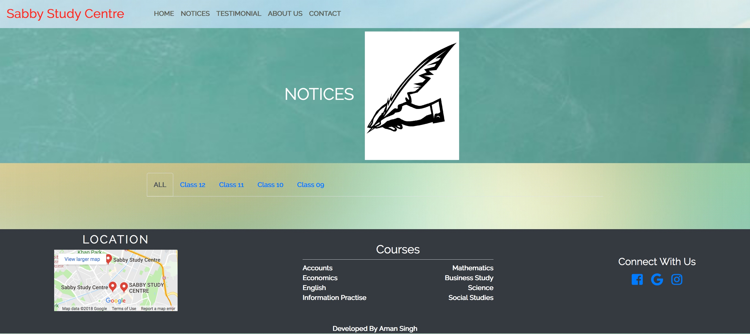
* **It allows user to get notifications from the Institute.**
* **Notifications can be in any form like results, assignments,notices etc.**
* **Notices can be in any format like word file ,pdf format ,image etc.**
* **By clicking user can download the specified content.**
* **ADMIN PANNEL**

