**EBS(Elastic Block Store) in AWS**

* AWS EBS is a cloud-based storage services that provides durable, high-performance block storage for use with Amazon EC2 instances.

It works like a virtual hard drive, allowing you to store and access data even when your EC2 instances are stopped or terminated.

* Amazon EBS is a block storage services designed to be used with EC2(Elastic Compute Cloud) instances. It provides persistent storage volumes that can be attached to EC2 instances.
* This service is used for hosting database (e.g., MySQL, PostgreSQL), storing files and logos with durability, taking automatic backups using snapshots.

**Lab Steps**

* Task 1: Sign in to AWS Management Console

1. Click on the open console button, and you will get redirected to AWS console in a new browser tab.
2. On the AWS sign-in page,

* Leave the Account ID as default. Never edit/remove the 12-digit Account ID present in the AWS console. Otherwise, you cannot proceed with the lab.
* Now copy your username and password in the lab console to the IAM username and password in AWS console and click on the sign-in button.

1. Once signed in to the AWS Management Console, make the default AWS Region as US East (N. Virginia) us-east-1.

Task 2: Open EC2 Dashboard

1. In the AWS search bar, type EC2 and click on it.
2. You will enter the EC2 Dashboard.

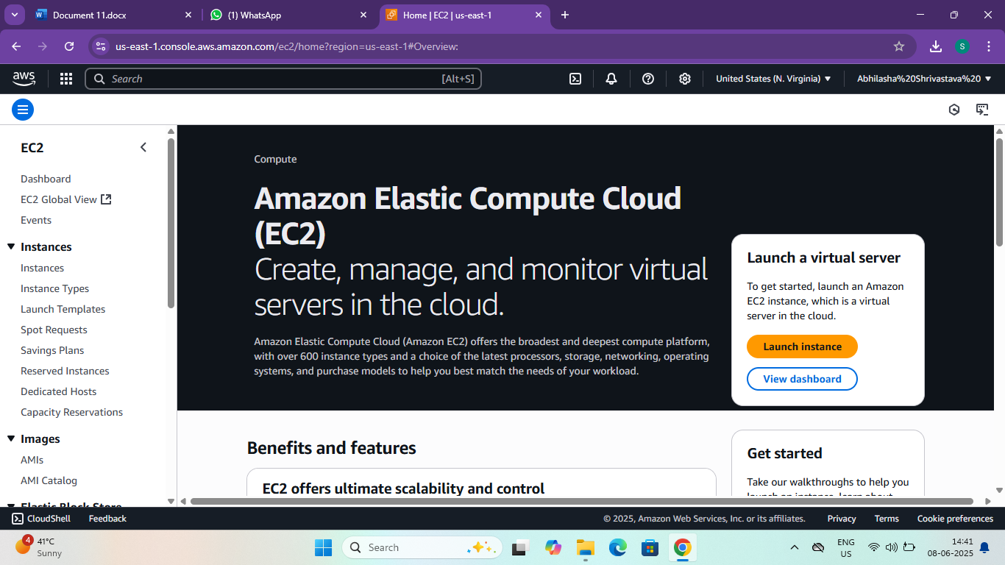

Task 3: Launch an Instances

1. Click the “Launch Instances” button.
2. Fill out the following:

21. Name and Tags

* Give your instance a name (My first Instance).

2. Application and OS Images (AMI)

* Choose an AMI (Amazon Machine Image):

* Example: ubuntu, windows etc.

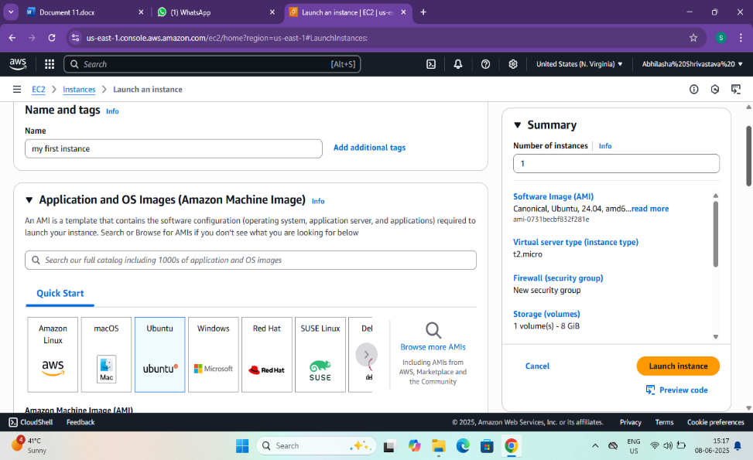

3.Instance Type

* Choose an Instances type (default is t2. micro- Free Tier eligible).

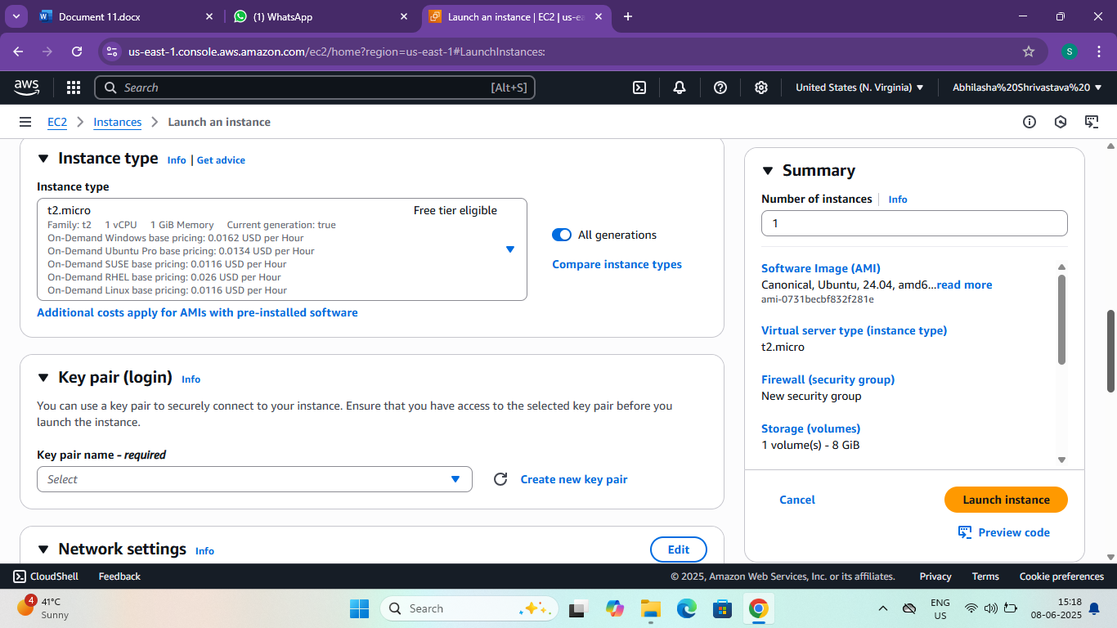

4. Key Pair (login)

* Create a new key pair (if you don't have one)
* Download the. pem file- this is needed for SSH access.

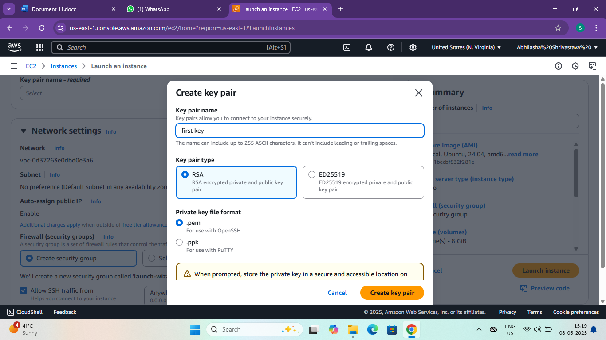

Task 4: Launch the Instance

1. Click “Launch Instances”.

Task 5: Connect to the Instances

For Linux:

1. Go to the Instances-> Select your Instances-> Connect.

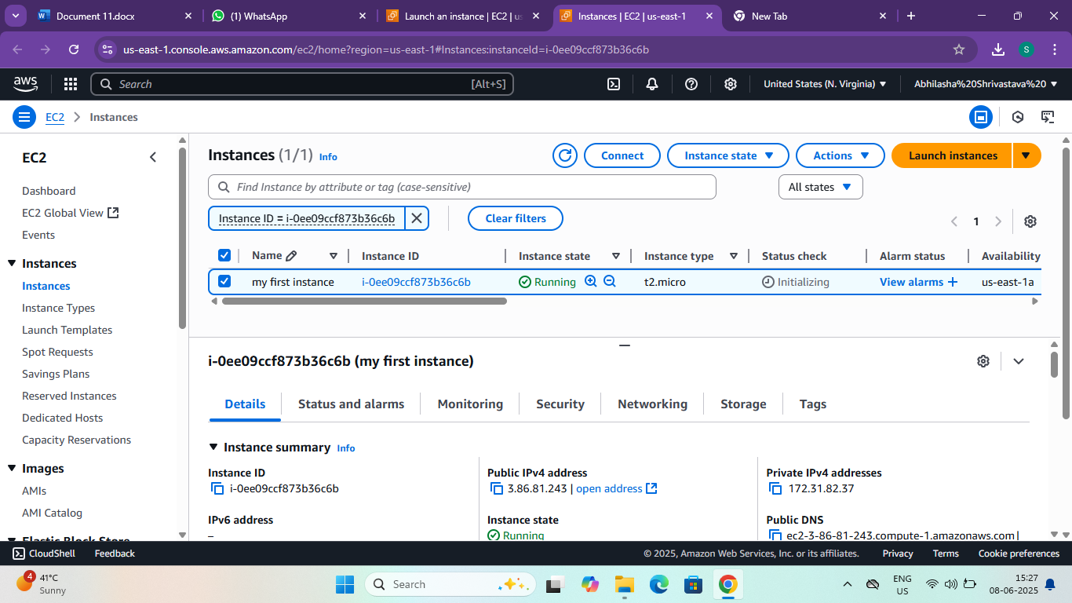

Task 6: Go to EC2 Dashboard

* In the AWS search bar, type “EC2” and select EC2.
* In the left menu, scroll to Elastic Block Store and click "volumes”.

Task 7: Create a volume

* Click the “create volume” button.
* Fill the following details:

1. Volume type- gp3(general purpose SSD)
2. Size-10 GiB (or more as needed)

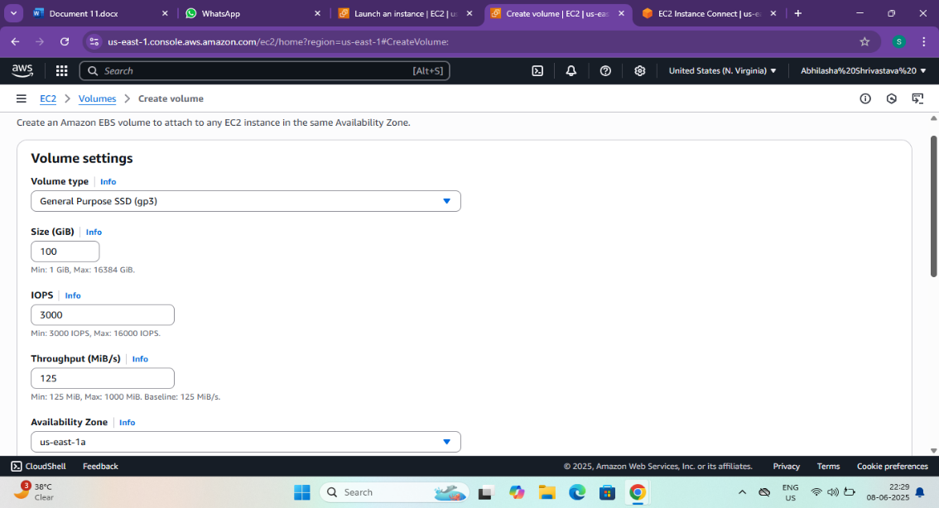

1. Availability Zone-Same as your EC2(e.g., us-east-1a)
2. Encrypted-Optional (choose if you want encryption)

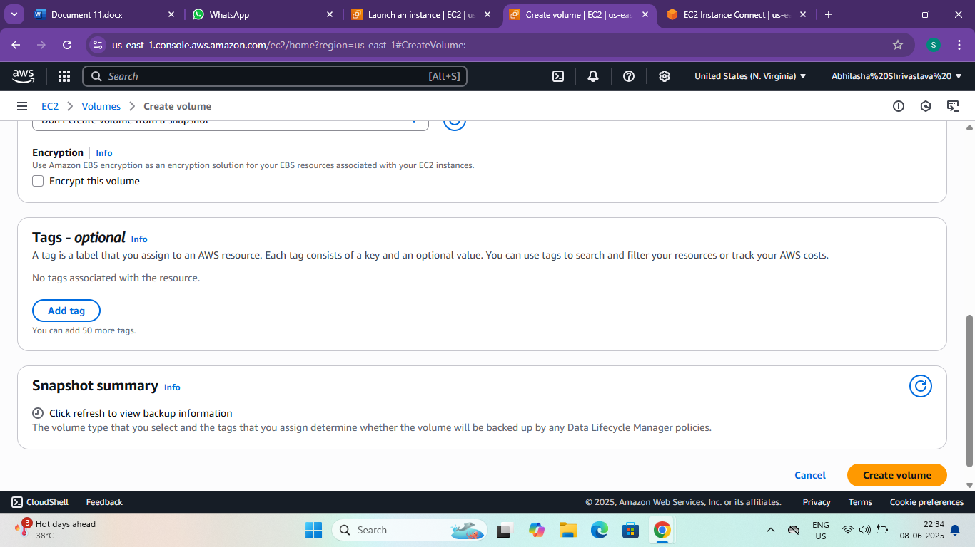

* Click create Volume.

Task 8: Attach Volume to EC2 Instance

1. After creation, Select the new volume.
2. Click Actions-> Attach volume.

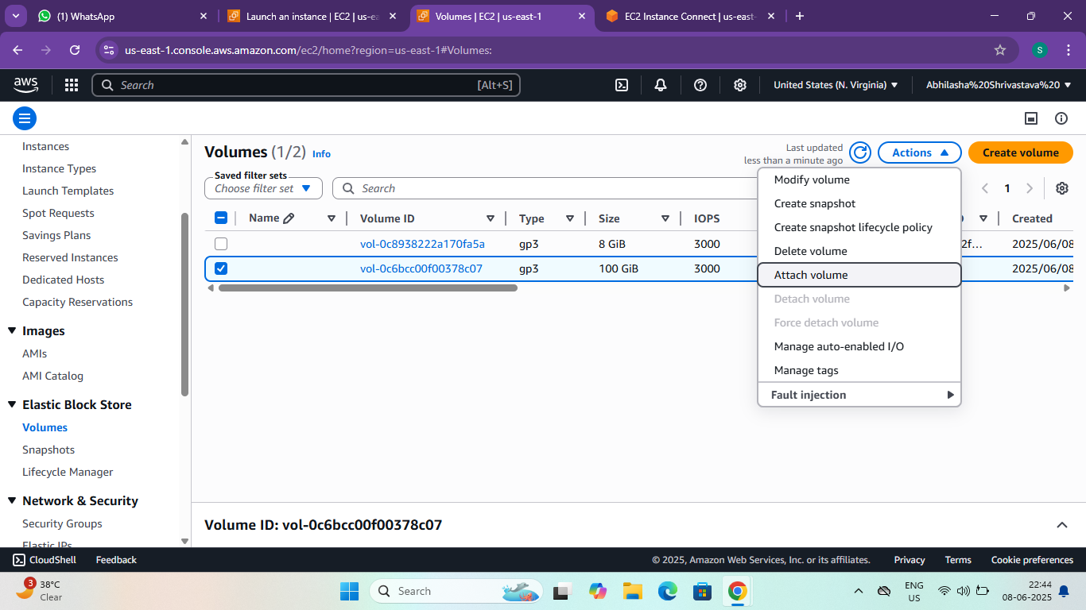

1. Choose the EC2 instances (must be in the same availability zone).
2. Click Attach.
3. 