INTERNET OF THINGS

SMART WASTE MANAGEMENT SYSTEM FOR METROPOLITIAN CITIES

**BY TEAMNO:13**

* AMARLAPUDI VIJAY KUMAR.
* CHANDANA MANOJ KUMAR.
* VEERANJANEYULU DODDAKULA.

**Table of Contents**

**1 INTRODUCTION**

1.1 Overview

1.2 Purpose

**2 LITERATURE SURVEY**

2.1 Existing problem

2.2 Proposed solution

**3 THEORITICAL ANALYSIS**

3.1 Block diagram

3.2 Hardware / Software designing

**4 EXPERIMENTAL INVESTIGATIONS**

**5 FLOWCHART**

**6 RESULT**

**7 ADVANTAGES & DISADVANTAGES**

**8 APPLICATIONS**

**9 CONCLUSION**

**10 FUTURE SCOPE**

**11 BIBILOGRAPHY**

**12 APPENDIX**

**1)INTRODUCTION:**

1.1 overview

Waste bins are part of our lives for decades and mostly its condition are overflowing due to improper waste dumping, collection and management, which leads in foul smell and unhygienic condition, thus inherently results in environment pollution. Therefore, in this paper, design of a Waste Bin with real time monitoring is presented and a smart waste management system is proposed using the recent technical advancements of automation and Internet of Things (IoT).

1.2 purpose

Such smart bins are connected to the cloud, where the bin status are communicated, recorded and monitored by the local bodies through and android app or a centralized server. Thus the designed smart bin and proposed waste management system have better level of smartness compared to existing ones in metropolitan cities in a centralized manner.

**2)Literature Survey:**

2.1 Existing problems

The existing system requires manual work. Every time the people should monitor the dustbin, and have to clean it.

2.2 Proposed solution:

1. The smart, sensor based dustbin will judge the level of waste in it and send the

messege directly to the municipal corporation.

1. It can sense all the type of waste material either it is in the form of solid or liquid.
2. According to the filled level of the dustbin, the vehicles from the municipal
3. corporation will choose the shortest path with the help of the “TRANSPORTATION SOFTWARE”, which will save their time.
4. It emphasizes on “DIGITAL INDIA”.
5. The system is simple. If there is any problem with any equipment in the future, that

part is easily replaceable with new one without any difficulty and delay.

**3)Theoretical Analysis:**

3.1 Block diagram

**IBM cloud**

**IBM Platform**

**Node Red**

**Ultra sonic sensor**

3.2 Hardware / Software designing

WE developed this application some software designations

1)IBM Cloud

(i). iot platform

(ii). Ultra sonic sensor

(iii). Node-red

2)Python software

3) Ultra sonic sensor

4)Fast2 SMS service

5)MIT APP inventer

**4)Experimental Investigation:**

While performing this experiment (or) Project we will investigate about the dustbin and the code we had written for the automateddustbin status..By measuring the level of dustbin if if it crosses threshold value, the messages will send to municipal authority through Fast2 SMS service.

**5)Flowchart:**

**Ultra sonic sensor**

**Passlog data to cloud**

**Send sms to municipal authority using fast 2 sms**

**If dustbin crosses the threshold value**

**Keep on monitering**

YES

NO

**6)Result:**

By using ultra sonic sensor we can easily know the level of waste.

And an alert will be sent if level reaches to threshold value such that spread of waste will be reduced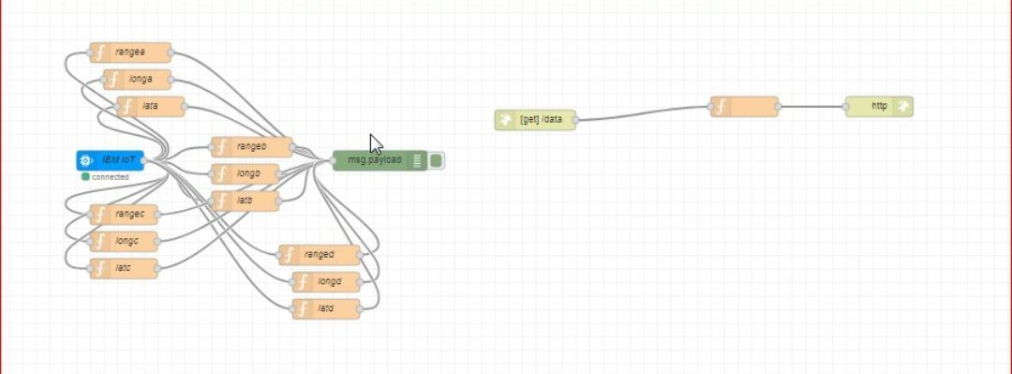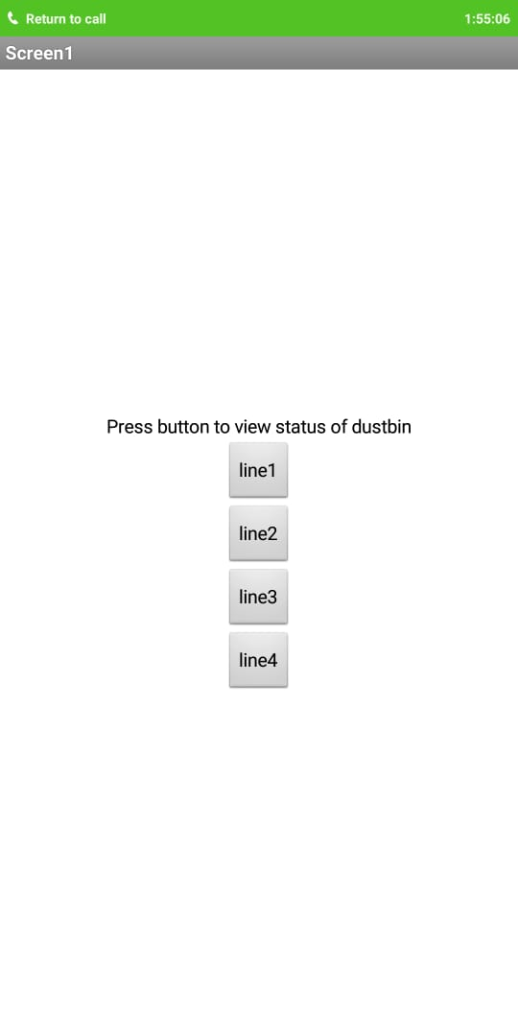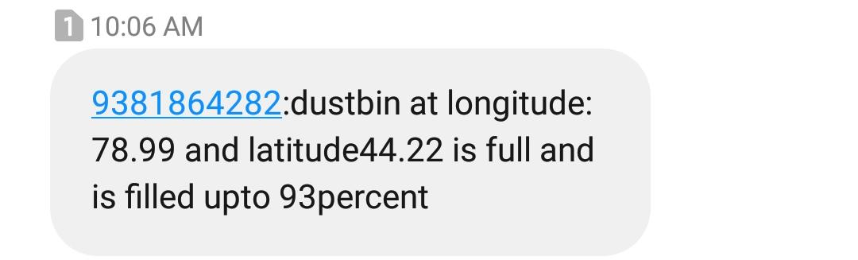

**7)Advantages and Disadvantages:**

Advantages:

1) more hygenic

2)waste will not spread

3)low cost

4)flues cannot be attracted

5)clean environment

Disadvantages:

* **System** requires more number of **waste** bins for separate **waste collection** as per population in the **city**.
* **what ever may be the waste notification will not sent untill reaches threshold value**

**8)Applications:**

a) integrated water management in industries.

b) Weather-based irrigation controls: This type of control system saves water usage and cost especially during the hot summer months.

c)Reduced water and sewer costs: Low flow water conservation devices reduce water usage and costs as well as sewer costs.

**9) Conclusion:**

It was a wonderful and learning experience while working on this project. We here by conclude that smart waste management system will reduce waste spreading on roads and helps people to be hygienic.

**10) Future Scope:**

As internet of things and it applications helps more in future our smart waste management system will be developed in a range that it could be able to recognise the type.of waste and waste that can be recyclable and reusable.

**11)Bibliography:**

**https://cloud.ibm.com/**

**https://cloud.ibm.com/services/iotf-service/crn%3Av1%3Abluemix%3Apublic%3Aiotf-service%3Aeu-gb%3Aa%2F4335f5bd7bcb40a58f65a184972de8d2%3A08277b61-416d-4d7b-b80a-71794af96a59%3A%3A?paneId=manage**

**https://dr398o.internetofthings.ibmcloud.com/dashboard/**

**https://cloud.ibm.com/apps/b215d607-219f-4acb-98b7-cfa1329b6dd7?ace_config=%7B%22region%22%3A%22eu-gb%22%2C%22crn%22%3A%22crn%3Av1%3Abluemix%3Apublic%3Acf%3Aeu-gb%3As%2Ff995ce89-6c79-4bd6-ae9a-3bf82d9a5083%3A%3Acf-application%3Ab215d607-219f-4acb-98b7-cfa1329b6dd7%22%2C%22resource_id%22%3A%22b215d607-219f-4acb-98b7-cfa1329b6dd7%22%2C%22orgGuid%22%3A%2258bebbf1-0699-44d9-91d8-ea728a5bf95e%22%2C%22spaceGuid%22%3A%22f995ce89-6c79-4bd6-ae9a-3bf82d9a5083%22%2C%22redirect%22%3A%22https%3A%2F%2Fcloud.ibm.com%2Fresources%22%2C%22bluemixUIVersion%22%3A%22v6%22%7D&env_id=ibm%3Ayp%3Aeu-gb&paneId=overview**