Drag and Drop Card Actions on the Web: Accessibility First, Functionality Second
Akhilesh Malani. Working notes. Web only. Last revised 4 September 2026.
Drag and drop is the most consistently broken pattern in modern SaaS. Trello, Jira, Notion, Linear, Monday, ClickUp, Asana. I have filed accessibility bugs on every one. The pattern is not intrinsically hostile to blind users; the problem is that most teams reach for the native HTML5 drag events, discover they work fine for their sighted mouse user, ship, and never come back. HTML5 drag events have no keyboard support and no screen reader announcements. If that is the only thing you wire up, blind users literally cannot use the feature. Not slowly, not painfully; not at all.
This document is my reference notes on card drag and drop on the web. What the pattern is, where you see it, the sub-types, and the three things that always have to be there for the feature to be usable by everyone: a keyboard interaction, a screen-reader announcement, and a no-drag alternative (a Move menu). WCAG 2.5.7 makes the last one legally required at Level AA.

What we are calling a drag-and-drop card
A card is a self-contained UI element with a title and some content that the user can pick up and move somewhere else. Kanban cards on Trello. Task rows on Todoist. Sticky notes on Miro. Blocks on Notion. Records on Airtable. Album tiles on Google Photos. The card is the thing being moved; the drop target is another position in a list, another column on a board, another folder, or another category.

Where you find drag-and-drop cards
Global examples in production: Trello (the archetype kanban), Jira, Asana, Linear, ClickUp, Monday.com, Notion (blocks, database rows, subitems), Miro and FigJam (sticky notes), Figma (layers panel), Airtable and Coda (record reorder), Todoist and TickTick (task reorder), Google Keep (note reorder), Google Photos (album organisation), Gmail (label drag), and the WordPress block editor. India examples: Zoho Projects kanban, Freshdesk ticket board, Freshworks CRM pipeline, Chargebee subscription workflow, and the pipeline view in Zoho CRM.

Sub-types of drag-and-drop card actions
- Within-list reorder. One-dimensional. The user changes a card's position in a single list. Todoist, Google Keep, Notion database row reorder. The move never crosses a container boundary.
- Between-column move (kanban). Two-dimensional. The user moves a card from one column to another and can also change its position within the destination. Trello, Jira, Asana, Linear. The combination of a column change and a position change is the hardest sub-type to announce well; most implementations get one of the two right and not both.
- Drop onto target. The user drags the card onto a distinct drop zone that is not a list. File upload areas (drag files here), drag to trash, drag to a folder tile. The card usually vanishes on drop; the target reacts.
- Multi-select drag. The user selects several cards and drags them as a group. Common on Trello with the multi-card select toolbar and on Gmail when moving several messages to a label. Rare and mostly missing on keyboard. This is where accessible implementations often quietly give up.
- Nested drag. Cards contain cards. Notion blocks inside toggle blocks; Todoist tasks with subtasks; Airtable linked-record cards. The move may change parent as well as position. Announcements need to include the new parent.
- Cross-window drag. The user drags a card between two browser windows or two panes of the same app (Chrome tabs, VS Code splits, some kanban tools that let you open a card in a detail pane and drag between the pane and the board). Almost always mouse-only; the accessibility story here is essentially a Move menu that includes 'move to other window'.
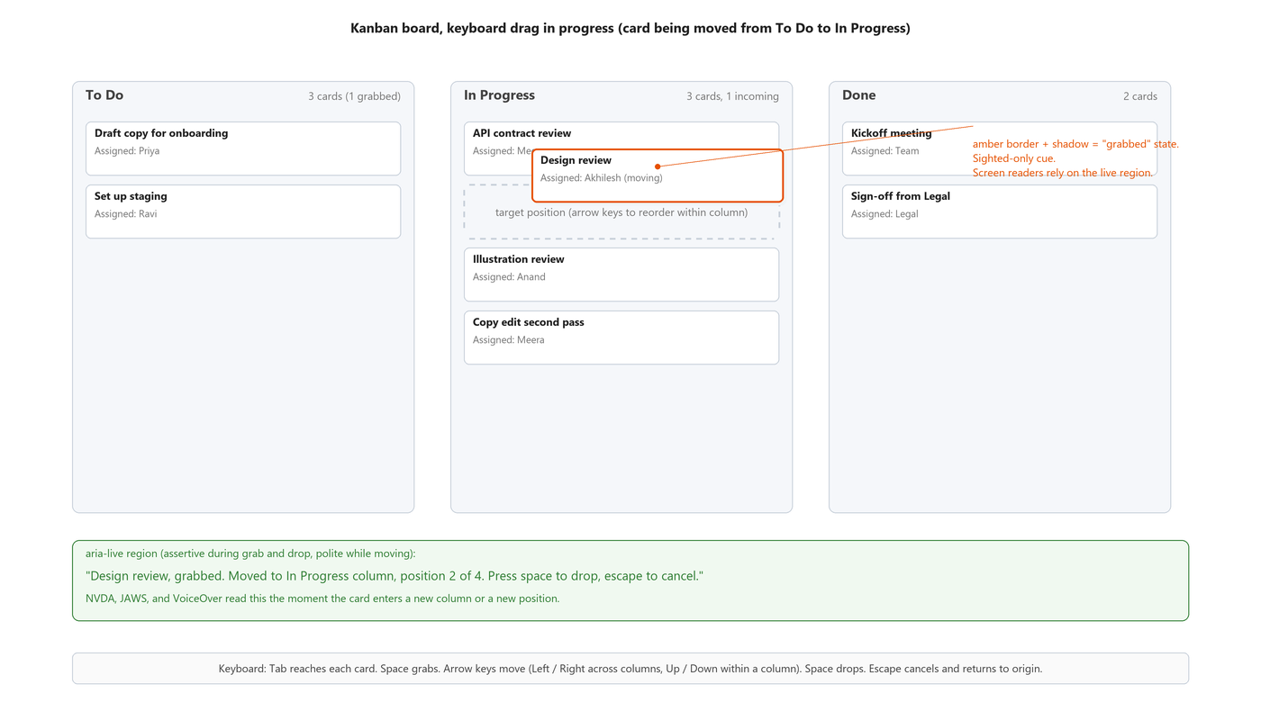
Figure: Between-column kanban drag mid-interaction. The 'Design review' card has been grabbed from the To Do column and is being moved to position 2 in the In Progress column. The green speech box shows the live-region announcement a screen reader is hearing at this moment.
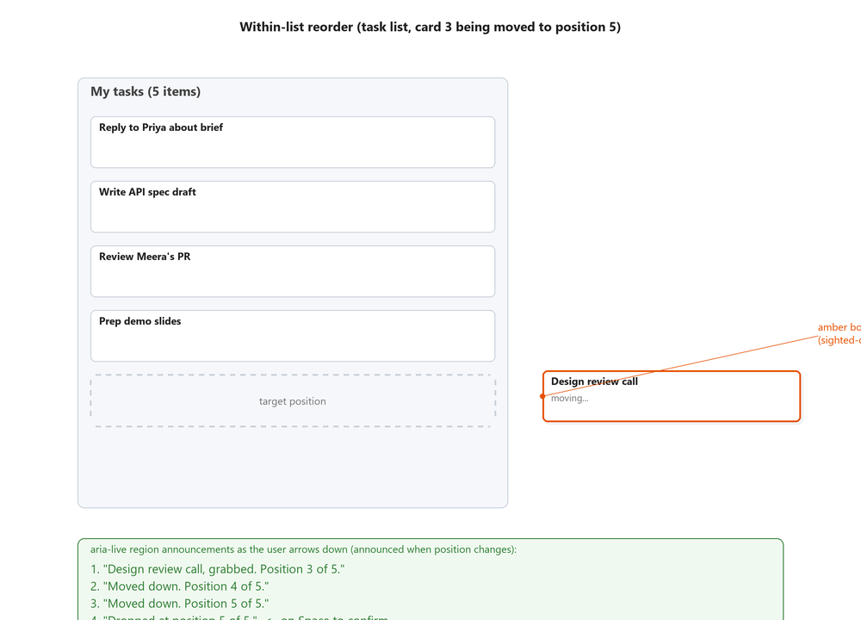
Figure: Within-list reorder. A single task list where 'Design review call' is being moved from its original position 3 down to position 5. The green box lists each polite live-region announcement the screen reader hears as the user presses the down arrow repeatedly.

Accessibility on the web: the three things that must all exist
For a card drag-and-drop feature to be usable by everyone, three separate things have to be built. Miss any one and you have an accessibility bug that a real blind user will hit within their first minute with the product.

1. A keyboard interaction pattern
The card is focusable (tabindex="0"). The user tabs to it. Pressing Space (or Enter, depending on the library) enters drag mode: the card is now 'picked up' logically, whether or not the visual moves. Arrow keys move the card around. Space or Enter drops. Escape cancels and returns the card to its origin.
The exact key bindings vary between libraries and design systems. What does not vary is that all four states must be reachable from the keyboard: pick up, move, drop, cancel. If Escape does nothing during a keyboard drag, the pattern is broken. A user who picks up the wrong card has to complete the move and then manually move it back, which is annoying at best and destructive at worst.
Code: Minimal keyboard handler for a kanban card (JavaScript)
// Every card is focusable and has an accessible name.
card.setAttribute('tabindex', '0');
card.setAttribute('role', 'button');
card.setAttribute('aria-roledescription', 'draggable');
card.setAttribute('aria-describedby', 'kanban-instructions');

let grabbedCard = null;

card.addEventListener('keydown', (e) => {
if (!grabbedCard && (e.key === ' ' || e.key === 'Enter')) {
grabbedCard = card;
e.preventDefault();
announce(`${card.dataset.title} grabbed. Position ${pos} of ${total} in ${column}. ` +
`Arrow keys to move. Space to drop. Escape to cancel.`, 'assertive');
return;
}
if (grabbedCard !== card) return;
switch (e.key) {
case ' ':
case 'Enter': drop(card); e.preventDefault(); break;
case 'Escape': cancelDrag(card); e.preventDefault(); break;
case 'ArrowLeft': moveColumn(-1); e.preventDefault(); break;
case 'ArrowRight': moveColumn(+1); e.preventDefault(); break;
case 'ArrowUp': moveWithin(-1); e.preventDefault(); break;
case 'ArrowDown': moveWithin(+1); e.preventDefault(); break;
}
});

One important note about libraries. If you are on React, use dnd-kit. It ships keyboard support and a11y-first primitives out of the box. react-beautiful-dnd is deprecated. Sortable.js can be made accessible but you have to wire everything yourself. Do not build drag-and-drop from scratch on top of the HTML5 drag events unless the whole team understands why that path is hostile to assistive tech.

2. Screen reader announcements via a live region
The ARIA aria-grabbed attribute is deprecated (removed in ARIA 1.2). Do not use it. The correct pattern is a visually hidden live region that receives short, specific announcements at the meaningful moments of the interaction: grab, cross-column entry, drop, cancel.
Do not announce on every single arrow-key press. Announcing every single-step move generates announcement spam that drowns out anything useful. Announce when the card enters a new column, when it crosses into a new position group, on drop, and on cancel. Movement within the same column can be batched or announced only when the user pauses.
Code: Live-region setup and announce helper (HTML + JavaScript)
<!-- Once, near the root of the page. -->
<div id="dnd-live" role="status" aria-live="polite" aria-atomic="true"
class="sr-only"></div>

<script>
const live = document.getElementById('dnd-live');
function announce(text, mode = 'polite') {
// Toggle role/aria-live so a repeat of the same string still fires.
live.setAttribute('aria-live', mode);
live.textContent = '';
requestAnimationFrame(() => { live.textContent = text; });
}

// Sample announcements at each stage:
announce('Design review grabbed. In To Do, position 1 of 3.', 'assertive');
announce('Moved to In Progress, position 2 of 4.', 'polite');
announce('Dropped in In Progress at position 2 of 4.', 'assertive');
announce('Move cancelled. Design review returned to To Do, position 1.',
'assertive');
</script>

3. A no-drag alternative: the Move menu
This is not optional. WCAG 2.5.7 Dragging Movements, Level AA in WCAG 2.2, says that any functionality that uses a dragging movement must also be operable with a single pointer without dragging. In practice, every card exposes a menu (usually under a three-dot icon or a 'Move' button) that offers the same move as a set of picker choices: which column, which position.
This helps not just blind users but every user with a tremor, arthritis, motor impairment, RSI, or an unusual input device. Trello, Asana, Linear, Notion, and Jira all ship this. If your product is missing it, you have a WCAG AA gap, and the drag interaction cannot be your only path.
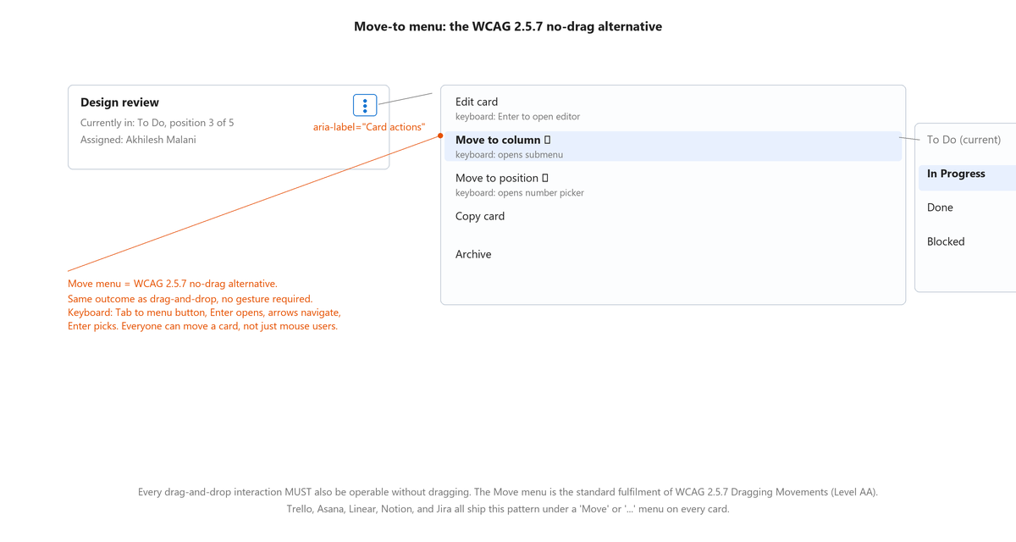
Figure: The Move menu pattern that satisfies WCAG 2.5.7. A kebab menu on the card exposes 'Move to column' and 'Move to position' submenus, so the same move can be completed by keyboard alone with no dragging gesture.
Code: Move menu invocation on a card (HTML)
<article class="kanban-card" tabindex="0"
aria-roledescription="draggable"
aria-labelledby="card-42-title">
<h3 id="card-42-title">Design review</h3>
<p class="meta">In To Do, position 3 of 5. Assigned Akhilesh.</p>

<button type="button"
aria-label="Actions for Design review"
aria-haspopup="menu"
aria-expanded="false"
class="kebab-menu-trigger">
<span aria-hidden="true">&#x22EE;</span> <!-- three vertical dots -->
</button>

<!-- Menu is rendered on open with role="menu" and role="menuitem"
children. The Move-to-column and Move-to-position items open
submenus that let the user pick a destination with keyboard alone. -->
</article>

What breaks
- Only mouse drag is wired. HTML5 dragstart / dragover / drop events are the only handlers. Keyboard users cannot move cards at all. Screen reader users cannot even discover the feature exists.
- Keyboard drag works but no announcements. The card moves silently; the SR user hears nothing between grab and drop and has to guess where the card ended up.
- Announcements fire on every single ArrowUp / ArrowDown. NVDA becomes unusable within three cards of movement because the previous announcement gets cut off by the next one.
- The Escape key does nothing during a keyboard drag. Users who grab the wrong card have to complete the move and manually reverse it.
- Focus is lost after drop. The dropped card should keep focus at its new location. Instead, focus jumps to the document root or disappears entirely.
- The card is not focusable. tabindex is missing or set to -1. Keyboard users cannot even tab to a card, so of course they cannot drag one.
- aria-grabbed is set on the card. This attribute was deprecated and removed in ARIA 1.2. Modern screen readers ignore it. Delete it and use a live region.
- Auto-scroll works on mouse drag but not on keyboard move. Users moving a card to the bottom of a long list watch the viewport stay put while the card scrolls off the bottom.
- No Move menu exists. The only way to move a card is to physically drag it. Fails WCAG 2.5.7 Dragging Movements at Level AA.
- The Move menu exists but is behind a mouse-only hover trigger. Not reachable from keyboard. Fails WCAG 2.1.1 Keyboard, Level A.
- Multi-select drag only works with mouse click plus Shift. There is no keyboard multi-select, so keyboard users can only move one card at a time.
- Drop targets are not announced when the card is dragged over them. In a between-column kanban, the user has no way to hear 'now hovering over In Progress' before dropping.

Testing checklist from actual screen reader use
Every one of these has bitten me on a real product. Run them all before shipping.
- Tab to a card. The card should announce as a button (or as a draggable item, if using aria-roledescription) with an accessible name and a hint about how to grab it.
- Press Space. Assertive announcement should fire naming the card, its source column, its position, and telling the user how to move, drop, and cancel.
- Arrow left, right, up, down. Announcements should fire when the card enters a new column or a new position group; not on every single key press.
- Press Escape. The card should return to its origin and an announcement should say 'move cancelled'.
- Grab a card, move it, drop it with Space. Announcement should confirm the drop with the final column and position. Focus should stay on the card at its new location.
- Open the card's action menu with the keyboard (Tab to it, Enter). Use Move-to-column and Move-to-position to move the card without ever dragging. The result should be identical to the drag path.
- On mouse: click and hold; move to the bottom of a long list. Auto-scroll should engage. Repeat with keyboard: arrow down past the visible viewport; auto-scroll should also engage.
- Try multi-select. If the product supports selecting multiple cards, verify the selection is possible from the keyboard, and the Move menu operates on the selection as a group.
- Cancel-safety. Grab a card, move it, then close the browser tab or reload the page mid-drag. The card should return to its origin, not stay in the dropped position, unless the interaction is committed.

What each screen reader should announce
When the pattern is implemented right, NVDA, JAWS, and VoiceOver converge on very similar announcements. If your test does not match this, the ARIA or the live-region timing is wrong.
Stage | Expected announcement (assertive on grab / drop / cancel; polite on movement)
On grab (Space pressed) | "Design review grabbed. In To Do, position 1 of 3. Arrow keys to move. Space to drop. Escape to cancel."
On column change (Right arrow) | "Moved to In Progress column, position 2 of 4."
On drop (Space pressed) | "Dropped in In Progress at position 2 of 4."
On cancel (Escape pressed) | "Move cancelled. Design review returned to To Do, position 1."

References with URLs

W3C standards
- WCAG 2.2 success criterion 2.1.1 Keyboard, Level A (https://www.w3.org/WAI/WCAG22/Understanding/keyboard)
- WCAG 2.2 success criterion 2.5.1 Pointer Gestures, Level A (https://www.w3.org/WAI/WCAG22/Understanding/pointer-gestures)
- WCAG 2.2 success criterion 2.5.7 Dragging Movements, Level AA (https://www.w3.org/WAI/WCAG22/Understanding/dragging-movements)
- WCAG 2.2 success criterion 2.5.8 Target Size (Minimum), Level AA (https://www.w3.org/WAI/WCAG22/Understanding/target-size-minimum)
- WCAG 2.2 success criterion 4.1.3 Status Messages, Level AA (https://www.w3.org/WAI/WCAG22/Understanding/status-messages)
- ARIA 1.2 specification, deprecated aria-grabbed and aria-dropeffect (https://www.w3.org/TR/wai-aria-1.2/#state_prop_deprecated)

Web reference (MDN)
- MDN: HTML Drag and Drop API (note the accessibility caveats) (https://developer.mozilla.org/en-US/docs/Web/API/HTML_Drag_and_Drop_API)
- MDN: ARIA Live Regions (https://developer.mozilla.org/en-US/docs/Web/Accessibility/ARIA/ARIA_Live_Regions)
- MDN: aria-roledescription (https://developer.mozilla.org/en-US/docs/Web/Accessibility/ARIA/Attributes/aria-roledescription)

Libraries and design systems
- dnd-kit: Accessibility (the modern React DnD library, a11y first) (https://docs.dndkit.com/guides/accessibility)
- Atlassian Design System: Drag and Drop (patterns used across Jira, Trello, Confluence) (https://atlassian.design/components/pragmatic-drag-and-drop/about)
- US Web Design System: guidance on Reorder actions (https://designsystem.digital.gov/components/)
- SortableJS: A JavaScript library for reorderable drag-and-drop lists (https://sortablejs.github.io/Sortable/)

Practical guides
- Sarah Higley: Grouping content (patterns applicable to drag-drop announcements) (https://sarahmhigley.com/writing/grouping-controls/)
- Salesforce Lightning Design System: keyboard patterns for reorderable lists (https://www.lightningdesignsystem.com/)
- GitHub: react-beautiful-dnd (deprecated but its docs on the SR pattern are still valuable) (https://github.com/atlassian/react-beautiful-dnd/blob/master/docs/guides/accessibility.md)
- WebAIM: Screen Reader User Survey (latest results) (https://webaim.org/projects/screenreadersurvey/)
- Adrian Roselli: A11y and Drag-and-Drop reorderable lists (https://adrianroselli.com/2022/03/tables-with-two-headers.html)

