Grid Components on the Web: Accessibility First, Functionality Second
Akhilesh Malani. Working notes. Web only. Last revised 8 September 2026.
'Grid' is one of the most overloaded words in the front-end vocabulary. In a single conversation with a designer and a front-end engineer, it can mean CSS Grid layout, an ARIA role='grid' widget, a photo grid on Google Photos, a product tile grid on Amazon, a spreadsheet cell in Google Sheets, or a calendar month view. These are not one component; they are five or six distinct components that happen to share a visual metaphor. Some of them need list semantics; some need role='grid' with roving tabindex; some need role='treegrid' with expand/collapse; one is not a component at all.
This document is my reference notes on the grid patterns that actually exist on the web, what each of them needs to be accessible, and how to tell them apart before you start building. Mobile platform notes (iOS and Android) live in a separate companion file.

Disambiguating the word 'grid'
- CSS Grid (display: grid). A CSS layout algorithm. Not a component, not an accessibility concern in itself. You can apply display: grid to a list, a section, or a form. What matters for accessibility is the semantic markup INSIDE the CSS grid, not the CSS. This document does not cover CSS Grid layout as such.
- Card / tile grid. A grid of self-contained cards visible to sighted users as a two-dimensional layout. Product listings, photo galleries, dashboard tiles, app launchers. Semantically a LIST, laid out with CSS Grid. Not role='grid'. Not a table.
- Data grid (role='grid'). An interactive widget with a defined keyboard focus model: one tab stop for the whole grid, arrow keys move focus between cells, Enter or F2 enters edit mode. Google Sheets, Airtable, Excel Online, ag-Grid. The whole point of the pattern is cell-level interaction.
- Treegrid (role='treegrid'). A data grid whose rows form a hierarchy. Rows can be expanded and collapsed. VS Code file explorer with columns, project management tools with sub-tasks, org-chart style views. Adds aria-level, aria-expanded, aria-posinset, aria-setsize to the base grid pattern.
- Calendar grid (date picker). A specific instance of role='grid' shaped like a month calendar. Cells are dates. Its keyboard model is arrow-keys-move-by-day, PageUp / PageDown move-by-month, and so on. Date pickers on booking sites, banking, HR portals.

Where you find each grid pattern
Card / tile grids. Global: Amazon product search results, eBay listings, Etsy shop grids, Nike and Apple store product grids, Airbnb search results, Booking.com hotel tiles, Google Photos, iCloud Photos, Instagram, Pinterest, Netflix show grid, YouTube channel video grid, Google Play app tiles, App Store app tiles, Dribbble, Behance. India: Flipkart, Meesho, Nykaa, Ajio, JioMart, Myntra product grids. Dashboard tile grids: Notion dashboard blocks, Airtable card view, Trello board tile view.
Data grids. Global: Google Sheets, Excel on the web, Airtable, Notion database table view, ag-Grid demos, TanStack Table, MUI DataGrid, Handsontable. India: Zoho Sheet, Zoho Creator table views, TallyPrime web reports.
Treegrids. Global: VS Code file explorer, GitHub file tree with columns, Salesforce Setup menu tree, Jira epic-story-subtask hierarchy grids, Google Drive detail view with folders expanded inline, AWS Console resource explorers. India: Zoho Projects task hierarchies, Freshworks CRM account tree views.
Calendar grids. Global: Google Calendar month view, Outlook Web month view, Airbnb reservation date picker, Booking.com check-in / check-out date pickers, Expedia flight date picker, Delta and Lufthansa flight search date pickers. India: MakeMyTrip, ClearTrip, IRCTC train search date pickers, HDFC net banking transaction-date filters, Income Tax e-filing return-year picker.

Accessibility on the web: card / tile grid
The single most common mistake here is treating a card grid as a role='grid'. It is not. When the user is BROWSING items (as opposed to editing or selecting at a cell level), the correct semantic is a list. Screen readers announce list position naturally (item 3 of 24), users can jump between list items with the L key in NVDA, and there is no need for the roving-tabindex plumbing that role='grid' requires.
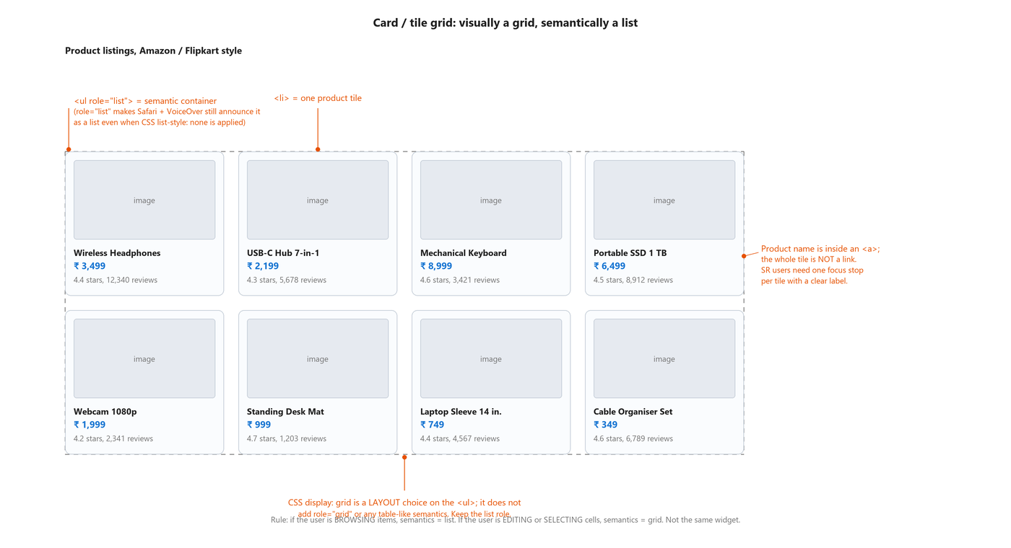
Figure: Product tile grid drawn as an eight-item catalogue. Callouts label the semantic ul role='list' container, each <li> tile, the product-name <a> as the single focus stop per tile, and a bottom note clarifying that CSS display: grid is a layout choice on the ul and does not add role='grid'.
Code: Card / tile grid: list semantics inside a CSS Grid layout (HTML + CSS)
<ul role="list" class="product-grid">
<li>
<article>
<img src="headphones.jpg" alt=""> <!-- alt="" if the name below repeats it -->
<h3><a href="/products/wireless-headphones">Wireless Headphones</a></h3>
<p class="price">&#8377; 3,499</p>
<p class="rating">4.4 stars, 12,340 reviews</p>
</article>
</li>
<li>
<article>
<img src="usb-hub.jpg" alt="">
<h3><a href="/products/usb-c-hub">USB-C Hub 7-in-1</a></h3>
<p class="price">&#8377; 2,199</p>
<p class="rating">4.3 stars, 5,678 reviews</p>
</article>
</li>
<!-- more tiles -->
</ul>

<style>
.product-grid {
display: grid;
grid-template-columns: repeat(auto-fill, minmax(220px, 1fr));
gap: 20px;
list-style: none; /* removes bullets visually */
padding: 0;
}
</style>

Card-grid checklist:
- Use <ul> for the container. Do not use role='grid'.
- Add role='list' to the <ul> too. This looks redundant but Safari + VoiceOver strip the implicit list role when CSS list-style: none is applied. The explicit role='list' restores it.
- Each tile is an <li>. Do not use role='listitem' on a div; use the real element.
- Inside each tile, the product name is the single interactive element (an <a> or a <button>). The whole tile is NOT a link. A screen-reader user needs one focus stop per tile with a clear accessible name.
- The tile image alt='' if the product name is already the link text. Otherwise the image would repeat the name to screen readers.
- For infinite-scroll grids, use aria-live to announce when new tiles have been appended (e.g. 'Loaded 24 more products, 72 total').

Accessibility on the web: data grid (role='grid')
Use role='grid' only when cell-level interaction is the whole point of the widget: editing cells in place, selecting individual cells, or navigating a spreadsheet's addressing grid. A read-only tabular display is a table, not a grid. Google Sheets is a grid. A pricing comparison you built for your marketing page is a table.
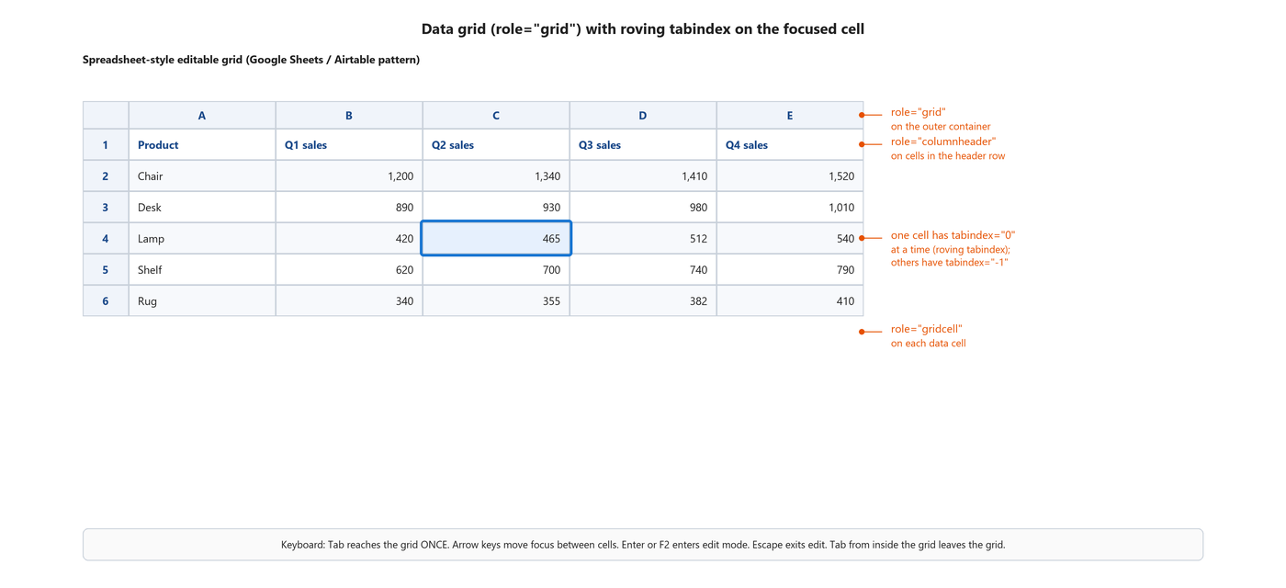
Figure: Spreadsheet-style data grid with a focus ring on one cell (Lamp, column C). Callouts label role='grid' on the container, role='columnheader' on header cells, role='gridcell' on data cells, and the roving-tabindex model where one cell at a time has tabindex='0'. Keyboard hint bar at the bottom explains the arrow-key navigation and Enter / F2 edit semantics.
Code: Minimal role='grid' with roving tabindex (HTML + JavaScript)
<div role="grid" aria-labelledby="grid-title" tabindex="-1">
<span id="grid-title" class="sr-only">Product sales by quarter</span>
<div role="row">
<span role="columnheader">Product</span>
<span role="columnheader">Q1 sales</span>
<span role="columnheader">Q2 sales</span>
<span role="columnheader">Q3 sales</span>
<span role="columnheader">Q4 sales</span>
</div>
<div role="row">
<span role="rowheader">Chair</span>
<span role="gridcell" tabindex="-1">1,200</span>
<span role="gridcell" tabindex="-1">1,340</span>
<span role="gridcell" tabindex="-1">1,410</span>
<span role="gridcell" tabindex="0">1,520</span> <!-- currently focused -->
</div>
<!-- more rows -->
</div>

<script>
// On arrow-key navigation, move tabindex from the old cell to the new one:
function moveFocus(from, to) {
from.setAttribute('tabindex', '-1');
to.setAttribute('tabindex', '0');
to.focus();
}
</script>

Data-grid checklist:
- role='grid' on the container. role='row' on each row. role='columnheader' and role='rowheader' on header cells. role='gridcell' on data cells.
- The grid must be a single tab stop. Only one cell inside has tabindex='0' at any time; every other cell has tabindex='-1'. This is called roving tabindex.
- Arrow keys move focus between cells. Left / Right within a row, Up / Down between rows.
- Enter or F2 enters cell-edit mode. Escape exits edit mode without saving. Tab from inside the grid EXITS the grid, not moves to the next cell.
- Home moves focus to the first cell in the row. End to the last. Ctrl + Home to the first cell in the grid. Ctrl + End to the last.
- Aria-selected on cells (or rows) if the grid supports selection. Aria-readonly='true' on the grid or per cell if editing is disabled.
- Only reach for role='grid' when the widget really is cell-interactive. A read-only pricing table is a <table>, not a grid.

Accessibility on the web: calendar grid (date picker)
A calendar month view is role='grid' with a very specific keyboard model. Each date cell is a role='gridcell' inside a role='row' representing a week. The keyboard model differs from a generic grid because users navigate by day, week, month, and year rather than just cell to cell.
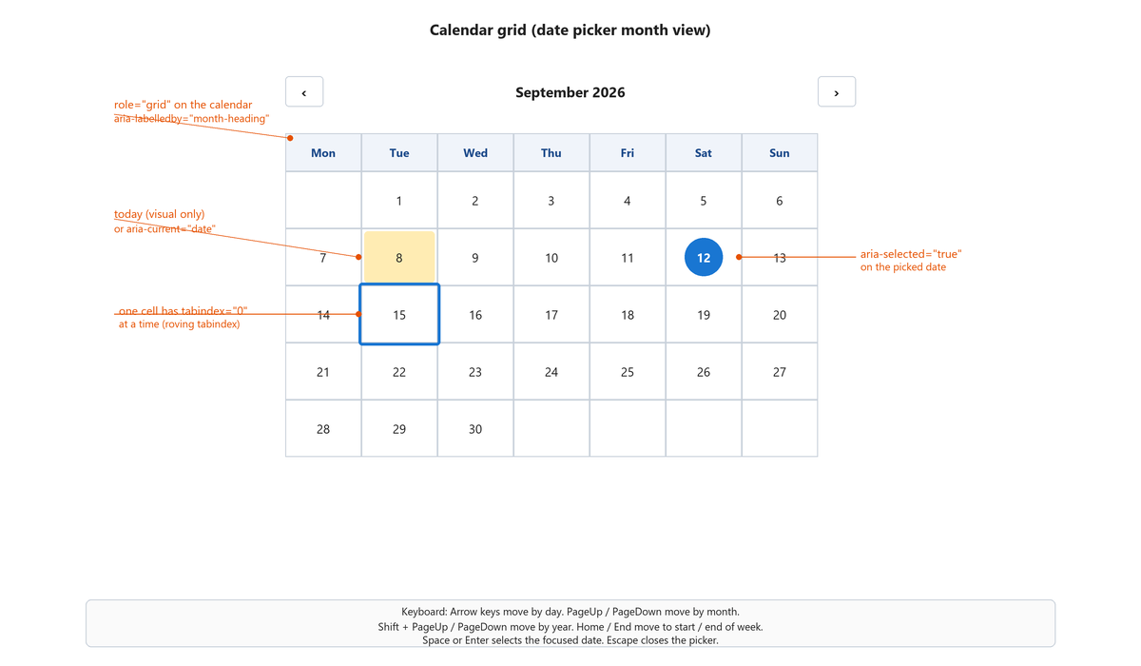
Figure: Calendar grid showing September 2026. Today (September 8) has an amber background; the selected date (September 12) has a blue filled circle; the focused date (September 15) has a blue focus ring. Callouts label role='grid' with aria-labelledby on the month heading, the today marker (aria-current='date' or visual only), aria-selected='true' on the picked date, and the roving-tabindex model on the focused cell. Keyboard hint area explains arrow / PageUp / PageDown / Shift+PageUp / Home / End / Space / Enter / Escape semantics.
Code: Calendar grid with correct roles and keyboard model (HTML)
<div role="grid" aria-labelledby="month-heading">
<div class="calendar-header">
<button type="button" aria-label="Previous month">&lsaquo;</button>
<h2 id="month-heading" aria-live="polite">September 2026</h2>
<button type="button" aria-label="Next month">&rsaquo;</button>
</div>

<div role="row">
<span role="columnheader" abbr="Monday">Mon</span>
<span role="columnheader" abbr="Tuesday">Tue</span>
<span role="columnheader" abbr="Wednesday">Wed</span>
<span role="columnheader" abbr="Thursday">Thu</span>
<span role="columnheader" abbr="Friday">Fri</span>
<span role="columnheader" abbr="Saturday">Sat</span>
<span role="columnheader" abbr="Sunday">Sun</span>
</div>

<!-- Each week is a row. Each date is a gridcell. -->
<div role="row">
<span role="gridcell"></span> <!-- empty Monday before Sept 1 -->
<span role="gridcell" tabindex="-1" aria-current="date">1</span>
<!-- ... -->
<span role="gridcell" tabindex="0" aria-selected="false">15</span>
<!-- 15 is the focused date; only cell with tabindex='0' -->
</div>
</div>

Calendar-grid keyboard shortcuts (ARIA APG date picker spec):
- Arrow keys move by day (Left = previous day, Right = next day, Up = previous week, Down = next week).
- PageUp / PageDown move by month.
- Shift + PageUp / Shift + PageDown move by year.
- Home moves to the first day of the current week. End moves to the last day of the current week.
- Space or Enter selects the focused date.
- Escape closes the picker without selecting.
- aria-current='date' marks the today cell (SR announces 'current date').
- aria-selected='true' marks the picked date once the user commits.
- The month/year label is a live region so it announces on month change.

Accessibility on the web: treegrid (role='treegrid')
A treegrid is a data grid whose rows have a hierarchical parent-child structure that can be expanded and collapsed. VS Code's file explorer with detail columns is the archetype. Jira epic-story-subtask views are another. It combines the roving-tabindex model of role='grid' with the hierarchical aria-level, aria-expanded, aria-posinset, aria-setsize attributes borrowed from role='tree'.
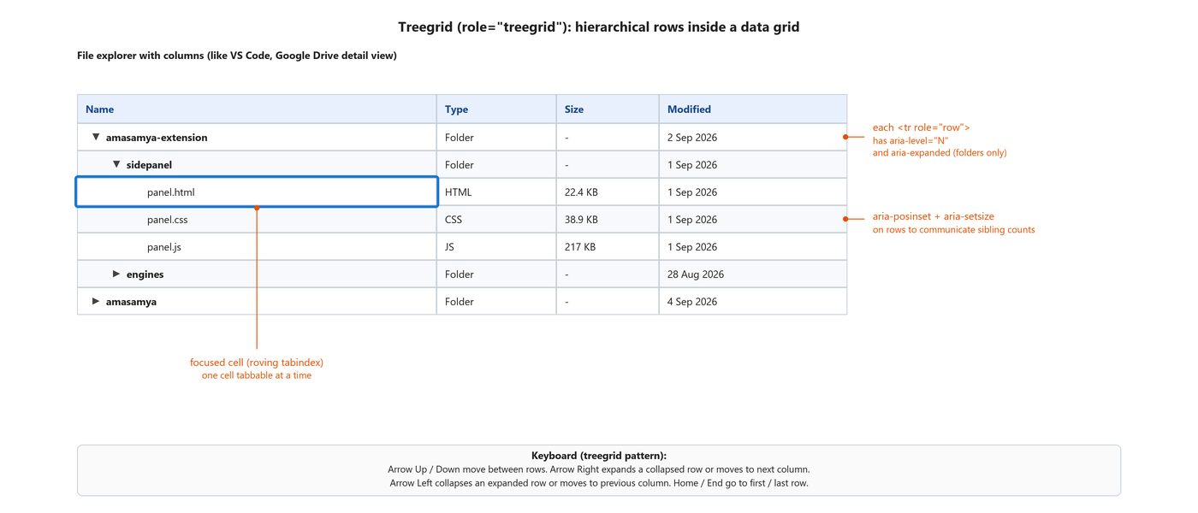
Figure: Treegrid file explorer with Name, Type, Size, Modified columns. Seven rows in a hierarchy: amasamya-extension folder expanded, sidepanel folder expanded showing panel.html, panel.css, panel.js; engines folder collapsed; amasamya folder collapsed. The panel.html row's Name cell has a focus ring. Callouts label each <tr role='row'> with aria-level and aria-expanded (folders only), aria-posinset + aria-setsize for sibling counts, and the focused cell with roving tabindex.
Code: Treegrid row with aria-level, aria-expanded, and posinset (HTML)
<div role="treegrid" aria-labelledby="explorer-heading">
<span id="explorer-heading" class="sr-only">Project files</span>

<div role="row" aria-level="1" aria-expanded="true"
aria-posinset="1" aria-setsize="2">
<span role="gridcell">amasamya-extension</span>
<span role="gridcell">Folder</span>
<span role="gridcell">-</span>
<span role="gridcell">2 Sep 2026</span>
</div>

<div role="row" aria-level="2" aria-expanded="true"
aria-posinset="1" aria-setsize="2">
<span role="gridcell">sidepanel</span>
<span role="gridcell">Folder</span>
<span role="gridcell">-</span>
<span role="gridcell">1 Sep 2026</span>
</div>

<div role="row" aria-level="3" aria-posinset="1" aria-setsize="3">
<span role="gridcell" tabindex="0">panel.html</span> <!-- focused -->
<span role="gridcell" tabindex="-1">HTML</span>
<span role="gridcell" tabindex="-1">22.4 KB</span>
<span role="gridcell" tabindex="-1">1 Sep 2026</span>
</div>
<!-- more rows -->
</div>

Treegrid-specific keyboard rules on top of the base grid model:
- Arrow Right on a collapsed row expands it (sets aria-expanded='true'). Arrow Right on an already-expanded row moves focus to the next column.
- Arrow Left on an expanded row collapses it (sets aria-expanded='false'). Arrow Left on a collapsed row (or non-expandable row) moves focus to the parent row or the previous column.
- aria-level indicates depth, starting at 1.
- aria-expanded is set on rows that have children. Do NOT set it on leaf rows.
- aria-posinset gives the row's position among its siblings; aria-setsize gives the total number of siblings at that level.
- * (asterisk) expands all sibling rows at the same level.

What breaks
- A product tile grid is built with role='grid'. Screen reader users hear 'grid' plus roving-tabindex behaviour they did not want. They lose list navigation shortcuts (L key in NVDA).
- A card grid uses <ul> with CSS list-style: none but no role='list'. Safari + VoiceOver strip the list semantics; SR users hear a bunch of orphan articles.
- A tile IS a link. The whole card wraps in an <a>. Screen readers announce the entire card content as one long link name; users cannot skim.
- A data grid uses tabindex='0' on every cell. Every cell becomes a tab stop; the user Tabs through a hundred cells to leave the grid.
- A data grid uses arrow keys AND Tab to move between cells. The roving-tabindex contract is broken; the grid becomes unpredictable.
- role='grid' has no aria-labelledby or aria-label. The grid announces as an anonymous grid; users have no context about what it holds.
- Calendar picker uses <button> per date with no role='gridcell'. Screen readers navigate day by day using Tab (bad), not arrow keys (correct).
- Calendar picker has no live region on the month heading. Changing months via PageUp / PageDown fires no announcement.
- Treegrid uses aria-expanded on leaf rows. Screen readers announce 'collapsed' on rows that have no children, which is confusing.
- Treegrid does not update aria-expanded when the user expands or collapses via arrow keys. State lies to the SR user.
- role='grid' is used on a read-only pricing table with no cell interaction. The pattern is wrong; it should be a <table>.
- role='treegrid' is used on a hierarchical DATA LIST with no columns. Should be role='tree'.

Testing checklist from actual screen reader use
Every one has bitten me on a real audit. Run them all before shipping.

For a card / tile grid
- Tab into the grid. Each tile should be one focus stop landing on the product name link (or main action).
- Press L in NVDA browse mode. Focus should jump to the list. Press it again to skip past.
- Confirm the list container announces as 'list with N items' when the user enters it.
- On infinite-scroll append, confirm the polite live-region announces the new count.

For a data grid
- Tab reaches the grid ONCE, not once per cell. From outside, Tab lands on the currently-focused cell (the one cell with tabindex='0').
- Arrow keys move focus between cells within the grid. Focus is visible on every move.
- Tab from inside the grid EXITS it. It should not move to the next cell.
- Enter or F2 enters cell-edit mode. Escape exits without saving. Enter (after edit) commits and moves down.
- Home / End / Ctrl+Home / Ctrl+End move focus as documented above.

For a calendar grid
- Tab lands on the focused date once. Arrow keys move by day.
- PageUp / PageDown move by month. The month heading should announce the new month via a polite live region.
- Shift + PageUp / Shift + PageDown move by year.
- Space or Enter selects the focused date. Confirm aria-selected updates and, if the picker closes, focus returns to the input that opened it.
- Escape closes the picker without selecting. Focus returns to the trigger.

For a treegrid
- Arrow Up / Down move between rows.
- Arrow Right on a collapsed row expands it. aria-expanded updates. SR announces 'expanded'.
- Arrow Left on an expanded row collapses it. aria-expanded updates. SR announces 'collapsed'.
- aria-level is announced as 'level N' when the user moves between depths.
- aria-posinset / aria-setsize are announced as 'N of M' at each level.

What each screen reader should announce
When each pattern is implemented right, NVDA, JAWS, and VoiceOver converge on very similar announcements. If your test does not match, something is missing.
Grid pattern and stage | Expected announcement
Card grid on entering the list | "Product listings, list with 8 items."
Data grid on entering the grid | "Product sales by quarter, grid with 6 rows and 5 columns. Row 4, Lamp, Q2 sales, 465."
Data grid on arrow-key move | "Row 4, Lamp, Q3 sales, 512."
Calendar grid on focusing a date | "Tuesday, 15 September 2026, not selected." (or "current date" if aria-current='date')
Treegrid on entering a row | "Level 3, panel.html, 1 of 3." (from aria-level, row content, and aria-posinset / aria-setsize)

References with URLs

W3C standards
- WCAG 2.2 success criterion 1.3.1 Info and Relationships, Level A (https://www.w3.org/WAI/WCAG22/Understanding/info-and-relationships)
- WCAG 2.2 success criterion 2.1.1 Keyboard, Level A (https://www.w3.org/WAI/WCAG22/Understanding/keyboard)
- WCAG 2.2 success criterion 2.4.3 Focus Order, Level A (https://www.w3.org/WAI/WCAG22/Understanding/focus-order)
- WCAG 2.2 success criterion 2.4.7 Focus Visible, Level AA (https://www.w3.org/WAI/WCAG22/Understanding/focus-visible)
- WCAG 2.2 success criterion 4.1.2 Name, Role, Value, Level A (https://www.w3.org/WAI/WCAG22/Understanding/name-role-value)
- ARIA Authoring Practices Guide, Grid pattern (https://www.w3.org/WAI/ARIA/apg/patterns/grid/)
- ARIA Authoring Practices Guide, Treegrid pattern (https://www.w3.org/WAI/ARIA/apg/patterns/treegrid/)
- ARIA Authoring Practices Guide, Date Picker Dialog (https://www.w3.org/WAI/ARIA/apg/patterns/dialog-modal/examples/datepicker-dialog/)
- ARIA 1.2 specification, roles: grid, gridcell, row, rowheader, columnheader, treegrid (https://www.w3.org/TR/wai-aria-1.2/#grid)

Web reference (MDN)
- MDN: grid role (https://developer.mozilla.org/en-US/docs/Web/Accessibility/ARIA/Roles/grid_role)
- MDN: treegrid role (https://developer.mozilla.org/en-US/docs/Web/Accessibility/ARIA/Roles/treegrid_role)
- MDN: gridcell role (https://developer.mozilla.org/en-US/docs/Web/Accessibility/ARIA/Roles/gridcell_role)
- MDN: CSS Grid Layout (https://developer.mozilla.org/en-US/docs/Web/CSS/CSS_grid_layout)
- MDN: aria-current (https://developer.mozilla.org/en-US/docs/Web/Accessibility/ARIA/Attributes/aria-current)

Design systems and libraries
- Material Design 3, Cards (for tile grids) (https://m3.material.io/components/cards/overview)
- US Web Design System, Card component (https://designsystem.digital.gov/components/card/)
- GOV.UK Design System, Date input pattern (https://design-system.service.gov.uk/patterns/dates/)
- ag-Grid (JS data-grid library) accessibility docs (https://www.ag-grid.com/javascript-data-grid/accessibility/)
- TanStack Table (React / Vue / Svelte data-grid library) (https://tanstack.com/table/latest)
- Adobe Spectrum Table View (implements ARIA grid pattern) (https://react-spectrum.adobe.com/react-spectrum/TableView.html)

Practical guides
- Sarah Higley: Not just a grid (https://sarahmhigley.com/writing/not-just-a-grid/)
- Adrian Roselli: Under-engineered responsive tables (grid vs table) (https://adrianroselli.com/2020/11/under-engineered-responsive-tables.html)
- WebAIM: ARIA Grid (versus native tables) (https://webaim.org/techniques/aria/)
- Heydon Pickering, Inclusive Components (list patterns applicable to card grids) (https://inclusive-components.design/)

