Progress Steppers on the Web: The Two Layouts and What They Actually Need to be Accessible
Akhilesh Malani. Working notes. Web only. Last revised 2 September 2026.
I have filed more accessibility bugs on stepper components than on any other pattern except modals. That is not because steppers are unusually hard. They are not, once you understand what you are building. It is because most teams treat them as decoration. A row of numbered circles that show which page the user is on. The visual designer picks the styling, a front-end engineer writes the HTML, and nobody thinks about what a screen reader will announce when the user tabs into it. Then it ships. The first time a blind user tries to file their income tax return online, or apply for a passport, or reset an insurance policy, the whole thing falls apart at step one.
This document is my reference notes on the two layouts (horizontal and vertical), the sub-patterns that show up inside each, and the accessibility work each needs on the web. It is not a design tutorial. If you want colour palettes and Figma tokens, look at Material Design 3 or the Apple Human Interface Guidelines. What follows is what a screen reader hears, what breaks, and how to stop it breaking.
Mobile platform notes (iOS and Android) are deliberately not in this document. They live in a separate companion file so that a web-only team is not weighed down by platform code they will never write.

What we are calling a stepper
In this doc, a stepper is the progress indicator on a multi-step form. The row of circles across the top of a checkout, or the stack of numbered rows down the side of a long application. That is it. Some designers also call the numeric plus and minus input a stepper. That is a different component (the ARIA spinbutton pattern) and is not covered here.

Horizontal steppers
You have seen these on almost every checkout you have used. Cart, address, payment, review, complete. Five little circles across the top of the page, joined by a bar that fills in as you progress. Left-to-right in most locales, right-to-left in Arabic and Hebrew flows.
They work when there is horizontal room to render meaningful labels next to each circle. On desktop widths they are the natural choice for anything up to six or seven steps. Push past that and the labels overlap, at which point the layout usually collapses into unlabelled circles with tooltips, which is where accessibility problems really start.
Global examples in production: Amazon checkout, Shopify-based store checkouts (which power a big share of independent commerce worldwide), Airbnb reservation flow, Booking.com hotel checkout, IKEA delivery setup, Apple Store checkout, Nike checkout, GOV.UK services such as Universal Credit and Register to Vote, US IRS Free File and TurboTax return preparation, USPS change-of-address, Coursera course enrolment, LinkedIn Premium signup, Delta and Lufthansa and Emirates flight booking. India examples: Income Tax e-Filing (the ITR filing flow), Passport Seva, Aadhaar update, PAN application, Flipkart checkout, MakeMyTrip flight booking.
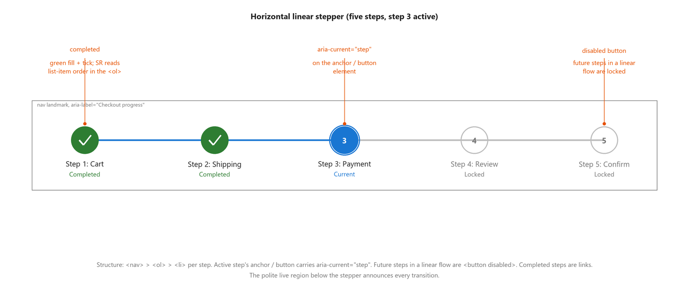
Figure: Horizontal linear stepper with five steps. Step 3 is active; steps 1 and 2 are completed; steps 4 and 5 are locked. Callouts show where aria-current='step' sits, how completed steps render, and how future steps are rendered as disabled buttons.

Sub-types within horizontal
- Linear. Each step must be completed before the next unlocks. The user can never jump forward. Backward navigation to review earlier steps is usually allowed but not always. This is the default for anything with legal or financial consequence: tax filings, insurance, visa applications, most bank onboarding flows.
- Non-linear. The user can activate any step in any order. Common on profile setups, preference forms, and dashboard onboarding where each screen is independent. Notion and Slack workspace setup let you skip around; so does Google Ads campaign creation.
- With optional steps. Some steps are labelled optional and can be skipped. The stepper should say 'optional' as part of the accessible name of the step, not just show it visually. This is where I see teams mess up first. The visual says 'Optional' in small grey text; the screen reader hears 'Step 3 of 5, Address details' with no indication it can be skipped.
- Compact horizontal. Narrow-width layouts where the labels are hidden and only the circles remain. Usually the current step's label appears below the row. Fine visually. Terrible for accessibility if the invisible labels are removed from the DOM instead of visually hidden with the correct CSS.
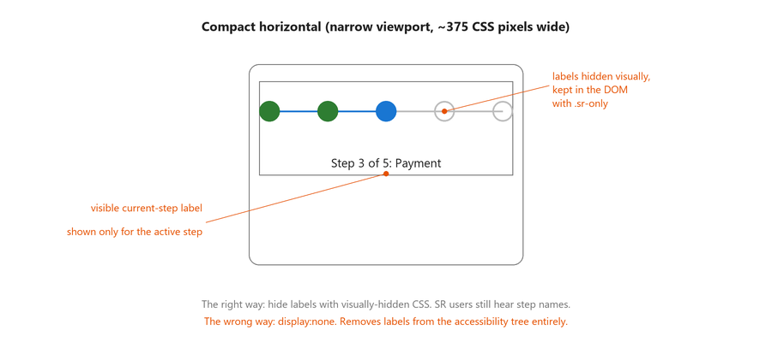
Figure: Compact horizontal stepper rendered inside a mobile-viewport frame. Only circles are drawn; the active step's label appears below the row. Callouts contrast the correct visually-hidden-labels approach with the wrong display:none approach that removes labels from the accessibility tree.
- With supporting text. Each step's circle is followed by a two-line label: the step title on top, a summary of the value entered on the bottom. Amazon checkout does this: 'Shipping address' followed by the actual address the user picked. Screen reader users need that summary to be part of the accessible name, not a separate paragraph they have to hunt for.
- Numbered vs icon-only. Numbered circles are self-labelling. Icon-only circles (a house for 'home', a card for 'payment') always need an aria-label, because a screen reader will not tell you what an SVG looks like. This gets missed almost every time. Icons that look obvious to a sighted designer are silent to a screen reader.

Accessibility on the web
The pattern is not documented in the ARIA Authoring Practices Guide, which is a gap in the guide, not permission to invent your own semantics. Use the primitives that already exist and combine them the right way.
Wrap the whole stepper in a nav landmark with a meaningful accessible name. 'Application progress' or 'Checkout progress', not just 'navigation'. Inside, use an ordered list, one item per step. That ordered-list markup is doing real work: it is what makes NVDA say 'list, 5 items, item 2 of 5' as the user arrows through.
The active step gets aria-current with the value 'step'. Not aria-current true, not aria-selected, and definitely not just a CSS class. aria-current='step' is the whole pattern in one attribute. Without it, no screen reader can tell the user which step they are on.
Code: Horizontal linear stepper, step 2 active (HTML)
<nav aria-label="Checkout progress">
<ol>
<li><a href="#step1">Step 1 of 4: Cart (completed)</a></li>
<li><a href="#step2" aria-current="step">Step 2 of 4: Shipping address</a></li>
<li><button type="button" disabled>Step 3 of 4: Payment (locked)</button></li>
<li><button type="button" disabled>Step 4 of 4: Review (locked)</button></li>
</ol>
</nav>
<div role="status" aria-live="polite" class="sr-only" id="step-live"></div>

Focus management is the other half of the pattern, and the half most teams skip. When the user activates 'Next' and the form moves to step 3, do not leave keyboard focus on the Next button, which is now scrolled off or replaced by different content. Move focus to the step 3 heading (an h2 with tabindex=-1 is the usual pattern) or to the first form field on the new step. Then push a polite live-region announcement so the screen reader user hears the transition happened. Skip either and the user hears silence, then whatever the browser reads next, which is often confusingly the page header again.
Code: On step transition, announce and move focus (JavaScript)
function goToStep(n, title) {
// Polite announcement so the SR user knows the transition happened.
document.getElementById('step-live').textContent =
'Step ' + n + ' of 4, ' + title;

// Focus the new step heading, not the Next button.
const heading = document.querySelector('#step' + n + ' h2');
heading.setAttribute('tabindex', '-1');
heading.focus();
}

For error handling, when validation fails, keep focus on the current step. Move focus to the first invalid field. Push an assertive live-region announcement summarising what went wrong. And mark the failing step on the stepper itself so if the user reviews it later, they know it needed attention.

What breaks (horizontal)
- The active step is styled with CSS only. No aria-current. Every screen reader announces the row identically and the user has no idea which step is live.
- The stepper is a series of divs with click handlers. No role, no keyboard support. Blind users hear 'clickable' and nothing else. Sighted keyboard users cannot reach it at all.
- Labels are removed from the DOM at narrow widths for compact display. Screen reader users on mobile browsers get numbered circles with no labels. Same defect on Bootstrap-based sites that use d-none / d-md-block to hide labels: those classes set display:none, which removes from the accessibility tree.
- The Next button lives inside an aria-live region that also contains the form. When step 3 loads, the live region blasts the entire form content at the user, including every label and every default value. Overwhelming and hard to interrupt.
- Focus is left on Next after transition. Sighted mouse users do not notice; keyboard users get dumped mid-page.
- Optional steps are not marked as optional in their accessible name.
- Step circles are 24 by 24 CSS pixels on narrow viewports with no padding. Fails WCAG 2.5.8 Minimum. I have hit this on government portals from three different countries.

Vertical steppers
Vertical steppers stack the steps top to bottom rather than laying them across. The main use case is narrow-viewport layouts, where you do not have horizontal room to render meaningful labels. But there are two other places they show up that people forget.
First, expandable vertical steppers, where each step is a header that expands to reveal its own form fields inline, and only one step's fields are visible at a time. Material Design's default vertical stepper works this way. It is essentially an accordion with progress semantics on top. Google Forms in edit mode is a familiar example; so are Google Ads campaign creation, Stripe onboarding, and HubSpot's form builder.
Second, timeline steppers. The tracking pattern you see on order-status pages worldwide. Amazon order tracking, FedEx / UPS / DHL package tracking, Uber ride status, Deliveroo and DoorDash delivery status; in India, Flipkart order tracking, Swiggy delivery status, and Indian Railways PNR status pages. Not a form, but the same visual language and most of the same accessibility considerations.
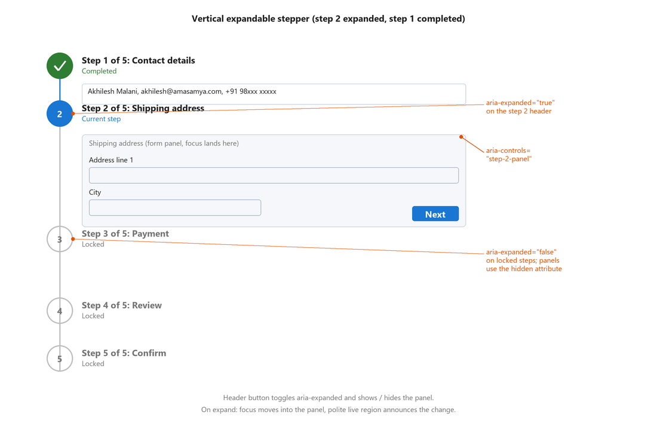
Figure: Vertical expandable stepper. Step 1 is completed with a collapsed summary line. Step 2 is the current step with its form panel expanded inline. Steps 3 to 5 are locked and collapsed. Callouts show aria-expanded on both open and locked headers, and aria-controls linking the header to its panel id.

Sub-types within vertical
- Static vertical. A stacked list of steps with the current one highlighted. The form itself renders elsewhere on the page. Common on admin dashboards where the stepper is a sidebar: Stripe Dashboard's onboarding checklist, GitHub's setup guide for a new organisation.
- Expandable vertical. Each step is a disclosure. Activating a step's header expands its form panel below the header. Only one step is expanded at a time. Material Design default. Widely used on long forms where vertical space is the constraint rather than horizontal space.
- Timeline vertical. Non-interactive. Reports past events chronologically with the current status highlighted. Order tracking, delivery status, application review status, courier tracking. No form to fill, just information.
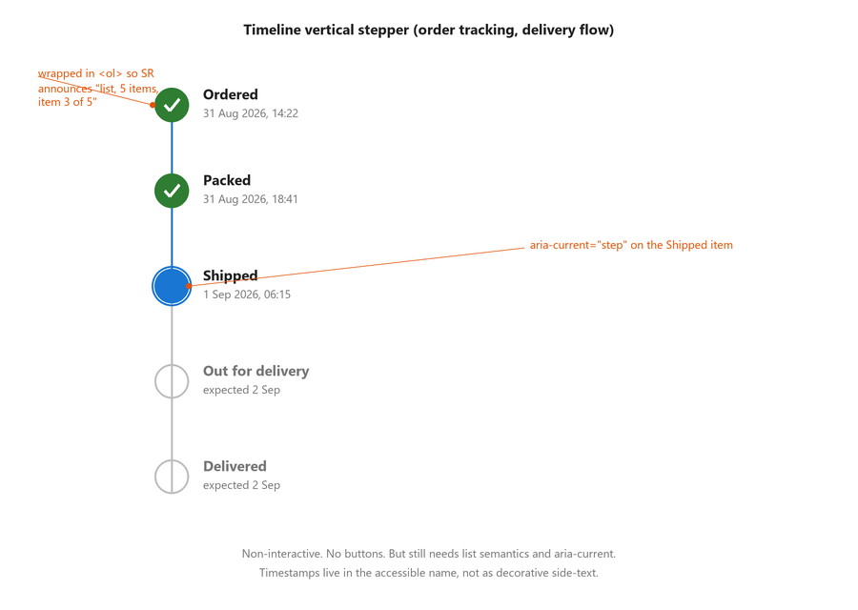
Figure: Timeline vertical stepper for an order-tracking flow. Ordered and Packed are completed, Shipped is the current status, Out for delivery and Delivered are pending. Callouts show aria-current='step' on the Shipped item and the surrounding ordered-list wrapper.
- Editable vertical. Once a step is completed, its expanded panel collapses down to a summary line ('Address: 4B Malaviya Nagar, New Delhi 110017' or '221B Baker Street, London NW1 6XE') with an Edit link. Activating Edit re-expands the panel with the form fields. Amazon checkout does this; so does Airbnb's booking flow. This is where accessibility bugs breed. The summary line often lacks structure, and the Edit link often has just an icon with no accessible name.
- Linear vs non-linear applies to vertical too, same rules as horizontal. Linear locks future step headers; non-linear leaves them all interactive.

Accessibility on the web
For the static and timeline variants, the pattern is essentially the same as horizontal: nav landmark with an ol, aria-current on the active one, meaningful labels. The interesting one is the expandable variant.
The step header is a button with aria-expanded (true or false) and aria-controls pointing to the id of the panel below. The panel below is a group (or a region if it is genuinely landmark-worthy). Hide it with the HTML hidden attribute when collapsed, not display:none via class, because the hidden attribute is the reliable signal that says 'this content does not exist right now' to every screen reader. When the user activates the header, expand the panel, move focus to the first field inside, and push a polite announcement.
Code: Expandable vertical stepper, one step (HTML)
<nav aria-label="Application progress">
<ol>
<li>
<h2>
<button type="button"
aria-expanded="true"
aria-controls="step-2-panel"
aria-current="step">
Step 2 of 5: Shipping address
</button>
</h2>
<div id="step-2-panel" role="group" aria-label="Shipping address fields">
<!-- form fields here -->
</div>
</li>
<li>
<h2>
<button type="button" aria-expanded="false" aria-controls="step-3-panel">
Step 3 of 5: Payment (locked until step 2 is complete)
</button>
</h2>
<div id="step-3-panel" hidden>
<!-- collapsed -->
</div>
</li>
</ol>
</nav>

The editable variant needs one more thing. The summary line that replaces the expanded panel has to be structured so that a screen reader can read it as a set of field-value pairs, not one blob of text. A definition list works. So does a small table with row headers. Do not use raw paragraphs with bold labels: that is a fine visual pattern, but screen readers get no structure from it.
Code: Editable summary line inside a collapsed step (HTML)
<div id="step-2-panel" role="group" aria-label="Shipping address summary">
<dl>
<dt>Name</dt> <dd>Akhilesh Malani</dd>
<dt>Street</dt> <dd>4B, Malaviya Nagar</dd>
<dt>City</dt> <dd>New Delhi</dd>
<dt>PIN</dt> <dd>110017</dd>
<dt>Country</dt> <dd>India</dd>
</dl>
<button type="button" aria-expanded="false" aria-controls="step-2-panel">
Edit shipping address
</button>
</div>

What breaks (vertical)
- Expandable header is a div with a click handler. No button role, no aria-expanded. Keyboard users cannot operate it at all; screen reader users hear no state change.
- Expanded panel is display:none when collapsed, but its contents are still in the accessibility tree because the framework did not strip them. VoiceOver reads through hidden form fields.
- Editable summary line is one long string. Screen reader user hears 'Address 4B Malaviya Nagar New Delhi 110017 India Edit' as one continuous blob with no way to hear it as separate fields.
- The Edit link has no accessible name, just an icon. NVDA reads 'link, edit dot svg' or 'link, graphic'.
- Timeline stepper announces every status as separate list items with no indication which is current. User has to remember the order to figure out where they are.
- Focus is lost when a step collapses. Sighted users see the collapse; screen reader users hear nothing and are dumped at the top of the page.

Which layout to pick
Vertical on narrow viewports, horizontal on wide viewports is the visual default, but there is more to it. Use horizontal when the number of steps is six or fewer, the labels are short, and you have desktop width to render them. That is the default for checkout, onboarding, and short applications.
Use vertical (specifically expandable vertical) when the viewport is narrow, or when the step count exceeds six, or when each step has substantial content that benefits from inline expansion. Long insurance applications, tax filings, multi-part surveys.
Use timeline vertical when you are not asking the user to fill anything, just showing them progress through a fixed sequence of external events. Order tracking, delivery status, application review status.
Nothing stops a single flow from using both. Big government portals often use horizontal on desktop and switch to vertical on narrow widths. That is fine, as long as the accessible name and semantics stay consistent across the switch. Same aria-current, same list role, same live-region announcements. Change the CSS, not the ARIA.

Testing checklist from actual screen reader use
Every one of these has bitten me on a real flow. Run them all before shipping.

For horizontal steppers
- Tab into the stepper. The active step should announce 'current step' or 'current, step' depending on the SR. Not just the step title.
- Arrow through the steps. Each one should announce 'N of M, list item' or the equivalent.
- Activate a step. Focus should land somewhere useful on the next screen, not on the Next button.
- Trigger a validation error on purpose. Focus should move to the first invalid field and you should hear the error text via an assertive live region.
- Shrink the browser to a narrow viewport (around 375 CSS pixels wide). The collapsed stepper should still be fully accessible. Labels present, order intact.

For vertical expandable steppers
- Tab to a collapsed step header. It should announce its collapsed state.
- Activate the header. You should hear 'expanded' (or similar) and focus should move into the newly visible content.
- Fill the step, activate Next. The panel should collapse, the summary line should appear, and the Edit link should be reachable and named.
- Tab to the Edit link. Its accessible name should be 'Edit contact details' or similar. Not 'Edit' alone. Not 'edit-icon'.
- Activate Edit. Focus should return to the first field of the re-expanded panel.

For timeline vertical steppers
- Tab or arrow through the timeline. The current status should announce as current.
- Past statuses should announce as completed; future ones as not yet done.
- Any timestamps or descriptive text (delivery agent name, tracking ID) should be part of the accessible content, not just visual decoration.

What each screen reader should announce
When the stepper is implemented right on a web page, NVDA, JAWS, and VoiceOver all say roughly the same thing with framing differences. If your test does not match this, something in the ARIA is missing.
Screen reader (web) | Expected announcement on the active step (step 2 of 4, Shipping address)
NVDA (Windows, Firefox / Chrome) | "navigation, Checkout progress, list with 4 items, link, Step 2 of 4: Shipping address, current step"
JAWS (Windows, Chrome) | "Checkout progress navigation region, list of 4 items, Step 2 of 4: Shipping address, current step, link"
VoiceOver (macOS Safari) | "Checkout progress, navigation, list, 4 items, Step 2 of 4: Shipping address, link, current step"

For an expandable vertical stepper, the announcement should also include the expand state. 'Step 2 of 5, Shipping address, current step, expanded, button' on the header when the panel is open. If you hear 'expanded, button' with no step context, the accessible name is missing.

References with URLs

W3C standards
- WCAG 2.2 success criterion 2.5.5 Target Size (Enhanced), Level AAA (https://www.w3.org/WAI/WCAG22/Understanding/target-size-enhanced)
- WCAG 2.2 success criterion 2.5.8 Target Size (Minimum), Level AA (https://www.w3.org/WAI/WCAG22/Understanding/target-size-minimum)
- WCAG 2.2 success criterion 3.2.2 On Input, Level A (https://www.w3.org/WAI/WCAG22/Understanding/on-input)
- WCAG 2.2 success criterion 3.3.4 Error Prevention (Legal, Financial, Data), Level AA (https://www.w3.org/WAI/WCAG22/Understanding/error-prevention-legal-financial-data)
- WCAG 2.2 success criterion 3.3.7 Redundant Entry, Level A (https://www.w3.org/WAI/WCAG22/Understanding/redundant-entry)
- WCAG 2.2 success criterion 4.1.3 Status Messages, Level AA (https://www.w3.org/WAI/WCAG22/Understanding/status-messages)
- ARIA 1.2 specification, aria-current property (https://www.w3.org/TR/wai-aria-1.2/#aria-current)
- ARIA 1.2 specification, aria-expanded property (https://www.w3.org/TR/wai-aria-1.2/#aria-expanded)

Web reference (MDN)
- MDN: aria-current attribute (https://developer.mozilla.org/en-US/docs/Web/Accessibility/ARIA/Attributes/aria-current)
- MDN: aria-expanded attribute (https://developer.mozilla.org/en-US/docs/Web/Accessibility/ARIA/Attributes/aria-expanded)
- MDN: ARIA Live Regions (https://developer.mozilla.org/en-US/docs/Web/Accessibility/ARIA/ARIA_Live_Regions)
- MDN: nav landmark role (https://developer.mozilla.org/en-US/docs/Web/Accessibility/ARIA/Roles/navigation_role)

Design systems
- Material Design 3, Stepper component (horizontal and vertical) (https://m3.material.io/components/stepper/overview)
- US Web Design System, Step Indicator component (https://designsystem.digital.gov/components/step-indicator/)
- GOV.UK Design System, Question pages pattern (multi-step by default) (https://design-system.service.gov.uk/patterns/question-pages/)
- BBC Global Experience Language, Multi-step forms (https://www.bbc.co.uk/gel/features/multi-step-forms)
- Shopify Polaris, Progress bar and step indicators (https://polaris.shopify.com/components/feedback-indicators/progress-bar)

Practical guides
- WebAIM: Creating Accessible Forms (https://webaim.org/techniques/forms/)
- WebAIM: Screen Reader User Survey (latest results) (https://webaim.org/projects/screenreadersurvey/)
- Adrian Roselli: aria-current support (https://adrianroselli.com/2016/08/aria-current-support.html)
- Sarah Higley: Progress bars, spinners, and skeletons (https://sarahmhigley.com/writing/loading-states/)
- Heydon Pickering, Inclusive Components: A Todo List (patterns applicable to editable steps) (https://inclusive-components.design/a-todo-list/)

