Table Components on the Web: Accessibility First, Functionality Second
Akhilesh Malani. Working notes. Web only. Last revised 8 September 2026.
Tables are the oldest structured-data component on the web. They also carry more accessibility rules than almost any other HTML pattern, and every single one matters. A row without a header association is a row a screen-reader user cannot make sense of. A sort control without an aria-sort attribute is a sort that no one using JAWS can tell has happened. A responsive table that stacks its cells into a vertical list by setting display: block on the <tr> and <td> is a table that has silently deleted all of its own semantics. I have found each of these in production audits within the last twelve months, on well-funded products.
This document is my reference notes on the table component and its common variants on the web. Simple data tables. Sortable. Filterable. Paginated. Selectable. Editable. Expandable-row. Complex spanning-header tables. Responsive tables. And the distinction between a data table (role="table", best served by the native <table> element) and a data grid (role="grid", a keyboard-navigable widget with its own focus model). Mobile platform notes live in a separate companion file.

What we are calling a table
In this document, a table is a two-dimensional grid where the meaning of each data cell depends on the row it belongs to and the column it belongs to. Stock holdings, train search results, quarterly revenue by product line, order history, ticket listings. If the same data would be badly served as a flat list or a set of cards, you probably want a table. If a screen-reader user can only understand a cell by hearing both its row header and its column header, you definitely want a table.
The layout-only <table> tag from the 1990s is not a component; it is a defect. Any table you build today should carry real data and real semantic markup. If your layout tool of choice is CSS Grid or Flexbox, use those for layout. Reserve <table> for tabular data.

Where you find data tables
Global examples in production: Gmail inbox message list, Google Sheets, Airtable, Notion database view, GitHub issue and pull request lists, Jira issue list, Salesforce reports, Excel on the web, Google Analytics reports, Amazon Seller Central, Shopify admin orders, HubSpot reports, Stripe dashboard transactions, LinkedIn recruiter search, IMDb Top 250, Wikipedia (the largest single body of well-marked tables on the open web), Bloomberg terminal on the web, Yahoo Finance historical data, ESPN standings, Booking.com hotel search results, Amazon product search results. India examples: Zerodha Console positions and holdings, Groww portfolio, IRCTC train search results, income tax e-filing return summary tables, GSTN return tables, MCA company search, EPFO passbook, transaction history on SBI, HDFC, ICICI, and Bank of Baroda net banking, and BSE / NSE stock lists.

Sub-types of the table component
- Simple data table. Two-dimensional grid with a single row of column headers and no spanning. Stock holdings, invoice line items, a leaderboard. The base case; every other sub-type inherits from it.
- Sortable table. The user activates a column header to sort the table by that column. Ascending, descending, and often a neutral third state. The accessibility contract here is aria-sort on the active column header and a polite live-region announcement after the sort completes.
- Filterable and searchable table. One or more filter controls (search box, dropdown, chips) sit above the table; the row set updates as the user applies filters. The accessibility contract is a polite announcement after each filter apply, and correct empty-state text when the filter yields zero results.
- Paginated table. The table shows one page of results at a time with pagination controls (previous, next, page numbers). The current page number carries aria-current="page". Row counts ("showing 21 to 40 of 328") should live in a status region so they announce on change.
- Selectable table. Each row has a checkbox for single or multi-select; often a header-row checkbox for select-all. Each checkbox needs its own accessible name that includes the row identifier, not just "Select row". The header checkbox should carry a mixed state (aria-checked="mixed") when only some rows are selected.
- Editable table. Cells accept in-place edits. This is the point at which you often need role="grid" instead of native <table>, because grid has a defined keyboard focus model where arrow keys move the focus between cells and Enter starts an edit. Airtable, Google Sheets, and Notion databases are grids in this technical sense.
- Expandable-row table. Each row can be expanded to reveal detail underneath (an accordion-in-a-table pattern). The expand control on each row is a <button> with aria-expanded and aria-controls, and the detail panel is either injected inside a wide-colspan <tr> beneath the parent row or rendered as a sibling region referenced by aria-controls.
- Complex spanning-header table. Multiple header levels: a top row of group headers spanning several sub-columns, possibly row-group headers too. Financial reports, timetables, comparison matrices. The scope attribute is not enough on its own; you need the headers / id relationship to spell out which headers apply to each cell.
- Responsive table. Behaves well on narrow viewports without destroying its own semantics. Two acceptable patterns: wrap the <table> in a role="region" scroll container with tabindex="0" and let the user scroll horizontally, optionally with a sticky first column; or use CSS to reflow the table into card-like blocks per row while keeping the underlying <table> markup intact via specific CSS properties. The unacceptable pattern is display: block on <tr> and <td>, which destroys the table's implicit ARIA semantics.
- Data grid (role="grid"). A widget-shaped table where the whole table is a single tab stop, and arrow keys move focus between cells. Different keyboard model from a plain data table. Use it when the table is interactive (edit, select, sort per cell), and only then. Regular data tables should stay as <table>.

Accessibility on the web: simple data table
Start here. Every table pattern is a simple data table with extra features layered on top. Get this base right and the rest follows.
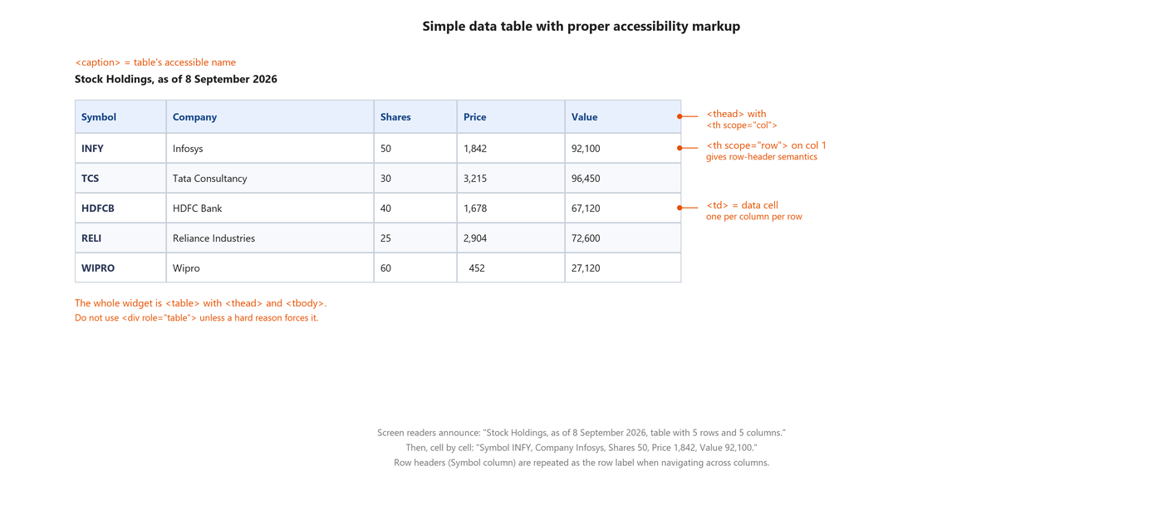
Figure: Simple data table (Stock Holdings) with proper accessible markup. Callouts label the caption, thead with th scope=col, th scope=row on the first column, td for data cells, and the outer <table> element.
Code: Minimal accessible data table (HTML)
<table>
<caption>Stock Holdings, as of 8 September 2026</caption>
<thead>
<tr>
<th scope="col">Symbol</th>
<th scope="col">Company</th>
<th scope="col">Shares</th>
<th scope="col">Price</th>
<th scope="col">Value</th>
</tr>
</thead>
<tbody>
<tr>
<th scope="row">INFY</th>
<td>Infosys</td>
<td>50</td>
<td>1,842</td>
<td>92,100</td>
</tr>
<!-- more rows -->
</tbody>
</table>

Structural checklist:
- Use the native <table> element. Do not wrap divs in role="table" unless a hard requirement (an existing framework component you cannot replace) forces you to.
- Give the table a <caption> as the first child. This is the table's accessible name and screen readers announce it on entry.
- Split into <thead>, <tbody>, and optionally <tfoot>. Groups the rows semantically and lets the browser style the header separately.
- Every column header is a <th scope="col">. Every row header is a <th scope="row">. If your first column is a natural row label (a ticker, an order id, a product name), promote it to a th scope="row".
- Do not use aria-label on the <table> in place of a caption. Caption is stronger semantically and works in more assistive tech.

Accessibility on the web: sortable table
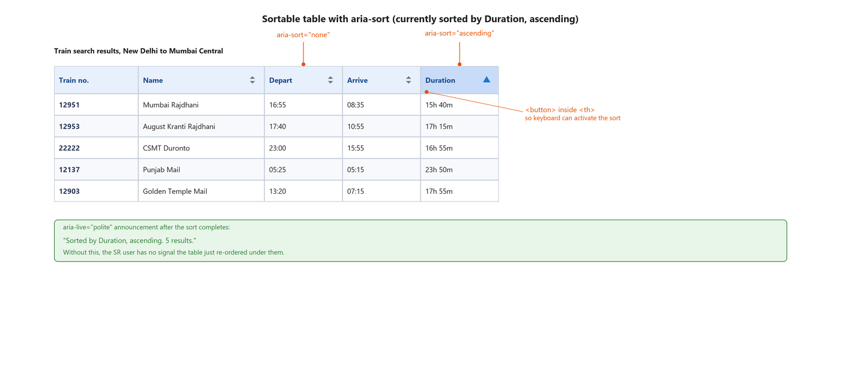
Figure: Sortable table (IRCTC-style train search results) currently sorted by Duration ascending. Callouts label aria-sort='ascending' on the active header, aria-sort='none' on other sortable headers, and the <button> inside <th> that makes the sort keyboard-activatable. A green speech box shows the polite aria-live announcement after the sort completes.
Code: Sortable column header with aria-sort and keyboard support (HTML + JavaScript)
<table>
<caption>Train search results, New Delhi to Mumbai Central</caption>
<thead>
<tr>
<th scope="col" aria-sort="none">
<button type="button">Train no.</button>
</th>
<th scope="col" aria-sort="none">
<button type="button">Name</button>
</th>
<th scope="col" aria-sort="none">
<button type="button">Depart</button>
</th>
<th scope="col" aria-sort="none">
<button type="button">Arrive</button>
</th>
<th scope="col" aria-sort="ascending">
<button type="button">Duration &#9650;</button> <!-- up arrow -->
</th>
</tr>
</thead>
<tbody>...</tbody>
</table>

<div id="table-live" role="status" aria-live="polite" class="sr-only"></div>

<script>
// After the sort completes:
document.getElementById('table-live').textContent =
'Sorted by Duration, ascending. ' + rowCount + ' results.';
</script>

Sort-specific checklist:
- Every sortable column header carries aria-sort. Value is "ascending", "descending", or "none". Exactly one header at a time has a value other than "none".
- The click target inside the <th> is a real <button>. A <span> with a click handler is not keyboard-activatable and screen readers will not announce it as interactive.
- After the sort completes, push a polite live-region announcement naming the column and direction. Without this, JAWS users often do not know the sort even happened.
- The sort direction indicator (arrow) is a visual affordance for sighted users. Do not rely on it as the only signal - aria-sort is what a screen reader picks up.
- For a table with many columns, consider a menu button ("Sort by...") as an alternative path that lists all sortable columns and directions.

Accessibility on the web: complex spanning-header table
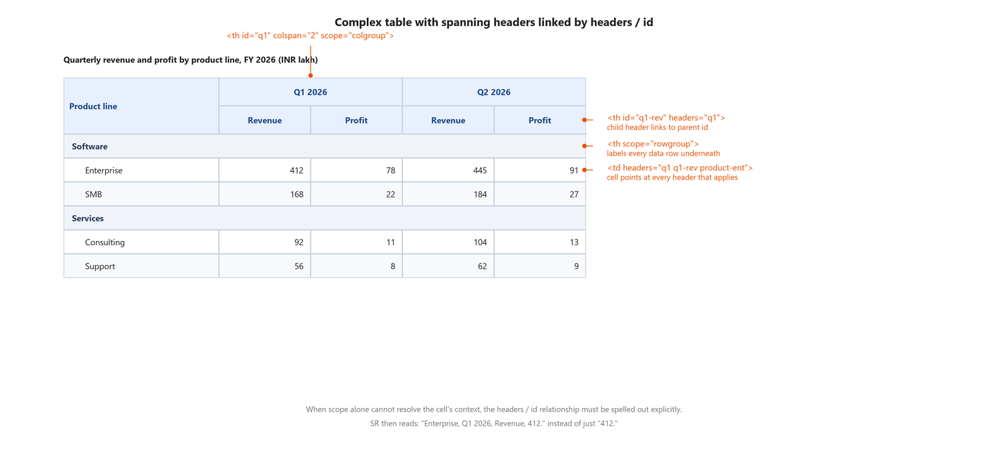
Figure: Complex table (quarterly revenue by product line) with two-level header structure. Callouts label <th id colspan scope='colgroup'> on the spanning Q1 header, the child sub-header linked via headers=, the <th scope='rowgroup'> group headers, and the <td headers> attribute on data cells that points at every header that applies.
Code: Complex table with headers and id linkage (HTML)
<table>
<caption>Quarterly revenue and profit by product line, FY 2026 (INR lakh)</caption>
<thead>
<tr>
<th id="pl" rowspan="2" scope="col">Product line</th>
<th id="q1" colspan="2" scope="colgroup">Q1 2026</th>
<th id="q2" colspan="2" scope="colgroup">Q2 2026</th>
</tr>
<tr>
<th id="q1-rev" headers="q1" scope="col">Revenue</th>
<th id="q1-profit" headers="q1" scope="col">Profit</th>
<th id="q2-rev" headers="q2" scope="col">Revenue</th>
<th id="q2-profit" headers="q2" scope="col">Profit</th>
</tr>
</thead>
<tbody>
<tr>
<th id="grp-sw" colspan="5" scope="rowgroup">Software</th>
</tr>
<tr>
<th id="pl-ent" scope="row" headers="grp-sw pl">Enterprise</th>
<td headers="grp-sw pl-ent q1 q1-rev">412</td>
<td headers="grp-sw pl-ent q1 q1-profit">78</td>
<td headers="grp-sw pl-ent q2 q2-rev">445</td>
<td headers="grp-sw pl-ent q2 q2-profit">91</td>
</tr>
<!-- more rows -->
</tbody>
</table>

The headers and id relationship is verbose. There is no shortcut. When scope alone cannot disambiguate a cell (which happens the moment you have spanning headers or row-group headers), the only way a screen reader can figure out which headers apply to a given cell is by following the ids listed in the cell's headers attribute.
With the markup above, NVDA reads a data cell as: "Enterprise, Q1 2026, Revenue, 412." Without headers and id, the same cell reads as just "412" and the user has no idea what quarter or what metric it belongs to.

Accessibility on the web: responsive table
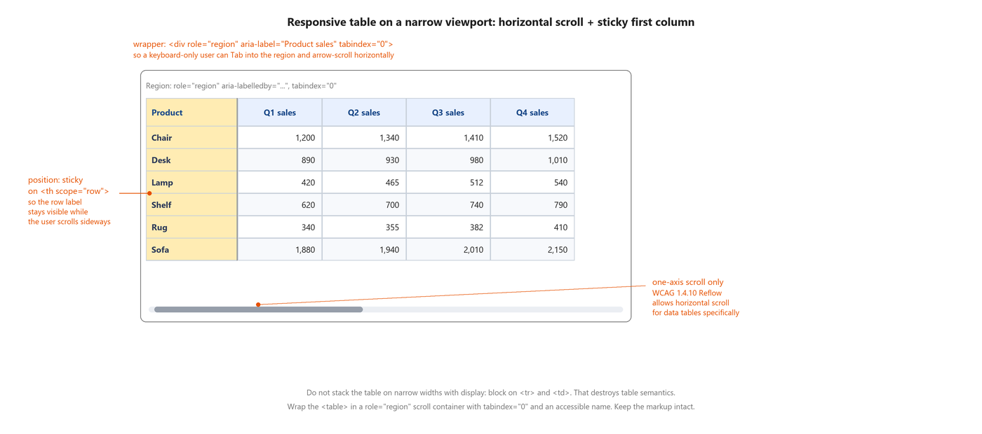
Figure: Responsive table on a narrow viewport with a sticky first column and horizontal scroll. Callouts label position:sticky on the row-header column, the role='region' wrapper that lets keyboard users scroll, and the WCAG 1.4.10 Reflow note that explicitly permits horizontal scroll for data tables.
Code: Responsive table with horizontal scroll and sticky first column (HTML + CSS)
<div role="region" aria-labelledby="sales-caption" tabindex="0"
class="table-scroll">
<table id="product-sales">
<caption id="sales-caption">Product sales by quarter</caption>
<thead>
<tr>
<th scope="col" class="sticky-col">Product</th>
<th scope="col">Q1 sales</th>
<th scope="col">Q2 sales</th>
<th scope="col">Q3 sales</th>
<th scope="col">Q4 sales</th>
</tr>
</thead>
<tbody>
<tr>
<th scope="row" class="sticky-col">Chair</th>
<td>1,200</td>
<td>1,340</td>
<td>1,410</td>
<td>1,520</td>
</tr>
<!-- more rows -->
</tbody>
</table>
</div>

<style>
.table-scroll { overflow-x: auto; }
.sticky-col { position: sticky; left: 0; background: #ffecb3; }
</style>

Responsive-table checklist:
- Wrap the <table> in a <div> with role="region", tabindex="0", and an aria-labelledby that points at the caption or a visible heading. tabindex makes it keyboard-focusable so a keyboard-only user can arrow-scroll.
- The wrapper's overflow-x should be auto so a horizontal scrollbar appears when needed.
- Optionally use position: sticky on the row-header column so the row label stays visible while the user scrolls sideways.
- Do NOT set display: block on <tr> or <td> to "stack" the table on narrow widths. That removes the implicit ARIA table semantics and the screen reader stops treating it as a table at all.
- If you really need the stacked-cards look on narrow widths, use CSS Grid on the <tr> and pair each cell's value with its header using generated content (::before with data-attribute), while keeping the underlying <table> markup intact.
- WCAG 1.4.10 Reflow explicitly permits horizontal scroll for data tables. Reflow does not require you to reshape a data table into a single column on 320-pixel widths.

Data grid vs data table: when to use which
Both use table-shaped markup, but they behave differently for keyboard and screen reader users. Choosing wrong means the pattern feels broken.
A data table (role="table", native <table>) has each cell independently addressable by the browser's table navigation. NVDA and JAWS have their own table navigation shortcuts (Ctrl + Alt + arrow keys) that move a virtual cursor between cells. The table itself is not a tab stop; it is a passive information structure that reading commands walk through. This is what most tables should be.
A data grid (role="grid") is a widget. The whole grid takes one tab stop. Once focus is inside, arrow keys move focus between cells (roving tabindex or aria-activedescendant). Enter or F2 enters cell-edit mode. Escape exits it. Google Sheets, Airtable, and Excel Online are grids. Their whole purpose is cell-level interaction; passive reading is not the main use case.
Rule of thumb: if the user's primary interaction with the table is READING the data, use <table>. If the primary interaction is EDITING or SELECTING at the cell level, use role="grid". Do not mix. A read-only table with a couple of sortable columns is still a table, not a grid.

What breaks
- The table has no <caption>. Screen readers announce "table with 5 rows and 5 columns" with no context about what the table is showing.
- Header cells are <td> with bold styling. Screen readers announce them as data cells, so the header semantics are lost entirely.
- <th> is used without a scope attribute. Screen readers cannot reliably associate cells with headers, especially in tables with row headers.
- Sortable columns lack aria-sort. The visual arrow indicator is decorative CSS; JAWS and NVDA have no way to announce which column is active.
- Sort control is a <span> with a click handler. Keyboard users cannot activate the sort at all.
- After sorting or filtering, no live-region announcement fires. The screen-reader user has no clue the row set just changed.
- Pagination controls do not carry aria-current="page" on the active page number. Screen reader users cannot tell what page they are on.
- Row-selection checkboxes have generic labels like "Select row". Screen reader users hear five identical checkboxes with no way to tell them apart.
- Select-all checkbox in the header does not update to aria-checked="mixed" when only some rows are selected. Its state lies to the user.
- Complex spanning-header table uses only scope, not headers / id. Every data cell reads as a bare number with no context.
- Responsive breakpoint sets display: block on <tr> and <td>. The table's ARIA semantics vanish entirely at that breakpoint.
- Expandable-row expand button is missing aria-expanded and aria-controls. Screen reader users have no signal that a row expanded, and cannot see the panel that appeared.
- Grid pattern uses tab to move between cells instead of arrow keys. Grid semantics require a single tab stop for the whole grid and arrow-key movement inside; tab everywhere leaves the grid entirely on the first cell.
- Table wrapper for horizontal scroll is missing tabindex="0". Sighted mouse users can scroll; keyboard-only users cannot.
- Cells in a data grid are not focusable (tabindex is not managed correctly). Keyboard users are stuck at the first cell.

Testing checklist from actual screen reader use
Run these on a real screen reader with real assistive input. Every one has bitten me on a real audit.
- Move to the table. NVDA or JAWS should announce "caption text, table with N rows and M columns".
- Use table navigation (Ctrl + Alt + arrow keys in NVDA and JAWS). Cell-by-cell announcements should include the column header (and row header if the first column is th scope="row").
- Activate a sortable header with Enter or Space. Confirm the polite live-region announcement fires naming the column and the new sort direction.
- Apply a filter. Confirm a polite announcement fires with the new row count. If no rows match, confirm the empty state is announced too.
- Move to a pagination control. The current page number should announce as "current page" (from aria-current). Move to the next page. Confirm the new row range announces.
- Select a row via its checkbox. Confirm the checkbox accessible name identifies the row ("Select order INF-4821", not just "Select row").
- In a spanning-header table, navigate to any data cell. Confirm the announcement includes ALL applicable headers, not just the immediate column header.
- On a responsive table with horizontal scroll: Tab into the scroll region. Arrow-right to scroll. Confirm the sticky column stays visible and the row header does not disappear.
- In a data grid, tab into the grid once. Arrow keys should move focus between cells. Tab again should exit the grid, not move to the next cell.
- Test on both desktop (NVDA / JAWS) and mobile (VoiceOver iOS / TalkBack Android; see the mobile companion doc). Table navigation gestures on mobile are different.

What each screen reader should announce
When the pattern is implemented right, NVDA, JAWS, and VoiceOver converge on very similar announcements. If your test does not match this, something in the semantic markup is missing.
Stage | Expected announcement (NVDA / JAWS on the web, similar on VoiceOver macOS Safari)
On entering the table | "Stock Holdings, as of 8 September 2026, table with 5 rows and 5 columns."
Moving into a data cell | "Row 2, column 2, Company, Infosys." (row header + column header read as part of the cell content)
On a sortable column header | "Duration, column header, ascending, button. Press Enter to sort descending."
After activating a sort | "Sorted by Duration, ascending. 5 results." (from the polite live region)
On a spanning-header data cell | "Enterprise, Q1 2026, Revenue, 412." (row header + parent col header + col header + value)

References with URLs

W3C standards
- WCAG 2.2 success criterion 1.3.1 Info and Relationships, Level A (https://www.w3.org/WAI/WCAG22/Understanding/info-and-relationships)
- WCAG 2.2 success criterion 1.3.2 Meaningful Sequence, Level A (https://www.w3.org/WAI/WCAG22/Understanding/meaningful-sequence)
- WCAG 2.2 success criterion 1.4.10 Reflow, Level AA (https://www.w3.org/WAI/WCAG22/Understanding/reflow)
- WCAG 2.2 success criterion 2.1.1 Keyboard, Level A (https://www.w3.org/WAI/WCAG22/Understanding/keyboard)
- WCAG 2.2 success criterion 4.1.2 Name, Role, Value, Level A (https://www.w3.org/WAI/WCAG22/Understanding/name-role-value)
- WCAG 2.2 success criterion 4.1.3 Status Messages, Level AA (https://www.w3.org/WAI/WCAG22/Understanding/status-messages)
- ARIA Authoring Practices Guide, Table pattern (https://www.w3.org/WAI/ARIA/apg/patterns/table/)
- ARIA Authoring Practices Guide, Grid pattern (https://www.w3.org/WAI/ARIA/apg/patterns/grid/)
- ARIA 1.2 specification, aria-sort property (https://www.w3.org/TR/wai-aria-1.2/#aria-sort)

Web reference (MDN)
- MDN: HTML <table> element (https://developer.mozilla.org/en-US/docs/Web/HTML/Element/table)
- MDN: HTML <caption> element (https://developer.mozilla.org/en-US/docs/Web/HTML/Element/caption)
- MDN: HTML <th> scope attribute (https://developer.mozilla.org/en-US/docs/Web/HTML/Element/th#scope)
- MDN: HTML <td> headers attribute (https://developer.mozilla.org/en-US/docs/Web/HTML/Element/td#headers)
- MDN: aria-sort attribute (https://developer.mozilla.org/en-US/docs/Web/Accessibility/ARIA/Attributes/aria-sort)
- MDN: table role vs grid role (https://developer.mozilla.org/en-US/docs/Web/Accessibility/ARIA/Roles/table_role)

Design systems
- Material Design 3, Data table (https://m3.material.io/components/data-table/overview)
- US Web Design System, Table component (https://designsystem.digital.gov/components/table/)
- GOV.UK Design System, Table component (https://design-system.service.gov.uk/components/table/)
- Salesforce Lightning Design System, Data Tables (https://www.lightningdesignsystem.com/components/data-tables/)
- Atlassian Design System, Table (https://atlassian.design/components/table/examples)
- Shopify Polaris, Data table (https://polaris.shopify.com/components/tables/data-table)

Practical guides
- WebAIM: Creating Accessible Tables (https://webaim.org/techniques/tables/)
- WebAIM: Data Tables (advanced markup) (https://webaim.org/techniques/tables/data)
- Adrian Roselli: Tables with two headers (https://adrianroselli.com/2022/03/tables-with-two-headers.html)
- Adrian Roselli: Under-engineered responsive tables (https://adrianroselli.com/2020/11/under-engineered-responsive-tables.html)
- Heydon Pickering, Inclusive Components: Data Tables (https://inclusive-components.design/data-tables/)

