## DESCRIBING A NEW AMBER FOSSIL SPECIES

**─ FINAL REPORT**

OLIVIA BÄBLER AND ROBIN VON ALLMEN

University of Basel, DUW, Zoology, Block Course “Zoology and Evolution”.

Figure 1: Illustration from O. Bäbler

# ABSTRACT

The family of Ichneumonidae (Darwin Wasps) has encountered a rapid radiation (Klopfstein, et al., 2019) which explains its high diversity and the fact that a lot of its diversity has not been described yet. Our goal in this research is to determine whether the provided fossil from the late Eocene (approx. 34-38 mya, S. Klopfstein) era embedded in baltic amber can be described as a new species.

To reach our goal, we planned to establish a taxonomic placement of the specimen by describing fossil-specific characteristics of certain body parts.

We then used geometric morphometrics on the forewings in order to get a more precise classification and to assess its viability when classifying new specimens.

# INTRODUCTION

Darwin Wasps are a family of parasitoid wasps, which parasitize Lepidoptera, Hymenoptera, Diptera, Coleoptera and rarely spiders or other arthropods (Li, et al., 2019). Already more than 24’000 species are described (Broad, et al., 2018). However, the fossil in our case originates from an era (Eocene) where there is little information about the diversity of Darwin Wasps (Klopfstein, et al., 2019). Moreover, it is difficult to find synapomorphies in a subfamily or genus that are homologous, since their morphology is extensively related to the host, they parasitize on (Spasojevic, et al., 2018).

Existing keys are often not conclusive enough to determine the genus of a specimen, which is why new and regional keys, as well as modern methods, are needed for more detailed taxonomic placements (Klopfstein, et al., 2019). The way how the specimen has been entombed in its preservation medium including post-burial processes (e.g. diagenesis) can affect the quality of the fossil (Martínez-Delclòs, et al., 2003). As a result, the forewings are usually better preserved than the rest of the carcass (mostly in rock fossils), because it can rip off during its fossilization or may not be as informative for taxonomic placement (Spasojevic, et al., 2018).

Revision of priorly described specimens with geometric morphometrics could therefore be a useful approach to eliminate misplacements and to build a framework that facilitates higher-level classification of new specimens by their venation (Spasojevic, et al., 2018). In Addition, forewing venation patterns are mostly specific for different subfamilies despite homoplasies (Klopfstein, et al., 2019). As we were told by our supervisors, geometric morphometrics has been increasingly used to describe phenetic relationships but remains a relatively new method and its viability for constructing phenetic connections, especially in Ichneumonidae, is not completely evaluated. In light of this we want to prove the following:

1. Our specimen belongs to a taxon that has not been described before.
2. With the help of geometric morphometrics based on forewing venation, the fossil can be asserted to a subfamily and to a genus.

# MATERIAL AND METHODS

The fossil specimen, which was newly described, is deposited in the Hymenoptera collection at the natural historical museum of Basel. It belongs to the family of the Darwin Wasps and has been preserved between 37 and 54 (arguably even less (Perkovsky, et al., 2007)) million years in baltic amber.

### 3.1 **Morphological** Approach

First, we made a description of certain body parts from our specimen with the morphological terminology in “Ichneumonid Wasps (Hymenoptera: Ichneumonidae: their classification and Biology)” by Broad, et al. 2018. As material, we used photographs of the fossil, that were previously taken by A. Viertler under a Keyence VHX 6000 with a magnification of 200, as well as a CT-Scan of the fossil also provided by A. Viertler. For the first attempt to determine the fossil into a subfamily we used a simplified determination key again provided by A. Viertler and “The genera of Ichneumonidae'' by Henry Townes 1969.

### 3.2 Morphometric Approach

We used 21 distinct type 1 landmarks of Bookstein’s terminology and eight semilandmarks on the 2m-cu vein (Bookstein 1991; see Figure 2). We decided to use these landmarks as A. Viertler provided us with a larger dataset to which we then added information about the subfamilies Ichneumoninae, Cryptinae and Phygodeuontinae.

The data was acquired from “The genera of Ichneumonidae'' by Henry Townes 1969 and “Illustrated key to the tribes of subfamilia Ichneumoninae and genera of the tribe Platylabini of world fauna” by A.M. Tereshkin 2009 by using the windows’ built-in function Snipping Tool.

The drawings illustrating genera from Phygadeuontinaeand Cryptinaewere made under the direction of Prof. Masaaki Tokunaga of Kyoto (Townes, 1969). As Townes followed an old taxonomy in his work, where the subfamilies mentioned above were still formerly known as tribes from the subfamily Gelinae, we needed to check for recent changes. We aimed to randomly pick from our listed genera in the subfamilies in order to minimize bias during data acquisition. However, we excluded randomly picked specimens from our analysis which either had reduced wings (e.g. *Obisiphaga stenoptera*) or whose taxonomic classification was very uncertain.

In contrast, there was no such preanalytical preparation needed when collecting data for Ichneumoninae from A.M.Tereshkin 2009, as his work is much more recent. However, there were usually only a few taxa per tribe depicted except for the tribe Platylabini.

The illustrations were converted into TPS files with the program tpsUtil 1.78 and then used for setting landmarks in the program tpsDig2 2.31.

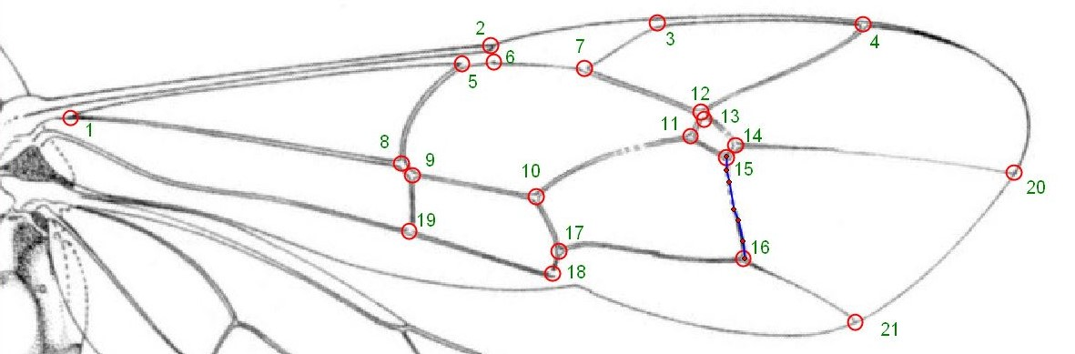

Figure 2: Illustration of Deleboea sp. (Townes, 1969) with landmarks (red circles), numeration (green letters) and curves (blue line) with semilandmarks (small red dots).

For us to obtain the same information about our fossil, we created snapshots at different angles of our fossil in MeshLab 2020.12. We then created a mean shape of our fossil from 5 different pictures, which each of us set landmarks on. The reason for this was that we were comparing a dataset of illustrations (Townes, 1969) with a 3D-Scan where the forewings were not flat. Hence, we were removing some of the errors that would be later created during analysis to prevent misinterpretations.

In order to make a placement of the fossil in the higher groupings, higher and lower Ophioniformes, Pimpliformes and Ichneumoniformes, we used the dataset from A. Viertler. We took specimens from the following subfamilies for our analyses: 57 Banchinae (lower Ophioniformes), 35 Ophioninae (higher Ophioniformes), 62 Phygadeuontinae (Ichneumoniformes) and 80 Pimplinae (Pimpliformes). First, we made a principal component analysis (PCA) in MorphoJ 1.06d without analysing the semilandmarks, as the program is not able to read them. To obtain an analysis of the semilandmarks, we did a PCA in R 4.04. A canonical variates analysis (CVA) was done in both programs R and MorphoJ for the same reason as described above. We did a cluster analysis in R using the clustering method “ward.D2”.

To make a more detailed placement in between the subfamilies of our higher grouping, we only used the data we prepared beforehand. In a smaller data collection of 59 specimens, we tested whether the vein RS and 1m-cu&M together or separately could improve the separation of our subfamilies in a principal component analysis. For later analyses with 198 species, we excluded them again. We also examined in MorphoJ and R how the exclusion of different landmarks does influence the Procrustes fit and the overall analysis. We generated a dendrogram from a bootstrapping analysis with one thousand cycles and the clustering method “average”. We decided to take another method as “ward.D2”, as we were using Procrustes distances in this case and not principal components and this method performed better in reconstructing the current taxonomy.

The dendrogram was generated with the packages “geomorph” 3.0.6 and “pvclust” 2.2-0 from the CRAN repository.

We proceeded with the assertion of our fossil to a certain genus by reducing our dataset according to our results and interpretations in the previous analysis. With this data, we generated another PCA, as well as a cluster analysis. For the interpretation of the cluster analysis, we used approximately unbiased tests, as it “adjusts the selection bias overlooked in the standard use of the bootstrap probability and Kishino–Hasegawa tests” (Shimodaira, 2002). The bootstrap analysis was performed with the clustering method “average”, distance method “correlation”, relative sample sizes were set to default and the number of bootstrap replications was set to ten thousand.

Based on our data from morphological characteristics as well as from morphometric analyses we discussed possible names for our new species and whether we will follow an open-taxonomy approach or ultimately assert it to one of our genera according to our final analysis.

# 4. RESULTS

## 4.1 Description of the Fossil

Short general description of the fossil: Forewing 3 mm long, mandible with 2 teeth, sternaulus more than half as long as mesopleuron, aerolet closed and pentagonal.

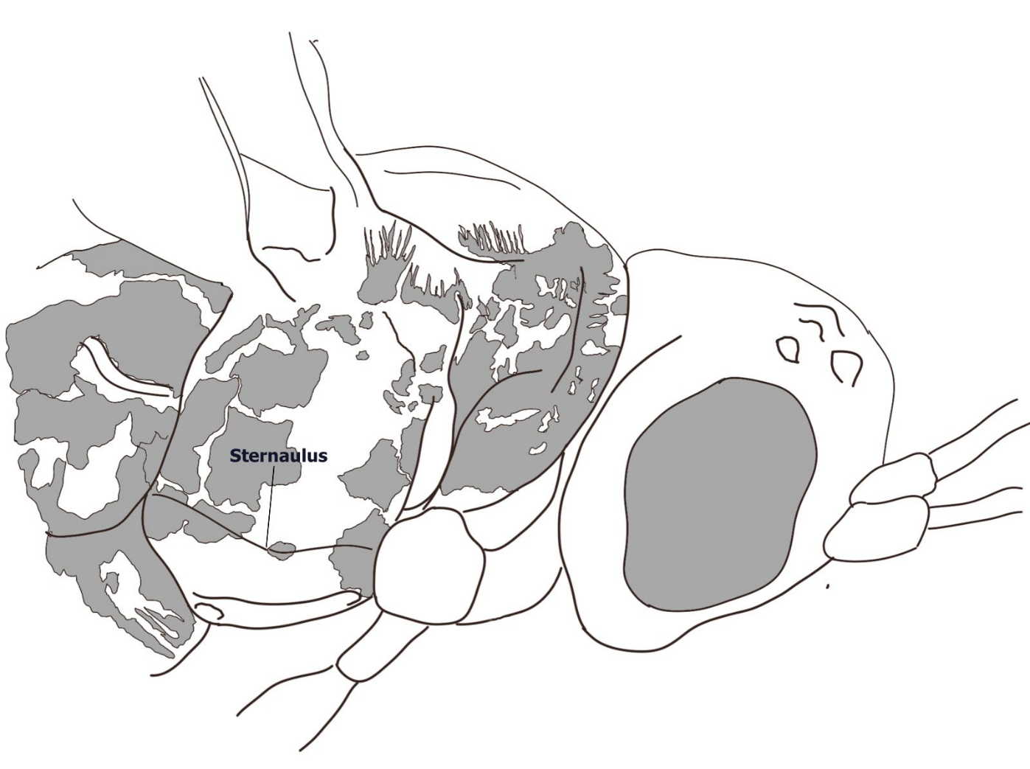

Figure 3: Mesopleurum with sternaulus from R. von Allmen

Detailed forewing description:

|  |  |
| --- | --- |
| 2m-cu | 2 bulla, bended |
| Aerolet | -Closed, pentagonal, sites uneven  -2RS 0.69x 2+3M and 0.79x 3rs-m  -2+3M 1.75x 4M  -3RS 0.7x 4M |
| CU | Seems not to touch border of the wing |
| 1cu-a | Seems to be interstitial relative to M&RS |

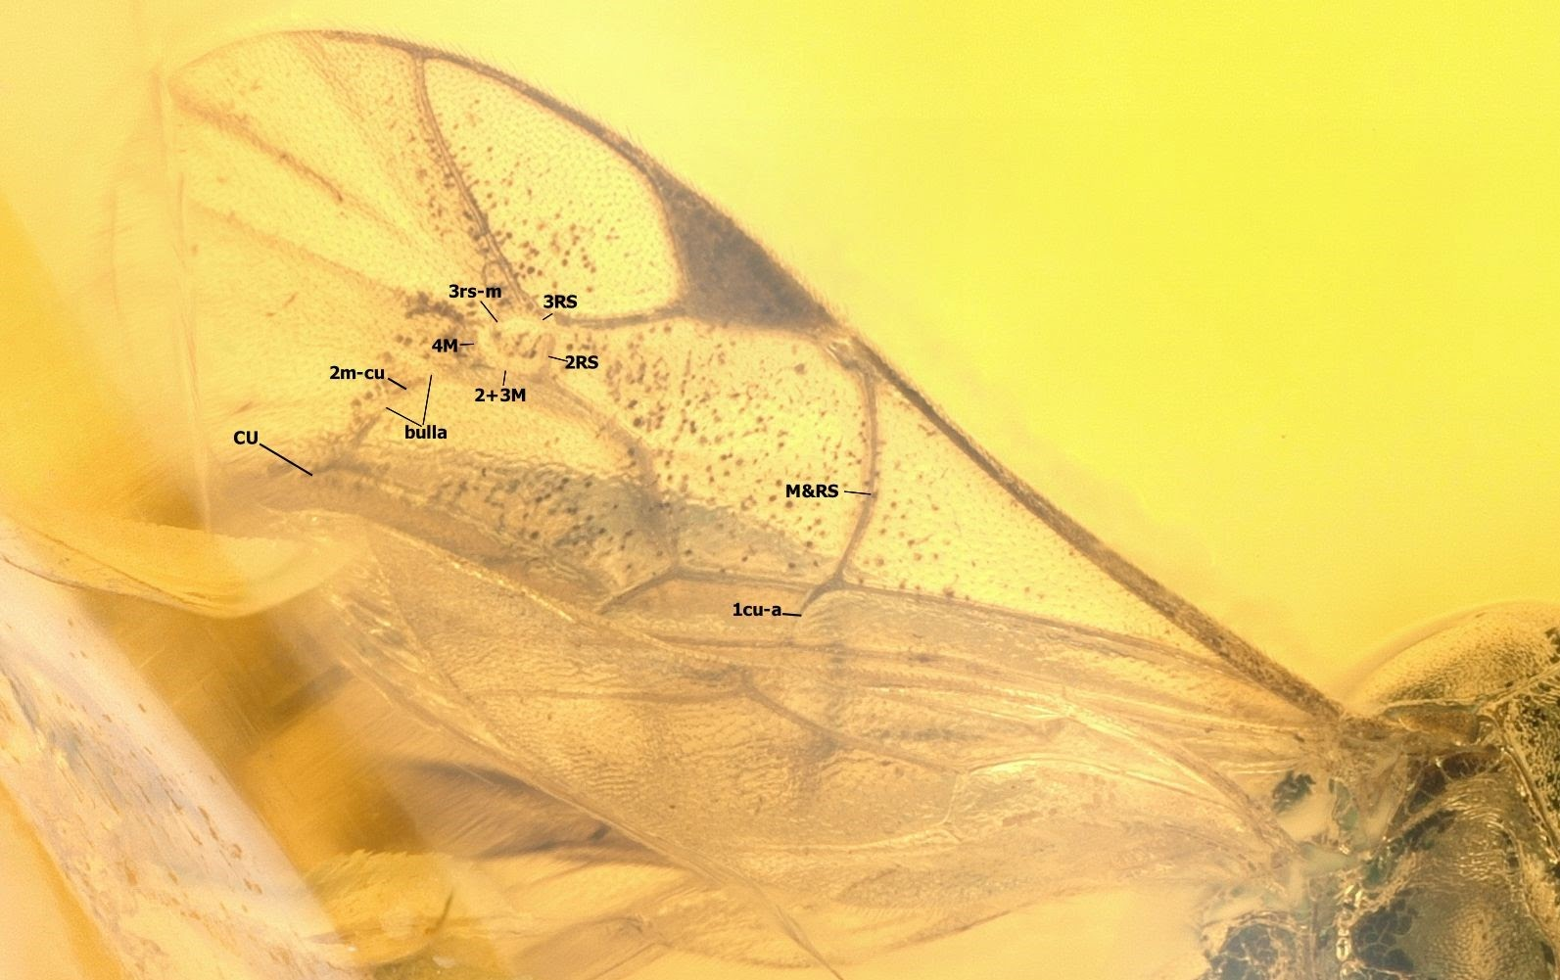

Figure 4: picture of forewing from A. Viertler

Detailed ovipositor description: Distinct nodus not visible, no dorsal notch, with teeth, ovipositor 1.6 times bigger than apical depth of abdomen.

Detailed propodeum description: Pleural carina (pc) good visible and complete, anterior transverse carina (atc) complete, propodeum with anterior transverse carina and lateral longitudinal carina (llc), lateromedian longitudinal carina (lmc) seems not complete, posterior transverse carina complete (ptc).

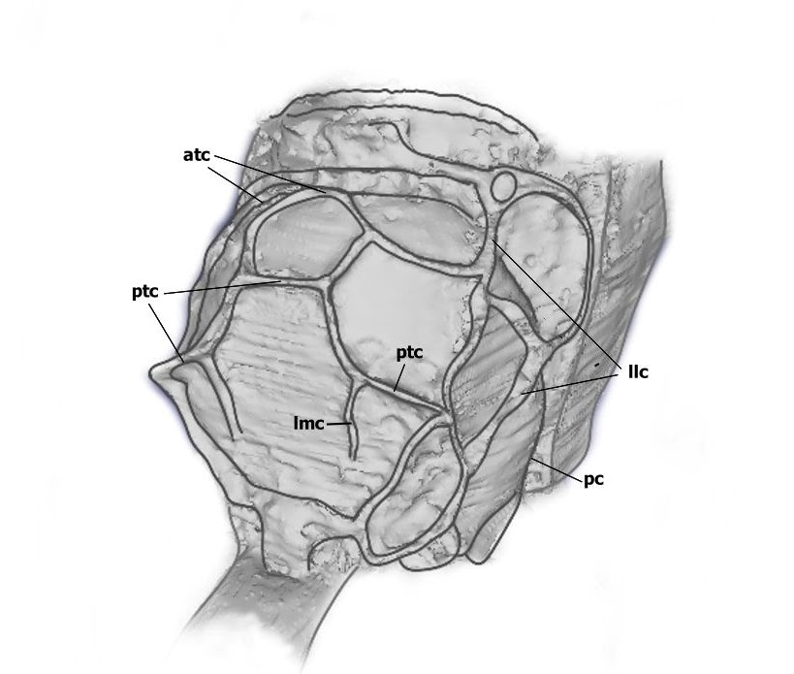

Figure 5: CT-Scan from A. Viertler with highlighted carinae of Propodeum from R. von Allmen.

## 4.2 Placement of the fossil in higher groupings

Approximately 70% of the variance of the wing shape in the principal component analysis (PCA) was explained with the first three principal components (PC). PC1 contributed about 34.4%, PC2 about 21.4% and PC3 about 12.2% of the overall wing shape variance.

The PCA of the higher groupings (see Figure 6) showed a strong separation of the Ophioninaefrom the other subfamilies. The Pimplinae were also separated though some of them did overlap with Phygadeuontinae.  Furthermore, the Phyadeuontinae did overlap mostly with Banchinaeand as mentioned above, partially with the Pimplinae. The fossil was placed near the Phygadeuontinaeand Pimplinae. Overall, it could be seen that the subfamilies clustered mostly in groups, however, there were some outliers clustering in other groups.

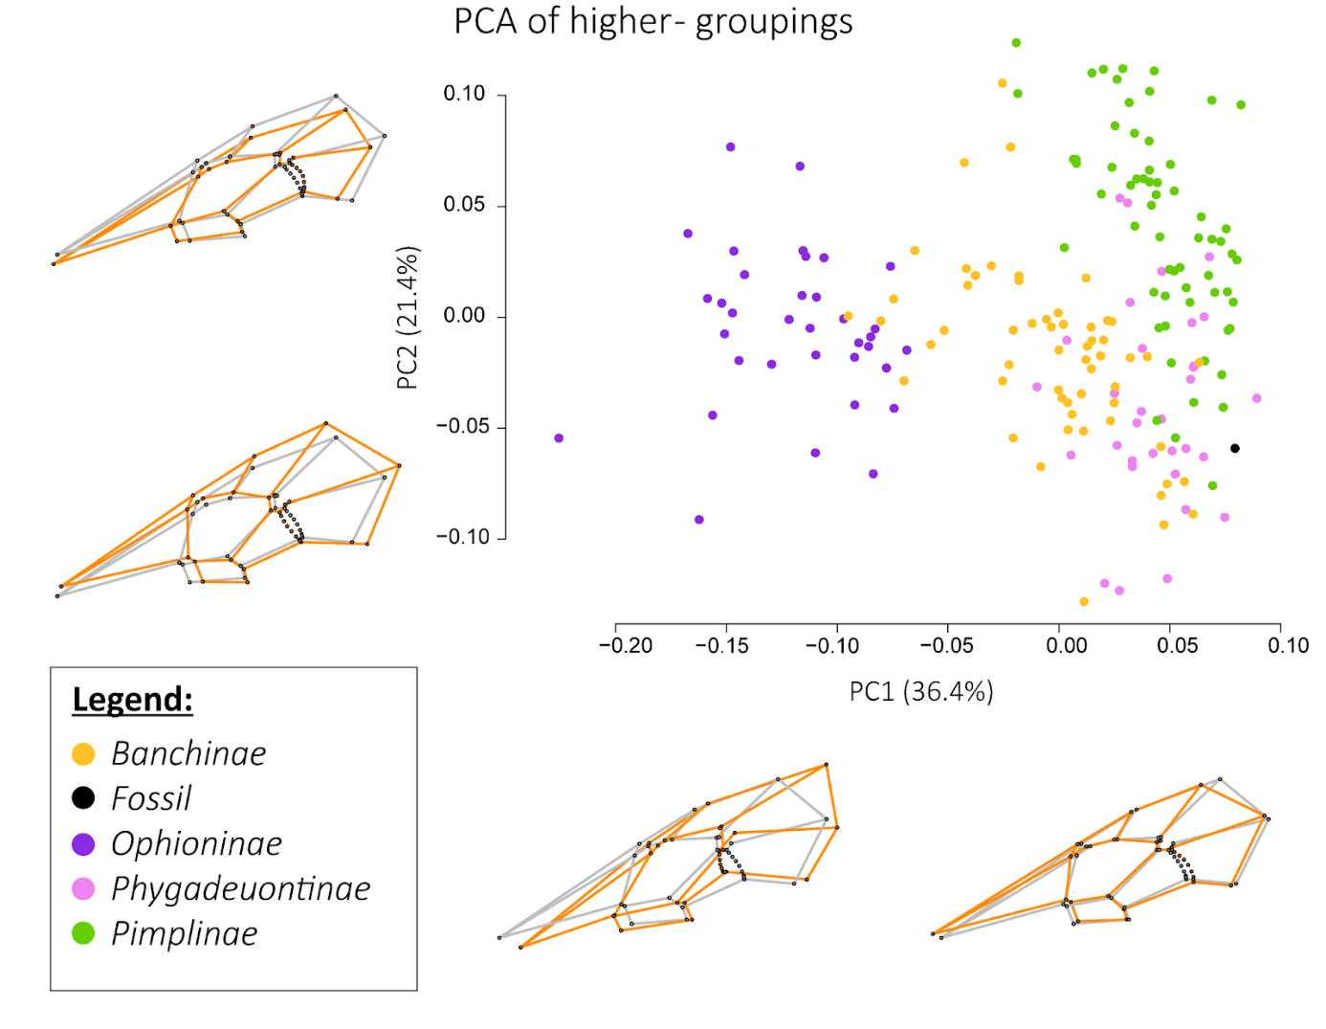

Figure 6: PCA plot (made in R) of the higher groupings with subfamilies Banchinae (lower Ophioniformes), Ophioninae (higher Ophioniformes), Phygadeuontinae (Ichneumoniformes) and Pimplinae (Pimpliformes). The wing shapes show the mean from the PCA (grey) and the extreme ends of PC1 and PC2 axes (orange).

In the CVA (see Figure 7) the subfamily Ophioninae was again strongly separated from the other subfamilies.  The Phygadeuontinae and our fossil clustered separately as well, although the fossil was respected as its own group for the analysis. In the first two CV scores of the analysis (82.5% of variation) the only overlapping subfamilies were the Pimplinae and the Banchinae.

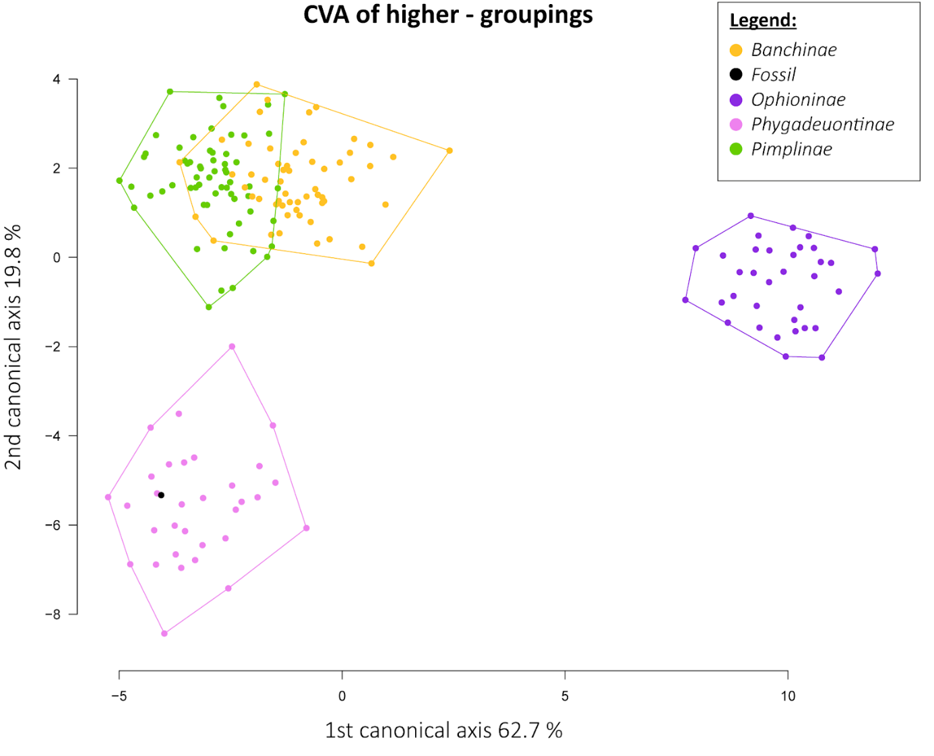

Figure 7: CVA plot (made in R) of the higher groupings.

## 4.3 Detailed Placement within Ichneumoniformes

The first three principal components from the PCA explained approximately 60% of the cumulative variation in wing shape between the different taxa. Figure 8 shows that the different subfamilies tend to build clusters with only two principal components and that there is only partial overlap. The second plot, however, which plots PC1 against PC3 performed better in visually separating the subfamilies than the first plot, although it visualizes less variation.

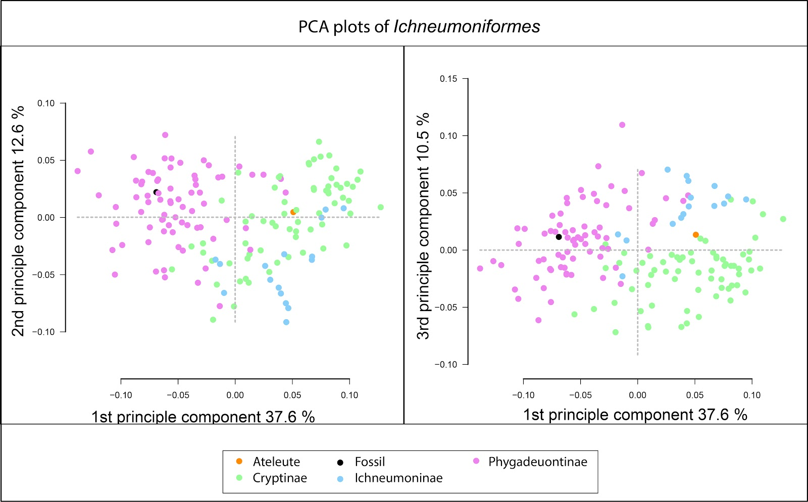

Figure 8: On the left graph a PCA plot with PC1 (x-axis) against PC2 (y-axis) and on the right side a PCA plot with PC1 (x-axis) against PC3 (y-axis). The grey dotted lines indicate where the mean of each principal component is.

In the cluster analysis (see Figure 9) our fossil clusters within Phygadeuontinae. The subfamilies Phygadeuontinae and Cryptinae mostly cluster within the same node, while Ichneumoninae are scattered. The clade which contains only Phygadeuontinae (except *Demopheles*) and our fossil, was inferred with a significance level of 0.06. Furthermore, the fossil clustered within the higher clade, which also includes the majority of the subtribe Aptesini, with a significance level of 0.03 (in Figure 9 abbreviated with a blue dot) and it clusters with *Grasseiteles* with a significance level of 0.20.

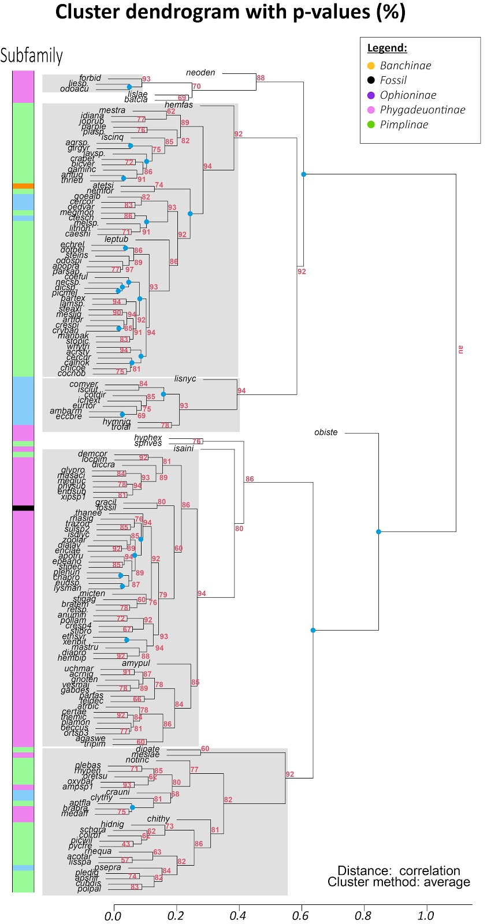

Figure 9: Bootstrapped cluster analysis with approximately unbiased (au) p-values in red. Blue dots represent nodes with a lower significance level than 0.05 and grey colored rectangles are clusters with a lower significance level than 0.1.

## 4.4 Assertion to a Genus

The PCA plot in this case does not help to visualize any tendency towards a certain genus, as we are only able to plot three principal components on one plot. This would only allow us to cover 51% of cumulative variation from our superimposed Procrustes fit, which is not sufficient to make a placement.

However, Figure 10 shows us a bootstrapped dendrogram, which gives us a more valid result, as it respects Procrustes distances between all genera. This model of our data suggests that our fossil can be clustered among the genera *Grasseiteles, Isadelphus* and *Polyaulon* with a significance level of 0.13.

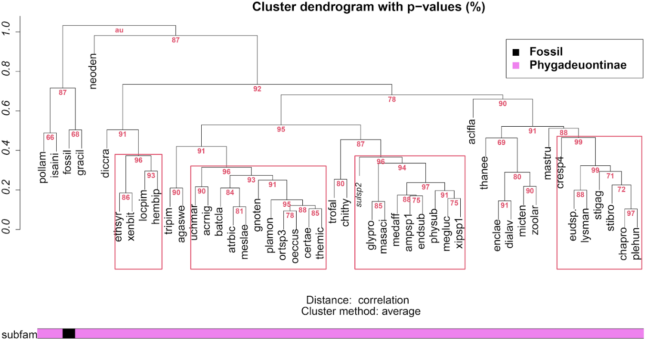

Figure 10: Bootstrapped cluster analysis with approximately unbiased (au) p-values in red. Clusters that were built with a significance level lower than 0.05 are indicated in red rectangles.

# DISCUSSION

## 5.1 Description of the fossil

With the help of the simplified determination key (A. Viertler), we assigned our fossil to the former subfamily Gelinae, based on the pentagonal aerolet and the sternaulus that is more than half as long as the mesopleuron.  Our fossil shares the following characteristics for Gelinae described in Townes (1969): Mandible with two teeth and the ovipositor longer than the apical depth of abdomen. Our fossil exceeds the described forewing length in Townes of 2 to 2.7 mm. A. Viertler, who already had determined the subfamily of our fossil before, confirmed our result. Furthermore, we placed the fossil into the former tribe Gelini (Townes 1969), because of the two bullae that were on the 2m-cu vein and the propodeum which had an anterior transverse carina and a lateral longitudinal carina. It became clear that the subfamily “Gelinae” as it was described in Townes 1969 does not exist anymore according to modern taxonomy. The Gelinae are now divided into the subfamily Cryptinae and Phygadeutinae (Broad et al. 2018) with the tribe “Gelini” belonging to Phygadeuontinae, which means that, according to modern taxonomy, the fossil belongs to this subfamily.

### 5.2 Placement of the fossil in higher groupings

The PCA suggests that there is variation among the forewing shapes in the subfamilies that clusters them into groups. About 70% of the variation is explained by the first three principal components. Getting a closer look into principal component 1 (in MorphoJ), it seems that it is landmark 4 that varies the most among the subfamilies. However, it is not visible in the plot if the fossil clusters more with Phygadeuontinaeor Pimplinae*.*

The CVA gives a better separation of the subfamilies than the PCA, as it respects that we have knowledge about the relation between the species and to what subfamily they belong. It suggests that there is support for distinguishing the subfamilies based on their forewing venation as they are all clustering into different groups. According to the CVA, the forewing shape of the fossil is most similar to the forewing shapes of Phygadeuontinae*,* which is interesting, as the fossil had its own category.   The algorithm performs in a way to maximize the distance between the means of different groups while minimizing the variation within the category. The only canonical variate that showed separation from the fossil to Phygadeuontinae explained less than five percent of the overall variation.

Regarding the wing shapes that are seen in Figure 6, the Ophioninaeseem to have a long stretched third distal cell and their first subdiscal cell is rectangular in opposite to the other subfamilies, which have a pentagonal first subdiscal cell. Interestingly the Phygadeuontinaeseem to have a bigger pterostigma than the other subfamilies. Looking at the forewing of the fossil, the same could be observed there too.

### 5.3 Placement within Ichneumoniformes

However, since only one subfamily per higher grouping was used to determine to which subfamily our fossil belongs, we were required to reject the possibility that it might belong to another subfamily than Phygadeuontinae within Ichneumoniformes. Therefore, we analysed the placement of the fossil among the different subfamilies in Ichneumoniformes.

Even though one would expect to find less variation in between the same higher grouping, the PCA, was sufficient enough to separate the subfamilies with only little overlap between them. This time our fossil data was generated from the mean of several landmark settings created from different pictures of the fossil by two different people. Before doing so, our fossil was always isolated from the other clusters, which one could interpret as a result of convergent evolution, which results in similar wing shapes among existing taxa. More likely though, this is the result of the different materials that were used. The fossil had no entirely flat wings and therefore a two-dimensional picture would not be able to show the true shape of the forewing. We tried to minimize this by using a mean shape of our fossil, which was generated from pictures of different angles. In this case, our fossil did cluster nicely within Phygadeuontinae. However, as explained before, a PCA plot does not show the whole variation of our data.

To analyse its relationship with Phygadeuontinae, we conducted a cluster analysis, which further supported the assertion to this subfamily. The bootstrapping we then applied on this dendrogram was used to assess the significance of this model. As already mentioned in the results we can reject the probability that it does not belong to Phygadeuontinae with a significance level of 0.06. However, this only applies under the restriction of the dataset that we generated and could change when more data is included for the analysis.

## 5.4 Genus Assertion

As mentioned above, the PCA plot only covered a small proportion of the overall variance in the wing shape, leading to misinterpretation of the data, as the placement in our dendrogram looks completely different. Therefore we decided to omit it from our interpretation and used the Procrustes distances instead to generate a bootstrapped model of a dendrogram. The outcome was satisfying in terms of that the fossil was placed somewhat isolated, which one would expect when comparing it with recent specimens. However, this again can be due to the fact that there was another method used to acquire the landmark information. This is also reflected in a relatively high significance level of 0.32. The clustering within this clade that is apart from the other Phygadeuontinae was created with a significance level of 0.13. This placement is depending strongly on the size of our initial dataset. Therefore, one would expect to see a different placement of our fossil when including all subfamilies in Phygadeuontinae. However, in Figure 9 the fossil is still placed next to *Grasseiteles* with a significance level of 0.21, which is even lower than the significance level with Phygadeuontinae alone. This enforces our interpretation that our fossil may be mostly morphologically related to the genus of *Grasseiteles*. A definite placement among the genera would require either a much larger dataset with more genera from Phygadeuontinae or an in-depth morphological description.

# CONCLUSION

While the geometric morphometric approach did work well for placing the fossil within the higher groupings and within Ichneumoniformes, it was not sufficient for the clear assertion to a genus. This is probably linked to the higher variation in forewing shapes between and within higher groupings, compared to the variation of genera in the same subfamily. The higher significance levels in the cluster analysis among genera in Phygadeuontinae show that there is not sufficient information for precise placements.

Nevertheless, geometric morphometrics is a method that is useful for describing phenetic relationships, especially once larger data would be collected with which one could make more valid assessments.

Because a Phygadeuontinae fossil in baltic amber has hitherto not been described and because of our morphological and morphometric analysis, we conclude that it can be described as a new species.

Subfamily **Phygadeuontinae** Santos, 2017

Genus ***Grasseiteles*** Aubert, 1965

***Grasseiteles? antiquanovi*** sp. nov.

We added a question mark at the end of the name of the genus, as proposed by Spasojevic et al (2018) in order to point out uncertainty about its placement.

For the name of the species, we chose *antiquanovi* (lat. Subst. v. antiquus (nt) - Perf v. nosco) because the fossil remains are approximately between 34 and 38 million years old, but it is the first fossilized Phygadeuontinae in baltic amber that has been described.

# OUTLOOK

Since there are various collections of fossils scattered over different localities and there are considerable concerns that we may not be able to establish the vast diversity of Darwin Wasps, we highly rely on inventive procedures to speed up this process (Klopfstein, et al., 2019). We were able to show in this project that a geometric morphometric approach with forewing venation did succeed in establishing a higher taxonomic order. Thus, this method could be used to make a first taxonomic placement in Ichneumonidae, which then can be confirmed or specified by morphological description.

Because there are species with anomalous forewing patterns (e.g. Chirotica), which resulted in lower support values during our analyses, other body parts for geometric morphometric analyses should be included. This would also prevent misplacements of taxa, where the wing venation looks similar to other subfamilies (e.g. Ichneumoninae with pentagonal areolet and small marginal cell).

However, in order to assess the performance of such new models, the taxonomic order in Ichneumonidae needs to be fully resolved, as we are not able to tell whether outliers in our data arise from homoplasies or misplacements in the taxonomy.

# ACKNOWLEDGMENTS

We thank our supervisors Alexandra Viertler and Seraina Klopfstein for their engagement in our project and their support during our analyses. Also, we thank Alexandra Viertler for all the material she provided us including written R-Scripts and the CT-Scan of the fossil, as well as for her daily surveillance over the project. We thank Daniel Berner for his advice in our statistical analysis.

# APPENDIX

All the statistical evaluations, as well as data that was used for the analysis, can be downloaded, or inspected on the public repository on GitHub:

https://github.com/AMBERFOSSILS/Ichneumonidae

The data might have changed since writing this document. In order to replicate our work, download the latest changes in the document history on April 11, 2020 on the main branch.

The only data that is not freely available in our repository are the references and literature used in this project.

# REFERENCES

Bookstein, F. L., 1991. Morphometric tools for landmark data: geometry and biology. *Cambridge University Press*, p. 63 ff..

Broad, G. R., Shaw, M. R. & Fitton, M. G., 2018. *Ichneumonid Wasps (Hymenoptera: Ichneumonidae): their Classification and Biology.* St Albans: Royal Entomological Society.

Klopfstein, S., Santos, B. F., Shaw, M. R., Alvarado, M., Bennett, A. M. R., Dal Pos, D., Giannotta, M., Florez, A. F. H., Karlsson, D., Khalaim, A. I., Lima, A. R., Mikó, I., Sääksjärvi, I. E., Shimizu, S., Spasojevic, T., van Noort, S., Vilhelmsen, L. & Broad, G. R., 2019. Darwin wasps: a new name heralds renewed efforts to unravel the evolutionary history of Ichneumonidae. *Entomological Communications*, p. 2019: ec01006.

Li, L., Shih, P. J. M., Kopylov, D. S., Li, D. & Ren, D., 2019. Geometric morphometric analysis of Ichneumonidae (Hymenoptera: Apocrita) with two new Mesozoic taxa from Myanmar and China. *Journal of Systematic Palaeontology*, pp. Vol. 0, No. 0, 1–13.

Martínez-Delclòs, X., Briggs, D. E. & Peñalver, E., 2003. Taphonomy of insects in carbonates and amber. *PALAEO*, pp. 203:19-64.

Perkovsky, E., Rasnitsyn, A. P., Vlaskin, A. & Taraschuk, M. V., 2007. A Comparative analysis of the Baltic and Rovno Amber arthropod faunas: Representative Samples. *African Invertebrates*, pp. 48(1):229-245.

Schwarzfeld, M. D. & Sperling, F. A., 2014. Species delimitation using morphology, morphometrics, and molecules: definition of the Ophion scutellaris Thomson species group, with descriptions of six new species (Hymenoptera, Ichneumonidae). *ZooKeys*, pp. 462:59-114.

Shimodaira, H., 2002. An approximately unbiased test of phylogenetic tree selection. *Systematic Biology*, 1 May, pp. 492-508.

Spasojevic, T., Broad, G. R., Bennett, A. M. R. & Klopfstein, S., 2018. Ichneumonid parasitoid wasps from the Early Eocene Green River Formation: five new species and a revision of the known fauna (Hymenoptera, Ichneumonidae). *Paläontologische Zeitschrift*, pp. 92:35-63.

Townes, H., 1969. *The Genera of Ichneumonidae, Part 2.* Michigan: The American Entomological Institute.

Weitschat, W. & Wichard, W., 2010. Baltic amber. In: *Biodiversity of fossils in amber from the major world deposits.* s.l.:Siri Scientific Press.