Name : Ambika Kashyap
UID : 23BCC70026
Class : 23BCC-1(A)

EXPERIMENT -3.3

Aim:
To implement a class hierarchy in C++ where Person is the base class, and Student and Teacher are subclasses, showing inheritance and method overriding.

Code:
#include <iostream>
using namespace std;

// Base Class
class Person {
protected:
string name;
int age;
public:
Person(string n, int a) {
name = n;
age = a;
}
void display() {
cout << "Name: " << name << ", Age: " << age << endl;
}
};

// Derived Class: Student
class Student : public Person {
string course;
public:
Student(string n, int a, string c) : Person(n, a) {
course = c;
}
void display() {
cout << "Student -> Name: " << name << ", Age: " << age
<< ", Course: " << course << endl;
}
};

// Derived Class: Teacher
class Teacher : public Person {
string subject;
public:
Teacher(string n, int a, string s) : Person(n, a) {
subject = s;
}
void display() {
cout << "Teacher -> Name: " << name << ", Age: " << age
<< ", Subject: " << subject << endl;
}
};

// Main Function
int main() {
Student s1("Rahul", 20, "Computer Science");
Teacher t1("Meera", 35, "Mathematics");

s1.display();
t1.display();

return 0;
}
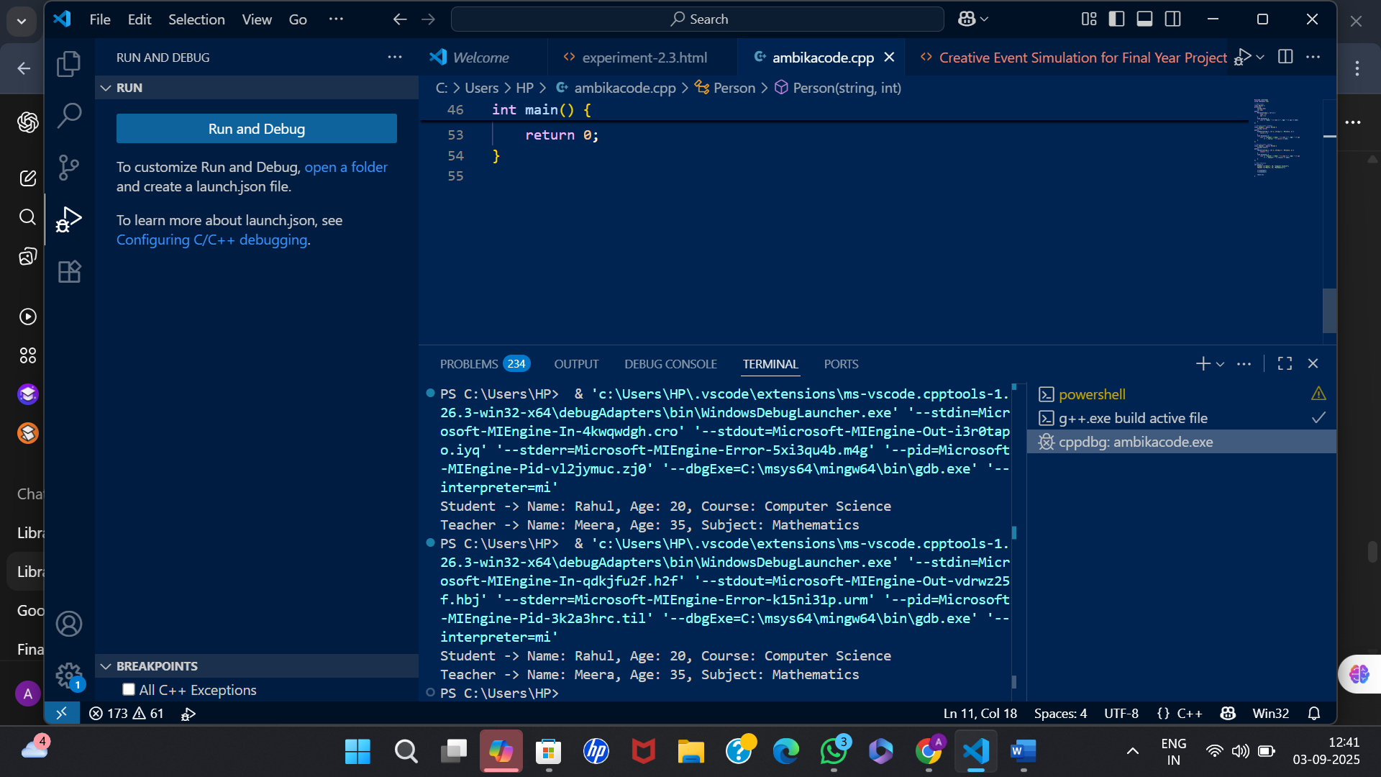
OUTPUT:

