Name : Ambika Kashyap
UID : 23BCC70026
Class : 23BCC-1(A)

Experiment: CRUD Operations for Product Database Using Mongoose

Aim
To implement Create, Read, Update, and Delete (CRUD) operations on a Product Database using Mongoose (an ODM for MongoDB) in a Node.js application.

Theory
- CRUD Operations
  - Create → Insert new product records into the database.
  - Read → Retrieve product details.
  - Update → Modify existing product records.
  - Delete → Remove product records.
- Mongoose
  - Mongoose is an Object Data Modeling (ODM) library for MongoDB.
  - Provides schema-based modeling, validation, and easy-to-use query methods.
- Schema & Model
  - Schema defines the structure of documents (fields, types, constraints).
  - Model is a compiled version of the schema, used for performing CRUD.

Code :
const mongoose = require("mongoose");

// 1. Connect to MongoDB
mongoose.connect("mongodb://127.0.0.1:27017/productDB", {
useNewUrlParser: true,
useUnifiedTopology: true,
})
.then(() => console.log("✅ MongoDB Connected"))
.catch(err => console.error("❌ Connection Error:", err));

// 2. Define Schema
const productSchema = new mongoose.Schema({
name: { type: String, required: true },
price: { type: Number, required: true },
category: String,
inStock: { type: Boolean, default: true }
});

// 3. Create Model
const Product = mongoose.model("Product", productSchema);

// 4. CRUD Operations

// CREATE
async function createProduct() {
const product = new Product({
name: "Laptop",
price: 55000,
category: "Electronics",
inStock: true,
});
const result = await product.save();
console.log("Created:", result);
}

// READ
async function getProducts() {
const products = await Product.find();
console.log("All Products:", products);
}

// UPDATE
async function updateProduct(id) {
const result = await Product.findByIdAndUpdate(
id,
{ price: 60000, inStock: false },
{ new: true }
);
console.log("Updated:", result);
}

// DELETE
async function deleteProduct(id) {
const result = await Product.findByIdAndDelete(id);
console.log("Deleted:", result);
}

// Run functions
(async () => {
await createProduct();
await getProducts();
// Replace with actual _id after creating
// await updateProduct("64f9d0b0e1a9c3bcd1234567");
// await deleteProduct("64f9d0b0e1a9c3bcd1234567");
})();

Output
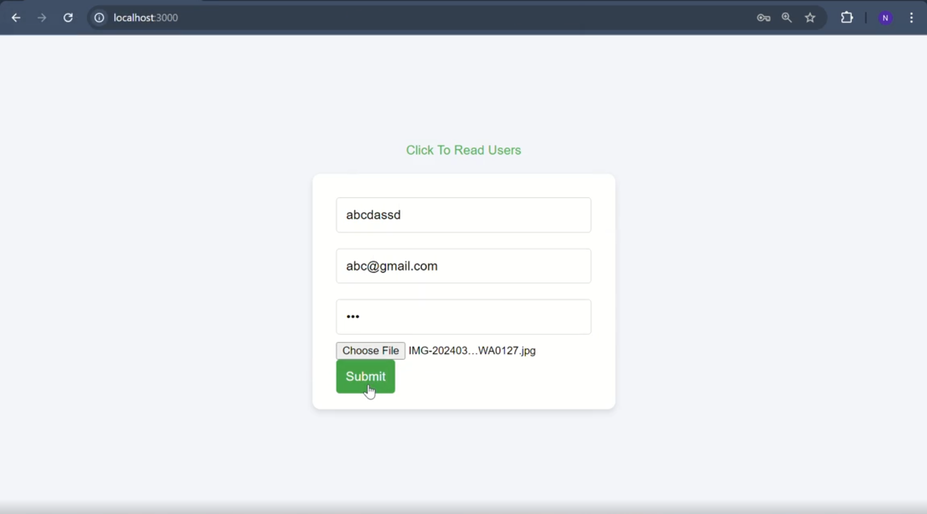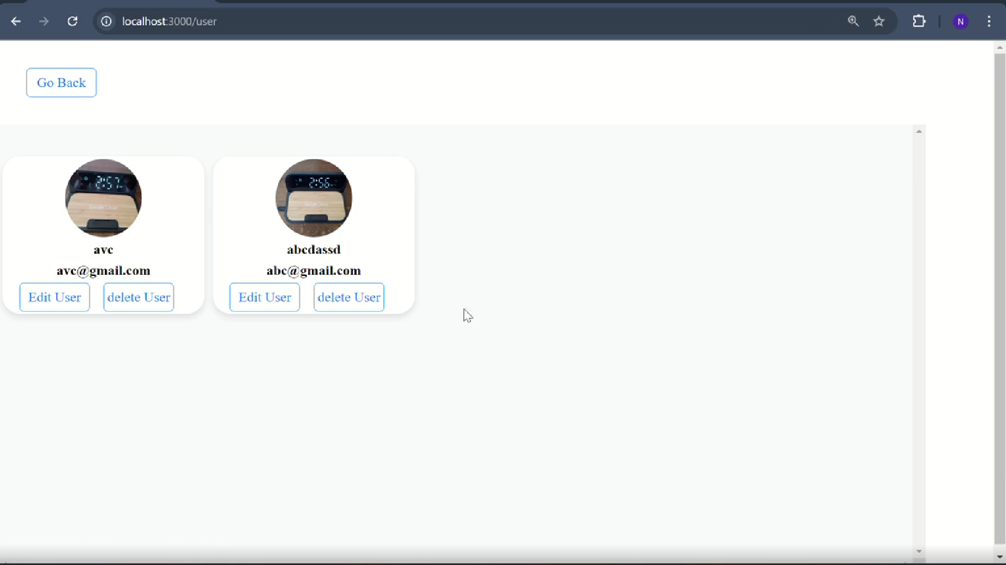

Learning Outcomes
- Understood CRUD operations in MongoDB using Mongoose.
- Learned how to define schemas and models in Mongoose.
- Implemented asynchronous functions with async/await.
- Practiced connecting Node.js with MongoDB.
- Gained skills to build a basic product management system.

