The README was written by Zhiming Gao (Phone 865-946-1339, email gaoz@ornl.gov) The detailed model are reported in the manuscript of “*Z. Gao, O. Abdelaziz, M. Qu. Modeling and Simulation of Membrane-Based Dehumidification and Energy Recovery Process. 2017 ASHRAE Winter Conference, Las Vegas, NV, Jan. 28 – Feb. 1, 2017.*”

# Document file

The zipped files include two folders: **CODE_MODEL** and **CASES**. In the folder of **CODE_MODEL**, there are totally fifteen source-code files. The source-code files were written in C++. The functions are explained in the Code function.

In the folder of **CASE**, there are ten files which include one executable file and 9 input text files for case studies.

* Membrane_Model.exe is an executable file which can be generated from the source codes in the folder of code_model. The used compiler is Microsoft Visual Studio Community 2015. The executable file can be used directly to study any cases with the format of the attached input files.
* 9 input files for case studies include a2a104_s3_cr.txt, a2a520_s3_cr.txt, a2v360_caseA_cr.txt, a2v360_caseB_cr.txt, a2v360_caseC_cr.txt, a2v360_caseD_cr.txt, a2v360_caseE_cr.txt, a2v360_caseF_cr.txt, a2v360_caseG_cr.txt. Here, a2a104_s3_cr.txt and a2a520_s3_cr.txt are the input files for the AIR-AIR cases, and the input file can used to repeat the results reported in **Figures 4-6** of the manuscript; and a2v360_caseA_cr.txt et. al. are the input files for the AIR-vapor cases where the permeate side is under the condition of vacuum, and these input file can used to repeat the results reported in **Figure 3** of the manuscript.

# Code function

|  |  |
| --- | --- |
| Code | Function |
| Cmatric.cpp | The defined routines are used to allocating memory for any variables used in the open-source codes. |
| Component.cpp | The defined Class is used to carry out a general heat exchanger component simulation based segment-by segment methodology for various flow configurations. |
| HXM.cpp | The defined Class is used to reanalyze heat exchanger parameters and geometry size, segment size, characteristic length. |
| Iofile.cpp | The defined namespace is used to read input data file and generate out data file. |
| Main.cpp | This is a Main function to call other functions. |
| Membrane.cpp | The namespace of Membrane is defined and is used to calculate membrane mass transport analysis. |
| MoistAirVapProperty.cpp | The namespace of MoistAirVapProperty is defined and is used to calculate moist air and vapor properties, and their heat transfer coefficients. |
| SegmentSolve.cpp | The defined Class is used to the heat and mass transport process in feed-side and permeate-side flow for each segment. The solving method is Gaussian elimination. |

# Input parameter introduction

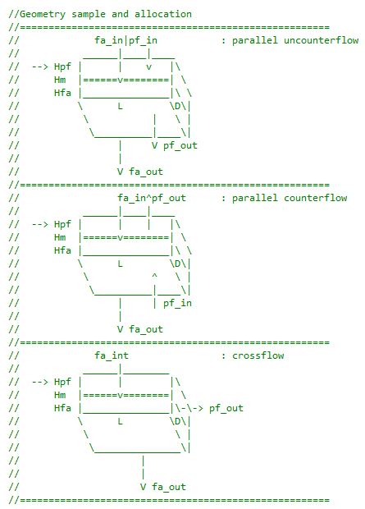

|  |  |  |
| --- | --- | --- |
| Parameter | | Description |
| length_dev | | length of device, m |
| deep_dev | | deep of device, m |
| height_feedchanel | | height of feedair channel, m |
| height_permeatechanel | | height of permeateflow channel, m |
| thick_membrane | | membrane thickness, m |
|  | |  |
| segment_length | | segment number of L-direction |
| segment_deep | | segment number of D-direction |
| layernum_membrane | | layer number of membrane |
| flowtype_device | | flow configuration1parallel uncounterflow; 2:parallel counterflow; 0 or 3 or othercrossflow |
| Parameter | | Description |
| poreradius_membrane | | pore radius of membrane,m (need it if membrane_model=0) |
| porosity_membrane | | porosity of membrane,(-) (need it if membrane_model=0) |
| tortuosity_membrane | | tortuosity of membrane,(-) (need it if membrane_model=0) |
| thermocond_membrane | | membrane thermocondivity,kW/m-K (need it if membrane_model=0) |
| Parameter | Description |
| mass_feedflow | mass flow rate @ feedair, kg/s |
| temp_feedflow | feedair temp, K |
| rh_feedflow | rh@feedair, (dimensionless) |
| press_feedflow | feedair pressure, Pa |
| mass_permeateflow | mass flow rate @ permeateflow, kg/s |
| temp_permeateflow | peameateflow temp, K |
| rh_permeateflow | rh@peameateflow, (dimensionless) |
| press_permeateflow | peameateflow pressure, Pa |
| Parameter | | Description |
| flowcondition_permeate | | 0: A2V,vapor only in permeateflow; 1: A2A,air in permeateflow |
| membrane_model | | 0: default model; 1: Dais data; 2: constant value-model |
| htc_correction | | HTC correction (0-1), (-) |
| ftc_correction | | FTC correction (0-1), (-) |
| mt_impact_ht | | 0: not enabled; 1: enabled mass permeated on ht impact |
| memsurf_correction | | membrane surface deflection (0-inf, 1 means perfectly flat) |

# Output parameter introduction

## General outputs

|  |  |
| --- | --- |
| Parameter | Description |
| tfa_in(c) | feedair temp @inlet |
| tfa_out(c) | feedair temp @outlet |
| humidfa_in(kg/kg) | feedair humidity ratio @inlet |
| humidfa_out(kg/kg) | feedair humidity ratio @outlet |
| rhfa_in | feedair RH @inlet |
| rhfa_out | feedair RH @outlet |
| Pvapfa_in(pa) | feedair vapor pressure @inlet |
| Pvapfa_out(pa) | feedair vapor pressure @outlet |
| tpf_in(c) | permeateflow temp @inlet |
| tpf_out(c) | permeateflow temp @outlet |
| humidpf_in(kg/kg) | permeateflow humidity ratio @inlet |
| humidpf_out(kg/kg) | permeateflow humidity ratio @outlet |
| rhpf_in | permeateflow RH @inlet |
| rhpf_out | permeateflow RH @outlet |
| Pvappf_in(pa) | permeateflow vapor pressure @inlet |
| Pvappf_out(pa) | permeateflow vapor pressure @outlet |

## Parallel and counter flows

|  |  |
| --- | --- |
| Parameter | Description |
| X/L_index | segment index |
| tfa(c) | feedair temp |
| tfam(c) | temp of interfacial membrane at feedair-side |
| humidfa(kg/kg) | feedair humidity ratio |
| pvapfa(pa) | feedair vapor pressure |
| flfa(kg/s) @per_segment_per_channel | feedair flow rate per_segment_per_channel |
| tpf(c) | permeateflow temp |
| tpfm(c) | temp of interfacial membrane at permeateflow-side |
| humidpf(kg/kg) | permeateflow humidity ratio |
| pvappf(pa) | permeateflow vapor pressure |
| flpf(kg/s) @per_segment_per_channel | permeateflow flow rate per_segment_per_channel |
| vappermeat(kg/m2/s) from feed-side to permeate-side @per_segment_per_channel | permeated vapor rate @per_segment_per_channel |

## Crossflow

|  |  |
| --- | --- |
| Parameter | Description |
| D/L_index | segment index in D/L directions |
| Tfa(c)_map | feedair temp |
| tfam(c)_map | temp of interfacial membrane at feedair-side |
| humidfa(kg/kg)_map | feedair humidity ratio |
| pvapfa(pa)_map | feedair vapor pressure |
| flfa(kg/s)_map @per_segment_per_channel | feedair flow rate per_segment_per_channel |
| tpf(c)_map | permeateflow temp |
| tpfm(c)_map | temp of interfacial membrane at permeateflow-side |
| humidpf(kg/kg)_map | permeateflow humidity ratio |
| pvappf(pa)_map | permeateflow vapor pressure |
| flpf(kg/s)_map @per_segment_per_channel | permeateflow flow rate per_segment_per_channel |
| vappermeat(kg/m2/s)_map from feed-side to permeate-side @per_segment_per_channel | permeated vapor rate @per_segment_per_channel |