Use of Environmental DNA for early detection of invasive species, *Elodea canadensis and Elodea* *nuttallii,* in interior Alaska.

Benson, Anna-Marie1, Ora Russ2, James L. Fox3, Richard F. Lance4

**Abstract**

*Elodea* is an invasive genus in Alaska and its spread is a conservation threat to native salmon species. We developed *Elodea* markers and tested their efficacy as an early detection technique for inventorying this genus. We developed four qPCR assays: *Elodea canadensis*, *Elodea* *nuttallii*, and two *Elodea* genera markers. We tested the efficacy of the markers by sampling at a known *Elodea* infestation in Chena Lakes, Alaska (64.775°N, 147.232°W). We also used captive *Elodea* plants in two, 19-liter containers to evaluate the detection of their eDNA as a function of distance from the source during 2018 and 2019, at the Small Arms Complex Pond, Fort Wainwright, Alaska (64.811°N, -147.661°W). Our species-specific primers were effective in identifying *Elodea* from eDNA that has been extracted from water samples from thick *Elodea* infestations in 5 of 5 samples. However, in our controlled infestation, Elodea eDNA was present in 2 of 2 samples collected at the plants and was not detected at 76 locations (152 one-liter samples) that ranged from 1m to 100 m from the plants. Because *Elodea* eDNA could only be detected at the source, we found no evidence to support the use of an eDNA collection protocol for the early detection of *Elodea* infestations in Alaska.

Key Words: *Elodea*, eDNA, Alaska, inventory, early detection, invasive

1.U. S. Fish and Wildlife Service, Fisheries and Ecological Services, 101 12thAve, Fairbanks AK, 99701

2.U. S. Fish and Wildlife Service, Conservation Genetics Laboratory, 1011 E Tudor Rd, Anchorage, AK 99503

3.U.S. Fish and Wildlife Service, Yukon Flats National Wildlife Refuge, 101 12th Ave, Fairbanks AK, 99701

4.U.S. Army Corps of Engineers, Environmental Laboratory, 3909 Halls Ferry Rd. Vicksburg, MS, 39180

**1 INTRODUCTION**

*Elodea* is an aquatic submerged plant that is native to much of North America. There are two invasive species of *Elodea* in Alaska: *E. canadensis* (Canadian Waterweed)and *E. nuttallii* (Western Waterweed). Invasive *Elodea* is an immediate threat in Alaska because dense stands degrade salmon spawning habitat and impede boat and float plane movement on lakes (Carey et al. 2016). *Elodea* can be spread via boats and floatplanes, and because it can reproduce vegetatively, a single fragment can start a new infestation. Recent modeling data predicts some of the highest risk for future *Elodea* introductions via float plane traffic is associated with regions such as Bristol Bay (Schwoerer et al. 2022), which supports the world’s largest sockeye salmon runs (Cunningham et al. 2019).

In Alaska, the most common detection methods for *Elodea* are visual searches from boats, airplanes and, to a lesser extent, scuba diving. Visual searches are aided by the retrieval of a rake thrown from a boat or shoreline. To detect *Elodea* before eradication becomes difficult or infeasible, alternative methods have been suggested for inventorying and monitoring this species. Because recent publications have demonstrated the use of environmental DNA, hereafter eDNA, (i.e., the genetic material that can be extracted from an environmental sample (e.g., water), as an effective tool to determine whether a species is present (Barnes & Turner 2016, Thomsen and Willerslev 2015), this method has been suggested for inventorying new outbreaks of *Elodea* in Alaska.

A few publications have shown that eDNA could be a useful tool for detecting plant species, although several factors may affect the detection process. For example, Kuehne et al (2020) found that detection of *Myriophyllum spicatum* and *Egeria densa* was affected by plant growth, senescence, and abundance. Additionally, in a heavy infestation of *Elodea canadensis* in Lake Steinsfjorden in Norway, eDNA concentration varied seasonally within the lake, and as a function of distance in the outlet stream Tveia (Angles d’Auriac et al 2019). In some plant species, eDNA has been used consistently for detection; *Hydrilla verticillata* was detected using eDNA in ponds where it had been previously detected using visual observations (Matsuhashi et al. 2016, Gantz et al 2018). Similarly, Fujiwara et al. (2016) found that the eDNA from *Egeria densa* could be detected when the species was observed visually.

Although *Elodea* eDNA can be detected consistently from a dense population (Angles d’Auriac et al 2019), we found no information about the efficacy of using eDNA has an early detection method for invasive plant species. A species would be a good candidate if its eDNA could be detected at a reasonable distance from a low-density infestation. Gantz et al (2018) found that eDNA from small amounts of *Elodea* (.25-25g) could be detected with certainty in an aquarium (length = 50.8 cm, width = 25.4 cm, height = 30.48 cm), yet it’s unclear how these densities could be detected in a natural environment. An estimate of detection distance is needed from a low-density outbreak in a cold-water Alaska lake within one year of introduction of this species to design a sampling plan using eDNA as an early detection method.

We had 3 objectives in this investigation: 1.) Develop qPCR assays for *E. canadensis* and *E.* *nuttallii,* 2.) Evaluate whether assays and markerscould be used to identify species from eDNA that has been extracted from water samples, and 3.) Evaluate whether eDNA could be used as an early detection tool for a two, permeable 19-liter containers of l *Elodea* in a 5.6-hectare water body. Our statistical objective was to determine the distance *Elodea* eDNA could be detected from two, permeable 19-liter containers of Elodea plants in a 5.6-hectare water body with a minimum of 80% probability of site occupancy (whether or not the eDNA occupies a sample unit) and 95% confidence.

**2 MATERIALS AND METHODS**

*2.1 Assay Development and Testing*

A suite of four qPCR assays for *Elodea* eDNA were designed by the US Army Engineer Research and Development Center (ERDC, Vicksburg, MS). These four qPCR assays include two *Elodea* genera markers (to identify *Elodea* regardless of lineage/hybridization status) a marker for *E. canadensis* and a marker for *E.* *nuttallii*. New infestations in Alaska are morphologically challenging to distinguish interspecifically, therefore developing both genus-selective and species-selective markers allows for a robust approach to identify *Elodea* and understand how it may be spreading. Whole chloroplast DNA (cpDNA) sequencing was conducted using keyed out voucher specimens from all *Elodea* species known. Specimens were obtained from *E. canadensis*, *E. nuttallii*, and *E. bifoliate*. Whole cpDNA molecules were extracted from plant tissues following Mariac et al. (2000). Solutions of cpDNA from each sample were prepared for paired-end sequencing-by-synthesis (SBS) using Nextera XT Index Kits (illumina®, San Diego, CA), with unique nucleotide indexes attached to the sequencing libraries for each sample. For each sample we prepared duplicate libraries, each with a unique index. SBS was performed on all 10 libraries using the illumina® MiSeq system and 150 base-pair (bp) paired-end reads. MiSeq Reporter Software (illumina®) was used to sort the resulting pool of sequences by index into separate data sets. For each sample (duplicates treated individually), paired DNA sequence reads were identified and merged in Geneious R9 (Biomatters Ltd., Auckland, New Zealand). Chloroplast DNA genomes were assembled by aligning the reads to a complete cpDNA sequence for ELCA7 (NC_018541) found in the National Center for Biotechnology Information (NCBI) online genetic data repository GenBank (Benson et al. 2013), using the medium sensitivity/fast settings in Geneious R9. Aligned sequences were visually scanned for highly conserved regions for genus-level marker development and for highly, variable regions for species-level marker development. Forward and reverse primers, and associated probes, were designed using Primer3 version 2.3.4 (Rozen and Skaletsky 1999) as embedded in Geneious R9. Markers were then tested for potential non-target cross-amplification issues using Primer-BLAST (Ye et al. 2012) as provided online by NCBI.

An initial batch of 21 draft markers was selected and tested for relative sensitivity (to 1 ng/µl of cpDNA) from each of E. canadensis, E. nuttallii and E. bifoliata). The DNA concentrations of *Elodea* cpDNA extracts were measured using a NanoDrop 1000 spectrophotometer (Thermo Fisher Scientific, Waltham, MA, USA) and used to create 1 ng/μL cpDNA solutions in sterile, DNAse-free water. The qPCRs contained1X TaqMan® Environmental Master Mix 2.0 (Applied Biosystems, Foster City, CA, USA), 0.5 μM of each primer, 0.125 μM of probe, 1 μL of the 1 ng/μl cpDNA template (final approximate mass of template DNA = 0.05 ng), and DNAse free/sterile water to achieve a total volume of 20 μL. The qPCR thermal cycle program was run on a ViiA™ 7 Real-Time PCR System (Applied Biosystems) and included an initial 10 min. denaturation step at 95° C, followed by 40 cycles of 95° C for 15 sec. and 60° C for 60 sec. Each combination for draft marker and *Elodea* cpDNA template was run as three replicate qPCRs and the mean cycle number at which fluorescence crossed the detection threshold (Ct) was used as a basis for comparisons of performance among markers. At the end of these trials, we eliminated 15 markers from further testing and carried six potential markers into specificity testing.

Specificity testing was conducted with specimens collected from 15-non-target co-occurring aquatic plants and one multi-cellular algae (Chara) across multiple locations with *Elodea* infestations representing Fairbanks Borough regions and Valdez-Cordova regions (Table 1 from report). ERDC extracted whole genomic DNA (gDNA) from each plant sample using modified cetyltrimethyl ammonium bromide (CTAB) methodology (Doyle and Doyle 1987). Following methods described in Farrington et al. (2015), we created standard test gDNA solutions of 1 ng/μL in sterile, DNAse-free water for each sample following DNA quantitation with the Nanodrop 1000. We then tested each sample against the remaining six potential markers using qPCR, 1 μl DNA template, and reaction protocols described above. Samples were identified by staff Missouri Botanical Garden and archived as voucher specimens. Following the above non-*Elodea*-target testing, the six markers were tested for intrageneric amplification using both E. Canadensis and E. nuttallii plant tissue samples from multiple regions in Alaska (Cordova-Valdez, Fairbanks Borough, Yukon-Koyukuk Borough). Whole gDNA was extracted as described above and using the qPCR conditions above.

The initial sensitivity and specificity testing narrowed down the marker suite to four optimal performing markers, with two markers targeting *Elodea* plants in general, one marker targeting *E. canadensis*, and one targeting *E. nuttallii*. These four markers were designated Elod-1, Elod-2, ELCA7-1, and ELNU2-1, respectively (Table with sequences and length and dye prob label info.).

The final suite of four markers were evaluated for limits of detection (LOD’s) and limits of quantification (LOQ’s) using custom designed synthetic double-stranded DNA fragments (gBlocks®; Integrated DNA Technologies, Coralville, IA, USA) matching each of the select eDNA markers. For LOD’s, serial dilutions were created with classes of 2, 4, 8, and 16 copies/μl.

*2.2 Study Area*

Water samples were collected to field validate markers on two dense *Elodea* infestations: at Chena Lakes near Fairbanks, Alaska (64.775°N, 147.232°W), and Potter Marsh, Anchorage Alaska (61.0561°N, 149.7972°W). Elodea plants, sourced from Chena Lakes with an approved permit, were introduced to the Small Arms Complex Pond (SAC Pond, Fig. 1) located on Fort Wainwright, Alaska, approximately 10 miles from Chena Lakes, on 14 August 2018. Access to the 5.6-hectare water body was controlled by military personnel (Fig. 2).

Two 19-liter permeable containers were loaded 25% full of *Elodea* (Fig.2), which was obtained from Chena Lakes and moved to the SAC Pond within one hour of removal. Both containers had windows on the sides and top that were covered with mesh that allowed water to flow through. The openings in the wire mesh were 2.5 mm x 2.5 mm to contain *Elodea* plant fragments and any seeds. *Elodea* seeds are typically 4-5 mm long, fusiform, round, and narrowly cylindrical. One container was anchored at the northern side of the lake and the second container was anchored at the southern part of the lake. The containers were opened and examined biweekly during the summer to monitor plant growth and scrub algae off mesh to ensure water flow-through.

*2.3 Sample Design*

In 2018, we used a 25m x 25m grid to define our sample frame as a list of grid cells. Our sample unit was defined as a grid cell, where two one-liter samples were collected. We used stratified random sampling where all grid cells within 50 m of each plant that could be sampled from the shoreline were sampled (shallow strata) and we randomly selected grid cells that did not touch the shoreline (deep strata). This resulted in our closest sample being 10meters from an Elodea plant. Sampling was conducted on 27 September 2018. Because we had no positive eDNA hits at any sample locations, we reduced the size of the grid and sampled more closely to the plants in 2019.

In 2019, we reduced the grid size to 12.5m x 12.5m grid and used the same sampling strategy used in 2018 (except we randomly sampled the shoreline grid cells). Note that final sample locations were not always the center of the grid cell in the deep area, because wind and drifting in the boat. We also collected several other samples: at the source of the plants, 1m, 3m and 5m from the container s. Additionally, in 2019 we used a transect sampler for 10 grid cells sampled with one-liter draws.

We estimated sample sizes required to estimate probability of site occupancy as a function of distance from known Elodea source using a multi-level occupancy model (Nichols et al 2008, Mordecai et al 2011, Schmidt et al 2013). We simulated presence-absence data with an average 80% probability of site occupancy (site occupancy was simulated to decrease as a function of distance from Elodea source), 60% availability probability and 90% detection probability. The 80% site occupancy was our statistical objective, and we selected these availability and detection probabilities based on previous studies and our own expertise. We estimated the parameter estimates from each simulation and results were stored, then simulations were repeated 1,000 times. Confidence intervals were estimated for parameter estimates using the stored results. Our results indicated we needed a minimum of 25 sampled grid cells, 2 water samples collected at each site, and these water samples were split into triplicate for the PCR analysis in the lab.

Figure 1. Map of Alaska and inset Small Arms Complex Pond, Fort Wainwright, Alaska, with the 12.5m x 12.5m grid used to define our sample units in 2019. Captive *Elodea* plants are illustrated with a dark grey diamond and water samples collected on 8/28/2019 are the filled black circles.

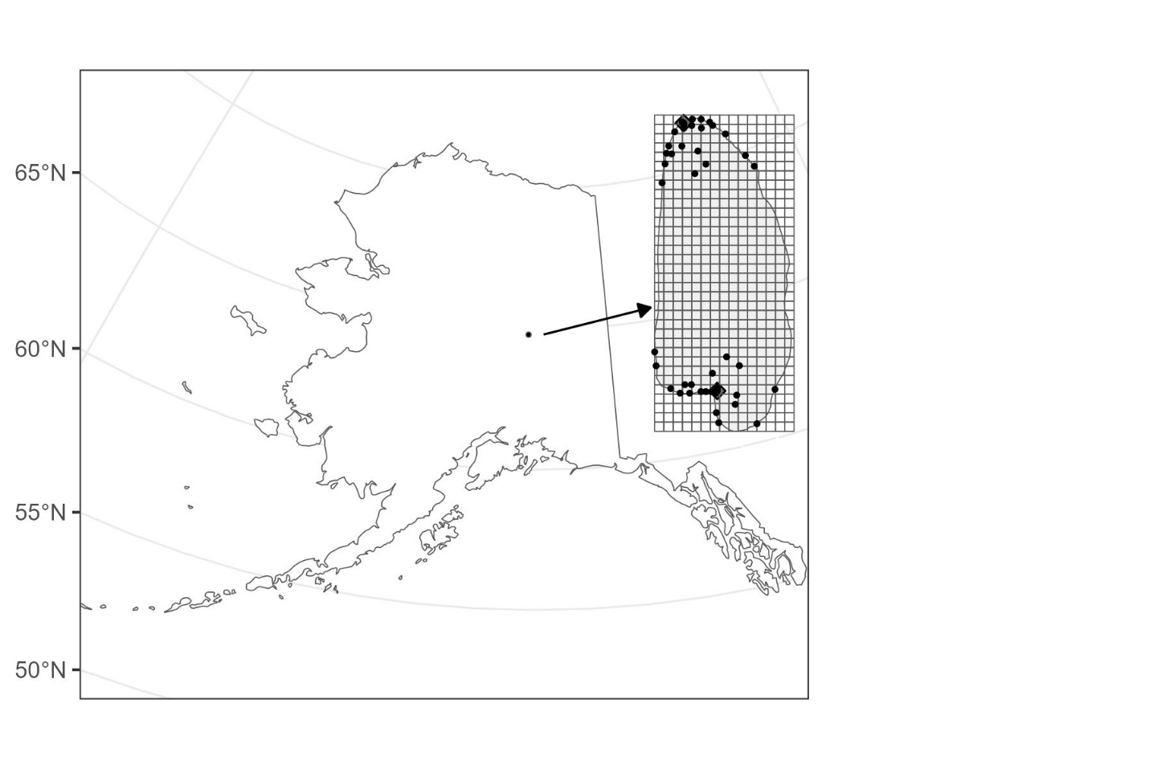

*2.4 Sample Collection*

Our eDNA sampling protocol was based on Carim et al. (2016), Dunker et al. (2016), and Evans and Lamberti (2017). Sampling locations were accessed from the shoreline, without entering the water when possible, and from a canoe or rowboat when sample locations could not be accessed from the shoreline. Latex gloves were worn and changed after each sample was collected. The point-of-entry for water into the collection device was approximately 20 cm below the surface (Newton et al 2016).

Each 1-liter water sample was filtered through a Whatman GF/Filter (1.2 micron). After collection of each 1 L sample the collection device was removed from the water with the pump running for approximately 30 seconds to dry the filter. The filter assembly and collection tube should not be allowed to touch anything out of context with the site (e.g. worker skin, clothing, or other anthropogenic items).

Sterile forceps were then removed from a protective bag and used to remove and fold the filter (dirty side inward) and placed into a sterile sample bag and sealed shut. The sample bag was then labeled with date, site identification number, GPS coordinates, number of filters sampled, and worker initials. The sample bag was stored in a cooler with an ice pack until taken back to a freezer (within 24 hours) at the USFWS Fairbanks laboratory for temporary storage before being shipped to the Conservation Genetics Laboratory (CGL) in Anchorage, Alaska.

*2.5 Sample Genetic Analysis*

Once at the CGL, 3 PCR replicates were extracted from each of the samples. All filter samples were tested for Elodea eDNA at U.S. Fish & Wildlife’s Conservation Genetics Laboratory (Anchorage, AK). DNA was extracted from filter samples using The Qiagen DNeasy® Blood & Tissue Kit and Investigator® Lyse & Spin Kits (Qiagen GmbH, Hilden, Germany). The standard DNeasy protocol was modified to utilize the Lyse&Spin tubes for the filter digest stage. The entire filter was digested in adjusted volumes of 370 µL of ATL buffer and 25 µL of proteinase K for a final volume of 395 µL per sample. A total of 400 µL each of AL and ethanol was added to the supernatant following digestion and discarding of field filters. The volumes for Buffers AW1 and AW2 adhered to the DNeasy handbook. The final elution was adjusted to 120 µL of Buffer AE at 55°C.

Fig.2. Two containers containing *Elodea* were anchored at the North and South limits of the SAC Pond.

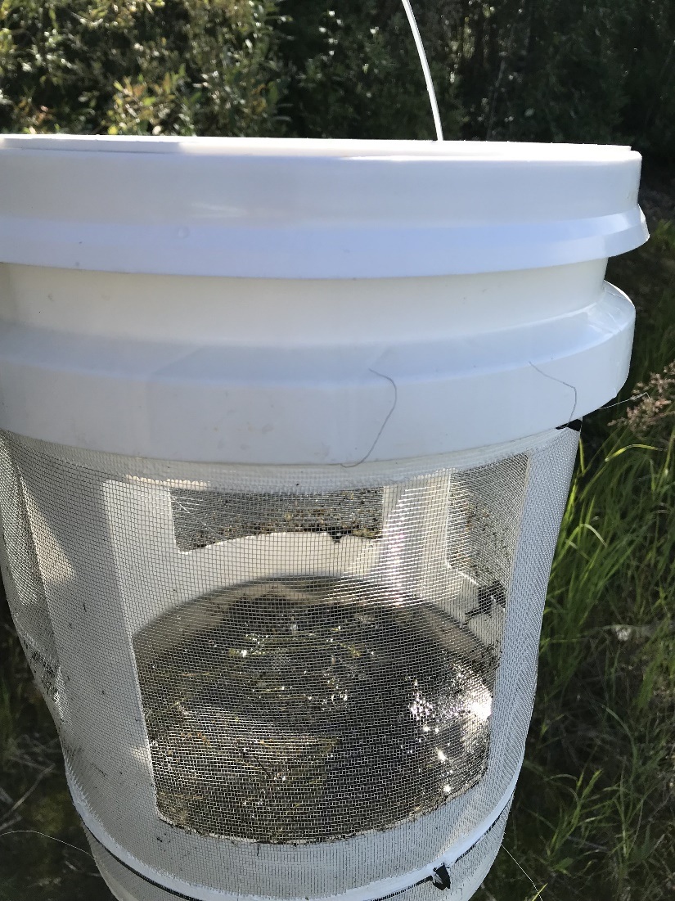

**3 RESULTS**

We developed species-specific primers and demonstrated that these markers can identify species from eDNA that has been extracted from water samples. The five water samples taken at Chena Lakesall showed high concentrations of eDNA. Additionally, water samples taken at the SAC Pond, also contained *Elodea* eDNA in both samples taken at the source.

The Elodea plants in the containers appeared to flourish during both summers. In 2019, by mid-July the plants were bright green and doubled their volume from the early spring. In 2018, we sampled 30 grid cells and collected 2 one-liter samples at each grid cell. Elodea was not detected in any of the 60 water samples. In 2019, we collected more samples closer to the Elodea source (Fig. 3), however Elodea was only detected in water samples collected at the plants and not detected at 46 other locations (absent in 92 1-liter samples). Inside? both Elodea containers, the two one-liter samples had positive detections of Elodea. Samples collected greater than or equal to one meter from the containers did not contain Elodea eDNA.

Fig. 3. Distribution of water samples as a function of distance from Elodea plant at the Small Arms Complex Pond (SAC Pond) at Fort Wainwright, Alaska. In 2018, 30 grid cells were sampled, and 2 one-liter samples were collected at each grid cell. In 2019, 2 one-liter samples were collected at 48 locations.

**4 DISCUSSION**

Our results support the use of eDNA to detect dense infestations in interior Alaska. We found no evidence to support the use of an eDNA collection protocol for the early detection of *Elodea* in a small, cold-water lake in central Alaska. Despite healthy plant growth, more than doubling its volume, the eDNA from the plants was only detected at the source. This was not surprising as Kuehne et al (2020) found low levels of detection and concluded there were substantial hurdles to use eDNA

for early detection of aquatic invasive plants.

We found that *Elodea* eDNA could be detected with a water sample within a few cm of its source in agreement with the findings of Gantz et al (2018). However, beyond detections at the source, we did not detect eDNA elsewhere in the SAC Pond. Although plants do not release constant amounts of DNA (Matsuhashi et al 2016), both of our sampling events at the SAC Pond occurred during autumn, which has been shown to be the peak of eDNA concentrations for *E. candadensis* in lake Steinsfjorden in Norway (Angles d’Auriac et al 2019). It should also be noted that although Angles d’Auriac et al (2019) did detect *Elodea* eDNA downstream from an infestation, *Elodea* fragments were likely present downstream from the infestation, and it is not possible to know whether sample locations were close to undetected *Elodea* fragments.

Our sampling was limited to inference at this single lake. Still, this study was a realistic application of using water samples to detect eDNA from an invasive species. In interior Alaska, lakes are reliably ice free for no more than five months and an autumn sampling event is likely the best temporal window to collect Elodea eDNA. Additionally, it is unlikely a more spatially robust experiment could be conducted on *Elodea*-free lakes in an extreme cold-water environment like interior Alaska, as it was non-trivial to obtain permits to introduce an invasive species, despite security assurances that prevented spread. However, we found no evidence of eDNA detection from a small amount of contained Elodea, as would be seen in an accidental release. Our study will be used to inform biologists that at this time, visual inspection is a better approach to *Elodea* detection than eDNA from water samples.

**ACKNOWLEDGEMENTS**

This project was funded by the United States Fish and Wildlife Service. The Anchorage Conservation Genetics Laboratory and the Northern Alaska Field Office helped with sampling and supported the project. Joshua Buzby, Fort Wainwright Alaska, was instrumental in supporting field operations at the SAC Pond. The opinions and findings expressed herein are those of the authors and do not necessarily represent the United States Fish and Wildlife Service.

## REFERENCES

Angles d’Auriac M.B., Strand D.A., Mjelde M., Demars B.O.L., Thaulow J. (2019). Detection of an invasive aquatic plant in natural water bodies using environmental DNa. PLoS ONE 14(7): https://doi.org/10.1371/journal.pone.0219700

Barnes M.A., Turner C.R. (2016). The ecology of environmental DNA and implications for conservation genetics. Conservation Genetics, 17(1),1-17.

Carim K.J., K.S. McKelvey, M.K. Young, T.M. Wilcox and M.K. Schwartz. (2016). A protocol for collecting environmental DNA samples from streams. Gen. Tech. Rep. RMRS-GTR-355. Fort Collins, CO: U.S. Department of Agriculture, Forest Service, Rocky Mountain Research Station. 18 p.

Carey M.P., Sethi S.A., Larsen S.J., Rich C.F. (2016). A primer on potential impacts, management priorities, and future directions for Elodea spp. in high latitude systems: learning from the Alaskan experience. Hydrobiologia, 777(1), 1-19.

Dunker K.J., A.J. Sepuldveda, R.L. Massengill, J.B. Olsen, O.L. Russ, et al. (2016). Potential of environmental DNA to evaluate Northern Pike (*Esox Lucius*) eradication efforts: An experimental test and case study. PLOS ONE 12: e0173837.<https://doi.org/10.1371/journal.pone.0173837>.

Cunningham, C.J., Anderson, C.M., Yun-Ling Wang, J., Link, M. and Hilborn, R. (2019). A management strategy evaluation of the commercial sockeye salmon fishery in Bristol Bay, Alaska. Canadian Journal of Fisheries and Aquatic Sciences76(9), 1669-1683.

Evans N.T. and G.A. Lamberti. 2017. Freshwater fisheries assessment using environmental DNA: A primer on the method, its potential, and shortcomings as a conservation tool. Journal of Fisheries Research: <http://dx.doi.org/10.1016/j.fishres.2017.09.013>.

Fujiwara A., Matsuhashi S., Doi H., Yamamoto S., Minamoto T. (2016). Use of environmental DNA to survey the distribution of an invasive submerged plant in ponds. Freshwater Science 35(2),748-754.

Gantz C.A., Renshaw M.A., Erickson D., Lodge D.M., Egan S.P. (2018). Environmental DNA detection of aquatic invasive plants in lab mesocosm and natural field conditions. Biological Invasions 20, 2535-2552.

Kuehne L.M., Ostberg C.O., Chase D.M., Duda J.J., Olden J.D. (2020). Use of environmental DNA to detect the invasive aquatic plants *Myriophyllum spicatum* and *Egeria densa* in lakes. Freshwater Science 39(3), 521-533.

Matsuhashi S., Doi H., Fujiwara A., Watanabe S., Minamoto T. (2016). Evaluation of the environmental DNA method for estimating distribution and biomass of Submerged aquatic plants. PLoS ONE 11(6): e0156217. doi:10.1371/journal.pone.0156217

Mordecai R.S., Mattsson B.J., Tzilkowski C.J., Cooper R.J. (2011). Addressing challenges when studying mobile or episodic species: Hierarchical Bayes estimation of occupancy and use. Journal of Applied Ecology 48(1), 56-66.

Newton J., Sepulveda A., Sylvester K., Thum R.A. (2016). Potential utility of environmental DNA for early detection of Eurasian watermilfoil (*Myriophyluum spicatum*). Journal of Aquatic Plant Management. 54:46-49.

Nichols J.D., Bailey L.L., O’Connell A.F. Junior, Talancy N.W., Campbell Grant E.H., Gilbert A.T., Annand E.M., Husband T.P., Hines J.E. (2008). Multi-scale occupancy estimation and modeling using multiple detection methods. Journal of Applied Ecology 45, 1321-1329.

Schmidt B.R., Kery M., Ursenbacher S., Hyman O.J., Collins J.P. (2013). Site occupancy models in the analysis of environmental DNA presence/absence surveys: a case study of an emerging amphibian pathogen. Methods in Ecology and Evolution 4(7), 646-653.

Schwoerer, T., Morton, J. (2018). Human dimensions of aquatic invasive species in alaska: lessons learned while integrating economics, management, and biology to incentivize early detection and rapid response. In: Lewis T (ed) Alaska: economic, environmental, and social issues. Nova Science Publishers Inc, New York City, pp 1–46.

Schwoerer, T., Dial, R.J., Little, J.M., Martin A.M., Morton, J.M., Schmidt, J.I., Ward, E.J. (2022). Flight plan for the future: floatplane pilots and researchers team up to predict invasive species dispersal in Alaska. *Biol Invasions* **24**, 1229–1245. https://doi.org/10.1007/s10530-021-02712-3

Thomsen P., Willerslev E. (2015). Environmental DNA-An emerging tool in conservation for monitoring past and present biodiversity. Biological Conservation 183 (1),4-18.