Reviewers’ comments in blue; Response in black.

We thank the editors and all reviewers for the constructive assessment of our work. Here, we provide a track-changed revised manuscript along with this point-by-point response to all reviewers’ comments.

Reviewer #1: Very well argued results and thoughtful discussion. The paper is an important public health contribution to the literature.

We thank the reviewer for the careful consideration of our manuscript.

1. The paper is very long and complex, and it does sometimes feel like the key messages get lost in the detail, especially in the figures, and then reduced into a single message ''test the symptomatics'', when it feels like there is more complexity there. I had difficulty, though, coming up with suggestions as to what to move to the Supplements, as each figure did add significantly.

While preferentially testing symptomatic individuals over asymptomatic persons is one of the key conclusions of our study, we also found that (1) test-and-isolation would only achieve its greatest impact if Re<1.5, and as such (2) other public health interventions (e.g. vaccination, physical distancing, masking, etc.) would be needed to lower $R_{e}$ such that testing in conjunction would achieve the greatest reduction in transmissions, and (3) if there are excess test availability such that symptomatic testing demand is satisfied, asymptomatic screening should be preferentially be taking place in households given the relative larger household sizes expected in many LMICs. We therefore agree with the reviewer that each figure provided support of these conclusions and thus chose to retain all figures and sections within the main manuscript.

1. There is almost no discussion on Table 1 - the practical implications for health care planners. May be useful to toss in ''If Zambia had 10 million tests during January 2022 during the Omicron initial wave, and used it as suggested in symptomatic patients in xxx scenarios, x number of infections would have been averted if no household quarantining'' and ""If Thailand had 30 million tests etc etc"", in one para in the discussion.

We have now more explicitly discussed the implication of Table 1 and included similar statements suggested by the reviewer in the Discussion:

Line 392: “***For instance, if Zambia had ~10 million Ag-RDTs available through the first three months (i.e. ~600 tests/100k/day over three months for 18 million people) of its first Omicron wave ($R_{e}$ ~2.5) which were only used for symptomatic testing, ~37,000 infections could likely be averted. However, if testing rate was at 100 tests/100k/day, the number of infections averted drops nearly 10-fold to ~3700 cases averted on average despite only a 6-fold reduction in testing****.*

*If $R_{e}<$ 1.5, or can be reduced to that point through other public health interventions, increasing testing capacity from 100 tests/100k/day to 200-400 tests/100k/day provides the greatest proportional reduction in secondary transmissions. Furthermore, testing has the potential to be most effective at reducing transmission when 1.5.* ***We would also obtain the greatest reduction in transmissions through increased testing volumes if ~1.0 (Table 1).*** *As SARS-CoV-2 outbreaks can have appreciably above 1.5, it is important to combine testing with other public health measures such as vaccination, physical distancing and masking so as to maximize impact.*”

1. Introduction para 3: PCR is also a very imperfect test for transmissability, as it stays positive long after infectiousness has ended. Ag testing positivity is pretty well correlated with infectiousness. This para could be summarized into a single sentence or two, highlighting the pros and cons of the two.

We agree and have now revised paragraph 3 of the introduction:

Line 115: “*Furthermore, RNA can still be detected even after infectiousness has declined, rendering PCR tests imperfect for determining the infectious potential of an infected person.[11] While the sensitivity of antigen rapid diagnostic tests (Ag-RDTs) is lower than PCR(>80%)[12], Ag-RDTs are cheaper, capable of producing results in under 30 minutes and can be performed easily at point-of-care.[13] As such, when used in a timely fashion, Ag-RDTs can identify potentially infectious people more quickly. Ag-RDTs offer a practical alternative diagnostic tool to enable massive scale up of testing in all countries. In resource-limited settings, Ag-RDTs could potentially reduce the testing equity gap between HICs and LMICs.[5]*”

1. You could be provocative and have a para talking to why this (or similar assumptions) could apply to HIC countries too? I honestly cant see why not. PCR testing is never going to cut it, and Omicron transmission dynamics are such a leveler, that many assumptions are going to apply across the board.

See response to point 3 above.

Reviewer #2: An excellent modeling study looking at the role of rapid antigen tests in reducing transmission of SARS-CoV-2. It is incredibly well written and an excellent study on an important topic that will be a nice contribution to the literature.

I have a few minor questions and comments which I think should be addressed to make it stronger.

We thank the reviewer for the careful consideration of our work.

1. I would recommend adding citations to line 57 on page 4 since the impact of testing on transmission reduction has been a bit controversial. There are some studies that have shown a benefit, including: https://jkms.org/DOIx.php?id=10.3346/jkms.2020.35.e396 and <https://www.thelancet.com/journals/landig/article/PIIS2589-7500(20)30241-7/fulltext>

It should be noted that both references provided by the reviewers assessed the impact of test-and-trace programs on transmission reduction in high-income countries (i.e. South Korea and UK). It is important to differentiate between test-and-trace and test-and-isolation (i.e. the only intervention is the required isolation of individuals with a positive diagnosis and no further contact tracing) since many LMICs did not implement contact tracing programs given the large amount of resources required. We have thus included the suggested citations in the following revised text instead:

Line 128: “*Furthermore, while there have been studies investigating the impact of comprehensive test-and-trace programs on transmission reductions,[14,15] it is less clear to what extent a test-and-isolation strategy (i.e. the only intervention is the required isolation of individuals with a positive diagnosis) would impact total infections. It is thus important to estimate the impact of test-and-isolation only since most low-resource settings did not implement resource-intensive contact tracing programs.[16]*”

1. In line 79 on page 5, small grammatical correction: please change "it is" to "they are"

Changed.

1. Throughout the paper the authors use R0 (for instance on page 8, line 36). I wonder if they actually mean Re (effective reproductive number). If so, would update this.

We have now revised the manuscript using $R_{e}$ only to avoid confusion.

1. In your methods, please clarify on what day of symptoms patients are being tested in your model. I assume there is a range? This will be important in terms of the effectiveness of the intervention (if tested earlier in the course of symptoms, impact is likely to be greater)

Our assumptions on testing delay since symptom onset were only described in the technical details of the model in the Supplementary Materials previously. We have now stated them in the main text as well:

Line 230: “*We assumed that symptomatic individuals would seek testing at clinics based on a probability distribution that inversely correlate with the distance between their homes and the nearest clinic[23] (Table S1).* ***We assumed that the time delay between testing and symptom onset follows lognormal distribution of with mean of one day and standard deviation of 0.5 day.***”

1. Lines 224-226: I was thinking about the "false negative" rapid tests that would be expected. It wasn't clear to me how these were addressed.

Since we are modelling to determine the impact of testing on reducing infections, the only behavioural changes that result in transmission reduction would be isolation upon positive tests or by an asymptomatic household member going into quarantine (under the close contact quarantine scenario). There is some likelihood that a person with symptoms would self-isolate but we had assumed this to be low (10%). As such, (line 247) “*we also assumed that SARS-CoV-2 infected individuals who were tested but received a false negative result continue mixing with the community. In turn, any false positive tested individual would then go into isolation*”.

1. The findings in lines 251-253 on page 13 are sobering. The effective reproductive number of the omicron variant was around 3.5 (citations: https://pubmed.ncbi.nlm.nih.gov/35262737/ and https://europepmc.org/article/MED/35262737). This number is well above the values where you showed a benefit to testing. I think this should be addressed explicitly in the manuscript. How much does testing alone at the levels you were modeling matter in terms of impact on an outbreak?

It should be noted that the article cited by the reviewer collated $R_{e}$ estimates from various studies performed globally for data collected around December 2021 and reported Re~3.4 as the mean value averaged across all estimates. The actual $R_{e}$ estimate from each individual study, however, ranges between 0.88 and 9.4, depending on the location and methodology used to estimate these $R_{e}$ values. A better summary representation of potential $R_{e}$ values across these studies is the median value Re~2.8 with an interquartile range of 2.0-3.8. We had simulated epidemic waves up to $R_{e}$ = 3.0, well within the range of likely Omicron BA.1 $R_{e}$ values.

As stated in the Discussion (and now also more clearly stated in the Introduction as well), we only modelled scenarios where “*test-and-isolation was the only public health intervention*”. In other words, any benefit in transmission reduction computed from our simulations is mainly derived from testing (and isolation of individuals after positive diagnoses).

Indeed, one of our main conclusions is that even if symptomatic testing demand is met fully, testing alone is insufficient to result in substantial reduction in infections at high $R_{e}$. As discussed in line 401:

“*If $R_{e}<$ 1.5, or can be reduced to that point through other public health interventions, increasing testing capacity from 100 tests/100k/day to 200-400 tests/100k/day provides the greatest proportional reduction in secondary transmissions. Furthermore, testing has the potential to be most effective at reducing transmission when 1.5. We would also obtain the greatest reduction in transmissions through increased testing volumes if ~1.0 (Table 1). As SARS-CoV-2 outbreaks can have appreciably above 1.5, it is important to combine testing with other public health measures such as vaccination, physical distancing and masking so as to maximize impact.”*

1. Page 20 line 388-389: these are key points. Testing alone is unlikely to impact an outbreak where the effective reproductive number is too high (like omicron, see my prior point). In addition to social distancing, I think you should mention some of the other important tools required for an impactful public health response including masking

We now mention other tools beside physical distancing:

Line 406: “*As SARS-CoV-2 outbreaks can have $R_{e}$ appreciably above 1.5, it is important to combine testing with other public health measures such as vaccination, physical distancing and masking so as to maximize impact of testing programs.*”

1. Figure 8 on page 22: I don't follow where the Rts are coming. These seem too low to reflect omicron. I expect the effective reproductive number number for BA1 (omicron) to be closer to 3.5 (another citation: https://pubmed.ncbi.nlm.nih.gov/34967453/). The values you are reporting between 0.6-1.8 seem too low or I'm missing something and I think this needs to be explained further.

We used time-varying $R_{e}$ that were estimated based on reported case counts using EpiNow2 developed by the team at LSHTM (<https://github.com/epiforecasts/covid-rt-estimates>). This method has been widely used for $R_{e}$ estimation globally, including the World Health Organization COVID-19 Analytics unit (<https://epiforecasts.io/posts/2022-03-25-rt-reflections/>). It was also used to estimate the transmission advantage of Alpha (Davies et al., Science, 2021) and Delta (Abbott et al., *medrxiv*, 2021). These values corroborate with those independently computed by Arroyo-Marioli et al., 2021 using a different methodology as well (<http://www.globalrt.live/>).

While $R_{e}$ can be greater than 3 during the initial spread of Omicron depending on the country (which again was when the reference cited by the reviewer was estimating for – December 2021 in Denmark), they decrease over time into March (see Figure 8). We had previously plotted the monthly mean $R_{e}$ values between December 2021 and March 2022 in Figure 8 which averaged out the larger values during the initial weeks of Omicron’s spread. We have now revised the figure to show the weekly averaged $R_{e}$ values instead to provide a better resolution of how $R_{e}$ changes over time.

1. Page 24 lines 459-461, I'd like you to specifically state how you would expect your findings to change given the shorter generation intervals for omicron compared with Wuhan-Hu-1. I suspect it would make testing even less effective. Could you stress the importance of very accessible testing so that people are getting tested very early after the onset of symptoms? Could you show in your model the impact of testing on day 3-4 of symptoms versus day 1-2? I suspect earlier testing would improve the impact of testing on transmission reduction. With testing deployed to the household as you suggest people could test quite early after symptom onset

We assumed that symptomatic individuals would be tested within an average of 1 day after symptom onset (with a right-skewed lognormal distribution; see response to point 4 above). As such, our simulations were already assuming the “best case scenario” where symptomatic individuals seek testing promptly after onset of symptoms.

We have now performed a sensitivity analysis, repeating our symptomatic testing only simulations using incubation and virus shedding periods estimated for Omicron BA.1:

Line 490: “*Third, we parameterized incubation and virus shedding periods using those empirically measured from infections by wild-type (Wuhan-like) SARS-CoV-2[17,33] for this work. However, generation intervals have shortened considerably for recent VOCs such as Delta[34] and Omicron BA.1[35] and could impact the utility of testing in identifying an infection before it becomes infectious.* ***We thus repeated the symptomatic-testing only simulations using incubation and virus shedding periods estimated for Omicron BA.1. There is effectively no difference in the amount of infections averted between the wild-type and Omicron BA.1 variant across all testing rates at $R_{e}≥$ 1.5 (i.e. the expected initial effective reproduction number of the Omicron variant; Figure S5 and Supplementary Data).***”

Supplementary Text (*Sensitivity analysis with Omicron BA.1*): “*We repeated the symptomatic-testing only simulations for a subset of $R_{e}$ values between 1.1 and 2.0 using incubation and virus shedding periods estimated for Omicron BA.1[11] (Figure S5). At $R_{e}=$ 1.1-1.2, we estimated that the shorter generational interval of Omicron would half the maximum proportion of infections averted upon saturating symptomatic testing demand (i.e. 20% for Omicron BA.1 as opposed to 40% infections averted for wild-type SARS-CoV-2) and a far greater number of tests would be needed to saturate symptomatic testing demand (i.e. 800-1000 tests/100k/day for Omicron BA.1 as opposed to 200-400 tests/100k/day for wild-type SARS-CoV-2). However, when $R_{e}≥$ 1.5, the expected range of the initial $R_{e}$ of the Omicron BA.1 infection wave, there is effectively no difference in infections averted between the wild-type and Omicron variant across all testing rates.*”

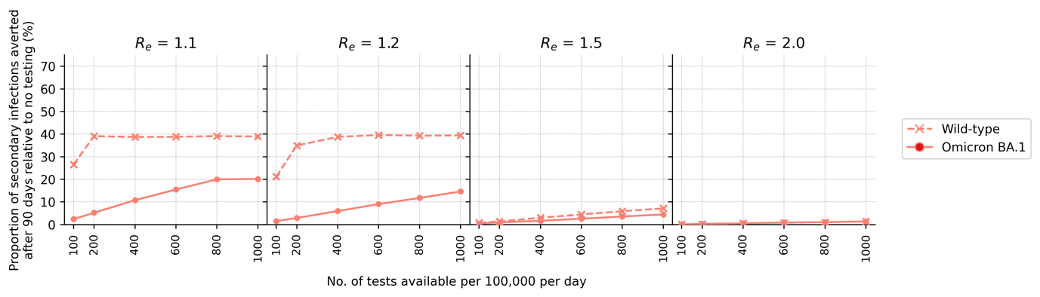

**Figure S5**: **Comparing impact of symptomatic testing only in an Omicron BA.1 wave against that for the wild-type (Wuhan-like) SARS-CoV-2 wave**. The proportion of secondary infections averted after 90 days relative to the no testing baseline for different number of tests available per 100,000 persons per day and assumed $R_{e}$ value is plotted.

1. One other note - I did not see mention of the asymptomatic fraction. Did you assume some cases will be persistently asymptomatic or were all cases assumed to be symptomatic?

We assumed an age-structure probability of individuals having symptomatic fractions which can be found in Table S1. See full technical details of the model under the “*Disease progression*” and “*Within-host viral dynamics*” subsections in the Supplementary Text.

Reviewer #3: The authors assessed the effectiveness of Ag-RDTs testing strategies in LMICs through a stochastic agent-based simulation model (Propelling Action for Testing and Treating (PATAT) simulation model). The impact of different testing strategies (symptomatic testing at healthcare facilities and asymptomatic community testing in different social settings (household, workplace, schools, gatherings such as churches) through the number of infection averted due to test-and-isolate and the testing demands for symptomatic infection. The main result of this work is that testing symptomatic individuals yields greater impacts in term of infection averted than any asymptomatic community testing strategy until most symptomatic individuals who sought testing have been tested. Symptomatic testing requires about 200-400 tests/100,000 people/day on average. Testing or asymptomatic infections among household members would yield the largest additional infections averted.

General comments:

This work is original and innovative. Using Ag-RDTs for testing in LMICS is in much more feasible than PCR testing and is a potential intervention to reduce SARS-COV-2 transmission in complement to other measures .So far there is no evidence on the usefulness of Ag-RDTs testing at large population scale in LMICs. The study provide simulation based evidence that Ag-RTDs based availability and weekly use at large scale through the healthcare system may have a substantial impact on averting SaRS-COV-2 infections.

The paper is very well written and presented. Although the PATAT model is not described in the method section, details on it's structure and implementation are given in a documented annex as well as the multiple parameters used. The findings are discussed appropriately and the limits of the work quite well recognized.

The reviewer have made several comments to be addressed by the authors

We thank the reviewer for the carefully considering our work.

Major comments:

1. The testing intervention remains a bit vague and unclear. It mentions distribution of test but does not say who does the test, train or who supervise it: testing through HCF only or through dedicated specifically trained staff? How at social settings? Does it mobilize trained staff for testing or supervision of self-testing? Although, these considerations are not included in the model, they impact on the quantity of test done per day and possibly also on the quality of the results and therefore the impact of the intervention. Authors should discuss the implications of these implementation factors, since they rely on the health workforce which has been shown to be a major limiting factor in the response to COVID-19 in LMICs.

We agree and have now listed this as a limitation of our model:

Line 462: “*Furthermore, we assumed that there was a sufficient number of qualified health workforce and implementation support available to implement the various testing strategies. The strained healthcare system, especially in more remote regions of the country, poses a major limiting factor in implementing a widespread testing program.*”

1. Although the study provides evidence in favor of large scale Ag-RDTs testing for symptomatic cases in LMICs, the level of evidence brought by this study remains modest (one simulation study done by the authors of this paper and no randomized community trial (RCT) or quasi-experimental evaluation referred to at this stage). This should be recognized, discussed and put in perspective in the paper; It calls for RCTs (cluster RCTs) to assess Ag-RDTs testing strategies in LMICs.

We recognize the need for such trials and have modified the Discussion as follows:

Line 458: “*First, we assumed that all healthcare facilities will have access to all Ag-RDT stocks available each week. However, there could be disparities in stock allocation between different clinics such as prioritizing stock allocation for hospitals. Such disproportionate distributions could lead to uneven fulfilment of symptomatic testing demand and consequently affect levels of infections. Furthermore, we assumed that there was a sufficient number of qualified health workforce available to implement the various testing strategies. The lack of well-trained healthcare workers in LMICs, especially in more remote regions of the country, pose a major limiting factor in implementing a widespread testing program.* ***While our key finding that >100 tests/100k/day is needed to saturate symptomatic testing demand before rolling out community testing programs is unlikely to change, randomized community trials in LMICs using Ag-RDTs for community testing can provide better impact estimates under realistic scenarios.****”*

1. Model calibration and validation. The authors do not discuss in the paper or in the annex model calibration and validation. This stage of the development of a complex stochastic agent-based model, which is the case in this study, is an important step to document.

In terms of calibration, the transmission probabilities used in our model are calibrated to reflect different $R_{e}$ values simulated. This has been described in the Supplementary Text detailing the technical details of PATAT under the “*Transmissions*” subsection:

“ $β$ is determined by running initial test simulations with a range of values on a naïve population with no interventions that would satisfy the target basic reproduction number $R_{0}$ as computed from the resulting exponential growth rate and distribution of generation intervals.[6] $f_{c}$ is similarly calibrated during these test runs such that the transmission probabilities in households, workplaces, schools, and all other community contacts are constrained by a relative weighting of 10:2:2:1.[1]”

We have now included a “*Validation*” subsection as well in the Supplementary Text:

“*To validate our model, we compared our simulation results against actual reported cases and deaths in Lusaka, Zambia between 25 December 2020 and 24 March 2021. Zambia was experiencing a second wave of infections as a result of the Beta variant.[9] Actual confirmed case and death tallies were retrieved from the Zambia COVID-19 Dashboard. During this time, Zambia was performing ~40 tests/100,000 people/day[10]. We assumed that initial $R_{e}$ ~ 2.0 and simulated a 90-day epidemic wave under the aforementioned testing rate for 1,000,000 individuals using the demography parameters for Zambia (Table S1) and performed 10 independent simulations using PATAT. We multiplied the estimated mean number of reported (i.e. diagnosed) cases and deaths from our simulations by three to proportionally scale up the results for three million people, the approximate population size in Lusaka, Zambia. Our simulation results fit well against both actual reported case and death counts (Mean absolute difference between actual and estimated reported numbers = ~290 (case counts), 8 (deaths); Figure S6).*”

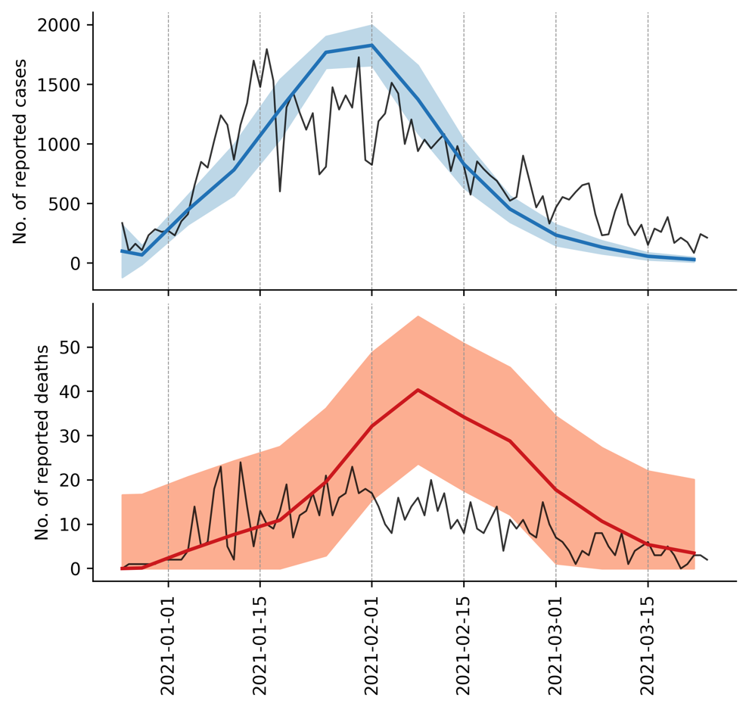

**Figure S6**: **Model validation**. We compared the mean number of reported cases (blue line, top panel) and deaths (red line, bottom panel) estimated by our simulations (10 simulations in total) against the actual case and death counts (black lines) in Lusaka, Zambia during the second wave of infections between 25 December 2020 and 24 March 2021. Actual case and death counts were retrieved from the Zambia COVID-19 Dashboard. The blue and red shaded regions in each plot denotes the standard deviation of reported cases (top panel) and deaths (bottom panel) respectively.

1. Sensitivity analysis. The authors discuss a bit the issue of the transmission parameters used in their model (which remain those of the Wuhan strain of SARS-CoV-2) while generation intervals have shortened considerably for recent VOCs (Delta, Omicron…) which impact the effectiveness of testing strategies. Authors speculate that it shall not impact their results which, for a simulation study, is quite shortcoming. Since the study is based on a simulation model, the reviewer recommend to do a sensitivity analysis on this specific parameter to assess it impact in this model.

We agree and have now performed the sensitivity analysis. See response to point 9 from reviewer 2.

1. The study target LMICs countries but is based mostly (quite exclusively) on data from Zambia. How representative are data from Zambia for all LMICs countries around the world? Why not considering sensitivity analysis? Alternatively, the authors should consider to adapt the title of the paper to reflect the link to Zambia. The title could then become : "Strategies for using antigen rapid diagnostic tests to reduce transmission of SARS-CoV-2 in a low- and middle-income countries: a mathematical modelling case study applied to Zambia"

While we had performed simulations based on Zambia, we had semi-quantitatively corroborated our simulation results against testing rates and epidemic intensities experienced in other countries during the spread of Omicron BA.1 between December 2021 and March 2022.

Line 415: “*As a corroboration of our results, we compared the weekly average testing rate[6] to the average $R_{e}$ values estimated from COVID-19 case counts (https://github.com/epiforecasts/covid-rt-estimates)[28] of 134 countries between December 2021 and March 2022 when the Omicron BA.1 VOC spread rapidly across multiple countries (Figure 8). Although the demographic profiles differ between high-income countries (HICs) and LMICs, we found that some HICs were expectedly testing at rates that were sufficient or even higher than what was likely needed to saturate the symptomatic testing demand we had estimated for LMICs at similar epidemic intensity (i.e. $R_{e}$ values). However, as Omicron (BA.1) cases surged, some HICs such as the United States, Germany and Australia were still reportedly facing test shortages.[29–31] Based on our results, these countries were indeed falling short of meeting symptomatic testing demand (Figure 8). Finally, if we assume that most HICs are testing at rates that sufficiently meet symptomatic testing demand, we found that most of them were testing >100 tests/100k/day.*”

We have nonetheless changed the title as suggested by the reviewer to avoid misleading readers.

1. Mass gatherings are referred to churches gathering only (line 100 and 108…"such as churches"). Why focusing on churches only for that transmission setting? They are many other mass gathering types that are of interest (sport events, cultural events…). In addition, what about LMICs with religion other than Christian where people meet in other setting than churches? Since the study intend to have wide implications in term of diversity of LMICs, the term "church" is not the most appropriate (if authors refer to religious gathering it can be Moshes, Temples…).

The focus on churches was specific to Zambia since >90% of the country is affiliated with Christian churches and that >80% of individuals were estimated to be committed to worship attendance weekly (<https://www.pewresearch.org/religion/wp-content/uploads/sites/7/2018/06/ReligiousCommitment-FULL-WEB.pdf>). As such, church attendance in Zambia is a significant mass gathering event that occurs routinely enough to be isolated as a key transmission setting.

We agree with the reviewer that “church” is not the most generalized term and have replaced it with “religious gathering” instead.

Minor comments:

1. Line 69 : « substantial underestimation … and mortality… ». It should be "Covid-19 attributable mortality"

Corrected.

1. Line 85-87: The sentence "As such, Ag-RDTs offer a practical alternative diagnostic tool to enable massive scale up of testing, including in resource-limited settings, potentially bridging the testing equity gap between HICs and LMICs.[5]" is too strong: rather than bridging the gap it may contribute to reduce it. In addition saying that Ag-RDTs in LMICs may bridge with countries that have full access to PCR and Ag-RDTs testing is quite unrealistic.

We have now revised this statement in the introduction:

Line 122: “*In resource-limited settings, Ag-RDTs could potentially reduce the testing equity gap between HICs and LMICs.[5]*”

1. Line 122: Although defined later, please define SEIRD (at first occurrence)

We have now defined SEIRD at the first occurrence (line 178).

1. Line 164: a "of" is missing before "5 members"

Corrected.

1. Figure 2: quite unclear: on the left axis, incidence of what? SARSCOV2 positive infection or SARSCOV2 symptomatic infection?

We have now revised Figure 2 to make y-axis label more informative.

1. Line 208-210: "Community testing would only outperform symptomatic testing when the same number of available tests saturated symptomatic testing demand in the only-symptomatic testing scenario." is unclear: do you mean that you need to have more tests in community testing than in the symptomatic testing when all symptomatic cases are tested to have an equal or larger number of averted infection in the community testing?

Indeed, and we have now rephrased the line:

Line 268: “*A far greater number of tests is needed under the community testing scenarios relative to the only-symptomatic one to result in an equal or larger proportion of infections averted.*”

1. Lines 244-46: For panel (B) the 7-day moving average of instantaneous reproduction number () over simulated epidemic period (90 days) for different assumed basic reproduction number (0) assumes that the testing demand is met which should be indicated in the title.

We have now indicated this in the caption of Figure 4B: “*7-day moving average of time-varying effective reproduction number ($R_{e}$) over simulated epidemic period (90 days) assuming that testing demand is fully satisfied.*”