

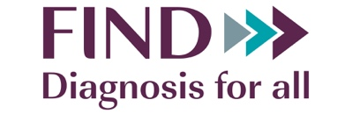

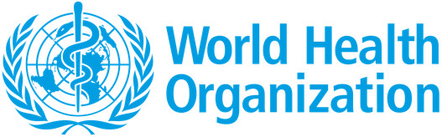

19 May 2022

Dear Editor,

Please find enclosed, our manuscript entitled “Low testing rates limit the ability of genomic surveillance programs to monitor SARS-CoV-2 variants: a mathematical modelling study”, which we would be grateful for your consideration for publication in *The Lancet*.

Genomic surveillance has been at the forefront of the global COVID-19 pandemic response and has served as the primary tool for identifying variants of concern (VOCs). To date, high income countries (HICs) have produced ~20 times more genomic surveillance data than low- and middle-income countries (LMICs). The problem with this disparity is obvious when looking at the emergence of the Omicron VOC – Omicron had already circulated widely in South Africa and to at least five other countries before being first described in early December 2021. The consequences of low testing and sequencing rates are now looming larger as many countries around the world begin to dismantle parts of their surveillance programs in the post-crisis phase of the pandemic.

To enhance genomic surveillance capacities, much focus and investments have been channelled towards boosting sequencing volumes in LMICs. Genomic surveillance guidelines from public health agencies, including the World Health Organization (WHO) and other academic groups have largely focused on estimating the number of cases to be sequenced to ensure robust variant detection and prevalence monitoring. However, all of these guidelines fundamentally assume high levels of COVID-19 diagnostic testing such that the sequenced samples are representative of the viral diversity circulating the population. These guidelines are infeasible in most LMICs given their low COVID-19 testing rates (i.e. mean ~ 27 tests per 100,000 people per day (tests/100k/day) relative to >800 tests/100k/day in HICs between 2020 and March 2022) leading to substantial biases in the samples collected for sequencing.

In a joint effort from FIND (the global alliance for diagnostics), the World Health Organization, and the Amsterdam University Medical Center we sought to identify meaningful surveillance targets for LMICs that account for both testing and sequencing needs. We developed a modelling framework and simulated VOC epidemics an LMIC setting under a range of diagnostic test availability and different genomic surveillance strategies for variant detection. We found that at the mean LMIC test availability of 27 tests/100k/day, current sequencing sample size guidance provided by WHO and other academic groups would either lead to weeks-to-months delays in new variant detection or failure to detect novel VOCs owing to the inherent biases resulting from low testing rates.

Crucially, we found that diagnostics testing rates play a far more important role in the early detection of novel SARS-CoV-2 variants and monitoring of variant growth than the amount of genetic sequencing. Increasing testing rates to at least 100 tests/100k/day and sequencing 5-10% of collected specimens represents a critical juncture to ensure the prompt detection of novel variants (i.e. within one month since its introduction and <25% of circulating variant proportion) and accurate measurements of their circulating prevalence. For countries with low testing capacities, investments should prioritise increasing diagnostic test availability and access to testing. Sequencing quantities should only be of concern after a vital amount of diagnostic capacity is already in place and even then, excessive sequencing capacities would only yield diminished returns in variant detection and monitoring at the expense of resource wastage.

While our results were derived from modelling surveillance outcomes in LMICs, our findings on the impact of diagnostic testing on genomic surveillance programs are pertinent to HICs as well, especially since multiple countries are beginning to scale down surveillance efforts in the post-crisis phase of the COVID-19 pandemic.

Preliminary versions of this work have been presented directly to the heads of WHO, Global Fund, Wellcome Trust, USAID, Unitaid, UNICEF, and PATH and we are now partnered with many of these organizations to further develop this work. Up to now, this work has already resulted in the re-allocation of >$6 billion in aid to support the expansion of diagnostics to programs in LMICs. To this end, we expect our work will be of high interest to an extremely wide audience, including governments, clinicians, epidemiologists, global, and public health experts working on pandemic mitigation and pathogen surveillance. We feel that *The* *Lancet* is the right forum for getting this work into the hands of as many people as possible.

Thank you for your consideration and we look forward to your decision.

Sincerely,

Alvin X. Han, Brooke E. Nichols and Colin A. Russell on behalf of all authors