**Supplementary appendix to Han et al. (2022)**

Technical details of the PATAT simulation model 2

Population demography 2

Household 2

Schools 2

Workplaces 2

Mass gatherings (Churches) 2

Random community 3

Disease progression 3

Within-host viral dynamics 3

Transmissions 3

Testing by Ag-RDT 4

Isolation and quarantine 4

Emergence of SARS-CoV-2 variants of concern 5

Alpha variant 5

Beta variant 5

Gamma variant 5

Delta variant 5

Supplemental Figures 7

Supplemental Tables 13

References 15

# Technical details of the PATAT simulation model

PATAT is a stochastic agent-based model designed to investigate the use and impact of SARS-CoV-2 antigen-detecting rapid diagnostic tests (Ag-RDT) in low-middle income countries. The computational flow of a PATAT simulation is summarised as follows: First, an age-structured population of agents is created. Close contact networks are subsequently created based on the given demographic data. The simulation is then initialised and iterates over a given period of time where each time step corresponds to a day. The operations during each timestep encompass updating the disease progression of infected individuals, the status of isolated/quarantined agents, application of community testing strategies and computation of transmission events within contact networks.

## Population demography

Using input demographic data which includes information such as population age and sex distribution, household composition, employment and schooling rates, PATAT generates a population of individuals who are linked by a series of underlying contact network settings where transmission may occur. These contact network settings include households, schools, workplaces, regular mass gatherings (i.e. church) as well as random community contacts.

## Household

PATAT randomly generates a Poisson distribution of household sizes based on the given mean household size. A reference individual (e.g. head of the household) above an assumed prime adult age (e.g. 20 years) is first randomly assigned to each household. To account for multigenerational households, the remaining household members are then randomly sampled multinomially by the input age distribution of households. Although PATAT does not explicitly model the geolocation of agents, households are ordered to implicitly approximate neighbourhood proximity.

## Schools

PATAT distinguishes between elementary and secondary schools. For each education level, schooling children are randomly sampled from the population based on given enrolment rates and gender parity. Class sizes are then randomly drawn from a Poisson distribution based on the input mean class size while constrained by the number of schooling children attending the same grade (i.e. age; a class include only students studying the same grade). Schools are created by random allotment of classes such that (1) all schools will have equitable distributions of classes of all grades for the given education level and (2) the total number of students approximately equals to the expected school size. Classes are then populated by schooling agents such that (1) agents of proximally ordered households will tend to attend the same school and (2) children of the same grade (age) from identical households will not be assigned to the same class even though they may attend the same school. School teachers are then randomly drawn from the employed prime adult population based on the input teacher-to-student ratio and are assumed to have contact with each other during school days. Each class is randomly assigned to one teacher.

## Workplaces

PATAT generates both formal and informal workplace contact networks based on separate employment rates. Youth (15-19 years) employment is also considered in the potential workforce. The distinction between formal and informal settings is made as mean employee contact rates likely differ between them. Furthermore, workplace distribution of Ag-RDTs for community testing is assumed to be feasible for formal employment entities only. Unlike schools, PATAT does not explicitly model for workplaces but sets up contact matrices between employed individuals who would be in regular contact at work. Different sizes of workplace contact networks are randomly drawn from a Poisson distribution based on the given mean employee contact size. An employed agent would only be associated with one workplace contact network.

## Mass gatherings (Churches)

High-density mass gatherings are considered in the model in the form of contacts among church congregations given the large weekly worship attendance in Zambia (i.e. >70%)1 which we had modelled as our prototypical low-income country. The size of a church is assumed to follow a Normal distribution with the given mean and variance. PATAT assumes that all members of a household will visit a church together every Sunday. Other than close contacts with each other, each household member would also have a random number of close contacts from other households that attend the same church. This random contact number is drawn from a Gamma distribution with the given shape and scale parameters. Churches are also ordered such that proximally ordered households in the same neighbourhood would visit the same church.

## Random community

PATAT assumes that every agent within a given age range would have a random number of contacts with the community daily, drawn from a Poisson distribution with a given mean.

## Disease progression

PATAT implements a SEIRD epidemic model where the simulated population is distinguished between five compartments: susceptible, exposed (i.e. infected but is not infectious yet; latent phase), infected (which include the presymptomatic infectious period for symptomatic agents), recovered and dead. The infected compartments are further stratified by their presented symptoms, including asymptomatic, presymptomatic, symptomatic mild or severe. All symptomatic agents will also first undergo an infectious presymptomatic period after the exposed latent period. They will either develop mild symptoms who will always recover from the disease or experience severe infection which could either lead to death or recovery. PATAT uses age-structured wild-type SARS-CoV-2 disease severity and mortality probabilities that were also used in Covasim2 (Table S1). As a simplification, PATAT currently assumes that all agents presenting severe symptoms will be hospitalized and removed from the population.

The total duration of infection since exposure depends on the symptoms presented by the patient and is comprised of different phases (i.e. latent, asymptomatic, presymptomatic, onset-to-recovery/death). The time period of each phase is drawn from the same distributions used by Covasim as well (Table S1).

## Within-host viral dynamics

For each infected agent, PATAT explicitly simulates their viral load trajectory of cycle threshold (Ct) values over the course of their infection using a stochastic model modified from the one previously developed by Quilty et al.3 A baseline Ct value () of 40 is established upon exposure. The infected agent becomes infectious upon the end of the latent period and their Ct value is assumed to be . A peak Ct value is then randomly drawn from a normal distribution with the given mean and standard deviation values of the transmitted variant virus (Table S1). Peak Ct is assumed to occur upon symptom onset for symptomatic agents and one day after the latent period for asymptomatic individuals. Cessation of viral shedding (i.e. return to ) occurs upon recovery or death. PATAT assumes that the transition rate towards peak Ct value should not be drastically different to that when returning to baseline upon cessation (i.e. there should be no sharp increase to baseline Ct value after gradual decrease to peak Ct value or vice versa). As such, the time periods of the different phases of infection are randomly drawn from the same quintile of their respective sample distribution. The viral load trajectory is then simulated by fitting a cubic Hermite spline to the generated exposed (, ), latent (, ), peak (, ) and cessation values (, ). The slope of the fitted curve is assumed to be zero for all of them except during where its slope is assumed to be . PATAT then uses the fitted trajectory to linearly interpolate the viral load transmissibility factor () of an infectious agent assuming that they are twice as transmissible at peak Ct value (i.e. ) relative to when they first become infectious (i.e. Ct value = 30; ).

## Transmissions

When an infectious agent comes into contact with a susceptible individual , the probability of transmission () is given by:

where is the base transmission probability per contact, is the overdispersion factor modelling individual-level variation in secondary transmissions (i.e. superspreading events), is a relative weight adjusting for the network setting where the contact has occurred, is the assumed relative transmissibility factor if infector is asymptomatic, measures the immunity level of susceptible against the transmitted virus (i.e. if completely naïve; if fully protected), is the age-dependent susceptibility of , and are the contact rates of infector and susceptible respectively.

is randomly drawn from a negative binomial distribution with mean of 1·0 and shape parameter of 0·45.4 As evidence have been mixed as to whether asymptomatic agents are less transmissible, we conservatively assume there is no difference relative to symptomatic patients (i.e. ). The age-structured relative susceptibility values are derived from odds ratios reported by Zhang et al.5 (Table S1).

is determined by running initial test simulations with a range of values on a naïve population with no interventions that would satisfy the target basic reproduction number as computed from the resulting exponential growth rate and distribution of generation intervals.6 is similarly calibrated during these test runs such that the transmission probabilities in households, workplaces, schools, and all other community contacts are constrained by a relative weighting of 10:2:2:1.2

## Testing by Ag-RDT

Unlike PCR which is highly sensitive due to prior amplification of viral genetic materials, the sensitivity of Ag-RDT depends on the viral load of the tested patient. While the specificity of Ag-RDT is assumed to be 98·9%, its sensitivity depends on the Ct values of the tested infected agent: Ct (0%); 35 – 30 (20·9%); 29 – 25 (50·7%); Ct (95·8%).7

Testing by Ag-RDT may either occur via symptomatic testing at healthcare facilities. First, a symptomatic agent may opt to go into self-isolation upon symptom onset prior to being tested, as decided by a Bernoulli trial with probability . Regardless if they were self-isolated, after days from symptom onset, the symptomatic agent may then decide to get tested with a Bernoulli probability of that inversely correlates with the distance between the agent’s household and the nearest healthcare facility (Table S1). PATAT assumes that agents who have decided against symptomatic testing (i.e. failed Bernoulli trial) or received negative test results will not seek symptomatic testing again.

## Isolation and quarantine

We assumed that agents would change their behaviour when (1) they start to present symptoms and go into self-isolation (10% compliance assumed, 71% endpoint adherence8); (2) they test positive and are isolated for 10 days (50% compliance assumed, 86% endpoint adherence8); or (3) they are household members (without symptoms) of positively-tested agents and are required to be in quarantine for 14 days (50% compliance assumed, 28% endpoint adherence8). Once an agent goes into isolation/quarantine, we linearly interpolate their probability of adherence to stay in isolation/quarantine over the respective period. Given the lack of infrastructure and resources to set up dedicated isolation/quarantine facilities in many low-middle income countries, we assumed that all isolated and quarantined individuals would do so at home. Although they have no contact with agents outside of their home, we assumed that they would maintain 90% contact rate with household members.

# Emergence of SARS-CoV-2 variants of concern

Here, we briefly recount the emergence of other SARS-CoV-2 variants-of-concern (VOC; i.e. the Alpha, Beta, Gamma and Delta) besides Omicron (i.e. timepoint in collection of the first variant sequence) given the prevailing circumstance, then-level of testing and sequencing performed in the respective countries where they likely first emerged from.

## Alpha variant

The Alpha variant was first reported in the UK in early December 2020 after public health agencies investigated the rapid increase in COVID-19 cases in Kent, South East England despite prevailing high levels of non-pharmaceutical interventions.9 Retrospective analyses found that the first Alpha virus that was later sequenced was collected on 20 September 2020 and phylogenetic analyses estimated the time to most recent common ancestor (TMRCA) of the Alpha lineage to be around the same time.10 The UK was testing at a mean rate of >300 tests per 100,000 people per day (tests/100k/day) in September 202011 and randomly sampling an average of 7.9% cases every week in Kent for sequencing.10 From on our genomic surveillance simulation results, albeit derived for a Zambian population, we would expect the first Alpha virus variant to be collected for sequencing within one week of its emergence under a random sampling approach at these testing and sequencing rates.

## Beta variant

The Beta variant was first reported in South Africa in December 2020 as the country experienced its second wave of SARS-CoV-2 infections. The earliest Beta virus selected for sequencing was collected on 8 October 2020 and the TMRCA was estimated to between July and August 2020.12 South Africa was still in the midst of the peak of the first wave of infection during the estimated TMRCA period and testing at mean rates of ~60 and ~40 tests/100k/day in July and August 2020 respectively.11 Only ~0.3% of cases identified in South Africa in July-August 2020 were sequenced and deposited in the GISAID EpiCoV database.13,14 The estimated ~2-3-month delay in sampling the first Beta variant sequence is therefore likely due to a combination of relatively low levels of testing and sequencing that was further exacerbated by the variant virus emerging during the peak circulation of the extant SARS-CoV-2 wild-type virus.

## Gamma variant

The Gamma variant was first reported in January 2021 in Brazil as a result of investigating the rapid rise in hospitalizations in Manaus in December 202015 as well as in Japan from infected travelers who recently returned from the Amazonas.16 The first Gamma variant virus selected for sequencing was collected on 6 December 2020 and phylogenetic analyses estimated that the VOC lineage likely emerged in Manaus between October and November 2020.15 During this period, Brazil was testing at 10-30 tests/100k/day on average11 and sequenced ~0.1% of all confirmed cases.13,14 By early January 2021 when the sequencing results were obtained and shared, the circulating proportion of the Gamma variant in Manaus was estimated to be ~75%.15 The 1-2 month gap between emergence and sampling of a VOC sequence is likely due to low testing and sequencing rates. Moreover, the turnaround time between sample collection and sequencing data acquisition added an additional month in delay before the Gamma variant was first reported in Brazil.

## Delta variant

The earliest Delta (i.e. PANGO lineage B.1.617.2) sequence (Accession: EPI_ISL_9232357) collected in India that is deposited in the GISAID EpiCoV database was collected on 3 September 2020. This sample however was only sequenced retrospectively as (1) it was submitted to the database on 28 January 2022 and (2) published works by the Indian SARS-CoV-2 Genomics Consortium (INSACOG), the national sentinel sequencing network, referred to earliest identification of Delta in state of Maharashtra in December 202017,18. The identification of Delta in Maharashtra was only done so retrospectively to investigate the surge in cases in the state in January 2021. Using Delta sequences collected globally, the likely TMRCA period was estimated to be around September 2020 as well.19 During this time, India was still experiencing the peak of its first wave of SARS-CoV-2 infections.14 The second wave of SARS-CoV-2 infections across the country caused by the Delta variant only took off in March 2021, six months after the estimated TMRCA.20 Between December 2020 when the first wave of infections subsided and the beginning of the second wave in March 2021, there were several competing lineages circulating in India, including the Alpha VOC as well as the Kappa variant of interest (i.e. B.1.617.1), a sub-lineage descending from the same parental lineage of Delta (i.e. B.1.617).20 There was no coordinated efforts to perform active genomic surveillance across India in 2020; Sequencing analyses then were largely performed retrospectively in response to surge in cases.18,21 The INSACOG was only established by the government on 30 December 2020 in response to monitor genetic variations in light of the introduction of the Alpha variant into the country.22,23 Owing to complexities attributed to multiple co-circulating and competing variant lineages, nonuniformity in sampling, in part due to a lack of ongoing active coordinated nation-wide genomic surveillance efforts then, and that the “earliest” Indian Delta sequences were all identified from retrospective analyses, there are uncertainties around both the emergence and early spread of the Delta variant within India.

# Supplemental Figures

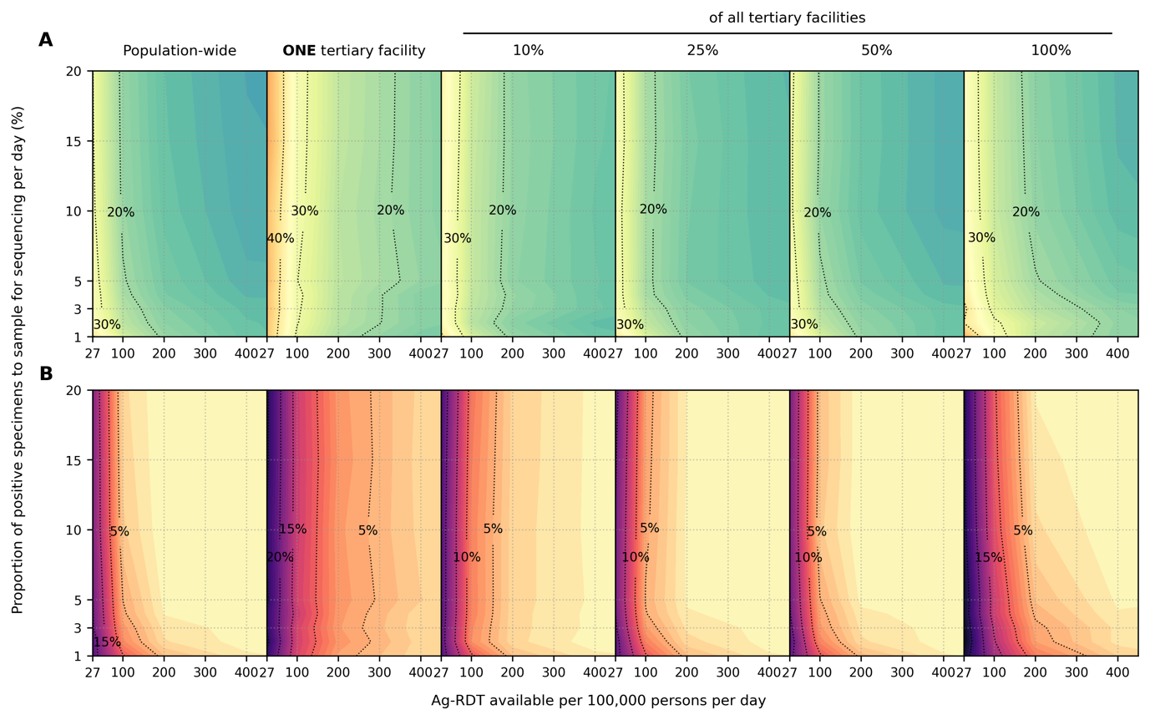

**Figure S1**: **Impact of SARS-CoV-2 Ag-RDT testing rates and daily proportion of positive specimens to sample for sequencing on observed Omicron variant proportions**. Different genomic surveillance strategies (i.e. all specimens collected from all healthcare facilities sent to onefacility to be sampled for sequencing (*population-wide* strategy); only *one*, 10%, 25%, 50% or 100% of all tertiary facilities acting as sentinel sites that would sample the specimens they collected for sequencing) were simulated. (**A**) Maximum absolute difference between observed and circulating variant proportions. (**B**) Proportion of timepoints when sequencing was performed that the absolute difference between observed and circulating variant proportions is greater than 20%.

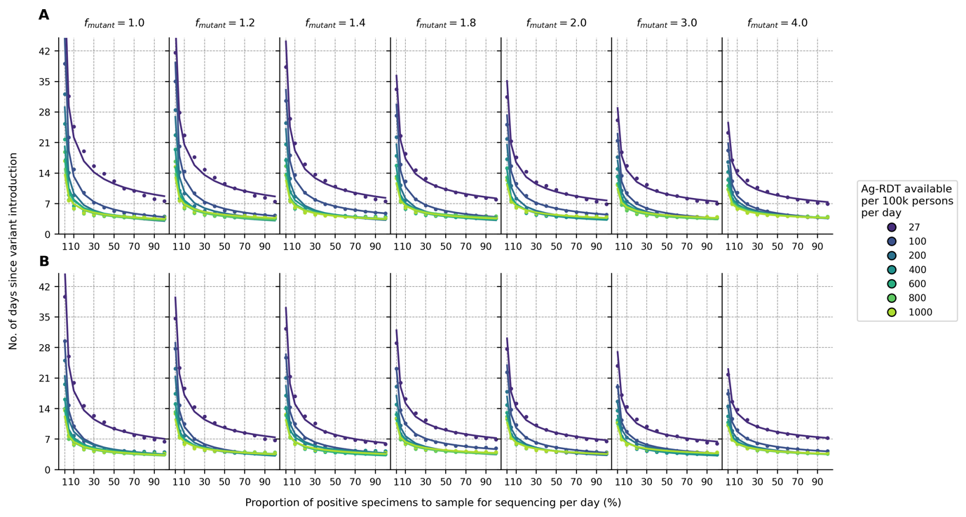

**Figure S2**: **Sensitivity analyses on variant detection operating curve for different relative transmissibility factor**. For each Ag-RDT availability, the expected day when the first Omicron variant specimen (in the background of extant Delta variant) is sampled for sequencing since its introduction is plotted against the proportion of positive specimens to be sampled for sequencing daily. All specimens collected from the population from all healthcare facilities were sent to onefacility to be sampled for sequencing (population-wide genomic surveillance strategy). Different transmissibility factor of Omicron relative to Delta () were assumed. (**A**) 10% and (**B**) 40% of the population had immunity against Omicron initially.

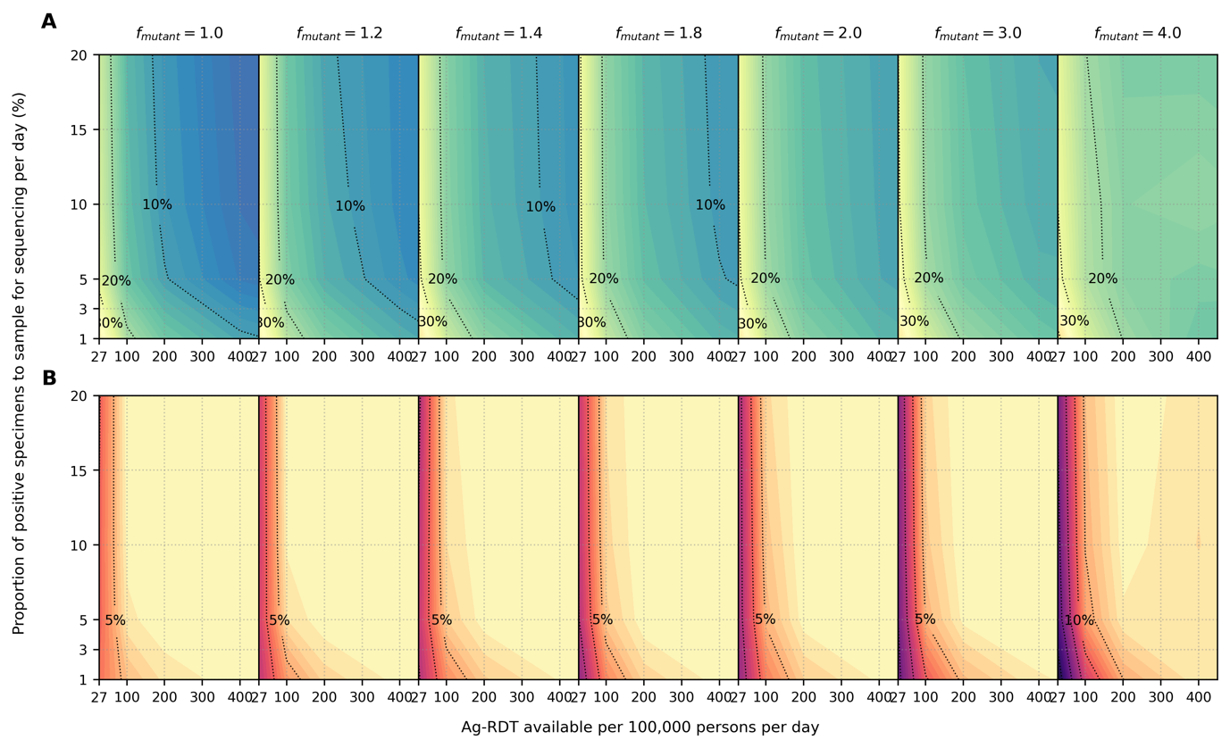

**Figure S3**: **Sensitivity analyses on accuracy of observed variant proportions for different relative transmissibility factor**. Omicron-like virus properties assumed for variant and initial proportion of population with some degree of protection against the variant virus assumed at 10%. All specimens collected from the population from all healthcare facilities were sent to onefacility to be sampled for sequencing (population-wide genomic surveillance strategy). Different transmissibility factor of Omicron relative to Delta () were assumed. (**A**) Maximum absolute difference between observed and circulating variant proportions. (**B**) Proportion of timepoints when sequencing was performed that the absolute difference between observed and circulating variant proportions is greater than 20%.

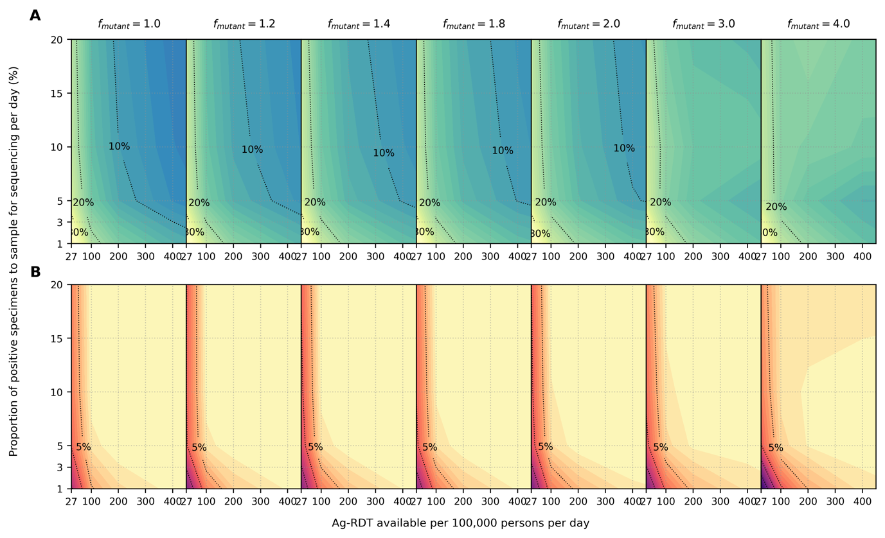

**Figure S4**: **Sensitivity analyses on accuracy of observed variant proportions for different relative transmissibility factor**. Omicron-like virus properties assumed for variant and initial proportion of population with some degree of protection against the variant virus assumed at 40%. All specimens collected from the population from all healthcare facilities were sent to onefacility to be sampled for sequencing (population-wide genomic surveillance strategy). Different transmissibility factor of Omicron relative to Delta () were assumed. (**A**) Maximum absolute difference between observed and circulating variant proportions. (**B**) Proportion of timepoints when sequencing was performed that the absolute difference between observed and circulating variant proportions is greater than 20%.

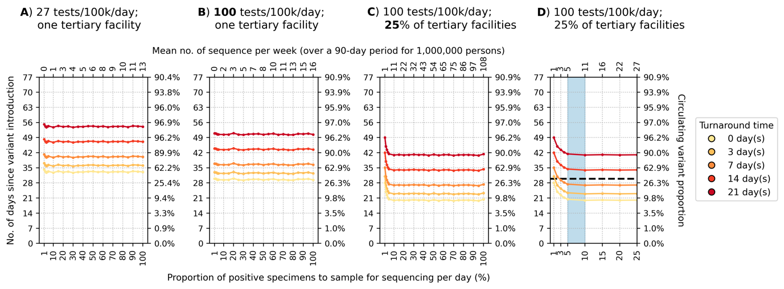

**Figure S5**: **Recommended approach to enhance genomic surveillance robustness**. In each plot, the operating curves of the *expected detection day of the Omicron variant* with *Delta variant in the background circulating at* ***1%*** are plotted for different proportion of specimens to sample for sequencing per day and turnaround times. The vertical axes denote the number of days passed since the introduction of the Omicron variant (left) and its corresponding circulating proportion (right). The horizontal axes denote the proportion of positive specimens to sample for sequencing per day (bottom) and the corresponding mean number of sequences to be generated per week per 1,000,000 people over a 90-day epidemic period. (**A**) Specimen pools for sequencing from *one* tertiary facility with testing rate at 27 tests per 100,000 persons per day (tests/100k/day). (**B**) Specimen pools for sequencing from *one* tertiary sentinel facility with testing rate at 100 tests/100k/day. (**C**) Specimen pools for sequencing from 25% of all tertiary facilities acting as sentinel sites with testing rate at 100 tests/100k/day. (**D**) Zoomed-in plot of (C) for sequencing proportions varying between 1-25%. Sequencing 5-10% of positive specimens (blue shaded region) would ensure that we would expectedly detect Omicron within 30 days if turnaround time is kept within one week.

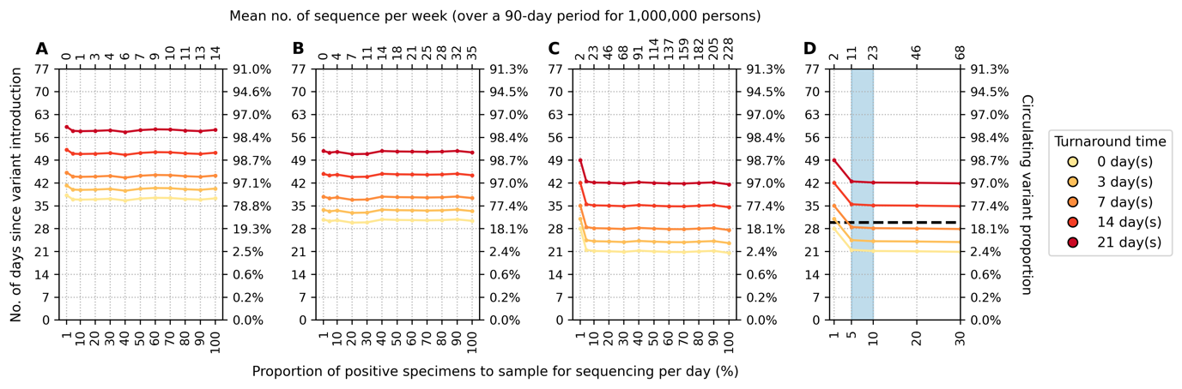

**Figure S6**: **Recommended approach to enhance genomic surveillance robustness**. In each plot, the operating curves of the *expected detection day of the Omicron variant* with *Delta variant in the background circulating at* ***5%*** are plotted for different proportion of specimens to sample for sequencing per day and turnaround times. The vertical axes denote the number of days passed since the introduction of the Omicron variant (left) and its corresponding circulating proportion (right). The horizontal axes denote the proportion of positive specimens to sample for sequencing per day (bottom) and the corresponding mean number of sequences to be generated per week per 1,000,000 people over a 90-day epidemic period. (**A**) Specimen pools for sequencing from *one* tertiary facility with the community testing at 27 tests per 100,000 persons per day (tests/100k/day). (**B**) Specimen pools for sequencing from *one* tertiary facility with the community testing at 400 tests/100k/day. (**C**) Specimen pools for sequencing from 25% of all tertiary facility with the community testing at 400 tests/100k/day. (**D**) Zoomed-in plot of (C) for sequencing proportions varying between 1-25%. Sequencing 5-10% of positive specimens (blue shaded region) would ensure that we would expectedly detect Omicron within 30 days if turnaround time is kept within one week.

# Supplemental Tables

**Table S1**: **PATAT simulation parameters**

|  |  |  |
| --- | --- | --- |
| **Parameter** | **Values/Distribution** | **Source** |
| *Population demography* | | | |
| Total population size | 1,000,000 |  |
| Mean household size | 5·0 | 24 |
| Age structure (in bins of 5 years) | [0·161, 0·165, 0·157, 0·101, 0·083, 0·068, 0·057, 0·051, 0·042, 0·030, 0·024, 0·015, 0·016, 0·009, 0·008, 0·005, 0·006, 0·002, 0·000, 0·000] | 24 |
| Minimum prime adult age | 20 years | Assumed |
| Proportion of women | 51% | 25 |
| Minimum working age | 15 years | 25 |
| Employment rate | 39% (male), 23% (female) | 25 |
| Formal employment rate | 36% (employed male), 24% (employed female) | 25 |
| Schooling rate | 79% (male), 40% (female) | 24 |
| School gender parity | 1·0 (Primary), 0·9 (Secondary) | 24 |
| Church participation rate | 70% of all households | Assumed |
| Mean employment contacts (formal) | 20 | Assumed |
| Mean employment contacts (informal) | 5 | Assumed |
| Mean class size | 37 (Primary and secondary) | 24 |
| Mean school size | 700 (Primary and secondary) | Assumed |
| Student-teacher ratio | 42 (Primary and secondary) | 24 |
| Mean church size (s.d.) | 500 (100) | Assumed |
| Mean random contacts in church per person | 10 | Assumed |
| Mean random community contacts per day | 10 | Assumed |
| *SARS-CoV-2 transmissions related parameters* | | | |
| Age-structured relative susceptibility (in bins of 5 years) | [0·34, 0·34, 0·67, 0·67, 1·00, 1·00, 1·00, 1·00, 1·00, 1·00, 1·00, 1·00, 1·00, 1·00, 1·24, 1·24, 1·47, 1·47, 1·47, 1·47] | 2,5 |
| Age-structured probability of becoming symptomatic (in bins of 5 years) | [0·50, 0·50, 0·55, 0·55, 0·60, 0·60, 0·65, 0·65, 0·70, 0·70, 0·75, 0·75, 0·80, 0·80, 0·85, 0·85, 0·90, 0·90, 0·90, 0·90] | 26,27 |
| Age-structured probability of developing severe disease (in bins of 5 years) | [0·00050, 0·00050, 0·00165, 0·00165, 0·00720, 0·00720, 0·02080, 0·02080, 0·03430, 0·03430, 0·07650, 0·07650, 0·13280, 0·13280, 0·20655, 0·20655, 0·24570, 0·24570, 0·24570, 0·24570] | 26,27 |
| Age-structured probability of death (in bins of 5 years) | [0·00002, 0·00002, 0·00002, 0·00002, 0·00010, 0·00010, 0·00032, 0·00032, 0·00098, 0·00098, 0·00265, 0·00265, 0·00766, 0·00766, 0·02439, 0·02439, 0·08292, 0·08292, 0·16190, 0·16190] | 28,29 |
| Latent period (days) | Wild-type SARS-CoV-2/Alpha: Lognormal (4·5, 1·5)  Delta/Omicron: Lognormal (4·0, 1·3) | 2,30–32 |
| Pre-symptomatic period (days) | Wild-type SARS-CoV-2/Alpha : Lognormal (1·1, 0·9)  Delta/Omicron: Lognormal (1·8, 1·7) | 2,30,32 |
| Period between symptom onset and severe disease (days) | Lognormal (6·6, 4·9) | 30 |
| Period between severe disease and death (days) | Lognormal (8·6, 6·7) | 30 |
| Recovery period for symptomatic agents with mild disease (days) | Wild-type SARS-CoV-2/Alpha: Lognormal (8·0, 2·0)  Delta: Lognormal (6·23, 0·53*)  Omicron: Lognormal (5·35, 0·37*) | 32,33 |
| Recovery period for asymptomatic agent (days) | Wild-type SARS-CoV-2/Alpha: Lognormal (8·0, 2·0)  Delta: Lognormal (6·23, 0·53*)  Omicron: Lognormal (5·35, 0·37*) | 32,33 |
| Recovery period of agents with severe disease (days) | Lognormal (18·1, 6·3) | 26 |
| Peak Ct values | Wild-type SARS-CoV-2/Alpha/Delta: Normal (20·5, 0·79*)  Omicron: Normal (23·3, 0·58*) | 32 |
| Cross-immunity to variant virus after infection by extant virus | Wild-type SARS-CoV-2/Alpha: 87%  Delta/Omicron: 20% | 34,35 |
| Severity (chance of hospitalization) of variant relative to extant virus | Wild-type SARS-CoV-2/Alpha: 100%  Delta/Omicron: 40% | 36 |
| *Testing parameters* | | | |
| Delay in visiting healthcare facility for symptomatic testing (days) | Lognormal (1·0, 0·5) | Assumed |
| Ag-RDT specificity | 0·989 | 7 |
| Agents to healthcare facilities ratio | 7,000:1 | 37,38 |
| Distance-structured distribution of households to nearest healthcare facility (in bins of 1km) | [0·048, 0·193, 0·119, 0·08, 0·074, 0·098, 0·068, 0·072, 0·056, 0·191] | 39 |
| Distance-structured probabilities of agent visiting nearest healthcare facility for testing services (in bins of 1km) | [0·853, 0·808, 0·762, 0·717, 0·672, 0·626, 0·581, 0·536, 0·49, 0·445] | 39 |
| *Isolation/quarantine parameters* | | | |
| Isolation period | 10 days |  |
| Quarantine period | 14 days |  |
| Self-isolation period | 10 days |  |
| Reduction in contact rates under isolation/quarantine (in order of households, schools, workplaces, church and random community) | [10%, 100%, 100%, 100%, 100%] |  |

*Standard deviation values inferred from 95% confidence interval computed in reference.

# References

1 Pew Research Center. The Age Gap in Religion Around the World. 2018; published online June 13. https://www.pewresearch.org/religion/2018/06/13/the-age-gap-in-religion-around-the-world/ (accessed April 5, 2022).

2 Kerr CC, Stuart RM, Mistry D, *et al.* Covasim: An agent-based model of COVID-19 dynamics and interventions. *PLOS Computational Biology* 2021; **17**: e1009149-.

3 Quilty BJ, Clifford S, Hellewell J, *et al.* Quarantine and testing strategies in contact tracing for SARS-CoV-2: a modelling study. *The Lancet Public Health* 2021; **6**: e175–83.

4 Endo A, Abbott S, Kucharski AJ, Funk S. Estimating the overdispersion in COVID-19 transmission using outbreak sizes outside China. *Wellcome Open Research 2020 5:67* 2020; **5**: 67.

5 Zhang J, Litvinova M, Liang Y, *et al.* Changes in contact patterns shape the dynamics of the COVID-19 outbreak in China. *Science (1979)* 2020; **368**: 1481–6.

6 Wallinga J, Lipsitch M. How generation intervals shape the relationship between growth rates and reproductive numbers. *Proceedings of the Royal Society B: Biological Sciences* 2006; **274**: 599–604.

7 Brümmer LE, Katzenschlager S, Gaeddert M, *et al.* Accuracy of novel antigen rapid diagnostics for SARS-CoV-2: A living systematic review and meta-analysis. *PLOS Medicine* 2021; **18**: e1003735-.

8 Brazeau NF, Verity R, Jenks S, *et al.* Report 34 - COVID-19 Infection Fatality Ratio Estimates from Seroprevalence | Faculty of Medicine | Imperial College London. 2020. DOI:10.25561/83545.

9 Investigation of SARS-CoV-2 variants of concern: technical briefings - GOV.UK. https://www.gov.uk/government/publications/investigation-of-novel-sars-cov-2-variant-variant-of-concern-20201201 (accessed April 28, 2022).

10 Hill V, Plessis L du, Peacock TP, *et al.* The origins and molecular evolution of SARS-CoV-2 lineage B.1.1.7 in the UK. *bioRxiv* 2022; : 2022.03.08.481609.

11 Test tracker - FIND. https://www.finddx.org/covid-19/test-tracker/ (accessed April 28, 2022).

12 Tegally H, Wilkinson E, Giovanetti M, *et al.* Detection of a SARS-CoV-2 variant of concern in South Africa. *Nature 2021 592:7854* 2021; **592**: 438–43.

13 GISAID - Initiative. https://www.gisaid.org/ (accessed April 28, 2022).

14 CSSEGISandData/COVID-19: Novel Coronavirus (COVID-19) Cases, provided by JHU CSSE. https://github.com/CSSEGISandData/COVID-19 (accessed April 28, 2022).

15 Faria NR, Mellan TA, Whittaker C, *et al.* Genomics and epidemiology of the P.1 SARS-CoV-2 lineage in Manaus, Brazil. *Science (1979)* 2021; **372**. DOI:10.1126/SCIENCE.ABH2644/SUPPL_FILE/ABH2644_FARIA_REPRODUCIBILITY-CHECKLIST.PDF.

16 Fujino T, Nomoto H, Kutsuna S, *et al.* Novel SARS-CoV-2 Variant in Travelers from Brazil to Japan - Volume 27, Number 4—April 2021 - Emerging Infectious Diseases journal - CDC. *Emerging Infectious Diseases* 2021; **27**: 1243–5.

17 Mlcochova P, Kemp S, Dhar MS, *et al.* SARS-CoV-2 B.1.617.2 Delta variant replication and immune evasion. *Nature 2021 599:7883* 2021; **599**: 114–9.

18 Cherian S, Potdar V, Jadhav S, *et al.* SARS-CoV-2 Spike Mutations, L452R, T478K, E484Q and P681R, in the Second Wave of COVID-19 in Maharashtra, India. *Microorganisms 2021, Vol 9, Page 1542* 2021; **9**: 1542.

19 McCrone JT, Hill V, Bajaj S, *et al.* Context-specific emergence and growth of the SARS-CoV-2 Delta variant. *medRxiv* 2021; : 2021.12.14.21267606.

20 Dhar MS, Marwal R, Radhakrishnan VS, *et al.* Genomic characterization and epidemiology of an emerging SARS-CoV-2 variant in Delhi, India. *Science (1979)* 2021; **374**: 995–9.

21 Srivastava S, Banu S, Singh P, Sowpati DT, Mishra RK. SARS-CoV-2 genomics: An Indian perspective on sequencing viral variants. *Journal of Biosciences* 2021; **46**: 1–14.

22 Thiagarajan K. Why is India having a covid-19 surge? *BMJ* 2021; **373**: n1124.

23 Q&A on Indian SARS-CoV-2 Genomics Consortium (INSACOG) | Department of Biotechnology. https://dbtindia.gov.in/pressrelease/qa-indian-sars-cov-2-genomics-consortium-insacog (accessed April 28, 2022).

24 Zambia Statistics Agency. Zambia Demographic and Health Survey 2018. 2018. https://www.zamstats.gov.zm/index.php/publications/category/8-demorgraphy?download=364:zambia-demographic-and-health-survey-2018 (accessed Jan 26, 2022).

25 Zambia Statistics Agency. 2019 Labour Force Survey Report. 2019. https://www.zamstats.gov.zm/index.php/publications/category/7-labour (accessed Jan 26, 2022).

26 Verity R, Okell LC, Dorigatti I, *et al.* Estimates of the severity of coronavirus disease 2019: a model-based analysis. *The Lancet Infectious Diseases* 2020; **20**: 669–77.

27 Ferguson NM, Laydon D, Nedjati-Gilani G, *et al.* Report 9: Impact of non-pharmaceutical interventions (NPIs) to reduce COVID-19 mortality and healthcare demand. 2020. DOI:10.25561/77482.

28 O’Driscoll M, Ribeiro Dos Santos G, Wang L, *et al.* Age-specific mortality and immunity patterns of SARS-CoV-2. *Nature 2020 590:7844* 2020; **590**: 140–5.

29 Report 34 - COVID-19 Infection Fatality Ratio Estimates from Seroprevalence | Faculty of Medicine | Imperial College London. 2020. https://www.imperial.ac.uk/mrc-global-infectious-disease-analysis/covid-19/report-34-ifr/ (accessed Jan 26, 2022).

30 Linton NM, Kobayashi T, Yang Y, *et al.* Incubation Period and Other Epidemiological Characteristics of 2019 Novel Coronavirus Infections with Right Truncation: A Statistical Analysis of Publicly Available Case Data. *Journal of Clinical Medicine 2020, Vol 9, Page 538* 2020; **9**: 538.

31 Kang M, Xin H, Yuan J, *et al.* Transmission dynamics and epidemiological characteristics of Delta variant infections in China. *medRxiv* 2021; : 2021.08.12.21261991.

32 Hay JA, Kissler SM, Fauver JR, *et al.* Viral dynamics and duration of PCR positivity of the SARS-CoV-2 Omicron variant. *medRxiv* 2022; : 2022.01.13.22269257.

33 Wölfel R, Corman VM, Guggemos W, *et al.* Virological assessment of hospitalized patients with COVID-2019. *Nature 2020 581:7809* 2020; **581**: 465–9.

34 Pouwels KB, Pritchard E, Matthews PC, *et al.* Impact of Delta on viral burden and vaccine effectiveness against new SARS-CoV-2 infections in the UK. *medRxiv* 2021; : 2021.08.18.21262237.

35 Report 49 - Growth, population distribution and immune escape of Omicron in England | Faculty of Medicine | Imperial College London. https://www.imperial.ac.uk/mrc-global-infectious-disease-analysis/covid-19/report-49-Omicron/ (accessed Feb 25, 2022).

36 Report 50 - Hospitalisation risk for Omicron cases in England | Faculty of Medicine | Imperial College London. https://www.imperial.ac.uk/mrc-global-infectious-disease-analysis/covid-19/report-50-severity-omicron/ (accessed March 17, 2022).

37 Nichols BE, Girdwood SJ, Crompton T, *et al.* Monitoring viral load for the last mile: what will it cost? *J Int AIDS Soc* 2019; **22**: e25337.

38 Girdwood SJ, Nichols BE, Moyo C, Crompton T, Chimhamhiwa D, Rosen S. Optimizing viral load testing access for the last mile: Geospatial cost model for point of care instrument placement. *PLOS ONE* 2019; **14**: e0221586.

39 Dovel K, Balakasi K, Gupta S, *et al.* Frequency of visits to health facilities and HIV services offered to men, Malawi. *Bull World Health Organ* 2021; **99**: 618–26.

## 

## 