The global demand and potential public health impact of oral antiviral treatment stockpile for influenza pandemics

Alvin X. Han¹, Katina D. Hulme¹, Colin A. Russell ¹
¹Department of Medical Microbiology and Infection Prevention, Amsterdam University Medical Center, University of Amsterdam, Amsterdam, The Netherlands

Corresponding author: Alvin X. Han (x.han@amsterdamumc.nl)

Abstract
Stockpiling and rapid use of oral influenza antiviral drugs such as oseltamivir and baloxavir marboxil (BXM) can reduce the disease burden of a nascent influenza pandemic before vaccines are available. Current estimates for pandemic preparedness drug stockpile size vary widely depending on modeling assumptions and do not account for heterogeneities in healthcare-seeking behaviour or drug-specific transmission risk reduction. Here, we developed a novel transmission model that accounts for heterogeneous healthcare-seeking behaviour and recent estimates of transmission risk reduction by antivirals to estimate country-specific demand and impact of distributing oseltamivir and BXM in 186 countries. Due to its transmission reducing properties, BXM could maximally double the median percentage of mean pandemic deaths averted (37%-68%) relative to oseltamivir with ~5%-10% with smaller stockpile size (7%-34% per-capita). Under limited drug availability, age-based rationing does not meaningfully lower total antiviral demand and drug priority should be given to treatment over post-exposure prophylaxis.

Introduction
Influenza A viruses (IAV) remain an emerging threat to human health owing to persistent spillover risk of novel IAV subtypes from reservoir species. Given their antiviral activity against diverse IAV subtypes and the convenience of administration, orally or inhalation administered influenza antiviral drugs are potentially effective countermeasures to mitigate the impact of a nascent influenza pandemic prior to the availability of a targeted vaccine. Several approved drugs could be considered for pandemic preparedness stockpiling, including adamantanes, M2 ion-channel blockers preventing the initiation of viral replication, neuraminidase inhibitors such as oseltamivir, laninamivir and zanamivir that attenuates the release of progeny virions from infected cells, polymerase inhibitors such as baloxavir marboxil (BXM) and favipiravir that blocks viral replication, as well as umifenovir, a fusion inhibitor that prevents virus fusion to host cells. Although laninamivir and zanamivir are currently recommended for post-exposure prophylactic use, they, alongside favirpiravir and umifenovir, are not recommended by the World Health Organization for treatment of both severe and non-severe influenza infections given their limited effects in reducing illness duration (Gao et al., 2025, 2024; World Health Organization, 2024; Zhao et al., 2024), and thus unlikely going to be the primary antiviral stockpile. Adamantanes are also unlikely useful as the primary antiviral drug due to the high propensity of developing resistance among adamantane-treated individuals (Hayden and Pavia, 2006). Although the emergence and spread of oseltamivir and BXM resistance are also of concern, prompt treatment with either drug reduces symptom duration and risk of severe disease outcomes (Hayden and Pavia, 2006; Hayden Frederick G. et al., 2018). Both treatments are also effective post-exposure prophylactic drugs that lower infection risk (Zhao et al., 2024). Importantly, treatment with BXM has recently been demonstrated to provide a significant clinical benefit in preventing onward transmissions (Monto Arnold S. et al., 2025).
Mathematical modelling is a useful tool to rationally design evidence-based antiviral stockpiling options amidst uncertainties about the future influenza pandemic. However, existing studies have yielded inconsistent and even conflicting results owing to differences in modelling objectives, approaches and assumptions, making it challenging to meaningfully synthesise their findings for public health planning. For example, focusing on treatment demand estimation, a neuraminidase inhibitor stockpile covering ~30% of the population was estimated to be sufficient to treat all symptomatic individuals infected by the pandemic virus that seek care in the US during a nascent pandemic (O’Hagan et al., 2015). Conversely, a separate study estimated a much larger antiviral demand covering 40-144% of the Canadian population to account for additional contingencies such as treating non-specific infections that also present influenza-like illness (Greer and Schanzer, 2013). Several studies separately used simpler decision-tree approaches to design stockpile size options aimed at maximizing economic benefits. In Singapore, the cost-effective treatment-only oseltamivir stockpile size was estimated at 40-60% per-capita (Lee et al., 2006) while Siddiqui et al. suggest that stockpiling oseltamivir for the entire population of the UK for treatment is more prudent since the attack rate of the future pandemic virus is unknown (Siddiqui and Edmunds, 2008). In contrast, a dynamic transmission model applied to ten countries, including Singapore and UK, estimated a much smaller treatment-only oseltamivir stockpile size of 15-25% per-capita to minimise mortality rates and economic costs while also finding little benefit in giving antiviral prophylaxis to exposed contacts (Carrasco et al., 2011). Other studies, differently conclude that restricting antivirals for treatment is ineffective at limiting the impact of the pandemic virus (McCaw and McVernon, 2007), or that spread of the pandemic virus can only be constrained under widespread distribution of post-exposure prophylaxis (PEP), covering 20-50% of exposed contacts (McVernon et al., 2010) or that a nascent pandemic can even be contained at its source if >80% of exposed contacts were given prophylaxis (Ferguson et al., 2005; Longini et al., 2005).
Previous works would likely reach different conclusions in hindsight of the COVID-19 pandemic and availability of recent clinical data. First, all of the aforementioned studies assumed that at least 70% of symptomatic infections could be treated within two days after symptom onset. While symptomatic individuals might readily seek care during a pandemic (Siegler et al., 2020), healthcare-seeking behaviour, including the time to seeking treatment since symptom onset, is heterogeneous, even during a pandemic (Graham et al., 2022), predicating on sociodemographic factors and disease severity (Peppa et al., 2017), which could in turn diminished the effectiveness of the antiviral stockpile. Similarly, studies proposing mass distribution of PEP assume that countries can swiftly mobilise extensive and near-complete contact tracing but this was demonstrably challenging during the COVID-19 pandemic even in high-resource countries (Clark et al., 2021; Davis et al., 2021). Several studies also assume that the infectiousness of infected individuals treated with oseltamivir is reduced by >60% (Carrasco et al., 2011; Ferguson et al., 2005; Halloran et al., 2008; Longini et al., 2005) based on post-hoc analyses (Yang et al., 2006) of past clinical trial data that originally investigated the efficacy of oseltamivir as PEP to prevent infections among uninfected household contacts with no direct assessment of transmission risk reduction benefits of treatment among infected index patients (Hayden et al., 2004; Welliver et al., 2001). This is an overestimate as BXM which significantly reduces infectious viral load relative to oseltamivir (Hayden Frederick G. et al., 2018) and is found to reduce transmission of treated index patients to untreated contacts by 29% based on a recent randomised clinical trial (CENTERSTONE) (Monto Arnold S. et al., 2025).
In this study, we developed a novel mathematical modelling framework to estimate the maximum antiviral demand and associated impact on burden reduction when using either BXM or oseltamivir to mitigate the initial wave of an influenza pandemic (see Methods and Appendix). We applied our model to 186 countries where we have reliable demography and age-stratified contact pattern estimates, providing country-specific demand and impact estimates under the same modelling framework. We used the latest estimates of transmission risk reduction of antivirals based on direct measurements in clinical trials while accounting for delays and heterogeneity in treatment administration since infection across the population. We also estimated the additional antiviral demand and potential benefits in distributing PEP to household contacts. Finally, we quantified how the spread of antiviral resistance could potentially impact antiviral demand and burden reduction.

Results

Maximum antiviral treatment demand and mean deaths averted
Given the uncertainties in predicting morbidity and mortality for the next influenza pandemic, we propose that a useful guiding framework for pandemic antiviral stockpile planning is to first set expectations on the maximum drug demand and impact of distributing antivirals for treatment during past pandemic scenarios (i.e. 1918 A/H1N1 ($R_{0}$=2.0), 1968 A/H3N2 ($R_{0}$=1.8), 2009 A/H1N1 ($R_{0}$=1.5) and an influenza pandemic with COVID-19-like reproduction number ($R_{0}$=3.0) and disease burden but with IAV-like generation interval; see Methods and Appendix) prior to the availability of targeted vaccines under idealised assumptions about possible public health infrastructure, diagnostic testing, and drug use. Not only does the idealised case provide an upper bound to antiviral stockpile size, to which no added benefit is expected above this theoretical limit, it provides a useful reference when we continue to investigate how deviations in reality (i.e. limited antiviral supply, heterogeneity in healthcare-seeking behaviour, delays to test-and-treat distribution, antiviral resistance spread) could change antiviral demand and impact. Under the idealised scenario, we assumed that 95% of all symptomatic individuals would ideally seek test-and-treat within two days after symptom onset, with no restrictions to availability and access to antivirals. We also assumed that country-wide distribution of antivirals could ideally begin one week after pandemic initiation in the country. We opted not to account for non-pharmaceutical interventions (NPIs) in our model. While NPIs can lower antiviral demand and augment disease burden reduction, it is challenging to assume an appropriate effectiveness of NPIs, to which modelling results will be highly sensitive to, as they depend on the type of NPIs, time-dependent variation, as well as influences owing to political, governance, cultural, behavioural and socioeconomic context (Haug et al., 2020; Liu et al., 2021). Not incorporating NPIs is also in line with our aim to estimate the upper theoretical bounds to antiviral demand.
Under the idealised scenarios, we find that BXM broadly doubles the percentage of mean pandemic deaths averted relative to oseltamivir (Fig. 1) with less treatment courses (Fig. 2) across all pandemic scenarios and countries (Fig. 3). The median percentage of mean pandemic deaths averted across all countries depends on the severity of the pandemic scenario. BXM could avert 68% of mean deaths in the relatively mild 2009 A/H1N1-like pandemic (interquartile range (IQR) = 62-100%; 13-34 deaths averted per million people) but only 48% in a 1968 A/H3N2-like pandemic (IQR = 45-52%; 194-329 mean deaths averted per million people), 37% in a COVID-19-like pandemic (IQR = 35-40%; 843-2,588 mean deaths averted per million people) and 44% in a 1918 A/H1N1-like pandemic (IQR = 42-45%; 2,798-2,993 mean deaths averted per million people). The corresponding median mean per-capita demand of BXM is 7% for a 2009 A/H1N1-like pandemic (IQR = 5-11%; 410-902 million courses of BXM as per the estimated 8.2 billion world population in 2024(United Nations, 2024)), 24% for a 1968 A/H3N2-like pandemic (IQR = 21-25%; 1.7-2.0 billion courses), 34% for a COVID-19-like pandemic (IQR = 33-36%; 2.7-3.0 billion courses) and 28% for a 1918 A/H1N1-like pandemic (IQR = 25-29%; 2.0-2.4 billion courses). In contrast, oseltamivir averts median mean deaths by 35% (IQR = 31-41%), 27% (IQR = 26-28%), 23% (IQR = 23-24%) and 25% (IQR = 25-26%) for the 2009 A/H1N1-like, 1968 A/H3N2-like, COVID-19-like and 1918 A/H1N1-like influenza pandemics respectively, while the median mean oseltamivir demand is ~5-10% greater than BXM, correspondingly amounting to 32% (IQR = 28-33%; 2.3-2.7 billion courses of oseltamivir), 28% (IQR = 25-30%; 2.0-2.5 billion courses), 36% (IQR = 35-37%; 2.9-3.0 billion courses) and 32% (IQR = 28-33%; 2.3-2.7 billion courses) per-capita for the four pandemic scenarios.
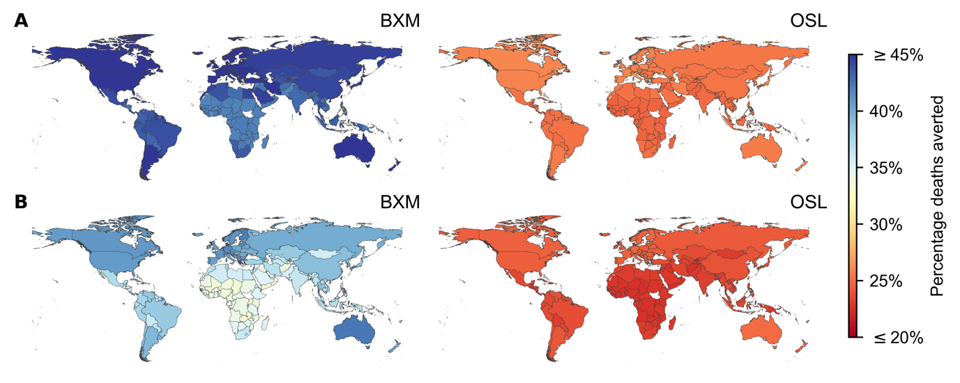
Fig. 1: Mean percentage deaths averted by test-and-treat with oral antivirals in 186 countries under idealised assumptions. Baloxavir marboxil (BXM; left column) or oseltamivir (OSL; right column) was administered to all individuals that were positively diagnosed, using a rapid test with 70% test sensitivity, within two days of symptom onset. All symptomatic individuals were assumed to have sought testing within one day after symptom onset on average. Distribution of oral antivirals for treatment began one week after the pandemic was initiated in the country with ten infections. (A) 1918 A/H1N1 pandemic ($R_{0}$=2.0). (B) Hypothetical influenza pandemic with COVID-19-like disease burden ($R_{0}$=3.0) but generation interval akin to seasonal influenza viruses.

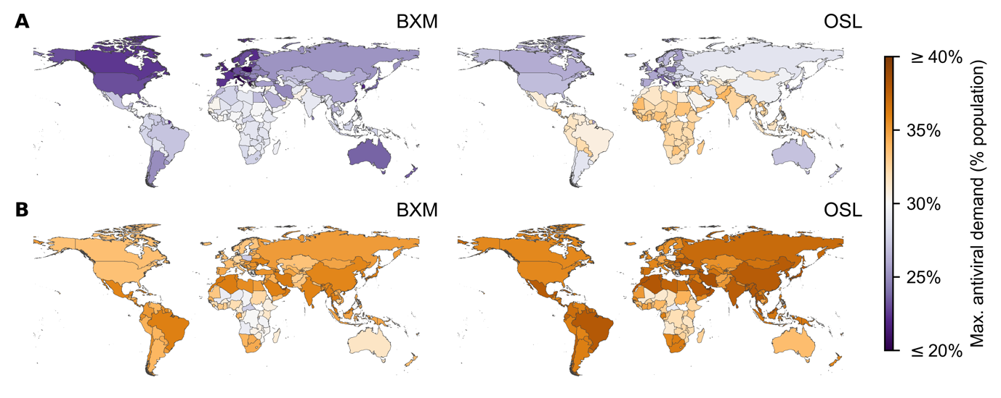
Fig. 2: Maximum treatment oral antiviral demand of 186 countries under idealised assumptions. Baloxavir marboxil (BXM; left column) or oseltamivir (OSL; right column) was administered to all individuals that were positively diagnosed, using a rapid test with 70% test sensitivity, within two days of symptom onset. All symptomatic individuals were assumed to have sought testing within one day after symptom onset on average. Distribution of oral antivirals for treatment began one week after the pandemic was initiated in the country with ten infections. (A) 1918 A/H1N1 pandemic ($R_{0}$=2.0). (B) Hypothetical influenza pandemic with COVID-19-like disease burden ($R_{0}$=3.0) but generation interval akin to seasonal influenza viruses.

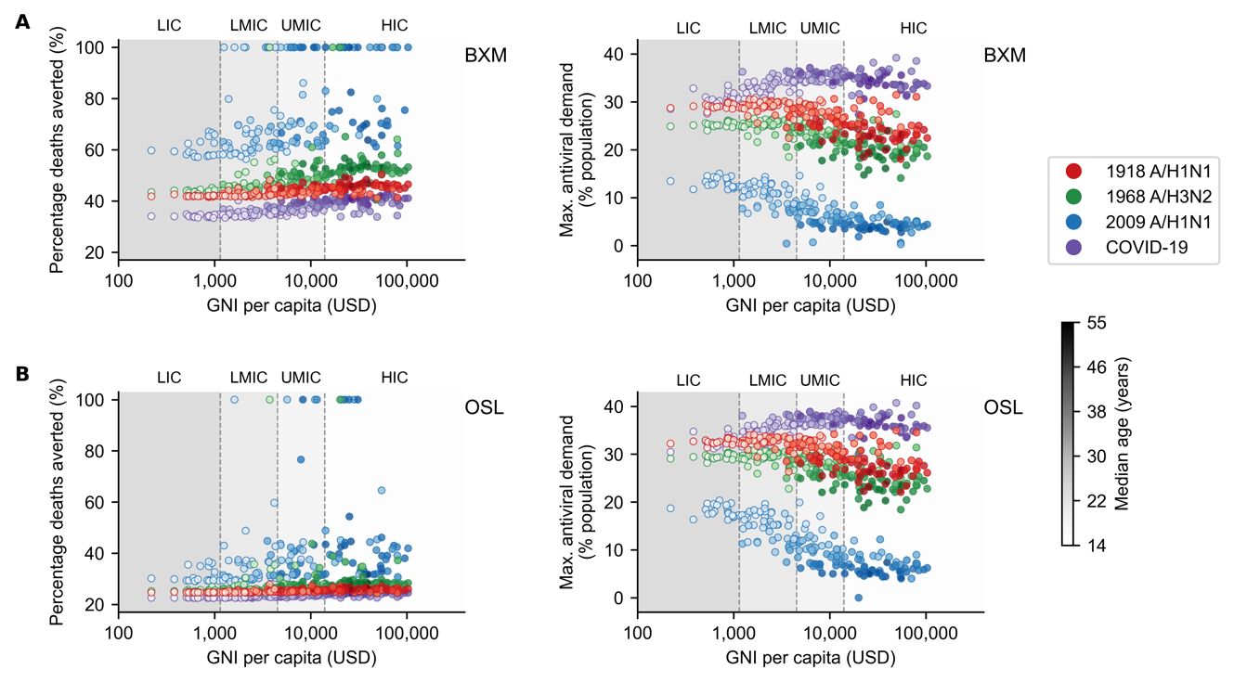
Fig. 3: Demographic and economic covariates to treatment oral antiviral demand and impact. Mean percentage deaths averted (left column) and maximum treatment oral antiviral demand (right column) for each country (circle, shading denotes median age of country’s population) under different pandemic scenarios (denoted by colour of circles; red, 1918 A/H1N1; green, 1968 A/H3N2; blue, 2009 A/H1N1; and purple, COVID-19-like) are plotted against their gross national income (GNI) per capita is US dollars (USD) in 2023. Background shading denotes the range of GNI per capita distinguishing between different country income groups as classified by the World Bank in 2024 (low income country, LIC; lower-middle income country, LMIC; upper-middle income country, UMIC; and high income country, HIC). Antiviral drugs were administered to all individuals that were positively diagnosed, using a rapid test with 70% test sensitivity, within two days of symptom onset. All symptomatic individuals were assumed to have sought testing within one day after symptom onset on average. Distribution of oral antivirals for treatment began one week after the pandemic was initiated in the country with ten infections. (A) Baloxavir marboxil. (B) Oseltamivir.

At the country level, owing to their generally younger demography, the maximum potential per-capita mean impact on disease burden by either antiviral is lower in lower-middle and low income countries while requiring up to four times more treatment courses relative to high income countries (Fig. 3), except for the COVID-19-like pandemic scenario which, unlike historical influenza pandemics, impacted younger individuals to a lesser extent owing to their lower susceptibility to SARS-CoV-2 infection, and in turn, reducing the estimated mean antiviral treatment demand in lower income countries. Appendix Table 3 tabulates the estimated maximum mean antiviral treatment demand, mean rapid testing demand and the corresponding mean deaths averted for each individual country across all four simulated pandemic scenarios.
We also performed sensitivity analyses to account for uncertainty surrounding two key parameters, including: (1) transmission risk reduction by BXM where the 95% confidence interval was estimated at 12-45% (Monto Arnold S. et al., 2025), and (2) the probability of asymptomatic infection, which we varied between 0.05 and 0.40. With greater transmission risk reduction by BXM, mean percentage deaths averted expectedly tend to increase with decreasing antiviral demand (Appendix Fig. 1). However, the marginal changes to mean percentage deaths averted and antiviral demand depends on the pandemic simulated, with more diffuse changes estimated for milder pandemics. Both mean percentage deaths averted and antiviral demand also expectedly decrease with higher probability of asymptomatic infection (Appendix Fig. 2 and 3). BXM tends to result in larger decreases in mean percentage deaths averted than oseltamivir since fewer symptomatic infections are tested for treatment with higher asymptomatic infection rates.

Impact of treatment delay, distribution strategies, post-exposure prophylaxis and antiviral resistance
We subsequently investigated how pandemic death reduction and the corresponding demand for BXM, the potentially more impactful antiviral drug, would change by deviations in reality from idealised assumptions. We used a Bayesian multilevel model to estimate the joint impact of these deviations (Fig. 4). First, distribution of test and treatment across the country is often delayed beyond one week since pandemic initiation in the country. Sufficient epidemiological evidence must accumulate before a pandemic emergency can be ascertained. Additionally, resource, logistical and public health infrastructure constraints, especially in low-resourced countries, can further impede timely test-and-treat interventions. Excluding pandemic- and country-specific effects, percentage of mean deaths averted by BXM decreases by 0.9% (95% highest posterior density (HPD) = 0.1-1.6%) for every week of delay to test-and-treatment distribution since the first infections in the country. This decrease is further exacerbated under pandemic scenarios with faster growth rates, for instance each week of distribution delay under a COVID-19-like pandemic scenario decreases percentage of mean deaths averted by 2.9% (95% HPD = 2.8-3.0%). Without prompt delivery and accessibility to test-and-treatment, the theoretical utility of a pandemic oral antiviral stockpile is greatly diminished (Han et al., 2023).

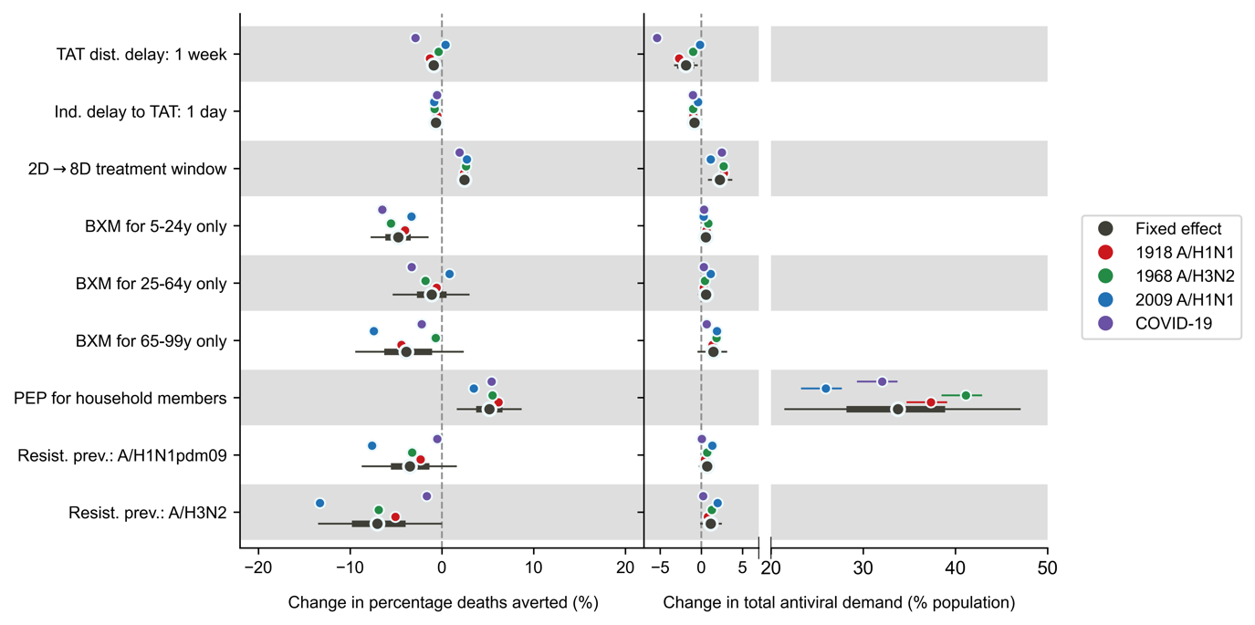
Fig. 4: Joint effects of treatment delays, distribution strategies, post-exposure prophylaxis and antiviral resistance on mean percentage deaths averted and total antiviral demand. Relative to the idealised scenario (i.e. antivirals are swiftly distributed to patients across the country one week after the first infection in the country, with no limits on access and availability of tests and antivirals; >95% of all symptomatic individuals are treated within two days after symptom onset if positively diagnosed by a rapid diagnostic test; No emergence and spread of BXM-resistant viruses), mean posterior changes in mean percentage deaths averted (left plot) and total antiviral (i.e. BXM and oseltamivir) demand (right plot) across pandemics and countries are plotted as black circles (i.e. fixed effects) while the thick and thin lines denote the corresponding 67% and 95% highest posterior density intervals respectively. The corresponding pandemic scenario-adjusted posterior effects are plotted alongside (posterior mean and 95% highest posterior density interval denoted by colour of circle and line respectively; red, 1918 A/H1N1; green, 1968 A/H3N2; blue, 2009 A/H1N1; and purple, COVID-19-like).

It is also unlikely that most infected persons would seek test-and-treatment within two days of symptom onset on average given heterogenous healthcare-seeking behaviour across the population (Graham et al., 2022; Peppa et al., 2017). For every day of delay in mean time to treatment since symptom onset across the population, the population-level reduction in mean deaths is expected to decrease by 0.7% (95% HPD = 0.5-0.8%). To mitigate the diminishing impact of individual treatment delay, we considered extending the current indicated BXM treatment use of within two days post-symptom onset to eight days. Leveraging on BXM’s rapid inhibition of viral replication (Hayden Frederick G. et al., 2018), additionally treating individuals who sought treatment after two days post-symptom onset could theoretically lower their infectiousness (Appendix Fig. 4) such that population-level percentage mean deaths averted would increase by 2.4% (95% HPD = 1.8-3.0%) while requiring 2.3% (95% HPD = 0.9-3.6%) more per-capita courses of BXM.
Age-based rationing is a common resource saving strategy under limited drug availability. We estimated how overall pandemic deaths and BXM demand would change, relative to the idealised scenario of no age restriction, if BXM was differently restricted for individuals aged 5–24 years, 25–64 years, and those $≥$65 years of age only while other age groups were allotted oseltamivir instead. Rationing BXM for different age groups leads only to trivial changes in total antiviral (i.e. BXM and oseltamivir) demand (i.e. age group, 95% HPD: 5–24 years, -0.1-1.2%; 25–64 years, -0.3-1.4%; $≥$65 years, -0.3-3.0%). However, mean BXM demand could approximately be halved if rationed for individuals aged 5–24 years, lowered by ~60% if given to 25–64 years only and further reduced by ~96% if only seniors $≥$65 years are given BXM, with variation depending on the pandemic and the country (Appendix Table 4).
Changes to percentage mean pandemic deaths averted depends on the age group allotted BXM (Fig. 4). If BXM is given to younger individuals aged 5–24 years only, percentage mean pandemic deaths averted decreases by 4.7% (95% HPD = 1.6-7.7%). If BXM is restricted to individuals aged 25–64 years, changes to percentage mean pandemic deaths averted strongly depends on pandemic-specific effects with trivial country-level effects despite the variation in age demography between countries (Appendix Fig. 5). For example, if BXM is distributed to 25–64 years only, percentage mean deaths averted would decrease by 3.3% (95% HPD = 3.0-3.6%) under COVID-19-like pandemic scenario but increase by 0.8% (95% HPD = 0.5-1.2%) during the 2009 A/H1N1-like pandemic which disproportionately affected middle-aged adults (Dawood et al., 2012) (Fig. 4). If BXM is allotted to older individuals $≥$65 years of age only, decrease in percentage mean deaths averted depends on the pandemic scenario (i.e. 1918 A/H1N1-like, 95% HPD = -4.9-4.0%; 1969 A/H3N2-like, 95% HPD = -1.1-0.2%; 2009 A/H1N1-like, 95% HPD = -7.9-7.0%; COVID-19-like, 95% HPD = -2.7-1.8%; Fig. 4).
Although BXM is effective as PEP (Ikematsu Hideyuki et al., 2020), swift and extensive contact tracing for PEP distribution can be challenging to implement during a pandemic (Clark et al., 2021; Davis et al., 2021). Under the ideal assumption of same-day BXM administration to household contacts upon the identification of the index patient, excluding pandemic- or country-level effects, providing BXM as PEP on top of treatment increases mean pandemic deaths averted by 5.2% (95% HPD = 1.7-8.6%) while incurring additional per-capita BXM demand by 33.8% (95% HPD = 21.6-47.0%). Changes in BXM impact and demand due to PEP varies by country (Appendix Fig. 5–7) where lower-income countries, which tend to have larger mean household sizes, would benefit from PEP distribution when mean household size is $≥$4 members, further increasing mean pandemic deaths averted by up to ~6%. However, realizing this benefit would require up to ~50% more per-capita mean BXM demand.
Multiple studies reported that seasonal IAVs readily acquire treatment-emergent BXM-resistant mutations without a loss in viral fitness (Hayden Frederick G. et al., 2018; Omoto et al., 2018; Takashita et al., 2019b, 2019a; Uehara et al., 2020; Imai et al., 2020), especially among children, albeit at different rates of emergence (Imai et al., 2020; Omoto et al., 2018; Takashita et al., 2019b), which have been shown to be transmissible between ferrets (Imai et al., 2020; Jones et al., 2020) and potentially between humans (Imai et al., 2020; Takashita et al., 2019a). We assessed the degree to which widespread transmission of resistance mutations could potentially diminish the impact and demand of BXM, assuming treatment-emergent resistance prevalence at average levels observed for seasonal A/H1N1pdm09 and A/H3N2 viruses. Under the higher prevalence of treatment-emergent resistance akin to treatment of A/H3N2 infections, excluding pandemic- and country-level effects, mean pandemic deaths averted by BXM could potentially decrease by 7.0% (95% HPD = 0.1-13.4%) relative to no resistance emergence. Pandemics with slower growth rates would more likely lead to wider resistance spread, as evidenced by lower total percentage of mean pandemic deaths averted (Fig. 4). Conversely, resistance spread under A/H1N1pdm09 resistance prevalence yields trivial fixed effects on mean pandemic deaths averted (95% HPD = -8.6-1.5%) and is instead strongly dependent on the pandemic scenario (Fig. 4) with generally trivial country-level effects (Appendix Fig. 5) despite the age dependency of resistance emergence rates. Assuming that rapid testing does not distinguish between drug-sensitive and -resistant viruses for treatment administration, changes in mean BXM treatment demand are trivial under both treatment-emergent resistance prevalence levels (i.e. A/H3N2, 95% HPD = 0.0-2.0%; A/H1N1pdm09, 95% HPD = -0.2-1.5%).

Discussion
To investigate how heterogeneous individual behaviour to seeking treatment with antivirals post-infection impact influenza virus infectiousness and transmission dynamics, we developed a novel multi-scale and multi-type model that links heterogeneous within-host infectiousness to between-host influenza transmission dynamics. This is also the first study that incorporates recent clinical estimates of transmission risk reduction by antiviral treatment (Monto Arnold S. et al., 2025). We estimated the maximum country-specific influenza antiviral demand for either BXM or oseltamivir and their corresponding impact in reducing pandemic deaths during a nascent influenza pandemic for 186 countries under the same age-structured transmission model, resolving difficulties in either synthesizing or extrapolating findings from previous modeling studies, which have focused on either one or a handful of countries based on used outdated assumptions, to inform potential influenza antiviral stockpiling options that fit country-specific needs.
Regardless of the antiviral drug, treatment-only antiviral demand maximally amounts to 20-40% per-capita, with lower income countries needing more antiviral drugs, and can avert >20% of expected pandemic deaths during the first epidemic wave of a nascent influenza pandemic. Because of its demonstrated benefits in reducing transmission, BXM is the more effective and treatment course-efficient antiviral drug as BXM distribution doubles the reduction in pandemic deaths relative to oseltamivir, with the potential to maximally avert 37-68% of mean pandemic deaths, while requiring ~5-10% less courses of drugs. However, due to existing patent and cost constraints on BXM, oseltamivir will remain as the more accessible option for lower income countries. Unless global health actors, in particular high-income countries, muster the political will to address the many challenges underlying global health inequity (Lavery et al., 2023; Pai et al., 2024), cooperation between regional states could present opportunities to increase affordable access to BXM, alongside other pandemic medicines and vaccines, before the next influenza pandemic through pooled procurement mechanisms and/or technology transfer agreements (Rahman-Shepherd et al., 2025). Nonetheless, procuring enough antivirals to sufficiently meet demand does not necessarily confer the aforementioned impact estimates unless similar investments are made to public health infrastructure to ensure prompt drug distribution across a country upon pandemic initiation, with enough testing resources to identify most symptomatic individuals shortly after infection.
Under limited availability, age-based rationing of BXM while providing oseltamivir to the rest of the population can substantially lower BXM demand even though total antiviral courses needed will likely remain unchanged. Rationing for individuals with greater risk of mortality (i.e. the elderly) or those with greater mobility, and thus more likely to spread the virus (i.e. young individuals), would both lead to more pandemic deaths, the magnitude of which depends on the pandemic scenario. However, rationing BXM for the elderly could lead to far greater reduction in BXM demand by >90%. Cost-effectiveness analyses should be performed to determine the appropriateness of age-based rationing under different pandemic scenarios and country-specific drug prices but are beyond the scope of this work.
Besides treatment, providing antivirals as PEP to exposed contacts could confer additional benefits in reducing disease burden. Household members of index patients are potentially easier contact tracing targets for PEP distribution and a recent modelling study found that combining treatment of the index patient and PEP for exposed household members could yield considerable reduction in burden within individual households (Zaaraoui et al., 2024). However, given the heightened risk of infection during a pandemic across the population, independent of country-level effects, distributing BXM to household contacts would only lead to modest population-level increase in mean pandemic deaths averted by ~5% while increasing mean BXM demand by >30%. PEP would only additionally reduce disease burden in settings where the mean household size is ≥4. Under limited drug availability and/or below the mean household size of four, prioritizing antiviral drugs for treatment as opposed to PEP is more effective and treatment course-efficient considering population-level outcomes.
Finally, it is important to consider the degree to which antiviral resistance attenuates impact as it may be more prudent to limit BXM to individuals that would most likely derive clinical benefit from treatment as opposed to mass antiviral distribution. When assuming mean treatment-emergent prevalence of BXM resistant mutations was similar to seasonal A/H3N2 infections, percentage reduction in mean pandemic deaths under the spread of BXM resistance was still substantial, estimated to be >24% compared to no intervention. As such, in spite of resistance spread, mass distributing BXM for treatment could still lead to substantial life-saving benefits. Various strategies have been proposed to potentially suppress the spread of resistance, such as cycling the distribution of two different antiviral drugs (Wu et al., 2009) or combining them for treatment (Park et al., 2021; Koszalka Paulina et al., 2022). Previous modelling work showed that either strategy could work well to suppress resistance spread if the probability of resistance emergence of the primary antiviral drug is <5% (Wu et al., 2009), which could be the case if treatment-emergent resistance prevalence of the pandemic virus is similar to that empirically observed for A/H1N1pdm09 infections.
There are limitations to our study. First, we used clinical observations on viral load dynamics, treatment effectiveness and resistance prevalence measured for seasonal influenza virus infections to parameterize our model. While a future pandemic virus can have distinct epidemiological properties, in contrast to extrapolations considered in previous studies, we sought to inform antiviral treatment demand and impact using a model that is grounded on up-to-date, high-quality empirical data. Second, we did not account for the availability and use of pre-pandemic vaccines. We had previously showed that increasing vaccination coverage, if pre-pandemic vaccines are available, should be prioritised over mass test-and-treat distribution as it is the more resource-efficient option to lowering pandemic disease burden (Han et al., 2023). Third, although we accounted for imperfect sensitivity of rapid influenza diagnostic tests, we did not consider the impact of false positives on antiviral demand and mortality reduction given uncertainties on background influenza-like illness activity that might prompt uninfected individuals with similar symptoms to seek test-and-treat. However, given the uniformly high specificities of existing rapid tests (>98%) (Merckx et al., 2017), false positives are unlikely going to change our antiviral demand and impact estimates substantially. Finally, our country-level modelling framework and results are intended to inform public health planning and distribution of antiviral stockpiles for individual countries. We have also only considered the impact of drug resistance spread owing to endogenous emergence of resistant mutations within the country and not by exogeneous introduction. Future work should investigate the impact of global resistance transmission dynamics on antiviral effectiveness.
Influenza antiviral drugs, in particular BXM given its demonstrated clinical effectiveness in lowering transmission risks, have the potential to significantly lower the disease burden of future influenza pandemics. We have computed the expected maximum antiviral demand for treatment and its corresponding impact in 186 countries. We then quantified how this theoretical demand and impact could change depending on real-world variations. Countries could consider our demand and impact estimates to guide their antiviral stockpile sizes and drug distribution strategies as part of pandemic preparedness planning. Global and regional organizations could use our estimates as targets for procurement negotiations while antiviral drug manufacturers could base their production capacity on the same estimates. However, no single country can stockpile its way out of a global pandemic emergency. Global health actors must act now to ensure access to pandemic medicines before the next influenza pandemic.

Methods

Multiscale model
We developed a discrete-time, age-structured, deterministic SIR compartmental model of influenza transmission that can be flexibly parameterised for individual countries using relevant demographic and age-dependent contact rate data (see Appendix). To compute transmission dynamics, we adapted the multi-type renewal equation (Green et al., 2022) that accounts for heterogeneity in transmission due to reduction in infectiousness by antiviral treatment which effectiveness predicates on when treatment was initiated since infection, age-dependent contact rates between infected and uninfected individuals, susceptibility and, if given one, protection from infection by PEP of the uninfected individuals. The infectiousness of infected individuals was estimated by a separate target cell-limited within-host model (Hadjichrysanthou et al., 2016). Assuming that the pandemic IAV has similar within-host virus replication dynamics to seasonal IAVs, we estimated the cell infection and viral replication rate, as well as treatment effectiveness parameters of antivirals by fitting our within-host model to the viral load measurements taken from clinical trial for different treatment regimens (i.e. placebo, BXM or oseltamivir) that were administered within two days after symptom onset, with (Uehara et al., 2020) and without the emergence of BXM-resistant viruses (Hayden Frederick G. et al., 2018). Given that we still lack a quantitative understanding of how within-host viral load links to between-host transmission,(Handel and Rohani, 2015) we applied three different correlative models that were previously applied to infer infectiousness from viral load data of respiratory viral pathogens, estimating the best-fit parameters that align with empirical effectiveness estimates of BXM reducing onward transmission risk by 29% within five days after treatment (Monto Arnold S. et al., 2025). As all correlative models yield similar transmission dynamics (see Appendix for model validation against US influenza season in 2017/2018), we used the Hill equation model for all simulations and applied the best-fit parameters to estimate the mean infectiousness of infected individuals who were treated at different times during the course of their infection (i.e. within and beyond two days after symptom onset), accounting for individual variances in time to symptom onset since infection, delays in treatment since symptom onset, and whether or not resistant mutant viruses emerge after treatment.
See Appendix for the full formulation of the within- and between-host transmission models. We also included a table of parameters and corresponding values used (Appendix Table 1), and a summary of key modelling assumptions (Appendix Table 2) made for the between-host transmission model.

Maximum antiviral demand
We computed the maximum mean antiviral demand for treatment, using either oseltamivir or BXM as the sole infection control intervention, in 186 countries where age demography and contact rates were estimated by the UN World Population Prospects (United Nations, 2024) and (Prem et al., 2021) respectively, during the first wave of four influenza pandemic scenarios with distinct basic reproduction number, age-stratified susceptibility to infection and case fatality rates (i.e. a severe pandemic with a W-shaped age-specific mortality curve, 1918 A/H1N1 (Luk et al., 2001; Taubenberger and Morens, 2006); a moderately severe pandemic U-shaped age-specific mortality curve, 1968 A/H3N2 (Luk et al., 2001; Taubenberger and Morens, 2006); a mild pandemic with greater relative mortality rates among adults <65 years of age, 2009 A/H1N1 (Dawood et al., 2012); a severe pandemic with greater relative susceptibility and mortality rates among adults $≥$65 years of age, COVID-19 (Verity et al., 2020; Zhang et al., 2020); Appendix Table 1) akin to the 1918 A/H1N1 ($R_{0}$=2.0), 1968 A/H3N2 ($R_{0}$=1.8), 2009 A/H1N1 ($R_{0}$=1.5) and an influenza pandemic with COVID-19-like reproduction number ($R_{0}$=3.0) and disease burden but with IAV-like generation interval. We assumed that 84% of infections were symptomatic even though prevalence of asymptomatic influenza remains largely uncertain (Leung et al., 2015). We also assumed that asymptomatic individuals are as infectious as their symptomatic counterparts.
To estimate the maximum mean antiviral demand, we assumed that there were no age restrictions in access to antivirals and that 95% of all symptomatic individuals would ideally seek clinical intervention within two days after symptom onset, lognormally distributed across time (i.e. mean=1 day, sd=0.6 days after symptom onset). We also assumed that an idealised public health infrastructure was in place such that country-wide distribution of antivirals would begin one week after the pandemic was initiated with ten infections in the country. Given likely limited BXM supply, heterogeneity in healthcare-seeking behaviour, and delays to begin treatment distribution in reality, all of which would lead to lower antiviral demand, we would relax the aforementioned assumptions in subsequent analyses (see below).
Rapid testing would be required for same-day antiviral administration and was performed by a moderately sensitive rapid diagnostic test (70%) (Merckx et al., 2017). Given its multi-day, five-dose treatment course, probability of adherence to oseltamivir treatment was assumed to be lower (65%) (Smith et al., 2016) than the single-dose BXM (95%). Treated infected individuals that did not adhere to treatment were assumed to be effectively untreated. We estimated the impact of antiviral use by computing the total deaths reduced relative to no infection control. Total deaths during the pandemic wave was computed based on net incidence and the corresponding pandemic case fatality rates while accounting for mean reduction in mortality risks of treated individuals by 23% for both oseltamivir (Hsu et al., 2012) and BXM, for which robust mortality risk reduction estimates is currently lacking.

Additional simulated scenarios
We then used our model to simulate scenarios that deviate from the aforementioned idealised case. We simulated different delays to test-and-treatment distribution since pandemic initiation (i.e. one week, four weeks and three months). We also accounted for heterogeneity in healthcare-seeking behaviour by varying time to individual treatment since symptom onset (i.e. mean (sd) = 1.0 (0.6), 2.0 (1.2) and 5.0 (3.0) days, which correspond to 95% likelihood of seeking test-and-treat within two, four and eight days since symptom onset respectively). Furthermore, we simulated different BXM distribution strategies, including extending antiviral treatment window from two to eight days, providing PEP to asymptomatic, undiagnosed symptomatic and uninfected household members of positively-tested individuals. While asymptomatic and undiagnosed symptomatic individuals would lower their infectiousness by PEP similarly to symptomatic individuals treated with antivirals, uninfected individuals would lower their likelihood of infection by 57% for ten days after administering BXM as PEP (Ikematsu Hideyuki et al., 2020). We also simulated scenarios where BXM supply is limited and thus rationed for those aged 5-24 years, 25-64 years or $≥$65 years only while the rest of the population were given oseltamivir. Finally, we investigated the impact of BXM resistance emergence and spread based on age-stratified average treatment-emergent resistance prevalence reported for A/H1N1pdm09 (<12 years = 9.4%; $≥$12 years = 2.2%) (Baker et al., 2020; Hayden Frederick G. et al., 2018; Hirotsu et al., 2023) and A/H3N2 (<12 years = 21.0%; $≥$12 years = 8.5%) (Baker et al., 2020; Ison et al., 2020; Uehara et al., 2020) infections. BXM treatment has no effect on within-host replication of BXM-resistant viruses, and in turn their infectiousness. Given limited evidence that BXM-resistant virus may be fitter than their drug-sensitive counterparts (Checkmahomed et al., 2020; Hickerson Brady T. et al., 2023; Jones et al., 2022), we conservatively assumed that BXM-resistant strains have similar within-host viral replication fitness and between-host transmission advantage to untreated drug-sensitive viruses. We used a Bayesian multilevel model that partially pooled simulation results across all simulated countries and pandemic scenarios to estimate the effect size of each factor on the deaths averted and BXM demand.
See Appendix for the detailed formulation of the Bayesian multilevel model and assumed priors.

Appendix

Within-host model
We used a within-host model (Appendix Fig. 8) to estimate the replication dynamics of the inoculating treatment-susceptible virus and treatment-resistant mutant virus since infection, as well as the effectiveness of antiviral treatment to suppress treatment-susceptible virus replication ($e_{treatment}$):
$$\frac{dT}{dt}=-T\left(β_{w}V_{w}+β_{m}V_{m}\right)-lTF+rR$$ | $$(1)$$
$$\frac{dR}{dt}=lTF-rR$$ | $$(2)$$
$$\frac{dI_{V}}{dt}=β_{V}TV_{V}-d_{C}I_{V}-d_{I}I_{V}F ∀ V∈\left\{w,v\right\}$$ | $$(3)$$
$$\frac{dF}{dt}=p_{F}\left(I_{w}+I_{m}\right)-d_{F}F$$ | $$(4)$$
$$\frac{dV_{w}}{dt}=p_{w}\left[1-μδ\left(t≥t_{treatment}\right)\right]\left[1-e_{treatment}δ\left(t≥t_{treatment}\right)\right]I_{w}-c_{w}V_{w}$$ | $$(5)$$
$$\frac{dV_{m}}{dt}=p_{m}μδ\left(t≥t_{treatment}\right)I_{m}-c_{m}V_{m}$$ | $$(6)$$
where $T$, $R$, $I_{w}$, $I_{m}$, $F$, $V_{w}$ and $V_{m}$ are the respective number of uninfected target cells, the number of cells that enter an antiviral state in which they are refractory to infection, the number of cells infected by the wild-type virus, the number of cells infected by the antiviral-resistant mutant virus, the level of interferon response, the amount of free wild-type and mutant viruses. The parameters $β_{V}$, $l$, $r$, $d_{C}$, $d_{I}$, $p_{F}$, $d_{F}$, $p_{V}$ and $c_{V}$ refer to the respective target cell infection rate by variant virus $V$, interferon-induced antiviral efficacy, reversion rate from antiviral state, virus-induced infected cell death rate, interferon-induced infected cell death rate, production rate of interferons, decay rate of interferons, replication rate and free virus death rate of variant virus $V$ respectively. $δ\left(t\right)=1$ when and after the antiviral was administered at time $t_{treatment}$, and is otherwise zero.
We fitted the within-host model to viral load data measured since initiation of different treatment regimens (i.e. placebo, baloxavir marboxil (BXM) or oseltamivir) with and without the emergence of BXM-resistant viruses from a phase 3 clinical trial (CAPSTONE-1) (Hayden Frederick G. et al., 2018; Uehara et al., 2020). For the BXM-resistance, the rebound in viral load was dominated by BXM-resistant virions based on the estimated within-host mutation frequencies (Uehara et al., 2020). To fit the model, first, we fitted pooled data of the time of symptom onset since influenza virus infection to a lognormal distribution (i.e. mean = 0.35, standard deviation = 0.41; Appendix Fig. 9A) (Lessler et al., 2009). Second, we fitted the time of treatment initiation since symptom onset reported in the clinical trial to a Gamma distribution (i.e. placebo, shape = 2.91, scale = 8.31; BXM, shape = 2.40, scale = 10.12; oseltamivir, shape = 2.87, scale = 8.53; Appendix Fig. 9B-D). We then simulated the number of individuals assigned to each treatment regime as per the CAPSTONE-1 trial (i.e. $n=$ 210, 427 and 377 individuals administered with a course of placebo, BXM and oseltamivir respectively (Hayden Frederick G. et al., 2018); $n=$ 34 individuals with treatment-emergent BXM-resistant mutant viruses) (Uehara et al., 2020), randomly drawing the time of symptom onset and treatment initiation from the aforementioned fitted distributions. The CAPSTONE-1 trial reported the viral load distribution of participants in different treatment regimen each day for 7 days since treatment initiation with no further information on when sample collection was performed each day (Hayden Frederick G. et al., 2018). In turn, we randomly generated the timing when viral samples were collected for each individual assuming a uniform distribution within a 12-hour collection time window each day. We then fitted the within-host model to the viral load dynamics simulated individuals, estimating all parameters except for the initial uninfected target ($U_{0}$) and infected ($I_{0}$) cell populations which were assumed to be $4×{10}^{8}$ and 0 cells respectively (Handel et al., 2007). We used differential evolution to iteratively search for parameter values that maximise the joint Gaussian likelihood of the viral load data reported in the CAPSTONE-1 trial (Hayden Frederick G. et al., 2018) and in Uehara et al (Appendix Fig. 8) (Uehara et al., 2020). Applying these maximum-likelihood parameter estimates to our within-host model, we could then simulate the infectious viral load trajectories for different $t_{treatment}$ (Appendix Fig. 4).

Infectiousness estimates from within-host viral load
To correlate within-host viral dynamics to infectiousness (Handel and Rohani, 2015), we explored three different models that were previously applied to respiratory viral pathogens to estimate infectiousness ($ω\left(t\right)$) from the simulated viral load ($V\left(t\right)$) at time $t$:
Hill equation (Goyal et al., 2021; Handel et al., 2007) | $$ω\left(t\right)=\frac{1}{1+{\left[\frac{k_{1}}{\log_{10}\left\{V\left(t\right)\right\}}\right]}^{k_{2}}}$$  where $k_{1}$ is the viral load value leading to 50% infectiousness and $k_{2}$ is the Hill coefficient. | $$(7)$$
Logit function (Marc et al., 2021) | $$\text{logit}\left[ω\left(t\right)\right]=k_{1}\left[\log_{10}\left\{V\left(t\right)\right\}-k_{2}\right]+ k_{3} ∀\log_{10}\left\{V\left(t\right)\right\}>k_{2}$$  $$\text{logit}\left[ω\left(t\right)\right]=k_{3} ∀\log_{10}\left\{V\left(t\right)\right\}≤k_{2}$$  where $k_{1}$ and $k_{3}$ are the transmission coefficient and baseline log-odds respectively. | $$(8)$$
Logarithmic function (Lange and Ferguson, 2009) | $$ω\left(t\right)=1-\exp\left\{\frac{-\log_{10}\left[V\left(t\right)\right]}{k}\right\}$$  where $k$ is the scaling factor. | $$(9)$$

Assuming that treatment with BXM within two days of symptom onset leads to 29% reduction in infectiousness by five days post-treatment as reported in the phase 3 CENTERSTONE trial (Monto Arnold S. et al., 2025), we applied each infectiousness model to the infectious viral load trajectory of BXM treatment as estimated by our within-host model (Appendix Fig. 10) and fitted the $k$ parameters by differential evolution. We then applied the best-fit parameters to the within-host and infectiousness models to estimate the infectiousness $ω$ of infected individuals who were treated at different times during the course of their infection as a result of differences in time to symptom onset since infection, delays in treatment since symptom onset and whether or not resistant mutant viruses emerge after treatment.
We find negligible difference (<10% in total incidence) between all three infectiousness models when combined with the between-host transmission model (see below) to estimate population transmission dynamics (Appendix Fig. 11).

Between-host transmission model
We developed a discrete-time (i.e. timestep of one day), multi-type renewal process equation model to compute between-hosts transmissions over time to individuals with different susceptibility, contact rates and infectiousness profile. Assuming that the population is stratified into $n$ age groups and that infected individuals are further distinguished by their diagnosis status and infectiousness profile $y$, the mean incidence for individuals in group $a$ on day $t$ is modelled as:
$$I_{t,a}=\sum_{d=0}^{1}{\sum_{α=1}^{n}{\sum_{y=0}^{Y}{\sum_{τ=0}^{t-1}{R_{t,y,α→a,d}{\hat{ω}}_{t-τ, y}I_{τ,y,α,d}}}}}$$ | $$(10)$$
where $R_{t,y,α→a,d}$ is mean number of secondary infections in age group $a$ caused by an infector in age group $α$ with infectiousness profile $y$ on day $t$ with the boolean status $d$ indicating if their infection is identified either by testing or contact tracing; $I_{t,y,α,d}$ is the number of infected individuals in age group $α$ with infectiousness profile $y$ on day $t$ with status $d$; and ${\hat{ω}}_{τ, y}$ is the discretised, normalised infectiousness profile and only depends on profile $y$, given by:
$${\hat{ω}}_{τ, y}=\left\{\begin{aligned}\int_{τ-0.5}^{τ+0.5}{ω_{y}\left(τ\right)dτ} ∀ τ≥2 \\ \int_{0}^{1.5}{ω_{y}\left(τ\right)dτ} ∀ τ=1\end{aligned}\right.$$ | $$(11)$$
where $\int_{0}^{∞}{{\hat{ω}}_{y}\left(τ\right)dτ}=1$. Note that $y=0$ denotes the untreated infectiousness profile.
Given the limited evidence that BXM resistant mutations may be fitter or less fit than their wild-type BXM-sensitive counterparts (Checkmahomed et al., 2020; Hickerson Brady T. et al., 2023; Jones et al., 2022), we assumed that there is no difference in either within-host viral replication fitness or between-host transmission advantage between the drug-sensitive and resistant virus. In turn, for individuals who are infected by the drug-resistant variant virus, their infectiousness profiles are similar computed by equation 11 for the untreated infectiousness profile. For individuals who are infected by the drug-sensitive virus but later developed treatment-emergent resistance, given that influenza virus transmission bottleneck is likely tight such that either one variant is transmitted upon an infectious contact (Morris et al., 2020), we adjusted the infectiousness profiles of the drug-sensitive ($V_{1}$) and resistant ($V_{2}$) viruses such that:
$${\hat{ω}}_{τ, y,V_{1}}^{'}={\hat{ω}}_{τ, y,V_{1}}\left(1-{\hat{ω}}_{τ, y,V_{2}}\right)$$
$${\hat{ω}}_{τ, y,V_{2}}^{'}={\hat{ω}}_{τ, y,V_{2}}(1-{\hat{ω}}_{τ, y,V_{1}})$$
$R_{t,y,α→a}$ depends on the remaining number of susceptible individuals in age group $a$ on day $t$ ($S_{t,a}=N_{a}-\sum_{t}{I_{t,a}}$ where $N_{a}$ is the number of individuals of age group $a$ in the simulated population), the number of susceptible individuals in age group $a$ who were administered antivirals as post-exposure prophylaxis $ρ$ days ago ($S_{ρ,a}^{PEP}$) that reduces the likelihood of infection by $ϵ_{PEP}$ over a time period of $γ_{PEP}$ days (i.e. $ρ<γ_{PEP}$), the relative risk of infection $M_{α→a}$ of susceptible individuals in age group $a$ by infected individuals belonging to age group $α$ (assumed to be constant over time) and the impact of infectiousness profile $y$ on mean infectious period:
$$R_{t,y,α→a}=\frac{S_{t,a}-ϵ_{PEP}\sum_{t-γ_{PEP}}^{t-1}{S_{t,a}^{PEP}}}{N_{a}}⋅M_{α→a}⋅\left(1+ϵ_{y}\right)⋅R$$ | $$(12)$$
where $R$ is the basic reproduction number of the simulated pandemic scenario.
Infected individuals with different infectiousness profile $y$ change their mean infectiousness by a factor $ϵ_{y}$ given by:
$$ϵ_{y}=\frac{\int_{0}^{∞}{ω_{y}\left(τ\right)dτ}}{\int_{0}^{∞}{ω_{y=\text{untreated}}\left(τ\right)dτ}}-1$$ | $$(13)$$
where $ω_{y}$ is the unnormalised infectiousness of profile $y$ that was computed by either one of the viral load-to-infectiousness models (i.e. equations (7) – (9)).
$Μ$ is the normalised relative risk matrix given by:
$$Μ=\left[\begin{matrix}M_{1→1} & ⋯ & M_{α→1} \\ ⋮ & ⋱ & ⋮ \\ M_{1→a} & ⋯ & M_{α→a}\end{matrix}\right]=\frac{Cη^{T}}{ρ\left(Cη^{T}\right)}$$ | $$(14)$$
where $C=\left\{C_{α→a}\right\}$ is the mean contact rate matrix between individuals in age group $α$ and individuals in age group $a$, $η=\left\{η_{a}\right\}$ is the relative susceptibility of individuals in age group $a$, with the most susceptible group having a value of 1 and $ρ\left(Cη^{T}\right)$ is the spectral radius of $Cη^{T}$. We used country-specific estimates of $C$ from (Prem et al., 2021, 2017) and estimates of $η$ for seasonal influenza (Brugger and Althaus, 2020), 2009 A/H1N1 pandemic (Cauchemez Simon et al., 2009) and COVID-19 pandemic (Zhang et al., 2020) from various sources. For the 1918 A/H1N1 and 1968 A/H3N2 pandemics, we assumed $η=1$ for all age groups.

Test and treat
The probability that an infected individual is tested at time $τ$ since infection can be formulated as (Oliver Eales et al., 2023):
$$d\left(τ\right)=\int_{0}^{τ}{σ\left(ξ\right)λ\left(τ-ξ\right)dξ}$$ | $$(15)$$
where $σ\left(τ\right)$ is the probability of symptom onset on day $τ$ since infection and $λ\left(ν\right)$ is probability of symptomatic testing on day $ν$ since symptom onset. $\int_{0}^{∞}{σ\left(τ\right)dτ}$ can be less than one and is equal to the probability of a symptomatic infection: $\int_{0}^{∞}{σ\left(τ\right)dτ}=1-p_{\text{asymptomatic}}$ where $p_{\text{asymptomatic}}$ is expected probability of asymptomatic infection which we assumed to 16% for influenza infections.(Leung et al., 2015) On the other hand, $\int_{0}^{∞}{λ\left(θ\right)dθ}$ is equal to the willingness of testing provided that all individuals who seek testing will be tested which can also be less than one. In turn, the expected number of infected individuals $T\left(t\right)$ that are positively diagnosed at time $t$ is:
$$T\left(t\right)=ψ\int_{0}^{∞}{d\left(τ\right)I\left(t-τ\right)dτ}$$ | $$(16)$$
where $ψ$ is the sensitivity of the diagnostic test.
In the discrete form, assuming that $d\left(τ\right)$ is the same for all age groups, the expected number of infected individuals of age group $a$ with infection age of $τ$ days that are positively tested on day $t$ is therefore:
$$T_{t,a}=ψ\sum_{τ=0}^{t-1}{d_{t-τ}I_{τ,y=0,a,d=0}}=ψ\sum_{τ=0}^{t-1}{\left(\sum_{ξ=0 }^{t-τ}{σ_{ξ}λ_{t-τ-ξ}}\right)I_{τ,y=0,a,d=0}}$$ | $$(17)$$
We assumed the ideal scenario where rapid diagnostic tests are used, with no delay in obtaining results after testing, and are widely available and accessible to the whole population (i.e. no shortages).
Infected individuals that test positive may then be given antiviral that will change their infectiousness profile $y$ depending on the infection age $τ$ when the antiviral was administered and whether or not the individual adhered to the treatment regime. The number of test-and-treated individuals ($O_{treatment,τ,a}$) of age group $a$ with infection age of $τ$ days who are treated is then:
$$O_{treatment,τ,a}=ψd_{t-τ}I_{τ,y=0,a,d=0} ∀ τ≤t-1$$ | $$(18)$$
We also assumed that there is no delay in administration of antivirals upon receiving testing results (i.e. testing and drug administration occurs during the same clinical visit).

Post-exposure prophylaxis
Besides symptomatic testing, contacts of positively-tested individuals may be contact traced and be given antivirals as a post-exposure prophylaxis which has been shown to be effective at reducing transmission risk (Ikematsu Hideyuki et al., 2020; Zhao et al., 2024).
We focused on forward contact tracing: exposed contacts were identified by contact tracing after an index case was positively diagnosed (Scarabel et al., 2021). The number of individuals of age group $a$ that are traced on day $t$ ($c_{t,a}$) depends on the probability that an index case with infection age $τ$ was tested positive ($d_{τ})$, the number of infected individuals of age group $α$ with infection age $τ$ was undiagnosed before day $t$, the expected number of contacts that could be traced and the relative fraction of contacts in age group $a$ to index cases of age group $α$ ($f_{α→a}$):
$$C_{t,a}=\sum_{α=1}^{n}{\sum_{y}{\sum_{τ=0}^{t-1}{ψd_{t-τ}⋅I_{τ,y=0,α,d=0}⋅εf_{α→a}}}}$$ | $$(19)$$
Our mathematical framework does not explicitly model the underlying contact networks among individuals. However, assuming that household contacts are the most convenient individuals that can be traced and be given post-exposure prophylaxis, we could approximate the impact of distributing antivirals to exposed household contacts by assuming $ε$ as the mean number of household contacts based on estimates from the most recent United Nations World Population Prospects for that country (United Nations, 2024). $f_{α→a}$ is inferred from country-specific estimates of mean contact rate matrix in households from (Prem et al., 2021, 2017) The expected number of susceptible individuals of age group $a$ that are traced to be given post-exposure prophylaxis on day $t$ is then computed as:
$$S_{t,a}^{PEP}=C_{t,a}\left(\frac{S_{t,a}-\sum_{t-γ}^{t-1}{S_{t,a}^{PEP}}}{N_{a}}\right)$$ | $$(20)$$
In turn, the number of previously infected individuals of age group $a$ who are given post-exposure prophylaxis on day $t$ is equals to $C_{t,a}-S_{t,a}^{PEP}$. We assumed that only undiagnosed and untreated infected individuals (i.e. $I_{τ,y=0,a,d=0}$), including asymptomatic infected individuals, were given post-exposure prophylaxis which would lower their infectiousness that similarly depended on the age of their infection $τ$ when they were administered the drug. We assumed that post-exposure prophylaxis are distributed multinomially across individuals with infection age $τ$, employing the Sainte-Laguë apportionment method for integer allocation.

Hospitalization and deaths
We assumed that the expected number of hospitalisations and deaths correlate with the number of infected individuals. The number of individuals $H_{t,α}$ in group $α$ that are hospitalised on day $t$ is:
$$H_{t,α}=\sum_{τ=0}^{t-1}{\left(\sum_{ξ=0 }^{t-τ}{σ_{ξ}p_{α}^{hosp}}\right)I_{τ,α}}$$ | $$(21)$$
where $p_{α}^{hosp}$ is the probability that symptomatic individuals in group $α$ are hospitalised.
Analogously, the number of deaths in group $α$ on day $t$ ($D_{t,α}$) is
$$D_{t,α}=\sum_{τ=0}^{t-1}{\left(\sum_{ξ=0 }^{t-τ}{σ_{ξ}p_{α}^{dea}}\right)I_{τ,α}}$$ | $$(22)$$
where $p_{α}^{dea}$ is the probability that symptomatic individuals in group $α$ that died.
Appendix Table 1 tabulates the parameters used in the between-host transmission model.

Bayesian multilevel model
To determine the impact of delays to population distribution and individual treatment, different antiviral distribution strategies including extending the treatment window period since symptom onset, instituting age restrictions on access to treatment and providing prophylactic treatment to exposed contacts, as well as the spread of antiviral resistance, we used a Bayesian multilevel model that partially pooled simulation estimates of percentage of deaths averted by antiviral use and the amount of antivirals demand relative to population size for a range of the aforementioned factors across countries and pandemic scenarios. We assumed a linear correlation between the predicted mean-centered response variable ($Y_{c,p}$) for pandemic $p$ in country $c$ and predictor variables $X_{k}$:
$${\hat{Y}}_{c,p}=\sum_{k=1}^{n_{k}}{\left(β_{k}+b_{k,c}+b_{k,p}\right)X_{k,c,p}}+\left(β_{0}+b_{0,c}+b_{0,p}\right)$$ | $$(23)$$
where $β_{k},$ $b_{k,c}$ and $b_{k,p}$ are the respective normalised fixed, country- and pandemic-specific effects of predictor variable $k$ while $β_{0}$, $b_{0,c}$ and $b_{0,p}$ are the corresponding fixed, country- and pandemic-specific intercepts. Following Gelman et al.,(Andrew Gelman et al., 2008) we used weakly informative Student-t priors with three degrees of freedom, mean of zero and standard deviation (s.d.) of 2.5 for all effects (i.e. $β_{k}, b_{k,c}$ and $b_{k,p}$) while normal priors with mean of zero and s.d. of one were placed for intercepts ($β_{0}, b_{0,c}$ and $b_{0,p}$). Half-normal priors with mean of zero and s.d. of one were used for all standard deviations of effects, intercepts and residuals. For correlation between country- and pandemic-level effects, we used the Lewandowski-Kurowicka-Joe correlation prior with shape parameter of one. Posterior sampling was performed using four MCMC chains, with 1000-iteration burn-in and 1000-iteration of saved posterior samples, using a no-u-turn sampler implemented in the ‘brms’ package (Bürkner, 2017) in R (Core Team, 2024). Chain convergence was determined by checking traceplots, ensuring all Rhat values < 1.05 with sufficient effective sample size (>200).

Appendix Figures
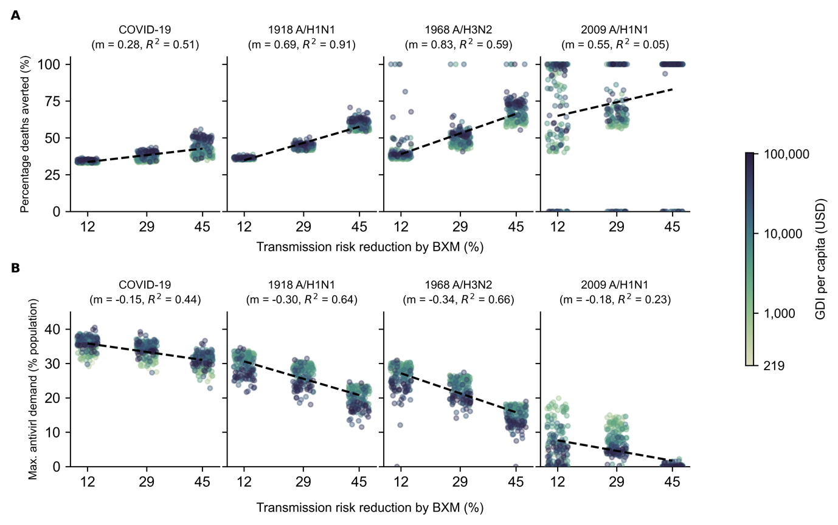
Appendix Fig. 1: Sensitivity analysis to account for uncertainty around transmission risk reduction estimate of baloxavir marboxil (BXM). BXM was administered to all individuals that were positively diagnosed, using a rapid test with 70% test sensitivity, within two days of symptom onset. All symptomatic individuals were assumed to have sought testing within one day after symptom onset on average. Distribution of oral antivirals for treatment began one week after the pandemic was initiated in the country with ten infections. Each circle plot represents a country coloured by its gross national income (GNI) per capita is US dollars (USD) in 2023. Linear regression line is plotted for each pandemic scenario with the estimated slope (m) and coefficient of determination ($R^{2}$) stated in subplot title. (A) Mean percentage deaths averted by test-and-treat. (B) Maximum BXM demand.
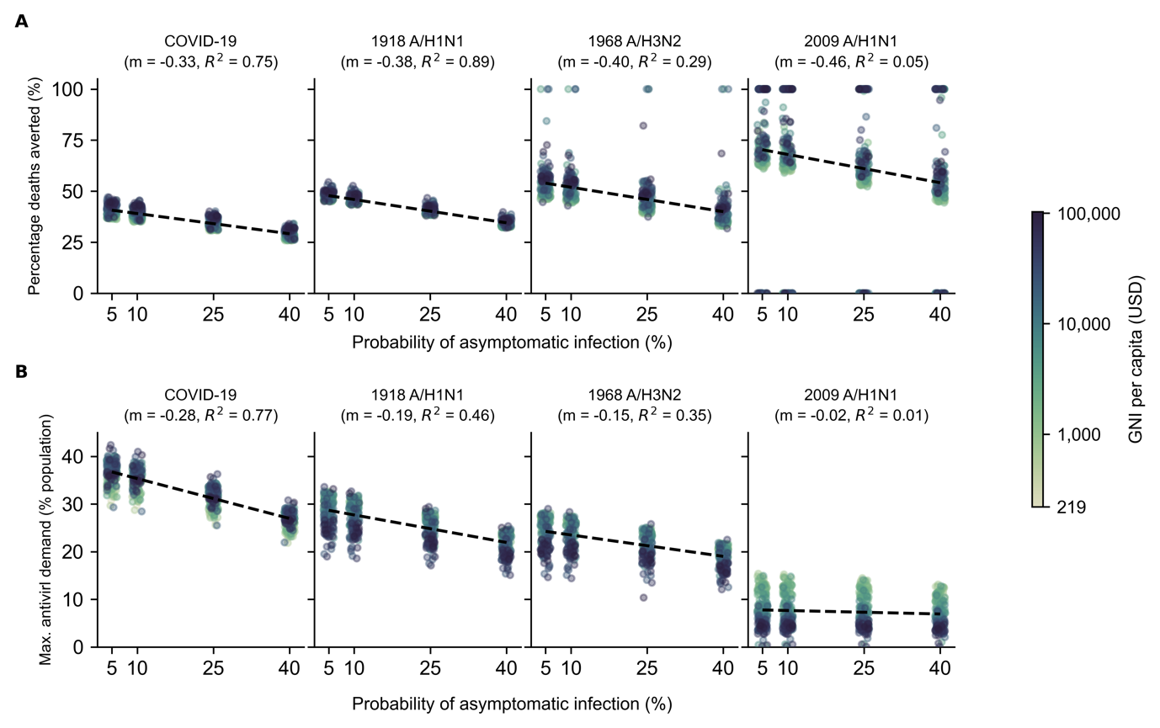
Appendix Fig. 2: Sensitivity analysis to account for uncertainty around probability of asymptomatic infection: Treatment with BXM. BXM was administered to all individuals that were positively diagnosed, using a rapid test with 70% test sensitivity, within two days of symptom onset. All symptomatic individuals were assumed to have sought testing within one day after symptom onset on average. Distribution of oral antivirals for treatment began one week after the pandemic was initiated in the country with ten infections. Each circle plot represents a country coloured by its gross national income (GNI) per capita is US dollars (USD) in 2023. Linear regression line is plotted for each pandemic scenario with the estimated slope (m) and coefficient of determination ($R^{2}$) stated in subplot title. (A) Mean percentage deaths averted by test-and-treat. (B) Maximum BXM demand.

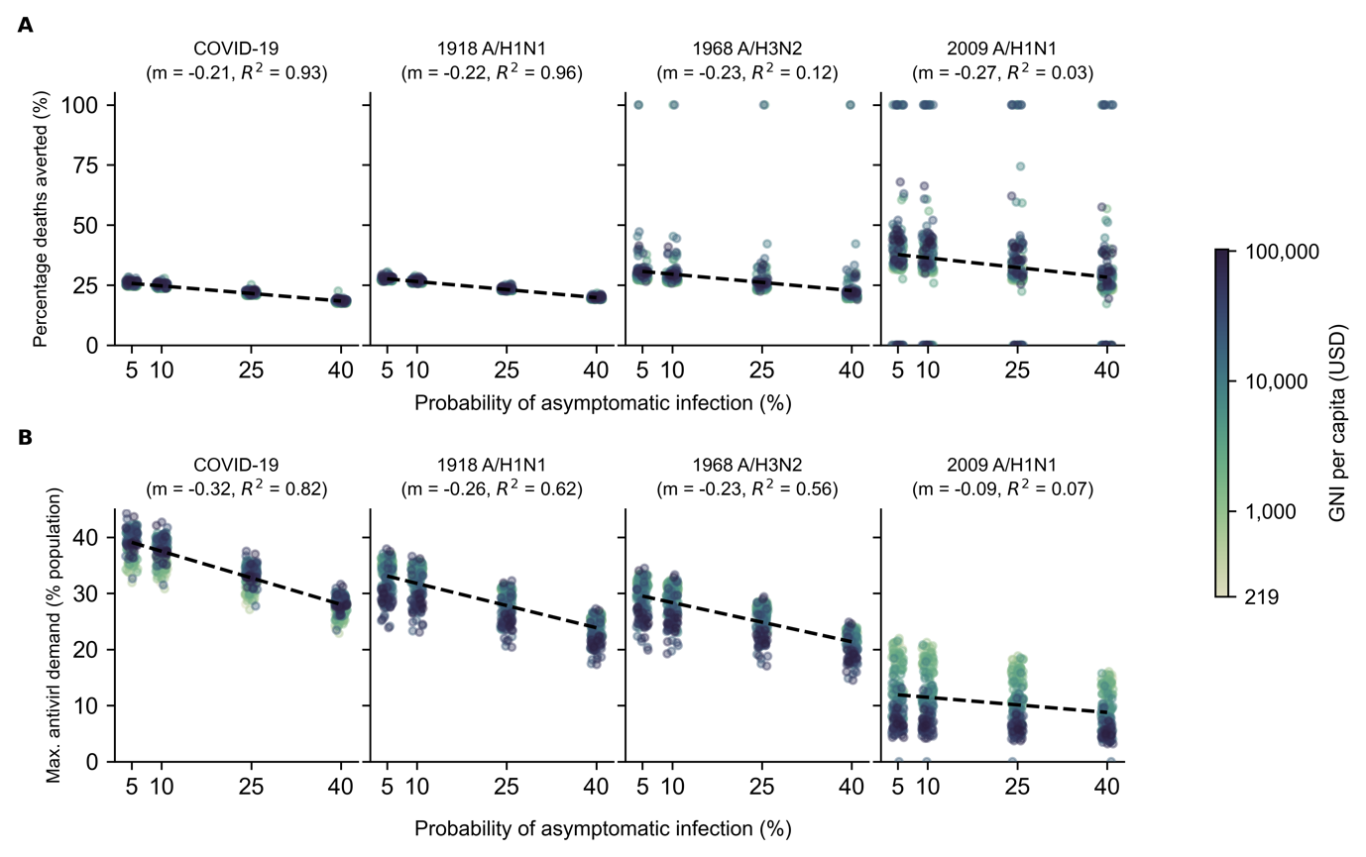
Appendix Fig. 3: Sensitivity analysis to account for uncertainty around probability of asymptomatic infection: Treatment with oseltamivir. Oseltamivir was administered to all individuals that were positively diagnosed, using a rapid test with 70% test sensitivity, within two days of symptom onset. All symptomatic individuals were assumed to have sought testing within one day after symptom onset on average. Distribution of oral antivirals for treatment began one week after the pandemic was initiated in the country with ten infections. Each circle plot represents a country coloured by its gross national income (GNI) per capita is US dollars (USD) in 2023. Linear regression line is plotted for each pandemic scenario with the estimated slope (m) and coefficient of determination ($R^{2}$) stated in subplot title. (A) Mean percentage deaths averted by test-and-treat. (B) Maximum BXM demand.

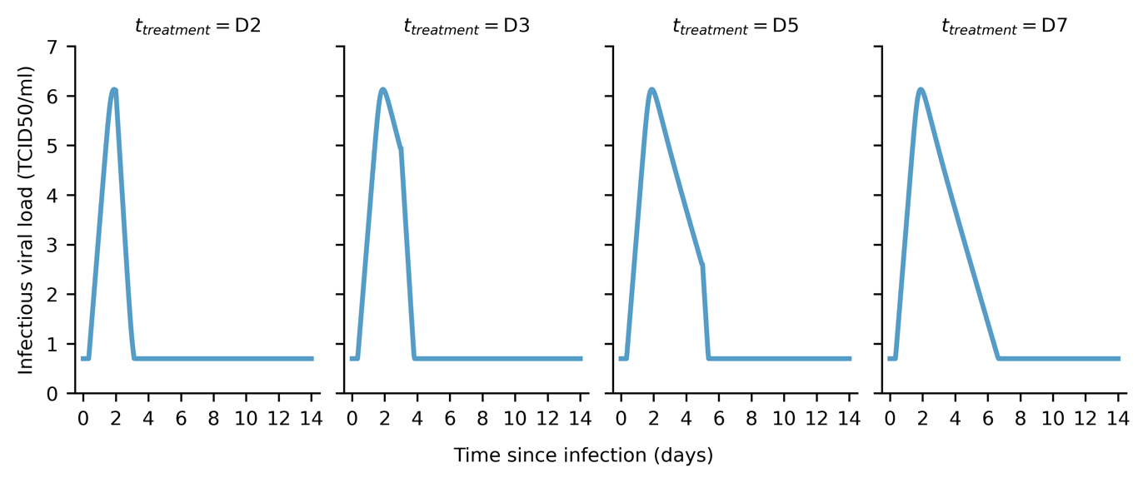
Appendix Fig. 4: Estimated infectiousness viral load when treated with baloxavir marboxil at different days since infection ($t_{treatment}$). Within-host viral load trajectories estimated by applying maximum-likelihood parameter estimates to our within-host model and varying $t_{treatment}$.

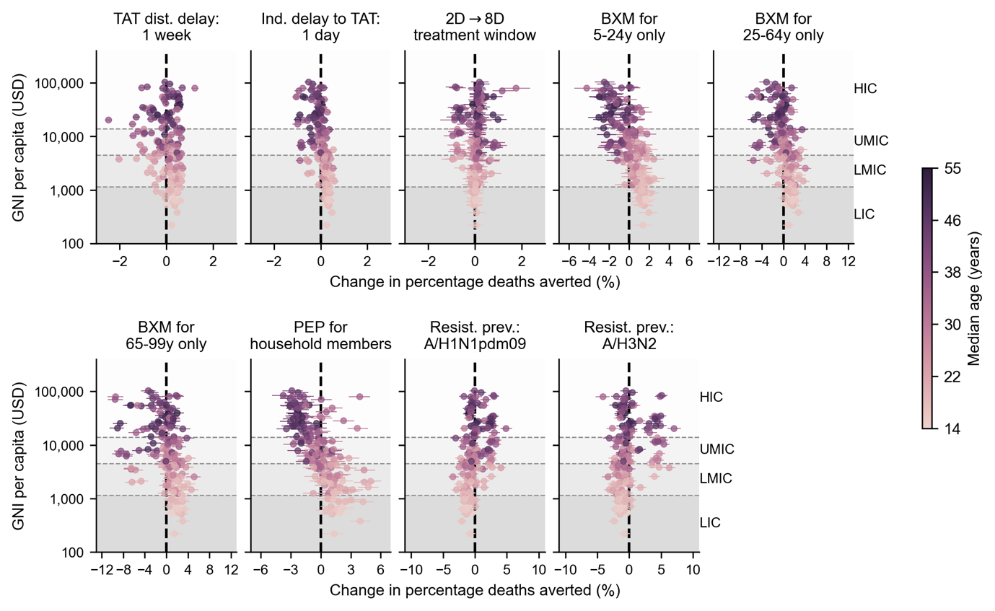
Appendix Fig. 5: Country-level effects of treatment delays, distribution strategies, post-exposure prophylaxis and antiviral resistance on mean percentage deaths averted by baloxavir marboxil (BXM) distribution. Relative to the idealised scenario (i.e. BXM are swiftly distributed to patients across the country one week after the first infection in the country, with no limits on access and availability of tests and antivirals; >95% of all symptomatic individuals are treated within two days after symptom onset if positively diagnosed by a rapid diagnostic test; no emergence and spread of BXM-resistant viruses), mean changes in mean percentage deaths averted due to country-level effects (each circle and line denotes the posterior mean and 95% highest posterior density interval estimated for each country, shading denotes median age of country’s population) are plotted against countries’ gross national income (GNI) per capita is US dollars (USD) in 2023. Background shading denotes the range of GNI per capita distinguishing between different country income groups as classified by the World Bank in 2024 (low income country, LIC; lower-middle income country, LMIC; upper-middle income country, UMIC; and high income country, HIC).

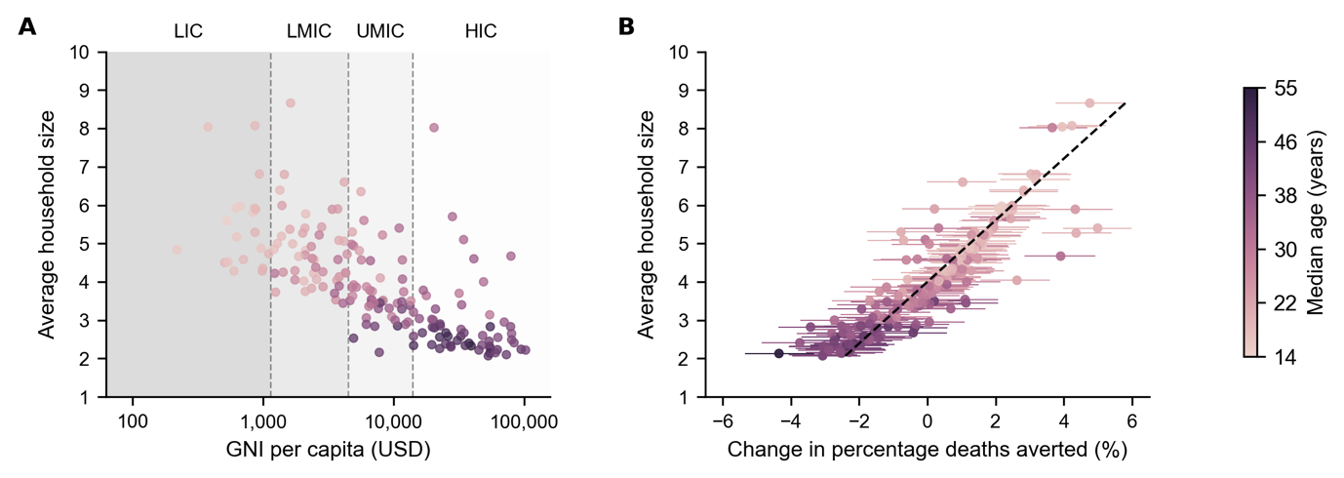
Appendix Fig. 6: Correlation between mean household size and country-level effect on mean percentage deaths averted by distributing baloxavir marboxil (BXM) as post-exposure prophylaxis to household members. (A) Mean household size of each country (United Nations, 2024) (circle, shading denotes median age of country’s population) plotted against their gross national income (GNI) per capita is US dollars (USD) in 2023. Background shading denotes the range of GNI per capita distinguishing between different country income groups as classified by the World Bank in 2024 (low income country, LIC; lower-middle income country, LMIC; upper-middle income country, UMIC; and high income country, HIC). (B) Mean household size of each country (circle, shading denotes median age of country’s population) plotted against mean changes in mean percentage deaths averted due to country-level effects (each circle and line denotes the posterior mean and 95% highest posterior density interval estimated for each country, shading denotes median age of country’s population). Dash line denotes the best-fit linear regression line ($R^{2}=0.80$).

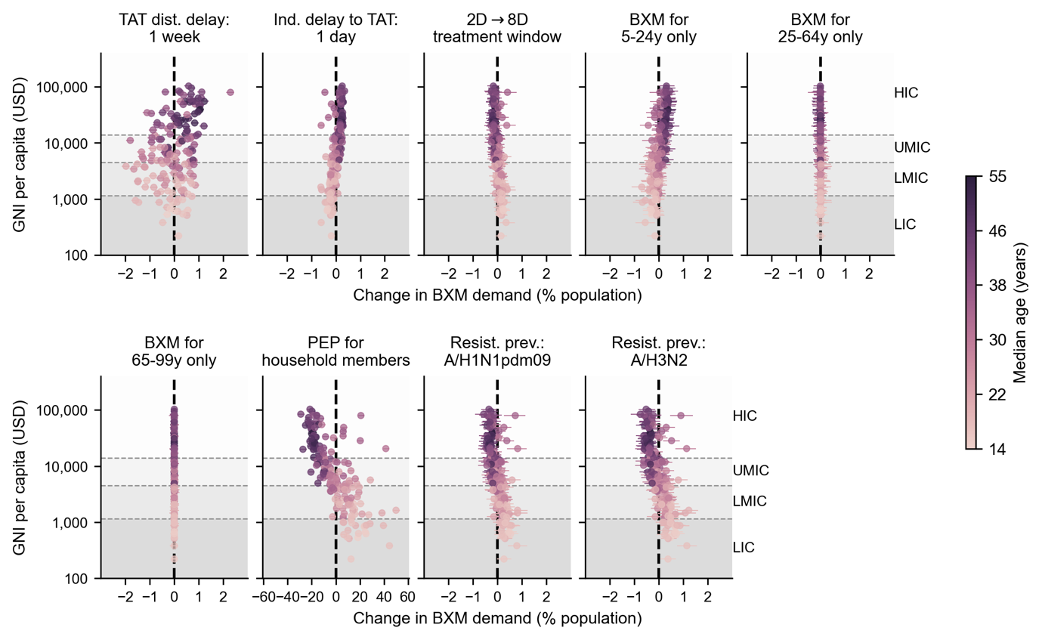
Appendix Fig. 7: Country-level effects of treatment delays, distribution strategies, post-exposure prophylaxis and antiviral resistance on mean baloxavir marboxil (BXM) demand. Relative to the idealised scenario (i.e. BXM are swiftly distributed to patients across the country one week after the first infection in the country, with no limits on access and availability of tests and antivirals; >95% of all symptomatic individuals are treated within two days after symptom onset if positively diagnosed by a rapid diagnostic test; no emergence and spread of BXM-resistant viruses), mean changes in BXM demand due to country-level effects (each circle and line denotes the posterior mean and 95% highest posterior density interval estimated for each country, shading denotes median age of country’s population) are plotted against countries’ gross national income (GNI) per capita is US dollars (USD) in 2023. Background shading denotes the range of GNI per capita distinguishing between different country income groups as classified by the World Bank in 2024 (low income country, LIC; lower-middle income country, LMIC; upper-middle income country, UMIC; and high income country, HIC).

Appendix Fig. 8: Within-host model schematic diagram summarizing equations 1-6.
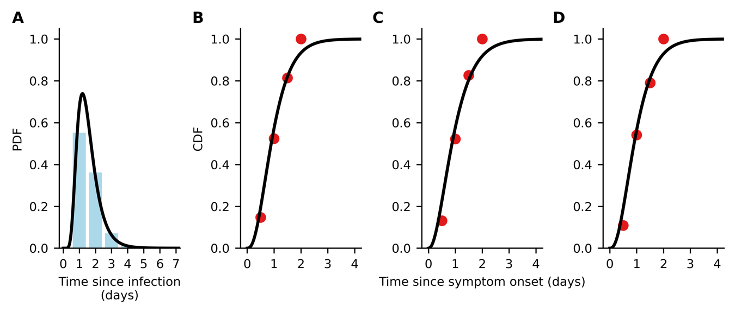
Appendix Fig. 9: Data fitting for time to symptom onset since infection and time to treatment administration since symptom onset. (A) Continuous (black line) and discrete (blue bars) probability distribution function (PDF) of lognormal distribution fit to pooled data of the time of symptom onset since influenza virus infection as reported in (Lessler et al., 2009). (B-D) Continuous (black line) cumulative distribution function of gamma distribution fit to time of treatment initiation since symptom onset in the phase 3 clinical trial of baloxavir marboxil (red circles) (Hayden Frederick G. et al., 2018; Uehara et al., 2020); (B) placebo, (C) baloxavir marboxil, and (D) oseltamivir.

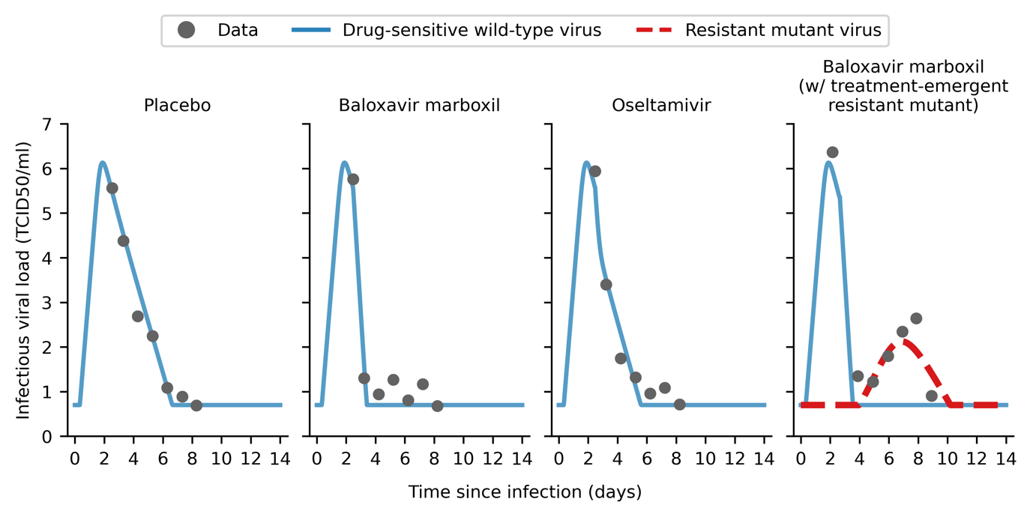
Appendix Fig. 10: Within-host viral load model fitted to clinical trial data. Maximum-likelihood within-host viral load trajectories for drug-sensitive wild type (blue solid line) and drug-resistant mutant (red dashed line) viruses by fitting to mean viral load data (gray circles) obtained in the phase 3 clinical trial of baloxavir marboxil (Hayden Frederick G. et al., 2018; Uehara et al., 2020).

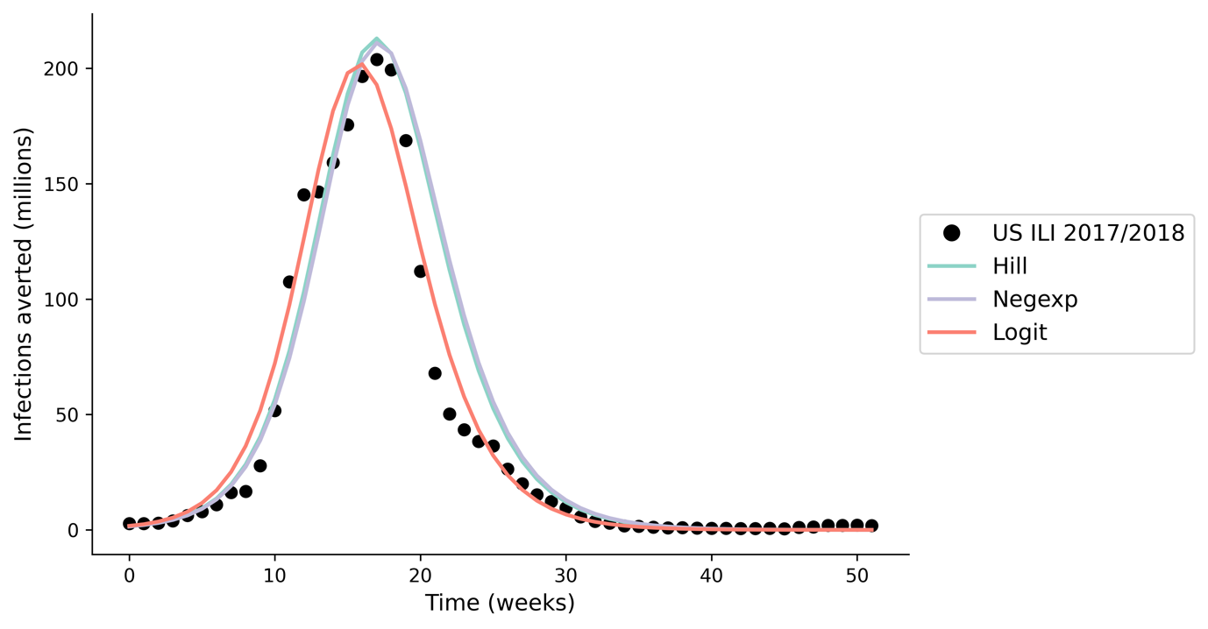
Appendix Fig. 11: Model validation; estimated incidence using our multiscale modelling approach when applying different within-host viral load to infectiousness correlative models. We compared the output of our multiscale model, applying seasonal influenza parameters (Brugger and Althaus, 2020) to estimate the incidence during the 2017/2018 influenza season ($R_{0}=1.3$) (Du et al., 2020) in the United States (US), against reported influenza-like (ILI) data (https://www.cdc.gov/flu/weekly/fluviewinteractive.htm; black circles). We find minimal difference in total incidence (<10% difference) when applying different within-host viral load to infectiousness correlative models (differently coloured lines).

Appendix Tables
Appendix Table 1. Parameters used in the between-host transmission model.
Parameter | Value | Source
Effectiveness in lowering infection likelihood by baloxavir marboxil (BXM) as post-exposure prophylaxis (PEP) ($ϵ_{PEP}$) | 0.57 | (Ikematsu Hideyuki et al., 2020)
Protective period of BXM as PEP in days ($γ_{PEP}$) | 10
Relative susceptibility to infection by age ($η_{a}$)
1918 A/H1N1, 0-99 years | 1.00 | Assumed
1968 A/H3N2, 0-99 years | 1.00 | Assumed
2009 A/H1N1, 0-19 years | 1.00 | (Cauchemez Simon et al., 2009)
2009 A/H1N1, 20-64 years | 0.510
2009 A/H1N1, 65-99 years | 0.087
COVID-19, 0-14 years | 0.231 | (Zhang et al., 2020)
COVID-19, 15-64 years | 0.680
COVID-19, 65-99 years | 1.00
Case fatality rate by age ($p_{α}^{dea}$)
1918 A/H1N1, 0-4 years | 0.01867 | By fitting W-shape mortality curve reported in (Luk et al., 2001; Taubenberger and Morens, 2006)
1918 A/H1N1, 5-14 years | 0.00201
1918 A/H1N1, 15-24 years | 0.00719
1918 A/H1N1, 25-34 years | 0.01327
1918 A/H1N1, 35-44 years | 0.00716
1918 A/H1N1, 45-54 years | 0.00512
1918 A/H1N1, 55-64 years | 0.00943
1918 A/H1N1, 65-74 years | 0.03005
1918 A/H1N1, 75-84 years | 0.05380
1918 A/H1N1, 85-99 years | 0.04155
1968 A/H3N2, 0-4 years | 0.0011824 | By fitting U-shape mortality curve reported in (Luk et al., 2001; Taubenberger and Morens, 2006)
1968 A/H3N2, 5-14 years | 0.0000240
1968 A/H3N2, 15-24 years | 0.0000410
1968 A/H3N2, 25-34 years | 0.0000601
1968 A/H3N2, 35-44 years | 0.0001298
1968 A/H3N2, 45-54 years | 0.0003386
1968 A/H3N2, 55-64 years | 0.0012583
1968 A/H3N2, 65-74 years | 0.0061872
1968 A/H3N2, 75-84 years | 0.0187919
1968 A/H3N2, 85-99 years | 0.0252286
2009 A/H1N1, 0-19 years | 0.00005 | (Dawood et al., 2012)
2009 A/H1N1, 20-64 years | 0.00029
2009 A/H1N1, 65-99 years | 0.00124
COVID-19, 0-9 years | 0.001 | (Verity et al., 2020; Zhang et al., 2020)
COVID-19, 10-19 years | 0.003
COVID-19, 20-29 years | 0.012
COVID-19, 30-39 years | 0.032
COVID-19, 40-49 years | 0.049
COVID-19, 50-59 years | 0.102
COVID-19, 60-69 years | 0.166
COVID-19, 70-79 years | 0.243
COVID-19, 80-99 years | 0.273
Basic reproduction number ($R_{0}$)
1918 A/H1N1 | 2.0 | (Biggerstaff et al., 2014)
1968 A/H3N2 | 1.8
2009 A/H1N1 | 1.5
COVID-19 | 3.0 | (Zhao et al., 2020)
Probability of asymptomatic infection ($p_{\text{asymptomatic}}$) | 0.16 | (Leung et al., 2015)
Sensitivity of diagnostic test ($ψ$) | 0.70 | (Merckx et al., 2017)
Adherence to treatment, BXM | 0.95 | Assumed
Adherence to treatment, oseltamivir | 0.65 | (Smith et al., 2016)

Appendix Table 2. Key assumptions in the between-host transmission model.
No. | Assumption | Implication
1 | SIR compartmental model with population structured in 5-year age bins using contact rate matrices estimated by Prem et al. (2021). | Country-level estimation of transmission dynamics with no further spatial delineation. Population contact rates are only structured by age demography. As such, the estimated antiviral demand and impact represent country-level antiviral needs and burden reduction.
2 | Rapid diagnostic testing and antiviral drug administration is assumed to during the same clinical visit. | No delay between obtaining test result and antiviral administration. If there are any delays, the effect would be equivalent to delayed time to seeking test-and-treat, which we had investigated.
3 | No supply and accessibility constraints to diagnostic tests and antivirals. | The key goal of this work is to generate the quantitative evidence to inform antiviral stockpiling efforts prior to the next pandemic. To that end, we focused on estimating the theoretical upper limit of antiviral demand during a nascent influenza pandemic under the ideal assumption of no constraints on diagnostic test and antiviral supply , which in turn informs the capacity needed to meet surge demand. We did, however, investigate the impact of rationing baloxavir marboxil by age and provided estimates on the per-capita amount of diagnostic tests required for each country in Appendix Table 3. We also discussed the critical need to expand access to pandemic medicines before the next influenza pandemic in the main text.
4 | High uptake rate (95%) of test-and-treat | Similar to above, we conservatively assumed a high uptake rate of test-and-treat for estimation of the upper limit of test-and-treat demand. We did, however, subsequently investigated how heterogeneity in healthcare-seeking behaviour would lead to heterogenous timing to seeking test-and-treat since symptom onset.
5 | No uptake of pre-pandemic vaccines | We focused on the scenario where the antiviral stockpile was used to limit the impact prior to the availability of vaccines. We have showed in previous work that vaccination is the more resource-efficient intervention compared to test-and-treat during a pandemic (Han et al., 2023).
6 | No implementation of non-pharmaceutical interventions (NPIs) | NPIs could lower antiviral demand and augment burden reduction. However, the effectiveness of NPIs are often context dependent, with varying degrees of socio-economic impacts (Haug et al., 2020) associated with different NPIs that must be carefully considered alongside the cost effectiveness of mass test-and-treat distribution, which is outside the scope of this work.

Appendix Table 3. Mean deaths averted by test-and-treat with oral antivirals (baloxavir marboxil (BXM) or oseltamivir (OSL), and the corresponding antiviral and rapid testing demand in 186 countries under idealised assumptions. [Supplementary file]

Appendix Table 4. Breakdown of baloxavir marboxil (BXM) and oseltamivir stockpile when performing age-based rationing of BXM. Countries are differentiated by their income groups (low-income, LIC; lower-middle income, LMIC; upper-middle income, UMIC; and high-income, HIC). The median and interquartile range (IQR) of the percentage of stockpile comprising of BXM, and the corresponding per-capita BXM and oseltamivir demand are tabulated.
Country income  group | Ration age group | Pandemic | Percentage of stockpile comprising of BXM |  | Per-capita BXM demand |  | Per-capita oseltamivir demand
 |  |  | Median | IQR | Median | IQR | Median | IQR
LIC | 5-24y | 1918 A/H1N1 | 64.1% | 58.4% - 67.7% | 18.3% | 15.6% - 55.2% | 13.7% | 10.3% - 28.5%
 |  | 1968 A/H3N2 | 61.6% | 55.9% - 66.0% | 27.7% | 14.5% - 56.9% | 16.0% | 11.3% - 28.2%
 |  | 2009 A/H1N1 | 68.8% | 64.5% - 71.7% | 21.5% | 11.1% - 43.2% | 11.2% | 4.4% - 22.7%
 |  | COVID-19 | 67.2% | 53.4% - 93.7% | 14.9% | 0.3% - 52.9% | 14.5% | 0% - 25.8%
 | 25-64y | 1918 A/H1N1 | 33.8% | 30.5% - 37.8% | 12.8% | 9.7% - 27.2% | 19.8% | 17.1% - 57.4%
 |  | 1968 A/H3N2 | 35.4% | 32.6% - 40.2% | 15.0% | 10.6% - 27.2% | 28.7% | 16% - 58.9%
 |  | 2009 A/H1N1 | 29.9% | 27.2% - 33.7% | 10.9% | 4.5% - 21.7% | 22.2% | 12.1% - 44%
 |  | COVID-19 | 30.9% | 5.8% - 42.8% | 13.5% | 0% - 24.6% | 16.6% | 0.3% - 55.7%
 | >64y | 1918 A/H1N1 | 2.5% | 2.0% - 3.0% | 1.0% | 0.7% - 1.8% | 31.6% | 27.3% - 84.6%
 |  | 1968 A/H3N2 | 2.5% | 2.0% - 3.1% | 1.1% | 0.8% - 1.8% | 43.0% | 26.7% - 84.8%
 |  | 2009 A/H1N1 | 1.0% | 0.7% - 1.8% | 0.5% | 0.1% - 1.2% | 33.9% | 17.1% - 66.1%
 |  | COVID-19 | 2.1% | 0.5% - 3.4% | 1.1% | 0% - 1.7% | 29.5% | 0.3% - 80%
LMIC | 5-24y | 1918 A/H1N1 | 56.1% | 51.4% - 60.8% | 16.7% | 12.3% - 44.9% | 15.6% | 11.6% - 31.8%
 |  | 1968 A/H3N2 | 55.4% | 51.3% - 59.4% | 16.6% | 12.7% - 44.3% | 15.6% | 12.1% - 30.6%
 |  | 2009 A/H1N1 | 66.6% | 60.8% - 72.7% | 13.2% | 8.5% - 28.4% | 5.8% | 3.2% - 18.5%
 |  | COVID-19 | 59.8% | 48.3% - 81.5% | 14.0% | 0.1% - 45.1% | 17.2% | 0% - 29.8%
 | 25-64y | 1918 A/H1N1 | 40.5% | 36.4% - 44.8% | 14.2% | 10.7% - 30% | 18.3% | 13.6% - 47.1%
 |  | 1968 A/H3N2 | 41.2% | 38.0% - 44.4% | 14.2% | 11.2% - 29% | 17.9% | 14.1% - 46.4%
 |  | 2009 A/H1N1 | 31.9% | 26.4% - 37.3% | 6.9% | 3.4% - 18.5% | 13.4% | 9.3% - 30.7%
 |  | COVID-19 | 37.3% | 15.7% - 46.5% | 15.7% | 0% - 28.1% | 16.1% | 0.1% - 48.4%
 | >64y | 1918 A/H1N1 | 3.3% | 2.6% - 4.0% | 1.3% | 0.9% - 2.2% | 31.3% | 24.6% - 77.8%
 |  | 1968 A/H3N2 | 3.4% | 2.6% - 3.9% | 1.3% | 1% - 2.2% | 29.6% | 26% - 76%
 |  | 2009 A/H1N1 | 0.9% | 0.7% - 2.2% | 0.3% | 0.1% - 1.1% | 20.4% | 12.8% - 49.5%
 |  | COVID-19 | 3.4% | 2.2% - 4.8% | 1.4% | 0% - 2.4% | 31.6% | 0.2% - 77.1%
UMIC | 5-24y | 1918 A/H1N1 | 45.8% | 40.3% - 50.4% | 13.2% | 8.5% - 30% | 16.8% | 11.2% - 31.8%
 |  | 1968 A/H3N2 | 46.5% | 42.1% - 51.0% | 13.3% | 9.8% - 30.2% | 16.3% | 13.3% - 30.2%
 |  | 2009 A/H1N1 | 64.0% | 59.6% - 74.0% | 8.1% | 5.6% - 15.2% | 4.0% | 2% - 10.9%
 |  | COVID-19 | 47.0% | 36.7% - 61.3% | 11.4% | 0.1% - 33.5% | 22.2% | 0% - 36%
 | 25-64y | 1918 A/H1N1 | 49.1% | 45.4% - 53.5% | 14.8% | 10.1% - 28.7% | 14.8% | 9.7% - 31.9%
 |  | 1968 A/H3N2 | 48.4% | 45.0% - 52.2% | 14.2% | 11.7% - 27.2% | 14.5% | 11% - 31.9%
 |  | 2009 A/H1N1 | 34.5% | 25.2% - 38.4% | 4.0% | 2.2% - 11.1% | 8.7% | 6.4% - 16.9%
 |  | COVID-19 | 45.9% | 25.3% - 54.7% | 19.5% | 0% - 32.5% | 14.5% | 0.1% - 38.7%
 | >64y | 1918 A/H1N1 | 4.8% | 3.9% - 5.7% | 1.6% | 1.1% - 2.7% | 29.2% | 19.5% - 60.8%
 |  | 1968 A/H3N2 | 4.5% | 3.7% - 5.2% | 1.5% | 1.2% - 2.5% | 28.1% | 23.3% - 59.5%
 |  | 2009 A/H1N1 | 1.2% | 0.6% - 2.2% | 0.2% | 0% - 0.7% | 12.9% | 8.9% - 28.7%
 |  | COVID-19 | 6.5% | 4.2% - 8.8% | 2.5% | 0% - 4% | 32.0% | 0.1% - 68.3%
HIC | 5-24y | 1918 A/H1N1 | 37.7% | 31.9% - 41.3% | 9.3% | 6.1% - 18.2% | 17.3% | 12.1% - 26.1%
 |  | 1968 A/H3N2 | 39.5% | 34.6% - 43.1% | 10.0% | 7.3% - 17.4% | 16.3% | 12.9% - 24%
 |  | 2009 A/H1N1 | 66.5% | 61.2% - 77.5% | 5.0% | 3.6% - 6.8% | 2.4% | 1.1% - 4.2%
 |  | COVID-19 | 33.8% | 25.6% - 40.7% | 8.5% | 0% - 21.2% | 25.0% | 0.1% - 35.2%
 | 25-64y | 1918 A/H1N1 | 55.6% | 52.2% - 59.3% | 14.6% | 10.3% - 22.4% | 10.9% | 7.4% - 20.2%
 |  | 1968 A/H3N2 | 53.9% | 51.1% - 57.2% | 13.9% | 11% - 20.5% | 11.2% | 8.4% - 19%
 |  | 2009 A/H1N1 | 32.4% | 21.8% - 37.1% | 2.5% | 1.2% - 4.2% | 5.5% | 4% - 7.4%
 |  | COVID-19 | 51.1% | 33.3% - 58.8% | 19.9% | 0% - 29.2% | 13.2% | 0.1% - 27.1%
 | >64y | 1918 A/H1N1 | 6.6% | 5.3% - 8.2% | 1.8% | 1.2% - 2.7% | 25.2% | 17.1% - 41.5%
 |  | 1968 A/H3N2 | 5.9% | 4.7% - 6.7% | 1.5% | 1.1% - 2.4% | 25.2% | 19.8% - 39.5%
 |  | 2009 A/H1N1 | 0.5% | 0.3% - 1.5% | 0.0% | 0% - 0.2% | 8.5% | 5.5% - 11.9%
 |  | COVID-19 | 12.3% | 8.3% - 17.4% | 3.7% | 0% - 5.7% | 29.3% | 0.1% - 49.5%

Data availability
All simulation data, model source and custom analysis codes are available at https://github.com/AMC-LAEB/flu-antiviral-stockpile.

Contributions
A.X.H. and C.A.R. contributed to conceptualization and funding acquisition. A.X.H. contributed to methodology, formal analysis and data curation, and wrote the original draft. A.X.H., K.D.H. and C.A.R. contributed to investigation, validation and visualization. C.A.R. provided supervision. All authors reviewed and edited the manuscript.

Competing interests
We declare no competing interests.

Acknowledgements
A.X.H., K.D.H. and C.A.R. were supported by the European Research Council NaviFlu (grant 818353). A.X.H. and C.A.R. were also supported by the Dutch Research Council (NWO) Modelling for Pandemic Preparedness grant (10710062310004). A.X.H. was supported by the Dutch Research Council (NWO) Veni Award (09150162210121). C.A.R. was supported by the Dutch Research Council (NWO) Vici Award (09150182010027).

References
Andrew Gelman, Aleks Jakulin, Maria Grazia Pittau, Yu-Sung Su. 2008. A weakly informative default prior distribution for logistic and other regression models. Ann Appl Stat 2:1360–1383. doi:10.1214/08-AOAS191
Baker J, Block SL, Matharu B, Burleigh Macutkiewicz L, Wildum S, Dimonaco S, Collinson N, Clinch B, Piedra PA. 2020. Baloxavir Marboxil Single-dose Treatment in Influenza-infected Children: A Randomized, Double-blind, Active Controlled Phase 3 Safety and Efficacy Trial (miniSTONE-2). Pediatr Infect Dis J 39.
Biggerstaff M, Cauchemez S, Reed C, Gambhir M, Finelli L. 2014. Estimates of the reproduction number for seasonal, pandemic, and zoonotic influenza: a systematic review of the literature. BMC Infect Dis 14:480. doi:10.1186/1471-2334-14-480
Brugger J, Althaus CL. 2020. Transmission of and susceptibility to seasonal influenza in Switzerland from 2003 to 2015. Epidemics 30:100373. doi:10.1016/j.epidem.2019.100373
Bürkner P-C. 2017. brms: An R Package for Bayesian Multilevel Models Using Stan. J Stat Softw 80:1–28. doi:10.18637/jss.v080.i01
Carrasco LR, Lee VJ, Chen MI, Matchar DB, Thompson JP, Cook AR. 2011. Strategies for antiviral stockpiling for future influenza pandemics: a global epidemic-economic perspective. J R Soc Interface 8:1307–1313. doi:10.1098/rsif.2010.0715
Cauchemez Simon, Donnelly Christl A., Reed Carrie, Ghani Azra C., Fraser Christophe, Kent Charlotte K., Finelli Lyn, Ferguson Neil M. 2009. Household Transmission of 2009 Pandemic Influenza A (H1N1) Virus in the United States. N Engl J Med 361:2619–2627. doi:10.1056/NEJMoa0905498
Checkmahomed L, M’hamdi Z, Carbonneau J, Venable M-C, Baz M, Abed Y, Boivin G. 2020. Impact of the Baloxavir-Resistant Polymerase Acid I38T Substitution on the Fitness of Contemporary Influenza A(H1N1)pdm09 and A(H3N2) Strains. J Infect Dis 221:63–70. doi:10.1093/infdis/jiz418
Clark E, Chiao EY, Amirian ES. 2021. Why Contact Tracing Efforts Have Failed to Curb Coronavirus Disease 2019 (COVID-19) Transmission in Much of the United States. Clin Infect Dis 72:e415–e419. doi:10.1093/cid/ciaa1155
Core Team R. 2024. R: A Language and Environment for Statistical Computing.
Davis EL, Lucas TCD, Borlase A, Pollington TM, Abbott S, Ayabina D, Crellen T, Hellewell J, Pi L, Lowe R, Endo A, Davies N, Gore-Langton GR, Russell TW, Bosse NI, Quaife M, Kucharski AJ, Nightingale ES, Pearson CAB, Gibbs H, O’Reilly K, Jombart T, Rees EM, Deol AK, Hué S, Auzenbergs M, Houben RMGJ, Funk S, Li Y, Sun F, Prem K, Quilty BJ, Villabona-Arenas J, Barnard RC, Hodgson D, Foss A, Jarvis CI, Meakin SR, Eggo RM, Abbas K, Zandvoort K van, Emery JC, Tully DC, Sandmann FG, Edmunds WJ, Gimma A, Knight G, Munday JD, Diamond C, Jit M, Leclerc Q, Rosello A, Chan Y-WD, Simons D, Clifford S, Flasche S, Procter SR, Atkins KE, Medley GF, Hollingsworth TD, Klepac P, CMMID COVID-19 Working Group. 2021. Contact tracing is an imperfect tool for controlling COVID-19 transmission and relies on population adherence. Nat Commun 12:5412. doi:10.1038/s41467-021-25531-5
Dawood FS, Iuliano AD, Reed C, Meltzer MI, Shay DK, Cheng P-Y, Bandaranayake D, Breiman RF, Brooks WA, Buchy P, Feikin DR, Fowler KB, Gordon A, Hien NT, Horby P, Huang QS, Katz MA, Krishnan A, Lal R, Montgomery JM, Mølbak K, Pebody R, Presanis AM, Razuri H, Steens A, Tinoco YO, Wallinga J, Yu H, Vong S, Bresee J, Widdowson M-A. 2012. Estimated global mortality associated with the first 12 months of 2009 pandemic influenza A H1N1 virus circulation: a modelling study. Lancet Infect Dis 12:687–695. doi:10.1016/S1473-3099(12)70121-4
Du Z, Nugent C, Galvani AP, Krug RM, Meyers LA. 2020. Modeling mitigation of influenza epidemics by baloxavir. Nat Commun 11:2750. doi:10.1038/s41467-020-16585-y
Ferguson NM, Cummings DAT, Cauchemez S, Fraser C, Riley S, Meeyai A, Iamsirithaworn S, Burke DS. 2005. Strategies for containing an emerging influenza pandemic in Southeast Asia. Nature 437:209–214. doi:10.1038/nature04017
Gao Y, Guyatt G, Uyeki TM, Liu M, Chen Y, Zhao Y, Shen Y, Xu J, Zheng Q, Li Z, Zhao W, Luo S, Chen X, Tian J, Hao Q. 2024. Antivirals for treatment of severe influenza: a systematic review and network meta-analysis of randomised controlled trials. The Lancet 404:753–763. doi:10.1016/S0140-6736(24)01307-2
Gao Y, Zhao Y, Liu M, Luo S, Chen Y, Chen X, Zheng Q, Xu J, Shen Y, Zhao W, Li Z, Huang S, Huang J, Tian J, Guyatt G, Hao Q. 2025. Antiviral Medications for Treatment of Nonsevere Influenza: A Systematic Review and Network Meta-Analysis. JAMA Intern Med 185:293–301. doi:10.1001/jamainternmed.2024.7193
Goyal A, Reeves DB, Cardozo-Ojeda EF, Schiffer JT, Mayer BT. 2021. Viral load and contact heterogeneity predict SARS-CoV-2 transmission and super-spreading events. eLife 10:e63537. doi:10.7554/eLife.63537
Graham MS, May A, Varsavsky T, Sudre CH, Murray B, Kläser K, Antonelli M, Canas LS, Molteni E, Modat M, Cardoso MJ, Drew DA, Nguyen LH, Rader B, Hu C, Capdevila J, Hammers A, Chan AT, Wolf J, Brownstein JS, Spector TD, Ourselin S, Steves CJ, Astley CM. 2022. Knowledge barriers in a national symptomatic-COVID-19 testing programme. PLOS Glob Public Health 2:e0000028. doi:10.1371/journal.pgph.0000028
Green WD, Ferguson NM, Cori A. 2022. Inferring the reproduction number using the renewal equation in heterogeneous epidemics. J R Soc Interface 19:20210429. doi:10.1098/rsif.2021.0429
Greer AL, Schanzer D. 2013. Using a Dynamic Model to Consider Optimal Antiviral Stockpile Size in the Face of Pandemic Influenza Uncertainty. PLOS ONE 8:e67253. doi:10.1371/journal.pone.0067253
Hadjichrysanthou C, Cauët E, Lawrence E, Vegvari C, de Wolf F, Anderson RM. 2016. Understanding the within-host dynamics of influenza A virus: from theory to clinical implications. J R Soc Interface 13:20160289. doi:10.1098/rsif.2016.0289
Halloran ME, Ferguson NM, Eubank S, Longini IM, Cummings DAT, Lewis B, Xu S, Fraser C, Vullikanti A, Germann TC, Wagener D, Beckman R, Kadau K, Barrett C, Macken CA, Burke DS, Cooley P. 2008. Modeling targeted layered containment of an influenza pandemic in the United States. Proc Natl Acad Sci 105:4639–4644. doi:10.1073/pnas.0706849105
Han AX, Hannay E, Carmona S, Rodriguez B, Nichols BE, Russell CA. 2023. Estimating the potential impact and diagnostic requirements for SARS-CoV-2 test-and-treat programs. Nat Commun 14:7981. doi:10.1038/s41467-023-43769-z
Handel A, Longini IM Jr, Antia R. 2007. Neuraminidase Inhibitor Resistance in Influenza: Assessing the Danger of Its Generation and Spread. PLOS Comput Biol 3:e240. doi:10.1371/journal.pcbi.0030240
Handel A, Rohani P. 2015. Crossing the scale from within-host infection dynamics to between-host transmission fitness: a discussion of current assumptions and knowledge. Philos Trans R Soc B Biol Sci 370:20140302. doi:10.1098/rstb.2014.0302
Haug N, Geyrhofer L, Londei A, Dervic E, Desvars-Larrive A, Loreto V, Pinior B, Thurner S, Klimek P. 2020. Ranking the effectiveness of worldwide COVID-19 government interventions. Nat Hum Behav 4:1303–1312. doi:10.1038/s41562-020-01009-0
Hayden FG, Belshe R, Villanueva C, Lanno R, Hughes C, Small I, Dutkowski R, Ward P, Carr J. 2004. Management of Influenza in Households: A Prospective, Randomized Comparison of Oseltamivir Treatment With or Without Postexposure Prophylaxis. J Infect Dis 189:440–449. doi:10.1086/381128
Hayden FG, Pavia AT. 2006. Antiviral Management of Seasonal and Pandemic Influenza. J Infect Dis 194:S119–S126. doi:10.1086/507552
Hayden Frederick G., Sugaya Norio, Hirotsu Nobuo, Lee Nelson, de Jong Menno D., Hurt Aeron C., Ishida Tadashi, Sekino Hisakuni, Yamada Kota, Portsmouth Simon, Kawaguchi Keiko, Shishido Takao, Arai Masatsugu, Tsuchiya Kenji, Uehara Takeki, Watanabe Akira. 2018. Baloxavir Marboxil for Uncomplicated Influenza in Adults and Adolescents. N Engl J Med 379:913–923. doi:10.1056/NEJMoa1716197
Hickerson Brady T., Petrovskaya Svetlana N., Dickensheets Harold, Donnelly Raymond P., Ince William L., Ilyushina Natalia A. 2023. Impact of Baloxavir Resistance-Associated Substitutions on Influenza Virus Growth and Drug Susceptibility. J Virol 97:e00154-23. doi:10.1128/jvi.00154-23
Hirotsu N, Sakaguchi H, Fukao K, Kojima S, Piedra PA, Tsuchiya K, Uehara T. 2023. Baloxavir safety and clinical and virologic outcomes in influenza virus-infected pediatric patients by age group: age-based pooled analysis of two pediatric studies conducted in Japan. BMC Pediatr 23:35. doi:10.1186/s12887-023-03841-5
Hsu J, Santesso N, Mustafa R, Brozek J, Chen YL, Hopkins JP, Cheung A, Hovhannisyan G, Ivanova L, Flottorp SA, Sæterdal I, Wong AD, Tian J, Uyeki TM, Akl EA, Alonso-Coello P, Smaill F, Schünemann HJ. 2012. Antivirals for Treatment of Influenza. Ann Intern Med 156:512–524. doi:10.7326/0003-4819-156-7-201204030-00411
Ikematsu Hideyuki, Hayden Frederick G., Kawaguchi Keiko, Kinoshita Masahiro, de Jong Menno D., Lee Nelson, Takashima Satoru, Noshi Takeshi, Tsuchiya Kenji, Uehara Takeki. 2020. Baloxavir Marboxil for Prophylaxis against Influenza in Household Contacts. N Engl J Med 383:309–320. doi:10.1056/NEJMoa1915341
Imai M, Yamashita M, Sakai-Tagawa Y, Iwatsuki-Horimoto K, Kiso M, Murakami J, Yasuhara A, Takada K, Ito M, Nakajima N, Takahashi K, Lopes TJS, Dutta J, Khan Z, Kriti D, van Bakel H, Tokita A, Hagiwara H, Izumida N, Kuroki H, Nishino T, Wada N, Koga M, Adachi E, Jubishi D, Hasegawa H, Kawaoka Y. 2020. Influenza A variants with reduced susceptibility to baloxavir isolated from Japanese patients are fit and transmit through respiratory droplets. Nat Microbiol 5:27–33. doi:10.1038/s41564-019-0609-0
Ison MG, Portsmouth S, Yoshida Y, Shishido T, Mitchener M, Tsuchiya K, Uehara T, Hayden FG. 2020. Early treatment with baloxavir marboxil in high-risk adolescent and adult outpatients with uncomplicated influenza (CAPSTONE-2): a randomised, placebo-controlled, phase 3 trial. Lancet Infect Dis 20:1204–1214. doi:10.1016/S1473-3099(20)30004-9
Jones JC, Pascua PNQ, Fabrizio TP, Marathe BM, Seiler P, Barman S, Webby RJ, Webster RG, Govorkova EA. 2020. Influenza A and B viruses with reduced baloxavir susceptibility display attenuated in vitro fitness but retain ferret transmissibility. Proc Natl Acad Sci 117:8593–8601. doi:10.1073/pnas.1916825117
Jones JC, Zagribelnyy B, Pascua PNQ, Bezrukov DS, Barman S, Okda F, Webby RJ, Ivanenkov YA, Govorkova EA. 2022. Influenza A virus polymerase acidic protein E23G/K substitutions weaken key baloxavir drug-binding contacts with minimal impact on replication and transmission. PLOS Pathog 18:e1010698. doi:10.1371/journal.ppat.1010698
Koszalka Paulina, George Ankita, Dhanasekaran Vijaykrishna, Hurt Aeron C., Subbarao Kanta. 2022. Effect of Baloxavir and Oseltamivir in Combination on Infection with Influenza Viruses with PA/I38T or PA/E23K Substitutions in the Ferret Model. mBio 13:e01056-22. doi:10.1128/mbio.01056-22
Lange A, Ferguson NM. 2009. Antigenic Diversity, Transmission Mechanisms, and the Evolution of Pathogens. PLOS Comput Biol 5:e1000536. doi:10.1371/journal.pcbi.1000536
Lavery JV, Porter RM, Addiss DG. 2023. Cascading failures in COVID-19 vaccine equity. Science 380:460–462. doi:10.1126/science.add5912
Lee V, Phua KH, Chen M, Chow A, Ma S, Goh KT, Leo YS. 2006. Economics of Neuraminidase Inhibitor Stockpiling for Pandemic Influenza, Singapore. Emerg Infect Dis J 12:95. doi:10.3201/eid1201.050556
Lessler J, Reich NG, Brookmeyer R, Perl TM, Nelson KE, Cummings DA. 2009. Incubation periods of acute respiratory viral infections: a systematic review. Lancet Infect Dis 9:291–300. doi:10.1016/S1473-3099(09)70069-6
Leung NHL, Xu C, Ip DKM, Cowling BJ. 2015. Review Article: The Fraction of Influenza Virus Infections That Are Asymptomatic: A Systematic Review and Meta-analysis. Epidemiology 26.
Liu Y, Morgenstern C, Kelly J, Lowe R, Munday J, Villabona-Arenas CJ, Gibbs H, Pearson CAB, Prem K, Leclerc QJ, Meakin SR, Edmunds WJ, Jarvis CI, Gimma A, Funk S, Quaife M, Russell TW, Emory JC, Abbott S, Hellewell J, Tully DC, Houben RMGJ, O’Reilly K, Gore-Langton GR, Kucharski AJ, Auzenbergs M, Quilty BJ, Jombart T, Rosello A, Brady O, Atkins KE, van Zandvoort K, Rudge JW, Endo A, Abbas K, Sun FY, Procter SR, Clifford S, Foss AM, Davies NG, Chan Y-WD, Diamond C, Barnard RC, Eggo RM, Deol AK, Nightingale ES, Simons D, Sherratt K, Medley G, Hué S, Knight GM, Flasche S, Bosse NI, Klepac P, Jit M, CMMID COVID-19 Working Group. 2021. The impact of non-pharmaceutical interventions on SARS-CoV-2 transmission across 130 countries and territories. BMC Med 19:40. doi:10.1186/s12916-020-01872-8
Longini IM, Nizam A, Xu S, Ungchusak K, Hanshaoworakul W, Cummings DAT, Halloran ME. 2005. Containing Pandemic Influenza at the Source. Science 309:1083–1087. doi:10.1126/science.1115717
Luk J, Gross P, Thompson WW. 2001. Observations on Mortality during the 1918 Influenza Pandemic. Clin Infect Dis 33:1375–1378. doi:10.1086/322662
Marc A, Kerioui M, Blanquart F, Bertrand J, Mitjà O, Corbacho-Monné M, Marks M, Guedj J. 2021. Quantifying the relationship between SARS-CoV-2 viral load and infectiousness. eLife 10:e69302. doi:10.7554/eLife.69302
McCaw JM, McVernon J. 2007. Prophylaxis or treatment? Optimal use of an antiviral stockpile during an influenza pandemic. Math Biosci 209:336–360. doi:10.1016/j.mbs.2007.02.003
McVernon J, McCaw JM, Nolan TM. 2010. Modelling strategic use of the national antiviral stockpile during the CONTAIN and SUSTAIN phases of an Australian pandemic influenza response. Aust N Z J Public Health 34:113–119. doi:10.1111/j.1753-6405.2010.00493.x
Merckx J, Wali R, Schiller I, Caya C, Gore GC, Chartrand C, Dendukuri N, Papenburg J. 2017. Diagnostic Accuracy of Novel and Traditional Rapid Tests for Influenza Infection Compared With Reverse Transcriptase Polymerase Chain Reaction. Ann Intern Med 167:394–409. doi:10.7326/M17-0848
Monto Arnold S., Kuhlbusch Klaus, Bernasconi Corrado, Cao Bin, Cohen Herman Avner, Graham Emily, Hurt Aeron C., Katugampola Laurie, Kamezawa Takashi, Lauring Adam S., McLean Barry, Takazono Takahiro, Widmer Andreas, Wildum Steffen, Cowling Benjamin J. 2025. Efficacy of Baloxavir Treatment in Preventing Transmission of Influenza. N Engl J Med 392:1582–1593. doi:10.1056/NEJMoa2413156
Morris DH, Petrova VN, Rossine FW, Parker E, Grenfell BT, Neher RA, Levin SA, Russell CA. 2020. Asynchrony between virus diversity and antibody selection limits influenza virus evolution. eLife 9:e62105. doi:10.7554/eLife.62105
O’Hagan JJ, Wong KK, Campbell AP, Patel A, Swerdlow DL, Fry AM, Koonin LM, Meltzer MI. 2015. Estimating the United States Demand for Influenza Antivirals and the Effect on Severe Influenza Disease During a Potential Pandemic. Clin Infect Dis 60:S30–S41. doi:10.1093/cid/civ084
Oliver Eales, James M. McCaw, Freya M. Shearer. 2023. Challenges in the case-based surveillance of infectious diseases. medRxiv 2023.12.19.23300224. doi:10.1101/2023.12.19.23300224
Omoto S, Speranzini V, Hashimoto T, Noshi T, Yamaguchi H, Kawai M, Kawaguchi K, Uehara T, Shishido T, Naito A, Cusack S. 2018. Characterization of influenza virus variants induced by treatment with the endonuclease inhibitor baloxavir marboxil. Sci Rep 8:9633. doi:10.1038/s41598-018-27890-4
Pai M, Bandara S, Kyobutungi C. 2024. Shifting power in global health will require leadership by the Global South and allyship by the Global North. The Lancet 404:1711–1713. doi:10.1016/S0140-6736(24)02323-7
Park J-H, Kim B, Antigua KJC, Jeong JH, Kim C il, Choi W-S, Oh S, Kim CH, Kim E-G, Choi YK, Baek YH, Song M-S. 2021. Baloxavir-oseltamivir combination therapy inhibits the emergence of resistant substitutions in influenza A virus PA gene in a mouse model. Antiviral Res 193:105126. doi:10.1016/j.antiviral.2021.105126
Peppa M, John Edmunds W, Funk S. 2017. Disease severity determines health-seeking behaviour amongst individuals with influenza-like illness in an internet-based cohort. BMC Infect Dis 17:238. doi:10.1186/s12879-017-2337-5
Prem K, Cook AR, Jit M. 2017. Projecting social contact matrices in 152 countries using contact surveys and demographic data. PLOS Comput Biol 13:e1005697. doi:10.1371/journal.pcbi.1005697
Prem K, Zandvoort K van, Klepac P, Eggo RM, Davies NG, Centre for the Mathematical Modelling of Infectious Diseases COVID-19 Working Group, Cook AR, Jit M. 2021. Projecting contact matrices in 177 geographical regions: An update and comparison with empirical data for the COVID-19 era. PLOS Comput Biol 17:e1009098. doi:10.1371/journal.pcbi.1009098
Rahman-Shepherd A, Aghogho Evaborhene N, Berman A, Amaya AB, Boro E, Dar O, Ho ZJM, Jung A-S, Khan M, Mohamed-Ahmed O, Oyebanji O, Pangestu TE, Rashid SF, Razavi A, Riggirozzi P, Legido-Quigley H, Hsu LY. 2025. Establishing the value of regional cooperation and a critical role for regional organisations in managing future health emergencies. Lancet Glob Health 13:e585–e592. doi:10.1016/S2214-109X(24)00500-X
Scarabel F, Pellis L, Ogden NH, Wu J. 2021. A renewal equation model to assess roles and limitations of contact tracing for disease outbreak control. R Soc Open Sci 8:202091. doi:10.1098/rsos.202091
Siddiqui MR, Edmunds WJ. 2008. Cost-effectiveness of Antiviral Stockpiling and Near-Patient Testing for Potential Influenza Pandemic. Emerg Infect Dis J 14:267. doi:10.3201/eid1402.070478
Siegler AJ, Hall E, Luisi N, Zlotorzynska M, Wilde G, Sanchez T, Bradley H, Sullivan PS. 2020. Willingness to Seek Diagnostic Testing for SARS-CoV-2 With Home, Drive-through, and Clinic-Based Specimen Collection Locations. Open Forum Infect Dis 7:ofaa269. doi:10.1093/ofid/ofaa269
Smith LE, D’Antoni D, Jain V, Pearce JM, Weinman J, Rubin GJ. 2016. A systematic review of factors affecting intended and actual adherence with antiviral medication as treatment or prophylaxis in seasonal and pandemic flu. Influenza Other Respir Viruses 10:462–478. doi:10.1111/irv.12406
Takashita E, Ichikawa M, Morita H, Ogawa R, Fujisaki S, Shirakura M, Miura H, Nakamura K, Kishida N, Kuwahara T, Sugawara H, Sato A, Akimoto M, Mitamura K, Abe T, Yamazaki M, Watanabe S, Hasegawa H, Odagiri T. 2019a. Human-to-Human Transmission of Influenza A(H3N2) Virus with Reduced Susceptibility to Baloxavir, Japan, February 2019. Emerg Infect Dis J 25:2108. doi:10.3201/eid2511.190757
Takashita E, Kawakami C, Morita H, Ogawa R, Fujisaki S, Shirakura M, Miura H, Nakamura K, Kishida N, Kuwahara T, Mitamura K, Abe T, Ichikawa M, Yamazaki M, Watanabe S, Odagiri T, Japan on behalf of the IVSG of. 2019b. Detection of influenza A(H3N2) viruses exhibiting reduced susceptibility to the novel cap-dependent endonuclease inhibitor baloxavir in Japan, December 2018. Eurosurveillance.
Taubenberger J, Morens D. 2006. 1918 Influenza: the Mother of All Pandemics. Emerg Infect Dis J 12:15. doi:10.3201/eid1201.050979
Uehara T, Hayden FG, Kawaguchi K, Omoto S, Hurt AC, De Jong MD, Hirotsu N, Sugaya N, Lee N, Baba K, Shishido T, Tsuchiya K, Portsmouth S, Kida H. 2020. Treatment-Emergent Influenza Variant Viruses With Reduced Baloxavir Susceptibility: Impact on Clinical and Virologic Outcomes in Uncomplicated Influenza. J Infect Dis 221:346–355. doi:10.1093/infdis/jiz244
United Nations. 2024. World Population Prospects. https://population.un.org/wpp/
Verity R, Okell LC, Dorigatti I, Winskill P, Whittaker C, Imai N, Cuomo-Dannenburg G, Thompson H, Walker PGT, Fu H, Dighe A, Griffin JT, Baguelin M, Bhatia S, Boonyasiri A, Cori A, Cucunubá Z, FitzJohn R, Gaythorpe K, Green W, Hamlet A, Hinsley W, Laydon D, Nedjati-Gilani G, Riley S, van Elsland S, Volz E, Wang H, Wang Y, Xi X, Donnelly CA, Ghani AC, Ferguson NM. 2020. Estimates of the severity of coronavirus disease 2019: a model-based analysis. Lancet Infect Dis 20:669–677. doi:10.1016/S1473-3099(20)30243-7
Welliver R, Monto AS, Carewicz O, Schatteman E, Hassman M, Hedrick J, Jackson HC, Huson L, Ward P, Oxford JS, for the Oseltamivir Post Exposure Prophylaxis Investigator Group. 2001. Effectiveness of Oseltamivir in Preventing Influenza in Household ContactsA Randomized Controlled Trial. JAMA 285:748–754. doi:10.1001/jama.285.6.748
World Health Organization. 2024. Clinical practice guidelines for influenza. https://www.who.int/publications/i/item/9789240097759
Wu JT, Leung GM, Lipsitch M, Cooper BS, Riley S. 2009. Hedging against Antiviral Resistance during the Next Influenza Pandemic Using Small Stockpiles of an Alternative Chemotherapy. PLOS Med 6:e1000085. doi:10.1371/journal.pmed.1000085
Yang Y, Longini IM Jr, Halloran ME. 2006. Design and Evaluation of Prophylactic Interventions Using Infectious Disease Incidence Data from Close Contact Groups. J R Stat Soc Ser C Appl Stat 55:317–330. doi:10.1111/j.1467-9876.2006.00539.x
Zaaraoui H, Schumer C, Duval X, Hoen B, Opatowski L, Guedj J. 2024. Modelling the effectiveness of antiviral treatment strategies to prevent household transmission of acute respiratory viruses. PLOS Comput Biol 20:e1012573. doi:10.1371/journal.pcbi.1012573
Zhang J, Litvinova M, Liang Y, Wang Y, Wang W, Zhao S, Wu Q, Merler S, Viboud C, Vespignani A, Ajelli M, Yu H. 2020. Changes in contact patterns shape the dynamics of the COVID-19 outbreak in China. Science 368:1481–1486. doi:10.1126/science.abb8001
Zhao S, Lin Q, Ran J, Musa SS, Yang G, Wang W, Lou Y, Gao D, Yang L, He D, Wang MH. 2020. Preliminary estimation of the basic reproduction number of novel coronavirus (2019-nCoV) in China, from 2019 to 2020: A data-driven analysis in the early phase of the outbreak. Int J Infect Dis 92:214–217. doi:10.1016/j.ijid.2020.01.050
Zhao Y, Gao Y, Guyatt G, Uyeki TM, Liu P, Liu M, Shen Y, Chen X, Luo S, Li X, Huang R, Hao Q. 2024. Antivirals for post-exposure prophylaxis of influenza: a systematic review and network meta-analysis. The Lancet 404:764–772. doi:10.1016/S0140-6736(24)01357-6

