The global demand and potential public health impact of oral antiviral treatment stockpile for influenza pandemics

Alvin X. Han¹, Katina D. Hulme¹, Colin A. Russell ¹
¹Department of Medical Microbiology and Infection Prevention, Amsterdam University Medical Center, University of Amsterdam, Amsterdam, The Netherlands

Corresponding author: Alvin X. Han (x.han@amsterdamumc.nl)

Abstract (150/150 words)
Stockpiling and rapid use of oral influenza antiviral drugs such as oseltamivir and baloxavir marboxil (BXM) can reduce the disease burden of a nascent influenza pandemic before vaccines are available. Current estimates for pandemic preparedness drug stockpile size vary widely depending on modeling assumptions and do not account for heterogeneities in healthcare-seeking behaviour or drug-specific transmission risk reduction. Here, we developed a novel transmission model that accounts for heterogeneous healthcare-seeking behaviour and recent estimates of transmission risk reduction by antivirals to estimate country-specific demand and impact of distributing oseltamivir and BXM in 186 countries. Due to its transmission reducing properties, BXM could maximally double the median percentage of mean pandemic deaths averted (37%-68%) relative to oseltamivir with ~5%-10% with smaller stockpile size (7%-34% per-capita). Under limited drug availability, age-based rationing does not meaningfully lower total antiviral demand and drug priority should be given to treatment over post-exposure prophylaxis.

Main Text
Influenza A viruses (IAV) remain an emerging threat to human health owing to persistent spillover risk of novel IAV subtypes from reservoir species. Given their antiviral activity against diverse IAV subtypes and the convenience of administration, orally or inhalation administered influenza antiviral drugs are potentially effective countermeasures to mitigate the impact of a nascent influenza pandemic prior to the availability of a targeted vaccine. Several approved drugs could be considered for pandemic preparedness stockpiling, including adamantanes, M2 ion-channel blockers preventing the initiation of viral replication, neuraminidase inhibitors such as oseltamivir, laninamivir and zanamivir that attenuates the release of progeny virions from infected cells, polymerase inhibitors such as baloxavir marboxil (BXM) and favipiravir that blocks viral replication, as well as umifenovir, a fusion inhibitor that prevents virus fusion to host cells. Although laninamivir and zanamivir are currently recommended for post-exposure prophylactic use, they, alongside favirpiravir and umifenovir, are not recommended by the World Health Organization for treatment of both severe and non-severe influenza infections given their limited effects in reducing illness duration,^{1–4} and thus unlikely going to be the primary antiviral stockpile. Adamantanes are also unlikely useful as the primary antiviral drug due to the high propensity of developing resistance among adamantane-treated individuals.⁵ Although the emergence and spread of oseltamivir and BXM resistance are also of concern, prompt treatment with either drug reduces symptom duration and risk of severe disease outcomes.^{5,6} Both treatments are also effective post-exposure prophylactic drugs that lower infection risk.² Importantly, treatment with BXM has recently been demonstrated to provide a significant clinical benefit in preventing onward transmissions.⁷
Mathematical modelling is a useful tool to rationally design evidence-based antiviral stockpiling options amidst uncertainties about the future influenza pandemic. However, existing studies have yielded inconsistent and even conflicting results owing to differences in modelling objectives, approaches and assumptions, making it challenging to meaningfully synthesise their findings for public health planning. For example, focusing on treatment demand estimation, a neuraminidase inhibitor stockpile covering ~30% of the population was estimated to be sufficient to treat all symptomatic individuals infected by the pandemic virus that seek care in the US during a nascent pandemic⁸. Conversely, a separate study estimated a much larger antiviral demand covering 40-144% of the Canadian population to account for additional contingencies such as treating non-specific infections that also present influenza-like illness.⁹ Several studies separately used simpler decision-tree approaches to design stockpile size options aimed at maximizing economic benefits. In Singapore, the cost-effective treatment-only oseltamivir stockpile size was estimated at 40-60% per-capita¹⁰ while Siddiqui et al. suggest that stockpiling oseltamivir for the entire population of the UK for treatment is more prudent since the attack rate of the future pandemic virus is unknown.¹¹ In contrast, a dynamic transmission model applied to ten countries, including Singapore and UK, estimated a much smaller treatment-only oseltamivir stockpile size of 15-25% per-capita to minimise mortality rates and economic costs while also finding little benefit in giving antiviral prophylaxis to exposed contacts.¹² Other studies, differently conclude that restricting antivirals for treatment is ineffective at limiting the impact of the pandemic virus,¹³ or that spread of the pandemic virus can only be constrained under widespread distribution of post-exposure prophylaxis (PEP), covering 20-50% of exposed contacts¹⁴ or that a nascent pandemic can even be contained at its source if >80% of exposed contacts were given prophylaxis.^{15,16}
Previous works would likely reach different conclusions in hindsight of the COVID-19 pandemic and availability of recent clinical data. First, all of the aforementioned studies assumed that at least 70% of symptomatic infections could be treated within two days after symptom onset. While symptomatic individuals might readily seek care during a pandemic,¹⁷ healthcare-seeking behaviour, including the time to seeking treatment since symptom onset, is heterogeneous, even during a pandemic,¹⁸ predicating on sociodemographic factors and disease severity,¹⁹ which could in turn diminished the effectiveness of the antiviral stockpile. Similarly, studies proposing mass distribution of PEP assume that countries can swiftly mobilise extensive and near-complete contact tracing but this was demonstrably challenging during the COVID-19 pandemic even in high-resource countries.^{20,21} Several studies also assume that the infectiousness of infected individuals treated with oseltamivir is reduced by >60%^{12,15,16,22} based on post-hoc analyses²³ of past clinical trial data that originally investigated the efficacy of oseltamivir as PEP to prevent infections among uninfected household contacts with no direct assessment of transmission risk reduction benefits of treatment among infected index patients.^{24,25} This is an overestimate as BXM, which significantly reduces infectious viral load relative to oseltamivir,⁶ is found to reduce transmission of treated index patients to untreated contacts by 29% based on a recent randomised clinical trial (CENTERSTONE).²⁶
In this study, we developed a novel mathematical modelling framework to estimate the maximum antiviral demand and associated impact on burden reduction when using either BXM or oseltamivir to mitigate the initial wave of an influenza pandemic (see Methods). We applied our model to 186 countries where we have reliable demography and age-stratified contact pattern estimates, providing country-specific demand and impact estimates under the same modelling framework. We used the latest estimates of transmission risk reduction of antivirals based on direct measurements in clinical trials while accounting for delays and heterogeneity in treatment administration since infection across the population. We also estimated the additional antiviral demand and potential benefits in distributing PEP to household contacts. Finally, we quantified how the spread of antiviral resistance could potentially impact antiviral demand and burden reduction.

Results

Maximum antiviral treatment demand and mean deaths averted
Given the uncertainties in predicting morbidity and mortality for the next influenza pandemic, we propose that a useful guiding framework for pandemic antiviral stockpile planning is to first set expectations on the maximum drug demand and impact of distributing antivirals for treatment during past pandemic scenarios (i.e. 1918 A/H1N1 ($R_{0}$=2.0), 1968 A/H3N2 ($R_{0}$=1.8), 2009 A/H1N1 ($R_{0}$=1.5) and an influenza pandemic with COVID-19-like reproduction number ($R_{0}$=3.0) and disease burden but with IAV-like generation interval; see Methods and Supplementary Information) prior to the availability of targeted vaccines under idealised assumptions about possible public health infrastructure, diagnostic testing, and drug use. Not only does the idealised case provide an upper bound to antiviral stockpile size, to which no added benefit is expected above this theoretical limit, it provides a useful reference when we continue to investigate how deviations in reality (i.e. limited antiviral supply, heterogeneity in healthcare-seeking behaviour, delays to test-and-treat distribution, antiviral resistance spread) could change antiviral demand and impact. Under the idealised scenario, we assumed that 95% of all symptomatic individuals would ideally seek test-and-treat within two days after symptom onset, with no restrictions to availability and access to antivirals. We also assumed that country-wide distribution of antivirals could ideally begin one week after pandemic initiation in the country. We opted not to account for non-pharmaceutical interventions (NPIs) in our model. While NPIs can lower antiviral demand and augment disease burden reduction, it is challenging to assume an appropriate effectiveness of NPIs, to which modelling results will be highly sensitive to, as they depend on the type of NPIs, time-dependent variation, as well as influences owing to political, governance, cultural, behavioural and socioeconomic context.^{27,28} Not incorporating NPIs is also in line with our aim to estimate the upper theoretical bounds to antiviral demand.
Under the idealised scenarios, we find that BXM broadly doubles the percentage of mean pandemic deaths averted relative to oseltamivir (Fig. 1) with less treatment courses (Fig. 2) across all pandemic scenarios and countries (Fig. 3). The median percentage of mean pandemic deaths averted across all countries depends on the severity of the pandemic scenario. BXM could avert 68% of mean deaths in the relatively mild 2009 A/H1N1-like pandemic (interquartile range (IQR) = 62-100%; 13-34 deaths averted per million people) but only 48% in a 1968 A/H3N2-like pandemic (IQR = 45-52%; 194-329 mean deaths averted per million people), 37% in a COVID-19-like pandemic (IQR = 35-40%; 843-2,588 mean deaths averted per million people) and 44% in a 1918 A/H1N1-like pandemic (IQR = 42-45%; 2,798-2,993 mean deaths averted per million people). The corresponding median mean per-capita demand of BXM is 7% for a 2009 A/H1N1-like pandemic (IQR = 5-11%; 410-902 million courses of BXM as per the estimated 8.2 billion world population in 2024²⁹), 24% for a 1968 A/H3N2-like pandemic (IQR = 21-25%; 1.7-2.0 billion courses), 34% for a COVID-19-like pandemic (IQR = 33-36%; 2.7-3.0 billion courses) and 28% for a 1918 A/H1N1-like pandemic (IQR = 25-29%; 2.0-2.4 billion courses). In contrast, oseltamivir averts median mean deaths by 35% (IQR = 31-41%), 27% (IQR = 26-28%), 23% (IQR = 23-24%) and 25% (IQR = 25-26%) for the 2009 A/H1N1-like, 1968 A/H3N2-like, COVID-19-like and 1918 A/H1N1-like influenza pandemics respectively, while the median mean oseltamivir demand is ~5-10% greater than BXM, correspondingly amounting to 32% (IQR = 28-33%; 2.3-2.7 billion courses of oseltamivir), 28% (IQR = 25-30%; 2.0-2.5 billion courses), 36% (IQR = 35-37%; 2.9-3.0 billion courses) and 32% (IQR = 28-33%; 2.3-2.7 billion courses) per-capita for the four pandemic scenarios.
At the country level, owing to their generally younger demography, the maximum potential per-capita mean impact on disease burden by either antiviral is lower in lower-middle and low income countries while requiring up to four times more treatment courses relative to high income countries (Fig. 3), except for the COVID-19-like pandemic scenario which, unlike historical influenza pandemics, impacted younger individuals to a lesser extent owing to their lower susceptibility to SARS-CoV-2 infection, and in turn, reducing the estimated mean antiviral treatment demand in lower income countries. Extended Data Table 3 tabulates the estimated maximum mean antiviral treatment demand, mean rapid testing demand and the corresponding mean deaths averted for each individual country across all four simulated pandemic scenarios.
We also performed sensitivity analyses to account for uncertainty surrounding two key parameters, including: (1) transmission risk reduction by BXM where the 95% confidence interval was estimated at 12-45%,⁷ and (2) the probability of asymptomatic infection, which we varied between 0.05 and 0.40. With greater transmission risk reduction by BXM, mean percentage deaths averted expectedly tend to increase with decreasing antiviral demand (Extended Data Fig. 1). However, the marginal changes to mean percentage deaths averted and antiviral demand depends on the pandemic simulated, with more diffuse changes estimated for milder pandemics. Both mean percentage deaths averted and antiviral demand also expectedly decrease with higher probability of asymptomatic infection (Extended Data Fig. 2 and 3). BXM tends to result in larger decreases in mean percentage deaths averted than oseltamivir since fewer symptomatic infections are tested for treatment with higher asymptomatic infection rates.

Impact of treatment delay, distribution strategies, post-exposure prophylaxis and antiviral resistance
We subsequently investigated how pandemic death reduction and the corresponding demand for BXM, the potentially more impactful antiviral drug, would change by deviations in reality from idealised assumptions. We used a Bayesian multilevel model to estimate the joint impact of these deviations (Fig. 4). First, distribution of test and treatment across the country is often delayed beyond one week since pandemic initiation in the country. Sufficient epidemiological evidence must accumulate before a pandemic emergency can be ascertained. Additionally, resource, logistical and public health infrastructure constraints, especially in low-resourced countries, can further impede timely test-and-treat interventions. Excluding pandemic- and country-specific effects, percentage of mean deaths averted by BXM decreases by 0.9% (95% highest posterior density (HPD) = 0.1-1.6%) for every week of delay to test-and-treatment distribution since the first infections in the country. This decrease is further exacerbated under pandemic scenarios with faster growth rates, for instance each week of distribution delay under a COVID-19-like pandemic scenario decreases percentage of mean deaths averted by 2.9% (95% HPD = 2.8-3.0%). Without prompt delivery and accessibility to test-and-treatment, the theoretical utility of a pandemic oral antiviral stockpile is greatly diminished.³⁰
It is also unlikely that most infected persons would seek test-and-treatment within two days of symptom onset on average given heterogenous healthcare-seeking behaviour across the population.^{18,19} For every day of delay in mean time to treatment since symptom onset across the population, the population-level reduction in mean deaths is expected to decrease by 0.7% (95% HPD = 0.5-0.8%). To mitigate the diminishing impact of individual treatment delay, we considered extending the current indicated BXM treatment use of within two days post-symptom onset to eight days. Leveraging on BXM’s rapid inhibition of viral replication,⁶ additionally treating individuals who sought treatment after two days post-symptom onset could theoretically lower their infectiousness (Extended Data Fig. 4) such that population-level percentage mean deaths averted would increase by 2.4% (95% HPD = 1.8-3.0%) while requiring 2.3% (95% HPD = 0.9-3.6%) more per-capita courses of BXM.
Age-based rationing is a common resource saving strategy under limited drug availability. We estimated how overall pandemic deaths and BXM demand would change, relative to the idealised scenario of no age restriction, if BXM was differently restricted for individuals aged 5–24 years, 25–64 years, and those $≥$65 years of age only while other age groups were allotted oseltamivir instead. Rationing BXM for different age groups leads only to trivial changes in total antiviral (i.e. BXM and oseltamivir) demand (i.e. age group, 95% HPD: 5–24 years, -0.1-1.2%; 25–64 years, -0.3-1.4%; $≥$65 years, -0.3-3.0%). However, mean BXM demand could approximately be halved if rationed for individuals aged 5–24 years, lowered by ~60% if given to 25–64 years only and further reduced by ~96% if only seniors $≥$65 years are given BXM, with variation depending on the pandemic and the country (Extended Data Table 4).
Changes to percentage mean pandemic deaths averted depends on the age group allotted BXM (Fig. 4). If BXM is given to younger individuals aged 5–24 years only, percentage mean pandemic deaths averted decreases by 4.7% (95% HPD = 1.6-7.7%). If BXM is restricted to individuals aged 25–64 years, changes to percentage mean pandemic deaths averted strongly depends on pandemic-specific effects with trivial country-level effects despite the variation in age demography between countries (Extended Data Fig. 5). For example, if BXM is distributed to 25–64 years only, percentage mean deaths averted would decrease by 3.3% (95% HPD = 3.0-3.6%) under COVID-19-like pandemic scenario but increase by 0.8% (95% HPD = 0.5-1.2%) during the 2009 A/H1N1-like pandemic which disproportionately affected middle-aged adults³¹ (Fig. 4). If BXM is allotted to older individuals $≥$65 years of age only, decrease in percentage mean deaths averted depends on the pandemic scenario (i.e. 1918 A/H1N1-like, 95% HPD = -4.9-4.0%; 1969 A/H3N2-like, 95% HPD = -1.1-0.2%; 2009 A/H1N1-like, 95% HPD = -7.9-7.0%; COVID-19-like, 95% HPD = -2.7-1.8%; Fig. 4).
Although BXM is effective as PEP,³² swift and extensive contact tracing for PEP distribution can be challenging to implement during a pandemic.^{20,21} Under the ideal assumption of same-day BXM administration to household contacts upon the identification of the index patient, excluding pandemic- or country-level effects, providing BXM as PEP on top of treatment increases mean pandemic deaths averted by 5.2% (95% HPD = 1.7-8.6%) while incurring additional per-capita BXM demand by 33.8% (95% HPD = 21.6-47.0%). Changes in BXM impact and demand due to PEP varies by country (Extended Data Fig. 5–7) where lower-income countries, which tend to have larger mean household sizes, would benefit from PEP distribution when mean household size is $≥$4 members, further increasing mean pandemic deaths averted by up to ~6%. However, realizing this benefit would require up to ~50% more per-capita mean BXM demand.
Multiple studies reported that seasonal IAVs readily acquire treatment-emergent BXM-resistant mutations without a loss in viral fitness,^{6,33–37} especially among children, albeit at different rates of emergence,^{33,34,37} which have been shown to be transmissible between ferrets^{37,38} and potentially between humans^{35,37}. We assessed the degree to which widespread transmission of resistance mutations could potentially diminish the impact and demand of BXM, assuming treatment-emergent resistance prevalence at average levels observed for seasonal A/H1N1pdm09 and A/H3N2 viruses. Under the higher prevalence of treatment-emergent resistance akin to treatment of A/H3N2 infections, excluding pandemic- and country-level effects, mean pandemic deaths averted by BXM could potentially decrease by 7.0% (95% HPD = 0.1-13.4%) relative to no resistance emergence. Pandemics with slower growth rates would more likely lead to wider resistance spread, as evidenced by lower total percentage of mean pandemic deaths averted (Fig. 4). Conversely, resistance spread under A/H1N1pdm09 resistance prevalence yields trivial fixed effects on mean pandemic deaths averted (95% HPD = -8.6-1.5%) and is instead strongly dependent on the pandemic scenario (Fig. 4) with generally trivial country-level effects (Extended Data Fig. 5) despite the age dependency of resistance emergence rates. Assuming that rapid testing does not distinguish between drug-sensitive and -resistant viruses for treatment administration, changes in mean BXM treatment demand are trivial under both treatment-emergent resistance prevalence levels (i.e. A/H3N2, 95% HPD = 0.0-2.0%; A/H1N1pdm09, 95% HPD = -0.2-1.5%).

Discussion
To investigate how heterogeneous individual behaviour to seeking treatment with antivirals post-infection impact influenza virus infectiousness and transmission dynamics, we developed a novel multi-scale and multi-type model that links heterogeneous within-host infectiousness to between-host influenza transmission dynamics. This is also the first study that incorporates recent clinical estimates of transmission risk reduction by antiviral treatment.²⁶ We estimated the maximum country-specific influenza antiviral demand for either BXM or oseltamivir and their corresponding impact in reducing pandemic deaths during a nascent influenza pandemic for 186 countries under the same age-structured transmission model, resolving difficulties in either synthesizing or extrapolating findings from previous modeling studies, which have focused on either one or a handful of countries based on used outdated assumptions, to inform potential influenza antiviral stockpiling options that fit country-specific needs.
Regardless of the antiviral drug, treatment-only antiviral demand maximally amounts to 20-40% per-capita, with lower income countries needing more antiviral drugs, and can avert >20% of expected pandemic deaths during the first epidemic wave of a nascent influenza pandemic. Because of its demonstrated benefits in reducing transmission, BXM is the more effective and treatment course-efficient antiviral drug as BXM distribution doubles the reduction in pandemic deaths relative to oseltamivir, with the potential to maximally avert 37-68% of mean pandemic deaths, while requiring ~5-10% less courses of drugs. However, due to existing patent and cost constraints on BXM, oseltamivir will remain as the more accessible option for lower income countries. Unless global health actors, in particular high-income countries, muster the political will to address the many challenges underlying global health inequity,^{39,40} cooperation between regional states could present opportunities to increase affordable access to BXM, alongside other pandemic medicines and vaccines, before the next influenza pandemic through pooled procurement mechanisms and/or technology transfer agreements.⁴¹ Nonetheless, procuring enough antivirals to sufficiently meet demand does not necessarily confer the aforementioned impact estimates unless similar investments are made to public health infrastructure to ensure prompt drug distribution across a country upon pandemic initiation, with enough testing resources to identify most symptomatic individuals shortly after infection.
Under limited availability, age-based rationing of BXM while providing oseltamivir to the rest of the population can substantially lower BXM demand even though total antiviral courses needed will likely remain unchanged. Rationing for individuals with greater risk of mortality (i.e. the elderly) or those with greater mobility, and thus more likely to spread the virus (i.e. young individuals), would both lead to more pandemic deaths, the magnitude of which depends on the pandemic scenario. However, rationing BXM for the elderly could lead to far greater reduction in BXM demand by >90%. Cost-effectiveness analyses should be performed to determine the appropriateness of age-based rationing under different pandemic scenarios and country-specific drug prices but are beyond the scope of this work.
Besides treatment, providing antivirals as PEP to exposed contacts could confer additional benefits in reducing disease burden. Household members of index patients are potentially easier contact tracing targets for PEP distribution and a recent modelling study found that combining treatment of the index patient and PEP for exposed household members could yield considerable reduction in burden within individual households.⁴² However, given the heightened risk of infection during a pandemic across the population, independent of country-level effects, distributing BXM to household contacts would only lead to modest population-level increase in mean pandemic deaths averted by ~5% while increasing mean BXM demand by >30%. PEP would only additionally reduce disease burden in settings where the mean household size is ≥4. Under limited drug availability and/or below the mean household size of four, prioritizing antiviral drugs for treatment as opposed to PEP is more effective and treatment course-efficient considering population-level outcomes.
Finally, it is important to consider the degree to which antiviral resistance attenuates impact as it may be more prudent to limit BXM to individuals that would most likely derive clinical benefit from treatment as opposed to mass antiviral distribution. When assuming mean treatment-emergent prevalence of BXM resistant mutations was similar to seasonal A/H3N2 infections, percentage reduction in mean pandemic deaths under the spread of BXM resistance was still substantial, estimated to be >24% compared to no intervention. As such, in spite of resistance spread, mass distributing BXM for treatment could still lead to substantial life-saving benefits. Various strategies have been proposed to potentially suppress the spread of resistance, such as cycling the distribution of two different antiviral drugs⁴³ or combining them for treatment.^{44,45} Previous modelling work showed that either strategy could work well to suppress resistance spread if the probability of resistance emergence of the primary antiviral drug is <5%,⁴³ which could be the case if treatment-emergent resistance prevalence of the pandemic virus is similar to that empirically observed for A/H1N1pdm09 infections.
There are limitations to our study. First, we used clinical observations on viral load dynamics, treatment effectiveness and resistance prevalence measured for seasonal influenza virus infections to parameterize our model. While a future pandemic virus can have distinct epidemiological properties, in contrast to extrapolations considered in previous studies, we sought to inform antiviral treatment demand and impact using a model that is grounded on up-to-date, high-quality empirical data. Second, we did not account for the availability and use of pre-pandemic vaccines. We had previously showed that increasing vaccination coverage, if pre-pandemic vaccines are available, should be prioritised over mass test-and-treat distribution as it is the more resource-efficient option to lowering pandemic disease burden.³⁰ Third, although we accounted for imperfect sensitivity of rapid influenza diagnostic tests, we did not consider the impact of false positives on antiviral demand and mortality reduction given uncertainties on background influenza-like illness activity that might prompt uninfected individuals with similar symptoms to seek test-and-treat. However, given the uniformly high specificities of existing rapid tests (>98%),⁴⁶ false positives are unlikely going to change our antiviral demand and impact estimates substantially. Finally, our country-level modelling framework and results are intended to inform public health planning and distribution of antiviral stockpiles for individual countries. We have also only considered the impact of drug resistance spread owing to endogenous emergence of resistant mutations within the country and not by exogeneous introduction. Future work should investigate the impact of global resistance transmission dynamics on antiviral effectiveness.
Influenza antiviral drugs, in particular BXM given its demonstrated clinical effectiveness in lowering transmission risks, have the potential to significantly lower the disease burden of future influenza pandemics. We have computed the expected maximum antiviral demand for treatment and its corresponding impact in 186 countries. We then quantified how this theoretical demand and impact could change depending on real-world variations. Countries could consider our demand and impact estimates to guide their antiviral stockpile sizes and drug distribution strategies as part of pandemic preparedness planning. Global and regional organizations could use our estimates as targets for procurement negotiations while antiviral drug manufacturers could base their production capacity on the same estimates. However, no single country can stockpile its way out of a global pandemic emergency. Global health actors must act now to ensure access to pandemic medicines before the next influenza pandemic.

Online Methods

Multiscale model
We developed a discrete-time, age-structured, deterministic SIR compartmental model of influenza transmission that can be flexibly parameterised for individual countries using relevant demographic and age-dependent contact rate data. To compute transmission dynamics, we adapted the multi-type renewal equation⁴⁷ that accounts for heterogeneity in transmission due to reduction in infectiousness by antiviral treatment which effectiveness predicates on when treatment was initiated since infection, age-dependent contact rates between infected and uninfected individuals, susceptibility and, if given one, protection from infection by PEP of the uninfected individuals. The infectiousness of infected individuals was estimated by a separate target cell-limited within-host model.⁴⁸ Assuming that the pandemic IAV has similar within-host virus replication dynamics to seasonal IAVs, we estimated the cell infection and viral replication rate, as well as treatment effectiveness parameters of antivirals by fitting our within-host model to the viral load measurements taken from clinical trial for different treatment regimens (i.e. placebo, BXM or oseltamivir) that were administered within two days after symptom onset, with³⁶ and without the emergence of BXM-resistant viruses.⁶ Given that we still lack a quantitative understanding of how within-host viral load links to between-host transmission,⁴⁹ we applied three different correlative models that were previously applied to infer infectiousness from viral load data of respiratory viral pathogens, estimating the best-fit parameters that align with empirical effectiveness estimates of BXM reducing onward transmission risk by 29% within five days after treatment.²⁶ As all correlative models yield similar transmission dynamics (see Supplementary Information for model validation against US influenza season in 2017/2018), we used the Hill equation model for all simulations and applied the best-fit parameters to estimate the mean infectiousness of infected individuals who were treated at different times during the course of their infection (i.e. within and beyond two days after symptom onset), accounting for individual variances in time to symptom onset since infection, delays in treatment since symptom onset, and whether or not resistant mutant viruses emerge after treatment.
See Supplementary Information for the full formulation of the within- and between-host transmission models. We also included a table of parameters and corresponding values used (Extended Data Table 1), and a summary of key modelling assumptions (Extended Data Table 2) made for the between-host transmission model.

Maximum antiviral demand
We computed the maximum mean antiviral demand for treatment, using either oseltamivir or BXM as the sole infection control intervention, in 186 countries where age demography and contact rates were estimated by the UN World Population Prospects²⁹ and Prem et al.⁵⁰ respectively, during the first wave of four influenza pandemic scenarios with distinct basic reproduction number, age-stratified susceptibility to infection and case fatality rates (i.e. a severe pandemic with a W-shaped age-specific mortality curve, 1918 A/H1N1;^{51,52} a moderately severe pandemic U-shaped age-specific mortality curve, 1968 A/H3N2;^{51,52} a mild pandemic with greater relative mortality rates among adults <65 years of age, 2009 A/H1N1;³¹ a severe pandemic with greater relative susceptibility and mortality rates among adults $≥$65 years of age, COVID-19;^{53,54} Extended Data Table 1) akin to the 1918 A/H1N1 ($R_{0}$=2.0), 1968 A/H3N2 ($R_{0}$=1.8), 2009 A/H1N1 ($R_{0}$=1.5) and an influenza pandemic with COVID-19-like reproduction number ($R_{0}$=3.0) and disease burden but with IAV-like generation interval. We assumed that 84% of infections were symptomatic even though prevalence of asymptomatic influenza remains largely uncertain.⁵⁵ We also assumed that asymptomatic individuals are as infectious as their symptomatic counterparts.
To estimate the maximum mean antiviral demand, we assumed that there were no age restrictions in access to antivirals and that 95% of all symptomatic individuals would ideally seek clinical intervention within two days after symptom onset, lognormally distributed across time (i.e. mean=1 day, sd=0.6 days after symptom onset). We also assumed that an idealised public health infrastructure was in place such that country-wide distribution of antivirals would begin one week after the pandemic was initiated with ten infections in the country. Given likely limited BXM supply, heterogeneity in healthcare-seeking behaviour, and delays to begin treatment distribution in reality, all of which would lead to lower antiviral demand, we would relax the aforementioned assumptions in subsequent analyses (see below).
Rapid testing would be required for same-day antiviral administration and was performed by a moderately sensitive rapid diagnostic test (70%).⁴⁶ Given its multi-day, five-dose treatment course, probability of adherence to oseltamivir treatment was assumed to be lower (65%)⁵⁶ than the single-dose BXM (95%). Treated infected individuals that did not adhere to treatment were assumed to be effectively untreated. We estimated the impact of antiviral use by computing the total deaths reduced relative to no infection control. Total deaths during the pandemic wave was computed based on net incidence and the corresponding pandemic case fatality rates while accounting for mean reduction in mortality risks of treated individuals by 23% for both oseltamivir⁵⁷ and BXM, for which robust mortality risk reduction estimates is currently lacking.

Additional simulated scenarios
We then used our model to simulate scenarios that deviate from the aforementioned idealised case. We simulated different delays to test-and-treatment distribution since pandemic initiation (i.e. one week, four weeks and three months). We also accounted for heterogeneity in healthcare-seeking behaviour by varying time to individual treatment since symptom onset (i.e. mean (sd) = 1.0 (0.6), 2.0 (1.2) and 5.0 (3.0) days, which correspond to 95% likelihood of seeking test-and-treat within two, four and eight days since symptom onset respectively). Furthermore, we simulated different BXM distribution strategies, including extending antiviral treatment window from two to eight days, providing PEP to asymptomatic, undiagnosed symptomatic and uninfected household members of positively-tested individuals. While asymptomatic and undiagnosed symptomatic individuals would lower their infectiousness by PEP similarly to symptomatic individuals treated with antivirals, uninfected individuals would lower their likelihood of infection by 57% for ten days after administering BXM as PEP.³² We also simulated scenarios where BXM supply is limited and thus rationed for those aged 5-24 years, 25-64 years or $≥$65 years only while the rest of the population were given oseltamivir. Finally, we investigated the impact of BXM resistance emergence and spread based on age-stratified average treatment-emergent resistance prevalence reported for A/H1N1pdm09 (<12 years = 9.4%; $≥$12 years = 2.2%)^{6,58,59} and A/H3N2 (<12 years = 21.0%; $≥$12 years = 8.5%)^{36,58,60} infections. BXM treatment has no effect on within-host replication of BXM-resistant viruses, and in turn their infectiousness. Given limited evidence that BXM-resistant virus may be fitter than their drug-sensitive counterparts,^{61–63} we conservatively assumed that BXM-resistant strains have similar within-host viral replication fitness and between-host transmission advantage to untreated drug-sensitive viruses. We used a Bayesian multilevel model that partially pooled simulation results across all simulated countries and pandemic scenarios to estimate the effect size of each factor on the deaths averted and BXM demand.
See Supplementary Information for the detailed formulation of the Bayesian multilevel model and assumed priors.

Contributions
A.X.H. and C.A.R. contributed to conceptualization and funding acquisition. A.X.H. contributed to methodology, formal analysis and data curation, and wrote the original draft. A.X.H., K.D.H. and C.A.R. contributed to investigation, validation and visualization. C.A.R. provided supervision. All authors reviewed and edited the manuscript.

Data availability
All simulation data for this study are available at https://github.com/AMC-LAEB/flu-antiviral-stockpile.

Code availability
All model source and custom codes are available at https://github.com/AMC-LAEB/flu-antiviral-stockpile.

Competing interests
We declare no competing interests.

Acknowledgements
A.X.H., K.D.H. and C.A.R. were supported by the European Research Council NaviFlu (grant 818353). A.X.H. and C.A.R. were also supported by the Dutch Research Council (NWO) Modelling for Pandemic Preparedness grant (10710062310004). A.X.H. was supported by the Dutch Research Council (NWO) Veni Award (09150162210121). C.A.R. was supported by the Dutch Research Council (NWO) Vici Award (09150182010027).

References
1. World Health Organization. Clinical practice guidelines for influenza. https://www.who.int/publications/i/item/9789240097759 (2024).
2. Zhao, Y. et al. Antivirals for post-exposure prophylaxis of influenza: a systematic review and network meta-analysis. The Lancet 404, 764–772 (2024).
3. Gao, Y. et al. Antivirals for treatment of severe influenza: a systematic review and network meta-analysis of randomised controlled trials. The Lancet 404, 753–763 (2024).
4. Gao, Y. et al. Antiviral Medications for Treatment of Nonsevere Influenza: A Systematic Review and Network Meta-Analysis. JAMA Intern. Med. 185, 293–301 (2025).
5. Hayden, F. G. & Pavia, A. T. Antiviral Management of Seasonal and Pandemic Influenza. J. Infect. Dis. 194, S119–S126 (2006).
6. Hayden Frederick G. et al. Baloxavir Marboxil for Uncomplicated Influenza in Adults and Adolescents. N. Engl. J. Med. 379, 913–923 (2018).
7. Cowling, B. J. Phase III CENTERSTONE trial of single-dose baloxavir marboxil for the reduction of transmission of influenza in households. (2024).
8. O’Hagan, J. J. et al. Estimating the United States Demand for Influenza Antivirals and the Effect on Severe Influenza Disease During a Potential Pandemic. Clin. Infect. Dis. 60, S30–S41 (2015).
9. Greer, A. L. & Schanzer, D. Using a Dynamic Model to Consider Optimal Antiviral Stockpile Size in the Face of Pandemic Influenza Uncertainty. PLOS ONE 8, e67253 (2013).
10. Lee, V. et al. Economics of Neuraminidase Inhibitor Stockpiling for Pandemic Influenza, Singapore. Emerg. Infect. Dis. J. 12, 95 (2006).
11. Siddiqui, M. R. & Edmunds, W. J. Cost-effectiveness of Antiviral Stockpiling and Near-Patient Testing for Potential Influenza Pandemic. Emerg. Infect. Dis. J. 14, 267 (2008).
12. Carrasco, L. R. et al. Strategies for antiviral stockpiling for future influenza pandemics: a global epidemic-economic perspective. J. R. Soc. Interface 8, 1307–1313 (2011).
13. McCaw, J. M. & McVernon, J. Prophylaxis or treatment? Optimal use of an antiviral stockpile during an influenza pandemic. Math. Biosci. 209, 336–360 (2007).
14. McVernon, J., McCaw, J. M. & Nolan, T. M. Modelling strategic use of the national antiviral stockpile during the CONTAIN and SUSTAIN phases of an Australian pandemic influenza response. Aust. N. Z. J. Public Health 34, 113–119 (2010).
15. Longini, I. M. et al. Containing Pandemic Influenza at the Source. Science 309, 1083–1087 (2005).
16. Ferguson, N. M. et al. Strategies for containing an emerging influenza pandemic in Southeast Asia. Nature 437, 209–214 (2005).
17. Siegler, A. J. et al. Willingness to Seek Diagnostic Testing for SARS-CoV-2 With Home, Drive-through, and Clinic-Based Specimen Collection Locations. Open Forum Infect. Dis. 7, ofaa269 (2020).
18. Graham, M. S. et al. Knowledge barriers in a national symptomatic-COVID-19 testing programme. PLOS Glob. Public Health 2, e0000028 (2022).
19. Peppa, M., John Edmunds, W. & Funk, S. Disease severity determines health-seeking behaviour amongst individuals with influenza-like illness in an internet-based cohort. BMC Infect. Dis. 17, 238 (2017).
20. Clark, E., Chiao, E. Y. & Amirian, E. S. Why Contact Tracing Efforts Have Failed to Curb Coronavirus Disease 2019 (COVID-19) Transmission in Much of the United States. Clin. Infect. Dis. 72, e415–e419 (2021).
21. Davis, E. L. et al. Contact tracing is an imperfect tool for controlling COVID-19 transmission and relies on population adherence. Nat. Commun. 12, 5412 (2021).
22. Halloran, M. E. et al. Modeling targeted layered containment of an influenza pandemic in the United States. Proc. Natl. Acad. Sci. 105, 4639–4644 (2008).
23. Yang, Y., Longini, I. M., Jr & Halloran, M. E. Design and Evaluation of Prophylactic Interventions Using Infectious Disease Incidence Data from Close Contact Groups. J. R. Stat. Soc. Ser. C Appl. Stat. 55, 317–330 (2006).
24. Welliver, R. et al. Effectiveness of Oseltamivir in Preventing Influenza in Household ContactsA Randomized Controlled Trial. JAMA 285, 748–754 (2001).
25. Hayden, F. G. et al. Management of Influenza in Households: A Prospective, Randomized Comparison of Oseltamivir Treatment With or Without Postexposure Prophylaxis. J. Infect. Dis. 189, 440–449 (2004).
26. Monto Arnold S. et al. Efficacy of Baloxavir Treatment in Preventing Transmission of Influenza. N. Engl. J. Med. 392, 1582–1593 (2025).
27. Haug, N. et al. Ranking the effectiveness of worldwide COVID-19 government interventions. Nat. Hum. Behav. 4, 1303–1312 (2020).
28. Liu, Y. et al. The impact of non-pharmaceutical interventions on SARS-CoV-2 transmission across 130 countries and territories. BMC Med. 19, 40 (2021).
29. United Nations. World Population Prospects. https://population.un.org/wpp/ (2024).
30. Han, A. X. et al. Estimating the potential impact and diagnostic requirements for SARS-CoV-2 test-and-treat programs. Nat. Commun. 14, 7981 (2023).
31. Dawood, F. S. et al. Estimated global mortality associated with the first 12 months of 2009 pandemic influenza A H1N1 virus circulation: a modelling study. Lancet Infect. Dis. 12, 687–695 (2012).
32. Ikematsu Hideyuki et al. Baloxavir Marboxil for Prophylaxis against Influenza in Household Contacts. N. Engl. J. Med. 383, 309–320 (2020).
33. Omoto, S. et al. Characterization of influenza virus variants induced by treatment with the endonuclease inhibitor baloxavir marboxil. Sci. Rep. 8, 9633 (2018).
34. Takashita, E. et al. Detection of influenza A(H3N2) viruses exhibiting reduced susceptibility to the novel cap-dependent endonuclease inhibitor baloxavir in Japan, December 2018. Eurosurveillance vol. 24 1800698 (2019).
35. Takashita, E. et al. Human-to-Human Transmission of Influenza A(H3N2) Virus with Reduced Susceptibility to Baloxavir, Japan, February 2019. Emerg. Infect. Dis. J. 25, 2108 (2019).
36. Uehara, T. et al. Treatment-Emergent Influenza Variant Viruses With Reduced Baloxavir Susceptibility: Impact on Clinical and Virologic Outcomes in Uncomplicated Influenza. J. Infect. Dis. 221, 346–355 (2020).
37. Imai, M. et al. Influenza A variants with reduced susceptibility to baloxavir isolated from Japanese patients are fit and transmit through respiratory droplets. Nat. Microbiol. 5, 27–33 (2020).
38. Jones, J. C. et al. Influenza A and B viruses with reduced baloxavir susceptibility display attenuated in vitro fitness but retain ferret transmissibility. Proc. Natl. Acad. Sci. 117, 8593–8601 (2020).
39. Lavery, J. V., Porter, R. M. & Addiss, D. G. Cascading failures in COVID-19 vaccine equity. Science 380, 460–462 (2023).
40. Pai, M., Bandara, S. & Kyobutungi, C. Shifting power in global health will require leadership by the Global South and allyship by the Global North. The Lancet 404, 1711–1713 (2024).
41. Rahman-Shepherd, A. et al. Establishing the value of regional cooperation and a critical role for regional organisations in managing future health emergencies. Lancet Glob. Health 13, e585–e592 (2025).
42. Zaaraoui, H. et al. Modelling the effectiveness of antiviral treatment strategies to prevent household transmission of acute respiratory viruses. PLOS Comput. Biol. 20, e1012573 (2024).
43. Wu, J. T., Leung, G. M., Lipsitch, M., Cooper, B. S. & Riley, S. Hedging against Antiviral Resistance during the Next Influenza Pandemic Using Small Stockpiles of an Alternative Chemotherapy. PLOS Med. 6, e1000085 (2009).
44. Park, J.-H. et al. Baloxavir-oseltamivir combination therapy inhibits the emergence of resistant substitutions in influenza A virus PA gene in a mouse model. Antiviral Res. 193, 105126 (2021).
45. Koszalka Paulina, George Ankita, Dhanasekaran Vijaykrishna, Hurt Aeron C., & Subbarao Kanta. Effect of Baloxavir and Oseltamivir in Combination on Infection with Influenza Viruses with PA/I38T or PA/E23K Substitutions in the Ferret Model. mBio 13, e01056-22 (2022).
46. Merckx, J. et al. Diagnostic Accuracy of Novel and Traditional Rapid Tests for Influenza Infection Compared With Reverse Transcriptase Polymerase Chain Reaction. Ann. Intern. Med. 167, 394–409 (2017).
47. Green, W. D., Ferguson, N. M. & Cori, A. Inferring the reproduction number using the renewal equation in heterogeneous epidemics. J. R. Soc. Interface 19, 20210429 (2022).
48. Hadjichrysanthou, C. et al. Understanding the within-host dynamics of influenza A virus: from theory to clinical implications. J. R. Soc. Interface 13, 20160289 (2016).
49. Handel, A. & Rohani, P. Crossing the scale from within-host infection dynamics to between-host transmission fitness: a discussion of current assumptions and knowledge. Philos. Trans. R. Soc. B Biol. Sci. 370, 20140302 (2015).
50. Prem, K. et al. Projecting contact matrices in 177 geographical regions: An update and comparison with empirical data for the COVID-19 era. PLOS Comput. Biol. 17, e1009098 (2021).
51. Luk, J., Gross, P. & Thompson, W. W. Observations on Mortality during the 1918 Influenza Pandemic. Clin. Infect. Dis. 33, 1375–1378 (2001).
52. Taubenberger, J. & Morens, D. 1918 Influenza: the Mother of All Pandemics. Emerg. Infect. Dis. J. 12, 15 (2006).
53. Zhang, J. et al. Changes in contact patterns shape the dynamics of the COVID-19 outbreak in China. Science 368, 1481–1486 (2020).
54. Verity, R. et al. Estimates of the severity of coronavirus disease 2019: a model-based analysis. Lancet Infect. Dis. 20, 669–677 (2020).
55. Leung, N. H. L., Xu, C., Ip, D. K. M. & Cowling, B. J. Review Article: The Fraction of Influenza Virus Infections That Are Asymptomatic: A Systematic Review and Meta-analysis. Epidemiology 26, (2015).
56. Smith, L. E. et al. A systematic review of factors affecting intended and actual adherence with antiviral medication as treatment or prophylaxis in seasonal and pandemic flu. Influenza Other Respir. Viruses 10, 462–478 (2016).
57. Hsu, J. et al. Antivirals for Treatment of Influenza. Ann. Intern. Med. 156, 512–524 (2012).
58. Baker, J. et al. Baloxavir Marboxil Single-dose Treatment in Influenza-infected Children: A Randomized, Double-blind, Active Controlled Phase 3 Safety and Efficacy Trial (miniSTONE-2). Pediatr. Infect. Dis. J. 39, (2020).
59. Hirotsu, N. et al. Baloxavir safety and clinical and virologic outcomes in influenza virus-infected pediatric patients by age group: age-based pooled analysis of two pediatric studies conducted in Japan. BMC Pediatr. 23, 35 (2023).
60. Ison, M. G. et al. Early treatment with baloxavir marboxil in high-risk adolescent and adult outpatients with uncomplicated influenza (CAPSTONE-2): a randomised, placebo-controlled, phase 3 trial. Lancet Infect. Dis. 20, 1204–1214 (2020).
61. Checkmahomed, L. et al. Impact of the Baloxavir-Resistant Polymerase Acid I38T Substitution on the Fitness of Contemporary Influenza A(H1N1)pdm09 and A(H3N2) Strains. J. Infect. Dis. 221, 63–70 (2020).
62. Jones, J. C. et al. Influenza A virus polymerase acidic protein E23G/K substitutions weaken key baloxavir drug-binding contacts with minimal impact on replication and transmission. PLOS Pathog. 18, e1010698 (2022).
63. Hickerson Brady T. et al. Impact of Baloxavir Resistance-Associated Substitutions on Influenza Virus Growth and Drug Susceptibility. J. Virol. 97, e00154-23 (2023).

Figures
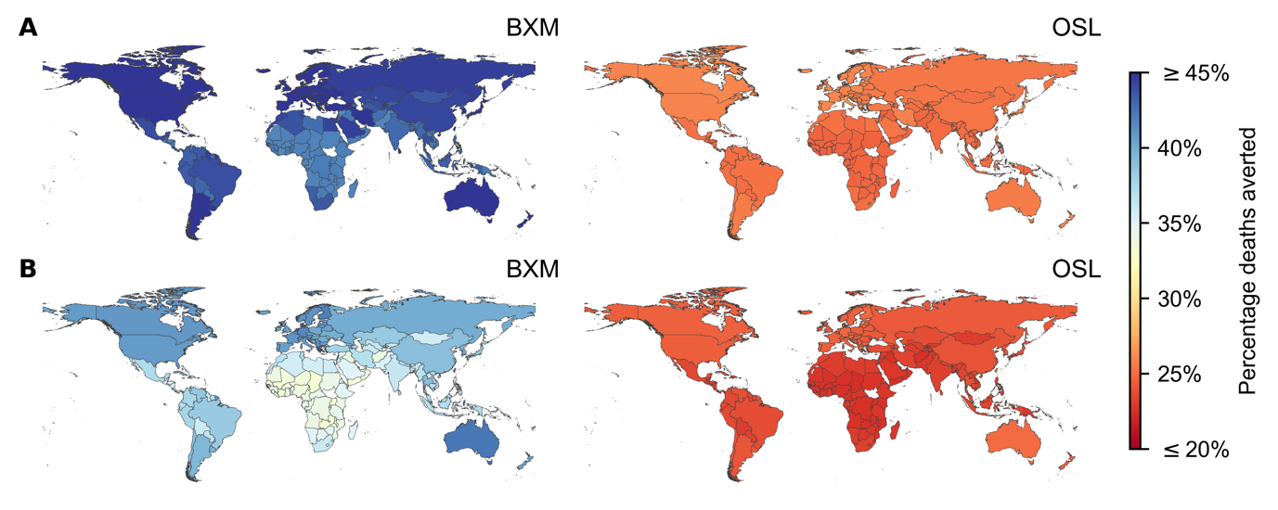
Fig. 1: Mean percentage deaths averted by test-and-treat with oral antivirals in 186 countries under idealised assumptions. Baloxavir marboxil (BXM; left column) or oseltamivir (OSL; right column) was administered to all individuals that were positively diagnosed, using a rapid test with 70% test sensitivity, within two days of symptom onset. All symptomatic individuals were assumed to have sought testing within one day after symptom onset on average. Distribution of oral antivirals for treatment began one week after the pandemic was initiated in the country with ten infections. (A) 1918 A/H1N1 pandemic ($R_{0}$=2.0). (B) Hypothetical influenza pandemic with COVID-19-like disease burden ($R_{0}$=3.0) but generation interval akin to seasonal influenza viruses.

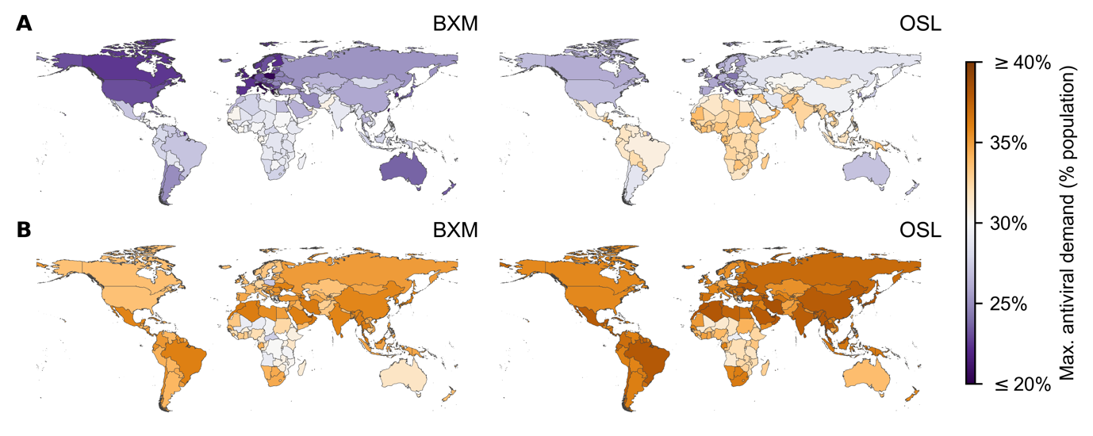
Fig. 2: Maximum treatment oral antiviral demand of 186 countries under idealised assumptions. Baloxavir marboxil (BXM; left column) or oseltamivir (OSL; right column) was administered to all individuals that were positively diagnosed, using a rapid test with 70% test sensitivity, within two days of symptom onset. All symptomatic individuals were assumed to have sought testing within one day after symptom onset on average. Distribution of oral antivirals for treatment began one week after the pandemic was initiated in the country with ten infections. (A) 1918 A/H1N1 pandemic ($R_{0}$=2.0). (B) Hypothetical influenza pandemic with COVID-19-like disease burden ($R_{0}$=3.0) but generation interval akin to seasonal influenza viruses.

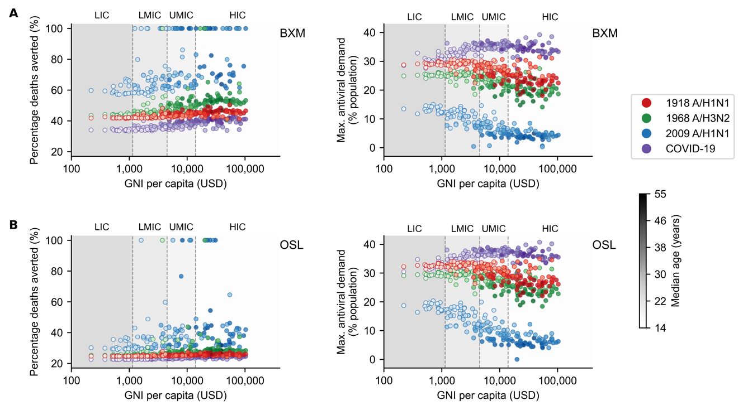
Fig. 3: Demographic and economic covariates to treatment oral antiviral demand and impact. Mean percentage deaths averted (left column) and maximum treatment oral antiviral demand (right column) for each country (circle, shading denotes median age of country’s population) under different pandemic scenarios (denoted by colour of circles; red, 1918 A/H1N1; green, 1968 A/H3N2; blue, 2009 A/H1N1; and purple, COVID-19-like) are plotted against their gross national income (GNI) per capita is US dollars (USD) in 2023. Background shading denotes the range of GNI per capita distinguishing between different country income groups as classified by the World Bank in 2024 (low income country, LIC; lower-middle income country, LMIC; upper-middle income country, UMIC; and high income country, HIC). Antiviral drugs were administered to all individuals that were positively diagnosed, using a rapid test with 70% test sensitivity, within two days of symptom onset. All symptomatic individuals were assumed to have sought testing within one day after symptom onset on average. Distribution of oral antivirals for treatment began one week after the pandemic was initiated in the country with ten infections. (A) Baloxavir marboxil. (B) Oseltamivir.

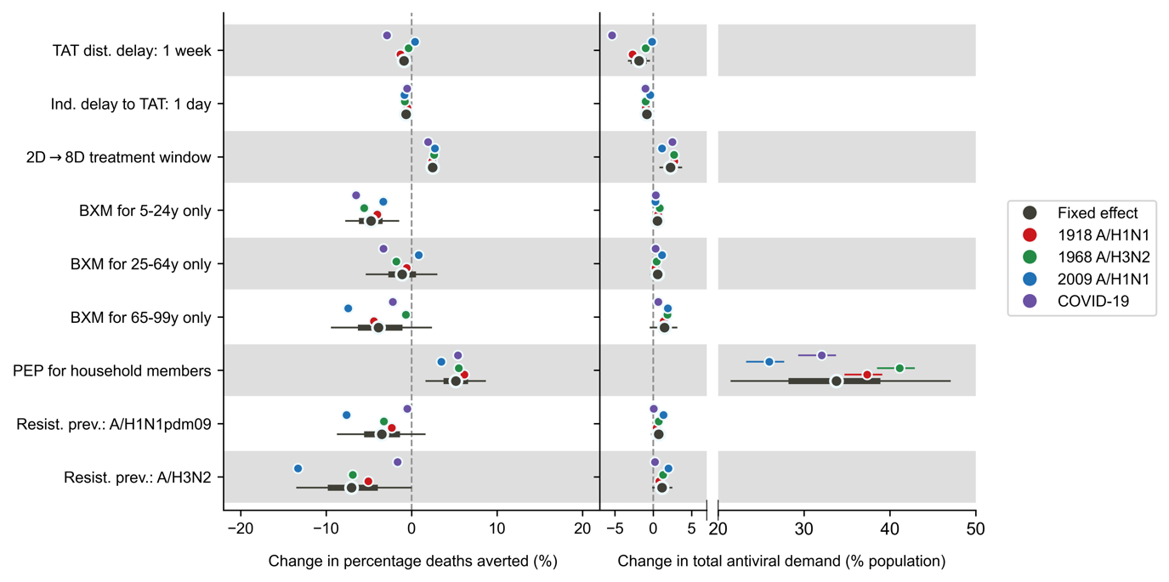
Fig. 4: Joint effects of treatment delays, distribution strategies, post-exposure prophylaxis and antiviral resistance on mean percentage deaths averted and total antiviral demand. Relative to the idealised scenario (i.e. antivirals are swiftly distributed to patients across the country one week after the first infection in the country, with no limits on access and availability of tests and antivirals; >95% of all symptomatic individuals are treated within two days after symptom onset if positively diagnosed by a rapid diagnostic test; No emergence and spread of BXM-resistant viruses), mean posterior changes in mean percentage deaths averted (left plot) and total antiviral (i.e. BXM and oseltamivir) demand (right plot) across pandemics and countries are plotted as black circles (i.e. fixed effects) while the thick and thin lines denote the corresponding 67% and 95% highest posterior density intervals respectively. The corresponding pandemic scenario-adjusted posterior effects are plotted alongside (posterior mean and 95% highest posterior density interval denoted by colour of circle and line respectively; red, 1918 A/H1N1; green, 1968 A/H3N2; blue, 2009 A/H1N1; and purple, COVID-19-like).

