# Estimating the global demand and potential public health impact of oral antiviral treatment stockpile for influenza pandemics: a mathematical modelling study

Alvin X. Han, PhD1, Katina D. Hulme, PhD1, Colin A. Russell, PhD1

1Department of Medical Microbiology and Infection Prevention, Amsterdam University Medical Center, University of Amsterdam, Amsterdam, The Netherlands

Corresponding author: Alvin X. Han ([x.han@amsterdamumc.nl](mailto:x.han@amsterdamumc.nl))

# Summary

## Background

Oral influenza antiviral drugs could potentially minimize the disease burden of a nascent influenza pandemic prior to the availability of vaccines. Mathematical modelling is useful for designing antiviral stockpiling options but previous studies have yielded conflicting results, using outdated assumptions on health-seeking behavior and transmission risk reduction effects of antivirals.

## Methods

We developed a novel multiscale model that accounts for heterogeneous transmission dynamics which depend on when individuals are treated with after infection, using recent clinical estimates of transmission risk reduction by antivirals. We estimated the antiviral demand of oseltamivir and baloxavir marboxil (BXM), and their corresponding reduction on pandemic deaths in 186 countries during the first epidemic wave of the 1918 A/H1N1, 1968 A/H3N2, 2009 A/H1N1 and COVID-19-like influenza pandemics.

## Findings

Across all simulated pandemic scenarios and countries, provided that drug distribution and treatment delays are minimized, BXM doubles the median percentage of mean pandemic deaths averted relative to oseltamivir, ranging between 37% and 68%, with ~5%–10% less mean treatment demand at 7%–34% per-capita. Drug rationing by age group does not meaningfully lower antiviral demand but instead diminishes the impact of the drug stockpile. Under limited drug availability, antivirals should be prioritized for treatment over provision of post-exposure prophylaxis to household contacts.

## Interpretation

BXM stockpile for treatment of symptomatic individuals can substantially lower the disease burden of future influenza pandemics but only if robust public health infrastructure is in place to swiftly test and distribute treatment.

## Funding

Dutch Research Council (NWO) and European Research Council.

# Research in context

## Evidence before this study

We searched PubMed and Google Scholar for peer-reviewed articles and preprints, published up to 31 December 2024, that relate to the use of modelling to design oral influenza antiviral stockpile sizing options for pandemic preparedness and their corresponding health and/or economic impact, using search terms “modelling”, “influenza”, “pandemic”, “oral antiviral”, “antiviral”, “antiviral stockpile”, “oseltamivir”, and “baloxavir marboxil”. Due to differences in modelling frameworks and study objectives that focus either on one or a handful of countries (i.e. no more than ten), existing studies have yielded inconsistent results, making it difficult to synthesize current findings for meaningful public health guidance. These studies proposed a wide range of antiviral stockpile size recommendations from covering as little as 15% of the population in the country to >140% of the population. Previous studies have also differently concluded on the effectiveness of distributing post-exposure prophylaxis to uninfected and/or asymptomatic individuals, from finding little benefit at reducing transmissions to the ability to contain a nascent influenza pandemic at its source. Most studies also liberally assumed that symptomatic individuals largely have similar health-seeking behaviors that prompt them to seek treatment swiftly after infection, within two days of symptom onset, which has now been shown to be far more heterogenous since the COVID-19 pandemic. Additionally, they assumed indirectly inferred and outsized effects of antivirals in lowering transmission risk based on post-hoc analyses of past clinical trial data.

## Added value of this study

Based on a recent randomized clinical trial, baloxavir marboxil, a polymerase inhibitor that blocks influenza viral replication and was approved for medical use in 2018, was found to reduce transmission risk of treated index patients by 29%. Baloxavir marboxil is therefore the first oral influenza antiviral drug to demonstrate reduction of transmission, which is typically achieved by prophylactic use of drugs of close contacts, by treatment of the index infected patient. We developed a novel mathematical modelling framework, parameterized by the new clinical data alongside more grounded assumptions on health-seeking behavior and simulated pandemic scenarios, accounting for country-specific demography and age-structured contact rates. This is the first study to estimate the maximum oral influenza antiviral treatment demand and the corresponding reduction in disease burden achievable with oral antivirals in the event of a nascent influenza pandemic in 186 countries.

## Implications of all the available evidence

This study suggests that baloxavir marboxil, owing to its demonstrated effectiveness in lowering transmission risk, can be considered by governments for stockpiling to mitigate disease burden during an influenza pandemic. If antiviral distribution is the sole intervention measure, the maximum baloxavir marboxil demand during the first wave of an influenza pandemic would amount to no more than 40% per-capita and can potentially averted >37% of expected pandemic deaths. However, its impact depends on the prompt and effective implementation of test-and-treat programs in the country upon pandemic initiation.

# Main Text

# Introduction

Influenza A viruses (IAV) remain an emerging threat to human health owing to persistent spillover risk of novel IAV subtypes from reservoir species. Given their antiviral activity against diverse IAV subtypes and the convenience of administration, oral influenza antiviral drugs are potentially effective countermeasures to mitigate the impact of a nascent influenza pandemic prior to the availability of a targeted vaccine. Several approved drugs could be considered for pandemic preparedness stockpiling, including: (1) adamantanes, M2 ion-channel blockers preventing the initiation of viral replication; (2) oseltamivir, a neuraminidase inhibitor that attenuates the release of progeny virions from infected cells; and (3) baloxavir marboxil (BXM), a polymerase inhibitor that blocks viral replication. Adamantanes are unlikely to be a useful primary antiviral stockpile due to the high propensity of developing resistance among adamantane-treated individuals.1 Although the emergence and spread of oseltamivir and BXM resistance are also of concern, prompt treatment with either drug reduces symptom duration and risk of severe disease outcomes.1,2 Both treatments are also effective post-exposure prophylactic drugs that lower infection risk.3 Recently, treatment with BXM has also demonstrated a significant clinical benefit in preventing onward transmissions.4

Mathematical modelling is a useful tool to rationally design evidence-based antiviral stockpiling options amidst uncertainties about the future influenza pandemic. However, existing studies have yielded inconsistent and even conflicting results owing to differences in modelling objectives, approaches and assumptions, making it challenging to meaningfully synthesize their findings for public health planning. For example, focusing on treatment demand estimation, a neuraminidase inhibitor stockpile covering ~30% of the population was estimated to be sufficient to treat all symptomatic individuals infected by the pandemic virus that seek care in the US during a nascent pandemic5. Conversely, a separate study estimated a much larger antiviral demand covering 40-144% of the Canadian population to account for additional contingencies such as treating non-specific infections that also present influenza-like illness.6 Several studies separately used decision-tree approaches and designed stockpile size options aimed at maximizing economic benefits. In Singapore, the cost-effective treatment-only oseltamivir stockpile size was estimated at 40-60% per-capita7 while Siddiqui et al. suggest that stockpiling oseltamivir for the entire population of the UK for treatment is more prudent since the attack rate of the future pandemic virus is unknown.8 In contrast, a dynamic transmission model applied to ten countries, including Singapore and UK, estimated a much smaller treatment-only oseltamivir stockpile size of 15-25% per-capita to minimize mortality rates and economic costs while also finding little benefit in giving antiviral prophylaxis to exposed contacts.9 Other studies, differently conclude that restricting antivirals for treatment is ineffective at limiting the impact of the pandemic virus,10 or that spread of the pandemic virus can only be constrained under widespread distribution of post-exposure prophylaxis (PEP), covering 20-50% of exposed contacts11 or that a nascent pandemic can even be contained at its source if >80% of exposed contacts were given prophylaxis.12,13

Previous works would likely reach different conclusions in hindsight of the COVID-19 pandemic and availability of recent clinical data. First, all of the aforementioned studies assumed that at least 70% of symptomatic infections could be treated within two days after symptom onset. While symptomatic individuals might readily seek care during a pandemic,14 health behavior, including the time to seeking treatment since symptom onset, is heterogeneous, even during a pandemic,15 predicating on sociodemographic factors and disease severity,16 which could in turn diminished the effectiveness of the antiviral stockpile. Similarly, studies proposing mass distribution of PEP assume that countries can swiftly mobilize extensive and near-complete contact tracing but this was demonstrably challenging during the COVID-19 pandemic even in high-resource countries.17,18 Several studies also assume that the infectiousness of infected individuals treated with oseltamivir is reduced by >60%9,12,13,19 based on post-hoc analyses20 of past clinical trial data that originally investigated the efficacy of oseltamivir as PEP to prevent infections among uninfected household contacts with no direct assessment of transmission risk reduction benefits of treatment among infected index patients.21,22 This is an overestimate as BXM, which significantly reduces infectious viral load relative to oseltamivir,2 is found to reduce transmission of treated index patients to untreated contacts by 29% based on a recent randomized clinical trial (CENTERSTONE).4

In this study, we developed a novel mathematical modelling framework to estimate the maximum antiviral demand and associated impact on burden reduction when using either BXM or oseltamivir to mitigate the initial wave of an influenza pandemic in 186 countries. We used the latest estimates of transmission risk reduction of antivirals based on direct measurements in clinical trials while accounting for delays and heterogeneity in treatment administration since infection across the population. We also estimated the additional antiviral demand and potential benefits in distributing PEP to household contacts. Finally, we quantified how the spread of antiviral resistance could potentially impact antiviral demand and burden reduction.

# Methods

## Multiscale model

We developed a discrete-time, age-structured, deterministic SIR compartmental model of influenza transmission that can be flexibly parameterized for individual countries using relevant demographic and age-dependent contact rate data. To compute transmission dynamics, we adapted the multi-type renewal equation23 that accounts for heterogeneity in transmission due to reduction in infectiousness by antiviral treatment which effectiveness predicates on when treatment was initiated since infection, age-dependent contact rates between infected and uninfected individuals, susceptibility and, if given one, protection from infection by PEP of the uninfected individuals. The infectiousness of infected individuals was estimated by a separate target cell-limited within-host model.24 Assuming that the pandemic IAV has similar within-host virus replication dynamics to seasonal IAVs, we estimated the cell infection and viral replication rate, as well as treatment effectiveness parameters of antivirals by fitting our within-host model to the viral load measurements taken from clinical trial for different treatment regimens (i.e. placebo, BXM or oseltamivir) that were administered within two days after symptom onset, with25 and without the emergence of BXM-resistant viruses.2 Given that we still lack a quantitative understanding of how within-host viral load links to between-host transmission,26 we applied three different correlative models that were previously applied to infer infectiousness from viral load data of respiratory viral pathogens, estimating the best-fit parameters that align with empirical effectiveness estimates of BXM reducing onward transmission risk by 29% within five days after treatment.4 As all correlative models yield similar transmission dynamics (see supplementary appendix p.2-3; multiscale model validated against US influenza season in 2017/2018), we used the Hill equation model for all simulations and applied the best-fit parameters to estimate the mean infectiousness of infected individuals who were treated at different times during the course of their infection (i.e. within and beyond two days after symptom onset), accounting for individual variances in time to symptom onset since infection, delays in treatment since symptom onset, and whether or not resistant mutant viruses emerge after treatment.

## Maximum antiviral demand scenarios

We computed the maximum mean antiviral demand for treatment, using either oseltamivir or BXM as the sole infection control intervention, in 186 countries where age demography and contact rates were estimated by the UN World Population Prospects27 and Prem et al.28 respectively, during the first wave of four influenza pandemic scenarios with distinct basic reproduction number, age-stratified susceptibility to infection and case fatality rates (W-shaped age-specific mortality curve, 1918 A/H1N1;29,30 U-shaped age-specific mortality curve, 1968 A/H3N2;29,30 a mild pandemic with greater relative mortality rates among adults <65 years of age, 2009 A/H1N1;31 a severe pandemic with greater relative susceptibility and mortality rates among adults 65 years of age, COVID-19;32,33 Table S1) akin to the 1918 A/H1N1 (=2.0), 1968 A/H3N2 (=1.8), 2009 A/H1N1 (=1.5) and an influenza pandemic with COVID-19-like reproduction number (=3.0) and disease burden but with IAV-like generation interval. We assumed that 60% of infections were symptomatic even though prevalence of asymptomatic influenza remains largely uncertain34 and that asymptomatic individuals are as infectious as their symptomatic counterparts.

There were no age restrictions in access to antivirals and that 95% of all symptomatic individuals would seek clinical intervention within two days after symptom onset, lognormally distributed across time (i.e. mean=1 day, sd=0.6 days after symptom onset) (we relaxed these assumptions later in the study). We assumed that an idealized public health infrastructure was in place such that country-wide distribution of antivirals would begin one week after the pandemic was initiated with ten infections in the country. Rapid testing would be required for same-day antiviral administration and was performed by a moderately sensitive rapid diagnostic test (70%).35 Given its multi-day, five-dose treatment course, adherence to oseltamivir treatment was assumed to be lower (65%)36 than the single-dose BXM (95%). Treated infected individuals that did not adhere to treatment were assumed to be effectively untreated. We estimated the impact of antiviral use by computing the total deaths reduced relative to no infection control. Total deaths during the pandemic wave was computed based on net incidence and the corresponding pandemic case fatality rates while accounting for mean reduction in mortality risks of treated individuals by 23% for both oseltamivir37 and BXM, for which robust mortality risk reduction estimates is currently lacking.

## Additional simulated scenarios

We then used our model to simulate scenarios that deviate from the aforementioned idealized case, with different delays to test-and-treatment distribution since pandemic initiation (i.e. one week, four weeks and three months) and individual treatment since symptom onset (i.e. mean (sd) = 1.0 (0.6), 2.0 (1.2) and 5.0 (3.0) days, which correspond to 95% likelihood of seeking test-and-treat within two, four and eight days since symptom onset respectively). We also simulated different BXM distribution strategies, including extending antiviral treatment window from two to eight days, providing PEP to household members of positively-tested individuals which lowers the likelihood of infection of uninfected individuals by 57% for ten days,38 and instituting restrictions to antiviral access to those aged 5-24 years, 25-64 years or 65 years only. Furthermore, we investigated the impact of BXM resistance emergence and spread based on age-stratified average treatment-emergent resistance prevalence reported for A/H1N1pdm09 (<12 years = 9.4%; 12 years = 2.2%)2,39,40 and A/H3N2 (<12 years = 21.0%; 12 years = 8.5%)25,39,41 infections. Given limited evidence that BXM-resistant virus may be fitter than their resistant counterparts,42–44 we assumed no difference in either within-host viral replication fitness or between-host transmission advantage between drug-sensitive and resistant viruses. We used a Bayesian multilevel model that partially pooled simulation results across all simulated countries and pandemic scenarios to estimate the effect size of each factor on the deaths averted and BXM demand. See supplementary appendix for the formulation of the within-host, transmission and multilevel models as well as their corresponding assumptions, parameterization and priors.

# Results

## Maximum antiviral treatment demand and mean deaths averted

Under the idealized assumptions about possible public health infrastructure, diagnostic testing, and drug use, the estimated reduction in deaths by the corresponding courses of antivirals represent the maximum potential reduction in mean pandemic deaths and treatment demand respectively. We find that BXM broadly doubles the percentage of mean pandemic deaths averted relative to oseltamivir (Figure 1) with less treatment courses (Figure 2) across all pandemic scenarios and countries (Figure 3). The median percentage of mean pandemic deaths averted across all countries depends on the severity of the pandemic scenario. BXM use could avert 68% of deaths in the relatively mild 2009 A/H1N1-like pandemic (interquartile range (IQR) = 62% – 100%; 13 – 34 deaths averted per million people) but only 48% in a 1968 A/H3N2-like pandemic (IQR = 45% – 52%; 194 – 329 mean deaths averted per million people), 37% in a COVID-19-like pandemic (IQR = 35% – 40%; 843 – 2,588 mean deaths averted per million people) and 44% in a 1918 A/H1N1-like pandemic (IQR = 42% – 45%; 2,798 – 2,993 mean deaths averted per million people). The corresponding median mean per-capita demand of BXM is 7% for a 2009 A/H1N1-like pandemic (IQR = 5% – 11%), 24% for a 1968 A/H3N2-like pandemic (IQR = 21% – 25%), 34% for a COVID-19-like pandemic (IQR = 33% – 36%) and 28% for a 1918 A/H1N1-like pandemic (IQR = 25% – 29%). In contrast, oseltamivir averts median mean deaths by 35% (IQR = 31% – 41%), 27% (IQR = 26% – 28%), 23% (IQR = 23% – 24%) and 25% (IQR = 25% – 26%) for the 2009 A/H1N1, 1968 A/H3N2, COVID-19-like and 1918 A/H1N1 influenza pandemics respectively, while the median mean oseltamivir demand is ~5% – 10% greater than BXM, correspondingly amounting to 32% (IQR = 28% – 33%), 28% (IQR = 25% – 30%), 36% (IQR = 35% – 37%) and 32% (IQR = 28% – 33%) per-capita for the four pandemic scenarios.

At the country level, owing to their generally younger demography, the maximum potential per-capita impact on disease burden by either antiviral is lower in lower-middle and low income countries while requiring up to four times more treatment courses relative to high income countries (Figure 3), except for the COVID-19-like pandemic scenario which, unlike historical influenza pandemics, impacted younger individuals to a lesser extent owing to their lower susceptibility to SARS-CoV-2 infection, and in turn, reducing the estimated antiviral treatment demand in lower income countries. Table S2 tabulates the estimated maximum mean antiviral treatment demand, mean rapid testing demand and the corresponding mean deaths averted for each individual country for all four simulated pandemic scenarios.

## Impact of treatment delay, distribution strategies, post-exposure prophylaxis and antiviral resistance

We subsequently investigated how pandemic death reduction and the corresponding demand for BXM, the potentially more impactful antiviral drug, would change by deviations from idealized assumptions. We used a Bayesian multilevel model to estimate the joint impact of these deviations (Figure 4). First, resource, logistical and public health infrastructure constraints, especially in low-resourced countries, will impede the timely distribution of test and treatment across the country. Excluding pandemic- and country-specific effects, mean percentage of deaths averted by BXM decreases by 0.9% (95% highest posterior density (HPD) = 0.1% – 1.6%) for every week of delay to test-and-treatment distribution since the first infections in the country. This decrease is further exacerbated under pandemic scenarios with faster growth rates, for instance each week of distribution delay under a COVID-19-like pandemic scenario decreases mean percentage deaths averted by 2.9% (95% HPD = 2.8% – 3.0%). Without prompt delivery and accessibility to test-and-treatment, the theoretical utility of a pandemic oral antiviral stockpile is greatly diminished.45

It is unlikely that most infected persons would seek test-and-treatment within two days of symptom onset on average.15,16 For every day of delay in time to treatment since symptom onset across the population, the mean population-level reduction in deaths is expected to decrease by 0.7% (95% HPD = 0.5% – 0.8%). To mitigate the diminishing impact of individual treatment delay, we considered extending the current indicated BXM treatment use of within two days post-symptom onset to eight days. Leveraging BXM’s rapid inhibition of viral replication,2 additionally treating individuals who sought treatment after two days post-symptom onset could theoretically lower their infectiousness (Figure S1) such that mean population-level percentage deaths averted would increase by 2.4% (95% HPD = 1.8% – 3.0%) while requiring 2.3% (95% HPD = 0.9% – 3.6%) more per-capita courses of BXM.

Restricting antiviral access to those at the highest risk of mortality, typically in the form of age-based rationing, is a common allocation strategy under limited drug availability. We estimated how overall pandemic deaths and BXM demand would change, relative to the idealized scenario of no age restriction, if treatment was differently restricted for individuals aged 5–24 years, 25–64 years, and those 65 years of age only. Restricting BXM access by different age groups leads only to trivial changes in treatment demand (i.e. age group, 95% HPD: 5–24 years, -0.1% – 1.2%; 25–64 years, -0.3% – 1.4%; 65 years, -0.3% – 3.0%). If BXM is given to individuals aged 5–24 years only, mean percentage pandemic deaths averted decreases by 4.7% (95% HPD = 1.6% – 7.7%). On the other hand, if BXM is restricted to individuals aged 25–64 years or 65 years only, changes to percentage pandemic deaths averted strongly depend on country- and pandemic-specific effects (e.g. if distributed to 25–64 years only, mean percentage deaths averted decrease by 3.3% (95% HPD = 3.0% – 3.6%) under COVID-19-like pandemic scenario but increase by 0.8% (95% HPD = 0.5% – 1.2%) during the 2009 A/H1N1 pandemic; Figure 4) with only trivial country-level effects despite the variation in age demography across countries (Figure S2).

Although BXM is effective as PEP,38 swift and extensive contact tracing for PEP distribution can be challenging to implement during a pandemic.17,18 Under the ideal assumption of same-day BXM administration to household contacts upon the identification of the index patient, excluding pandemic- or country-level effects, providing BXM as PEP on top of treatment increases mean pandemic deaths averted by 5.2% (95% HPD = 1.7% – 8.6%) while incurring additional per-capita BXM demand by 33.8% (95% HPD = 21.6% – 47.0%). Changes in BXM impact and demand due to PEP varies by country (Figure S2-4) where lower-income countries, which tend to have larger mean household sizes, would benefit from PEP distribution when mean household size is at least four members, further increasing mean pandemic deaths averted by up to ~6%. However, realizing this benefit would require up to ~50% more per-capita BXM demand.

Multiple studies reported that seasonal IAVs readily acquire treatment-emergent BXM-resistant mutations without a loss in viral fitness,2,46–48,25,49 especially among children, albeit at different rates of emergence,46,47,49 which have been shown to be transmissible between ferrets49,50 and potentially between humans48,49. We assessed the degree to which widespread transmission of resistance mutations could potentially diminish the impact and demand of BXM, assuming treatment-emergent resistance prevalence at average levels observed for seasonal A/H1N1pdm09 and A/H3N2 viruses. Under the higher prevalence of treatment-emergent resistance akin to A/H3N2 infections, excluding pandemic- and country-level effects, mean pandemic deaths averted by BXM could potentially decrease by 7.0% (95% HPD = 0.1% – 13.4%) relative to no resistance emergence. Pandemics with slower growth rates would more likely lead to wider resistance spread, as evidenced by lower total mean percentage pandemic deaths averted (Figure 4). Conversely, resistance spread under A/H1N1pdm09 resistance prevalence yields trivial fixed effects on mean pandemic deaths averted (95% HPD = -8.6% – 1.5%) and is instead strongly dependent on the pandemic scenario (Figure 4) with generally trivial country-level effects (Figure S2) despite the age dependency of resistance emergence rates. Assuming that rapid testing does not distinguish between drug-sensitive and -resistant viruses for treatment administration, changes in BXM treatment demand was trivial under both treatment-emergent resistance prevalence levels (i.e. A/H3N2, 95% HPD = 0.0% – 2.0%; A/H1N1pdm09, 95% HPD = -0.2% – 1.5%).

# Discussion

While this is not the first study to develop a multi-scale model linking within-host infectiousness to between-host influenza transmission dynamics, we are first to account for heterogeneous health-seeking behavior and its impact on infectiousness and transmission dynamics. This is also the first study to incorporate recent clinical estimates of transmission risk reduction by antiviral treatment. We estimated the maximum country-specific influenza antiviral demand for either BXM or oseltamivir and their corresponding impact in reducing pandemic deaths during a nascent influenza pandemic for 186 countries under a single age-structured model, resolving difficulties in either synthesizing or extrapolating findings from previous modeling studies, which have focused on either one or a handful of countries based on used outdated assumptions, to inform potential influenza antiviral stockpiling options that fit country-specific needs.

Regardless of the antiviral drug, treatment-only antiviral demand maximally amounts to 20% – 40% per-capita, with lower income countries needing more antiviral drugs, and can avert >20% of expected pandemic deaths during the first epidemic wave of a nascent influenza pandemic. Because of its demonstrated benefits in reducing transmission, BXM is the more effective and treatment course-efficient antiviral drug as BXM distribution doubles the reduction in pandemic deaths relative to oseltamivir, with the potential to avert 37% – 68% of mean pandemic deaths, while requiring ~5% – 10% less courses of drugs. Additionally, common drug rationing practices that restrict BXM to older individuals only, who often bear greater mortality risk, would not lower population treatment demand meaningfully while diminishing burden reduction benefits instead. Procuring enough antivirals that sufficiently meet demand would not necessarily confer the aforementioned impact estimates unless similar investments are made to public health infrastructure to ensure prompt drug distribution across a country upon pandemic initiation, with enough testing resources to identify most symptomatic individuals shortly after infection.

Besides treatment, providing antivirals as PEP to exposed contacts could confer additional benefits in reducing disease burden. Household members of index patients are potentially easier contact tracing targets for PEP distribution and a recent modelling study found that combining treatment of the index patient and PEP for exposed household members could yield considerable reduction in burden within individual households.51 However, given the heightened risk of infection during a pandemic across the population, independent of country-level effects, distributing BXM to household contacts would only lead to modest population-level increase in mean pandemic deaths averted by ~5% while increasing mean BXM demand by >30%. PEP would only additionally reduce disease burden in settings where the mean household size is ≥4. Under limited drug availability and/or below the mean household size of four, prioritizing antiviral drugs for treatment as opposed to PEP is more effective and treatment course-efficient considering population-level outcomes.

Finally, it is important to consider the degree to which antiviral resistance attenuates impact as it might be more prudent to limit BXM to individuals that would most likely derive clinical benefit from treatment as opposed to mass antiviral distribution. When assuming average treatment-emergent prevalence of BXM resistant mutations was similar to seasonal A/H3N2 infections, mean percentage reduction in pandemic deaths under the spread of BXM resistance was still substantial, estimated to be >24% compared to no intervention. As such, in spite of resistance spread, mass distributing BXM for treatment could still lead to substantial life-saving benefits. Various strategies have been proposed to potentially suppress the spread of resistance, such as cycling the distribution of two different antiviral drugs52 or combining them for treatment.53,54

There are limitations to our study. We have largely used clinical observations on viral load dynamics, treatment effectiveness and resistance prevalence measured for seasonal influenza virus infections to parameterize our model. While a future pandemic virus can have distinct epidemiological properties, in contrast to extrapolations considered in previous studies, we sought to inform antiviral treatment demand and impact using a model that is grounded on up-to-date, high-quality empirical data. Additionally, aiming to provide conservative antiviral stockpile sizing options and quantify their impact on burden reduction, we have estimated the maximum demand for antiviral drugs assuming that they are the sole public health intervention against a nascent pandemic prior to the availability of vaccines. We did not consider combinatorial effects from vaccination and other non-pharmaceutical interventions that could lower antiviral demand while augmenting burden reduction benefits. Finally, our country-level modelling framework and results are intended to inform public health planning of antiviral stockpiles for individual countries.

Influenza antiviral drugs, in particular BXM given its demonstrated clinical effectiveness in lowering transmission risks, have the potential to significantly lower the disease burden of future influenza pandemics. However, this potential can only be realized under a robust public health infrastructure that is able test and distribute treatment to patients swiftly upon pandemic initiation.

# Contributors

AXH and CAR contributed to conceptualization, methodology and funding acquisition. AXH contributed to formal analysis and data curation, and wrote the original draft. AXH, KDH and CAR contributed to investigation, validation and visualization. CAR provided supervision. All authors reviewed and edited the manuscript.

# Data sharing

The dataset and code to run all simulations and analyses are available at <https://github.com/AMC-LAEB/flu-antiviral-stockpile>.

# Declaration of interests

We declare no competing interests.

# Acknowledgements

AXH, KDH and CAR were supported by the European Research Council NaviFlu (grant 818353). AXH and CAR were also supported by the Dutch Research Council (NWO) Modelling for Pandemic Preparedness grant (10710062310004). AXH was supported by the Dutch Research Council (NWO) Veni Award (09150162210121). CAR was supported by the Dutch Research Council (NWO) Vici Award (09150182010027).

# References

1 Hayden FG, Pavia AT. Antiviral Management of Seasonal and Pandemic Influenza. *J Infect Dis* 2006; **194**: S119–26.

2 Hayden Frederick G., Sugaya Norio, Hirotsu Nobuo, *et al.* Baloxavir Marboxil for Uncomplicated Influenza in Adults and Adolescents. *N Engl J Med* 2018; **379**: 913–23.

3 Zhao Y, Gao Y, Guyatt G, *et al.* Antivirals for post-exposure prophylaxis of influenza: a systematic review and network meta-analysis. *The Lancet* 2024; **404**: 764–72.

4 Cowling BJ. Phase III CENTERSTONE trial of single-dose baloxavir marboxil for the reduction of transmission of influenza in households. 2024; published online Sept 29. https://medically.roche.com/content/dam/pdmahub/restricted/infectious-disease/options-xii-2024/Options-XII-2024-presentation-monto-phase-III-CENTERSTONE-study-of-single-dose.pdf.

5 O’Hagan JJ, Wong KK, Campbell AP, *et al.* Estimating the United States Demand for Influenza Antivirals and the Effect on Severe Influenza Disease During a Potential Pandemic. *Clin Infect Dis* 2015; **60**: S30–41.

6 Greer AL, Schanzer D. Using a Dynamic Model to Consider Optimal Antiviral Stockpile Size in the Face of Pandemic Influenza Uncertainty. *PLOS ONE* 2013; **8**: e67253.

7 Lee V, Phua KH, Chen M, *et al.* Economics of Neuraminidase Inhibitor Stockpiling for Pandemic Influenza, Singapore. *Emerg Infect Dis J* 2006; **12**: 95.

8 Siddiqui MR, Edmunds WJ. Cost-effectiveness of Antiviral Stockpiling and Near-Patient Testing for Potential Influenza Pandemic. *Emerg Infect Dis J* 2008; **14**: 267.

9 Carrasco LR, Lee VJ, Chen MI, Matchar DB, Thompson JP, Cook AR. Strategies for antiviral stockpiling for future influenza pandemics: a global epidemic-economic perspective. *J R Soc Interface* 2011; **8**: 1307–13.

10 McCaw JM, McVernon J. Prophylaxis or treatment? Optimal use of an antiviral stockpile during an influenza pandemic. *Math Biosci* 2007; **209**: 336–60.

11 McVernon J, McCaw JM, Nolan TM. Modelling strategic use of the national antiviral stockpile during the CONTAIN and SUSTAIN phases of an Australian pandemic influenza response. *Aust N Z J Public Health* 2010; **34**: 113–9.

12 Longini IM, Nizam A, Xu S, *et al.* Containing Pandemic Influenza at the Source. *Science* 2005; **309**: 1083–7.

13 Ferguson NM, Cummings DAT, Cauchemez S, *et al.* Strategies for containing an emerging influenza pandemic in Southeast Asia. *Nature* 2005; **437**: 209–14.

14 Siegler AJ, Hall E, Luisi N, *et al.* Willingness to Seek Diagnostic Testing for SARS-CoV-2 With Home, Drive-through, and Clinic-Based Specimen Collection Locations. *Open Forum Infect Dis* 2020; **7**: ofaa269.

15 Graham MS, May A, Varsavsky T, *et al.* Knowledge barriers in a national symptomatic-COVID-19 testing programme. *PLOS Glob Public Health* 2022; **2**: e0000028.

16 Peppa M, John Edmunds W, Funk S. Disease severity determines health-seeking behaviour amongst individuals with influenza-like illness in an internet-based cohort. *BMC Infect Dis* 2017; **17**: 238.

17 Clark E, Chiao EY, Amirian ES. Why Contact Tracing Efforts Have Failed to Curb Coronavirus Disease 2019 (COVID-19) Transmission in Much of the United States. *Clin Infect Dis* 2021; **72**: e415–9.

18 Davis EL, Lucas TCD, Borlase A, *et al.* Contact tracing is an imperfect tool for controlling COVID-19 transmission and relies on population adherence. *Nat Commun* 2021; **12**: 5412.

19 Halloran ME, Ferguson NM, Eubank S, *et al.* Modeling targeted layered containment of an influenza pandemic in the United States. *Proc Natl Acad Sci* 2008; **105**: 4639–44.

20 Yang Y, Longini IM Jr, Halloran ME. Design and Evaluation of Prophylactic Interventions Using Infectious Disease Incidence Data from Close Contact Groups. *J R Stat Soc Ser C Appl Stat* 2006; **55**: 317–30.

21 Welliver R, Monto AS, Carewicz O, *et al.* Effectiveness of Oseltamivir in Preventing Influenza in Household ContactsA Randomized Controlled Trial. *JAMA* 2001; **285**: 748–54.

22 Hayden FG, Belshe R, Villanueva C, *et al.* Management of Influenza in Households: A Prospective, Randomized Comparison of Oseltamivir Treatment With or Without Postexposure Prophylaxis. *J Infect Dis* 2004; **189**: 440–9.

23 Green WD, Ferguson NM, Cori A. Inferring the reproduction number using the renewal equation in heterogeneous epidemics. *J R Soc Interface* 2022; **19**: 20210429.

24 Hadjichrysanthou C, Cauët E, Lawrence E, Vegvari C, de Wolf F, Anderson RM. Understanding the within-host dynamics of influenza A virus: from theory to clinical implications. *J R Soc Interface* 2016; **13**: 20160289.

25 Uehara T, Hayden FG, Kawaguchi K, *et al.* Treatment-Emergent Influenza Variant Viruses With Reduced Baloxavir Susceptibility: Impact on Clinical and Virologic Outcomes in Uncomplicated Influenza. *J Infect Dis* 2020; **221**: 346–55.

26 Handel A, Rohani P. Crossing the scale from within-host infection dynamics to between-host transmission fitness: a discussion of current assumptions and knowledge. *Philos Trans R Soc B Biol Sci* 2015; **370**: 20140302.

27 United Nations. World Population Prospects. 2024. https://population.un.org/wpp/ (accessed Jan 6, 2025).

28 Prem K, Zandvoort K van, Klepac P, *et al.* Projecting contact matrices in 177 geographical regions: An update and comparison with empirical data for the COVID-19 era. *PLOS Comput Biol* 2021; **17**: e1009098.

29 Luk J, Gross P, Thompson WW. Observations on Mortality during the 1918 Influenza Pandemic. *Clin Infect Dis* 2001; **33**: 1375–8.

30 Taubenberger J, Morens D. 1918 Influenza: the Mother of All Pandemics. *Emerg Infect Dis J* 2006; **12**: 15.

31 Dawood FS, Iuliano AD, Reed C, *et al.* Estimated global mortality associated with the first 12 months of 2009 pandemic influenza A H1N1 virus circulation: a modelling study. *Lancet Infect Dis* 2012; **12**: 687–95.

32 Zhang J, Litvinova M, Liang Y, *et al.* Changes in contact patterns shape the dynamics of the COVID-19 outbreak in China. *Science* 2020; **368**: 1481–6.

33 Verity R, Okell LC, Dorigatti I, *et al.* Estimates of the severity of coronavirus disease 2019: a model-based analysis. *Lancet Infect Dis* 2020; **20**: 669–77.

34 Leung NHL, Xu C, Ip DKM, Cowling BJ. Review Article: The Fraction of Influenza Virus Infections That Are Asymptomatic: A Systematic Review and Meta-analysis. *Epidemiology* 2015; **26**. https://journals.lww.com/epidem/fulltext/2015/11000/review_article__the_fraction_of_influenza_virus.13.aspx.

35 Merckx J, Wali R, Schiller I, *et al.* Diagnostic Accuracy of Novel and Traditional Rapid Tests for Influenza Infection Compared With Reverse Transcriptase Polymerase Chain Reaction. *Ann Intern Med* 2017; **167**: 394–409.

36 Smith LE, D’Antoni D, Jain V, Pearce JM, Weinman J, Rubin GJ. A systematic review of factors affecting intended and actual adherence with antiviral medication as treatment or prophylaxis in seasonal and pandemic flu. *Influenza Other Respir Viruses* 2016; **10**: 462–78.

37 Hsu J, Santesso N, Mustafa R, *et al.* Antivirals for Treatment of Influenza. *Ann Intern Med* 2012; **156**: 512–24.

38 Ikematsu Hideyuki, Hayden Frederick G., Kawaguchi Keiko, *et al.* Baloxavir Marboxil for Prophylaxis against Influenza in Household Contacts. *N Engl J Med* 2020; **383**: 309–20.

39 Baker J, Block SL, Matharu B, *et al.* Baloxavir Marboxil Single-dose Treatment in Influenza-infected Children: A Randomized, Double-blind, Active Controlled Phase 3 Safety and Efficacy Trial (miniSTONE-2). *Pediatr Infect Dis J* 2020; **39**. https://journals.lww.com/pidj/fulltext/2020/08000/baloxavir_marboxil_single_dose_treatment_in.12.aspx.

40 Hirotsu N, Sakaguchi H, Fukao K, *et al.* Baloxavir safety and clinical and virologic outcomes in influenza virus-infected pediatric patients by age group: age-based pooled analysis of two pediatric studies conducted in Japan. *BMC Pediatr* 2023; **23**: 35.

41 Ison MG, Portsmouth S, Yoshida Y, *et al.* Early treatment with baloxavir marboxil in high-risk adolescent and adult outpatients with uncomplicated influenza (CAPSTONE-2): a randomised, placebo-controlled, phase 3 trial. *Lancet Infect Dis* 2020; **20**: 1204–14.

42 Checkmahomed L, M’hamdi Z, Carbonneau J, *et al.* Impact of the Baloxavir-Resistant Polymerase Acid I38T Substitution on the Fitness of Contemporary Influenza A(H1N1)pdm09 and A(H3N2) Strains. *J Infect Dis* 2020; **221**: 63–70.

43 Jones JC, Zagribelnyy B, Pascua PNQ, *et al.* Influenza A virus polymerase acidic protein E23G/K substitutions weaken key baloxavir drug-binding contacts with minimal impact on replication and transmission. *PLOS Pathog* 2022; **18**: e1010698.

44 Hickerson Brady T., Petrovskaya Svetlana N., Dickensheets Harold, Donnelly Raymond P., Ince William L., Ilyushina Natalia A. Impact of Baloxavir Resistance-Associated Substitutions on Influenza Virus Growth and Drug Susceptibility. *J Virol* 2023; **97**: e00154-23.

45 Han AX, Hannay E, Carmona S, Rodriguez B, Nichols BE, Russell CA. Estimating the potential impact and diagnostic requirements for SARS-CoV-2 test-and-treat programs. *Nat Commun* 2023; **14**: 7981.

46 Omoto S, Speranzini V, Hashimoto T, *et al.* Characterization of influenza virus variants induced by treatment with the endonuclease inhibitor baloxavir marboxil. *Sci Rep* 2018; **8**: 9633.

47 Takashita E, Kawakami C, Morita H, *et al.* Detection of influenza A(H3N2) viruses exhibiting reduced susceptibility to the novel cap-dependent endonuclease inhibitor baloxavir in Japan, December 2018. Eurosurveillance. 2019; **24**: 1800698.

48 Takashita E, Ichikawa M, Morita H, *et al.* Human-to-Human Transmission of Influenza A(H3N2) Virus with Reduced Susceptibility to Baloxavir, Japan, February 2019. *Emerg Infect Dis J* 2019; **25**: 2108.

49 Imai M, Yamashita M, Sakai-Tagawa Y, *et al.* Influenza A variants with reduced susceptibility to baloxavir isolated from Japanese patients are fit and transmit through respiratory droplets. *Nat Microbiol* 2020; **5**: 27–33.

50 Jones JC, Pascua PNQ, Fabrizio TP, *et al.* Influenza A and B viruses with reduced baloxavir susceptibility display attenuated in vitro fitness but retain ferret transmissibility. *Proc Natl Acad Sci* 2020; **117**: 8593–601.

51 Zaaraoui H, Schumer C, Duval X, Hoen B, Opatowski L, Guedj J. Modelling the effectiveness of antiviral treatment strategies to prevent household transmission of acute respiratory viruses. *PLOS Comput Biol* 2024; **20**: e1012573.

52 Wu JT, Leung GM, Lipsitch M, Cooper BS, Riley S. Hedging against Antiviral Resistance during the Next Influenza Pandemic Using Small Stockpiles of an Alternative Chemotherapy. *PLOS Med* 2009; **6**: e1000085.

53 Park J-H, Kim B, Antigua KJC, *et al.* Baloxavir-oseltamivir combination therapy inhibits the emergence of resistant substitutions in influenza A virus PA gene in a mouse model. *Antiviral Res* 2021; **193**: 105126.

54 Koszalka Paulina, George Ankita, Dhanasekaran Vijaykrishna, Hurt Aeron C., Subbarao Kanta. Effect of Baloxavir and Oseltamivir in Combination on Infection with Influenza Viruses with PA/I38T or PA/E23K Substitutions in the Ferret Model. *mBio* 2022; **13**: e01056-22.

# Figures

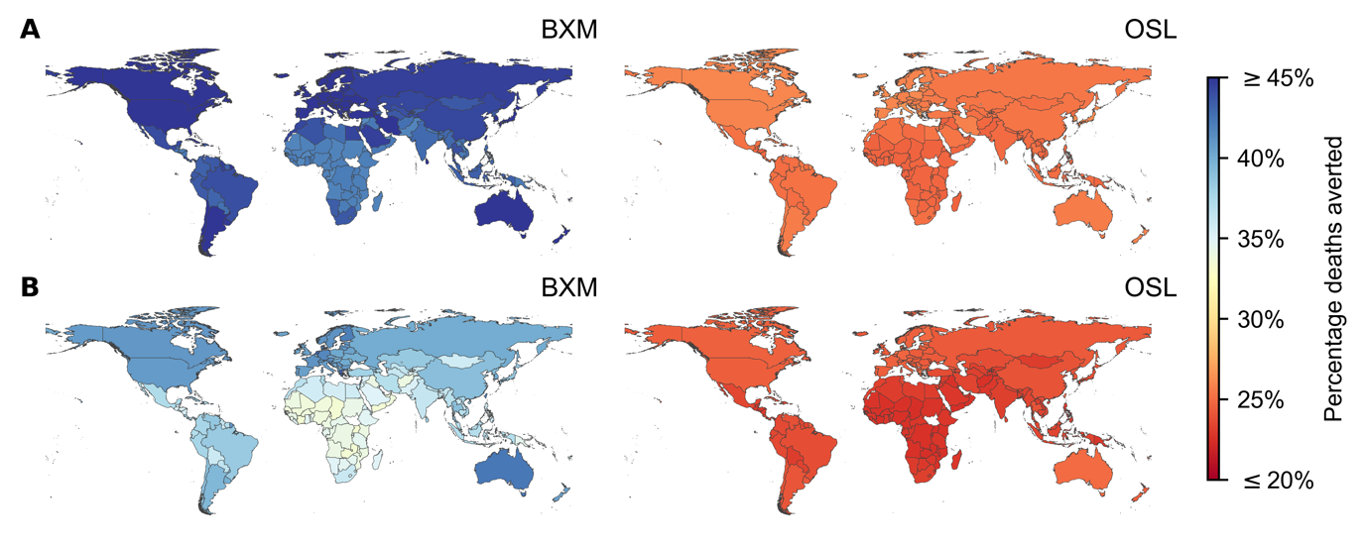

**Figure 1: Mean percentage deaths averted by test-and-treat with oral antivirals in 186 countries under idealized assumptions**. Baloxavir marboxil (BXM; left column) or oseltamivir (OSL; right column) was administered to all individuals that were positively diagnosed, using a rapid test with 70% test sensitivity, within two days of symptom onset. All symptomatic individuals were assumed to have sought testing within one day after symptom onset on average. Distribution of oral antivirals for treatment began one week after the pandemic was initiated in the country with ten infections. (**A**) 1918 A/H1N1 pandemic (=2.0). (**B**) Hypothetical influenza pandemic with COVID-19-like disease burden (=3.0) but generation interval akin to seasonal influenza viruses.

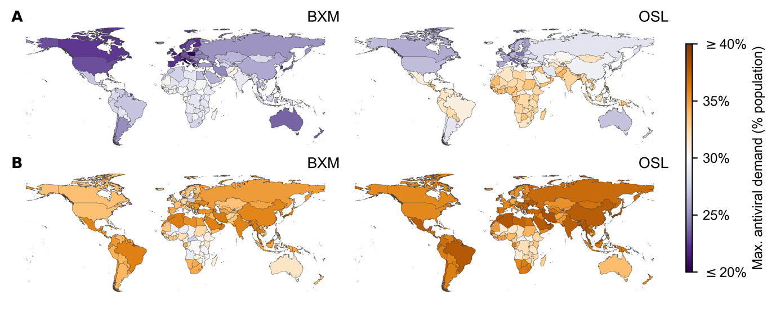

**Figure 2: Maximum treatment oral antiviral demand of 186 countries under idealized assumptions**. Baloxavir marboxil (BXM; left column) or oseltamivir (OSL; right column) was administered to all individuals that were positively diagnosed, using a rapid test with 70% test sensitivity, within two days of symptom onset. All symptomatic individuals were assumed to have sought testing within one day after symptom onset on average. Distribution of oral antivirals for treatment began one week after the pandemic was initiated in the country with ten infections. (**A**) 1918 A/H1N1 pandemic (=2.0). (**B**) Hypothetical influenza pandemic with COVID-19-like disease burden (=3.0) but generation interval akin to seasonal influenza viruses.

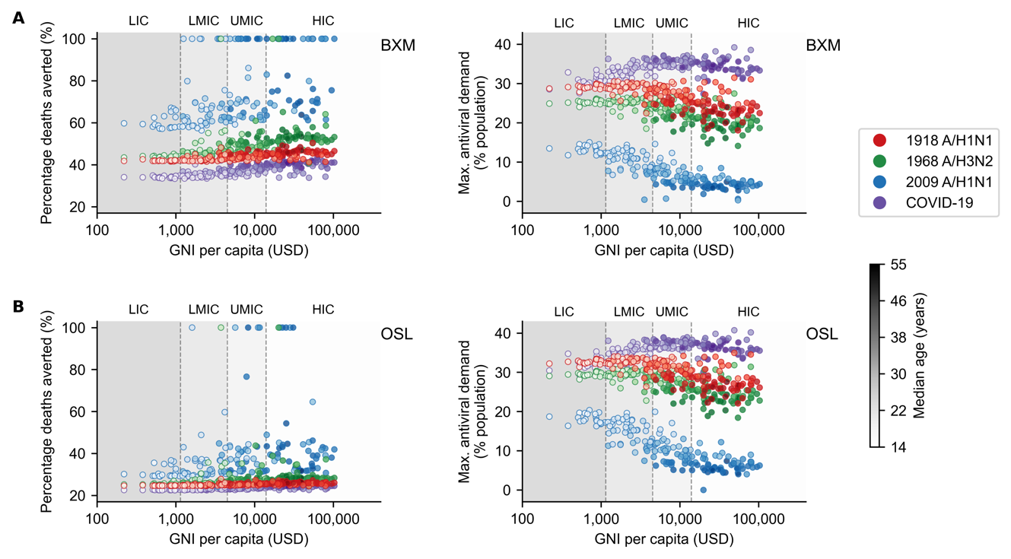

**Figure 3: Demographic and economic covariates to treatment oral antiviral demand and impact**. Mean percentage deaths averted (left column) and maximum treatment oral antiviral demand (right column) for each country (circle, shading denotes median age of country’s population) under different pandemic scenarios (denoted by color of circles; red, 1918 A/H1N1; green, 1968 A/H3N2; blue, 2009 A/H1N1; and purple, COVID-19-like) are plotted against their gross national income (GNI) per capita is US dollars (USD) in 2023. Background shading denotes the range of GNI per capita distinguishing between different country income groups as classified by the World Bank in 2024 (low income country, LIC; lower-middle income country, LMIC; upper-middle income country, UMIC; and high income country, HIC). Antiviral drugs were administered to all individuals that were positively diagnosed, using a rapid test with 70% test sensitivity, within two days of symptom onset. All symptomatic individuals were assumed to have sought testing within one day after symptom onset on average. Distribution of oral antivirals for treatment began one week after the pandemic was initiated in the country with ten infections. (**A**) Baloxavir marboxil. (**B**) Oseltamivir.

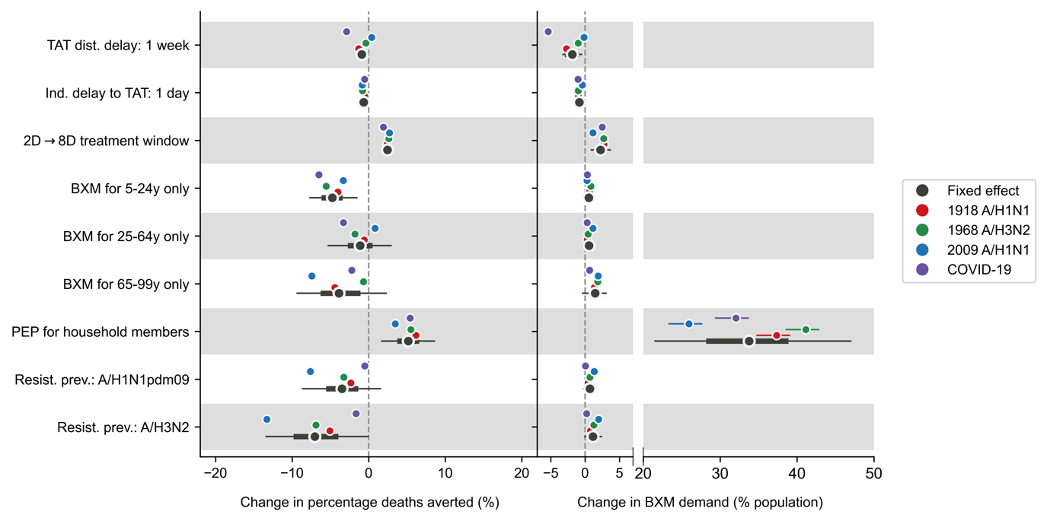

**Figure 4: Joint effects of treatment delays, distribution strategies, post-exposure prophylaxis and antiviral resistance on mean percentage deaths averted and baloxavir marboxil (BXM) demand**. Relative to the idealized scenario (i.e. antivirals are swiftly distributed to patients across the country one week after the first infection in the country, with no limits on access and availability of tests and antivirals; >95% of all symptomatic individuals are treated within two days after symptom onset if positively diagnosed by a rapid diagnostic test; No emergence and spread of BXM-resistant viruses), mean posterior changes in mean percentage deaths averted (left plot) and BXM demand (right plot) across pandemics and countries are plotted as black circles (i.e. fixed effects) while the thick and thin lines denote the corresponding 67% and 95% highest posterior density intervals respectively. The corresponding pandemic scenario-adjusted posterior effects are plotted alongside (posterior mean and 95% highest posterior density interval denoted by color of circle and line respectively; red, 1918 A/H1N1; green, 1968 A/H3N2; blue, 2009 A/H1N1; and purple, COVID-19-like).