**Supplementary Appendix: Estimating the global demand and potential public health impact of oral antiviral treatment stockpile for influenza pandemics: a mathematical modelling study**

Alvin X. Han, PhD1, Katina Hulme, PhD1, Colin A. Russell, PhD1

1Department of Medical Microbiology and Infection Prevention, Amsterdam University Medical Center, University of Amsterdam, Amsterdam, The Netherlands

Contents

Within-host model 2

Infectiousness estimates from within-host viral load 2

Between-host transmission model 3

Test and treat 4

Post-exposure prophylaxis 5

Hospitalization and deaths 6

Bayesian multilevel model 6

Supplementary Figures 7

Supplementary Tables 14

References 16

# Within-host model

We used a within-host model to estimate the replication dynamics of the inoculating treatment-susceptible virus and treatment-resistant mutant virus since infection, as well as the effectiveness of antiviral treatment to suppress treatment-susceptible virus replication ():

|  |  |
| --- | --- |
|  |  |
|  |  |
|  |  |
|  |  |
|  |  |
|  |  |

where , , , , , and are the respective number of uninfected target cells, the number of cells that enter an antiviral state in which they are refractory to infection, the number of cells infected by the wild-type virus, the number of cells infected by the antiviral-resistant mutant virus, the level of interferon response, the amount of free wild-type and mutant viruses. The parameters , , , , , , , and refer to the respective target cell infection rate by variant virus , interferon-induced antiviral efficacy, reversion rate from antiviral state, virus-induced infected cell death rate, interferon-induced infected cell death rate, production rate of interferons, decay rate of interferons, replication rate and free virus death rate of variant virus respectively. when and after the antiviral was administered at time , and is otherwise zero.

We fitted the within-host model to viral load data measured since initiation of different treatment regimens (i.e. placebo, baloxavir marboxil (BXM) or oseltamivir) with and without the emergence of BXM-resistant viruses from a phase 3 clinical trial (CAPSTONE-1).1,2 For the BXM-resistance, the rebound in viral load was dominated by BXM-resistant virions based on the estimated within-host mutation frequencies.1 To fit the model, first, we fitted pooled data of the time of symptom onset since influenza virus infection to a lognormal distribution (i.e. mean = 0.35, standard deviation = 0.41; Figure S5A).3 Second, we fitted the time of treatment initiation since symptom onset reported in the clinical trial to a Gamma distribution (i.e. placebo, shape = 2.91, scale = 8.31; BXM, shape = 2.40, scale = 10.12; oseltamivir, shape = 2.87, scale = 8.53; Figure S5B-D). We then simulated the number of individuals assigned to each treatment regime as per the CAPSTONE-1 trial (i.e. 210, 427 and 377 individuals administered with a course of placebo, BXM and oseltamivir respectively;2 34 individuals with treatment-emergent BXM-resistant mutant viruses),1 randomly drawing the time of symptom onset and treatment initiation from the aforementioned fitted distributions. The CAPSTONE-1 trial reported the viral load distribution of participants in different treatment regimen each day for 7 days since treatment initiation.2 In turn, we randomly generated the timing when viral samples were collected for each individual assuming a uniform distribution within a 12-hour collection time window each day. We then fitted the within-host model to the viral load dynamics simulated individuals, estimating all parameters except for the initial uninfected target () and infected () cell populations which were assumed to be and 0 cells respectively.4 We used differential evolution to iteratively search for parameter values that maximize the joint Gaussian likelihood of the viral load data reported in the CAPSTONE-1 trial2 and in Uehara et al (Figure S6).1

## Infectiousness estimates from within-host viral load

To correlate within-host viral dynamics to infectiousness,5 we explored three different models that were previously applied to respiratory viral pathogens to estimate infectiousness () from the simulated viral load () at time :

|  |  |  |
| --- | --- | --- |
| Hill equation4,6 | where is the viral load value leading to 50% infectiousness and is the Hill coefficient. |  |
| Logit function7 | where and are the transmission coefficient and baseline log-odds respectively. |  |
| Logarithmic function8 | where is the scaling factor. |  |

Assuming that treatment with BXM within two days of symptom onset leads to 29% reduction in infectiousness by five days post-treatment as reported in the phase 3 CENTERSTONE trial,9 we applied each infectiousness model to the infectious viral load trajectory of BXM treatment as estimated by our within-host model (Figure S6) and fitted the parameters by differential evolution. We then applied the best-fit parameters to the within-host and infectiousness models to estimate the infectiousness of infected individuals who were treated at different times during the course of their infection as a result of differences in time to symptom onset since infection, delays in treatment since symptom onset and whether or not resistant mutant viruses emerge after treatment.

We find negligible difference (<10% in total incidence) between all three infectiousness models when combined with the between-host transmission model (see below) to estimate population transmission dynamics (Figure S7).

# Between-host transmission model

We developed a discrete-time (i.e. timestep of one day), multi-type renewal process equation model to compute between-hosts transmissions over time to individuals with different susceptibility, contact rates and infectiousness profile. Assuming that the population is stratified into age groups and that *infected* individuals are further distinguished by their diagnosis status and infectiousness profile , the mean incidence for individuals in group on day is modelled as:

|  |  |
| --- | --- |
|  |  |

where is mean number of secondary infections in age group caused by an infector in age group with infectiousness profile on day with the boolean status indicating if their infection is identified either by testing or contact tracing; is the number of infected individuals in age group with infectiousness profile on day with status ; and is the discretized, normalised infectiousness profile and only depends on profile , given by:

|  |  |
| --- | --- |
|  |  |

where . Note that denotes the untreated infectiousness profile.

Given the limited evidence that BXM resistant mutations may be fitter or less fit than their wild-type BXM-sensitive counterparts,10–12 we assumed that there is no difference in either within-host viral replication fitness or between-host transmission advantage between the drug-sensitive and resistant virus. In turn, for individuals who are infected by the drug-resistant variant virus, their infectiousness profiles are similar computed by equation 11 for the untreated infectiousness profile. For individuals who are infected by the drug-sensitive virus but later developed treatment-emergent resistance, given that influenza virus transmission bottleneck is likely tight such that either one variant is transmitted upon an infectious contact,13 we adjusted the infectiousness profiles of the drug-sensitive () and resistant () viruses such that:

|  |  |
| --- | --- |
|  |  |

depends on the remaining number of susceptible individuals in age group on day ( where is the number of individuals of age group in the simulated population), the number of susceptible individuals in age group who were administered antivirals as post-exposure prophylaxis days ago () that reduces the likelihood of infection by over a time period of days (i.e. ), the relative risk of infection of susceptible individuals in age group by infected individuals belonging to age group (assumed to be constant over time) and the impact of infectiousness profile on mean infectious period:

|  |  |
| --- | --- |
|  |  |

where is the basic reproduction number of the simulated pandemic scenario.

Infected individuals with different infectiousness profile change their mean infectiousness by a factor given by:

|  |  |
| --- | --- |
|  |  |

where is the unnormalized infectiousness of profile that was computed by either one of the viral load-to-infectiousness models (i.e. equations (7) – (9)).

is the normalized relative risk matrix given by:

|  |  |
| --- | --- |
|  |  |

where is the mean contact rate matrix between individuals in age group and individuals in age group , is the relative susceptibility of individuals in age group , with the most susceptible group having a value of 1 and is the spectral radius of . We used country-specific estimates of from Prem et al.14,15 and estimates of for seasonal influenza,16 2009 A/H1N1 pandemic17 and COVID-19 pandemic18 from various sources. For the 1918 A/H1N1 and 1968 A/H3N2 pandemics, we assumed for all age groups.

## Test and treat

The probability that an infected individual is tested at time since infection can be formulated as:19

|  |  |
| --- | --- |
|  |  |

where is the probability of symptom onset on day since infection and is probability of symptomatic testing on day since symptom onset. can be less than one and is equal to the probability of a symptomatic infection: where is expected probability of asymptomatic infection which we assumed to 16% for influenza infections.20 On the other hand, is equal to the willingness of testing provided that all individuals who seek testing will be tested which can also be less than one. In turn, the expected number of infected individuals that are positively diagnosed at time is:

|  |  |
| --- | --- |
|  |  |

where is the sensitivity of the diagnostic test.

In the discrete form, assuming that is the same for all age groups, the expected number of infected individuals of age group with infection age of days that are positively tested on day is therefore:

|  |  |
| --- | --- |
|  |  |

We assumed the ideal scenario where rapid diagnostic tests are used, with no delay in obtaining results after testing, and are widely available and accessible to the whole population (i.e. no shortages).

Infected individuals that test positive may then be given antiviral that will change their infectiousness profile depending on the infection age when the antiviral was administered and whether or not the individual adhered to the treatment regime. The number of test-and-treated individuals () of age group with infection age of days who are treated is then:

|  |  |
| --- | --- |
|  |  |

We also assumed that there is no delay in administration of antivirals upon receiving testing results (i.e. testing and drug administration occurs during the same clinical visit).

## Post-exposure prophylaxis

Besides symptomatic testing, contacts of positively-tested individuals may be contact traced and be given antivirals as a post-exposure prophylaxis which has been shown to be effective at reducing transmission risk.21,22

We focused on forward contact tracing: exposed contacts were identified by contact tracing after an index case was positively diagnosed.23 The number of individuals of age group that are traced on day () depends on the probability that an index case with infection age was tested positive (, the number of infected individuals of age group with infection age was undiagnosed before day , the expected number of contacts that could be traced and the relative fraction of contacts in age group to index cases of age group ():

|  |  |
| --- | --- |
|  |  |

Our mathematical framework does not explicitly model the underlying contact networks among individuals. However, assuming that household contacts are the most convenient individuals that can be traced and be given post-exposure prophylaxis, we could approximate the impact of distributing antivirals to exposed household contacts by assuming as the mean number of household contacts based on estimates from the most recent United Nations World Population Prospects for that country.24 is inferred from country-specific estimates of mean contact rate matrix in households from Prem et al.14,15 The expected number of susceptible individuals of age group that are traced to be given post-exposure prophylaxis on day is then computed as:

|  |  |
| --- | --- |
|  |  |

In turn, the number of previously infected individuals of age group who are given post-exposure prophylaxis on day is equals to . We assumed that only undiagnosed and untreated infected individuals (i.e. ) were given post-exposure prophylaxis which would lower their infectiousness that similarly depended on the age of their infection when they were administered the drug. We assumed that post-exposure prophylaxis are distributed multinomially across individuals with infection age , employing the Sainte-Laguë apportionment method for integer allocation.

## Hospitalization and deaths

We assumed that the expected number of hospitalisations and deaths correlate with the number of infected individuals. The number of individuals in group that are hospitalized on day is:

|  |  |
| --- | --- |
|  |  |

where is the probability that symptomatic individuals in group are hospitalized.

Analogously, the number of deaths in group on day () is

|  |  |
| --- | --- |
|  |  |

where is the probability that symptomatic individuals in group that died.

Table S1 tabulates the parameters used in the between-host transmission model.

# Bayesian multilevel model

To determine the impact of delays to population distribution and individual treatment, different antiviral distribution strategies including extending the treatment window period since symptom onset, instituting age restrictions on access to treatment and providing prophylactic treatment to exposed contacts, as well as the spread of antiviral resistance, we used a Bayesian multilevel model that partially pooled simulation estimates of percentage of deaths averted by antiviral use and the amount of antivirals demand relative to population size for a range of the aforementioned factors across countries and pandemic scenarios. We assumed a linear correlation between the predicted mean-centered response variable () for pandemic in country and predictor variables :

|  |  |
| --- | --- |
|  |  |

where and are the respective normalized fixed, country- and pandemic-specific effects of predictor variable while , and are the corresponding fixed, country- and pandemic-specific intercepts. Following Gelman et al.,25 we used Student-*t* priors with three degrees of freedom, mean of zero and standard deviation (s.d.) of 2.5 for all effects (i.e. and ) while normal priors with mean of zero and s.d. of one were placed for intercepts ( and ). Half-normal priors with mean of zero and s.d. of one were used for all standard deviations of effects, intercepts and residuals. For correlation between country- and pandemic-level effects, we used the Lewandowski-Kurowicka-Joe correlation prior with shape parameter of one. Posterior sampling was performed using four MCMC chains, with 1000-iteration burn-in and 1000-iteration of saved posterior samples, using a no-u-turn sampler implemented in the ‘brms’ package26 in R.27 Chain convergence was determined by checking traceplots, ensuring all Rhat values < 1.05 with sufficient effective sample size (>200).

# Supplementary Figures

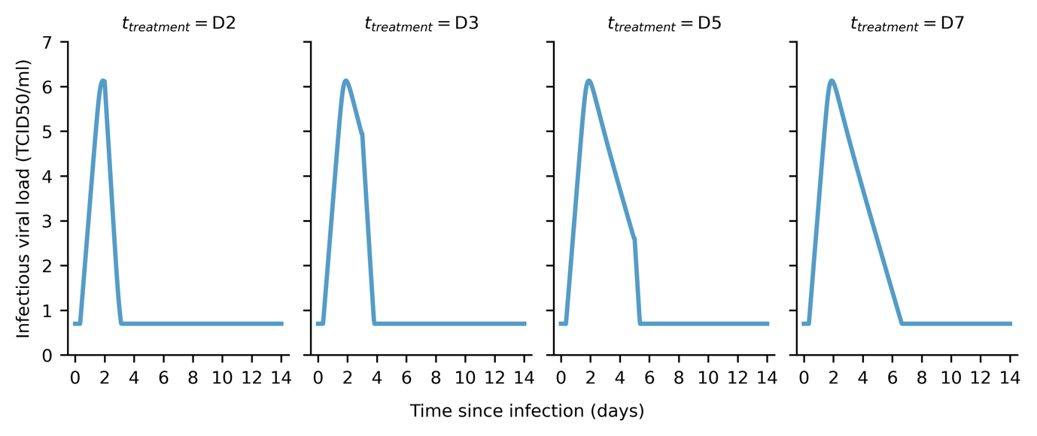

**Figure S1: Estimated infectiousness viral load when treated with baloxavir marboxil at different days since infection ().** Maximum-likelihood within-host viral load trajectories estimated by our within-host model.

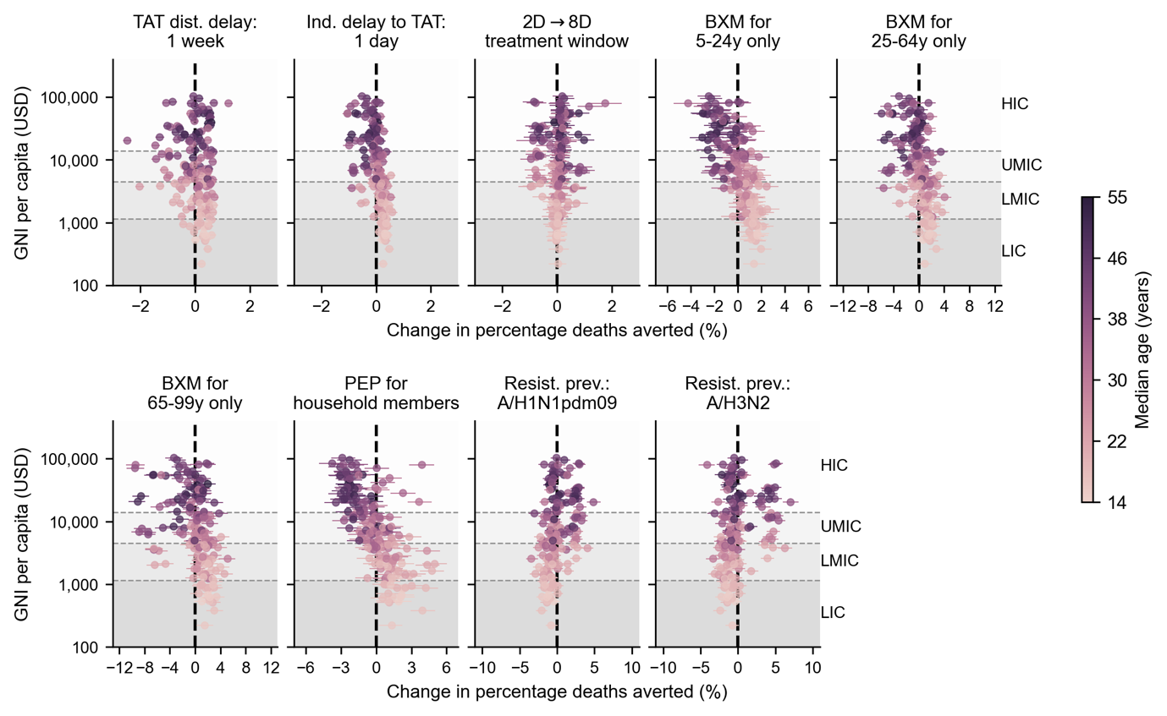

**Figure S2: Country-level effects of treatment delays, distribution strategies, post-exposure prophylaxis and antiviral resistance on mean percentage deaths averted by baloxavir marboxil (BXM) distribution**. Relative to the idealized scenario (i.e. BXM are swiftly distributed to patients across the country one week after the first infection in the country, with no limits on access and availability of tests and antivirals; >95% of all symptomatic individuals are treated within two days after symptom onset if positively diagnosed by a rapid diagnostic test; no emergence and spread of BXM-resistant viruses), mean changes in mean percentage deaths averted due to country-level effects (each circle and line denotes the posterior mean and 95% highest posterior density interval estimated for each country, shading denotes median age of country’s population) are plotted against countries’ gross national income (GNI) per capita is US dollars (USD) in 2023. Background shading denotes the range of GNI per capita distinguishing between different country income groups as classified by the World Bank in 2024 (low income country, LIC; lower-middle income country, LMIC; upper-middle income country, UMIC; and high income country, HIC).

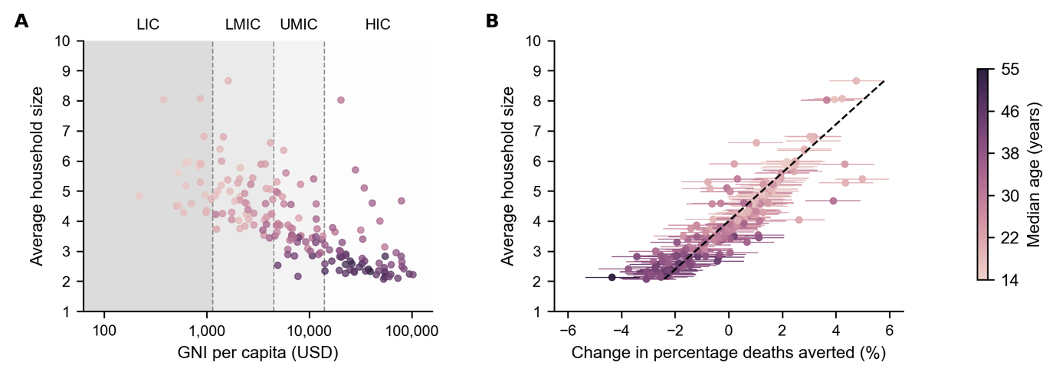

**Figure S3: Correlation between mean household size and country-level effect on mean percentage deaths averted by distributing baloxavir marboxil (BXM) as post-exposure prophylaxis to household members**. (**A**) Mean household size of each country24 (circle, shading denotes median age of country’s population) plotted against their gross national income (GNI) per capita is US dollars (USD) in 2023. Background shading denotes the range of GNI per capita distinguishing between different country income groups as classified by the World Bank in 2024 (low income country, LIC; lower-middle income country, LMIC; upper-middle income country, UMIC; and high income country, HIC). (**B**) Mean household size of each country (circle, shading denotes median age of country’s population) plotted against mean changes in mean percentage deaths averted due to country-level effects (each circle and line denotes the posterior mean and 95% highest posterior density interval estimated for each country, shading denotes median age of country’s population). Dash line denotes the best-fit linear regression line ().

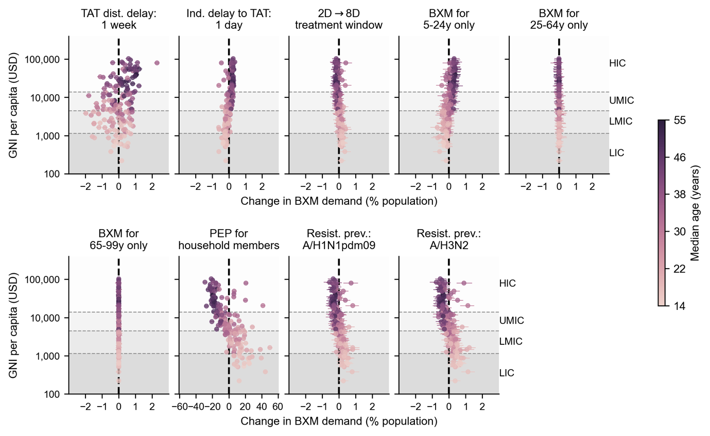

**Figure S4: Country-level effects of treatment delays, distribution strategies, post-exposure prophylaxis and antiviral resistance on mean baloxavir marboxil (BXM) demand**. Relative to the idealized scenario (i.e. BXM are swiftly distributed to patients across the country one week after the first infection in the country, with no limits on access and availability of tests and antivirals; >95% of all symptomatic individuals are treated within two days after symptom onset if positively diagnosed by a rapid diagnostic test; no emergence and spread of BXM-resistant viruses), mean changes in BXM demand due to country-level effects (each circle and line denotes the posterior mean and 95% highest posterior density interval estimated for each country, shading denotes median age of country’s population) are plotted against countries’ gross national income (GNI) per capita is US dollars (USD) in 2023. Background shading denotes the range of GNI per capita distinguishing between different country income groups as classified by the World Bank in 2024 (low income country, LIC; lower-middle income country, LMIC; upper-middle income country, UMIC; and high income country, HIC).

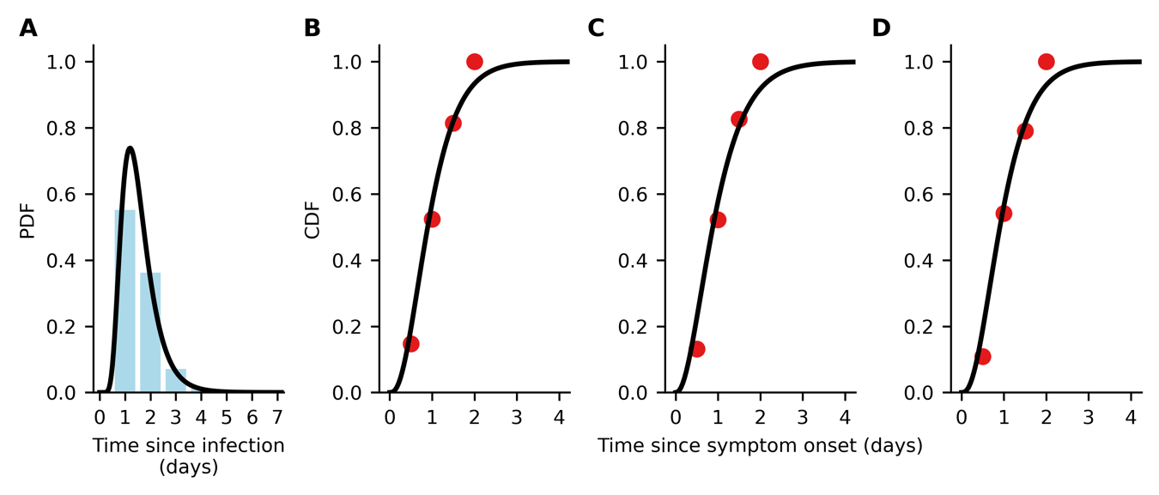

**Figure S5: Data fitting for time to symptom onset since infection and time to treatment administration since symptom onset.** (**A**) Continuous (black line) and discrete (blue bars) probability distribution function (PDF) of lognormal distribution fit to pooled data of the time of symptom onset since influenza virus infection as reported in Lessler et al.3 (**B-D**) Continuous (black line) cumulative distribution function of gamma distribution fit to time of treatment initiation since symptom onset in the phase 3 clinical trial of baloxavir marboxil (red circles);1,2 (**B**) placebo, (**C**) baloxavir marboxil, and (**D**) oseltamivir.

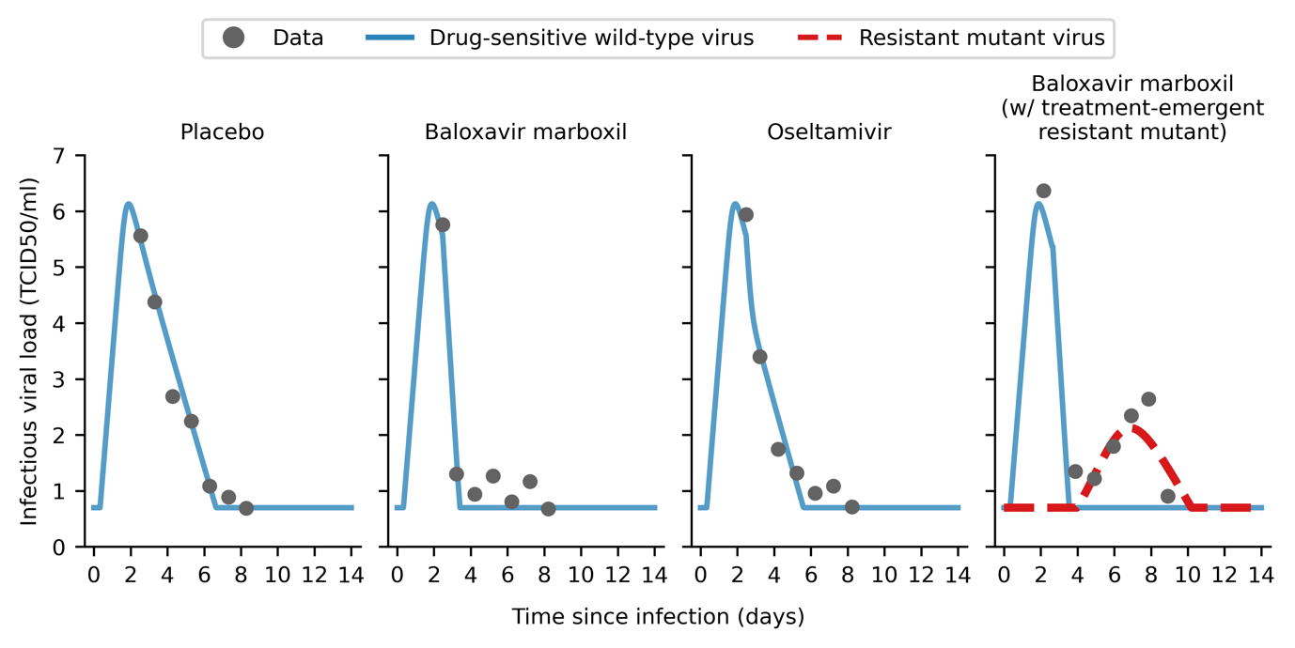

**Figure S6: Within-host viral load model fitted to clinical trial data.** Maximum-likelihood within-host viral load trajectories for drug-sensitive wild type (blue solid line) and drug-resistant mutant (red dashed line) viruses by fitting to mean viral load data (gray circles) obtained in the phase 3 clinical trial of baloxavir marboxil.1,2

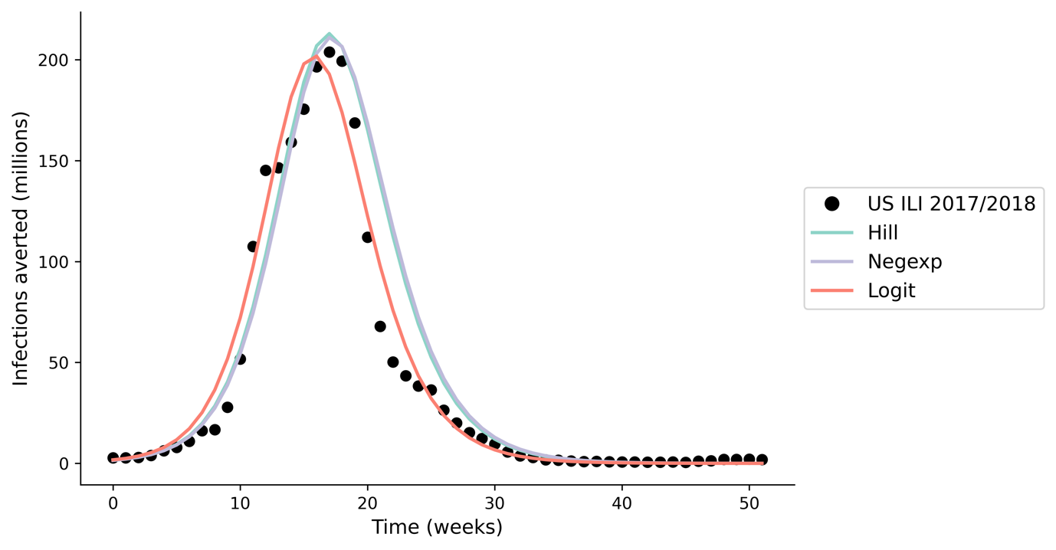

**Figure S7: Model validation; estimated incidence using our multiscale modelling approach when applying different within-host viral load to infectiousness correlative models.** We compared the output of our multiscale model, applying seasonal influenza parameters16 to estimate the incidence during the 2017/2018 influenza season ()28 in the United States (US), against reported influenza-like (ILI) data (<https://www.cdc.gov/flu/weekly/fluviewinteractive.htm>; black circles). We find minimal difference in total incidence (<10% difference) when applying different within-host viral load to infectiousness correlative models (differently colored lines).

# Supplementary Tables

**Table S1. Parameters used in between-host transmission model.**

|  |  |  |
| --- | --- | --- |
| **Parameter** | **Value** | **Source** |
| Effectiveness in lowering infection likelihood by baloxavir marboxil (BXM) as post-exposure prophylaxis (PEP) () | 0.57 | Ikematsu et al., 202021 |
| Protective period of BXM as PEP in days () | 10 |  |
| *Relative susceptibility to infection by age ()* | | |
| 1918 A/H1N1, 0-99 years | 1.00 | Assumed |
| 1968 A/H3N2, 0-99 years | 1.00 | Assumed |
| 2009 A/H1N1, 0-19 years | 1.00 | Cauchemez et al., 200917 |
| 2009 A/H1N1, 20-64 years | 0.510 |
| 2009 A/H1N1, 65-99 years | 0.087 |
| COVID-19, 0-14 years | 0.231 | Zhang et al., 202018 |
| COVID-19, 15-64 years | 0.680 |
| COVID-19, 65-99 years | 1.00 |
| *Case fatality rate by age ()* | | |
| 1918 A/H1N1, 0-4 years | 0.01867 | By fitting W-shape mortality curve reported in 29,30 |
| 1918 A/H1N1, 5-14 years | 0.00201 |
| 1918 A/H1N1, 15-24 years | 0.00719 |
| 1918 A/H1N1, 25-34 years | 0.01327 |
| 1918 A/H1N1, 35-44 years | 0.00716 |
| 1918 A/H1N1, 45-54 years | 0.00512 |
| 1918 A/H1N1, 55-64 years | 0.00943 |
| 1918 A/H1N1, 65-74 years | 0.03005 |
| 1918 A/H1N1, 75-84 years | 0.05380 |
| 1918 A/H1N1, 85-99 years | 0.04155 |
| 1968 A/H3N2, 0-4 years | 0.0011824 | By fitting U-shape mortality curve reported in 29,30 |
| 1968 A/H3N2, 5-14 years | 0.0000240 |
| 1968 A/H3N2, 15-24 years | 0.0000410 |
| 1968 A/H3N2, 25-34 years | 0.0000601 |
| 1968 A/H3N2, 35-44 years | 0.0001298 |
| 1968 A/H3N2, 45-54 years | 0.0003386 |
| 1968 A/H3N2, 55-64 years | 0.0012583 |
| 1968 A/H3N2, 65-74 years | 0.0061872 |
| 1968 A/H3N2, 75-84 years | 0.0187919 |
| 1968 A/H3N2, 85-99 years | 0.0252286 |
| 2009 A/H1N1, 0-19 years | 0.00005 | Dawood et al., 201231 |
| 2009 A/H1N1, 20-64 years | 0.00029 |
| 2009 A/H1N1, 65-99 years | 0.00124 |
| COVID-19, 0-9 years | 0.001 | Zhang et al., Verity et al, 202018,32 |
| COVID-19, 10-19 years | 0.003 |
| COVID-19, 20-29 years | 0.012 |
| COVID-19, 30-39 years | 0.032 |
| COVID-19, 40-49 years | 0.049 |
| COVID-19, 50-59 years | 0.102 |
| COVID-19, 60-69 years | 0.166 |
| COVID-19, 70-79 years | 0.243 |
| COVID-19, 80-99 years | 0.273 |
| *Basic reproduction number ()* |  |  |
| 1918 A/H1N1 | 2.0 | Biggerstaff et al., 201433 |
| 1968 A/H3N2 | 1.8 |
| 2009 A/H1N1 | 1.5 |
| COVID-19 | 3.0 | Zhao et al., 202034 |
| Probability of asymptomatic infection () | 0.16 | Leung et al., 201520 |
| Sensitivity of diagnostic test () | 0.70 | Merckx et al., 201735 |
| Adherence to treatment, BXM | 0.95 | Assumed |
| Adherence to treatment, oseltamivir | 0.65 | Smith et al., 201636 |

**Table S2. Mean deaths averted by test-and-treat with oral antivirals (baloxavir marboxil (BXM) or oseltamivir (OSL), and the corresponding antiviral and rapid testing demand in 186 countries under idealized assumptions.**  [Supplementary file]

# References

1 Uehara T, Hayden FG, Kawaguchi K, *et al.* Treatment-Emergent Influenza Variant Viruses With Reduced Baloxavir Susceptibility: Impact on Clinical and Virologic Outcomes in Uncomplicated Influenza. *J Infect Dis* 2020; **221**: 346–55.

2 Hayden Frederick G., Sugaya Norio, Hirotsu Nobuo, *et al.* Baloxavir Marboxil for Uncomplicated Influenza in Adults and Adolescents. *N Engl J Med* 2018; **379**: 913–23.

3 Lessler J, Reich NG, Brookmeyer R, Perl TM, Nelson KE, Cummings DA. Incubation periods of acute respiratory viral infections: a systematic review. *Lancet Infect Dis* 2009; **9**: 291–300.

4 Handel A, Longini IM Jr, Antia R. Neuraminidase Inhibitor Resistance in Influenza: Assessing the Danger of Its Generation and Spread. *PLOS Comput Biol* 2007; **3**: e240.

5 Handel A, Rohani P. Crossing the scale from within-host infection dynamics to between-host transmission fitness: a discussion of current assumptions and knowledge. *Philos Trans R Soc B Biol Sci* 2015; **370**: 20140302.

6 Goyal A, Reeves DB, Cardozo-Ojeda EF, Schiffer JT, Mayer BT. Viral load and contact heterogeneity predict SARS-CoV-2 transmission and super-spreading events. *eLife* 2021; **10**: e63537.

7 Marc A, Kerioui M, Blanquart F, *et al.* Quantifying the relationship between SARS-CoV-2 viral load and infectiousness. *eLife* 2021; **10**: e69302.

8 Lange A, Ferguson NM. Antigenic Diversity, Transmission Mechanisms, and the Evolution of Pathogens. *PLOS Comput Biol* 2009; **5**: e1000536.

9 Cowling BJ. Phase III CENTERSTONE trial of single-dose baloxavir marboxil for the reduction of transmission of influenza in households. 2024; published online Sept 29. https://medically.roche.com/content/dam/pdmahub/restricted/infectious-disease/options-xii-2024/Options-XII-2024-presentation-monto-phase-III-CENTERSTONE-study-of-single-dose.pdf.

10 Checkmahomed L, M’hamdi Z, Carbonneau J, *et al.* Impact of the Baloxavir-Resistant Polymerase Acid I38T Substitution on the Fitness of Contemporary Influenza A(H1N1)pdm09 and A(H3N2) Strains. *J Infect Dis* 2020; **221**: 63–70.

11 Jones JC, Zagribelnyy B, Pascua PNQ, *et al.* Influenza A virus polymerase acidic protein E23G/K substitutions weaken key baloxavir drug-binding contacts with minimal impact on replication and transmission. *PLOS Pathog* 2022; **18**: e1010698.

12 Hickerson Brady T., Petrovskaya Svetlana N., Dickensheets Harold, Donnelly Raymond P., Ince William L., Ilyushina Natalia A. Impact of Baloxavir Resistance-Associated Substitutions on Influenza Virus Growth and Drug Susceptibility. *J Virol* 2023; **97**: e00154-23.

13 Morris DH, Petrova VN, Rossine FW, *et al.* Asynchrony between virus diversity and antibody selection limits influenza virus evolution. *eLife* 2020; **9**: e62105.

14 Prem K, Cook AR, Jit M. Projecting social contact matrices in 152 countries using contact surveys and demographic data. *PLOS Comput Biol* 2017; **13**: e1005697.

15 Prem K, Zandvoort K van, Klepac P, *et al.* Projecting contact matrices in 177 geographical regions: An update and comparison with empirical data for the COVID-19 era. *PLOS Comput Biol* 2021; **17**: e1009098.

16 Brugger J, Althaus CL. Transmission of and susceptibility to seasonal influenza in Switzerland from 2003 to 2015. *Epidemics* 2020; **30**: 100373.

17 Cauchemez Simon, Donnelly Christl A., Reed Carrie, *et al.* Household Transmission of 2009 Pandemic Influenza A (H1N1) Virus in the United States. *N Engl J Med* 2009; **361**: 2619–27.

18 Zhang J, Litvinova M, Liang Y, *et al.* Changes in contact patterns shape the dynamics of the COVID-19 outbreak in China. *Science* 2020; **368**: 1481–6.

19 Oliver Eales, James M. McCaw, Freya M. Shearer. Challenges in the case-based surveillance of infectious diseases. *medRxiv* 2023; : 2023.12.19.23300224.

20 Leung NHL, Xu C, Ip DKM, Cowling BJ. Review Article: The Fraction of Influenza Virus Infections That Are Asymptomatic: A Systematic Review and Meta-analysis. *Epidemiology* 2015; **26**. https://journals.lww.com/epidem/fulltext/2015/11000/review_article__the_fraction_of_influenza_virus.13.aspx.

21 Ikematsu Hideyuki, Hayden Frederick G., Kawaguchi Keiko, *et al.* Baloxavir Marboxil for Prophylaxis against Influenza in Household Contacts. *N Engl J Med* 2020; **383**: 309–20.

22 Zhao Y, Gao Y, Guyatt G, *et al.* Antivirals for post-exposure prophylaxis of influenza: a systematic review and network meta-analysis. *The Lancet* 2024; **404**: 764–72.

23 Scarabel F, Pellis L, Ogden NH, Wu J. A renewal equation model to assess roles and limitations of contact tracing for disease outbreak control. *R Soc Open Sci* 2021; **8**: 202091.

24 United Nations. World Population Prospects. 2024. https://population.un.org/wpp/ (accessed Jan 6, 2025).

25 Andrew Gelman, Aleks Jakulin, Maria Grazia Pittau, Yu-Sung Su. A weakly informative default prior distribution for logistic and other regression models. *Ann Appl Stat* 2008; **2**: 1360–83.

26 Bürkner P-C. brms: An R Package for Bayesian Multilevel Models Using Stan. *J Stat Softw* 2017; **80**: 1–28.

27 Core Team R. R: A Language and Environment for Statistical Computing. 2024. https://www.R-project.org/.

28 Du Z, Nugent C, Galvani AP, Krug RM, Meyers LA. Modeling mitigation of influenza epidemics by baloxavir. *Nat Commun* 2020; **11**: 2750.

29 Luk J, Gross P, Thompson WW. Observations on Mortality during the 1918 Influenza Pandemic. *Clin Infect Dis* 2001; **33**: 1375–8.

30 Taubenberger J, Morens D. 1918 Influenza: the Mother of All Pandemics. *Emerg Infect Dis J* 2006; **12**: 15.

31 Dawood FS, Iuliano AD, Reed C, *et al.* Estimated global mortality associated with the first 12 months of 2009 pandemic influenza A H1N1 virus circulation: a modelling study. *Lancet Infect Dis* 2012; **12**: 687–95.

32 Verity R, Okell LC, Dorigatti I, *et al.* Estimates of the severity of coronavirus disease 2019: a model-based analysis. *Lancet Infect Dis* 2020; **20**: 669–77.

33 Biggerstaff M, Cauchemez S, Reed C, Gambhir M, Finelli L. Estimates of the reproduction number for seasonal, pandemic, and zoonotic influenza: a systematic review of the literature. *BMC Infect Dis* 2014; **14**: 480.

34 Zhao S, Lin Q, Ran J, *et al.* Preliminary estimation of the basic reproduction number of novel coronavirus (2019-nCoV) in China, from 2019 to 2020: A data-driven analysis in the early phase of the outbreak. *Int J Infect Dis* 2020; **92**: 214–7.

35 Merckx J, Wali R, Schiller I, *et al.* Diagnostic Accuracy of Novel and Traditional Rapid Tests for Influenza Infection Compared With Reverse Transcriptase Polymerase Chain Reaction. *Ann Intern Med* 2017; **167**: 394–409.

36 Smith LE, D’Antoni D, Jain V, Pearce JM, Weinman J, Rubin GJ. A systematic review of factors affecting intended and actual adherence with antiviral medication as treatment or prophylaxis in seasonal and pandemic flu. *Influenza Other Respir Viruses* 2016; **10**: 462–78.