Description of the problem

This coursework will focus on the accurate classification of object images within the cifar-10 image dataset, with this being defined as an accuracy rate of 80% or above correct class classifications across the test dataset used.
The following classes exist within the dataset provided, and will be used to perform class predictions on test data:

- airplane
- automobile
- bird
- cat
- deer
- dog
- frog
- horse
- ship
- truck

Although the dataset doesn’t contain strictly labelled attributes, each image is stored as a 32 element numpy array. Each element within the outer numpy array is another nested numpy array of size 32. using these outer and inner numpy arrays a matrix can be defined, with the outer numpy array representing the image y axis and each inner numpy array representing the image x axis.

Each pixel value entry contains 3 values within another nested numpy array, these values represent RBG values for the individual pixel.

This gives each image numpy array a shape of (32 (y axis pixel values) ,32 (x axis pixel values) ,3 (colour channels per pixel) ). This provides an attribute amount of 3 per pixel and 3072 per image (32 * 32 * 3)

The dataset was originally split into 50000 training images and 10000 test images. Within this coursework a validation dataset, taken from the pre-existing training set, is generated using 10000 training images.

The dataset split is 40000 training instances/66.7% training data, 10000 validation instances/16.7% validation data, 10000 testing instances 16.7% testing data.

When performing no further shuffling of the pre-shuffled training dataset values for the training and validation split, the following class instances appear across the datasets, this is shown in the dataframes below:

Training set
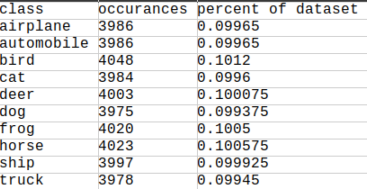

Validation set
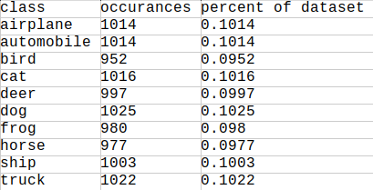

Testing set
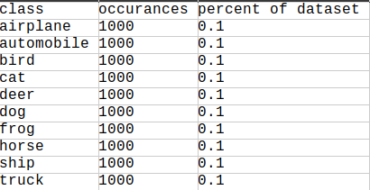

Analysis of the dataset statistics shows there are 6000 instances of each class across all datasets, while each dataset roughly contains 10% of its instances from each individual image class.

This is useful, as an even spread of data across datasets will:

- Allow accurate fitting of the model during training.
- Provide accurate evaluations of model performance during the training process to allow more effective trial and error tuning of model hyper-parameters.
- Provide precise insight into the performance of the complete model.

The dataset does not contain any missing values, as a dataset can’t contain a ‘missing’ image.

Constructing and tuning the supervised Machine Learning Model

The Keras deep learning library, a high level API for neural networks, was used to construct a CNN image classifier to address the problem. Tensorflow was used as the Keras backend machine learning framework.

The CNN constructed was initially composed of :

- an initial convolutional layer with 32 images filters and a filter shape / kernel size of (3,3)
- an activation function layer, used to extract non-linear data from feature maps
- A MaxPooling layer, used to reduce the complexity of feature maps
- Another convolution layer with 64 image filters and a filter shape of (3,3)
- Another activation layer, similar to the one used for the previous convolutional layer
- A flatten layer, used to flatten the pooled feature map matrices into 1 dimensional vectors
- a dense/fully connected layer, used to generate node connections.
- A final dense/fully connected layer, used to produce a CNN classification output.

RMSprop was the initial optimisation algorithm used for the network.

When using this initial network, with only pixel normalisation and a learning rate of 0.001 applied to the datasets , a classification accuracy of roughly 66% was achieved , which shows the model constructed achieves moderately successful classification accuracies with limited data , the loss was rather high however at around 4.73, which indicates the model was under-fitting on the training data provided. The model initally ran for 66 epochs/iterations. Results shown below.
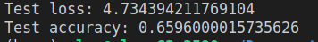

Tuning the model

Initially the learning rate was tuned further. This was due to it being the most important hyper-parameter to tune within a neural network[1]. The aim of this tuning was a resulting decrease in / better loss value and a improved/increased accuracy value.
The technique of using cyclical learning rates (CLRs) was used, due to its utilisation being found to improve classification accuracy, and reduce loss through lessened tuning and iteration requirements within neural networks[1].
This is explained by cyclical learning allowing networks to ‘break free’ from local minima areas, where areas of lower loss are not present[2].

An implementation of CLR on github [3] within the CNN model built.

Using the definition of iterations given by [4] and the formula shown in [2] a step size of 32 was used for cyclical learning within the model.

Initially, CLR resulted in a decreased classification accuracy of test data. Analysis of loss, an indication of the total errors made by a model, across datasets suggested the model was over-fitting to training data using the default learning rates of 0.001 to 0.006. A sample of these stats are shown below.

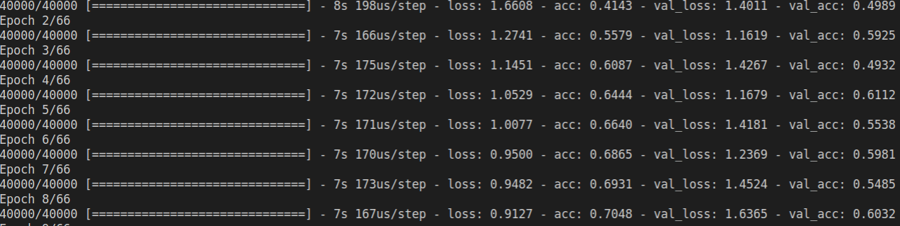

When reducing learning rates, to 0.0001 to 0.0006, over-fitting issues were reduced. Sample stats are shown below:

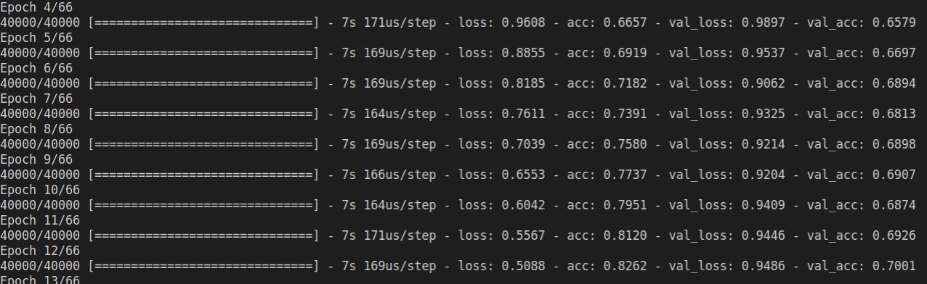

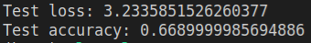

Through experimentation, it was decided that a learning rate of 0.000001 to 0.000009 should be used as a starting point to develop from. This did give a lower classification result of around 58%, however across training, testing and validation data, levels of loss were much lower and more similar. This suggested that the model was over-fitting on the training data to a much lesser extent. Example statistics below exemplify this when compared to the 0.0001 to 0.0006 statistics shown above.

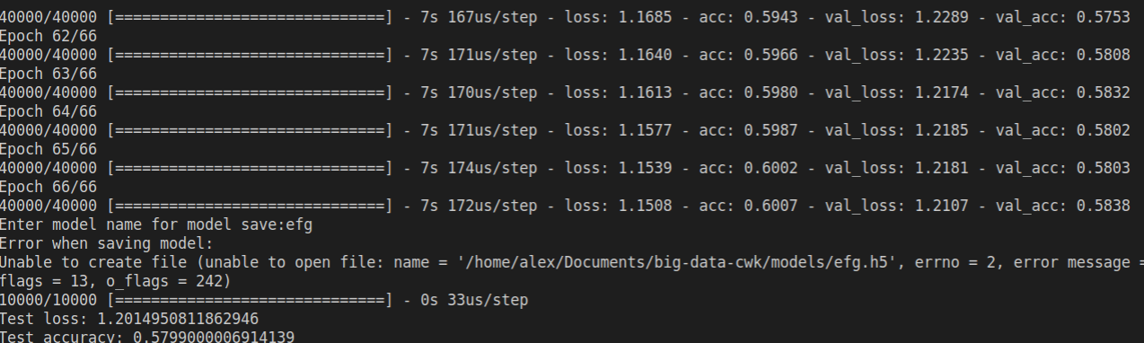
The low learning rates used did not seem to effectively extract important image features however. To achieve this 2 additional convolutional layers were added to the model. One with 64 image filters and one with 128 image filters. Epochs were also increased by a third to 88 to allow for better fitting on training data.

As the training progressed, it was found that the loss and accuracy between training and validation datasets began to increasingly diverge, This is shown below.

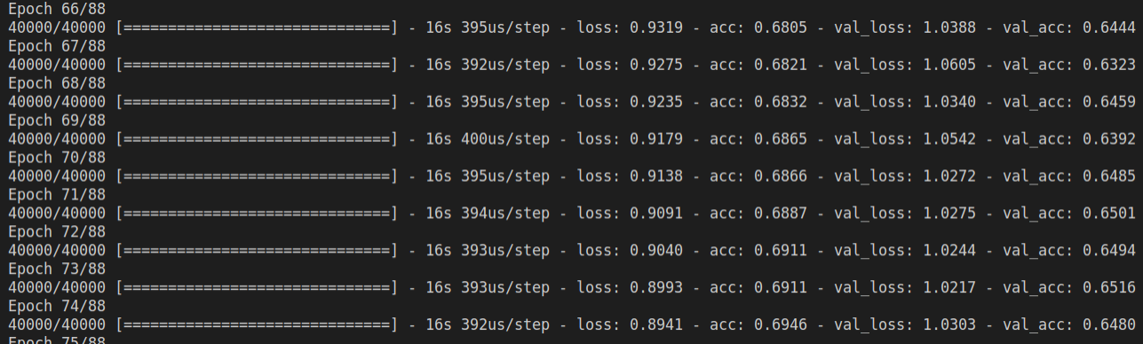

The training was stopped and max learning rate adjusted to 0.0005. The optimization algorithm was also switched from RMSprop to ADAM, due to its reduced need for greater amounts of training time vs other optimization algorithms.
This seemed to have a positive effect, although loss was increased, similar levels of loss were maintained across training, testing and validation sets, this is shown below.

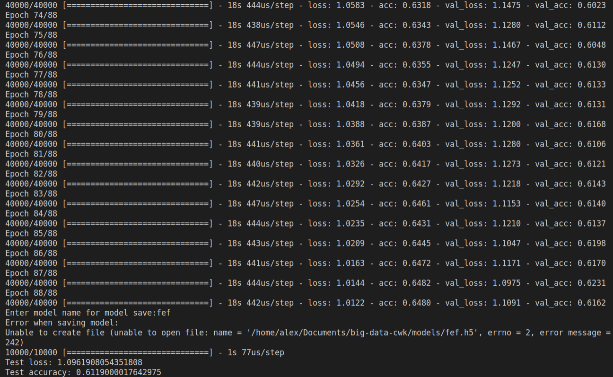
In an effort to improve feature learning while maintaining similar loss levels across datasets, the max learning rate was increased to 0.00014 while the base learning rate was reduced to 0.00001, in order to encourage a more gradual increase in classification results to help avoid overfitting. A dropout rate of 50% was also incorporated within the fully connected layer, this was due to dropouts ability to mitigate over-fitting on training data[6], due to reducing irrelevant features.
This proved effective, ‘dropping out’ 50% of the fully connected nodes improved classifications. This strengthened the hypothesis that the datasets contained many irrelevant features. This CNN model achieved an overall classification accuracy of ~74%, shown below, which was a ~9% increase from the starting model. A higher max learn rate did increase loss slightly, however loss was still much improved from the base model.
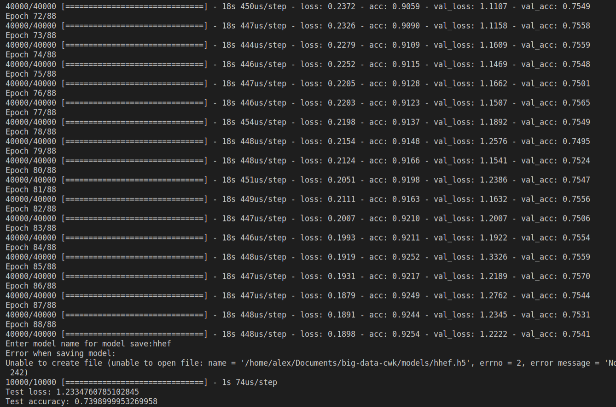
In an effort to improve loss and accuracy parity across datasets, dataset images were grey scaled, with the idea behind this being to remove potential variances introduced by pixel colour values. Code from a stack-overflow answer (answer2) [7] was used to perform this task.
Although classification accuracy reduced, loss values suggested the model was extraction much more relevant features. Classification accuracy and loss values maintained much closer parity for a longer period of time, an example of this is shown below.
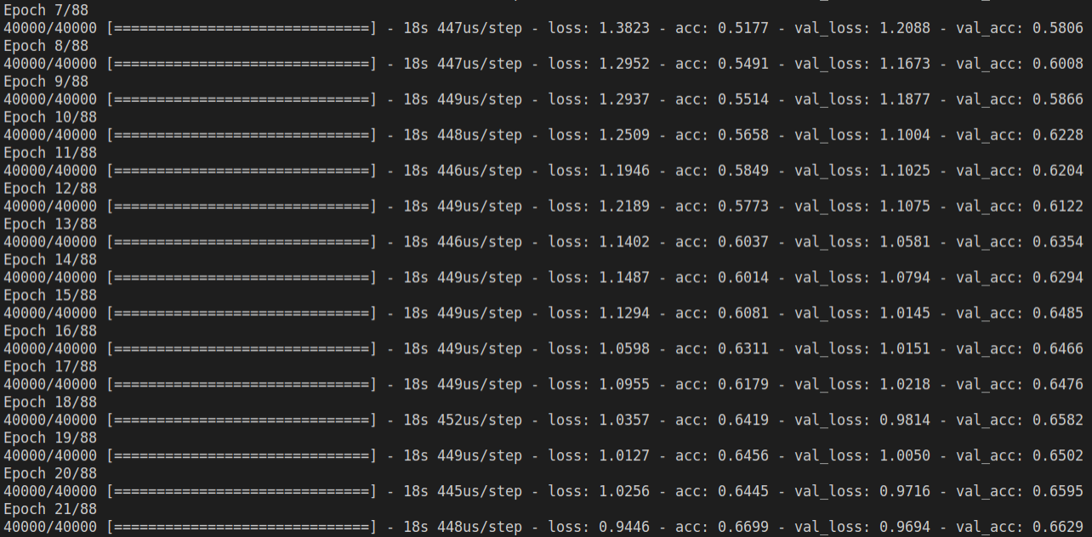

Eventual divergence of loss between training and validation datasets, with loss being lower on training data, suggested the CNN was still overfitting, so the max learning rate was reduced to 0.00008 and dropout increased to 60%

again, it was found that accuracy and loss maintained parity between test and validation sets for even longer, however still eventually diverged. In an effort to combat divergence, a regularizer was added after dropout was performed..

Initially it was decided that Ridge regression should be used. This is due to Lasso regression removing features completely[8]. The small size of the images and large dropout used suggested the amount of potential features to be extracted within images was limited.

However, loss and accuracy still diverged, suggesting the model was overfitting during training.
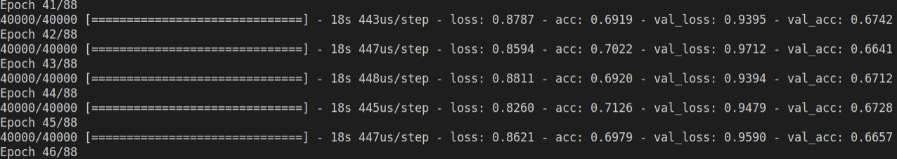
In an effort to overcome this, lasso regression was applied at an aggressive rate of 0.5.
lasso regression improved performance vs ridge regression. Its aggressive rate of application alongside a large dropout rate of 60% suggested that many irrelevant features existed within the dataset. A learning rate of base 0.00001 and 0.0006 was used in an attempt to overcome potential issue present in greatly limiting image features extracted. An accuracy of 73% was achieved.

The main issue present with this approach was that training results and validation results varied greatly. The continual max appearance of 73% also suggested the model was not able to extract features that were able to produce classification rates above this amount.

This could suggest that the model was relying too heavily on large feature variances extracted from max pooling, whilst also not extracting enough detailed image information. In an effort to combat this model complexity was experimented with and increased.

Model experimentation proved very successful. Although a moderate increase of 3%, to 76% accuracy, was found, variance between training loss, test loss and validation loss was greatly lowered.

The model was modified based on the feature outliers that seemed to be present within the datasets, and had the following components added.

- Average pooling was used over max pooling, and applied to all convolutional layers before the final layer, to avoid the extraction of stand out features and instead find the average/continually appearing features throughout images.
- Although CNNs tend to use max pooling, to find standout features of objects, it was established that fairly variant features were present throughout the datasets.
- final layer then used max pooling, in an effort to capture the most persistent average features appearing across images.
- a new convolutional layer of 512 image filters was added with dropout of 50% applied
- the 128 image filter convolutional layer was changed to use 256 image filters with dropout of 20% applied
- dropout of 20% was applied to all other convolutional layers.

Results of model experimentation are shown below.
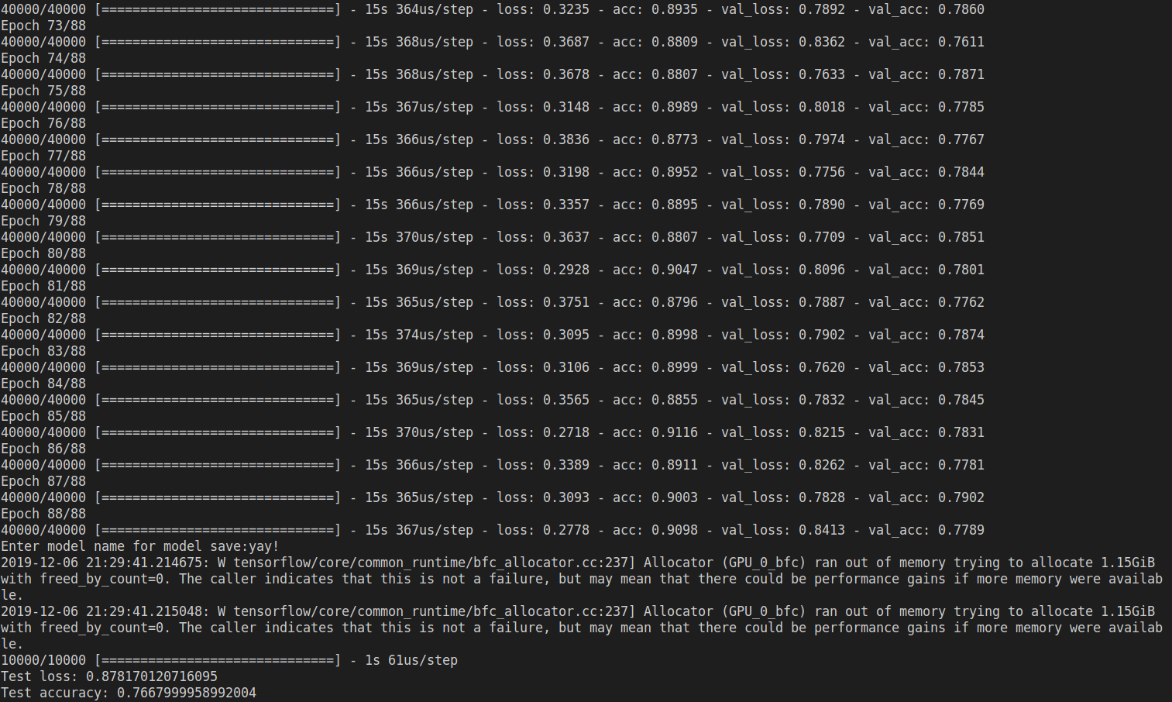

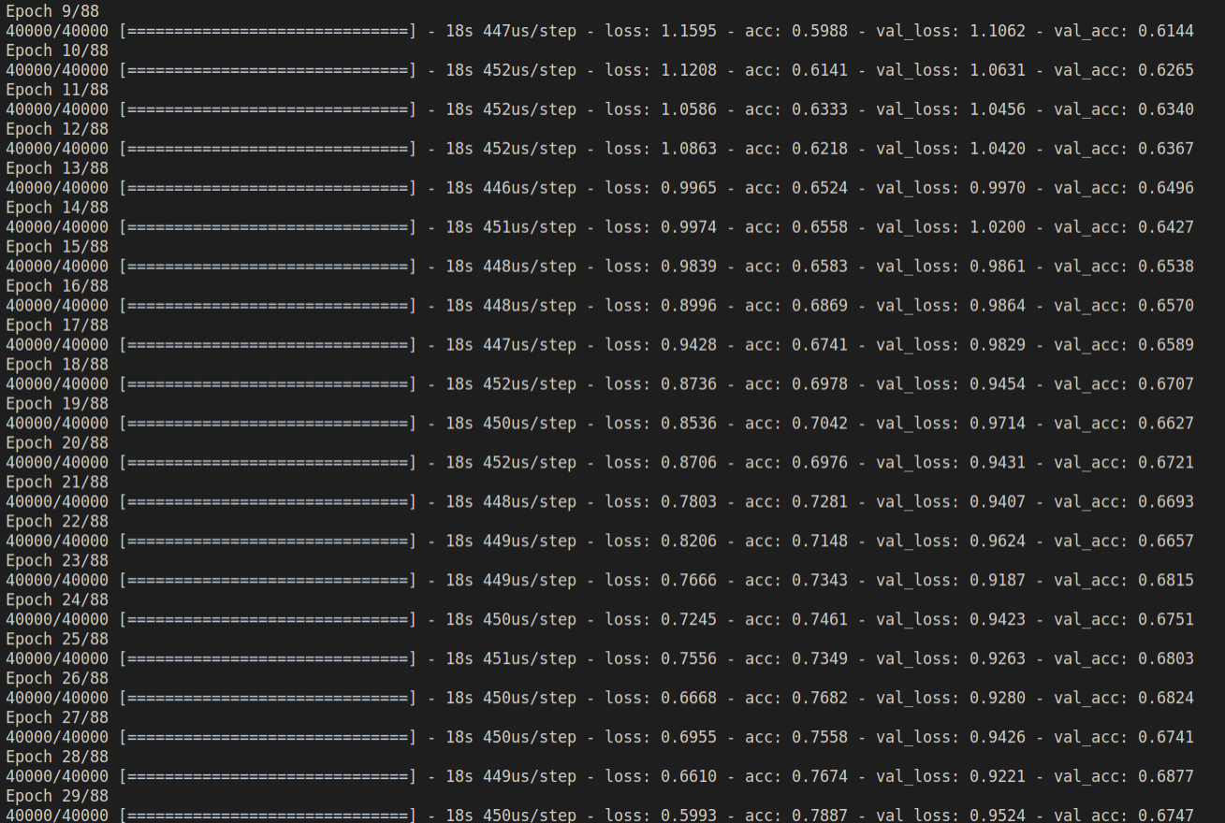
base learn rate = 0.000001 max learn rate = 0.00014 accuracy = 73/74%

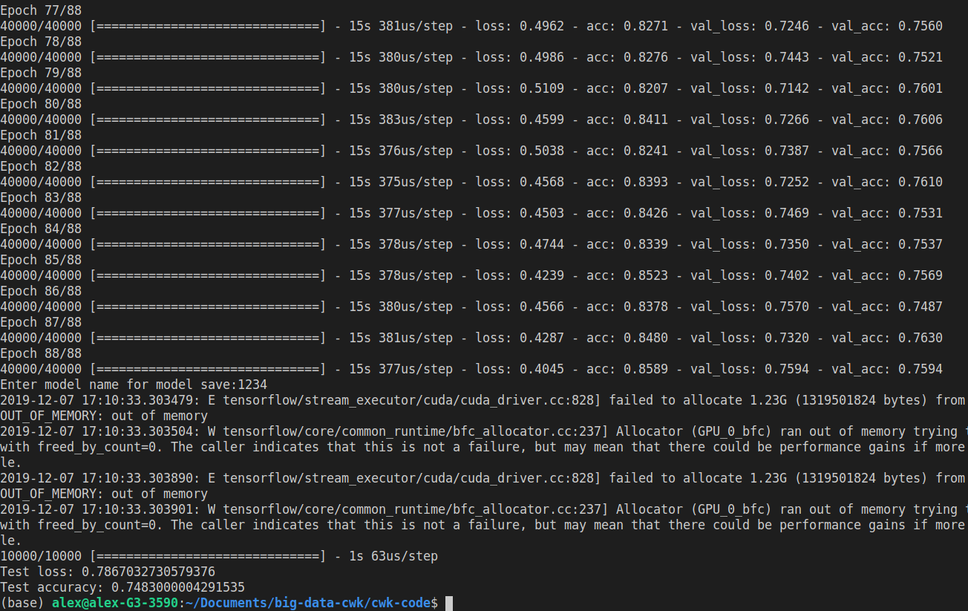
base learn rate = 0.00001 max learn rate = 0.00015 accuracy = 74/75% - overfitting slightly
final dropout = 75% previous layer dropouts = 30%

Throughout experimentations utilising a dropout within the final layer, the model still always over-fit, even if only by small margins. A new approach was tired, removing the dropout from the final hidden layer and increasing drop out rates (1st = 30%, 2nd = 50%, 3rd = 70%) for the previous hidden layers.
This approach achieved some success, loss levels were lower than ever before across training, validation and test sets whilst a classification rate of 75% was achieved.
It’s difficult to concretely explain why this worked, however a possibility could be that the dropout incorporation within the previous hidden layers was enough to remove many standout irrelevant features, whilst average pooling usage ensured standout irrelevant features that still remained were getting extracted at low rates. This could have then allowed for max pooling to be utilised within the final hidden layer, which would now be getting passed a feature map with predominantly relevant features.
Based on this hypothesis, it was deduced that an increase of the models base and max learning rates would allow for increased classification results, as the majority of the irrelevant image features had been ‘de-noised’ out of model feature maps.
Through experimentation, it was found that 0.00001 was still the best base learning rate, however a max learning rate of 0.012 achieved a classification accuracy of 77/78% during testing, and achieved fairly low, and similar, levels of loss across datasets.

This indicates that a max learning rate of 0.012 provides the best rate of feature extraction, while a base rate of 0.00001 provides the most optimised levels of loss.

Results are shown below.

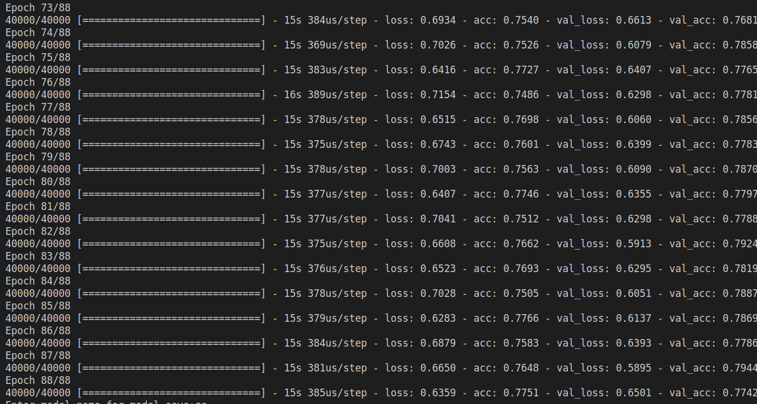
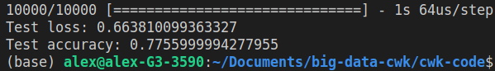

Dropout rates were also experimented with further, with the main aim being the identification of where the CNN was extracting irrelevant features within the hidden layers, and where relevant features were bing ‘dropped-out’ of the model.

For each hidden/convolutional layer with dropout applied it was found that:
Conv 1_1
it was found that applying dropout led to slight overfitting on training data, shown below with 20% dropout applied.

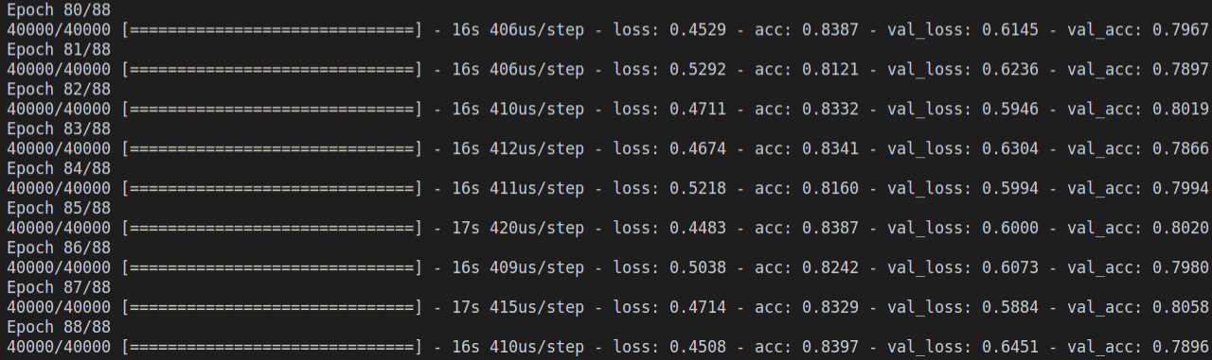

Conv 1_2
complete dropout removal led to overfitting on training data, shown below.
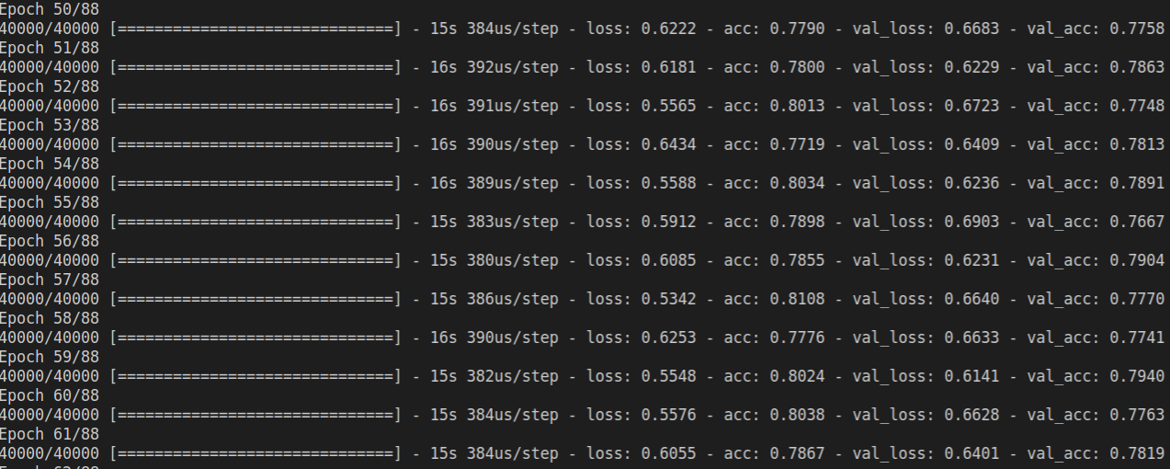
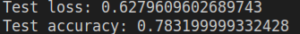
A dropout rate of 20% produced the best results, with a test loss of ~0.62 and a test accuracy of 78.3% shown below:

Conv 1_3
a dropout rate of 20% produced the best results, although loss increased to ~0.63 a test accuracy of 79.4% was achieved.

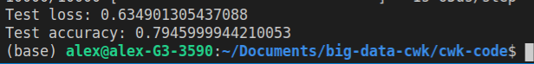

Conv 1_4

When experimenting with conv 1_4 dropout rates, it was found changes, either higher or lower, would cause the model to over-fit. 70% seemingly provided the most ideal model fit/loss amounts across datasets. The conclusion that was made from this was that the model was being held back by the number of filters in conv 1_4.
However attempts at increasing complexity within conv 1_4 led to increased overfitting on the training dataset, even when additional model hyperparameters were experimented with. An additional interconnected layer was also added to the model, which did not lead to any meaningful difference across dataset accuracy results.
Seemingly, the model was already highly optimised on the training dataset.
An explanation for this could be that more complexity led to a greater amount of irrelevant ‘deep’ features being extracted, which skewed model prediction accuracies to lower rates, while the previous models tuning was able to provide the greatest balance of meaningful and generalisable collection of image features vs irrelevant features.

Image pre-processing

Filters had already been applied to the model, such as normalization of pixel values and greyscaling images. Normalization had been used to reduce training time requirements while grayscaling was used to reduce overall image pixel value variances, which was useful in reducing rates of loss across datasets.
Initally a ‘filter’ was applied to the datatype of the matrix values. The datatype was changed from float 32 to float 64, with the idea being that a larger mantissa may allow for additional useful image features to be captured and used for classification, however this did not lead to a significant change in classification results.
Resizing dataset images was also trialled, as often larger images can expose accurate features for extraction more effectively, leading to improved model accuracy[9] initially image dimension were doubled to 64x64, however this lead to very poor performance rates of 10% accuracy. Dimensions 24x24 and 36x36 were also trialled, however consistent levels of results were shown across resizing operation. This could potentially be explained by the resize up and down not preserving image content.

An increase in layer filter size was trialled, filters were scaled to 4x4 matrices. Classification results were relatively similar to the use of 3x3 filters, however a greater amount of model overfitting could be observed, shown below.
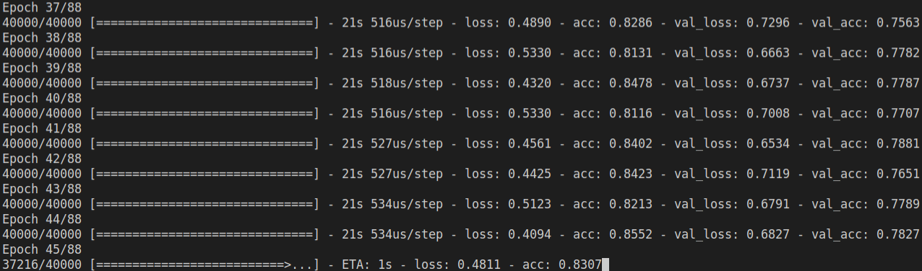
Data augmentation techniques were also trialled, this is due to their ability to generate new training data through image modification[10], which can allow for a model to improve it’s ability to generalize features learned to new images, such as testing and validation data.

Initially horizontal flip was applied, although an increase or accuracy was not increased or decreased, observing training and validation stats seemed to indicate the model was better able to generalize its features.

Levels of loss remained more consistent between training and validation datasets, while rates of accuracy also maintained more parity. Epoch time-to-run was also reduced, from 18 seconds to 8 seconds. Making the model around x2.25 faster/ taking run times from ~26 minutes to ~ 11 minutes Results shown below.
This had been mistakenly unnoticed previously, however the use of the data augmentation ImageDataGenerator class allowed for the implementation of batches within the model, so previously batches the batch size of 200 was not actually being used within the model, however now was.
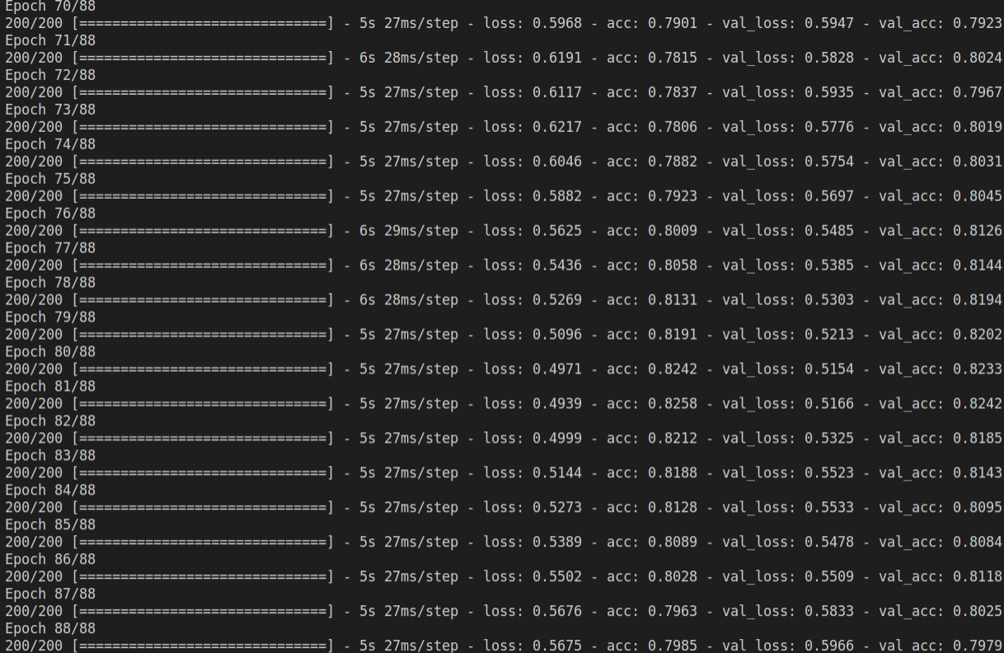
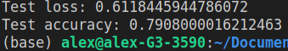

Random darkening was used, to allow the model to generalise features learned to darker images, however this drastically lowered validation and testing results to around 10% correct. This seemed to indicate there were no dark images present within the datasets. Results shown below.

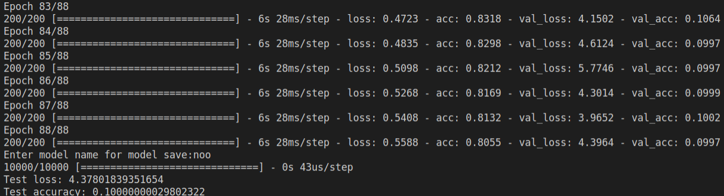
Randomly brightening images also led to similar results, indicating the dataset did not contain any overly bright images, results shown below.

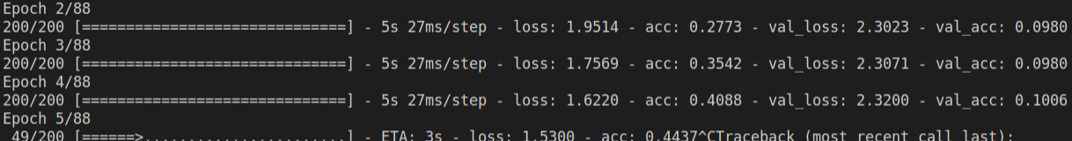
Random zooms between 70% zoom out and 130% zoom in were trialled. Although the accuracy of the model decreased overall, levels of loss were lower on validation and testing data vs training data. This seemed to indicate that the model was learning more general features through these random zooms. Results shown below.

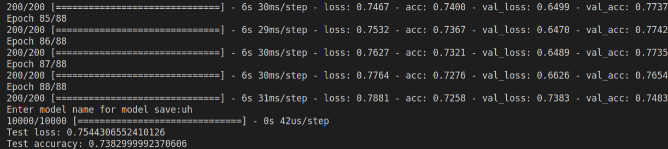

Removing zoom out allowed the model to generalise event better, shown below.
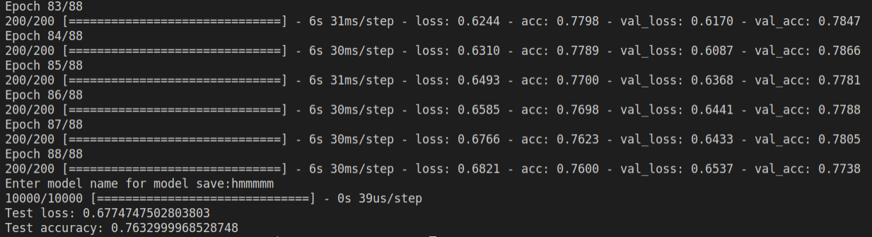
Based on these results, it was decided that zoom in levels should be experimented with even further, to identify which level gave the best model feature generalisation. It was found that a zoom range of no zoom out to 20% zoom in / 120% zoom gave the best model generalisation.
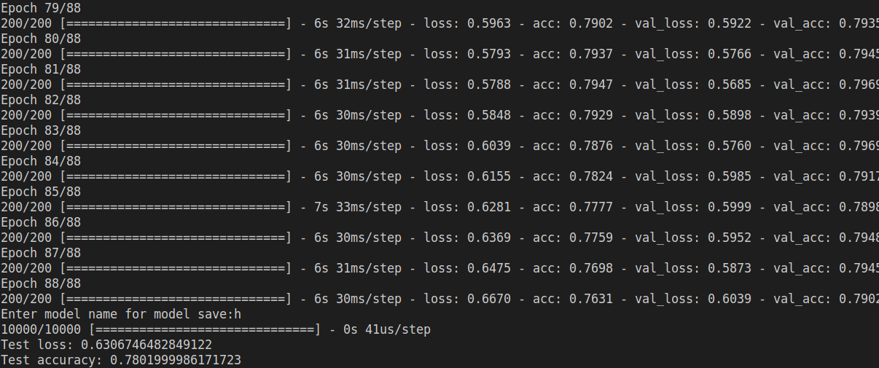
It was theorised that the now lower levels of accuracy and loss on the test set could be cause by the aggressive rate of dropout of 70% applied at the models classification layer. Perhaps this level of dropout was removing features made generalisable through slight image zoom ins, meaning these features no longer needed to be ‘regularised out’ of the models classifications.

Through experimentation it was found this was not the case however, 70% dropout still provided the best loss and accuracy results, even when increasing dropout amount.

Due to the continually lowering levels of loss observed with 70% dropout, model iterations were increased by half leading to an iteration amount of 124. This was to ascertain whether the trend of lowering loss levels and increased validation set accuracy would continue.

This proved true, loss and accuracy continued to increase across datasets. Based on this, it was decided iterations should be increased further. Test loss was lower than ever and test accuracy reach 80%. Results shown below.
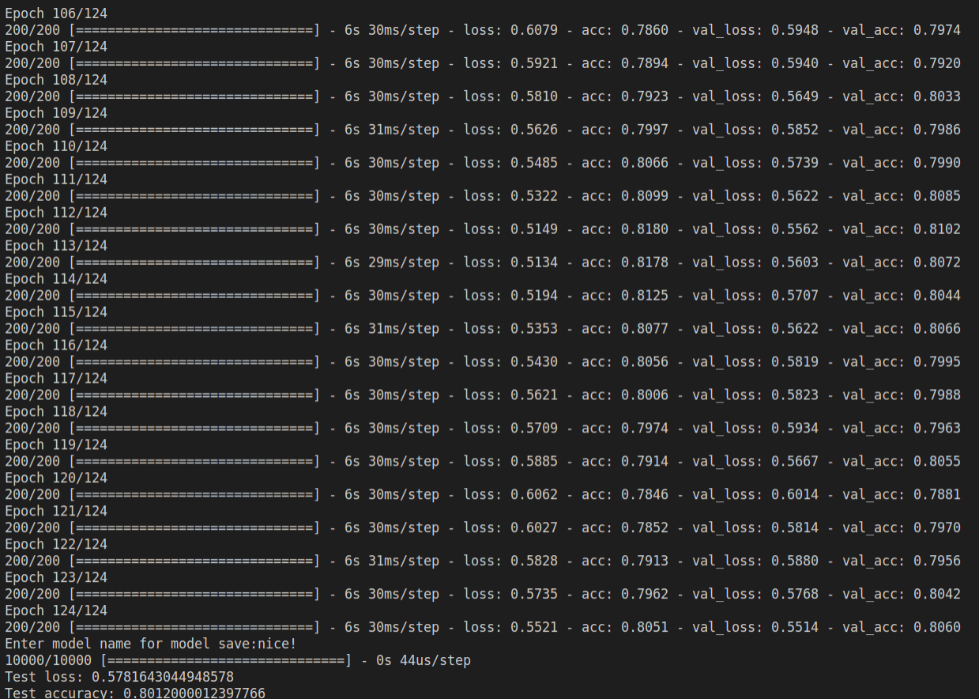
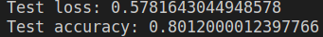

Increasing epochs to 186 showed somewhat similar results, however it was observed that the model began to over-fit very slightly towards the end of training. Epochs were taken back down to 124 for now and further image pre-processing was performed.

It was found that normalizing pixel values before grey-scaling images decreased accuracy slightly, with normalization of pixel values removed the model was able to achieve 81% accuracy, results shown below.
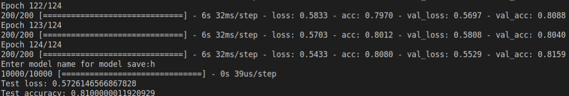

A decrease in batch size was also experimented, based on the first and second explanations of how batch size can affect model performance[11]. The main goal when experimenting with loss was to optimise the level of noise generated by smaller dataset batches to avoid reduce the extent to which the network would eventually remain within shallow areas of loss, which would hopefully lead to improved classification results.
Unfortunately however, a batch size of 200 seemed to consistently give the best results.
A larger amount of iterations were used to attempt to achieve a higher level of classification accuracy. 600 iterations were used initially however the model was found to eventually over-fit. 563 were trialled which led to a greater model accuracy of 83%, however when observing the results, it seemed as though the model greatly over-fit past the point of 560 iterations, so 560 iterations were trialled next.
563 results shown below.

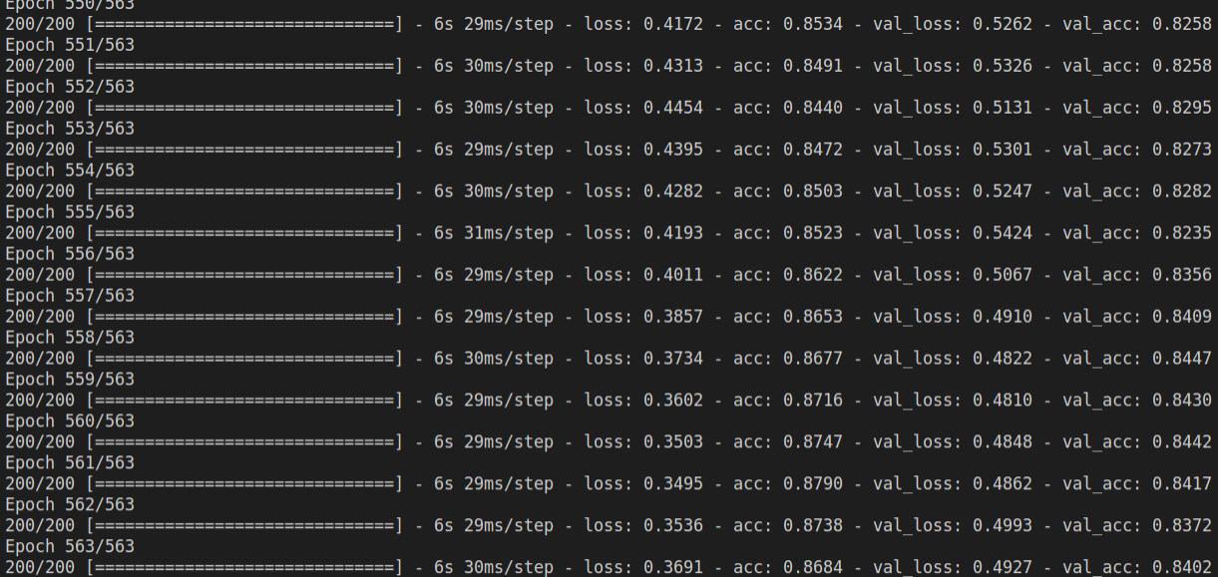
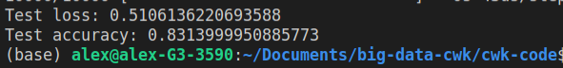

Otsu’s method was experimented with, due to its ability to effectively distinguish image foreground/subjects from the images background [12]. A decrease in accuracy results was seen when using this filter, however loss maintained parity across test and validation set for a considerable amount of epochs, up until epoch 139. This suggested the model was learning fairly generalisable features and that the method could be optimised further through adjusting of learning rates, dropout rates etc.
However there was not enough time left to experiment further with this method, so the model was reset back to its original configuration.
Results shown below
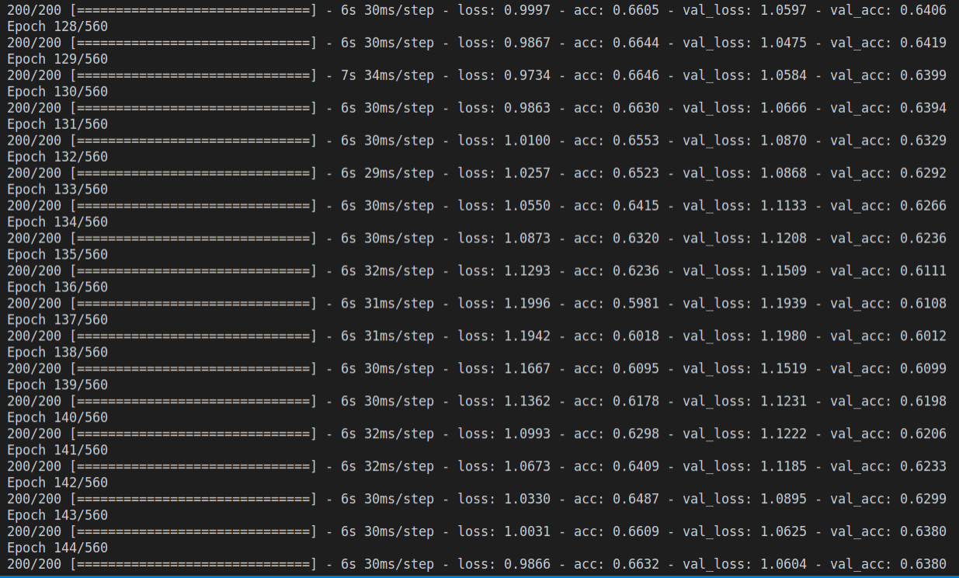
In an attempt to increase results further, epochs were raised to 800

References

- Smith, L.N., Cyclical Learning Rates for Training Neural Networks, 2015, https://arxiv.org/abs/1506.01186
- Rosebrok, A., Cyclical Learning Rates with Keras and Deep Learning, 2019, https://www.pyimagesearch.com/2019/07/29/cyclical-learning-rates-with-keras-and-deep-learning/
- Github users bckenstler, jeremyjordan & carlthome, CLR, 2018, https://github.com/bckenstler/CLR
- Sharma, S., Epoch vs Batch Size vs Iterations, 2017, https://towardsdatascience.com/epoch-vs-iterations-vs-batch-size-4dfb9c7ce9c9
- Mack, D., How to pick the best learning rate for your machine learning project, 2018, https://medium.com/octavian-ai/which-optimizer-and-learning-rate-should-i-use-for-deep-learning-5acb418f9b2
- Brownlee, J., A Gentle Introduction to Dropout for Regularizing Deep Neural Network, 2018, https://machinelearningmastery.com/dropout-for-regularizing-deep-neural-networks/
- stack-overflow answer to grayscaling RGB image. https://stackoverflow.com/questions/51285593/converting-an-image-to-grayscale-using-numpy
- Nagpal, A. L1 and L2 Regularization Methods, 2017, https://towardsdatascience.com/l1-and-l2-regularization-methods-ce25e7fc831c
- Bilogur, A. Boost your CNN image classifier performance with progressive resizing in Keras, 2019, https://towardsdatascience.com/boost-your-cnn-image-classifier-performance-with-progressive-resizing-in-keras-a7d96da06e20
- Brownlee, J. How to Configure Image Data Augmentation in Keras, 2019, https://machinelearningmastery.com/how-to-configure-image-data-augmentation-when-training-deep-learning-neural-networks/
- Intuitively, how does mini-batch size affect the performance of (stochastic) gradient descent., 2015, https://www.quora.com/Intuitively-how-does-mini-batch-size-affect-the-performance-of-stochastic-gradient-descent
- Otsu thresholding — image binarization, 2019, https://medium.com/@hbyacademic/otsu-thresholding-4337710dc519

