Test Table – User Registration
Test Name | Description | Sample Inputs | Expected Results | Actual Results | Pass/Fail
Password – no special characters | Enter a password does not contain any of the special characters required for user passwords | Username: i_donated_to_charity_once_im_a_good_person  password: needmorecash  institution: AmaBuseWorkersRights  institutional email: replace_em_with_robots@amabuseworkersrights.kp  Full Name:  Leff Lezos | Error indicating a special character should be added to the password entered | Error indicating a special character should be added to the password entered (see appendix screenshot 1) | pass
Password – length below 8 characters | Enter a password that does not meet the minimum password length requirements | Username: i_donated_to_charity_once_im_a_good_person  password: more$  institution: AmaBuseWorkersRights  institutional email: replace_em_with_robots@amabuseworkersrights.kp  Full Name:  Leff Lezos | Error indicating password entered is too short | Error indicating password entered is too short (see appendix screenshot 2) | pass
Password - length below 8 characters and no special characters | No special characters and length below 8 characters combined | Username: i_donated_to_charity_once_im_a_good_person  password: cash  institution: AmaBuseWorkersRights  institutional email: replace_em_with_robots@amabuseworkersrights.kp  Full Name:  Leff Lezos | Error indicating a special character should be added to the password entered | Error indicating a special character should be added to the password entered (see appendix screenshot 3) | pass
Password – length extreme low end data | Enter a password that exactly meets the minimum character length requirement | Username: i_donated_to_charity_once_im_a_good_person  password: more$$$$  institution: AmaBuseWorkersRights  institutional email: replace_em_with_robots@amabuseworkersrights.kp  Full Name:  Leff Lezos | User successfully registered and added to the database | User successfully registered and added to the database (see appendix screenshot 4) | pass
Password – enter a commonly used password | Enter a password that is one of the most commonly used across web apps | Username: i_donated_to_charity_once_im_a_good_person  password: iloveyou!  institution: AmaBuseWorkersRights  institutional email: replace_em_with_robots@amabuseworkersrights.kp  Full Name:  Leff Lezos | Error indicating password is too common | Error indicating password is too common (see appendix screenshot 5) | pass
Institution – Non-existent institution | Enter an institution that does not exist within the application database | Username: i_donated_to_charity_once_im_a_good_person666  password: more$$$$  institution: AWS  institutional email: replace_em_with_robots@amabuseworkersrights.kp  Full Name:  Leff Lezos | Error indicating AWS is not a valid institution for registration | Error indicating AWS is not a valid institution for registration (see appendix screenshot 6) | pass
Institutional Email – Incorrect domain | Enter a domain that does not conform to the domain of the institution entered | Username: i_donated_to_charity_once_im_a_good_person666  password: more$$$$  institution: AmaBuseWorkersRights  institutional email: replace_em_with_robots@hAWS.kp  Full Name:  Leff Lezos | Error indicating the domain entered is not valid for the institution entered | Error indicating the domain entered is not valid for the institution entered (see appendix screenshot 7) | pass
Institutional Email – Incorrect format | Enter an email with no ‘@’ symbol | Username: i_donated_to_charity_once_im_a_good_person666  password: more$$$$  institution: AmaBuseWorkersRights  institutional email: replace_em_with_robotsamabuseworkersrights.kp  Full Name:  Leff Lezos | Error indicating the domain entered is not valid for the institution entered | Error indicating the domain entered is not valid for the institution entered (see appendix screenshot 8) | pass
All data expected/within normal ranges | Enter data within expected formats, and well within input ranges set | Username: i_donated_to_charity_once_im_a_good_person666  password: morecash$$$$  institution: AmaBuseWorkersRights  institutional email: replace_em_with_robots666@amabuseworkersrights.kp  Full Name:  Leff Lezos | User successfully registered and added to the database | User successfully registered and added to the database (see appendix screenshot 9) | pass
All data attempts XSS injection | Attempt XSS script injection in each user input box | URL: https://127.0.0.1:5000/auth/register<script>alert(1)</script>  Username: i_donated_to_charity_once_im_a_good_person666<SCRIPT>alert(1)</SCRIPT>  password: <script>alert(1)</script>morecash$$$$  institution: <ScRiPt>alert(1)</ScRiPt>AmaBuseWorkersRights  institutional email: <ScRiPt>alert(1)replace_em_with_robots666@amabuseworkersrights.kp</ScRiPt>  Full Name:  <ScRiPt>alert(1)</ScRiPt> | An error appears indicating that a valid institution has not been registered. No alert box should appear. | An error appears indicating that a valid institution has not been registered. No alert box appears.(see appendix screenshot 10) | pass
No data entered | Make a post request/ click the register button with no data entered | [no data entered] | The application indicates the user must fill out required fields | The application indicates the user must fill out required fields (see appendix screenshot 11) | pass

Test Table – User Log-In
Test Name | Description | Input | Expected Result | Actual Result | Pass/Fail
No data entered | Make a post request/ click the log in button with no data entered | [no data entered] | The application indicates the user must fill out required fields | The application indicates the user must fill out required fields (see appendix screenshot 12) | pass
Enter invalid username | Attempt log in with a non-existent/incorrect username | Username: Ozzy Osbourne 666  Password: @BlackSabbath@$ | The application indicates the username entered is invalid | The application indicates the username entered is invalid (see appendix screenshot 13) | pass
Enter invalid password | Attempt to log in with an incorrect password | Username: i_donated_to_charity_once_im_a_good_person666  Password: coldhardcash | The application indicates the password is invalid | The application indicates the password is invalid (see appendix screenshot 14) | pass
Login from an unauthenticated device | Attempt to log in from a different device than the device used during user registration | Username: i_donated_to_charity_once_im_a_good_person666  Password: morecash$$$$ | The application indicates the device used is not authenticated | The application indicates the device used is not authenticated (see appendix screenshot 15) | pass
Device MAC address cannot be retrieved | Attempt to log in, in a scenario where the authorised device mac address cannot be retrieved | Username: i_donated_to_charity_once_im_a_good_person666  Password: morecash$$$$ | The application indicates the device can’t be authenticated | The application indicates the device can’t be authenticated (see screenshot 16) | pass
Attempt SQL and XSS injection | Attempt to execute XSS and HTML scripts within the username and password fields | Username:  ;DELETE FROM User WHERE UserID = 943180813;  password: <script>alert(1)</script> | The application inidcates the username is invalid. The user record is not deleted. The script is not executed. | The application inidcates the username is invalid. The user record is not deleted. The script is not executed.(see appendix screenshots 17 and 18) | pass
Login as expected | Login using correct credentials and a MAC address that can be retrieved | Username: i_donated_to_charity_once_im_a_good_person  password: cash$$$$ | The application logs the user in and redirects to the project index page | The application logs the user in and redirects to the project index page (see appendix screenshot 19) | pass

Test Table – Project Index
Test Name | Description | Input | Expected Result | Actual Result | Pass/Fail
Attempt to perform XSS injection | Insert a HTML script into the page URL | https://127.0.0.1:5000/<script>alert(1)</script> | The application returns a URL not found error. No alert window appears | The application returns a URL not found error (see appendix screenshot 20) | pass
Unauthorised access | Attempt to navigate back to the project index page after log out | Log out click → browser back button click | The application redirects to the login page | The application redirects to the login page (see appendix screenshot 21) | pass

Test Table – Create Project
Test Name | Description | Input | Expected Result | Actual Result | Pass/Fail
Attempt to perform XSS and SQL injection | Enter XSS and SQL text into the given fields. | Project Name: ;DELETE FROM User WHERE UserID = 943180813;  Project Description: <script>alert(1)</script> | The application creates a project with name and description ;DELETE FROM User WHERE UserID = 943180813; password: <script>alert(1)</script>. No alert appears. The given user is not deleted from the database. | The application creates a project with name and description ;DELETE FROM User WHERE UserID = 943180813; password: <script>alert(1)</script>. No alert appears. The given user is not deleted from the database. (see appendix screenshot 22) | pass
Leave fields blank | Don’t enter any data for project name or description when making a POST request/ clicking the save button. | save button click | The application indicates that the user must enter data into the required fields | The application indicates that the user must enter data into the required fields (see appendix screenshot 23) | pass
Enter data into fields as expected | Enter a project name and description as expected | Project Name: Banning toilet breaks  Project Description: Ban all toilet breaks to increase efficiency! *evil laugh ensues* | The application creates the project and redirects the user to the project index page | The application creates the project and redirects the user to the project index page (see appendix screenshot 24) | pass
Unauthorised access | Attempt to navigate back to the create project page after log out | Log out → back button click | The application redirects the user to the login page | The application redirects the user to the login page (see appendix screenshot 26) | pass

Test Table – Ticket Index
Test Name | Description | Input | Expected Result | Actual Result | pass/fail
Attempt to perform XSS injection | Insert a HTML script into the page URL | https://127.0.0.1:5000/ticket_viewer/Banning toilet breaks<script>alert(1)</script> | The application returns a URL not found error. No alert window appears | The application returns a URL not found error. No alert window appears (see screenshot 25) | pass
Unauthorised access | Attempt to navigate back to the ticket index page after log out | Log out → back button click | The application redirects the user to the login page | The application redirects the user to the login page (see appendix screenshot 27) | pass

Test Table – Create Ticket
Test Name | Description | Input | Expected Result | Actual Result | pass/fail
Attempt to perform XSS and SQL injection | Enter XSS and SQL text into the given fields. | Ticket Name: ;DELETE FROM User WHERE UserID = 943180813;  Assignee Username: <script>alert(1)</script>  Ticket Description:  <sCript>alert(1)</sCript> ;DELETE FROM User WHERE UserID = 943180813; | The application indicates that a ticket can’t be assigned to a user from a different institution. No alert box is shown. The given user is not deleted from the database. | The application indicates that a ticket can’t be assigned to a user from a different institution. No alert box is shown. The given user is not deleted from the database. (see appendix screenshots 28 and 29) | pass
Leave fields blank | Don’t enter any data for ticket name, assignee username or description when making a POST request/ clicking the save button. | Save button click | The application prompts the user to fill the required fields | The application prompts the user to fill the required fields (see appendix screenshot 30) | pass
Assign ticket to a different institutional user | Attempt to assign a ticket to a user that is registered within a different institution | Ticket Name: Investigate the use of plastic bottles  Assignee Username: Gamers2Gamblers (Microtransction Arts)  Ticket Description: Assign plastic bottles to each worker. Closely monitor workers through CCTV. Deduct their pay if they leave their station! | The application indicates that a ticket can’t be assigned to a user from a different institution. | The application indicates that a ticket can’t be assigned to a user from a different institution. (see appendix screenshot 31) | pass
Enter data into fields as expected | Enter a ticket name, correct user assignee and description as expected | Ticket Name: Investigate the use of plastic bottles  Assignee Username: bagsomoney  Ticket Description: Assign plastic bottles to each worker. Closely monitor workers through CCTV. Deduct their pay if they leave their station! | A ticket is created | A ticket is created as expected (see appendix screenshot 32) | pass
Unauthorised access | Attempt to navigate back to the create project page after log out | Back button click | The user is redirected to the login page | The user is redirected to the login page (see screenshot 33) | pass

Test Table – View Ticket
Test Name | Description | Input | Expected Result | Actual Result | pass/fail
Attempt to perform XSS and SQL injection | Input XSS and SQL text data into the comment title and ticket comment fields | Comment title: <sCript>alert(1)</sCript>  Ticket Comment: ;DELETE FROM User WHERE UserID = 943180813; | A comment is generated. An alert box is not shown. The given user is not deleted from the database. | A comment is generated. An alert box is not shown. The given user is not deleted from the database. (see screenshots 34 and 35) | pass
Attempt to submit an empty comment | Leave both the Comment title and ticket comments field blank | Submit button click | The application prompts the user to enter data into the empty fields | The application prompts the user to enter data into the empty fields (see appendix screenshot 36) | pass
Enter a comment as expected | Enter a comment title and ticket comment in an expected format | Comment title: Could we use goons?  Ticket Comment: Can we bend legislation to legally employ enforcers? Lord knows we’ve done it when it comes to dodging tax! | The application adds the comment to the ticket | The application adds the comment to the ticket (see appendix screenshot 37) | pass
Unauthorised access | Attempt to navigate back to the create project page after log out | Log out → back button click | The application redirect the user to the login page | The application redirect the user to the login page (see appendix screenshot 38) | pass
Closed ticket comment | Attempt to comment on a closed ticket | Comment title: Transcript from replacing workers with robots meeting at the Amazon warehouse in Dunfermline  Ticket Comment:  Dunfermline area manager: "I'll never turn to the dark side. You've failed, Your Highness. I am a Union Member, like my father before me."  Jeff Bezos: "So be it... Unionist." | The application indicates that a user cannot comment on a closed ticket. | The application indicates that a user cannot comment on a closed ticket. (see appendix screenshot 39) | pass

Known Bugs
- The application is unable to continually persist identification of MAC addresses between server runs. If the server is shutdown and restarted, the MAC address of the original device is no longer authenticated against as expected for user login

Appendix - Test Screenshots

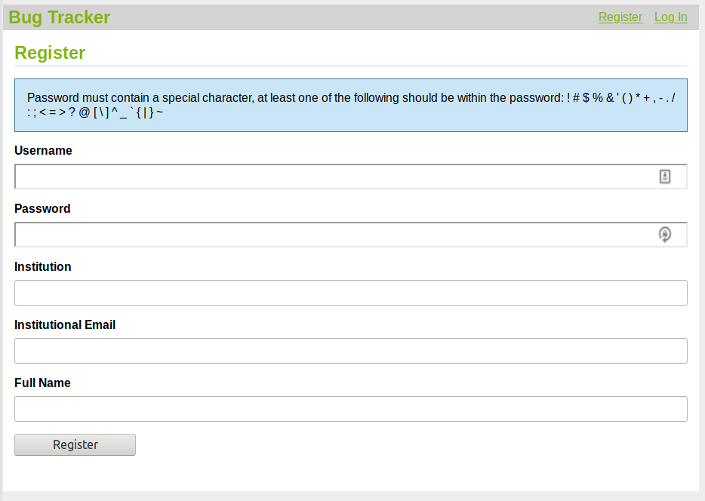Screenshot 1
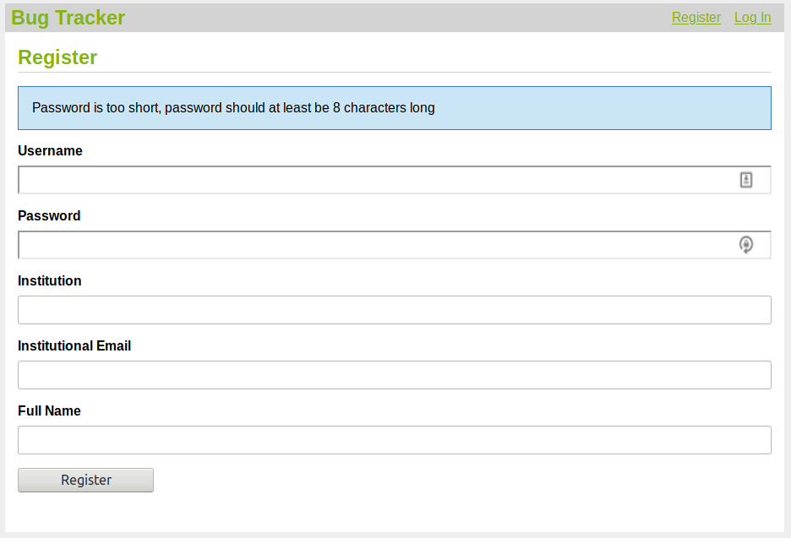Screenshot 2
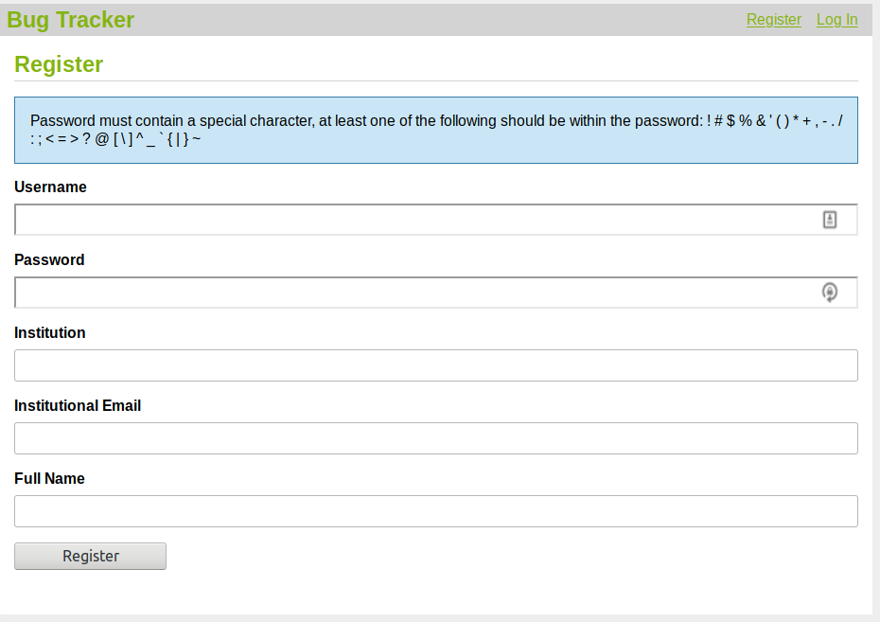Screenshot 3
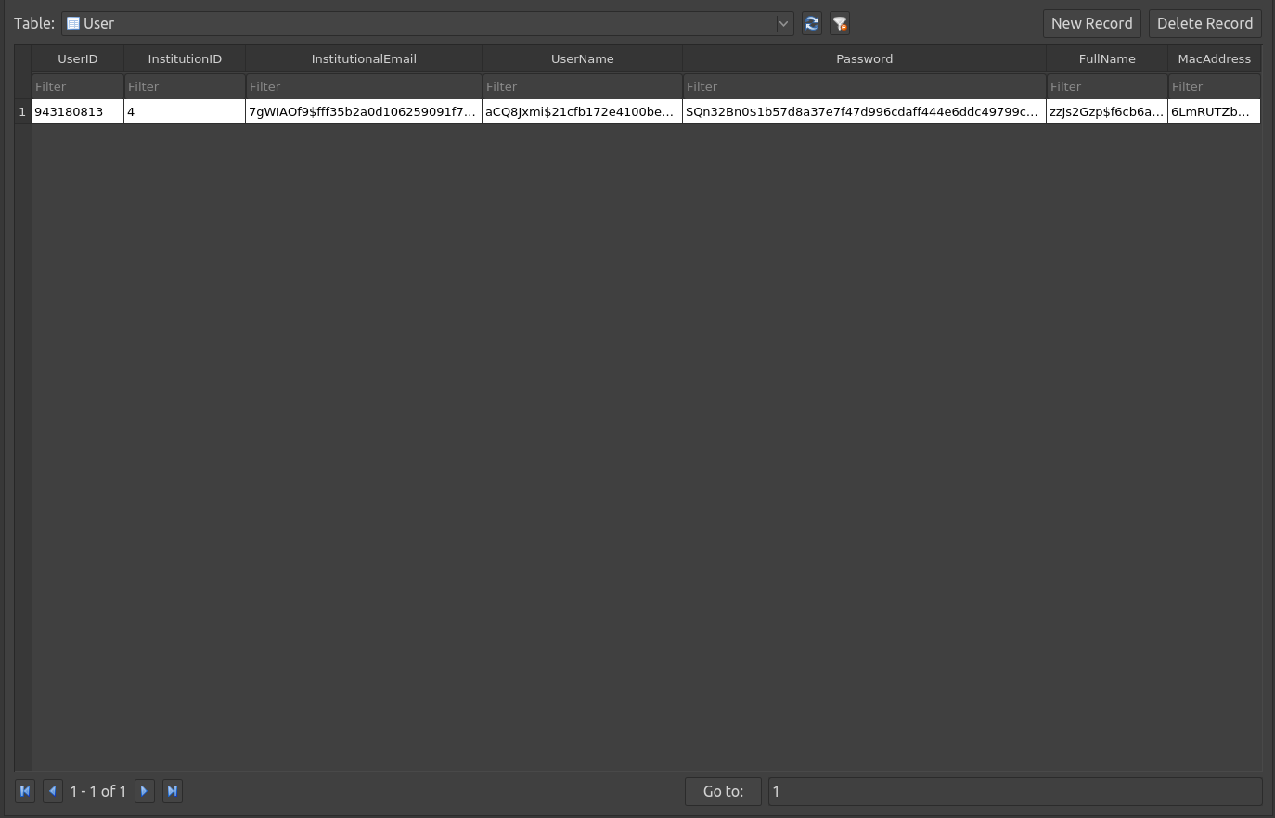Screenshot 4
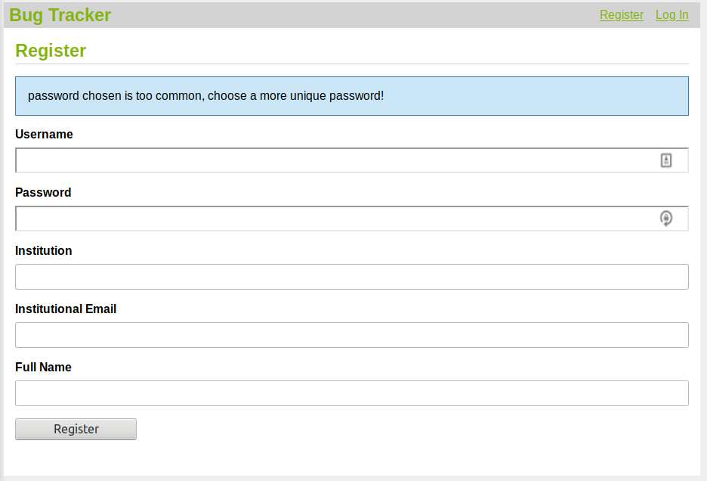Screenshot 5
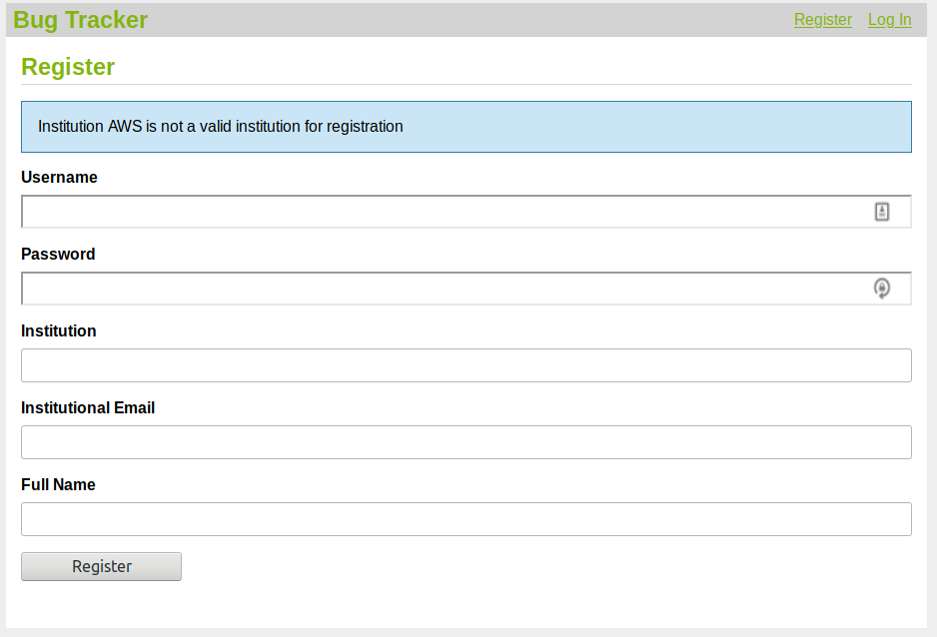Screenshot 6
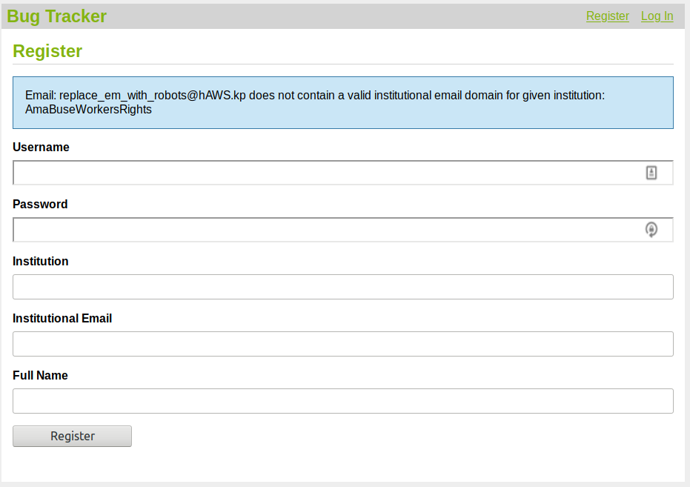Screenshot 7
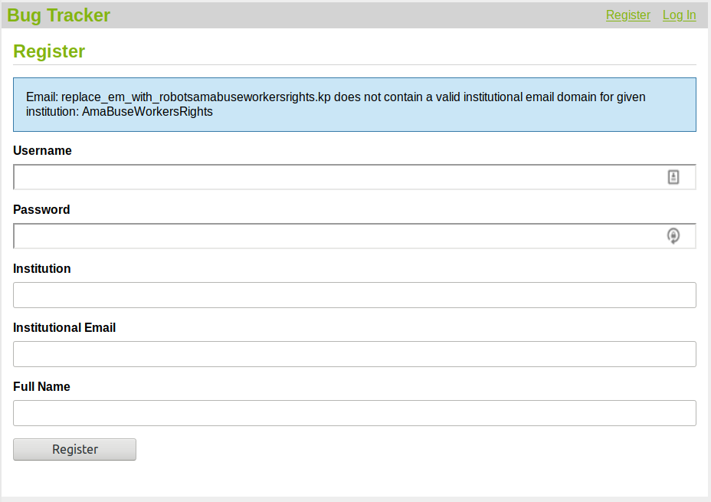Screenshot 8
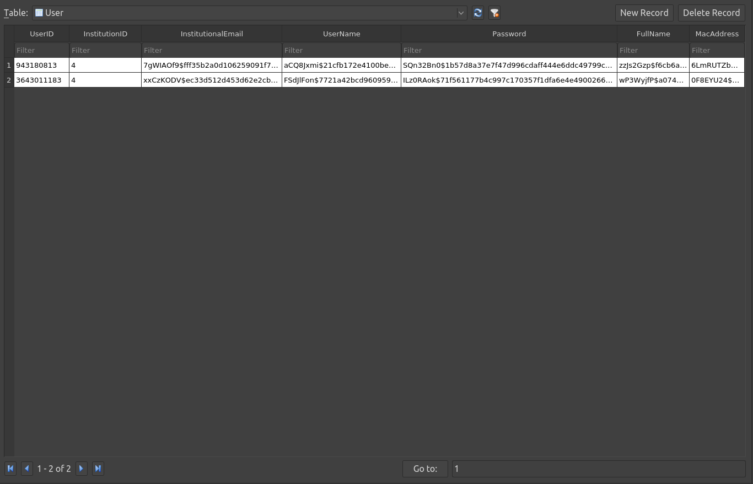Screenshot 9
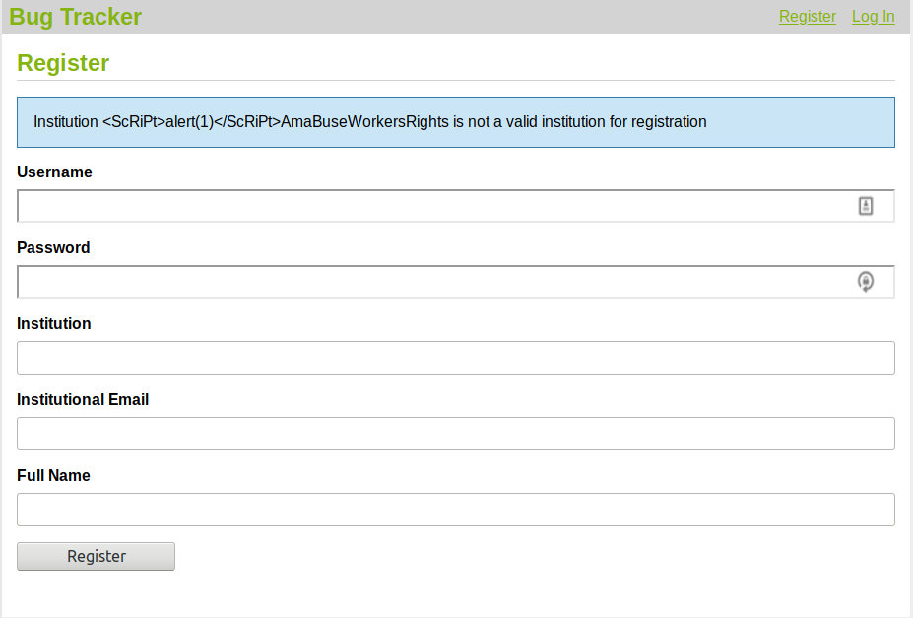Screenshot 10
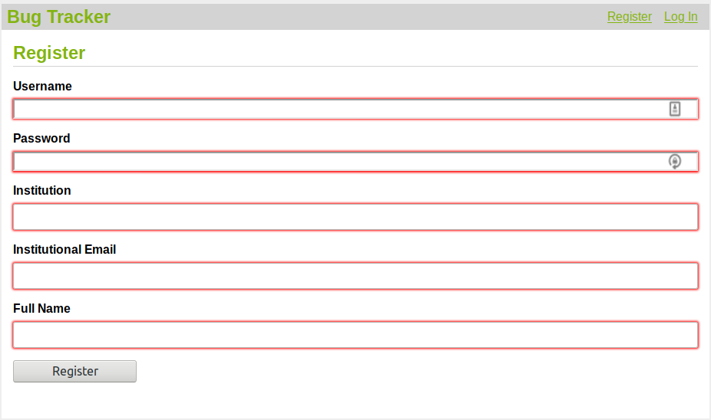Screenshot 11
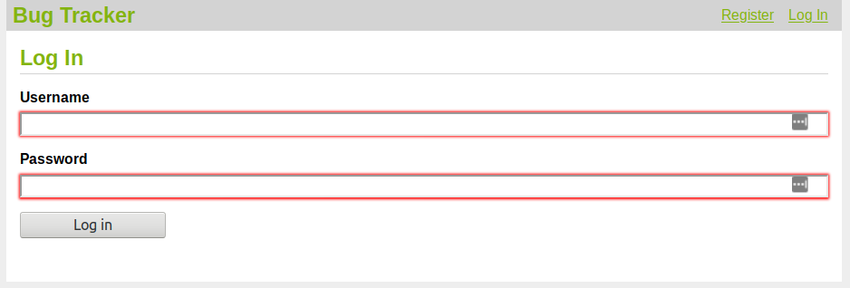Screenshot 12
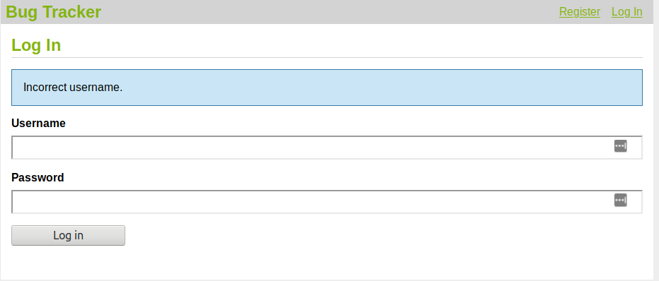Screenshot 13
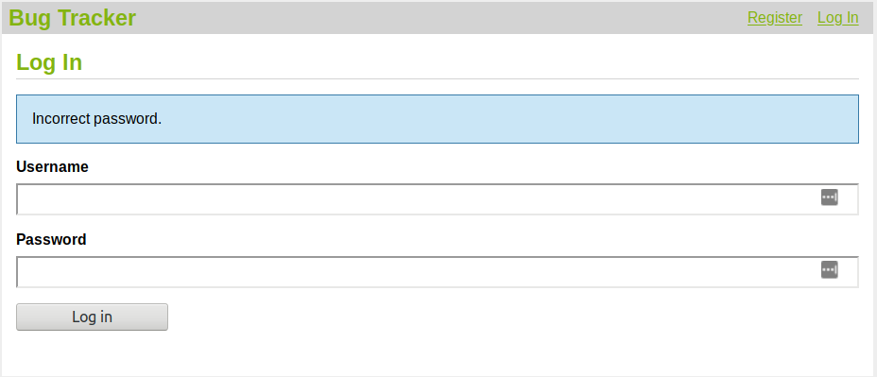Screenshot 14
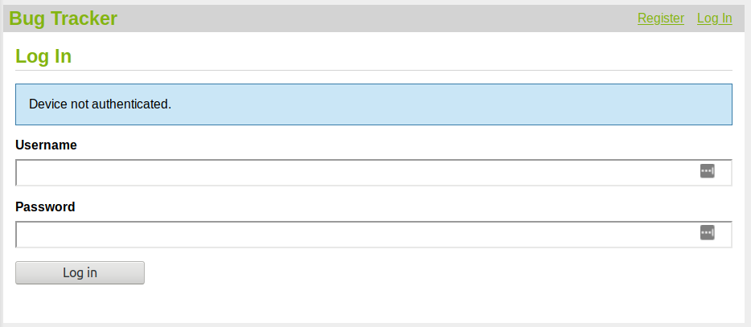Screenshot 15
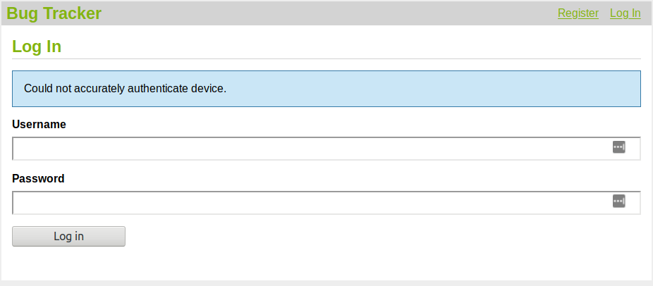Screenshot 16
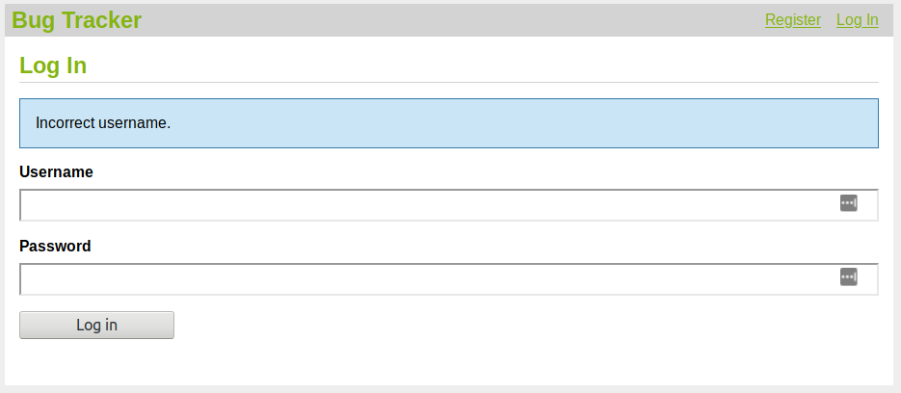Screenshot 17
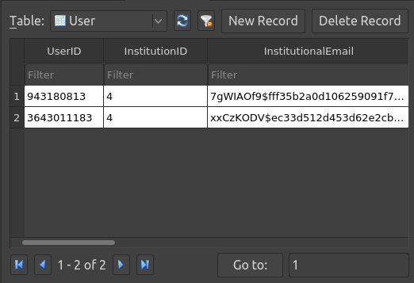Screenshot 18
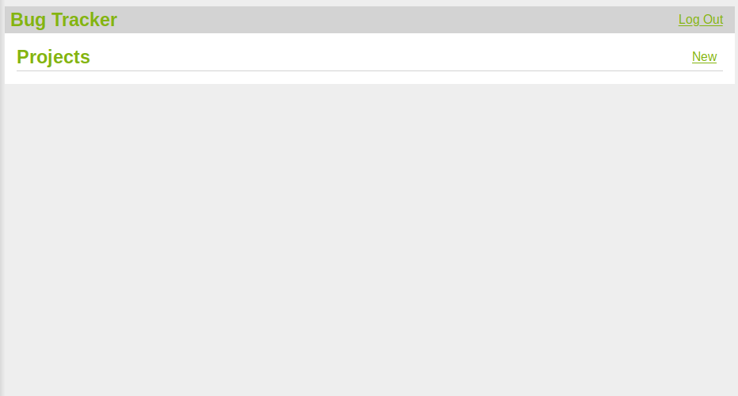Screenshot 19
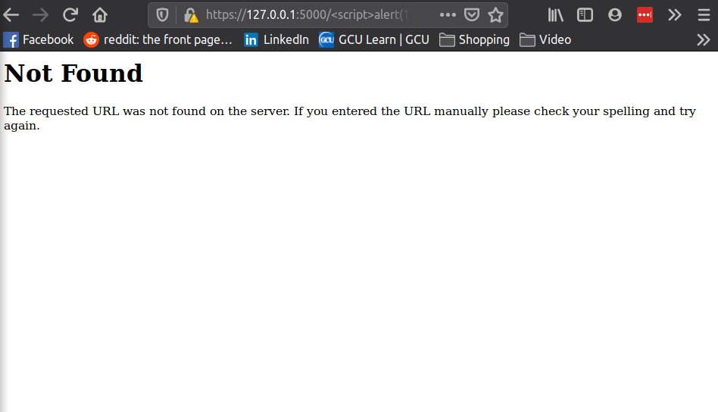Screenshot 20
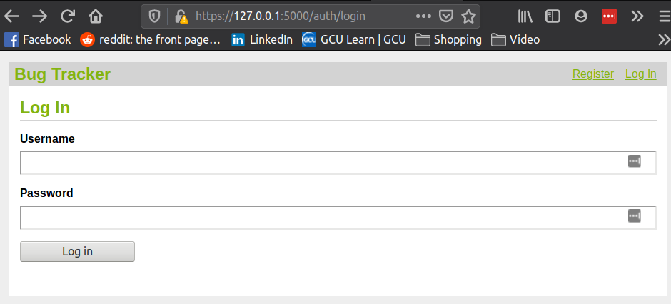Screenshot 21
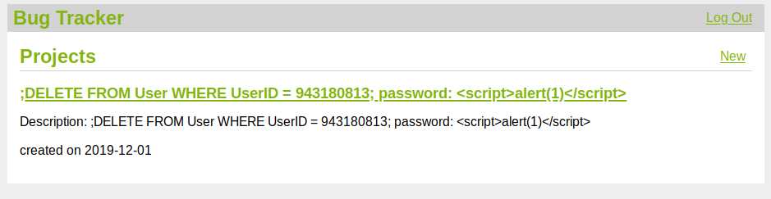Screenshot 22
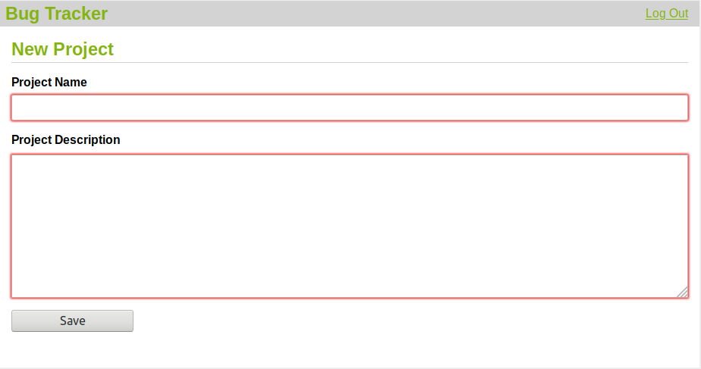Screenshot 23
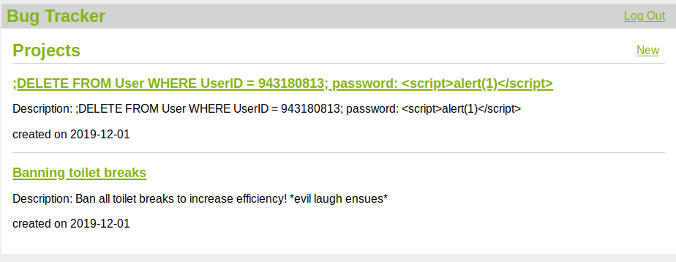Screenshot 24
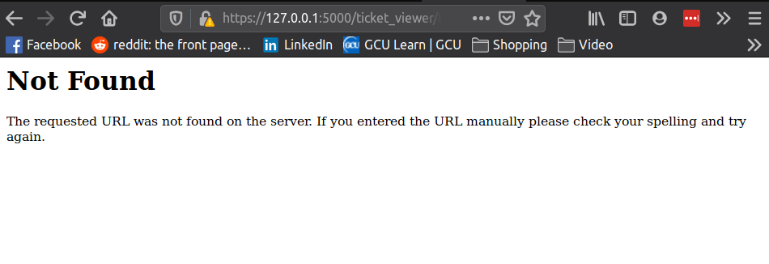Screenshot 25
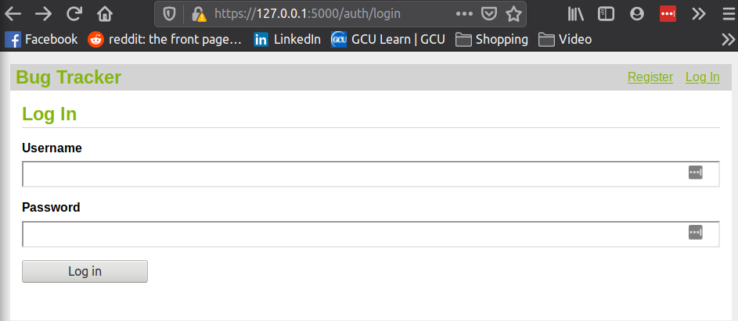Screenshot 26
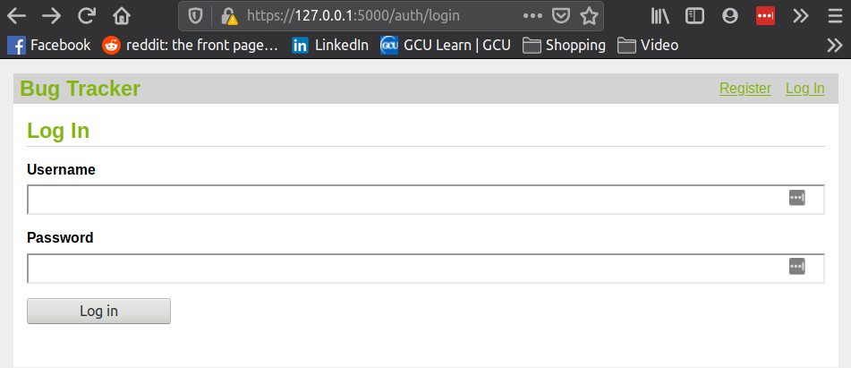screenshot 27
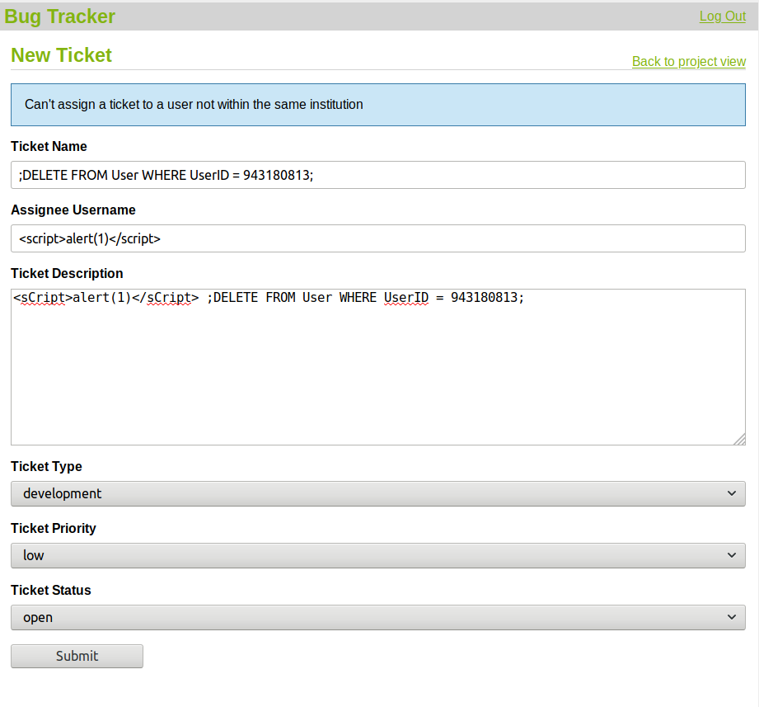Screenshot 28
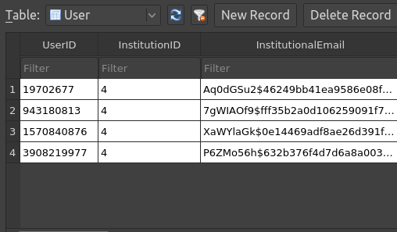Screenshot 29
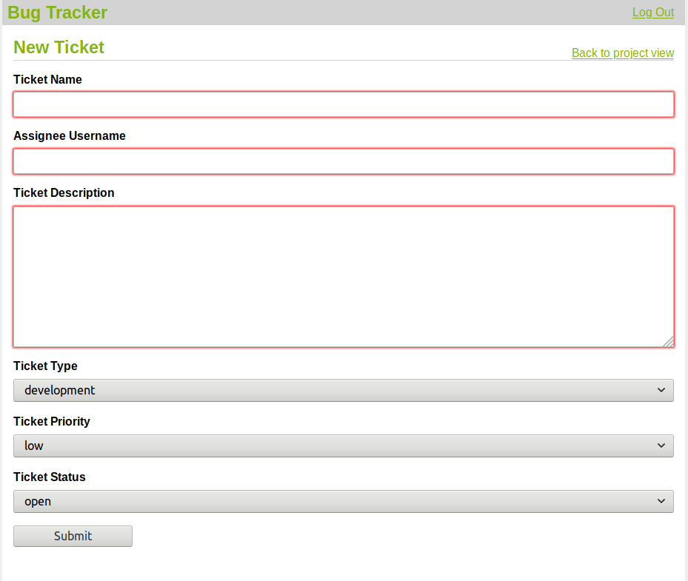Screenshot 30
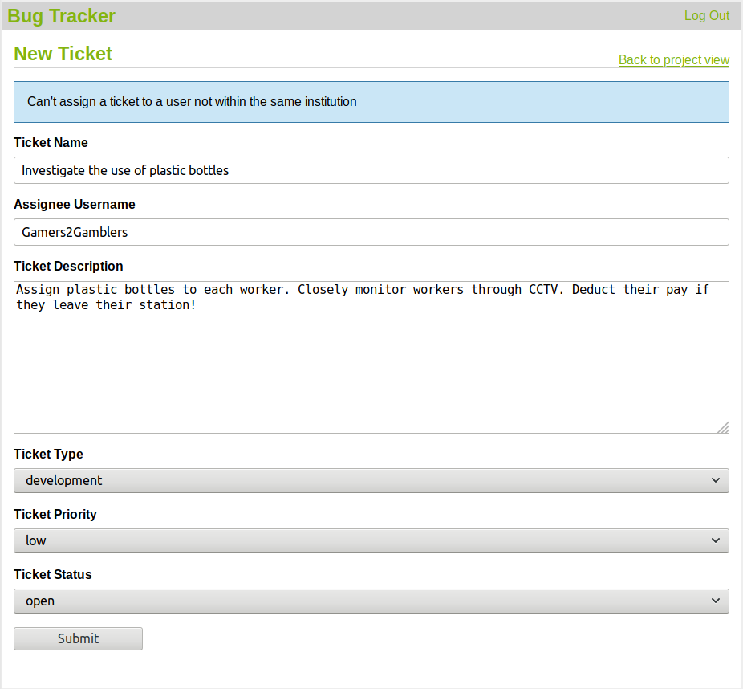Screenshot 31
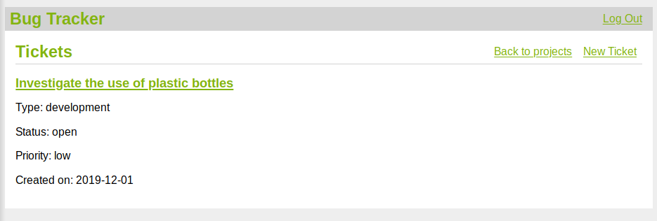Screenshot 32

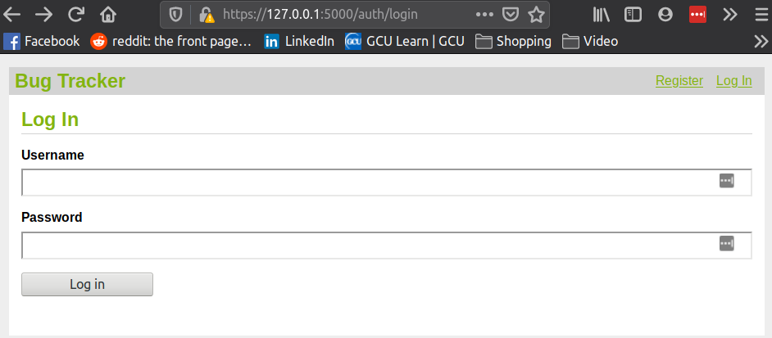Screenshot 33
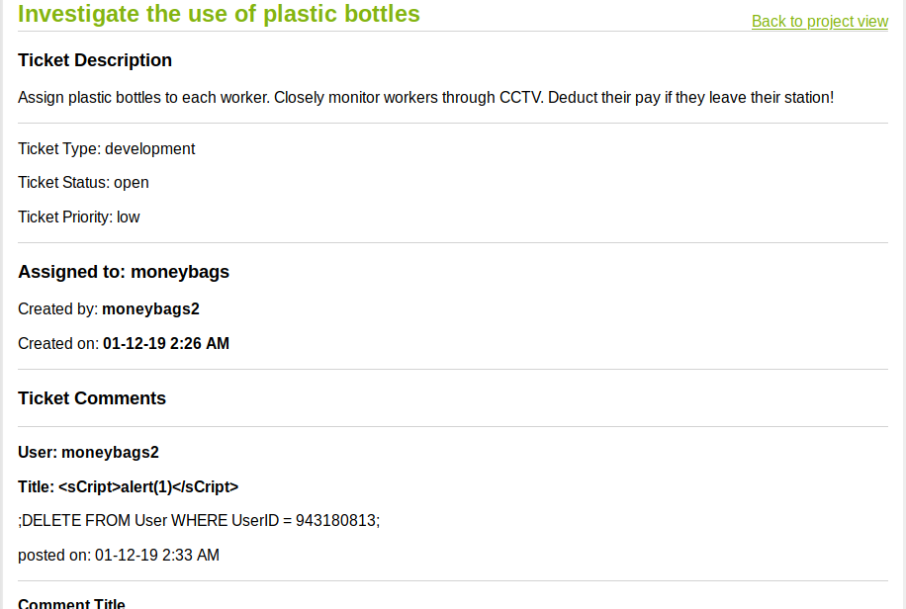Screenshot 34
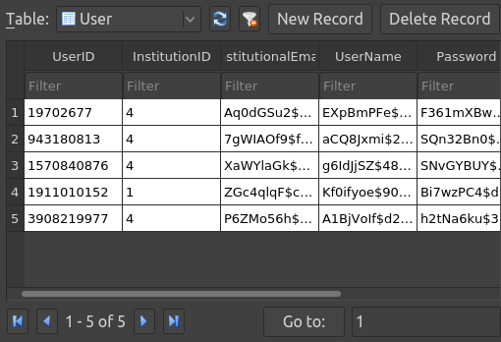Screenshot 35
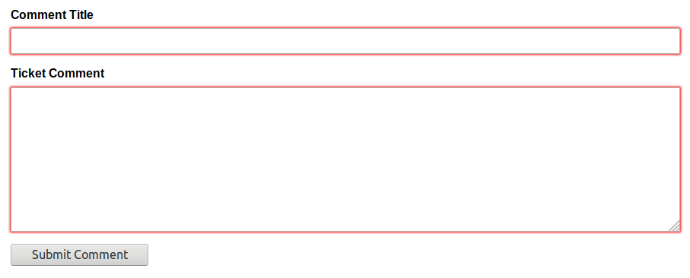Screenshot 36
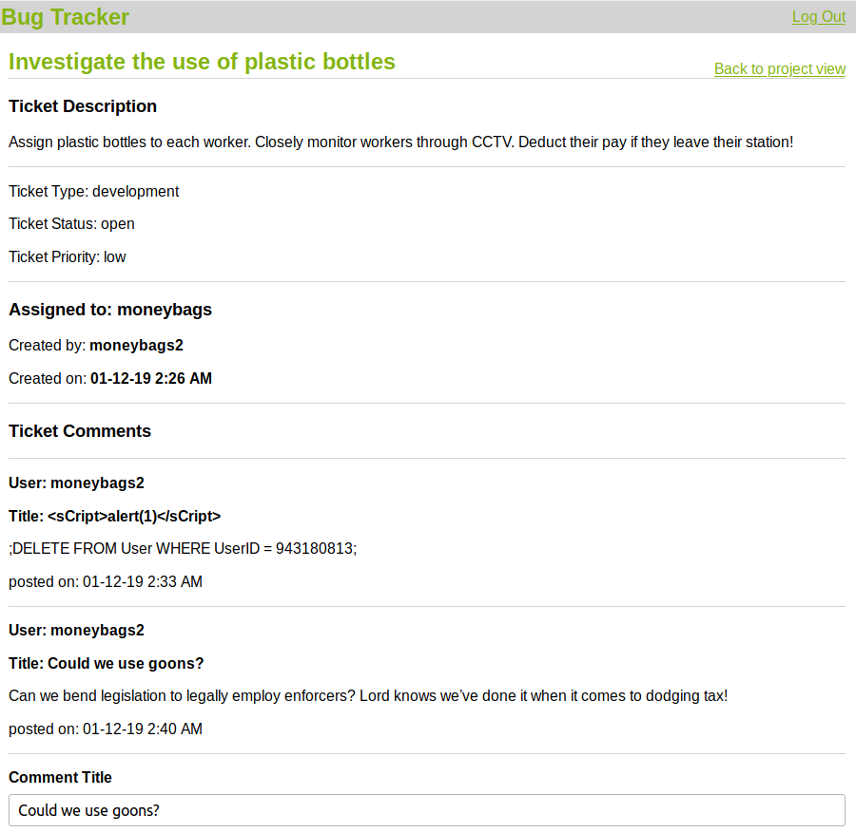Screenshot 37
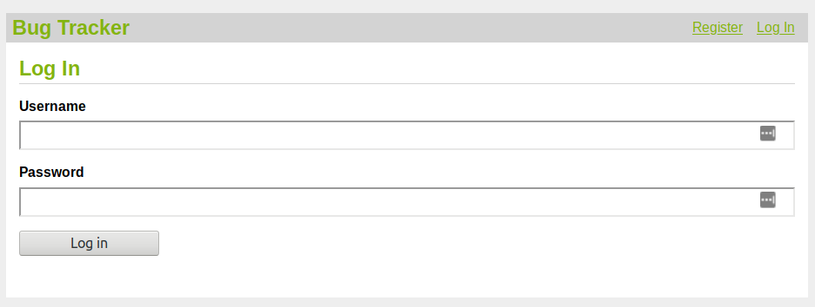Screenshot 38
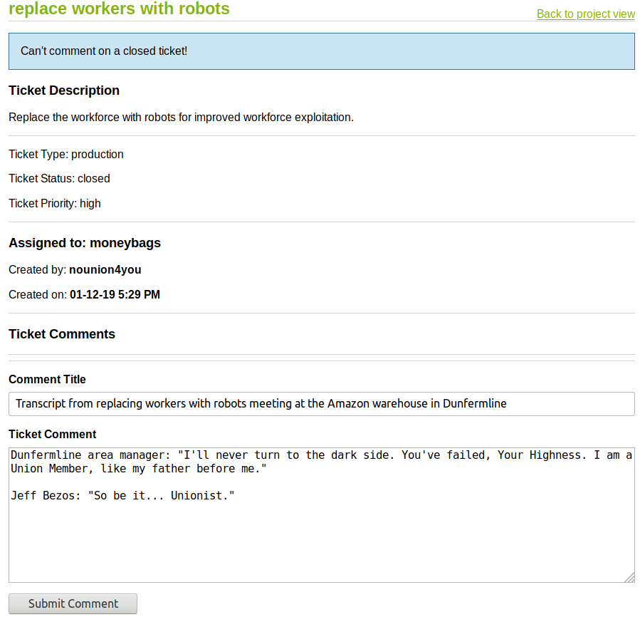Screenshot 39

