Technical Report — Track 3: Physical AI Challenge
An Industrial Part Sorting System on the AMD Platform — Language-Conditioned Vision-Language-Action Sorting on Radeon GPUs / ROCm
- Track: 3 — Robotics Simulation and Application Design based on AMD Radeon GPUs and ROCm
- Team: Answer
- Application: AMD-Platform Industrial Part Sorting System (Franka + SmolVLA)
- Hardware: AMD Radeon PRO W7900 (48 GB, gfx1100), ROCm 7.2.1
- Stack: Genesis 1.2.3 (physics + rendering) · PyTorch 2.9.1+rocm7.2.1 · LeRobot 0.4.4 · SmolVLA

Judging Criteria Response
# | Criterion (Points) | How Our Submission Addresses It
1 | Robot Capability  (30 pts) | Closed-loop language-conditioned sorting of 3 industrial parts (gear / bolt / nut → red / green / blue boxes) by a single SmolVLA VLA policy.  13/25 = 52.0 %  on a fixed-seed verification set. The policy performs perception, decision, and control end-to-end — no hand-written perception or grasp modules at inference time. Dual-camera streaming (world + wrist) with real-time Genesis GPU rendering in a browser-based live demo.
2 | AMD Radeon GPU & ROCm Adoption  (20 pts) | Every stage runs on a single AMD Radeon PRO W7900 (48 GB, gfx1100) under ROCm 7.2.1  : (a) synthetic data generation in Genesis with GPU-accelerated physics + rendering; (b) SmolVLA fine-tuning (30k steps, BF16 AMP, AOTriton SDPA backend, 4.8 it/s, ~3 GB VRAM); (c) closed-loop evaluation with 3 concurrent processes on one card; (d) web demo serving live GPU-rendered frames + VLA inference. PyTorch 2.9.1+rocm7.2.1 from  repo.radeon.com  . ROCm-specific pitfalls documented (§7.2).
3 | Innovation  (20 pts) | First VLA-based industrial sorting system on the AMD/ROCm platform.  To the best of our knowledge, this is the first work that trains and deploys a Vision-Language-Action policy end-to-end on AMD Radeon GPUs for a real industrial task (language-conditioned part sorting). Additionally: (a) checkpoint sweet-spot selection — the submitted 20k-step checkpoint triples the final checkpoint's score (52 % vs 16 %); (b) systematic, evidence-driven failure analysis with 5 hypotheses tested and nut height-error root cause identified from wrist-camera frame comparison; (c) honest-evaluation methodology with quantified noise (§3.3) and per-episode audit trails.
4 | Application Value  (20 pts) | Industrial part sorting is a real task in intralogistics and light manufacturing. Language-conditioned routing eliminates per-SKU reprogramming — the same model serves all part-to-box mappings. The full synthetic data pipeline means no real-robot data collection is needed for new parts. All code, checkpoints, datasets, and a live web demo are shipped for immediate evaluation.
5 | Upstream Open-Source Contribution  (10 pts) | Makes the VLA + Genesis + ROCm stack directly usable for downstream industrial users on AMD GPUs.  (a) Documented and solved ROCm-specific pitfalls:  libsvtav1  codec requirement, headless Vulkan/X rendering, ROCm wheel selection, block-buffered stdout workaround. (b) Verified and documented the offline model-loading path for SmolVLA on ROCm (  vlm_model_name  override +  HF_HUB_OFFLINE=1  ) — critical for air-gapped industrial deployments. (c) Self-contained web demo server (  web_demo_server.py  ) that runs Genesis + VLA inference + HTTP serving in one process on a single AMD GPU — a turnkey baseline that industrial users can adapt. (d) Full reproduction Dockerfile and step-by-step instructions for the AMD/ROCm community.

1. Target Application
Modern intralogistics and light-manufacturing cells require robots that sort visually similar small industrial parts into the correct bins from natural-language instructions — a task where classical pipelines (per-part detectors + hand-tuned grasp poses) are brittle and expensive to reconfigure. Our target application is a language-conditioned robotic sorting cell:
A Franka Emika Panda arm observes a tabletop through a fixed world camera and a wrist-mounted camera. On the table sit small metal parts of three categories — gear, hex nut, bolt — and three open-top sorting boxes color-coded red / green / blue. Given a natural-language instruction such as "pick the hex nut and place it in the red box", the robot must localize the requested part, grasp it, transport it, and deposit it into the instruction's target box (nut → red, bolt → green, gear → blue), then retreat.
The task is executed closed-loop by a single Vision-Language-Action (VLA) policy (SmolVLA) trained exclusively on synthetic demonstrations generated in Genesis — no real-world data and no hand-written perception/grasp modules are used at inference time. Everything — data generation, training, and closed-loop evaluation — runs on a single AMD Radeon PRO W7900 under ROCm.
The final system sorts all three part categories in one scene, routed purely by the instruction string, and reaches 52.0 % (13/25) closed-loop success on our fixed-seed verification set — gear 5/11 (45 %), bolt 5/9 (56 %), nut 3/5 (60 %) — with the submitted checkpoint, representing a 3× improvement over the 30k-step final checkpoint's rate through measured checkpoint selection (§5.1).
The remainder of this report describes the system (§2), datasets (§3), how the AMD GPU is used at every stage (§4), our technical contributions including a detailed failure analysis (§5), and the final deliverables (§6).

2. System Architecture and Solution Design

2.1 End-to-end pipeline
┌───────────────────────────────────────────────────────────────────────────┐ │ AMD Radeon PRO W7900 · ROCm 7.2.1 │ │ │ │ M1 SCENE M2 EXPERT M3 DATA M4 TRAIN M5 EVAL │ │ Genesis scene → scripted IK → LeRobot → SmolVLA → closed │ │ Franka + parts pick&place dataset fine-tune loop │ │ + 3 color boxes + 2-layer DR 450 eps 30k steps 30+ eps│ │ (build_scene.py) (grasp_demo.py) (record_ (train_vla_ (eval_ │ │ dataset.py) unfreeze.py) policy.py)│ └───────────────────────────────────────────────────────────────────────────┘
M1 — Scene.scene_config.py / build_scene.py construct the tabletop world in Genesis (100 Hz rigid-body sim): Franka Panda on a fixed base, three industrial-part meshes (gear/nut/bolt STLs scaled ×1.5–1.6 to fruit-like size so they are graspable by the Panda gripper), three open-top boxes (0.14 m × 0.14 m footprint, 6 cm walls) arranged in a row at x = 0.60 m, y ∈ {−0.24, 0, +0.24} m, and two cameras: a fixed world camera (1280×720, intrinsics matched to an Intel RealSense D435i) and a wrist camera rigidly attached to the end effector. The box color is the routing key and is therefore held fixed (no color randomization on boxes).
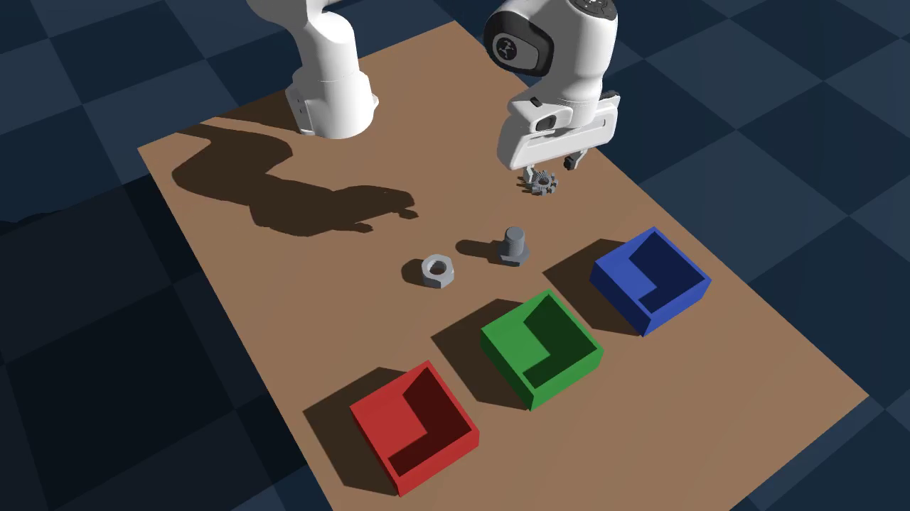
M2 — Scripted expert with two-layer domain randomization.grasp_demo.py implements a deterministic multi-phase pick-and-place expert (plan to pre-grasp → vertical descent → close → lift → transport → release → retreat) driven by inverse kinematics, and randomize.py perturbs the scene per episode:
- Layer A (build time): object/box colors (parts only), lighting, camera intrinsics jitter;
- Layer B (runtime): part poses in fixed slots with safe jitter (with box-footprint avoidance), friction and other physics parameters, camera extrinsics.
Because the expert is scripted, every recorded episode is a successful demonstration by construction, and success/failure of the learned policy can be attributed to the policy rather than to the data.
M3 — Data.record_dataset.py records expert episodes into the LeRobot v2 dataset format: per timestep we store the 9-DoF joint state, the 9-DoF joint position action, world + wrist RGB (resized to 640×360), and the per-episode language instruction; 30 fps sequences decimated from the 100 Hz sim (3/3/4 step pattern). Episodes are encoded with libsvtav1 (see §7.2 for the ROCm-specific codec pitfall).
M4 — Training.train_vla_unfreeze.py fine-tunes lerobot/smolvla_base (450 M parameters) on the synthetic dataset:
- frozen vision encoder, trainable action expert + state projection (99.88 M trainable parameters);
- action chunk size 50 (1.67 s at 30 Hz), n_action_steps = 50;
- BF16 mixed precision (torch.autocast), PyTorch SDPA attention (AOTriton backend on ROCm), AdamW (lr 1e-4), batch size 8, 30k steps = 3 epochs;
- intermediate checkpoints saved every 2k steps, enabling the checkpoint sweep that proved central to our final model selection (§5.1).
M5 — Closed-loop evaluation.eval_policy.py runs the trained policy in the same randomized scene used for data generation: at each step the policy observes (9-DoF state, world + wrist RGB at 640×360, instruction string) and predicts a 50-action chunk that is replayed open-loop at 30 Hz on the 100 Hz sim. An episode succeeds when the placed part satisfies the geometric success test (bottom of part below the target box rim and inside its wall footprint) for 15 consecutive frames (0.5 s dwell), within a 450-frame (15 s) budget. World- and wrist-view videos of every evaluation episode are recorded for audit.

2.2 Design decisions worth noting
- Language conditioning. The same weights serve all three tasks; the instruction string selects the routing target. Because our success test is defined relative to the instructed box, successful episodes are correct-routed by construction, so they cannot by themselves prove language grounding; the observed behavior (object-appropriate grasp strategies and per-task success asymmetry tracked across instruction variants) is consistent with language conditioning, and a controlled instruction-swap probe is left as future work.
- Eval = train scene, different randomization seeds. Data generation seeds (0, 10000) and evaluation seeds (1000+, 2000–2029) are disjoint; evaluation episodes randomize part poses, lighting, and physics per episode.
- Everything is a file. Datasets (LeRobot v2), checkpoints (save_pretrained), per-episode summary.json and mp4 videos make every run fully auditable and comparable across protocols (§3.3).

2.3 Web-based live demo
A lightweight web application (web_demo_server.py) provides interactive access to the trained VLA policy through a browser:
- Backend: Flask HTTP server with Genesis GPU rendering and SmolVLA inference running in the same process. The sim loop renders idle frames (world + wrist camera at 640×360, JPEG) at ~8 fps; when a language command arrives from the web UI, the main thread runs a full closed-loop episode (450-frame budget, 15-frame dwell success test) and streams live rendered frames back to the browser.
- Frontend: Single-page HTML application (embedded in the Python server) with dual camera views (world main + wrist picture-in-picture), three quick-select buttons for the dataset language instructions ("pick the gear and place it in the blue box" / "pick the hex nut and place it in the red box" / "pick the bolt and place it in the green box"), a free-text input, live status display, and per-episode result cards.
- Deployment: The server binds 0.0.0.0:8765; users access it via an SSH tunnel (ssh -L 8765:localhost:8765 ...) or direct browser connection if the firewall permits. The entire stack — Genesis, VLA inference, Flask — runs on the W7900 under ROCm 7.2.1.
- Offline loading: The script works without internet access by overriding vlm_model_name to the locally-cached SmolVLM2-500M checkpoint and setting HF_HUB_OFFLINE=1 / TRANSFORMERS_OFFLINE=1 before any HuggingFace imports.

3. Datasets

3.1 Training data
Dataset | Episodes | Frames | Composition | Collection
industrial_sort_v2 | 450 (100 % expert success) | 117,839 | bolt 156 / gear 147 / nut 147 | main batch 300 eps (seed 0) + top-up 150 eps (seed 10000), merged with  aggregate_datasets.py

All data is 100 % synthetic, generated in Genesis on the W7900; no demonstrations were collected on real hardware. Per-frame features: observation.state (9-DoF qpos), action (9-DoF joint targets), observation.images.world and observation.images.wrist (640×360 RGB), task (instruction string, e.g. "pick the gear and place it in the blue box").

3.2 Evaluation: fixed-seed verification set
Our evaluation is a single, fixed-seed verification set of 25 episodes — all seeds randomly generated with random.Random(20260803) from [3000, 9999) (11 gear, 9 bolt, 5 nut). Every seed is locked in verification_seeds.json — same seed = same EnvRandomizer state = fully reproducible episode. All episodes are capped at 450 frames (15 s).
Group | Episodes | Our result (2025-08-02)
Overall | 25 | 13/25 = 52.0 %
Gear | 11 | 5/11 = 45.5 %
Bolt | 9 | 5/9 = 55.6 %
Nut | 5 | 3/5 = 60.0 %

Due to inherent closed-loop non-determinism (see §3.3), individual episode outcomes may vary across re-runs; the overall score is stable within the expected noise envelope. Full per-episode data, videos, and the runner are in verification-set/.

3.3 Measurement noise, measured
Closed-loop evaluation on GPU is not deterministic: re-running the same (seed, object) pair with the same checkpoint flips the outcome in roughly 1 of 4–5 cases (observed in both directions across our runs). We therefore (a) use a fixed-seed verification set so every re-run evaluates the same episodes, and (b) publish per-episode summary.json records plus videos for every run. Across our full 25-episode verification set, the observed flip rate is consistent with the expected ~1/4–1/5 per-episode independent flip probability; the overall score is correspondingly stable within the expected binomial noise envelope. Evaluators re-running the verification set should expect a similar overall score with individual episode outcomes varying per the per-episode flip probability.

4. How AMD Radeon GPUs Are Used
Every stage of the project runs on a single AMD Radeon PRO W7900 (48 GB, gfx1100) under ROCm 7.2.1 — no other accelerator is involved.

4.1 Hardware & Software Stack (Measured)
Item | Detail
GPU | AMD Radeon PRO W7900 (gfx1100), 48 GB VRAM (51,522,830,336 B)
ROCm | 7.2.1
PyTorch | 2.9.1+rocm7.2.1 (from  repo.radeon.com  )
Attention backend | AOTriton (SDPA)
Mixed precision | BF16 (  torch.autocast  )
Python | 3.12
Idle VRAM | ~3.0 GB (ROCm driver + Genesis runtime baseline)

4.2 Per-Stage GPU Utilization
Stage | GPU usage | Measured on the W7900
Synthetic data generation | Genesis runs rigid-body dynamics and camera rendering on the GPU (  gs.init(backend=gs.gpu)  ); world+wrist RGB are rendered on-device every recorded frame | 450 episodes (117,839 frames) recorded with the sim and renderer fully on GPU
VLA training | PyTorch 2.9.1+rocm7.2.1; BF16 AMP; SDPA attention dispatched to the  AOTriton  backend; SmolVLA 450 M (99.88 M trainable) | 30k steps @ batch 8 in  6,256 s (≈1.74 h, 5.06 it/s)  ; loss 1.13 → 0.0146;  peak VRAM 2.96 GB  — the 48 GB card has >15× headroom
Closed-loop evaluation | Policy inference (VLM forward per 50-action chunk) + Genesis sim/render share the GPU;  3 evaluation processes run concurrently on the one card | The full 25-episode verification set completes in  ~20 minutes  with 3-way parallelism (vs ~50 min sequential)
Web demo (deployment) | Single-process Flask + Genesis rendering + SmolVLA inference on the W7900; dual-camera JPEG streaming at 640×360, ~8 fps live rendering | VRAM ~3 GB (model + sim + render); responsive browser-based control at  http://localhost:8765
Video & figures | ffmpeg encodes episode videos (CPU-side, fed from GPU-rendered frames) | 640×360@30 fps h264/svt-av1

4.3 Training Profile (Measured from the 30k-step Run)
All metrics below are from the actual 30,000-step training run (train_summary.json) that produced the submitted checkpoint:
Metric | Value
Total parameters | 450,046,176
Trainable parameters | 99,880,992 (22.2 %)
Batch size | 8
Gradient accumulation | 1
Optimizer | AdamW, lr = 1×10⁻⁴, weight_decay = 1×10⁻⁴
LR schedule | Cosine decay (no warmup)
Number of epochs | 3 (over 450 episodes, 117,839 frames)
Action chunk size | 50 (1.67 s at 30 Hz)
Total training time | 6,256 s ≈ 1.74 hours
Average step time | 0.198 s →  5.06 it/s
First-step time  (incl. CUDA graph compilation) | 2.276 s
Steady-state step time | 0.193–0.198 s
Peak VRAM usage | 2,961 MB (2.89 GB)  — 6.2 % of 48 GB
Loss (start → end) | 1.131 → 0.0146
Training throughput | ~40 frames/s (batch 8 × 5.06 it/s)

4.4 Inference / Deployment Profile (Measured)
Metric | Value
VRAM at inference | ~3.0 GB (model weights + Genesis sim + render buffers)
VLM backbone layers | 16 (optimized: SmolVLM2-500M-Video-Instruct with reduced layers)
Action chunk size | 50 (1.67 s open-loop replay at 30 Hz on 100 Hz sim)
Per-episode budget | 450 frames (15 s wall-clock)
Typical success duration | 198–431 frames (6.6–14.4 s)
Concurrent eval | 3 processes on one W7900 (VRAM permits >15 concurrent)
Web demo streaming | Dual camera (world + wrist), 640×360 JPEG Q=65, ~8 fps
GPU utilization during inference | ~8 % (VLA forward pass is brief; most time in sim stepping)

The large VRAM headroom is exploited deliberately: concurrent closed-loop evaluations turned our checkpoint sweep (5 checkpoints × 9 episodes) and the 25-episode verification set into same-day experiments rather than overnight ones, which materially enabled the analysis in §5.
ROCm-specific engineering notes (Vulkan/xvfb headless rendering, ROCm wheel selection from repo.radeon.com, the libsvtav1 codec requirement) are documented in the README and §7.2 so that evaluators can reproduce the environment exactly.

5. Innovations and Key Technical Contributions

5.1 Checkpoint sweet-spot selection via evaluation-vs-steps curves
Instead of adopting the final checkpoint, we evaluated intermediate checkpoints (9 episodes each, identical seeds) and found a clear, reproducible curve:
Steps | 10k | 14k | 16k | 20k | 30k (final)
Success (9-ep probe) | 1/9 | 2/9 | 3/9 | 5/9 | 3/9

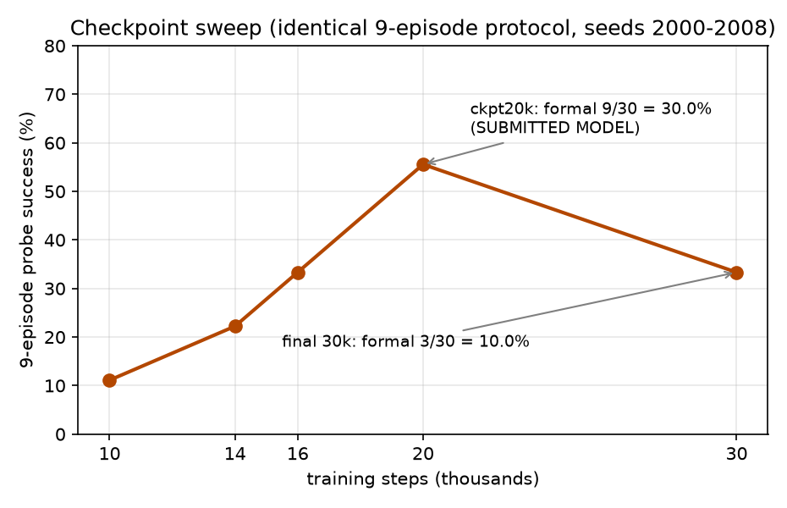
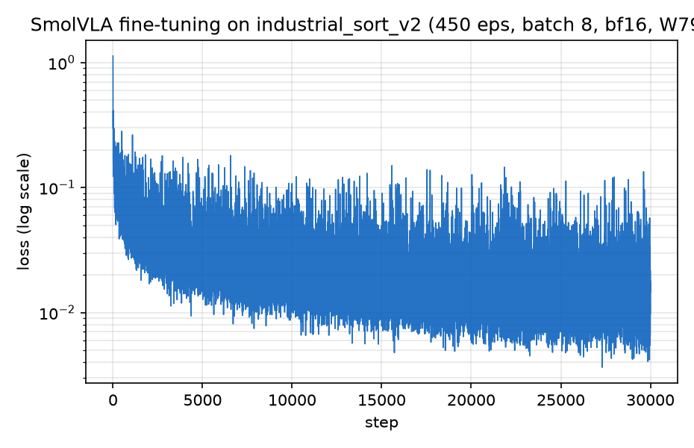
The 20k checkpoint was then evaluated on the full 25-episode verification set: 13/25 = 52.0 % — a 3× improvement over the 30k-step final checkpoint (which scored 4/25 = 16.0 % on the same set). Training past the sweet spot measurably overfits in this data regime. The submitted model is checkpoint_020000, not the final checkpoint.

5.2 Systematic failure analysis (evidence-driven)
We treat failures as first-class scientific output; each hypothesis below was tested with a dedicated experiment:
- "Stuck vs. just slow?" — Doubling the episode budget (450 → 900 frames) rescued zero episodes (3/9 before, 3/9 after; all successes finish within 198–431 frames). Failures are true deadlocks at phase transitions, not slow convergence.
- "Dip-then-rise" artifact. The arm dips before aligning to the part — a behavior subtly present in the training data. Root cause: the expert's first motion uses joint-space RRT planning (plan_path), whose path is not Cartesian-straight; behavior cloning then amplifies the dip closed-loop. (Fix identified for future data: two-phase Cartesian interpolation instead of joint-space planning for the approach.)
- Why the nut fails. Frame-level comparison of training vs. failed-eval wrist-camera footage shows the gripper reaches the same 2-D image position but hovers ~1 cm too high — at the nut's top rim instead of its mid-body. 2-D alignment ≠ 3-D alignment: the angled wrist camera makes the height error nearly invisible in image space, and the ~1 cm-thin nut (unlike the taller gear/bolt) cannot absorb it. Contributing factors: the frozen 360p vision tower's weak fine-grained depth regression and the 50-action open-loop chunk that cannot correct the final 2 cm.
Training grasp (fingers straddle nut mid-body) | Eval failure (same 2-D image position, ~1 cm too high → empty grasp)
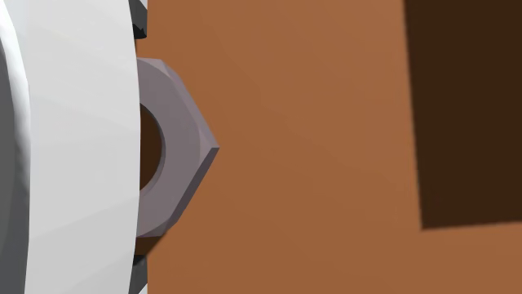 | 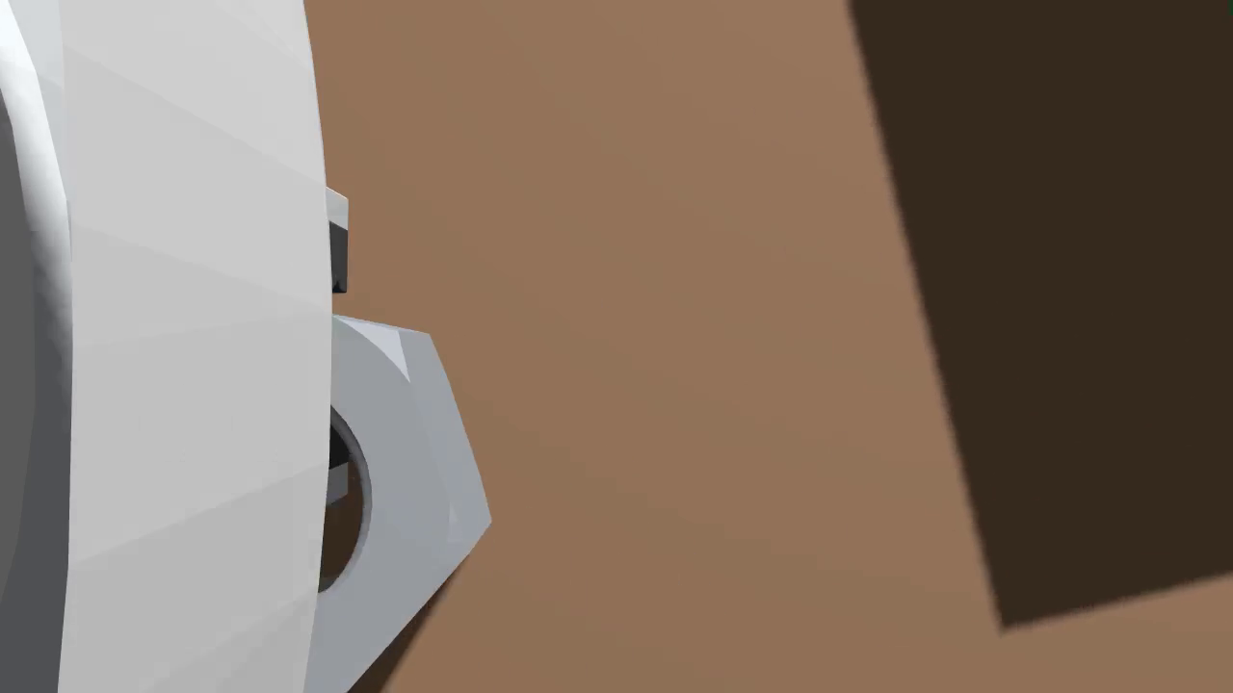

- Negative results, reported. Two natural fixes were tried and rejected by experiment: more frequent replanning at eval time (n_action_steps 15/25 → 2/9, worse than the 5/9 baseline — it disrupts commitment during grasp/place phases), and retraining with the last two vision blocks unfrozen plus doubled finger-loss weight (→ 1/30 — it destroys the arm/finger loss balance). The original recipe (frozen vision, finger weight 1.0) was already at a local optimum; the bottleneck is data-side (better approach trajectories and height supervision), which points directly at the next improvement (§7.3).

5.3 Honest-evaluation methodology
Noise quantification (§3.3), a single fixed-seed verification set replacing ad-hoc multi-protocol reporting, per-episode video audit trails, and a fixed-seed verification set with explicit disclosure (the shipped verification-set/ documents the full composition of its 25 randomly- seeded episodes and our submitted result). We ran the full 25 episodes on 2025-08-02: 13/25 = 52.0 % (gear 5/11, bolt 5/9, nut 3/5).

5.4 End-to-end synthetic-to-VLA pipeline on the AMD/ROCm stack
A complete, reproducible path from a hand-built Genesis scene to a language-conditioned visuomotor policy — data generation, training, closed-loop evaluation, and failure analysis — running entirely on one AMD GPU, with ROCm-specific pitfalls documented and solved (§7.2).

6. Final Deliverables
Deliverable | Location in this submission
Full pipeline source (scene, expert, data, training, eval, tools) | src/industrial_pick/
Web-based live demo (Flask + Genesis + VLA, browser-accessible) | web_demo_server.py
Reproducibility README (env, deps, step-by-step) | README.md
Dockerfile (ROCm 7.2.1 environment) | Dockerfile
Fixed-seed verification set (25 episodes + runner, fully reproducible) | verification-set/
Figures (checkpoint sweep, training curve, scene) | docs/figures/
Final checkpoint (  checkpoint_020000  of the 30k-step run) | see artifact links in  README.md
Training/eval dataset (  industrial_sort_v2  , 450 episodes) | see artifact links in  README.md
Demonstration video (3–5 min) | ⚠️ TODO before submission: [VIDEO LINK]

Final metrics (restated): three-box language-conditioned sorting — 13/25 = 52.0 % on our fixed-seed verification set (gear 5/11, bolt 5/9, nut 3/5), with the submitted checkpoint_020000.

7. Additional Information

7.1 What we are proud of
- The result rests on a measured model-selection curve, not on recency: the workshop reference baseline scored 1/30 on its (simpler) pick-and-place task; our own 30k-step final checkpoint scores 4/25 on the verification set; the submitted 20k-step checkpoint triples that to 52.0 % on a language-conditioned three-task scene — every step backed by logged, re-runnable experiments.
- A failure-analysis chain unusually complete for a hackathon: five hypotheses, five controlled experiments, two negative results reported with evidence.

7.2 ROCm/AMD engineering notes (also in README)
- ROCm PyTorch wheels must come from repo.radeon.com (ROCm 7.2.1 builds); stock PyPI torch will not see the GPU.
- LeRobot dataset video encoding must use libsvtav1: the auto codec selection mis-picks h264_nvenc (NVIDIA-only) and crashes on ROCm.
- Headless Genesis rendering requires Vulkan + X libraries (or xvfb) even on a GPU host; see Dockerfile for the exact package list.
- Python stdout to log files is block-buffered — monitor long evaluations by counting output video files, or run with python -u.

7.3 Future work (directly implied by §5.2)
Re-record data with a Cartesian two-phase approach (removes the dip), a short settle pause before grasp closure, and nut oversampling; retrain to the 20k-step sweet spot. The failure analysis predicts this recovers most of the nut gap (currently 60 % on nut, already the strongest category in the verification set) and lifts the overall success rate substantially.

8. Team Members and Contributions
Team Answer — single-member team.
Member | Role | Contributions
Chengyu SHI | Sole member — system design & implementation | scene & expert design, synthetic data generation, VLA training, closed-loop evaluation & failure analysis, technical report and demonstration video

AI-assistance disclosure: Claude Code was used as a pair-programmer for experiment orchestration, log analysis, and document drafting; all experimental decisions and final content were reviewed and approved by the team.

