Nova
Private Local Research Assistant
Project Specification Document
AMD AI DevMaster Hackathon — Track 2: Development & Local Deployment of Private AI Agents
Submitted by: DohaIsianioui

1. Application Scenarios
Nova is a fully local, private AI agent that answers questions grounded in a user's own documents, invokes local tools, and remembers conversation context — with all core inference running on an AMD Radeon GPU via the ROCm software stack. It targets the "local knowledge base Q&A assistant" use case defined in the Track 2 brief, extended with tool invocation and privacy controls so it functions as a general-purpose private research assistant rather than a single-purpose demo.
Primary application scenarios:
- Personal research assistant — grounding answers in a user's own notes, papers, or technical documentation without sending that content to any third-party API.
- Private knowledge base Q&A — teams or individuals who need to query internal documents (specifications, manuals, reports) locally, with no data leaving their own infrastructure.
- Lightweight office automation — quick file lookups and calculations handled by local tools rather than round-tripping through a cloud service.
Target users: individuals and small teams who need grounded, explainable answers from their own documents, and who care about keeping that data under their own control — a direct match for the "private AI Agent" framing of this track.

2. Agent Architecture
Nova's orchestration deliberately favors a transparent, rule-based intent router over a black-box function-calling loop. Every user turn is routed to exactly one grounding source — a tool, retrieved document chunks, or none — before the prompt reaches the model. This keeps tool-selection behavior auditable (important for a "private" agent handling potentially sensitive queries) and avoids the latency cost of an extra LLM round-trip just to decide whether to call a tool.
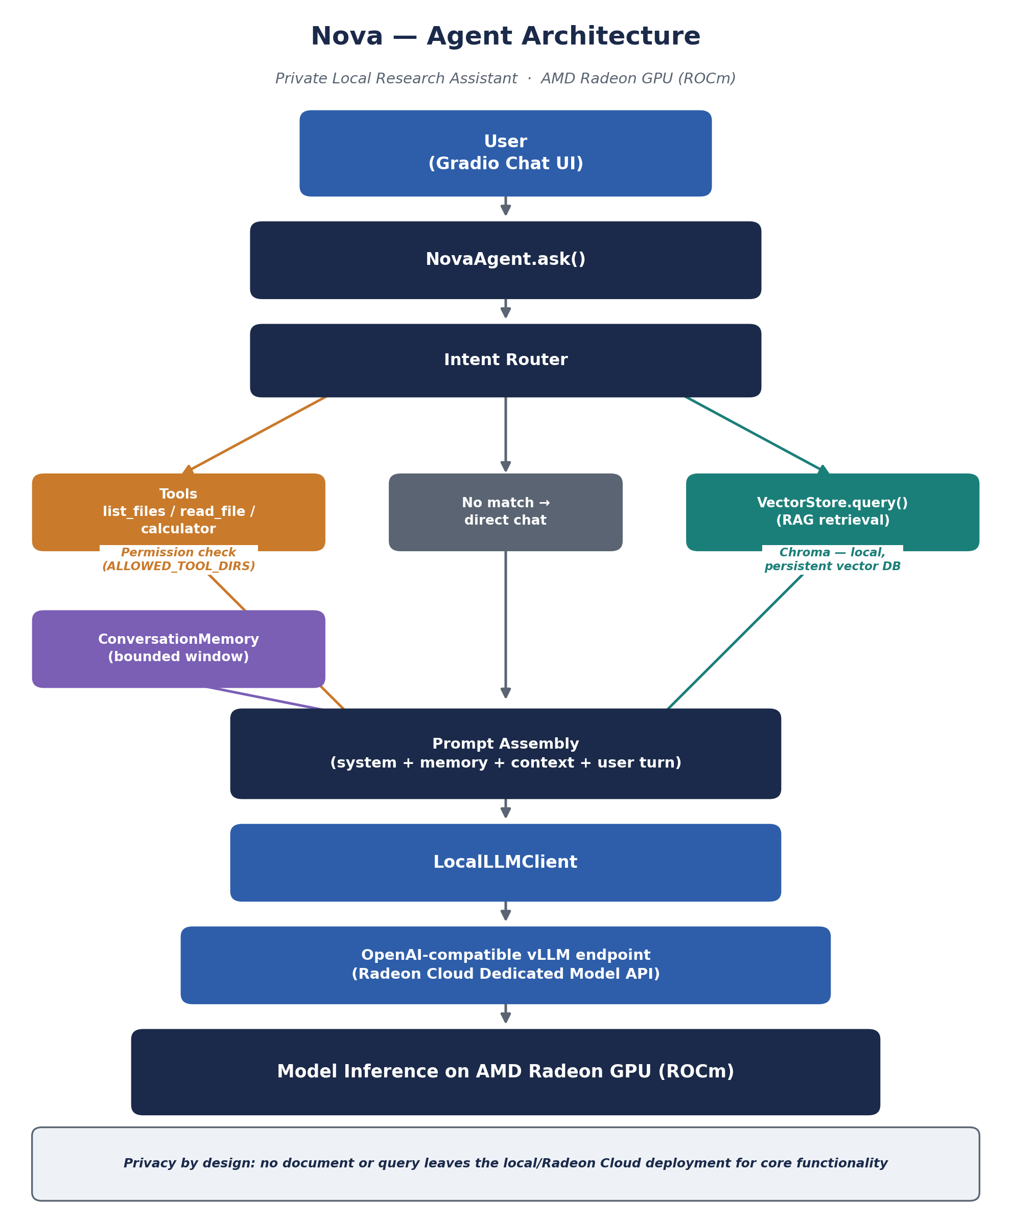
Pipeline for each user turn:
- Route — the intent router matches the query against tool patterns (list files, read file, calculator); if none match, it falls back to RAG retrieval when the knowledge base is non-empty, or direct chat otherwise.
- Gather context — the matched tool executes (permission-checked), or the top-k nearest chunks are retrieved from the local Chroma vector store.
- Assemble prompt — a system prompt, the recent conversation window, any retrieved/tool context, and the new user turn are combined.
- Infer — the assembled prompt is sent to the local vLLM endpoint (Radeon Cloud Dedicated Model API), running on the AMD Radeon GPU.
- Record — the turn and response are appended to the bounded conversation memory for subsequent turns.

3. Introduction to Core Capabilities
Nova implements three of the five Track 2 capabilities, plus the permission-control mechanism as a differentiator (four total, exceeding the minimum of two required):
Capability | Implementation
Local knowledge retrieval (RAG) | Documents are chunked, embedded locally (sentence-transformers, BAAI/bge-small-en-v1.5), and stored in a persistent Chroma vector database. User queries are embedded and matched against the closest chunks, which are injected into the model prompt as grounding context.
Tool invocation | A lightweight intent router matches user queries against registered tools (list_files, read_file, calculator) and dispatches to local Python handlers before falling back to RAG or direct chat, keeping tool-use behavior transparent and auditable.
Local multi-turn memory | A bounded, in-process conversation window (ConversationMemory) retains the most recent turns and is included in every prompt, allowing natural follow-up questions without external persistence.
Permission control & privacy protection | File-access tools resolve and validate every path against an explicit allow-list (ALLOWED_TOOL_DIRS) before touching disk. Any path outside the allow-list is refused automatically, regardless of how the request is phrased.

Design note: capabilities were deliberately kept composable and independently testable — each has dedicated unit tests (tests/test_agent.py) that mock the LLM and vector store, so routing and permission logic can be verified without a live GPU, in addition to end-to-end verification against the real deployed model.

4. Model Introduction & Local Deployment Plan

4.1 Model
Primary model: Qwen/Qwen2.5-7B-Instruct — a 7B-parameter instruction-tuned model chosen for a strong quality/VRAM tradeoff on a single Radeon GPU instance, and reliable performance on grounded, tool-augmented prompting.
Fallback model: Qwen/Qwen2.5-3B-Instruct, used if the primary model is VRAM-constrained on the provisioned instance.
Embedding model: BAAI/bge-small-en-v1.5, chosen to stay lightweight so it does not compete heavily with the main LLM for GPU resources.

4.2 Deployment Plan
Nova's LLM backend is deployed directly through Radeon Cloud's vLLM Dedicated Model API rather than a self-managed build, keeping the setup reproducible for evaluators:
- Container image: vllm-dev:rocm7.2.1_navi_ubuntu22.04_py3.10_pytorch_2.9_vllm_0.16.0 (Radeon Cloud template, ROCm 7.2.1 + vLLM 0.16.0 pre-installed).
- Deploy Type: vLLM Model API, with Serve Command: vllm serve Qwen/Qwen2.5-7B-Instruct --host 0.0.0.0 --port 8000.
- The platform exposes a dedicated, OpenAI-compatible Base URL (.../spaces/<id>/8000/v1), Model name, and API Key, which are provided to Nova via three environment variables (NOVA_LLM_BASE_URL, NOVA_LLM_MODEL_NAME, NOVA_LLM_API_KEY).
- Nova's own process (ingestion + Gradio UI) runs in the same Radeon Cloud environment via a JupyterLab terminal or SSH session, so the full pipeline — from document ingestion to model inference — executes on AMD Radeon hardware.
This satisfies the requirement that core inference execute locally on AMD Radeon GPU: no remote third-party API is used for the LLM or the embedding model.

5. Optimization Description for Inference Speed on AMD Radeon GPU
- vLLM's continuous batching and PagedAttention (used automatically by vllm serve) provide strong throughput on a single Radeon GPU without additional manual tuning.
- A 7B-parameter instruct model was selected specifically to fit comfortably within a single Radeon GPU instance's VRAM while retaining strong instruction-following quality; a 3B fallback is defined for more constrained instances.
- The embedding model is intentionally small (bge-small-en-v1.5) so RAG retrieval does not compete with the main LLM for GPU memory or compute during a turn.
- Conversation memory is capped (MEMORY_MAX_TURNS) to bound prompt length, which keeps per-turn latency predictable as a session grows longer.
- RAG retrieval uses a fixed top-k (default 4) and moderate chunk size (800 characters, 120 overlap), balancing answer groundedness against prompt length / inference time.
- The platform-required --host 0.0.0.0 --port 8000 serve configuration is preserved exactly, ensuring the routed endpoint remains stable across redeploys.

Appendix — Technology Stack Summary
Component | Choice
LLM inference | Qwen2.5-7B-Instruct (fallback: Qwen2.5-3B-Instruct), served via vLLM on Radeon Cloud's Dedicated Model API, exposing an OpenAI-compatible endpoint backed by an AMD Radeon GPU running ROCm 7.2.1.
Embeddings | sentence-transformers, BAAI/bge-small-en-v1.5 — lightweight, runs locally, GPU-accelerated automatically when a ROCm-enabled PyTorch build is present.
Vector store | Chroma, local persistent client — no external database service required.
Agent orchestration | Custom, transparent intent router (no black-box function-calling loop) implemented in src/agent.py — chosen over a heavier framework to keep tool-selection behavior auditable, which matters for a privacy-focused agent.
UI | Gradio ChatInterface, served locally on the deployment instance.
Container image | vllm-dev:rocm7.2.1_navi_ubuntu22.04_py3.10_pytorch_2.9_vllm_0.16.0 (Radeon Cloud template, pre-configured with vLLM 0.16.0 on ROCm 7.2.1).
Full source code, README, and reproduction instructions are included in the accompanying project source code submission.

