LifePreview
Project Profile

AI-Powered Life Story Generation and Experience Platform · Product Logic and AMD Technical Validation
English Edition · August 6, 2026

Contents
1 Executive Summary 4
2 Project Background 5
3 Target Users and Use Cases 6
3.1 Target Users 6
3.2 Use Cases 6
4 Product Solution 7
4.1 Life Overview 7
4.2 Curated Moments 7
4.3 Custom Journey 8
4.4 Immersive Viewing and Further Exploration 8
4.5 Product Value 9
5 Current Prototype and Demo Flow 10
5.1 Current Prototype Status 10
5.2 User-Side Demo Flow 11
5.3 Frontend-Backend Interaction 11
5.4 AMD-Compatible Runtime Flow 12
5.5 Three Life Overview Films 14
6 End-to-End Processing Flow 18
6.1 Overall System Architecture 18
6.2 User Intent and Task Creation 20
6.3 Research and Evidence Construction 20
6.4 Script and Storyboard Generation 20
6.5 Character References and Asset Generation 21
6.6 Native Audio-Video Generation 21
6.7 Automated Quality Control and Retry 21
6.8 Assembly and Media Delivery 22
7 AMD Technologies 23
7.1 AMD Runtime Platform 23
7.2 ROCm and PyTorch Compatibility 23
7.3 gfx1100 Model Adaptation 23
7.4 Single-GPU Scheduling Strategy 24
7.5 VRAM and System Memory Control 24
7.6 AMD Model Test Results 24
7.7 AMD Audio-Video Generation Validation 25
7.8 Browser Media Delivery Compatibility 25
8 Prototype Validation and Results 26
8.1 Frontend Validation 26
8.2 Frontend-Backend Interaction Validation 26
8.3 Validation of the Three Completed Films 27
9 Conclusion and Next Steps 28
9.1 Current-Stage Results 28
9.2 AMD Technical Results 28
9.3 Product and Content Results 28
9.4 Next Steps 29

Executive Summary
LifePreview is an AI-powered platform for generating and experiencing stories of remarkable lives. It transforms fragmented biographical material into concise, immersive narrative videos that can be explored in increasingly personalized ways, enabling users not only to know who a person was, but also to understand how experience, choice, and historical context shaped that life.
The product offers a three-layer experience. Life Overview builds a coherent map of an entire life in about 90 seconds; Curated Moments explores the pivotal moments that changed its course; and Custom Journey will allow users to generate the life story they genuinely want to see around a person, experience, or question. Users begin by watching a life, move closer to a defining moment, and ultimately help choose the direction of the story.
The current demo includes three completed Life Overview films featuring Steve Jobs, Su Dongpo, and Frida Kahlo, as well as a Curated Moment about the garage where Steve Jobs began building Apple. It also connects the key interactions for browsing people, choosing stories, managing tasks, and playing or downloading media. At this stage, the films are primarily generated offline with AI and then integrated into the product. Task APIs, media delivery, and FLUX.2 and MiniMax H3 Ref2VA inference on AMD Radeon gfx1100 / ROCm 7.2.1 have all been validated in real runs. One-click long-form generation for any person or question remains the next productization milestone.

Project Background
People are often introduced through a handful of labels: founder, artist, poet, reformer. Labels help us remember quickly, but they compress the circumstances, choices, and costs that shaped a life. Encyclopedias, timelines, and profiles can explain what happened, yet they often leave users to reconstruct the causal relationships and emotional experience required for genuine understanding.
Short-form video lowers the barrier to entry, but often trades context for a single highlight or sensational fragment. Full-length biographies offer depth, but demand more time and may still not address the question a user actually cares about. A clear experience gap remains between entering a life quickly and understanding it deeply.
On the production side, a high-quality biographical film requires research and fact-checking, narrative selection, storyboard design, identity consistency, audio-video generation, quality control, and media assembly. Conventional production depends heavily on specialist collaboration, takes time, and carries a high marginal cost, making it difficult to scale across people, life stages, and user questions.
Multimodal generative AI makes it possible to move from fixed films to a computable, recomposable narrative service. LifePreview's opportunity is not simply to turn biographical information into video, but to build a generation pipeline from credible evidence to narrative understanding and immersive expression, giving every user a lower-friction way into a life. Its product promise is: Unearth a story. Experience a life.

Target Users and Use Cases

Target Users
- Core users: younger content audiences who habitually learn through short-form video and want to understand a person quickly and intuitively, without settling for fragmented labels or sensational narratives.
- Learning users: students, young professionals, and lifelong learners who want to build a coherent biographical timeline and understand key choices and historical context with a limited time investment.
- Interest-driven users: people already interested in figures from history, art, business, and culture who want to re-enter a familiar life through a new question or life stage.
- Creative users: content creators who need character research, a narrative angle, a script draft, storyboard direction, or visual references.
- Extension users: educational, museum, and cultural institutions seeking a more intuitive format for courses, exhibitions, and cultural communication.

Use Cases
- Rapid orientation: build a timeline, understand the major turning points, and form an overall view through an approximately 90-second Life Overview.
- Deep exploration of a pivotal moment: understand the circumstances, conflict, options, cost, and lasting consequences surrounding a decision.
- Question-led exploration: reorganize a person's experiences around questions such as 'Why did they make that choice?' or 'How did that experience change them?'
- Learning and cultural communication: turn abstract biographical knowledge into narrative material that can be watched, discussed, and shared.
- Creative support: provide a workable starting point for subject selection, story structure, scripts, storyboards, and visual assets.
- Further reading and discussion: use the film as an entry point into related sources, works, and thematic conversations.

Product Solution
LifePreview does not treat a single video as the product endpoint. It creates a progressive path into a life: Life Overview establishes the full context, Curated Moments moves into decisive turning points, and Custom Journey will generate a personal story around the user's own question. Together, the three layers address rapid orientation, deeper understanding, and personalized exploration, forming a biographical content product designed to expand over time.

Life Overview
From a person's profile, users enter an approximately 90-second Life Overview. Rather than mechanically listing dates and achievements, the system selects events that explain how the person changed, preserving chronology, causality, and emotional progression so users can form an integrated understanding in a short time. The current demo provides Life Overviews for Steve Jobs, Su Dongpo, and Frida Kahlo.

Curated Moments
Curated Moments pauses at a specific point that changed the course of a life, revealing the background, central conflict, choice, cost, and later consequences. It is not a repeated excerpt from the Life Overview; it moves the user from knowing what happened to understanding why it happened. The current demo includes the Curated Moment about Steve Jobs's garage beginnings. Figure 1 shows the character entry point and content hierarchy.
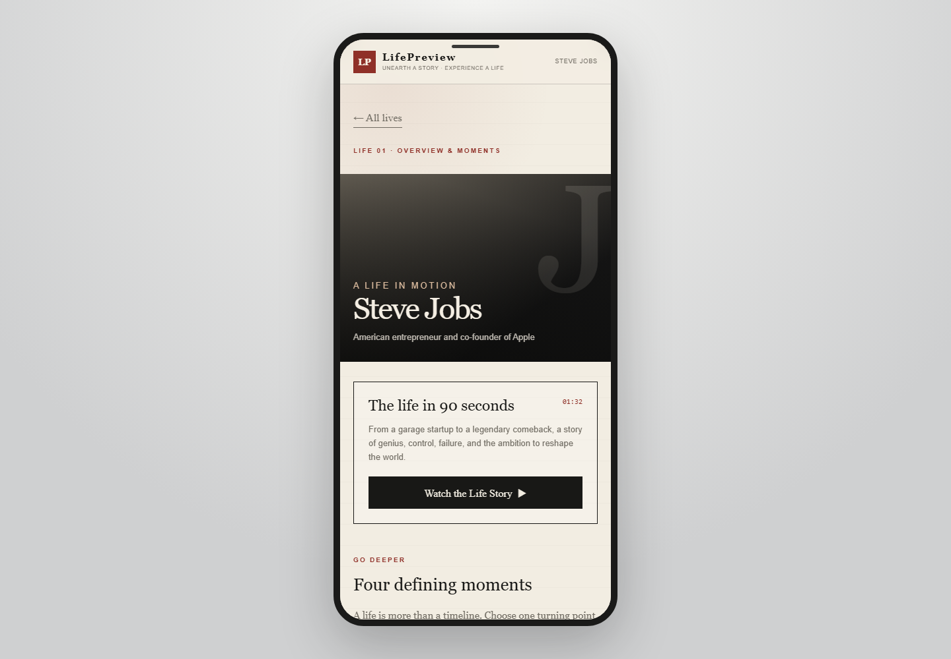
Figure 1. LifePreview profiles and story entry points

Custom Journey
In the future, users will be able to enter a person, experience, or specific question. The system will first generate a Director's Preview in a short time, explaining the context, central conflict, narrative angle, and emotional direction in text. Only after the user confirms will it create the more compute-intensive asynchronous video task. This mechanism reduces wasted generation while giving users a clear expectation before production begins. The current prototype has validated the Director's Preview interface and task interaction; stable end-to-end generation from arbitrary input to a complete long-form film is still being productized.

Immersive Viewing and Further Exploration
The result is presented as a continuous audio-visual narrative, combining character imagery, changing environments, native audio, and shot rhythm so users can understand circumstances and turning points through the viewing experience. The player supports playback, pause, seeking, and download. Future extensions can connect the film to source material, related works, thematic discussion, and sharing, making it an entry point for deeper understanding rather than one-off content consumption.

Product Value
- Cognitive value: transform label-based profiles into life stories with chronology, causality, and emotional progression.
- Experience value: use a progressive Overview-Moment-Custom structure to combine a low-friction entry point with deeper exploration.
- User value: let the user's question shape how the story is organized, shifting from passive reception of fixed content to active choice of narrative angle.
- Production value: connect evidence, scripts, character assets, audio-video generation, quality control, and delivery into a reusable production pipeline.
- Scale value: reduce the marginal cost of adding new people and narrative perspectives, with room to expand into education, cultural communication, and content creation.

Current Prototype and Demo Flow

Current Prototype Status
The current prototype completes the key interactions among the frontend, task interface, and media-delivery interface. The product presents profiles, Life Overviews, Curated Moments, the Director's Preview, and story playback; the backend provides task status and media resources; and the browser accesses video through signed URLs for online playback and download. The current demo uses pre-generated films to validate the core viewing experience, while runnable interfaces and model smoke tests validate the critical technical nodes required for future one-click generation.
LifePreview uses a bright, restrained editorial visual language. Profile cards provide the main exploration entry point; person pages arrange Life Overview and Curated Moments as progressive content; the Director's Preview confirms story direction; and the video page carries the final viewing experience. Figure 2 shows the profile entry page, and Figure 3 shows story playback.
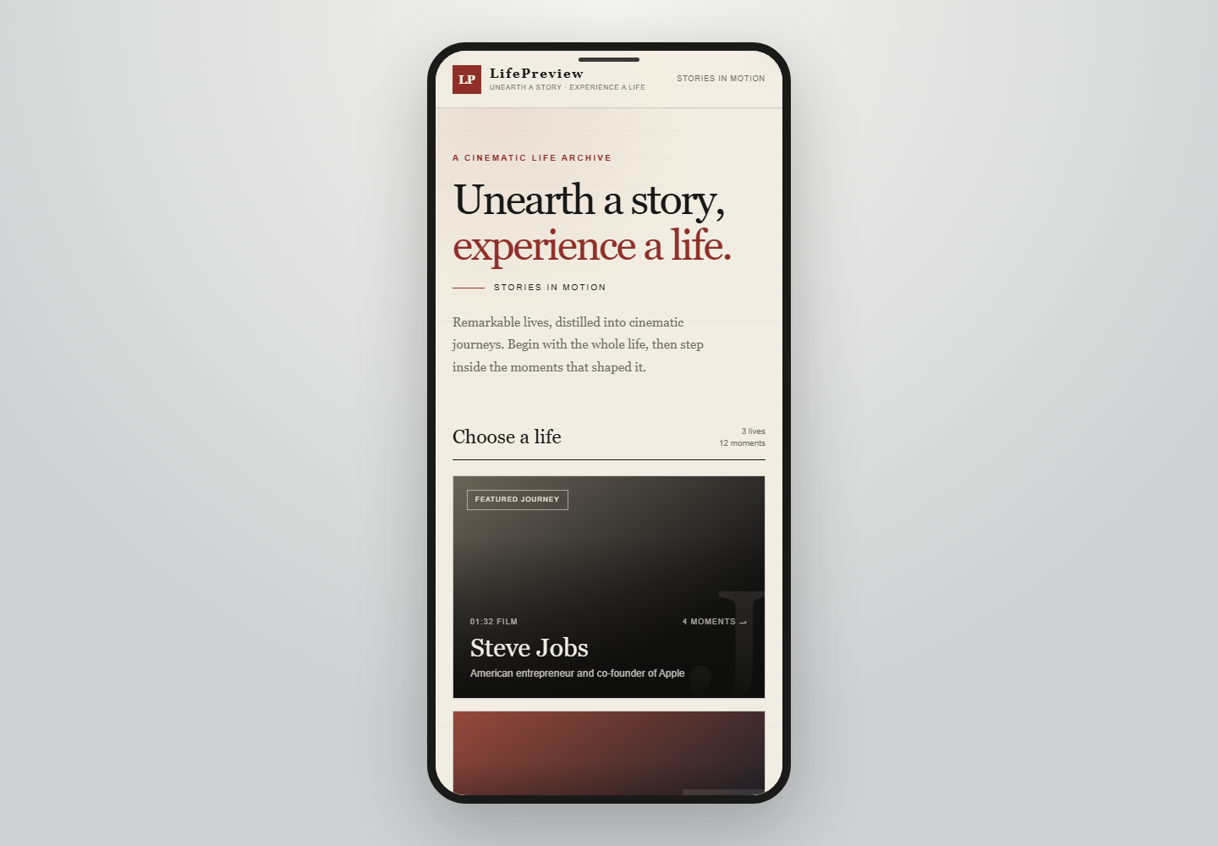
Figure 2. LifePreview home page and profile selection
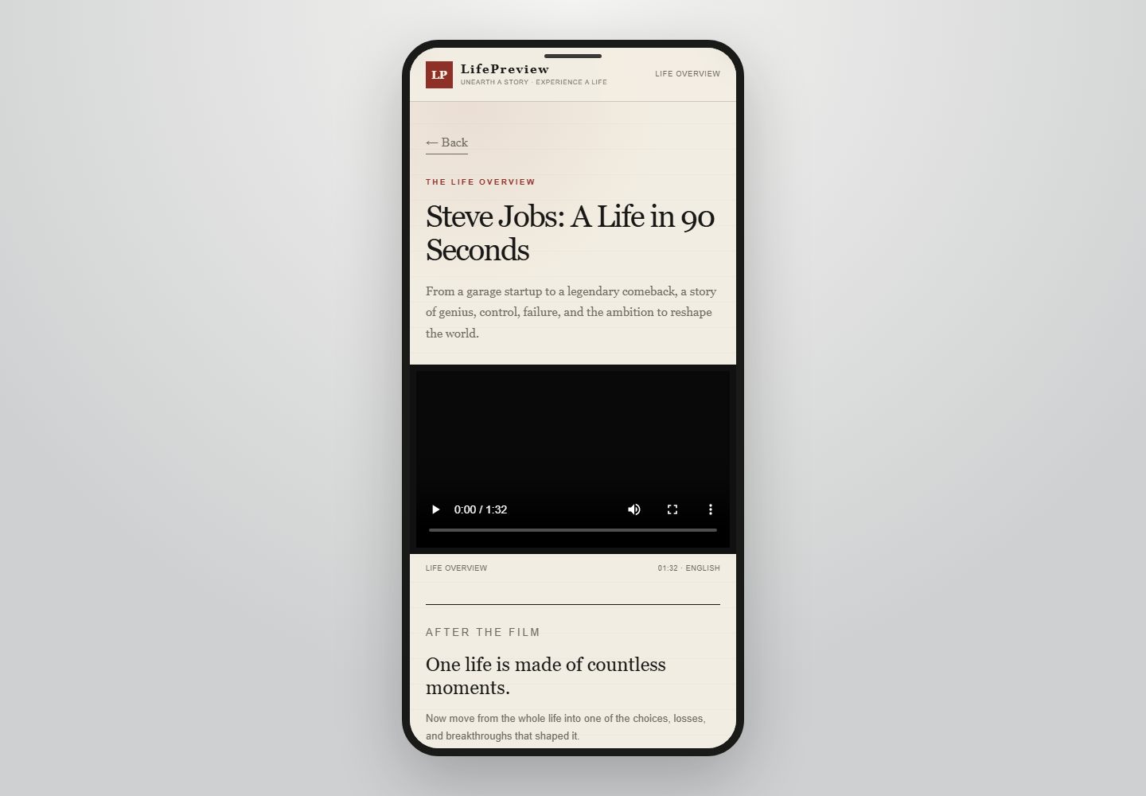
Figure 3. LifePreview story playback page

User-Side Demo Flow
- The user opens the LifePreview home page and browses profile cards and story themes.
- The user selects a person and enters the profile, Life Overview, and pivotal-moment page.
- The user reviews the story summary and confirms the content to watch or generate.
- The user selects Generate. The frontend submits the person, story direction, and video parameters. The formal validation task requests 3.0 seconds, 73 frames, 24 fps, native audio, and subtitles disabled.
- The backend creates the task and returns its identifier and status.
- The frontend queries progress and retrieves a signed media URL when the result is available.
- The browser loads the H.264/AAC video, enabling playback, seeking, and download.

Frontend-Backend Interaction
The frontend and backend communicate through explicit task states and allowlisted data objects. When a task is created, the frontend submits only the person's identity, the user's question, and permitted generation parameters. When results are queried, the backend exposes only the product-required status, reference assets, media metadata, and signed URL; it does not expose internal workflow paths, temporary files, or execution packages to the browser.
Media access uses a same-origin gateway and signed resource URLs. Validation records show that the media interface handles full requests, HEAD requests, Range and If-Range partial requests, If-None-Match cache validation, and rejection of invalid ranges. Chrome testing confirmed real video-frame rendering, playback, and download; video buffering and media-error states behaved as expected.

AMD-Compatible Runtime Flow
The AMD path uses pinned versions of ComfyUI and the PyTorch ROCm runtime on AMD Radeon gfx1100. After a generation task enters the single-GPU queue, the system loads FLUX.2 or MiniMax H3 weights by stage. It exits the corresponding large-model process after inference, performs targeted cache reclamation on the exact weight files used, and only then proceeds to the next stage.
FLUX.2 completed real ROCm smoke tests for text-to-image, single-reference editing, and dual-reference editing. MiniMax H3 Ref2VA completed an 8-second production-specification native audio-video smoke test. PyAV and ffprobe fully inspected the result and confirmed H.264 video, AAC audio, and no subtitle stream. Figure 4 shows the layers of the AMD technology stack.
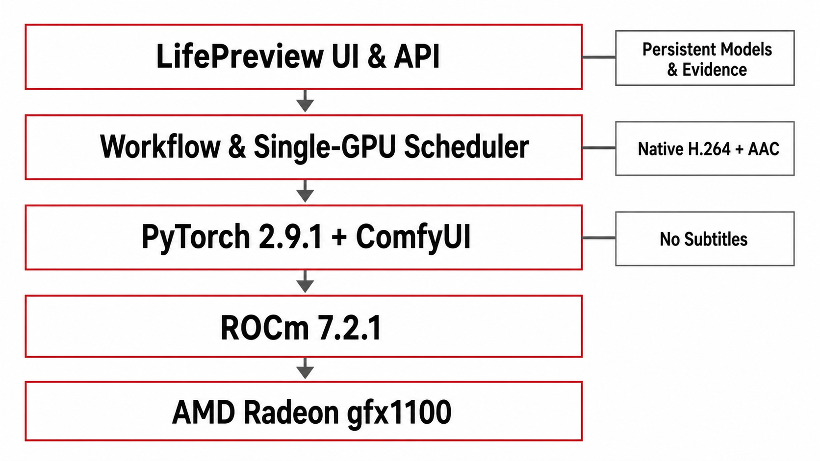

Figure 4. LifePreview AMD ROCm runtime stack

Three Life Overview Films
Life Overview films have been generated for Steve Jobs, Su Dongpo, and Frida Kahlo. All three are 1280×720 at 24 fps, with H.264 video and AAC stereo audio, and have passed media probing and integrity checks. Table 1 summarizes the media specifications.

Table 1. Three completed Life Overview films
Person | Duration | Resolution | Frame rate | Video | Audio | File size | SHA-256
Steve Jobs | 92.416667 s | 1280×720 | 24 fps | H.264 | AAC, 48 kHz, stereo | 33,002,113 B | CBBEA253…BE631
Su Dongpo | 105.728000 s | 1280×720 | 24 fps | H.264 | AAC, 48 kHz, stereo | 46,325,156 B | 182A1C36…F9E9F
Frida Kahlo | 102.291016 s | 1280×720 | 24 fps | H.264 | AAC, 32 kHz, stereo | 35,676,875 B | 69AC37E4…F4B4F

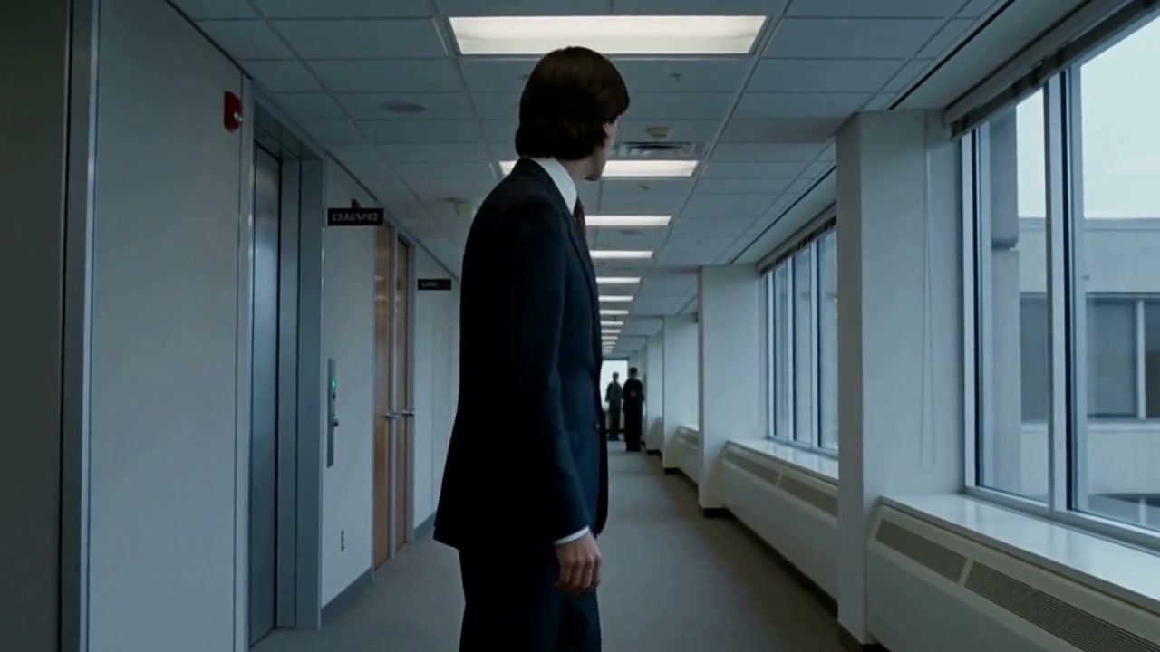
Figure 5. Representative frame from the Steve Jobs Life Overview

Figure 6. Representative frame from the Su Dongpo Life Overview
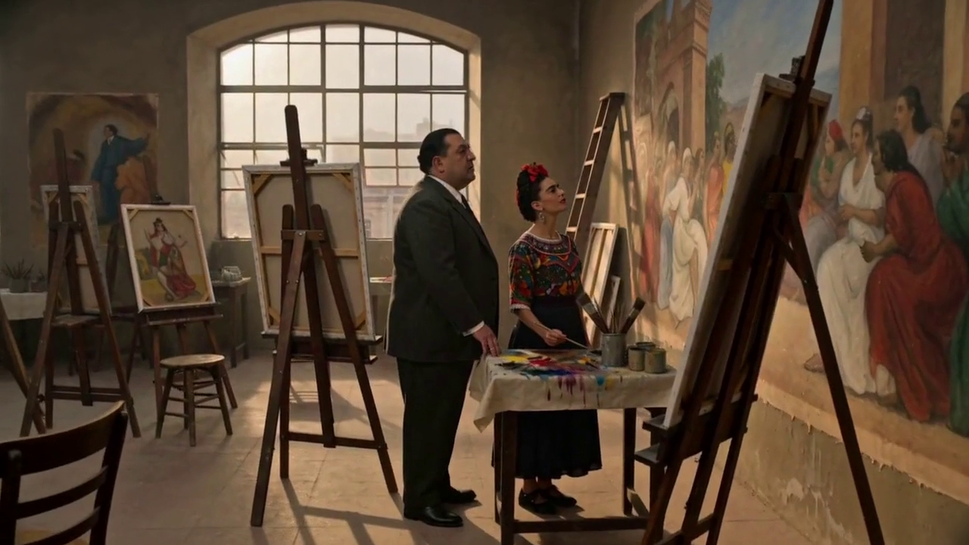
Figure 7. Representative frame from the Frida Kahlo Life Overview

End-to-End Processing Flow

Overall System Architecture
LifePreview divides character-film production into four layers: product interaction, AI workflow, AMD compute, and media delivery. The product-interaction layer handles profile selection, question input, status display, and viewing. The AI-workflow layer handles orchestration, evidence, scripts, character assets, shot generation, and quality control. The AMD-compute layer runs ROCm inference. The media-delivery layer manages artifact registration, signed access, cache validation, partial transfer, and browser playback.
The end-to-end process has six stages: User Intent, Research & Evidence, Script & Storyboard, Character References, Native Audio-Video, and QC & Delivery. Figure 8 summarizes the stages and their primary capabilities.

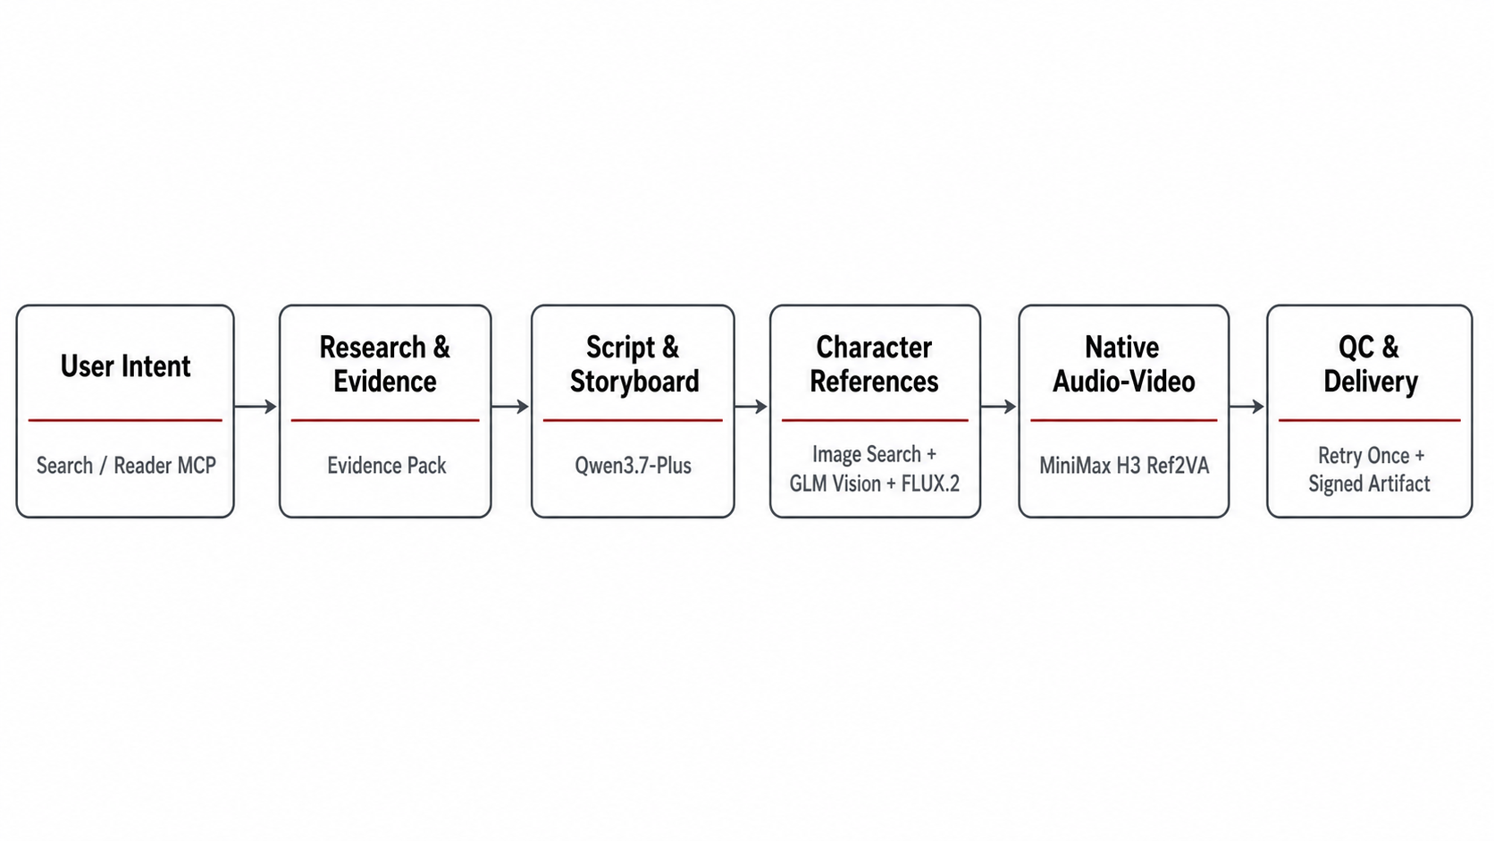
Figure 8. LifePreview end-to-end processing flow

User Intent and Task Creation
The system first normalizes the person, question, content direction, and video parameters into a task input. The person uses a stable identifier; the user's question becomes a narrative constraint; and duration, frame specifications, native audio, and subtitle policy enter a controlled parameter set. The current H3 product path always uses native audio and does not generate, embed, or burn in subtitles.
Task creation produces a unique identifier and enters an explicit state machine. The frontend displays only public states such as queued, processing, succeeded, or failed; it does not depend on internal file paths or temporary execution logs. Task state is separated from final artifacts so candidates that have not passed quality control are never exposed directly.

Research and Evidence Construction
The character-research stage divides work between Search MCP and Reader MCP. Search MCP discovers sources by person, time, event, and user question. Reader MCP reads the source text, extracts citable passages, and preserves source locations. The system organizes sources, excerpts, dates, themes, and related facts into an Evidence Pack for subsequent script generation.
Retrieved information is not automatically treated as a factual conclusion. The workflow reconciles identity, event timing, and source content, distinguishing source statements, inference, and narrative expression. The script stage consumes only material that has entered the Evidence Pack, reducing unsupported content in the resulting life story.

Script and Storyboard Generation
Qwen3.7-Plus uses the user's question and Evidence Pack to generate the story structure, including life stages, key events, causal links, narration, shot objectives, and visual prompts. Script generation is not a simple compression of a biography; it selects the events most relevant to the user's question and theme while controlling information density and narrative rhythm.
The storyboard decomposes the story into executable shots. Each shot includes the person's life stage, scene, action, camera language, narration, and duration. Structured fields carry these elements forward so character-asset generation, video generation, and quality control all reference the same shot definition.

Character References and Asset Generation
The visual-asset stage first uses independent Image Search/Fetch capabilities to discover candidate historical images. GLM Vision assesses character relevance, image quality, usable viewing angle, and visual risk. Qualified historical images become identity references, with source and licensing information retained in the asset record.
When image search succeeds but yields no qualified candidate, the system can derive a Character Appearance Spec from the script and use FLUX.2 text-to-image to generate a canonical front identity anchor. Other viewing angles and age stages are derived through reference editing, reducing identity drift that would result from generating each view independently from text.
FLUX.2 supports three paths in the AMD environment: text-to-image for the initial identity anchor; single-reference editing for changes in pose, viewpoint, or scene; and dual-reference editing to constrain both identity and a second visual condition. Each asset retains its parent source, generation capability, parameter summary, and content hash.

Native Audio-Video Generation
MiniMax H3 Ref2VA receives character references, shot prompts, actions, and sound information, then directly generates video clips with native audio. The native-audio path places movement, ambient sound, and speech rhythm within the same generation process, reducing the complexity of realigning separately generated voice and picture.
The production-specification smoke test used 1344×768, 24 fps, 192 frames, 8.0 seconds, and 20 steps. The output contains H.264 video and AAC audio, with zero subtitle streams. The workflow, submission nonce, result file, and media-probe record were all retained as validation evidence.

Automated Quality Control and Retry
Quality control first verifies that the file exists, the media can be opened, and the video and audio streams are complete. It then checks resolution, frame rate, frame count, duration, silence, black frames, and decoding errors. Character shots are also checked for subject visibility, obvious artifacts, identity consistency, and overall usability.
If a clip fails its first version, it is regenerated at most once. If the second version still has a quality-control exception, the system does not retry indefinitely; instead, a deterministic score selects the better of the two candidates for delivery. This strategy controls cost, execution time, and task recoverability.

Assembly and Media Delivery
Shots that pass quality control are assembled in script order. The system standardizes frame rate, dimensions, and audio parameters, completes shot concatenation and MP4 packaging, and calculates SHA-256. The selected final result is registered as an immutable media artifact; candidate files and the final public artifact use distinct states.
The media service exposes trusted artifacts only through signed URLs and supports HEAD, Range, If-Range, If-None-Match, and ETag. The browser can request video bytes as needed, seek within playback, and reuse cached data without downloading the complete file before playback begins.

AMD Technologies

AMD Runtime Platform
The project's AMD inference environment uses AMD Radeon gfx1100, ROCm 7.2.1, PyTorch 2.9.1+rocm7.2.1, Python 3.12, and a pinned ComfyUI version. Approximately 49 GiB of VRAM is available; container memory.max is 59,055,800,320 bytes (approximately 55 GiB), with no swap.
Table 2. AMD runtime environment and key versions
Layer | Component | Version / configuration | Role
GPU | AMD Radeon | gfx1100 | Runs FLUX.2 and H3 inference
GPU Runtime | ROCm | 7.2.1 | AMD GPU compute and operator runtime
AI Framework | PyTorch | 2.9.1+rocm7.2.1 | Tensor, model, and operator execution
Workflow | ComfyUI | 0.30.0 fixed slot | Model-node and workflow execution
Language | Python | 3.12 | Services, scheduling, and validation scripts
Media | ffprobe / PyAV | ffprobe 6.1.1 / PyAV 18.0 | Media probing and full decoding

ROCm and PyTorch Compatibility
PyTorch's ROCm build retains some CUDA-named compatibility interfaces. Consequently, torch.cuda and cuda:0 in code and runtime logs refer to PyTorch's compatibility access to a ROCm device; they do not indicate that the project uses NVIDIA CUDA. Platform identification must verify the PyTorch build, ROCm version, and actual GPU architecture together rather than infer hardware from an interface string alone.
At runtime, models and tensors are mapped to the ROCm device, and PyTorch dispatches the computation graph to the AMD backend. Device selection, data types, operator availability, and VRAM behavior were all validated in a real gfx1100 environment rather than inferred from CPU simulation or static configuration files.

gfx1100 Model Adaptation
FLUX.2 dev FP8 mixed completed text-to-image, single-reference, and dual-reference workflows on gfx1100. Adaptation focused on a pinned model manifest and SHA values, weight-loading order, reference-image inputs, data-type configuration, ComfyUI node connections, and atomic publication of outputs.
MiniMax H3 adaptation centers on the Ref2VA native audio-video workflow. Before submission, the system verifies the workflow SHA, weight SHA, frame specifications, frame grid, inference steps, native-audio setting, and no-subtitle policy. After completion, it verifies video frames, audio frames, codecs, duration, subtitle streams, and file hash.

Single-GPU Scheduling Strategy
FLUX.2 and H3 run strictly in sequence using one GPU, one ComfyUI instance, and one worker. The three FLUX views run sequentially in the same process without batch_size=3. H3 may enter GPU execution only after the FLUX stage has finished and released its resources.
The scheduler defines explicit states for task enqueueing, model loading, inference, result publication, and resource reclamation. This prevents multiple large models from competing for GPU and system memory, and enables recovery and deduplication after process interruption using the persistent task identifier, submission nonce, and result hash.

VRAM and System Memory Control
The system monitors both GPU VRAM and cgroup memory.current rather than relying only on available host memory. When memory reaches a constraint threshold, it stops accepting the next task and unloads models and reclaims resources. GPU and cgroup state are checked again before the next large-model stage begins.
By default, the system does not enable --lowvram, disable mmap, or run a global drop_caches. After a large-model process exits, POSIX_FADV_DONTNEED is applied only to the exact weight files used in that run, reducing file-page cache without affecting other services. After the formal H3 smoke test, targeted reclamation reduced cgroup RAM from approximately 34.10 GB to 0.73 GB and GPU VRAM to approximately 28 MB.

AMD Model Test Results
Table 3 records real execution results for the current machine, model manifest, and workflows. The data demonstrates compatibility, resource requirements, and reproducible validation conditions; it is not used to infer performance gains unsupported by a comparative experiment.
Table 3. AMD Radeon gfx1100 model test results
Workflow | Specification | Wall-clock time | Peak VRAM
FLUX.2 Text-to-Image | dev FP8 mixed | 346.558 s | 41,697 MiB
FLUX.2 Single-Reference | dev FP8 mixed | 452.917 s | 41,363 MiB
FLUX.2 Dual-Reference | dev FP8 mixed | 622.550 s | 41,909 MiB
MiniMax H3 Ref2VA | 1344×768, 24 fps, 192 frames, 20 steps | 11,948.314 s | 33,153 MiB

AMD Audio-Video Generation Validation
The formal H3 smoke-test output file is 1,186,476 bytes with SHA-256 5a2dd8744baba283d0e94c584ecd7e0ffa493fd8fc8b37e26baaa9126ecbac9b. PyAV 18.0 fully decoded 192 video frames and 250 audio frames. ffprobe 6.1.1 confirmed H.264 video, AAC audio, an 8.0-second duration, 24 fps, and zero subtitle streams.
When initial post-processing failed because ffprobe was absent from the runtime container, ComfyUI history already showed success and the MP4 had been generated. The system did not resubmit the workflow. Instead, it preserved the original error evidence, performed recovery decoding with PyAV, and then installed ffprobe for formal re-verification. This process validated fault isolation between generation and evidence post-processing.

Browser Media Delivery Compatibility
After AMD-generated artifacts enter content-addressed storage and are registered with database authority, the API generates a signed URL for delivery through a same-origin gateway. Real validation covered HEAD 200; Range and If-Range 206; If-None-Match 304; invalid Range 416; and consistency of file size and SHA for a complete GET.
In real Chrome acceptance testing, the signed MP4 rendered video frames successfully, media readyState was 4, the buffer covered the full eight seconds, media error was null, and the download completed. This demonstrates that AMD-generated media can be accessed and played in a standard browser through the H.264/AAC path.

Prototype Validation and Results

Frontend Validation
Prototype validation covers the home page, profiles, Life Overview, Curated Moments, and the Director's Preview. The interface uses an English editorial content hierarchy that keeps primary actions visible in desktop and mobile layouts. Before expensive generation begins, the Director's Preview makes the story angle and content expectation explicit. Figure 9 shows the interface.
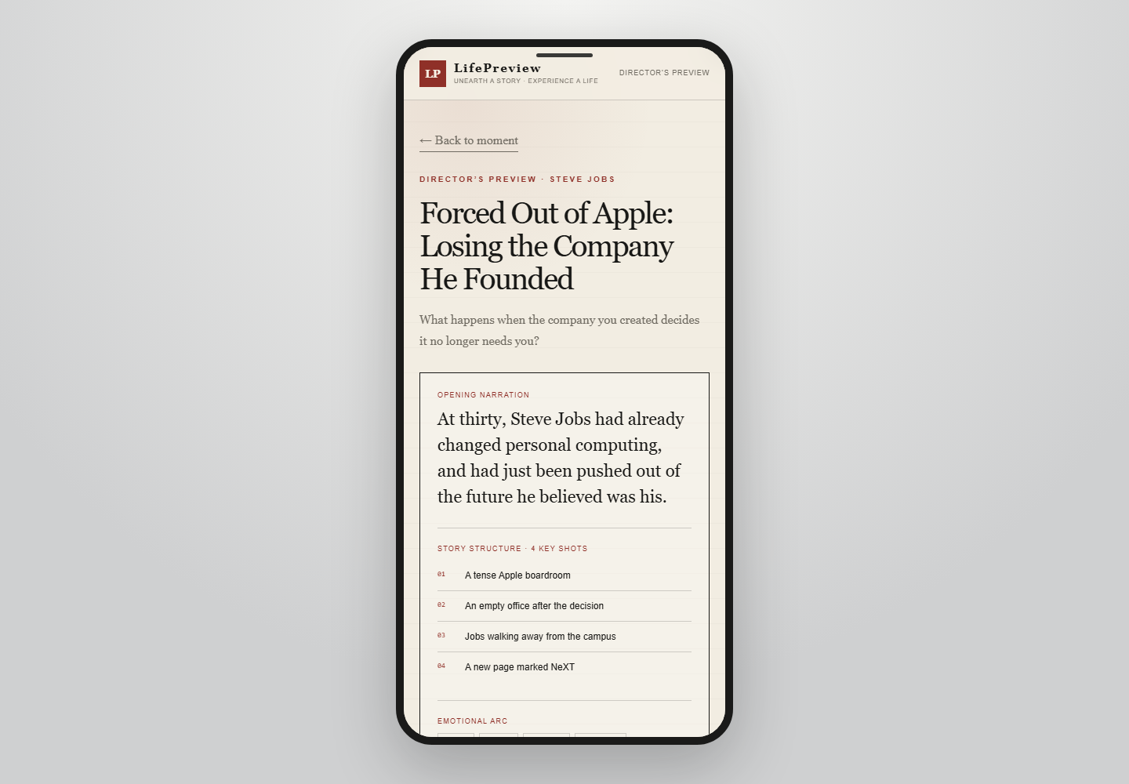
Figure 9. LifePreview Director's Preview and generation confirmation page

Frontend-Backend Interaction Validation
Validation covers generation-task submission, parameter allowlisting, task-status queries, media projection, signed URLs, the same-origin proxy, and browser playback and download. The API and gateway separate internal execution details from public media information, exposing only registered, trusted artifacts to the frontend.
Table 4 summarizes the key interactions already validated. The scope is limited to interface requests, media access, and user actions that were actually executed.
Table 4. Key frontend-backend interaction validations
Validation item | Input or operation | Expected result | Result
Page load | Open LifePreview | Home page and profiles visible | Passed
Status query | Request public task status | Return allowlisted status object | Passed
3-second task contract | 3.0 s, 73 frames, 24 fps, native audio, no subtitles | Request and acceptance logic are correct | Configuration and tests passed; final generation awaits user initiation and runtime verification
Signed media | Request a registered video | Return a controlled signed URL | Passed
Range | Request a specified byte range | Return 206 with the correct length | Passed
ETag | If-None-Match | Return 304 | Passed
Invalid Range | Out-of-bounds byte request | Return 416 | Passed
Chrome playback | Open signed MP4 | Video and native audio play successfully | Passed
Download | Trigger media download | File is complete and matches SHA | Passed

Validation of the Three Completed Films
All three films passed ffprobe media probing and contain one H.264 video stream and one AAC stereo audio stream. SHA-256 was calculated for each file, and representative frames were extracted from the actual films for this document. Each film runs for more than 90 seconds and covers a different cultural context and type of figure, validating both the content organization of Life Overview and the system's long-form assembly capability.

Conclusion and Next Steps

Current-Stage Results
LifePreview now provides a continuous product experience from profile selection, Life Overview, and Curated Moments to the Director's Preview, video viewing, and download. The AI workflow covers the major technical stages of research and evidence, scripts and storyboards, character assets, native audio-video generation, quality control, and delivery. The AMD environment has completed real inference validation for FLUX.2 and MiniMax H3, as well as configuration and testing of the request and acceptance logic for 3.0 seconds / 73 frames. Life Overview films have been generated for Steve Jobs, Su Dongpo, and Frida Kahlo.

AMD Technical Results
- Validated three FLUX.2 workflows on AMD Radeon gfx1100 and ROCm 7.2.1.
- Completed a production-specification MiniMax H3 Ref2VA native audio-video smoke test.
- Established a sequential, single-GPU, single-ComfyUI, single-worker strategy.
- Established methods for VRAM, cgroup memory, and exact-weight cache reclamation.
- Completed full decoding and browser-delivery validation for H.264/AAC media with no subtitles.
- Created an evidence record covering workflow SHA, submission identifier, runtime, peak VRAM, and media SHA.

Product and Content Results
- Created a bright editorial interface and a continuous path from profile selection to content viewing.
- Established the three-layer Life Overview, Curated Moments, and Custom Journey product structure, spanning rapid orientation, deeper understanding, and personalized exploration.
- Completed three Life Overview films and one Curated Moment about Steve Jobs's garage beginnings, with online playback, seeking, and download.
- Validated the adaptability of different narrative themes and visual languages across three figures from different periods and cultures.
- Validated the AI production pipeline from biographical evidence to video expression, and defined a clear path from a content demo to a generative product.

Next Steps
- Productize Custom Journey: open input for a person, experience, or question; use the Director's Preview for pre-generation confirmation; and run long-form generation as an asynchronous task.
- Improve stability at scale: continue optimizing identity consistency, age-stage continuity, transitions between shots, and quality-control strategy.
- Strengthen recovery, deduplication, and durable execution for long-form video tasks.
- Optimize task scheduling, model caching, exception recovery, and evidence archiving.
- Improve deployment monitoring, runtime logs, media-asset management, and alerts.
- Improve the waiting and delivery experience: show real task stages, allow users to leave the page, provide completion notifications, and support mobile playback and constrained-network loading.
- Continue improving model compatibility, resource utilization, and reproducible deployment on AMD platforms.

