* To use mongodb with php you need to use mongodb php driver. Download the driver from the url(<https://s3.amazonaws.com/drivers.mongodb.org/php/index.html>) Download PHP Driver. Make sure to download latest release of it. Now unzip the archive and put php_mongo.dll in your PHP extension directory ("ext" by default) and add the following line to your php.ini file:

extension=php_mongo.dll

Run the mongodb database (mongod.exe)

* Install neo4j by downloading from neo4j.com/download
* To establish the connection on neo4j using php we used php library downloaded from here <https://github.com/jadell/neo4jphp>
* Composer was run to adjust dependencies relevant to neoclient using

composer require "everyman/neo4jphp" "dev-master"

* This was a helpful tutorial for that <https://github.com/jadell/neo4jphp/wiki>
* Create the database named “repo”
* Create collection inside that repo named “invoices”
* Copy the csv file to working folder and set the file path of “index.php”
* Then run “ABC/index.php”
* When it is run,
* an API object would be created
* Since insertion is fast at mongodb,we first insert data to mongodb and then later input those data to graph database from where we access data
* So in index.php, insertdb function would be run - that would send all the data from the csv file to mongo db

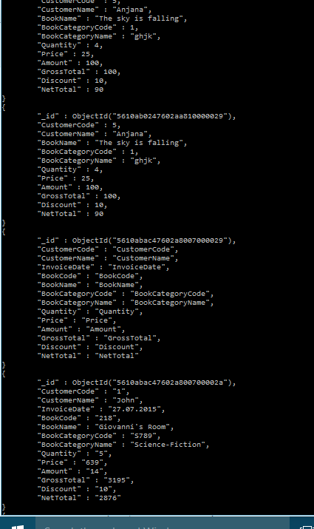

* getdb() function would call mapInvoice() of CustomerInvoice class and CategoryBook classes
* Then the graph database would be created with 274 nodes and 157 relationships as following

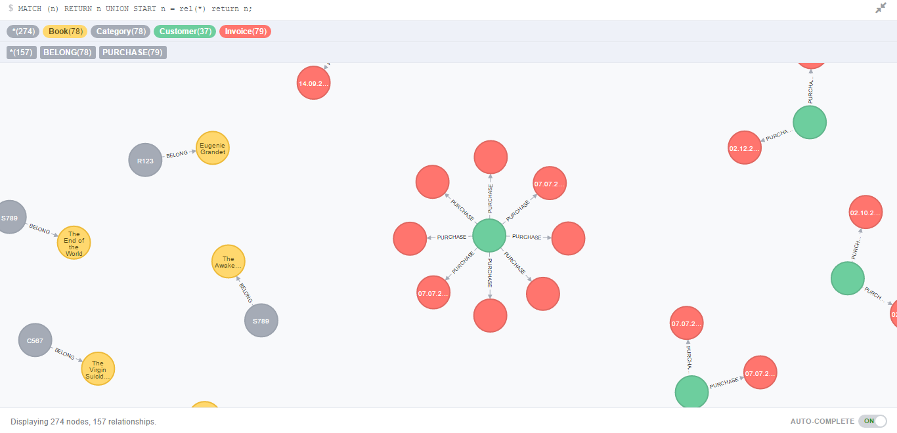

This graph is created in such a way that, it is the optimum way to store only the sufficient data with only the required relationships.

So,CustomerCode and InvoiceDate nodes are related where InvoiceDate node is having properties of invoiceDate,Category,Qty,NetAmt and BookName.

Then there is separate label set for CategoryName node and BookTitles which is being mapped by the relationship BELONG

(For this you need to run recommend/Form.php)

* For each customer max.category he has bought book from is found with in 30 days and the go to that category and recommend other books of that same category
* For all the customers,get the total quantity and select most number of invoices customer and get net total of him.