**ASSESSMENT - 3 ( Introduction To Database )**

**Q.1. )**  Create Database.

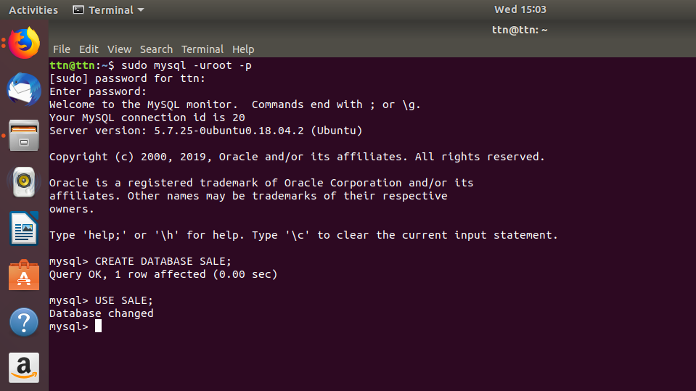

Q.2 ) Design Schema.

Solution :

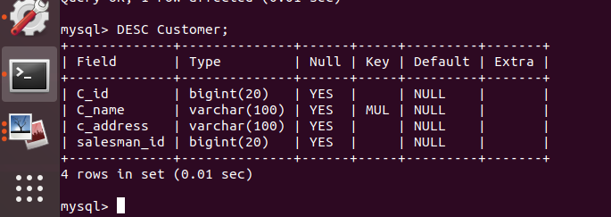

**Q.3 )** Create tables.

Solution :

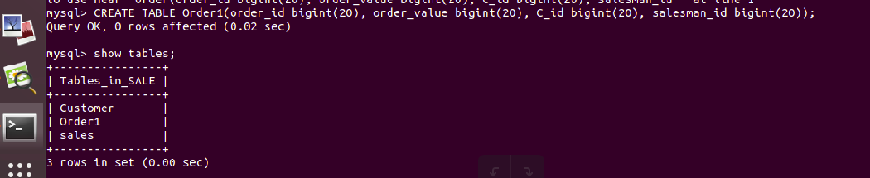

**Q.4 )** Insert sample data.

Solution :

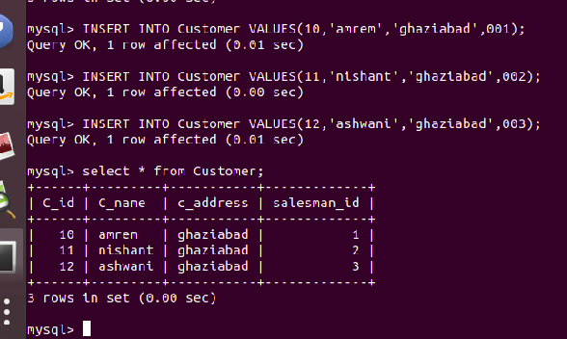

**Q.5 )** Find the sales person have multiple orders.

Solution :

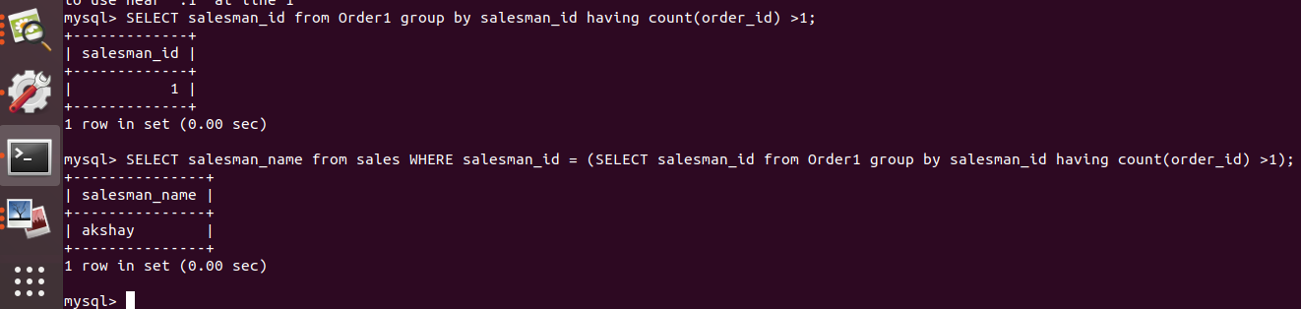

**Q.6 )** Find the all sales person details along with order details

Solution :

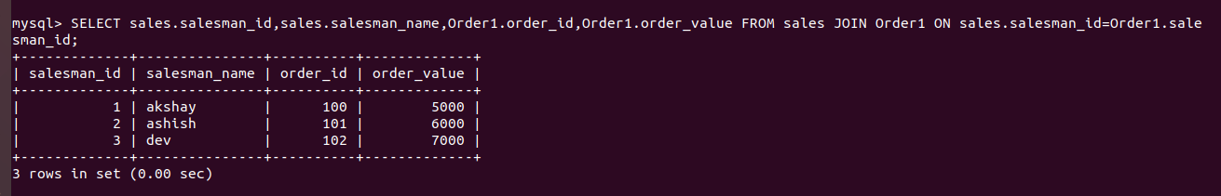

**Q.7 )** Create index.

**&**

**Q.8 )** How to show index on a table.

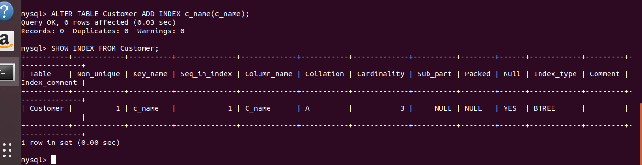Solution :

**Q. 9 )** Find the order number, sales person name, along with the customer to whom that order belongs to.

**Solution** :

