**ASSIGNMENT - 2**

**Q.1.)** Git Setup.

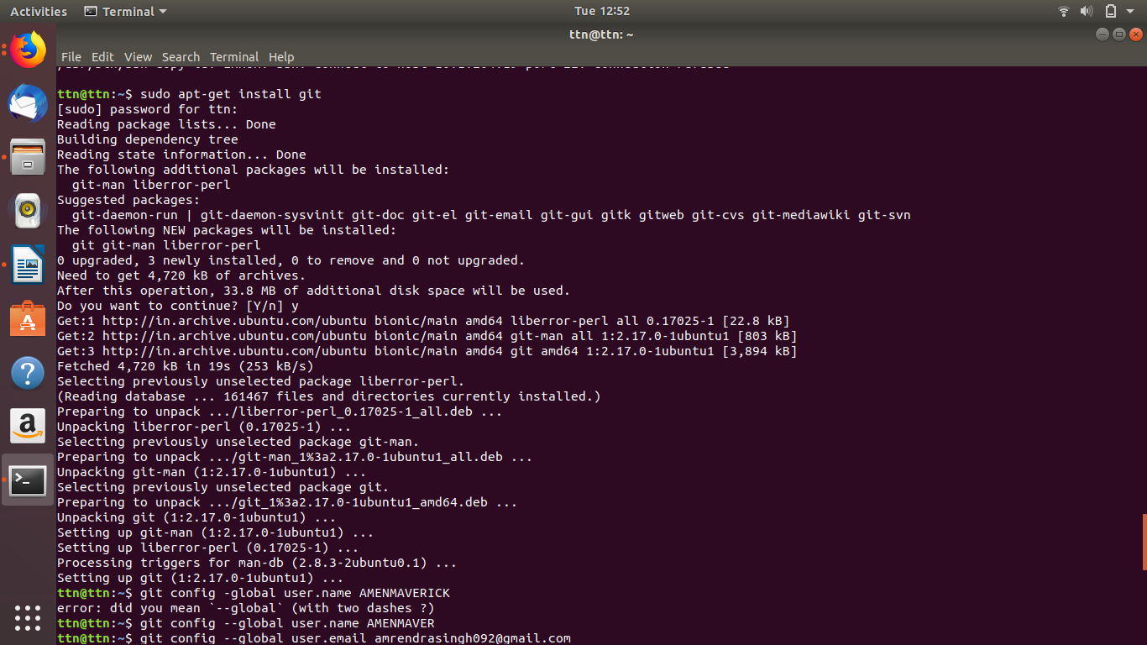

**Q.2.)** Initialize a Git Repository



**Q.3.)** Add files to the repository.

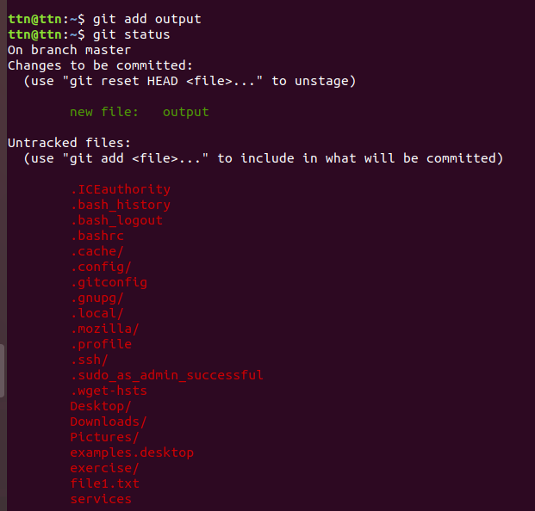

**Q.4.)** Unstage 1 file

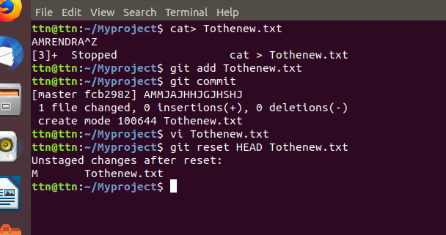

**Q.5.) Commit the file.**

**Solution :**

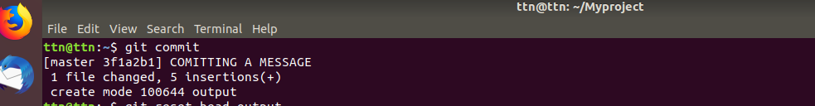

**Q.6.) Add a remote.**

**Solution :**

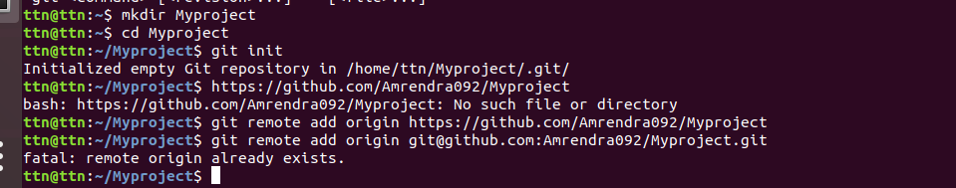

**Q.7.) Undo changes to a particular file.**

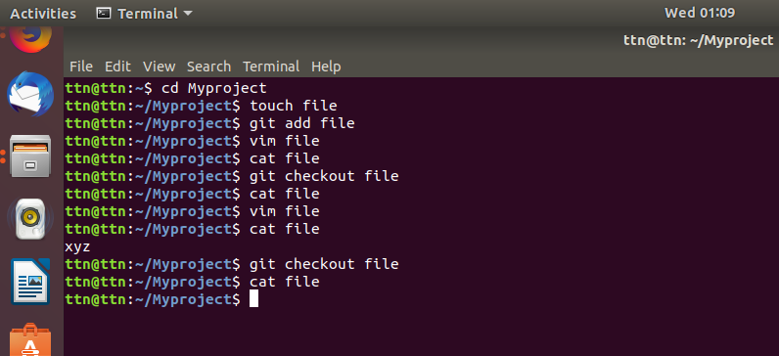

**Q.8.) Push changes to Github.**

**Solution :**

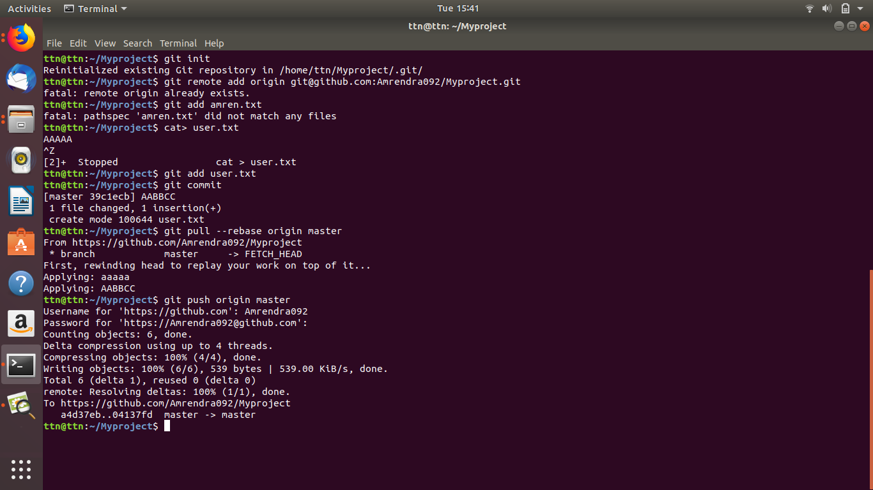

**Q.9.) Clone the repository.**

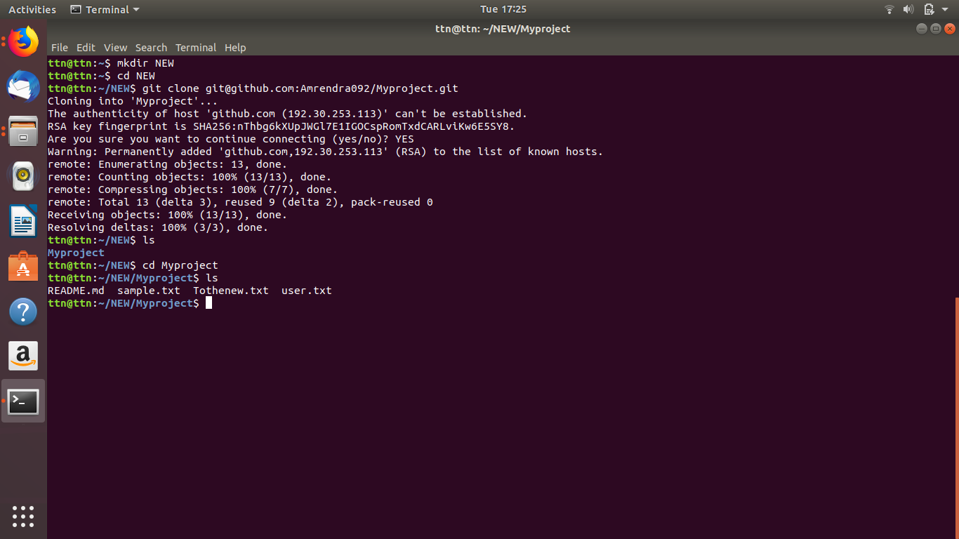**Solution :**

**Q.10.) Add changes to one of the copies and pull the changes in the other.**

**Solution :**

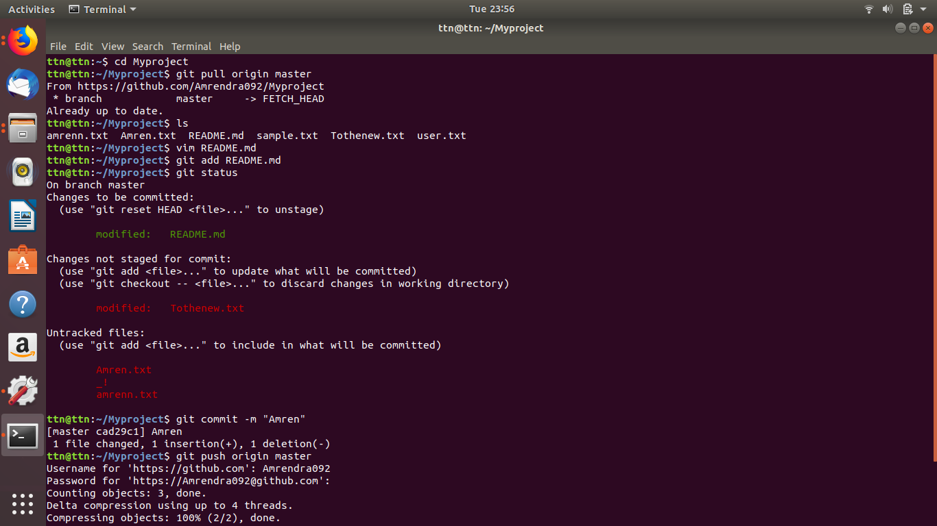

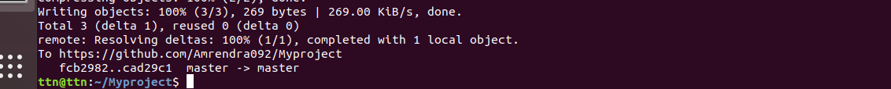

**Q.11.) Check differences between a file and its staged version.**

**Solution :**

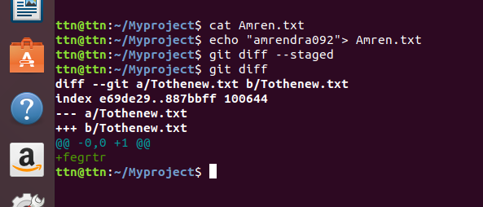

**Q. 12 ) Ignore a few files to be checked in.**

**Solution :**

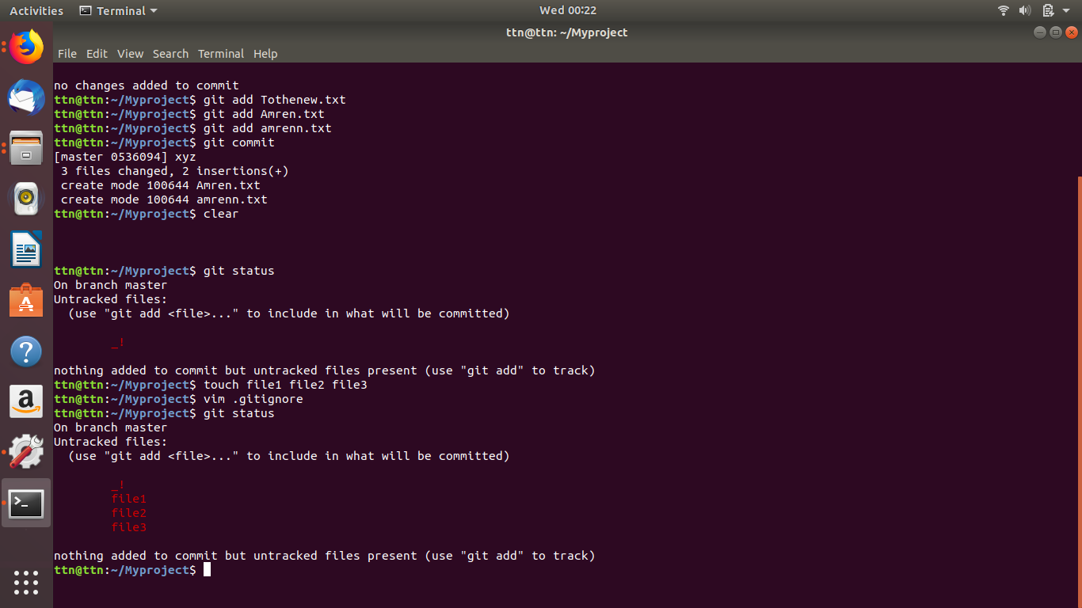

**Q.13 ) Create a new branch.**

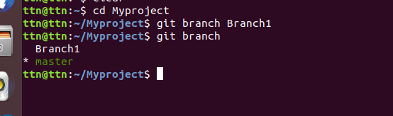**Solution :**

**Q.14. ) Diverge them with commits.**

**Solution :**

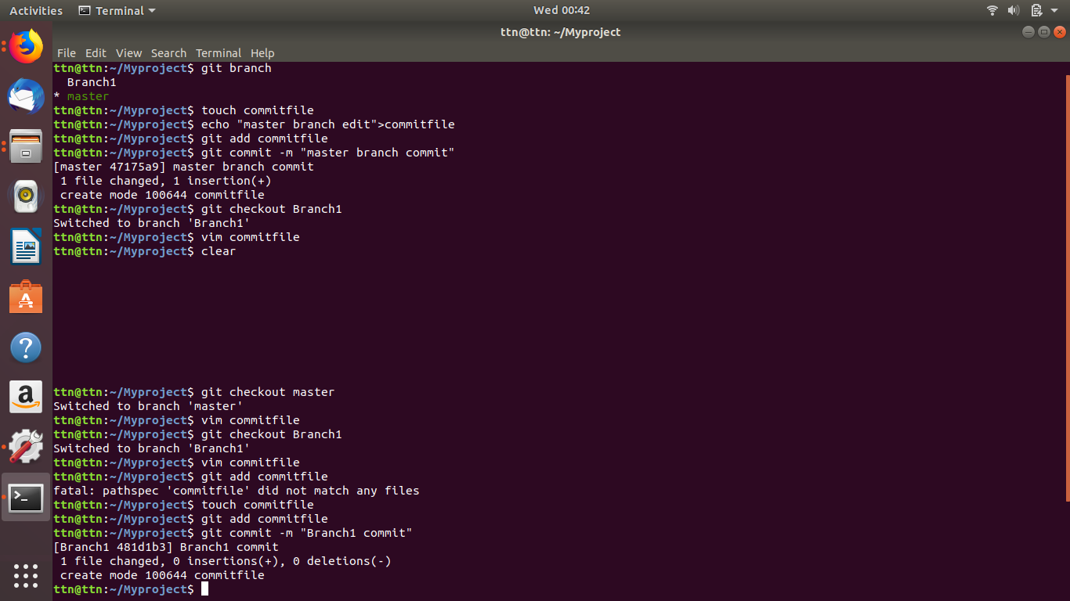

**Q. 15.) Edit the same file at the same line on both branches and commit.**

**Solution :**

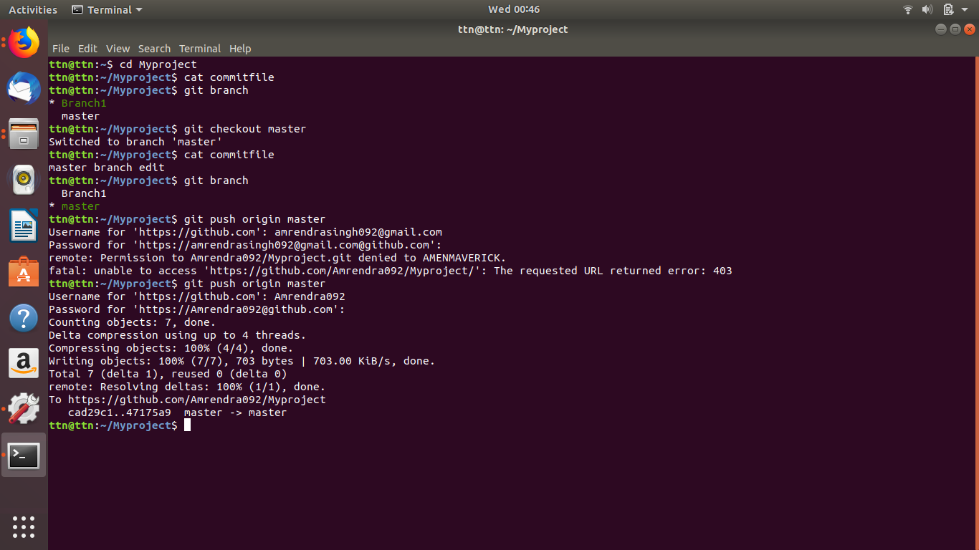

**Q.17 ) Stash the changes and pop them.**

**Solution :**

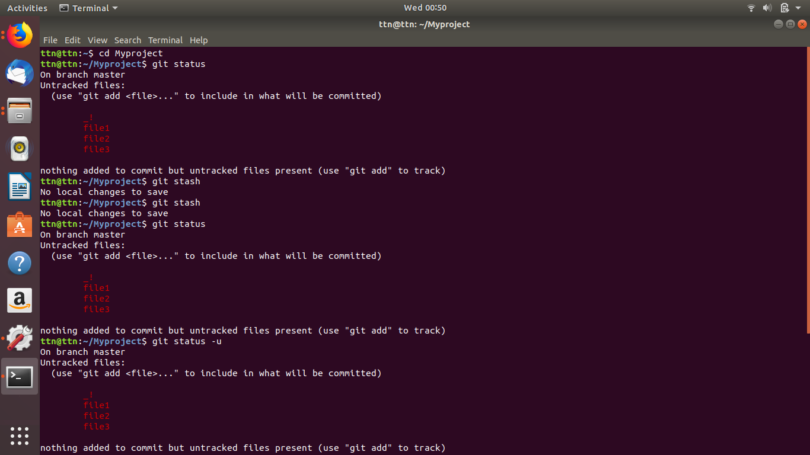

**Q.18) Try merging and resolve merge conflicts.**

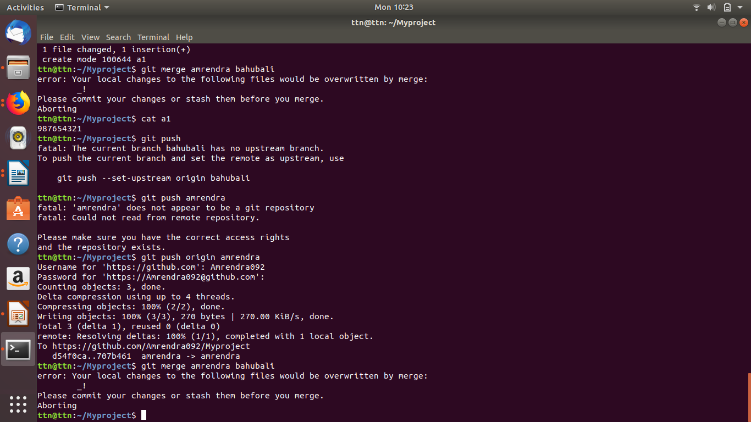**Solution :**

**Q.19 ) Add the following code to your .bashrc file : color_prompt="yes"**

**parse_git_branch() {**

**git branch 2> /dev/null | sed -e '/^[^*]/d' -e 's/* \(.*\)/(\1)/'**

**}**

**if [ "$color_prompt" = yes ]; then**

**PS1='\u@\h\[\033[00m\]:\[\033[01;34m\]\W\[\033[01;31m\] $(parse_git_branch)\[\033[00m\]\$ '**

**else**

**PS1='\u@\h:\W $(parse_git_branch)\$ '**

**fi**

**unset color_prompt force_color_prompt**

**Solution :**

