MA1008: MINI-PROJECT REPORT

NAME: ANISH MOHAN GANGAVARAM

SET ALGEBRA SYSTEM

GUIDE TO RUNNING THE PROGRAM:
- Run on python 3.8 or higher
- Turtle graphics module required to run the program
- For input file and loading the polygons from a file, name it polygons.txt before hand.
- If loading polygons is not needed, then saving the polygons from the program after creation will be stored in a file named polygons.txt
- Place the source file and polygons.txt (if needed to load) in the same folder.
- Run the code
- A numbered menu will pop up. Use numerical figures to perform desired tasks

PROGRAM ACTIONS AND INPUT REQUIREMENTS:
- Create polygon:
Allows the user to create polygons interactively. Just have to enter a polygon name, enter number of vertices (>=3) and coordinates for each polygon
- Display stored polygons:
Draws all polygons stored in the memory on the turtle graphics window
- Save polygons to file:
Saves all current polygons to file polygons.txt. Automatically creates file if needed or overwrites it
- Load polygons from file:
Loads polygons from polygons.txt to memory. In this case, polygons.txt must exist beforehand
- Delete a polygon:
Deletes a polygon from the memory and the file. User just has to enter name of polygon and give a confirmation of ‘y’ or ‘Y’ for deletion. Any other character terminates the process to avoid accidental deletion
- Perform Set Algebra:
Evaluates set operations between polygons and displays result. User is supposed to enter a valid expression, using ‘*’ as intersection, ‘+’ for union and ‘-‘ for difference. Precedence used is parentheses, intersection, then union and last difference. But to avoid ambiguity, put operations between two polygons in parentheses
- Exit program:
User can opt to exit the program and terminate it

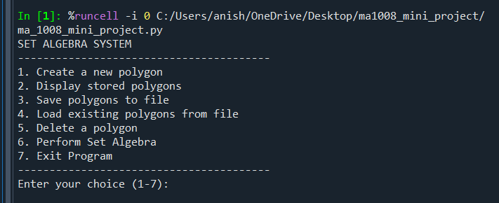
GRAPHICAL OUTPUT:
Suppose there are two polygons A (blue) and B (red)
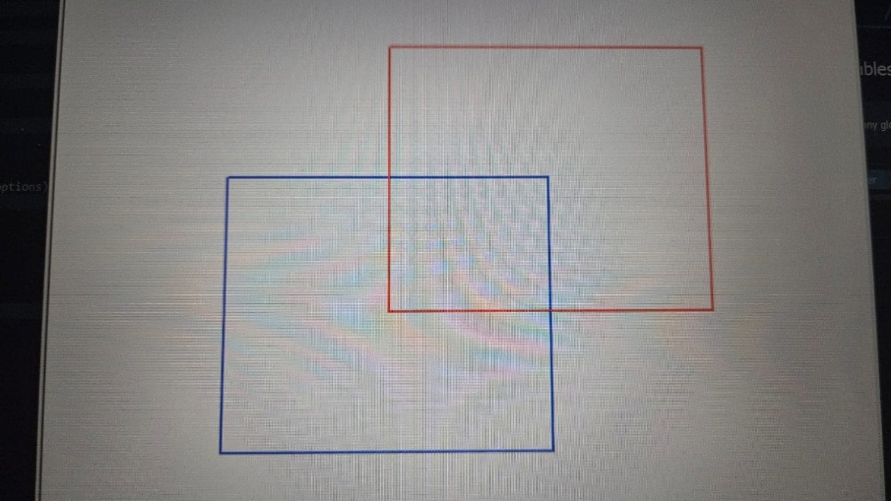
- A + B (Union)
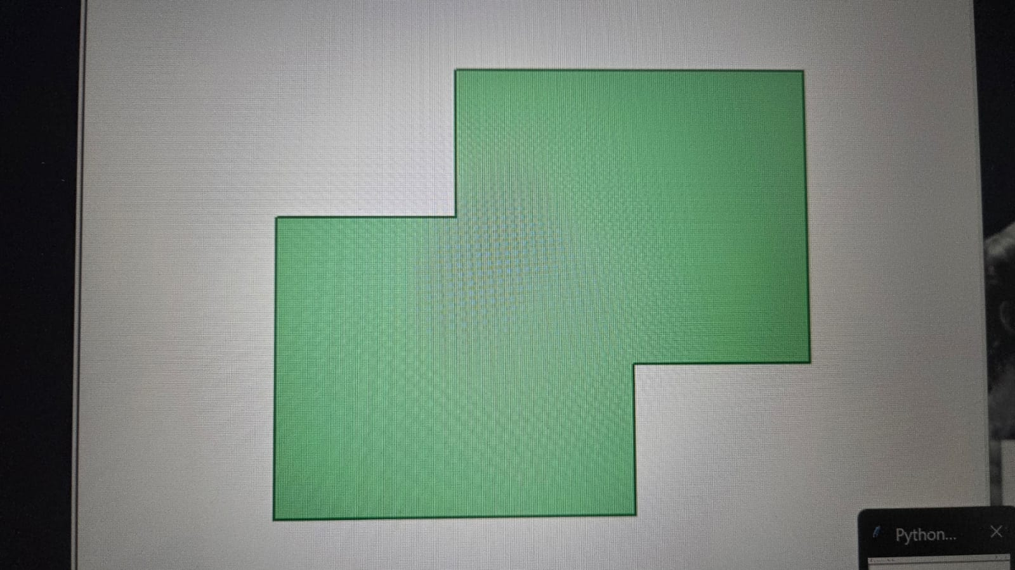
- A * B ( Intersection)
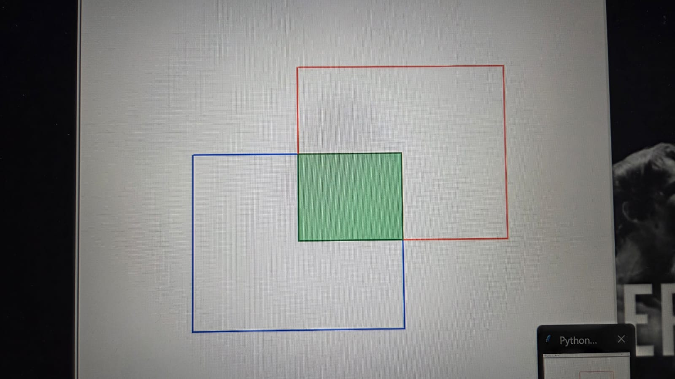
- A – B (Difference)
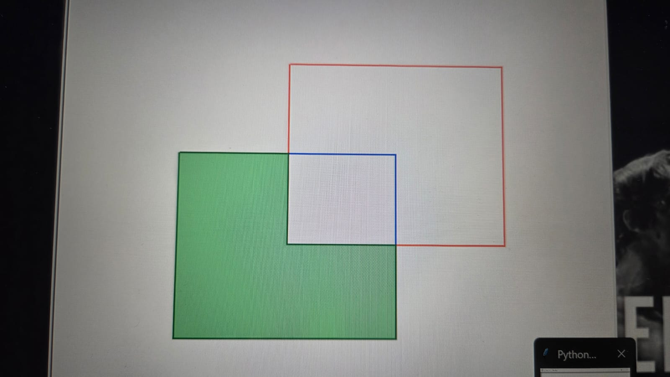
- B – A (Difference but different result)
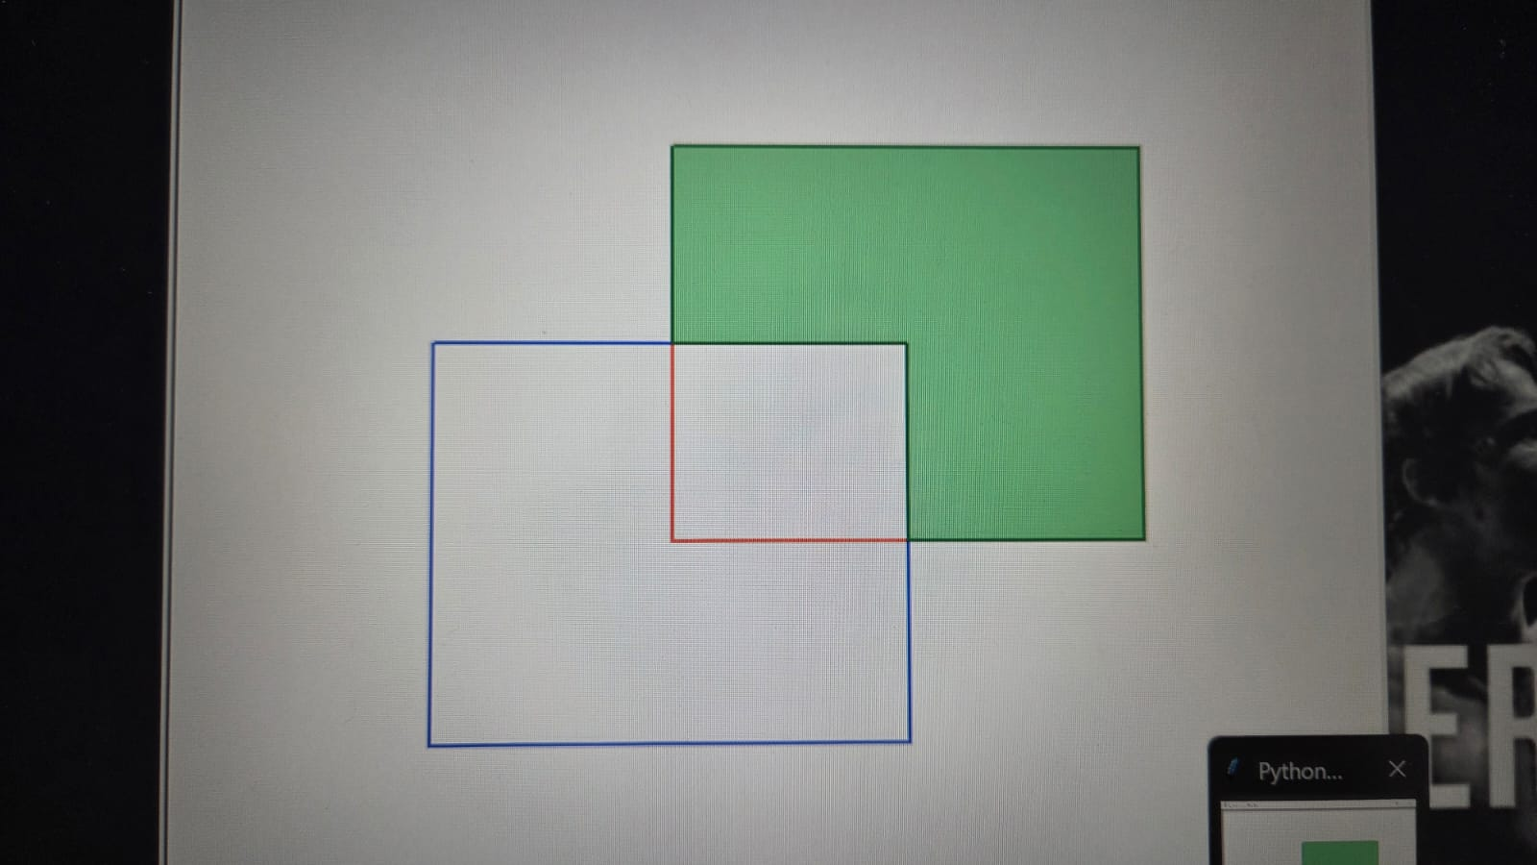
- A * ( B + C ) (Multi-polygonal operations)
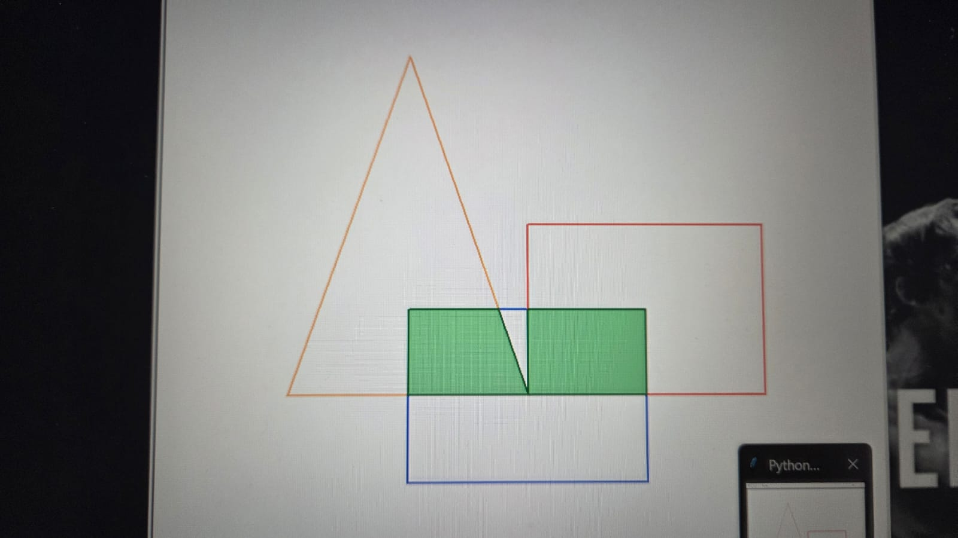
KEY STRENGTHS AND LIMITATIONS:
STRENGTHS:
- Interactive Creation: User can create custom polygons by a step by step guided input system
- Dynamic display: Auto-scale’s window for all stored polygons so that everything is in a visible range.
- Supports Nested Set Algebra: Handles expressions like A * ( B + C ) with parentheses and operator precedence.
- Data storage: Polygons can be loaded in and out of the file by just a click of a button
- Geometric Accuracy: Ray-casting algorithm used to determine whether a polygon is inside a polygon or no
- Error Handling: Invalid inputs by the user is handled gracefully and is re-looped till user enters a valid one
LIMITATIONS:
- Turtle graphics may hang after displaying the polygons
- Algorithm assumes that polygons are non-self intersecting
- Only supports 2-D cartesian coordinates system
- Point-clicking to create a polygon hasn’t been implemented. So vertices have to be entered manually by the user. Can be cumbersome for some
- In special cases, the colour filling can be inaccurate. But that is outside the scope of this project.

BONUS FEATURES:
- Interactive polygon creation: User-friendly prompts with proper error handling. Creates a smooth creation interface
- Attractive Display System: Every polygon is of a different colour. The resultant polygon is outlined by a green colour and filled with light green. Auto-scaling the turtle window helps with the aesthetic and clarity of the outputs
- Parenthesized Expression Parser: Handles multi-level set operations with parentheses using a recursive evaluator
- Robust Error Handling: Comprehensive input validation for coordinates, polygon names and set expressions.
- Supports for Disjoint Resultant Polygons: Automatically reconstructs and displays polygons of complex set algebraic problems in some cases. But in special cases, not so accurate. Logic is correct though.

CONCLUSION:
This Set Algebra System developed is a functional and visually interactive program. It can be used to perform set algebra on polygons using the fundamentals of Boolean Algebra and Computational Geometry. It combines mathematics, logic parsing and graphics within a clean user interface.

USE OF GEN AI:
Wherever I have used GenAI for assisting, I have mentioned in my program.
Note that I haven’t copy-pasted any code but I have understood and written on my own terms after understanding.

