**ILSGATEWAY Administration Guide**

Dimagi, Inc. July 19, 2012

**Contents:**

**1. Confirm that you are logged in as an admin user**

**2. Adding a new SMS user**

**3. Registering a new SMS user via SMS**

**4. Editing or Deleting an existing SMS user**

**5. Adding a new web dashboard user**

**6. Editing a web dashboard User**

**7. Activating or Deactivating a Facility**

**8. Refreshing Data via the Training tab**

**1. Confirm that you are logged in as an admin user**

To confirm that your user is an “admin” user:

* Login to [www.ilsgateway.com](http://www.ilsgateway.com)
  + If you do not have a username/password, please contact a local Tanzania ILSGateway administrator to set you up. If there are no local administrators, contact Dimagi support (logistics-support@dimagi.com).
* If you are an admin user, you’ll see extra tabs that non-admin users will not see. Make sure you can see the “Registration” tab on your screen once you are logged in:

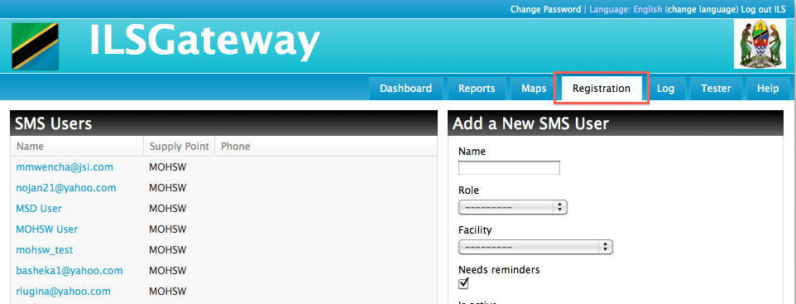

* + If you do not see the Registration tab, please contact a local Tanzania ILSGateway administrator to set you up. If there are no local administrators, contact Dimagi support (logistics-support@dimagi.com).

When you select the “Registration” tab, you’ll see two sections:

* SMS Users
  + This section lists the current users of the system
* Add a new SMS User
  + This section add and edits users

**2. Adding a new SMS user**

To add a new user, fill out the form on the right-hand side of the screen:

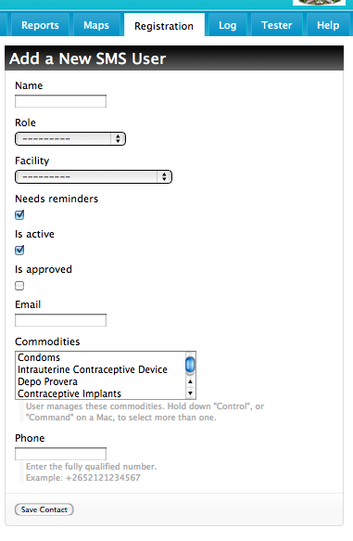

* Name
  + Name of user. Can be name or email.
* Role
  + Role of user. Defines what screens this user will have access to: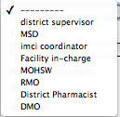
  + District Supervisor
  + MSD
  + IMCI Coordinator
  + Facility-in-charge
  + MOHSW
  + RMO
  + District Pharmacist
  + DMO
* Facility
  + Facility of user. These are listed alphabetically by name regardless of if it is a Region, District, MOHSW, etc.
* Needs Reminders
  + User will be sent reminders (for example to submit SOH, R&R, etc.)
* Is active
  + A checkbox that determines if user will be currently using the system. Mark “checked” for new users.
* Is approved
  + Set this to true. The approval process does not apply to ILSGateway.
* Email
  + Email address of user.
* Commodities
  + Lists the 21 products currently tracked. NOTE: In ILSGateway, all users will be able to manage all products, so you can leave this field with no selections.
* Phone
  + Phone number of user. Enter the full number starting with + and country code. Example: +2652121234567
* Save
  + Button to save information.

**3. Adding a new SMS user via SMS**

To add a new SMS user via SMS:

SMS one of the following keywords: “register”, “reg”, “join”, “sajili”, followed by the user’s name, and finally the facility code. Example:

“register Moe Green d1001”

Alternatively you may send the name of a facility if it follows a colon:

“register Moe Green : mohsw”

**4. Editing or Deleting an existing SMS user**

To edit an existing user, first click on the user’s name:

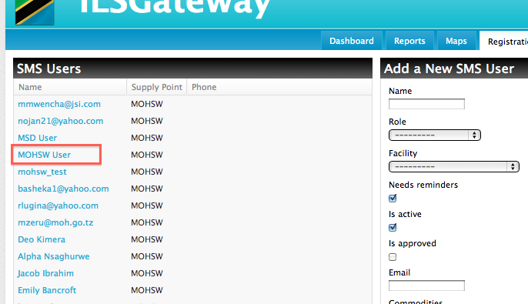

Once the user’s name is selected the form on the right side will update to show all of the information about that user:

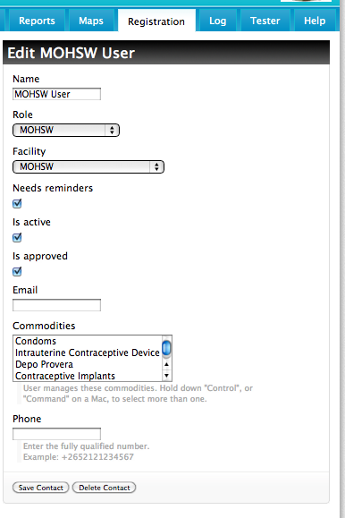

You can edit the form just as you would to add a new user. Refer to section 2, above, for more information on each field.

Additionally, to delete a contact, click the button “Delete Contact” which will remove the selected user from the system.

**5. Adding a new web dashboard user**

There are some users of ILSGateway who are not associated with specific facilities, and need to be added as “Web Dashboard Users.” Examples of these users are MOH staff, regional staff, or local JSI staff who monitor the ILSGateway site.

To manage these users, you’ll need to login to [www.ilsgateway.com/admin](http://www.ilsgateway.com/admin). Just like the other sections of this document, you’ll need administrative privileges to login to this screen.

Click on the “Users” link under the “Auth” section (or use the shortcut “Add”):

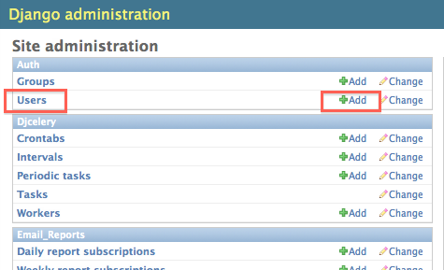

In creating a web dashboard user, first create a username and password (NOTE: Make sure to write down the username and password so that you can provide it to the new user):

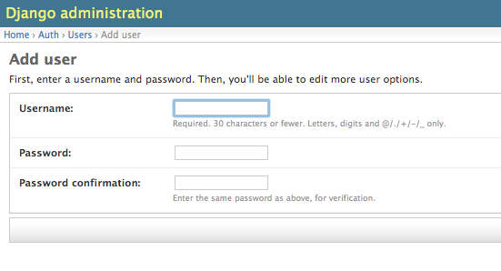

Click “Save and Continue Editing”.

On the next screen enter the first name, last name, and email address of the user:

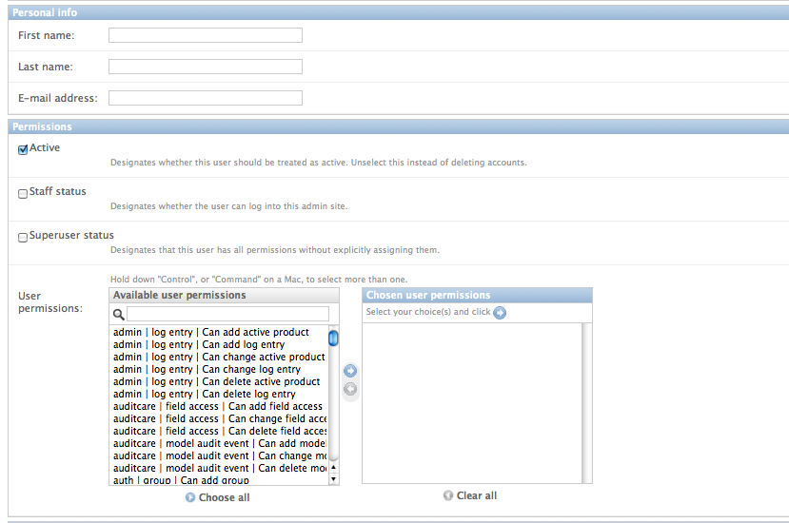

If the intention is to setup the new user as an admin, check both “Staff status” and “Superuser status”. Otherwise, leave these both unchecked.

NOTE: there is no need to select any of the permissions individually from the list, because “Superuser status” will automatically assign the user with all permissions.

**6. Editing a web dashboard User**

Just like section 5, above, first login to [www.ilsgateway.com/admin](http://www.ilsgateway.com/admin). Select “Users” from the “Auth” section of the admin webpage. This will take you to the list of users:

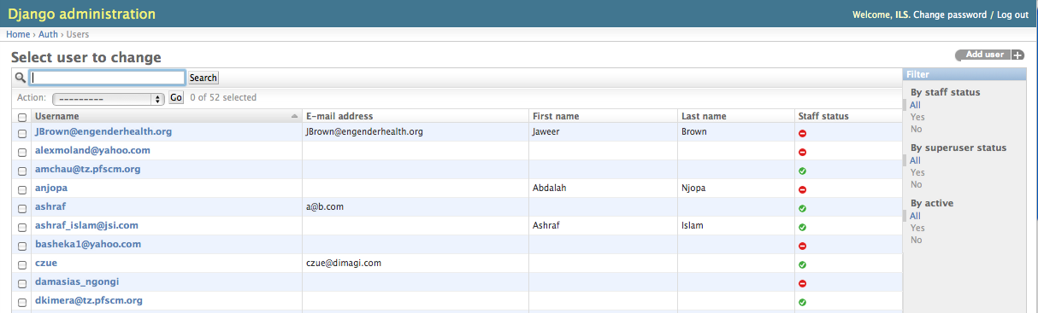

To search for a user, enter the username, first name, last name, or email address in the search box.

Once you see the user that needs editing, click the username.

Just like section 5, above, you’ll be brought to the personal info and permissions section for that user.



Once again, if the intention is to setup the new user as an admin, check both “Staff status” and “Superuser status”. Otherwise, leave these both unchecked.

NOTE: there is no need to select any of the permissions individually from the list, because “Superuser status” will automatically assign the user with all permissions.

**7. Activating or Deactivating a Facility**

Login to [www.ilsgateway.com/admin](http://www.ilsgateway.com/admin)

Click on the “Supply points” link under the “Logistics” section:

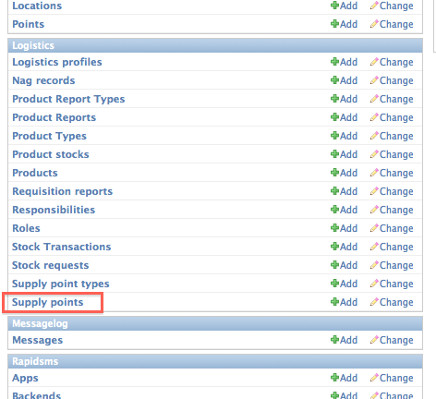

Select the Facility that needs to be activated or deactivated. You can sort this list by name or code by clicking the column header.

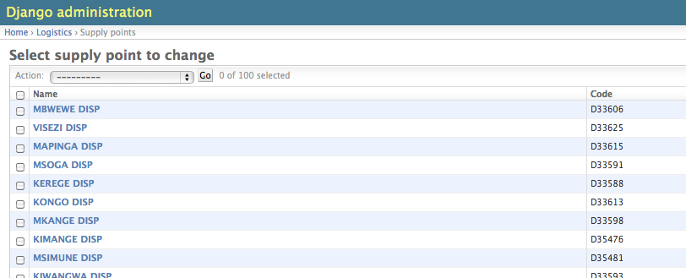

Activating the facility will allow it to be included in the system. Deactivated facilities will not be included.

Check or uncheck the “Active” checkbox in the Facility detail page:

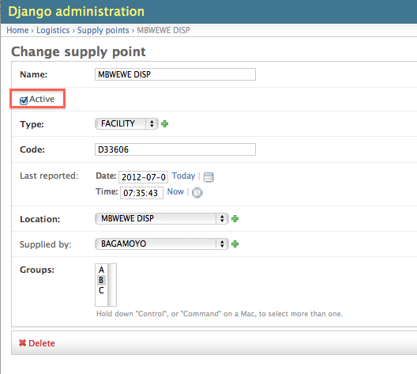

**8. Refreshing Data via the Training tab**

The ILSGateway site automatically refreshes the data every few hours. In case there is a need to immediately update the data on the site, there is a button only available to administrators in the “Training” tab.

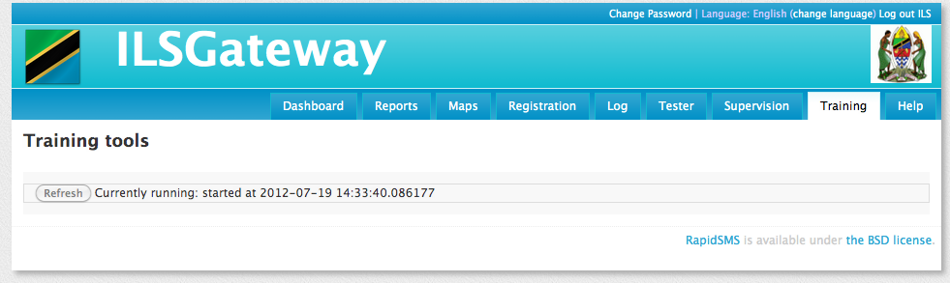

When the refresh is already running, the button will be gray and disabled. When a refresh is not currently running, the time of the most recent refresh will be annotated.

The refresh will take a few minutes or longer depending on the data volume.