CA1: Task 2

Amirarsalan Shahbazi 810101451

Farjad Fallah 810101483

Farnoush Fallah 810101484

Tableau public link (Story): <https://public.tableau.com/app/profile/amirarsalan.shahbazi/viz/CA1_17439581065030/WheretostayinNewyork?publish=yes>

Our story starts with the fact that during recent years that Airbnb becomes popular among people, we can extract great facts from people using Airbnb. For example, we can check which cities are favored by people the most.

We have data for New York city and five neighborhoods of it.

First of all, we join the two databases by common field of neighborhood group and we result in one joined data.

At first, we show on map geographical location of Airbnb places.

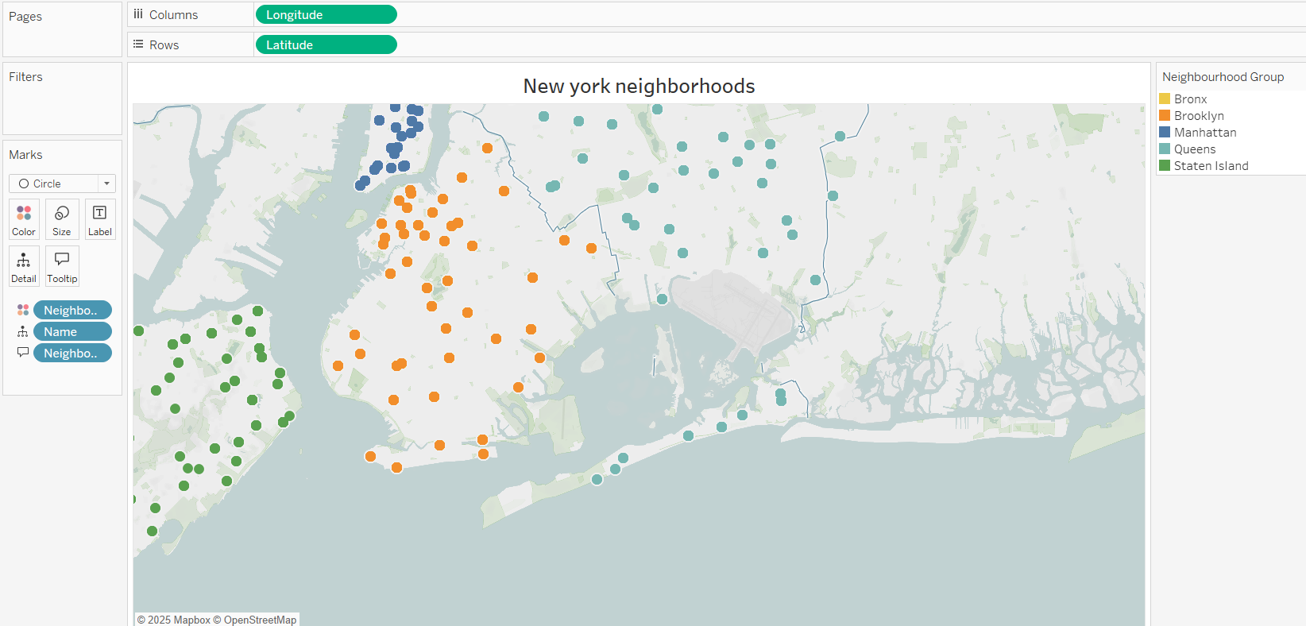

This result to our first dashboard that is our introduction dashboard.

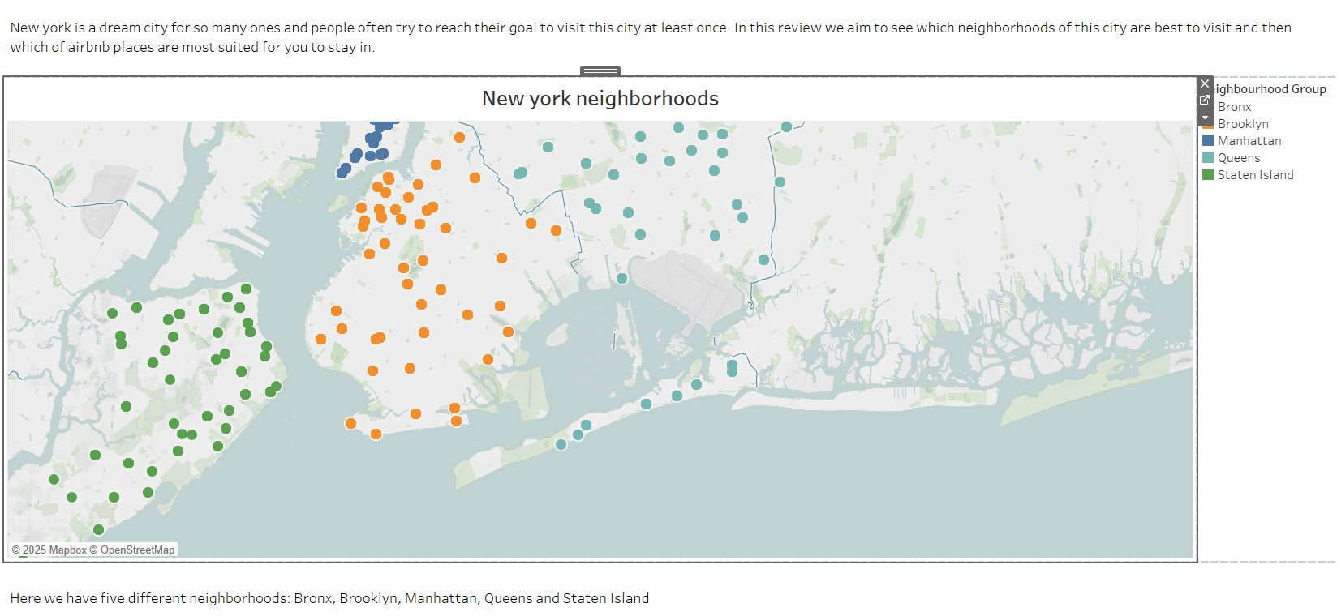

So, in this story we want to check if someone wanted to visit New York city which neighborhoods are best for them to stay in. And we aim to come up with some Airbnb places recommendation for them based on which attraction are they going to visit.

In next sheet we show price distribution in different areas.

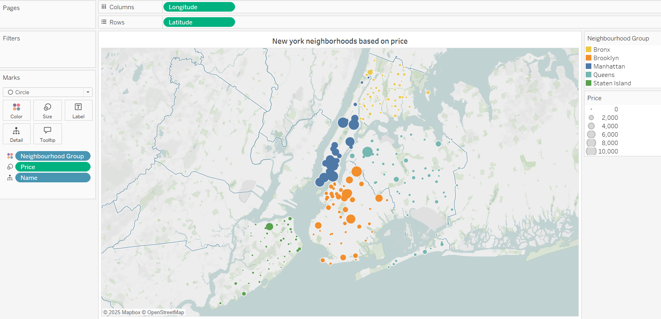

Our attention is absorbed to Manhattan and Brooklyn and we think because of their high price people may go other neighborhoods.

But with these three charts we see that people tend to rent a house in those two neighborhoods.

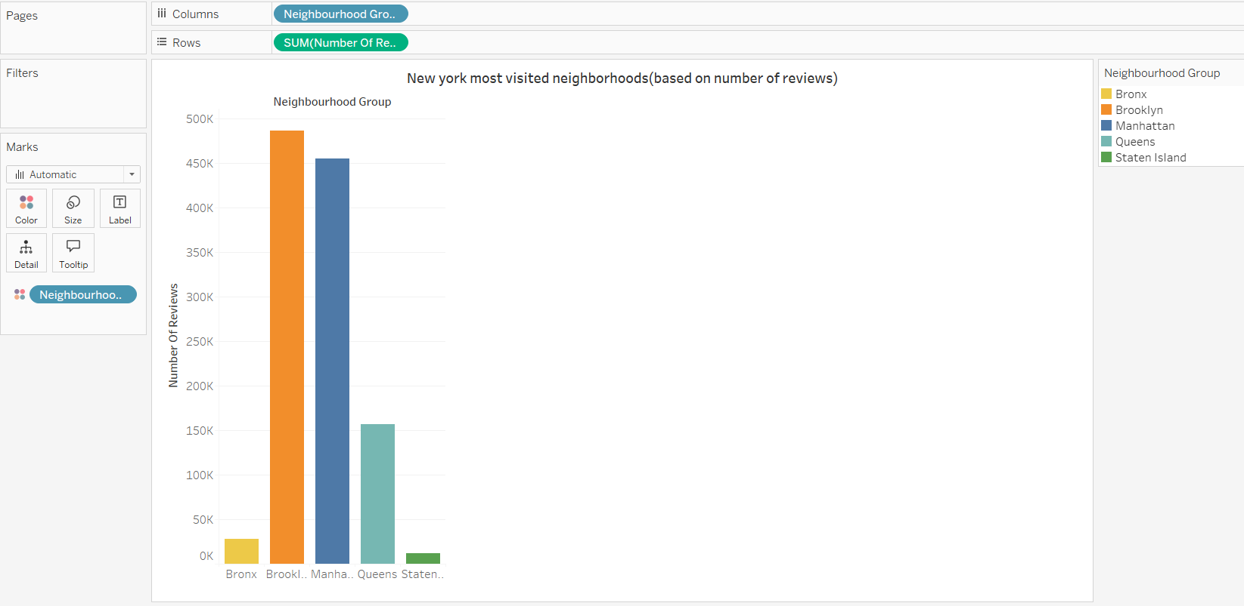

This chart shows that most reviews are recorded in Manhattan and Brooklyn.

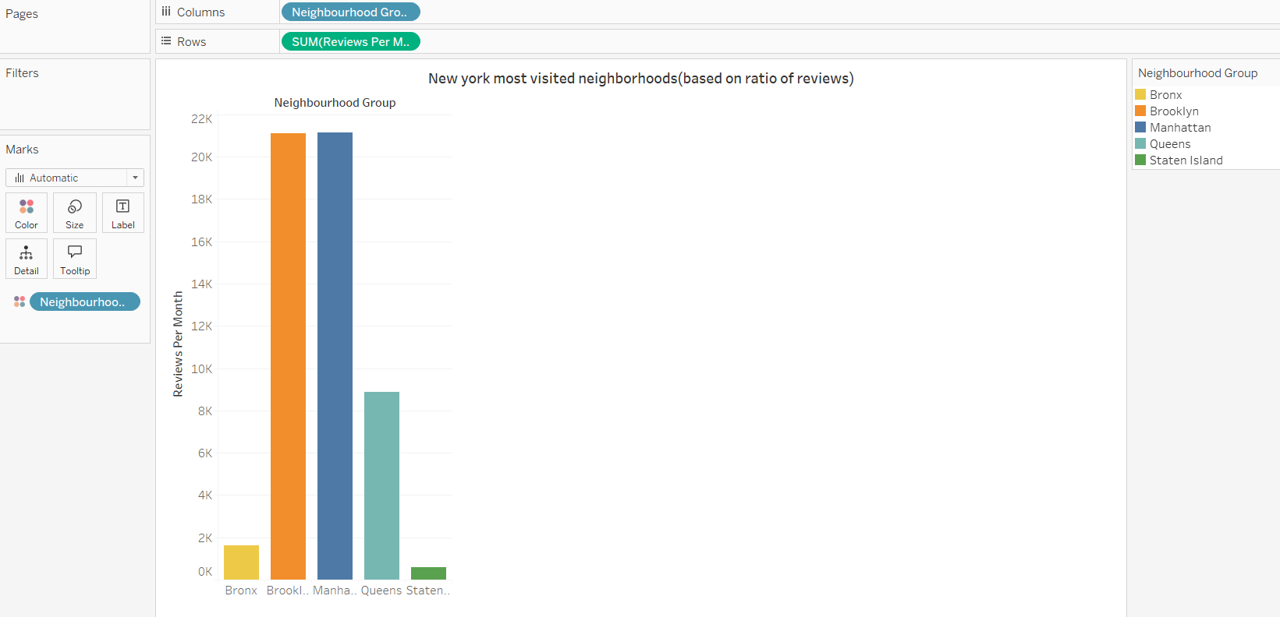

In addition to number of all reviews, ration of recorded reviews are higher in those neighborhoods too.

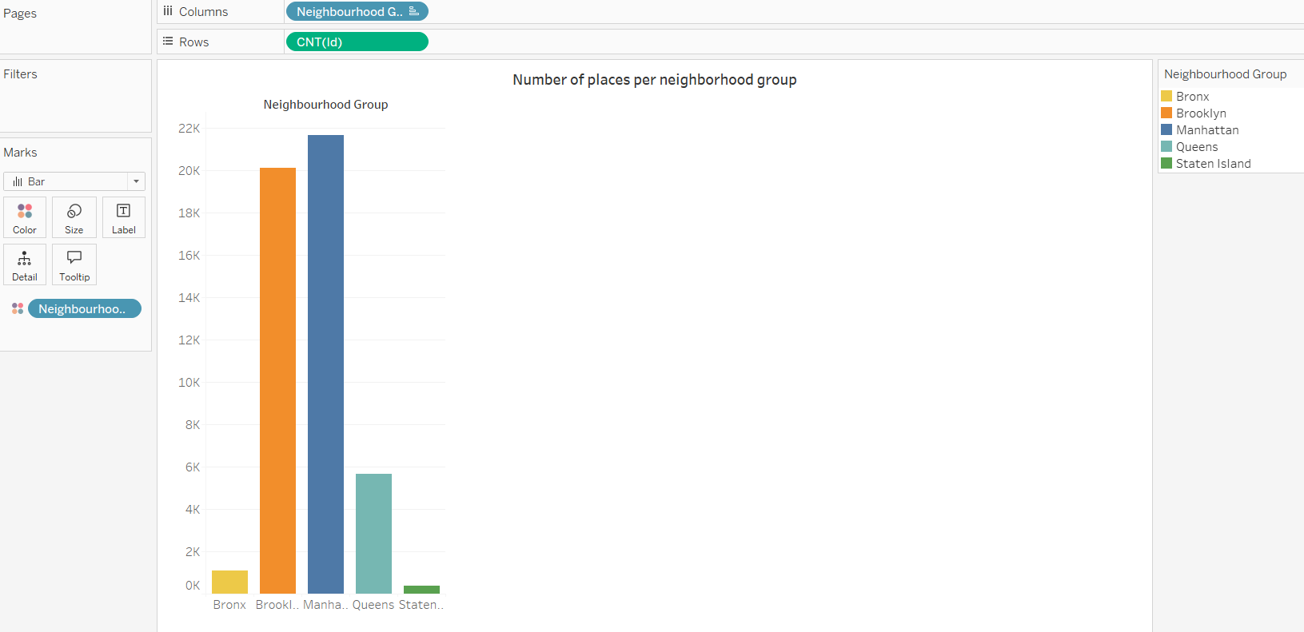

And at last, you can see number of places which are for rent is more in Brooklyn and Manhattan.

Charts above result in second dashboard.

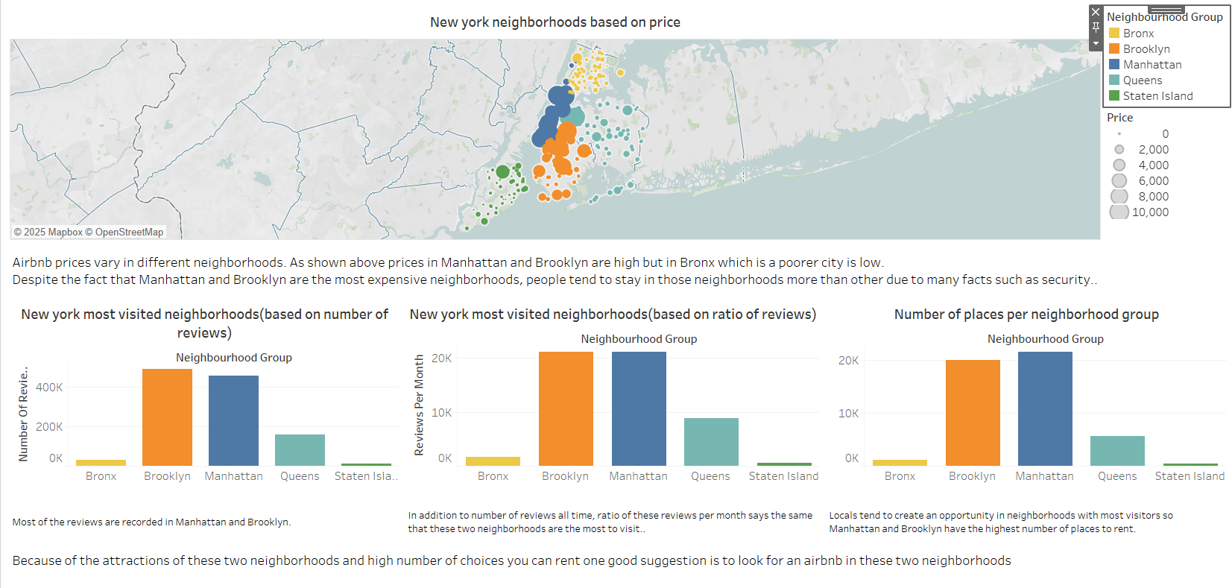

By conclusion from above dashboard, we aim to zoom in Manhattan and Brooklyn statistics.

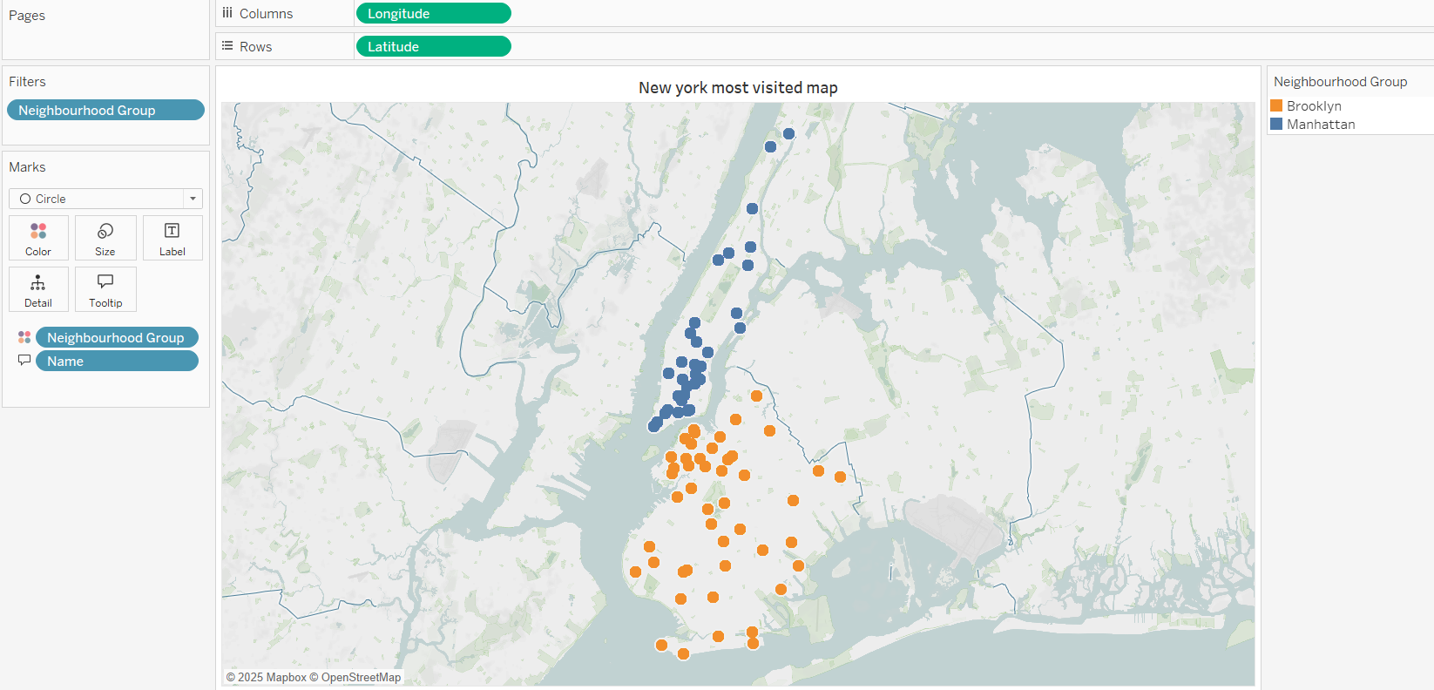

Now we come up with an idea of finding some famous attractions in those two neighborhoods.  
First of all we create a parameter called Selected Attraction. User can select the attraction that wants to visit during its presence.

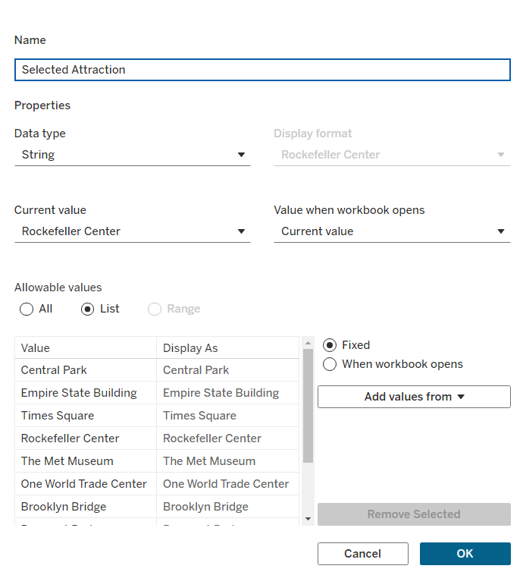

For each attraction we create a calculated field for their longitude and latitude.

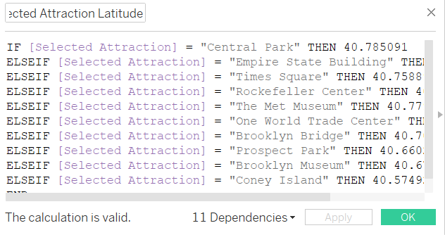

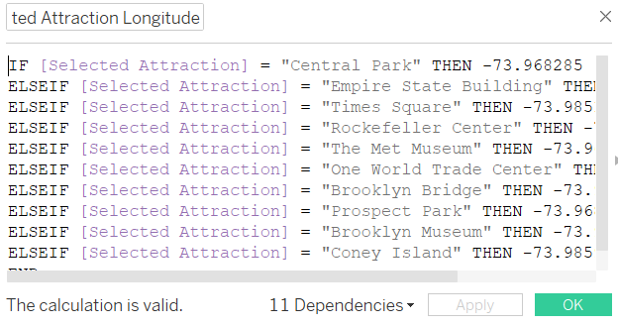

Also, we create another parameter to filter top hotel ranks in a feature we select.

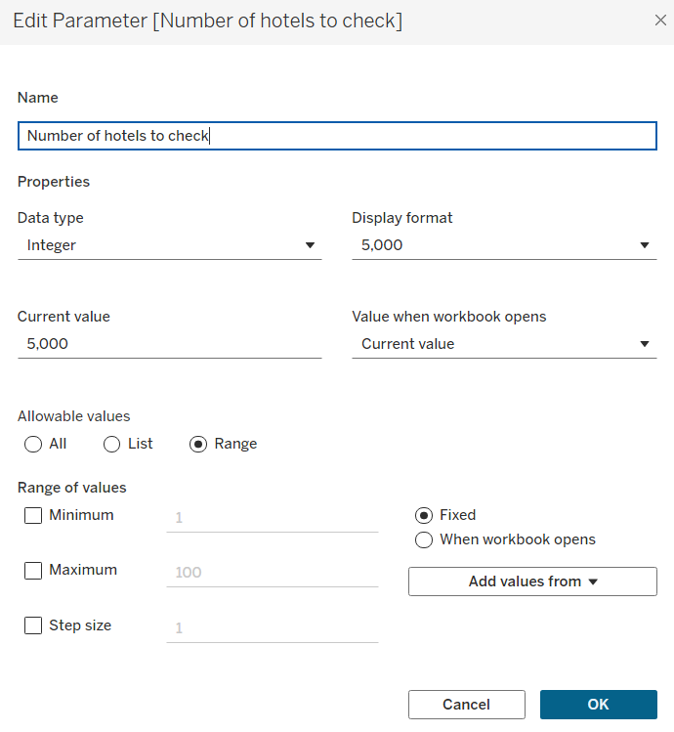

For example, in next sheet we rank top 5000 cheapest places in Manhattan and Brooklyn.

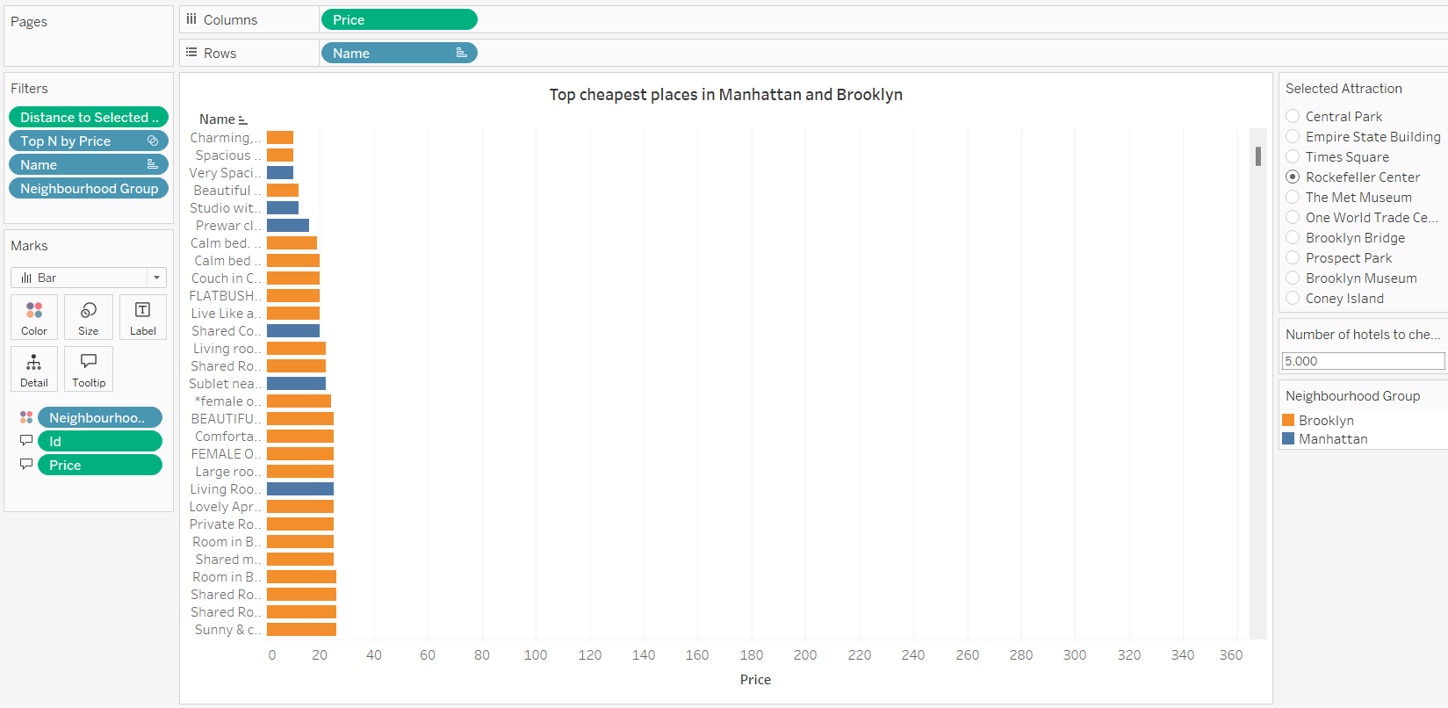

We do the same for the most reviewed places in those neighborhoods too.

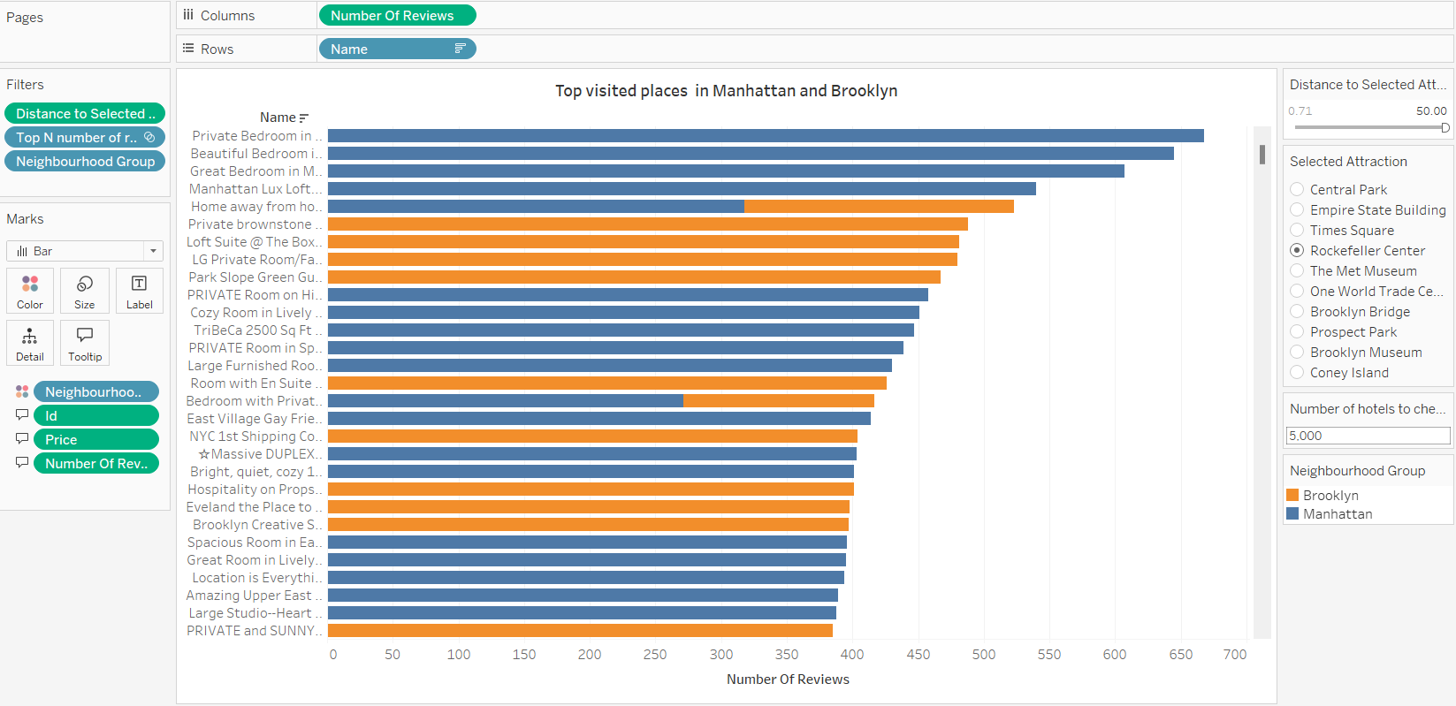

Next, we create a new calculated field for calculating the distance between hotels to attraction. This field is called Distance to Attraction.

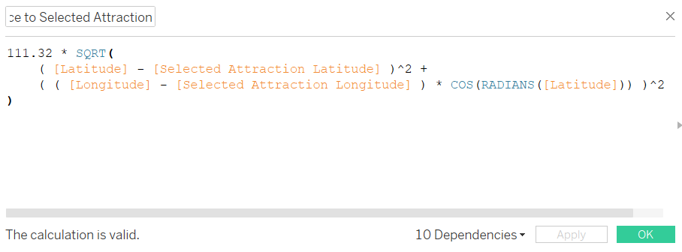

By using Latitudes and Longitudes we calculate distance between two points in kilometer.

With this field we find top nearest hotels to attraction selected by user which is shown below.

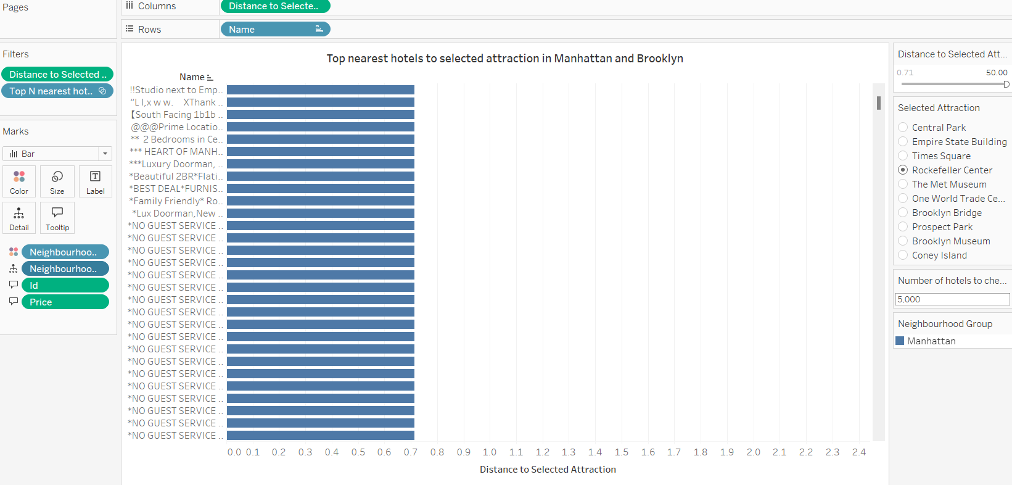

So, third dashboard consists of above sheets.

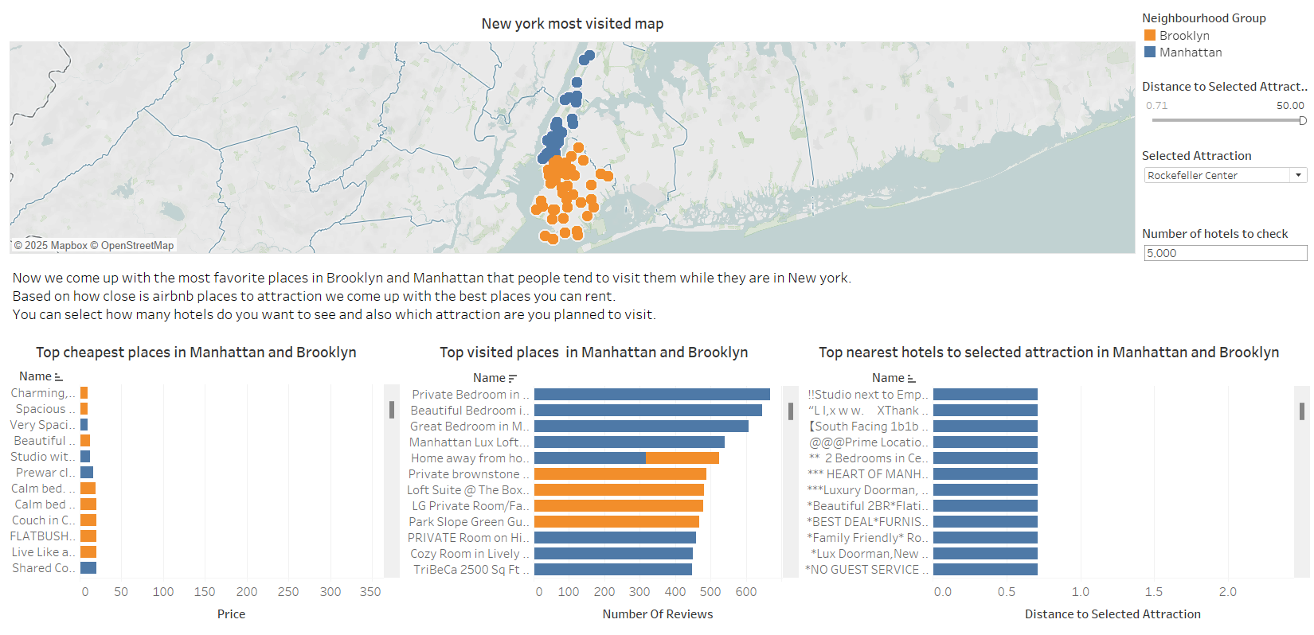

Here we gather best hotels based on three different factors and user can sort them in a way it wants.

Then we need to find hotels which are best in all three factors. In order to do that we create a new calculated field called Intersection of top Ns.

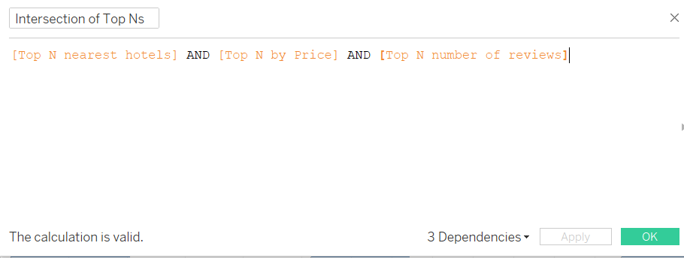

We find hotel names that are ranked top in all of these three sets.   
If we choose number of hotels we check, a higher number, we will come up with more hotels to recommend.

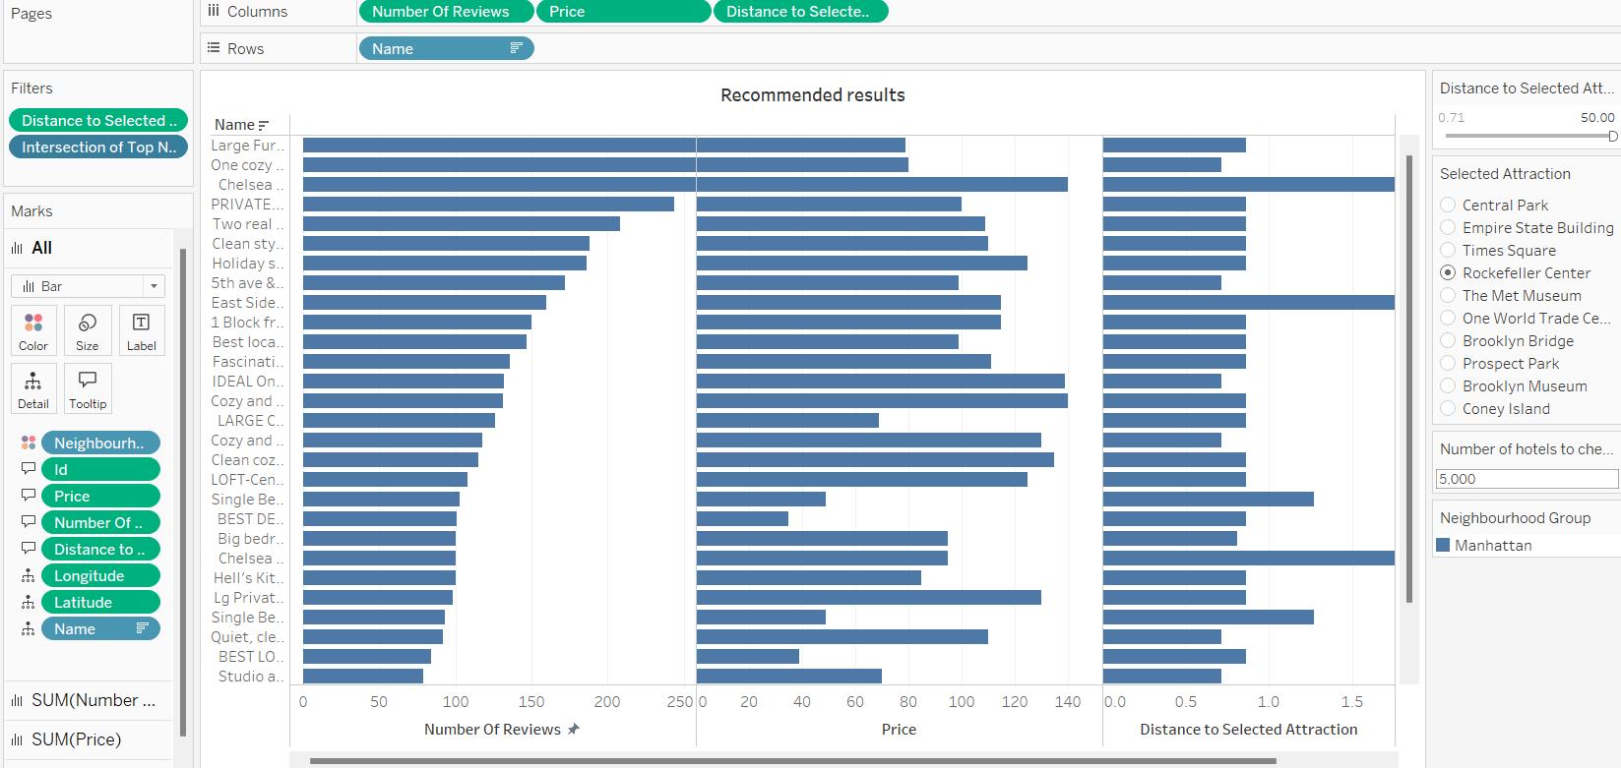

In this sheet we find out places that are ranked top in each factor. We can sort by each factor that is more important to us to find the best choice for our place.

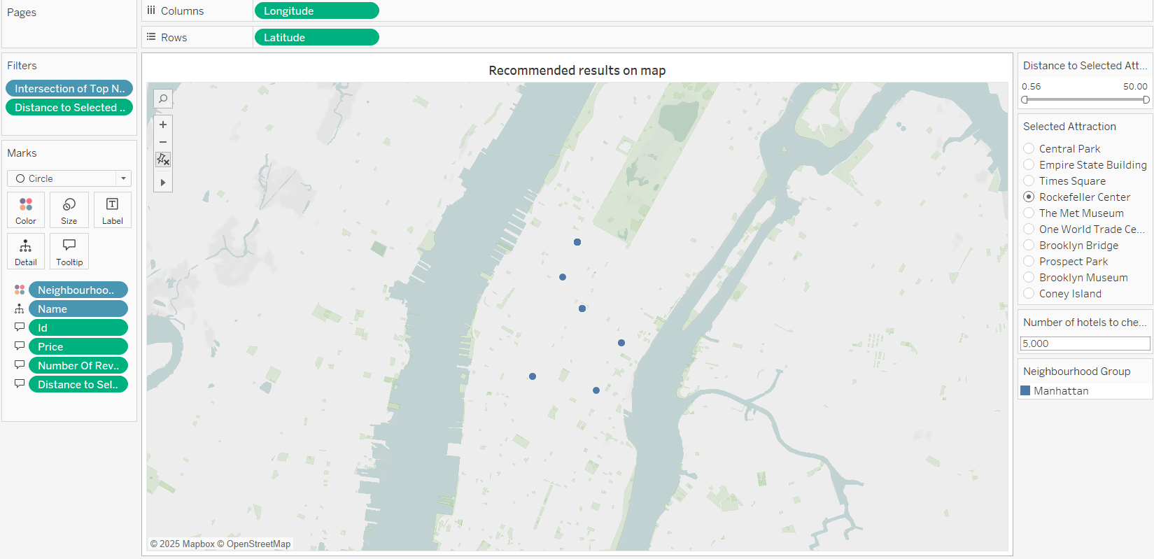

Next, we show geographical locations of recommended places too.

These too sheets lead to out finals dashboard which is used to recommend hotels based on the factors and also show the user its geographical location.

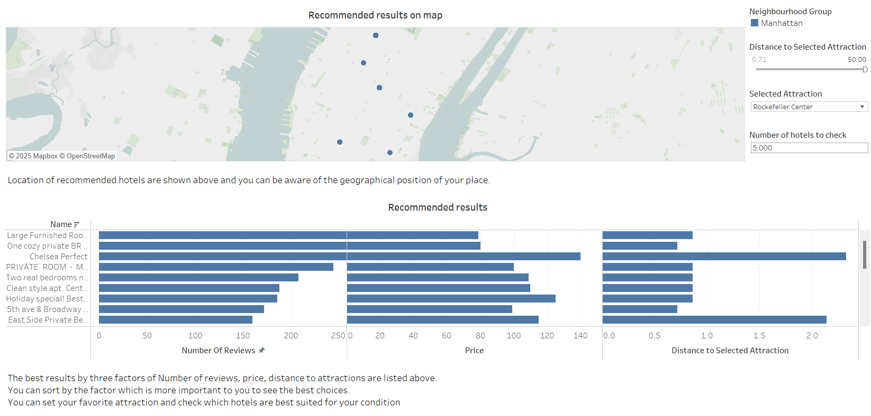

And at the end user can get different suggestions based on filters that are shown.

So, in conclusion, we start our story with New York places to rent. Then we come up with the idea to limit our journey by just choose one neighborhood between Manhattan or Brooklyn. Then based on an attraction that we want to attend, we come up with some hotel suggestion based on three factors and at last we aggregate our result in order to find a place which is good in all three factors.